Software Requirements Specification Document
<Your Project Name, Team’s Name and Members in Black>

Note: This is a “living document”, meaning its content will change with the implementation of the project. Use it to capture key project requirements and make sure that your product features match the requirements exactly – if you wish to add any features, they must be added first to the requirements. Changes in the document must be approved by the customer (mentor) and the instructor/TA in-charge.
Remove this text and the descriptive paragraphs in each section stating what to do before you turn it in.

Brief problem statement
Replace this text and the instructions below with your statement in black.
(2-5 lines describing the problem being addressed. Note that even if you are simply restating what is already in the project description, you must rephrase it in your words. This gives an opportunity for the customer to identify and provide feedback on differences in interpretation, if any).

System requirements
Replace this text and the instructions below with your statement in black.
(Identify the system requirements for your solution. If you require particular technologies, languages and libraries, list them as well).

Users profile
Replace this text and the instructions below with your statement in black.
(Identify who will be using the system, in what mode, and their profile in terms of familiarity with using computers and such software).
Kids and Pet Owners of any age are the targeted users of this application. Kids will use this application to have fun to view one animal makes the sounds of other animals from the given list of animals in the application. Along with parents, pre-school going kids can identify the correct sound for a selected animal.

Feature requirements (described using use cases)
Read the instructions below and fill in the table. Delete all the blue text turning it in.
(This is a numbered list of use cases that are the features of the system to be implemented. Each use case is an operation that the user can perform on/with the system. For each use case, provide a description (2-3 sentences) so you know what to build and so you can write a test case to demonstrate that your system provides that feature. For each use case, you will identify (during release planning) the release in which it will be implemented: R1 or R2. Typically, your project will have 10-15 use cases, but feel free to add or delete table rows if you decide to use finer-grain or coarse-grain use cases).

No. | User Case Name | Description | Release
 | Sound_Like_Another_Animal | User selects an animal from the list of given animals. User selects a sound (like: bark, roar, etc.,) and view the sound coming from the selected animal. | R1
 | Speak_In_Human_Voice | User selects an animal from the list of given animals. Enter text to be spoken and view the animal with human voice. | R2
 | Perform_Command_By_Master | User selects an animal from the list of given animals. User selects an action (like: Jump) and view the animal performing the action | R2

Use case diagram
Read the instructions below and fill in the table. Delete all the blue text before adding this to your repository or turning it in to your instructor.
Draw the UML use case diagram for the system. Make sure the use cases shown in the diagram correspond to the use cases described in the previous section.

Use Case Diagram:

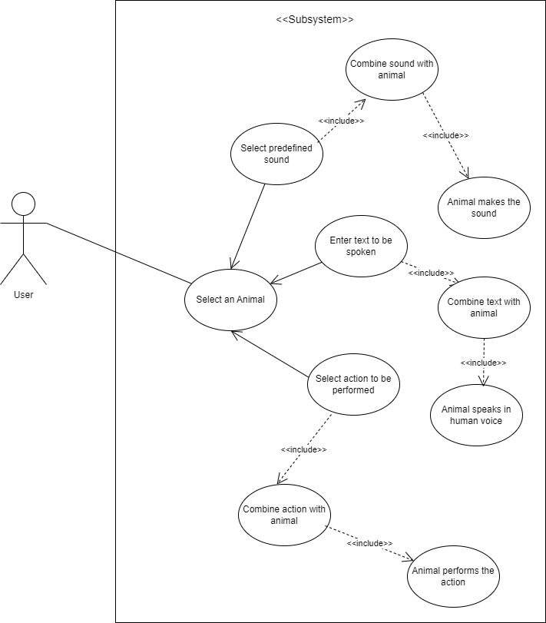

Use case description
Delete all the blue text and fill-in the template before adding this to your repository or turning it in to your instructor.

Use Case Number: | UC-01
Use Case Name: | Sound_Like_Another_Animal
Overview: | User selects an animal from the list of animals to choose from the application. After selecting an animal, user selects a sound they want to listen from the selected animal. The application will combine the animal and sound together and play it for the user.
Actors: | Application user
Pre condition: | Registered user has successfully logged in to the application.  User has internet connectivity
Flow: | Main (success) Flow:  - Select an Animal from the list of animals to choose from the application  - Select any animal sound from the list of sounds to choose from the application  - The animal will play the sound as selected by the user.
Alternate Flows:
In case internet connectivity is lost in between, the application will not move forward
Post Condition: | A button to go back to home screen will be displayed to the user so that on clicking the button, the user can go back to the home screen.

Use Case Number: | UC-02
Use Case Name: | Speak_In_Human_Voice
Overview: | User selects an animal from the list of animals to choose from the application. After selecting an animal, user enters text to be spoken. The application will combine the animal and speech together and play it for the user.
Actors: | Application user
Pre condition: | Registered user has successfully logged in to the application.  User has internet connectivity
Flow: | Main (success) Flow:  - Select an Animal from the list of animals to choose from the application  - Enter a text to be spoken  - The user can view the animal with speech merged
Alternate Flows:
In case internet connectivity is lost in between, the application will not move forward
Post Condition: | A button to go back to home screen will be displayed to the user so that on clicking the button, the user can go back to the home screen.

Use Case Number: | UC-03
Use Case Name: | Perform_Command_By_Master
Overview: | User selects an animal from the list of animals to choose from the application. After selecting an animal, user selects a command from the list of options to choose in the application. The application will show the animal performing the action.
Actors: | Application user
Pre condition: | Registered user has successfully logged in to the application.  User has internet connectivity
Flow: | Main (success) Flow:  - Select an Animal from the list of animals to choose from the application  - Select a command to be performed  - The user can view the animal performing the action
Alternate Flows:
In case the internet connectivity is lost in between, the application will not move forward
Post Condition: | A button to go back to home screen will be displayed to the user so that on clicking the button, the user can go back to the home screen.

