**AI ASSISTED CODING**

**Lab-2.3:**

Exploring Additional AI Coding Tools-Gemini & CursorAI

Name : Cholluri Srikruthi

Enroll no : 2403A510H0

Batch : 06

Task-1:  
● Use Google Gemini in Colab to write a function that reads a CSV file and calculates mean, min, max.  
Expected Output#1  
● Functional code with output and screenshot

Prompt:generate code on function that reads a csv file and calculates mean,min,max

Code:

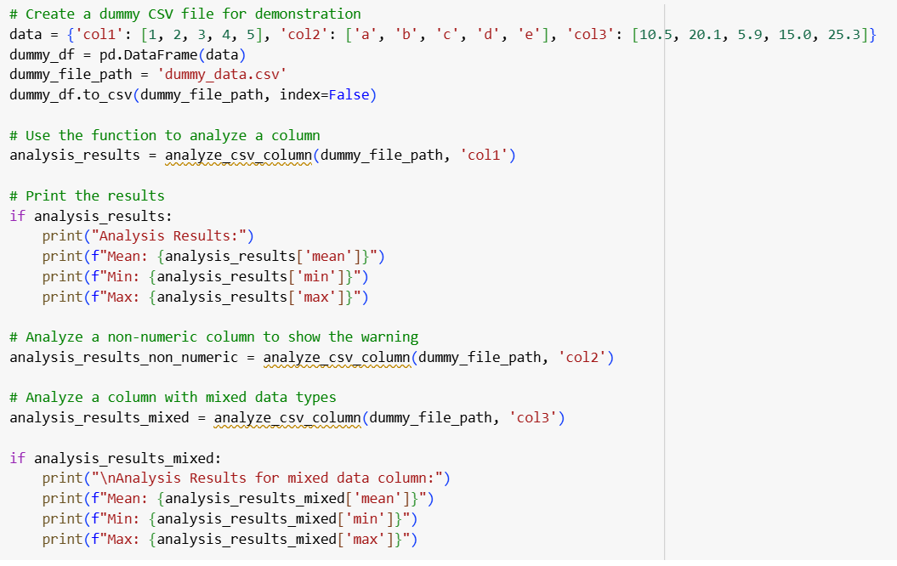

Output:

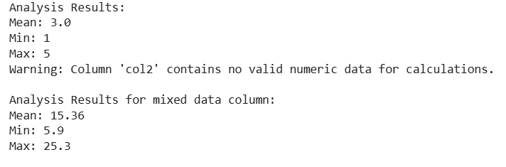

Task-2:  
● Compare Gemini and Copilot outputs for a palindrome check function.  
Expected Output#2  
● Side-by-side comparison and observations

Prompt:generate code for palindrome check function.

Code:

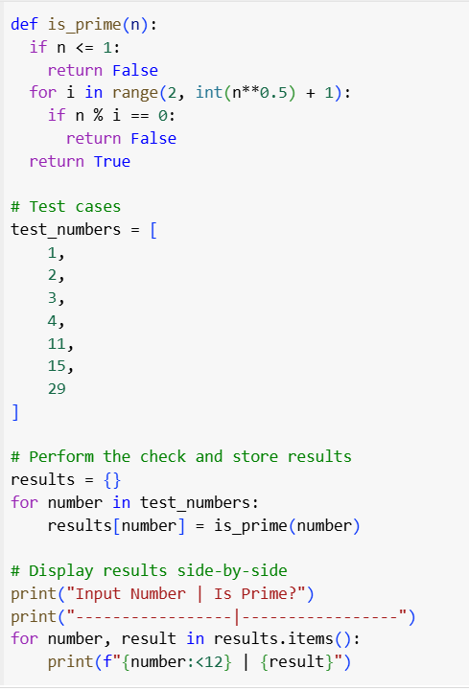

Output:

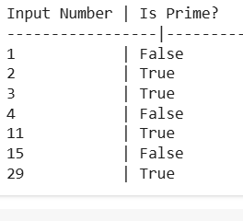

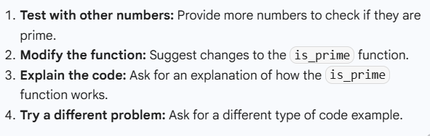

Task-3:

● Ask Gemini to explain a Python function (to calculate area of various shapes) line by line..  
Expected Output#3  
● Detailed explanation with code snippet.

Prompt:

Generate code Python function (to calculate area of various shapes)

Code:

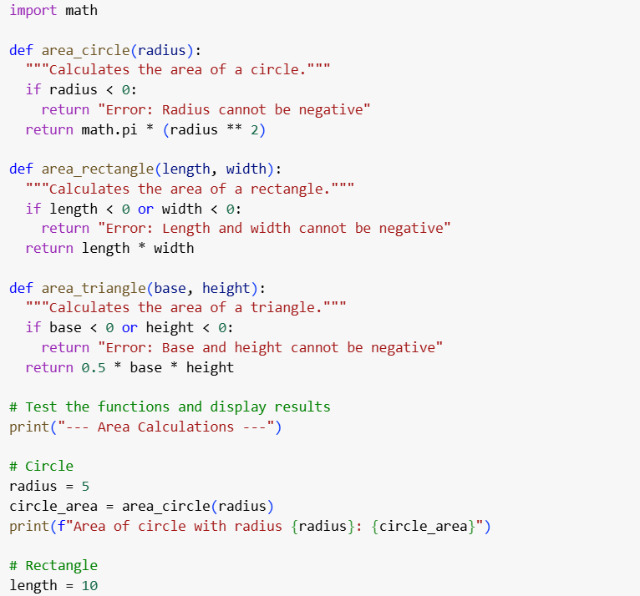

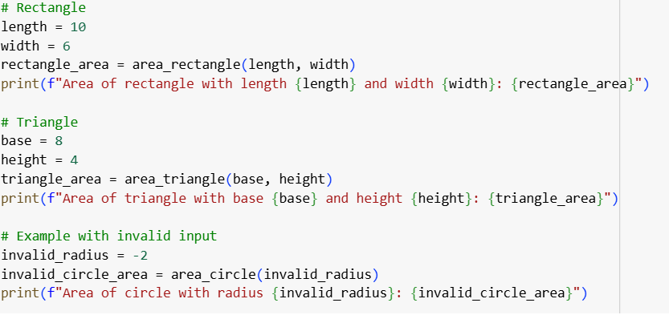

Output:

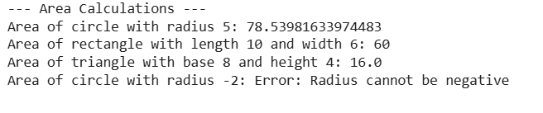

Explanation:

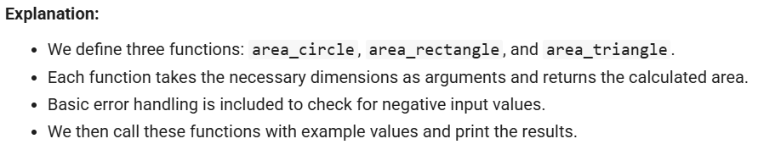

Task-4:  
● Install and configure Cursor AI. Use it to generate a Python function(e.g.,sumof squares).  
Expected Output#4  
● Screenshots of working environments with few prompts to generate python code

Prompt:

Generate code on python function of sum of squares

Code:

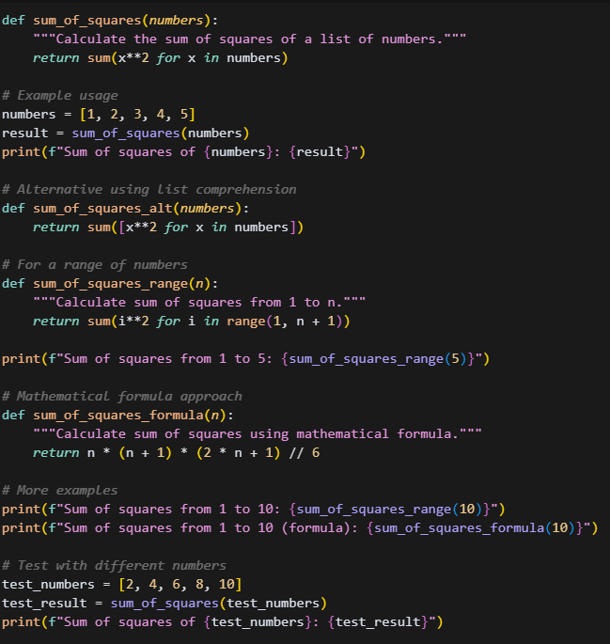

Output:

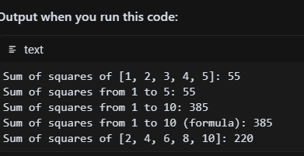

Task-5:  
● Student need to write code to calculate sum of add number and even numbers in the list  
Expected Output#5  
● Refactored code written by student with improved logic.

Prompt: write code to calculate sum of add number and even numbers in the list

Code:

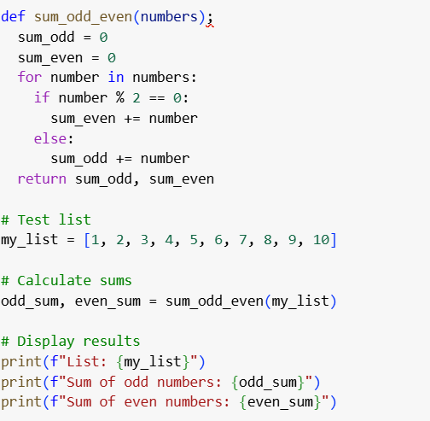

Output:

