**AI ASSISTED CODING**

**Lab-4.3:**

Advanced Prompt Engineering-Techniques

Name : Cholluri Srikruthi

Enroll no : 2403A510H0

Batch : 06

Task-1: Zero-shot

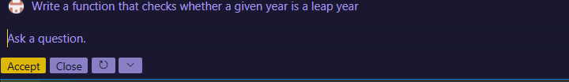

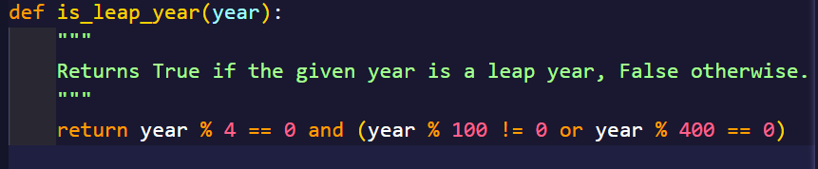

Task-2: One-shot

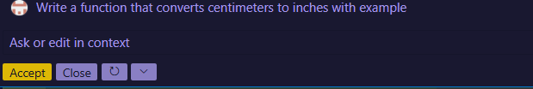

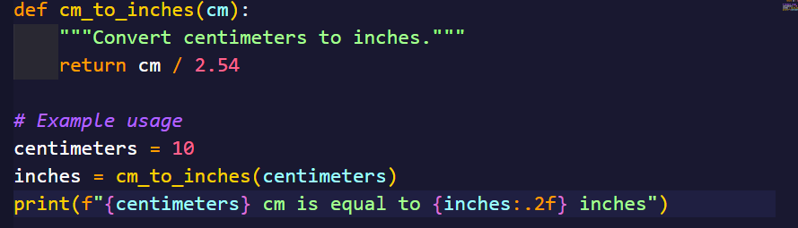



Task-3:



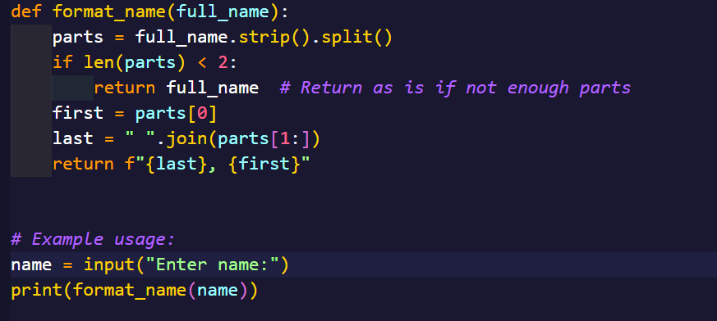

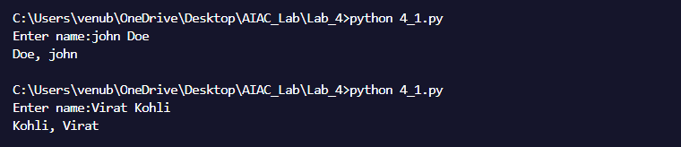

Task-4:

Zero-shot:



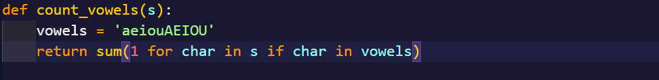

Few-shot:

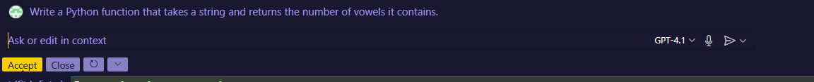

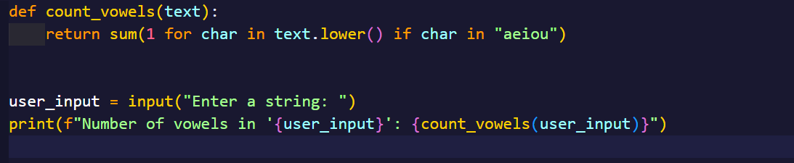

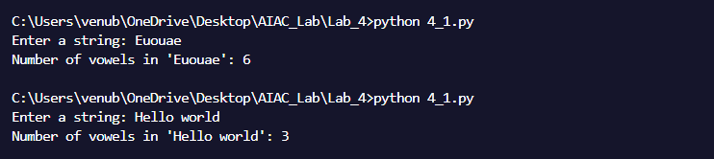

Comparison:

The **zero-shot** method gives a basic and correct solution. It works even without examples, but the code is usually longer and more manual. The AI has to guess what you want just from the question.

The **few-shot** method includes examples, so the AI understands better. It gives shorter, cleaner, and more efficient code.

Task-5:

