Name : Cholluri Srikruthi Enroll no : 2403A510H0 Batch : 06

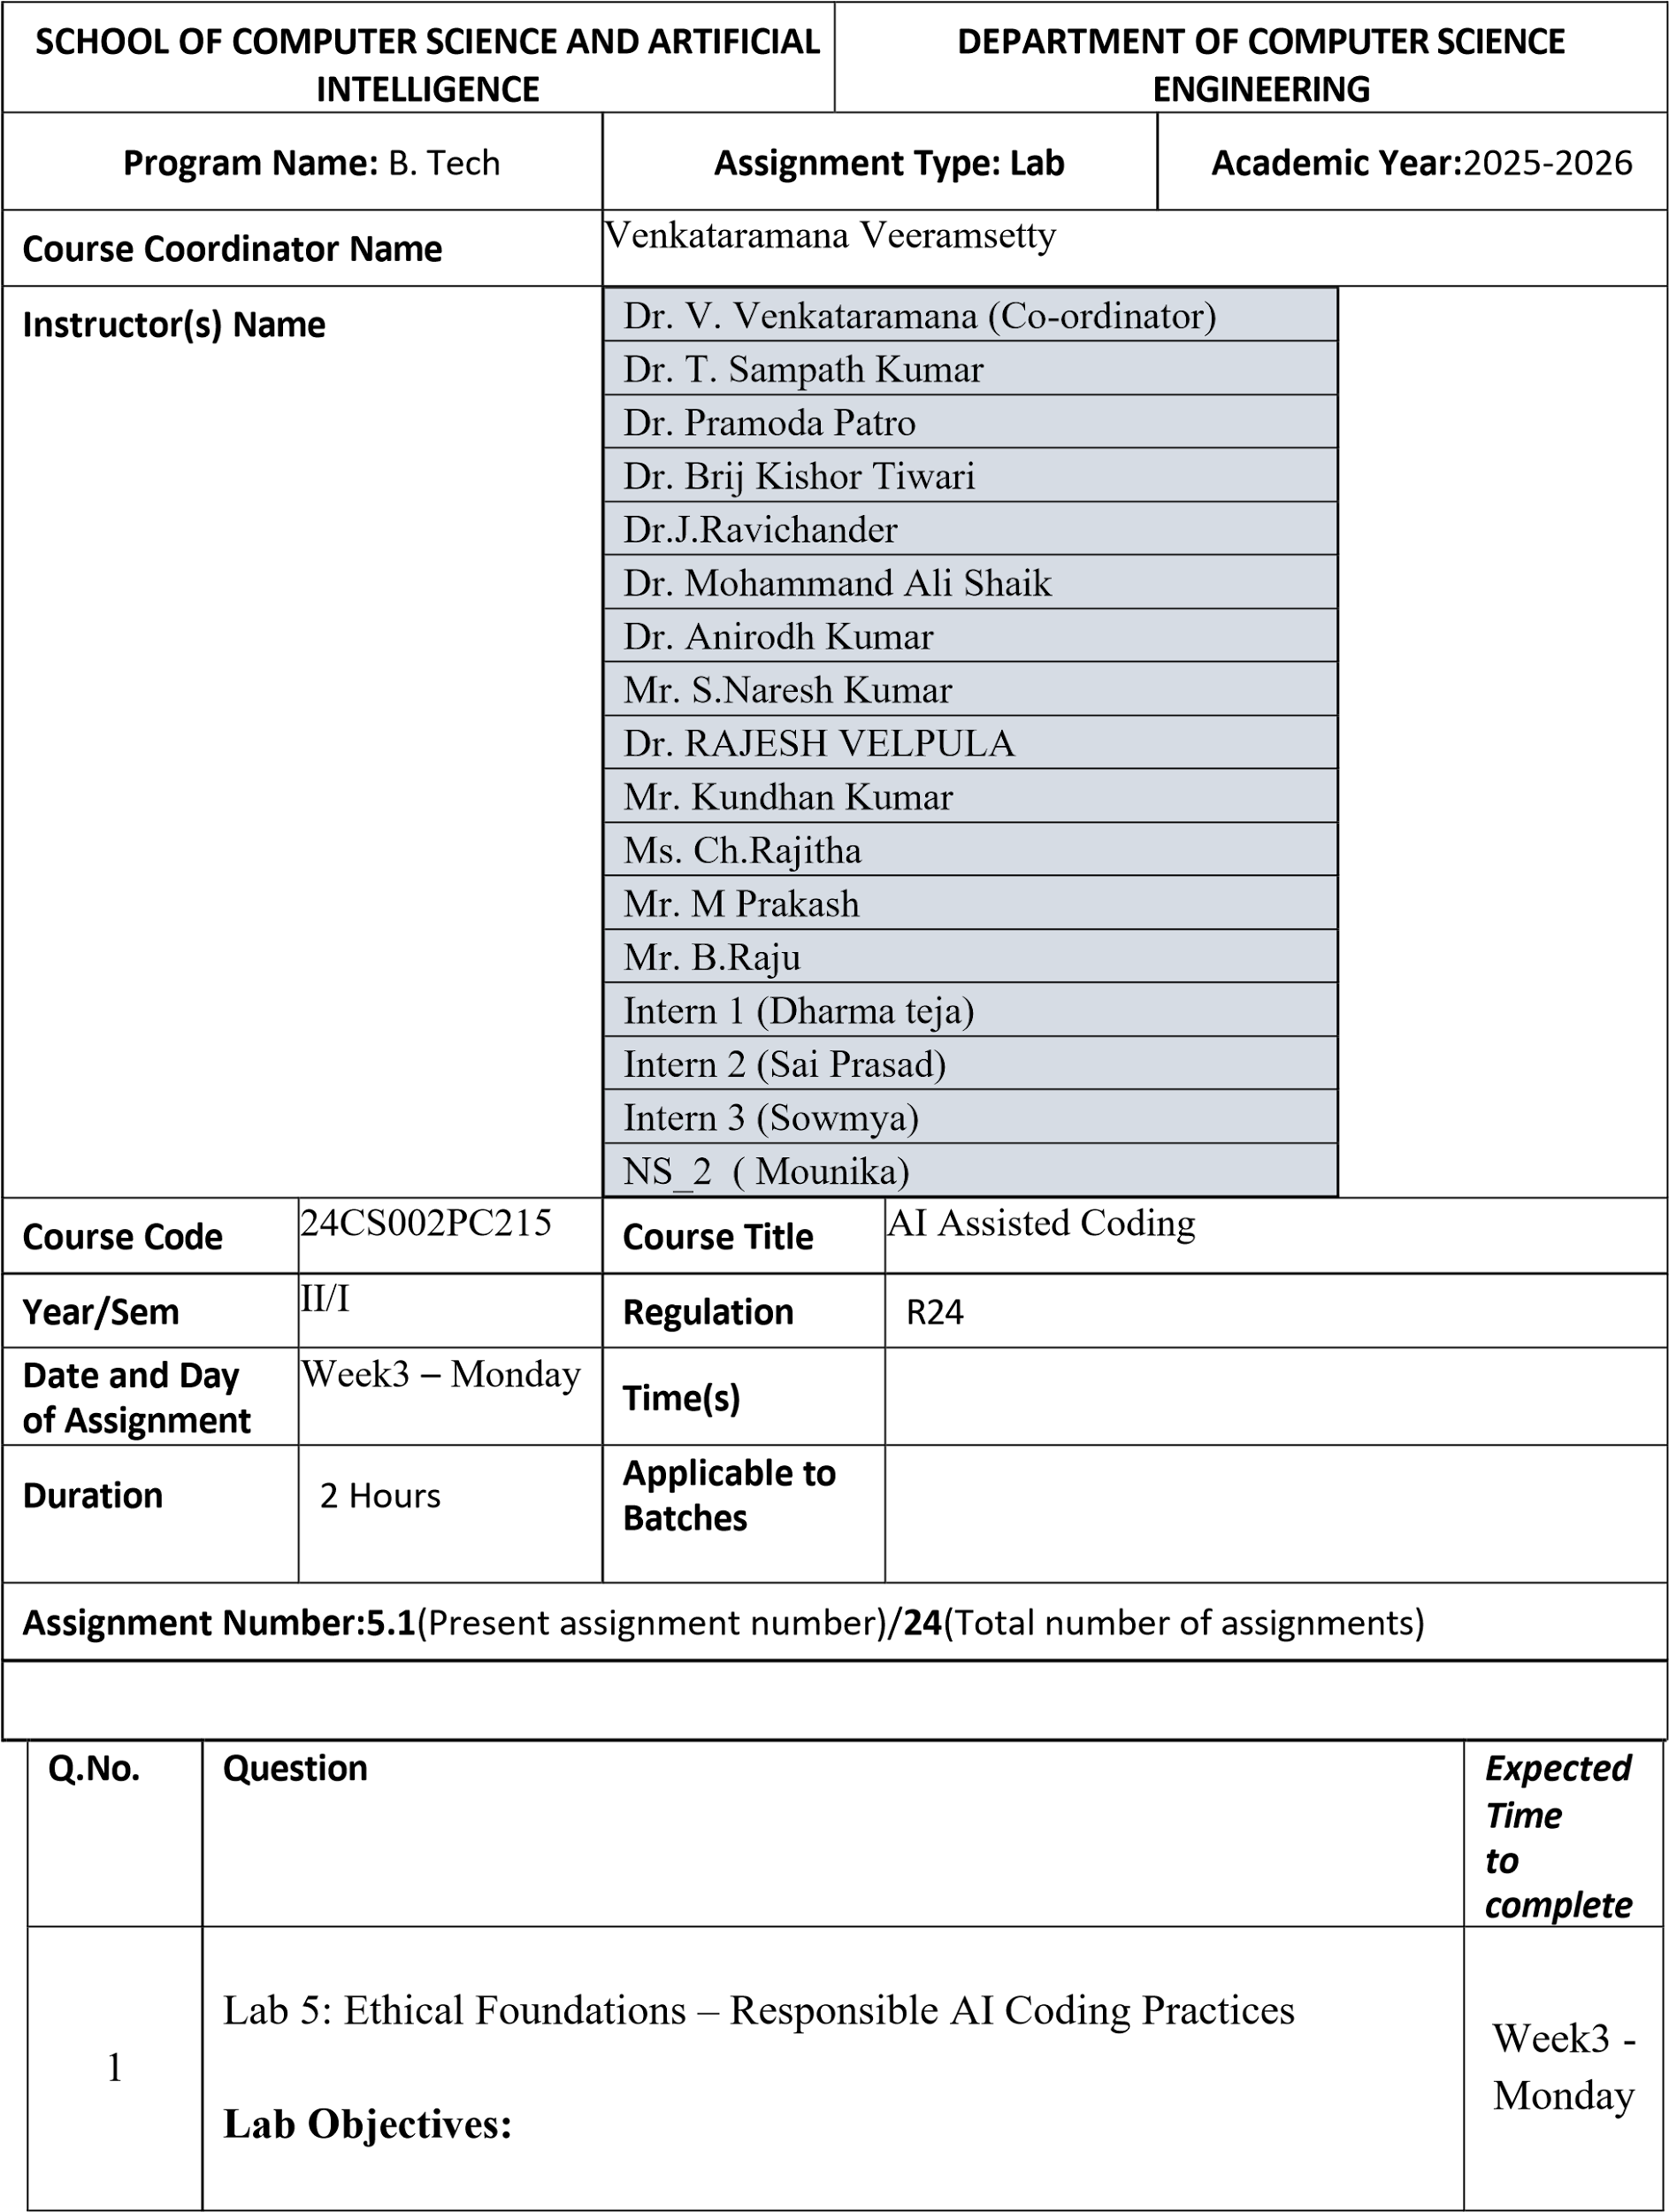

|  | * To explore the ethical risks associated with AI-generated code. * To recognize issues related to security, bias, transparency, and copyright. * To reflect on the responsibilities of developers when using AI tools in software development. * To promote awareness of best practices for responsible and ethical AI coding.     Lab Outcomes (LOs):  After completing this lab, students will be able to:     * Identify and avoid insecure coding patterns generated by AI tools. * Detect and analyze potential bias or discriminatory logic in AIgenerated outputs. * Evaluate originality and licensing concerns in reused AIgenerated code. * Understand the importance of explainability and transparency in AI-assisted programming. * Reflect on accountability and the human role in ethical AI coding practices..     Task Description #1 (Privacy in API Usage)  Task: Use an AI tool to generate a Python program that connects to a weather API.  Prompt:  *"Generate code to fetch weather data securely without exposing API keys in the code."* Expected Output:   * Original AI code (check if keys are hardcoded). * Secure version using environment variables Prompt:     Code: |  |
| --- | --- | --- |

|  | Output:      Task Description #2 (Privacy & Security in File Handling)  Task: Use an AI tool to generate a Python script that stores user data (name, email, password) in a file.  Analyze: Check if the AI stores sensitive data in plain text or without encryption.  Expected Output:   * Identified privacy risks. * Revised version with encrypted password storage (e.g., hashing).   Prompt: |  |
| --- | --- | --- |

|  | Code:    Output:    IN the file:   * Plain-text password storage: Passwords are stored exactly as entered. * No hashing or encryption: A data breach would expose user passwords. * Vulnerable to insider threats: Anyone with access to the file can read sensitive data.   Task Description #3 (Transparency in Algorithm Design)  Objective: Use AI to generate an Armstrong number checking function with comments and explanations.  Instructions:   1. Ask AI to explain the code line-by-line. 2. Compare the explanation with code functionality.   Expected Output:   * Transparent, commented code. * Correct, easy-to-understand explanation.   Prompt:    Code: |  |
| --- | --- | --- |

|  | Output:    Task Description #4 (Transparency in Algorithm Comparison)  Task: Use AI to implement two sorting algorithms (e.g., QuickSort and BubbleSort).  Prompt:  *"Generate Python code for QuickSort and BubbleSort, and include comments explaining step-by-step how each works and where they differ."*  Expected Output:   * Code for both algorithms. * Transparent, comparative explanation of their logic and efficiency.   Prompt:    Code: |  |
| --- | --- | --- |

|  | Output:      Task Description #5 (Transparency in AI Recommendations) Task: Use AI to create a product recommendation system.  Prompt:  *"Generate a recommendation system that also provides reasons for each suggestion."* |  |
| --- | --- | --- |

|  | Expected Output:   * Code with explainable recommendations. * Evaluation of whether explanations are understandable.   Prompt:    Code: |  |
| --- | --- | --- |

|  | Output:      Task Description #6 (Transparent Code Generation)  Task: Ask AI to generate a Python function for calculating factorial using recursion.  Prompt:  *"Generate a recursive factorial function with comments that explain each line and a final summary of the algorithm’s flow."* Expected Output:   * Fully commented code. * Clear documentation of how recursion works.   Prompt:    Code:    Output:    Task Description #7 (Inclusiveness in Customer Support) Code Snippet: |  |
| --- | --- | --- |

|  | Task:  Regenerate the code so that support messages use neutral language (e.g., “Dear {name}”) and optionally accept preferred titles.  Expected Output:  • Neutral, user-friendly support responses.    Prompt:    Code:    Output:      Note: Report should be submitted a word document for all tasks in a single document with prompts, comments & code explanation, and output and if required, screenshots      Evaluation Criteria: | | | |  |
| --- | --- | --- | --- | --- | --- |
|  |  | Criteria | Max Marks |  |  |
| Transparency | 1 |
|  |  | Inclusiveness | 0.5 |  |  |
| Data security and Privacy | 1 |
| Total | 2.5 Marks |