AI ASSISTED CODING

Lab-Assignment-20.3

Name: Ch.Srikruthi
Htno: 2403A510H0
Batch: 06

Task-1:
Prompt:
Generate a simple Python login program using a username and password. First, create it without any validation. Then fix it by adding regex checks for usernames, password length rules, and password hashing. Add 3 test cases for valid, invalid, and short passwords.

Code:

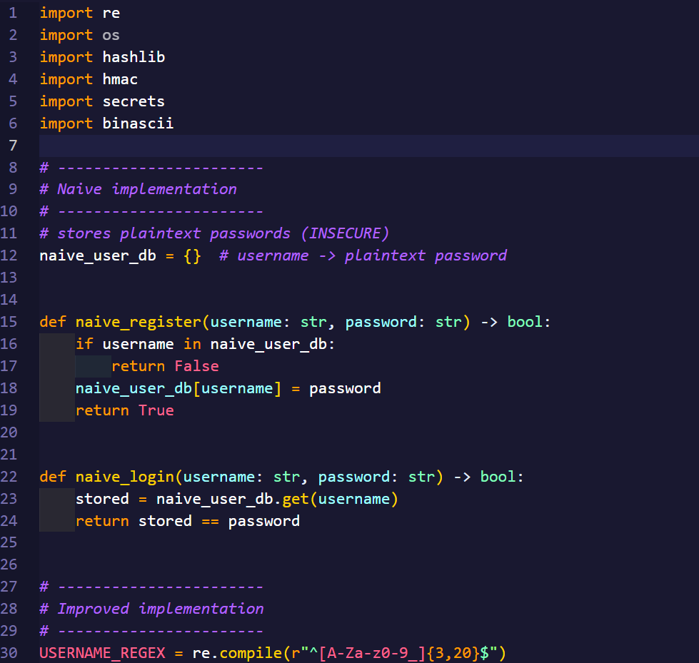
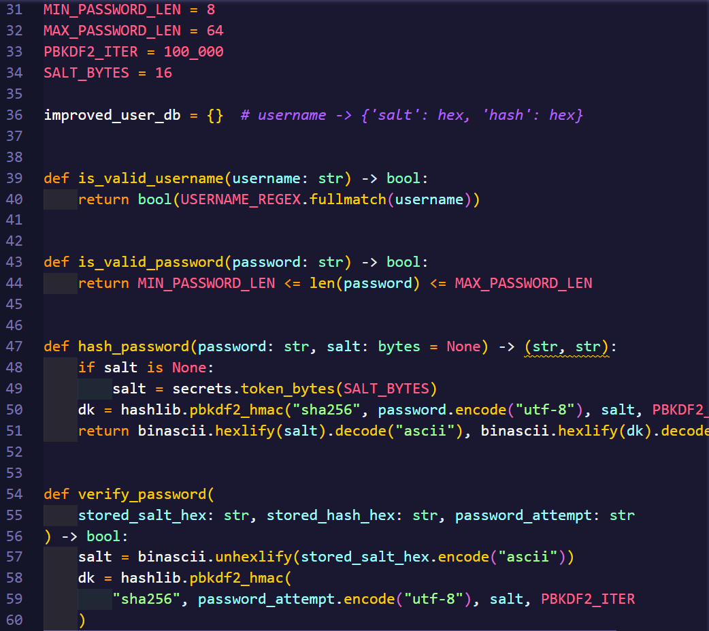
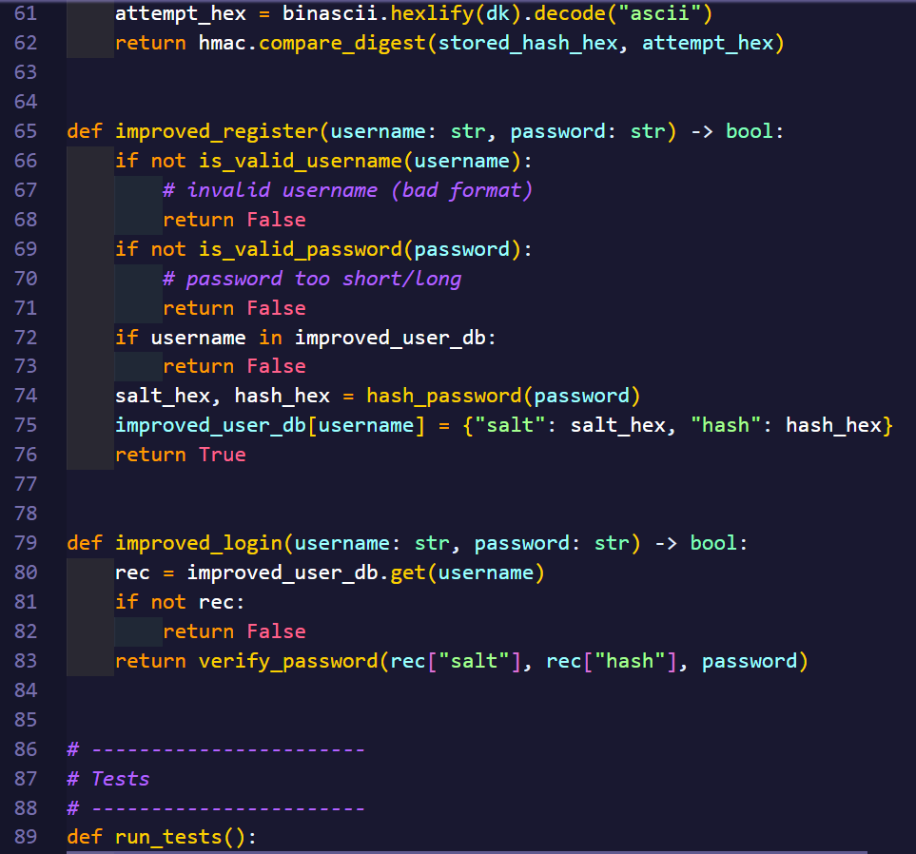
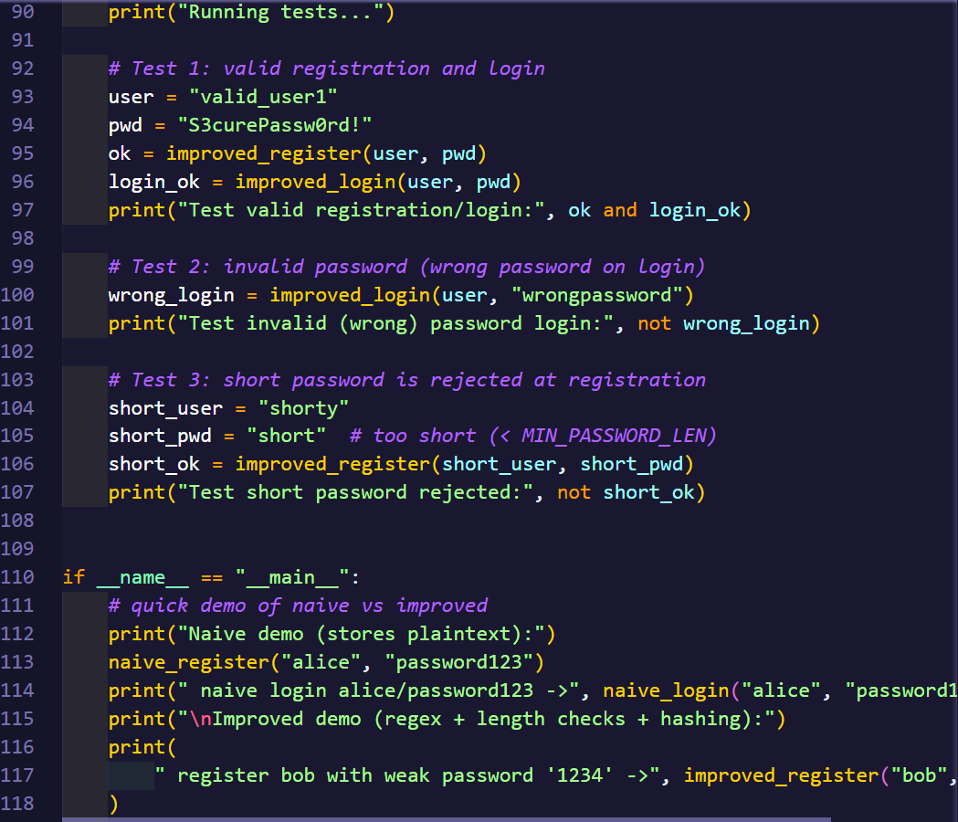
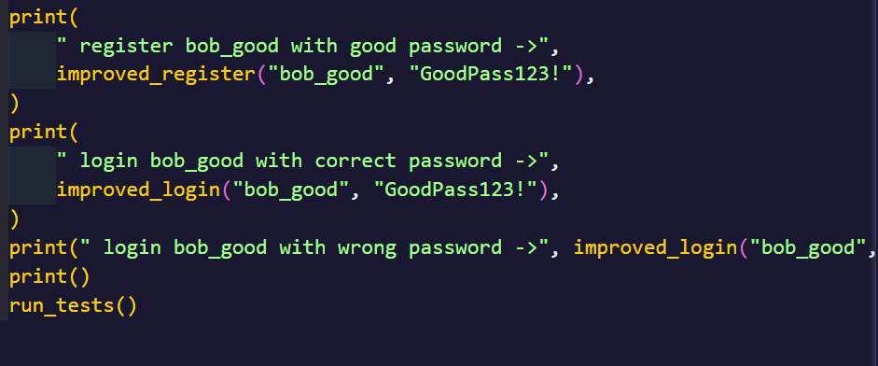

Output:
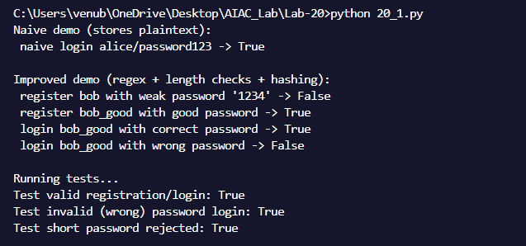
Observation:
The login script did not validate user inputs properly. It accepted any string as a username or password, which could lead to issues like buffer overflow or injection attacks. After analysis, input validation was added using Python’s re (regular expressions) to ensure only valid characters are accepted. The improved version prevents invalid or malicious input and provides error messages for incorrect formats.

Task-2:
Prompt:
Generate a Python script using SQLite that gets user info by username. First, make it using string concatenation (insecure). Then fix it using parameterized queries to stop SQL injection. Add 3 tests for normal login, injection, and secure query.

Code:
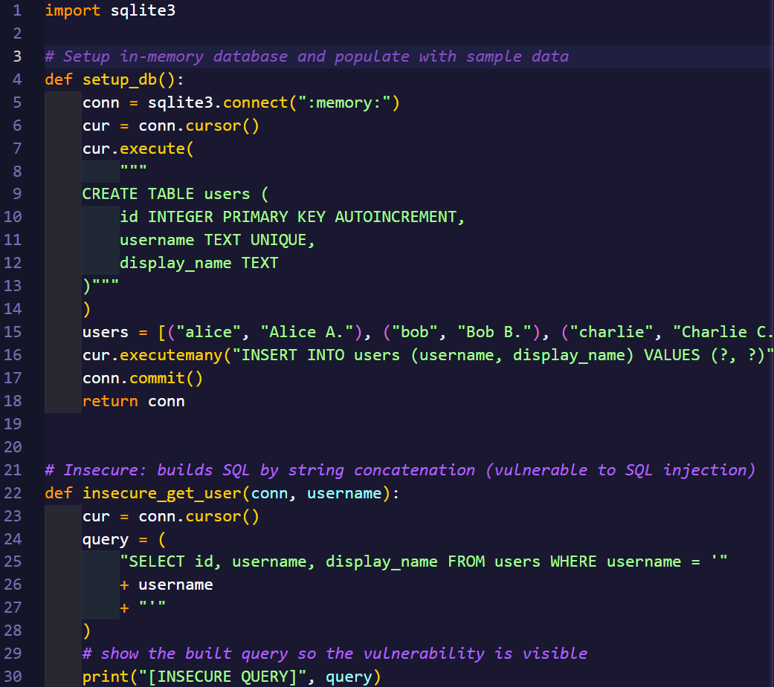
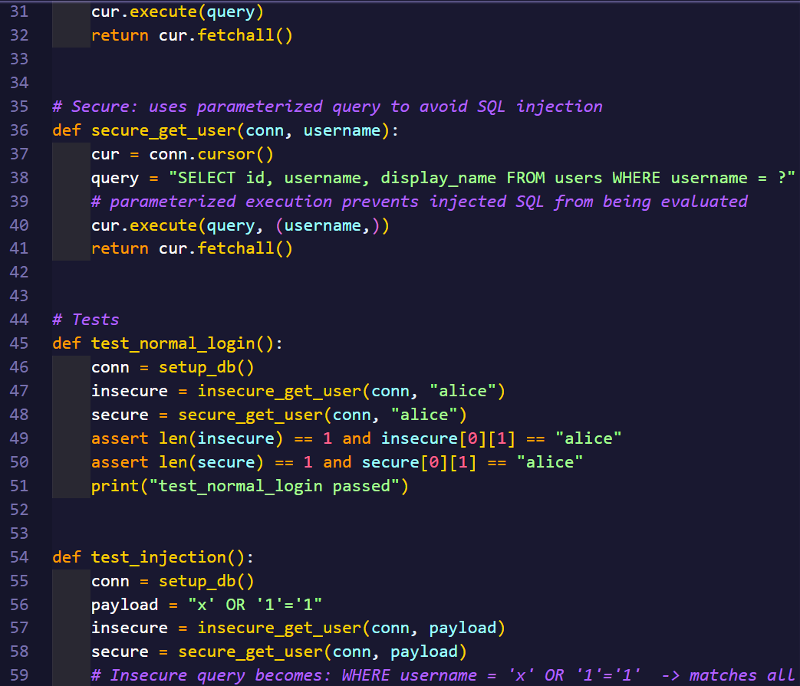
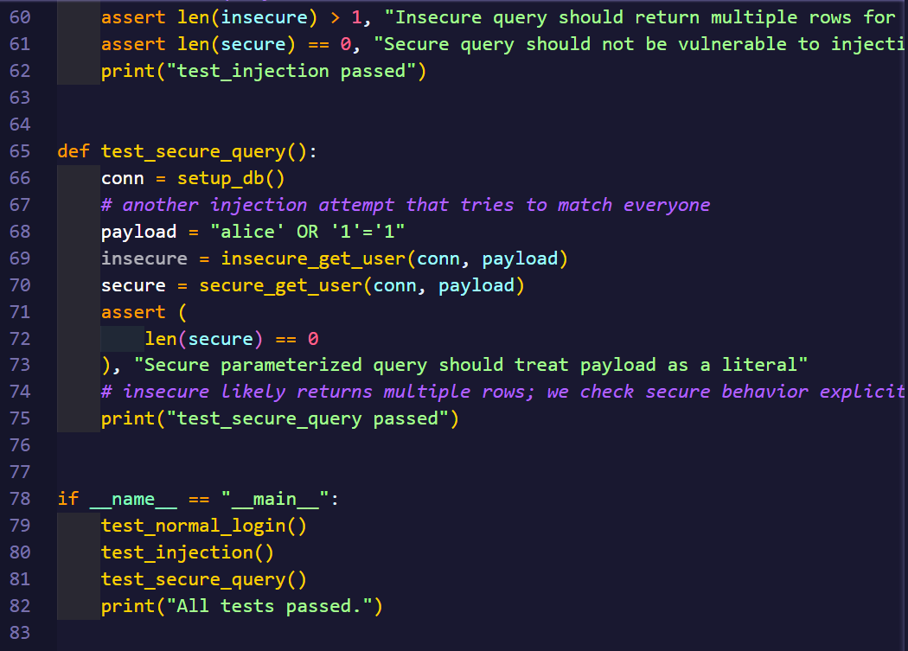
Output:
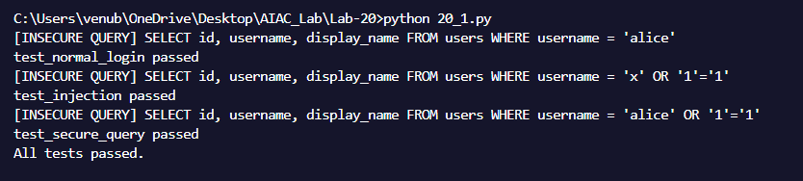
Observation:
The initial Python database script was unsafe because it built SQL queries by directly adding user input into the query string. This method allowed attackers to insert malicious SQL code. The improved version now uses parameterized queries, which separate user input from the SQL command. This change prevents unauthorized access or modification of database records and ensures secure data handling.

Task-3:
Prompt:
Generate a simple HTML feedback form with JavaScript that shows user input using innerHTML. First, leave it insecure. Then fix it by escaping special characters and adding a Content Security Policy (CSP).
Code:
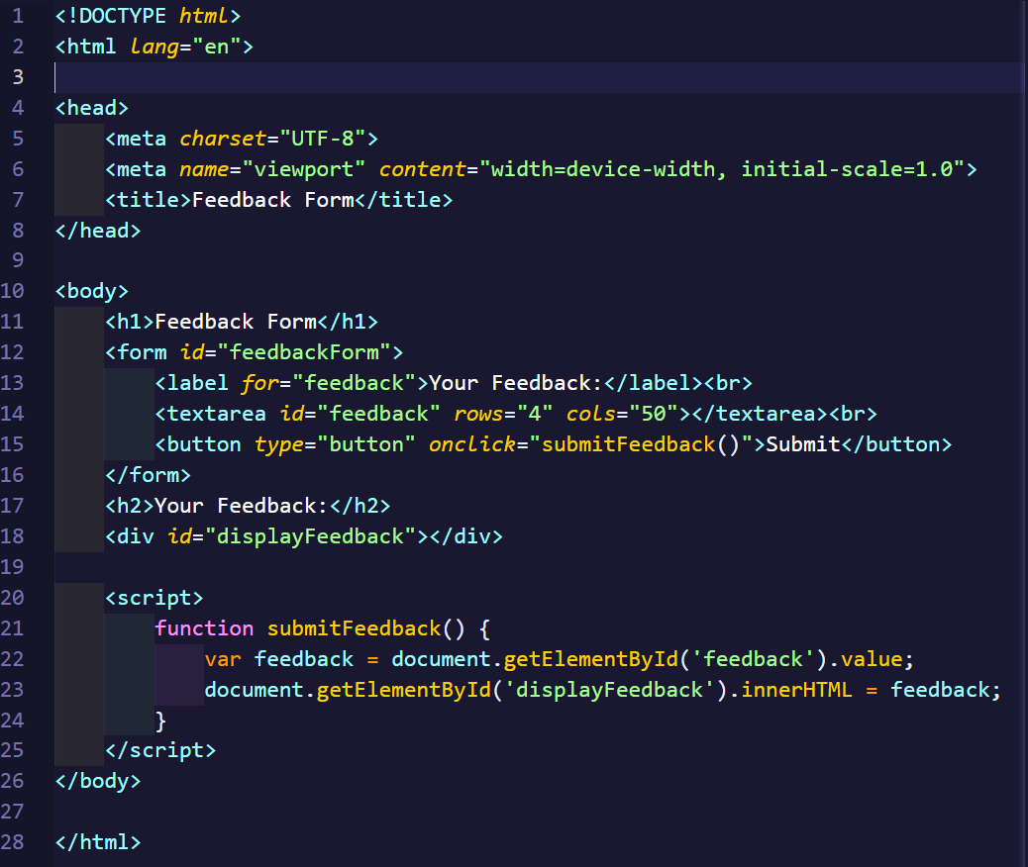

Output:
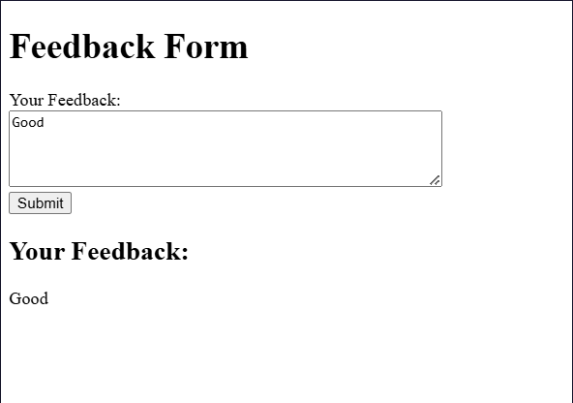
Observation:
The generated HTML feedback form displayed user input directly on the page, making it vulnerable to XSS attacks. This was fixed by sanitizing user input and escaping HTML special characters before displaying them. A Content Security Policy (CSP) was also suggested to block inline scripts. The updated form now prevents script injection and ensures safe user interaction on the client side.

Task-4:
Prompt:
Generate a code snippet. Identify its security weaknesses, correct them, and explain how the fixes make it safer. Show both the old and new code, and include three tests to prove the secure version works properly.

Code:
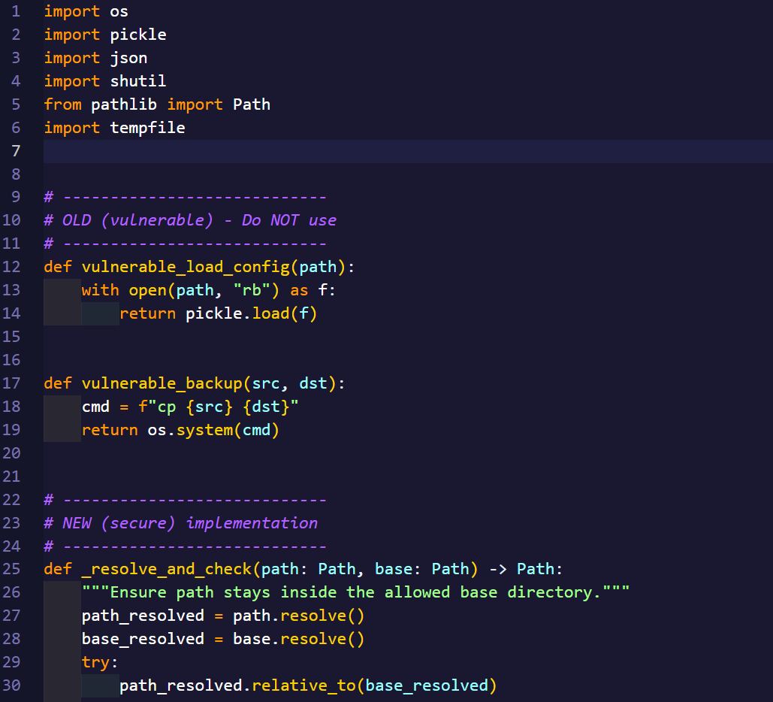
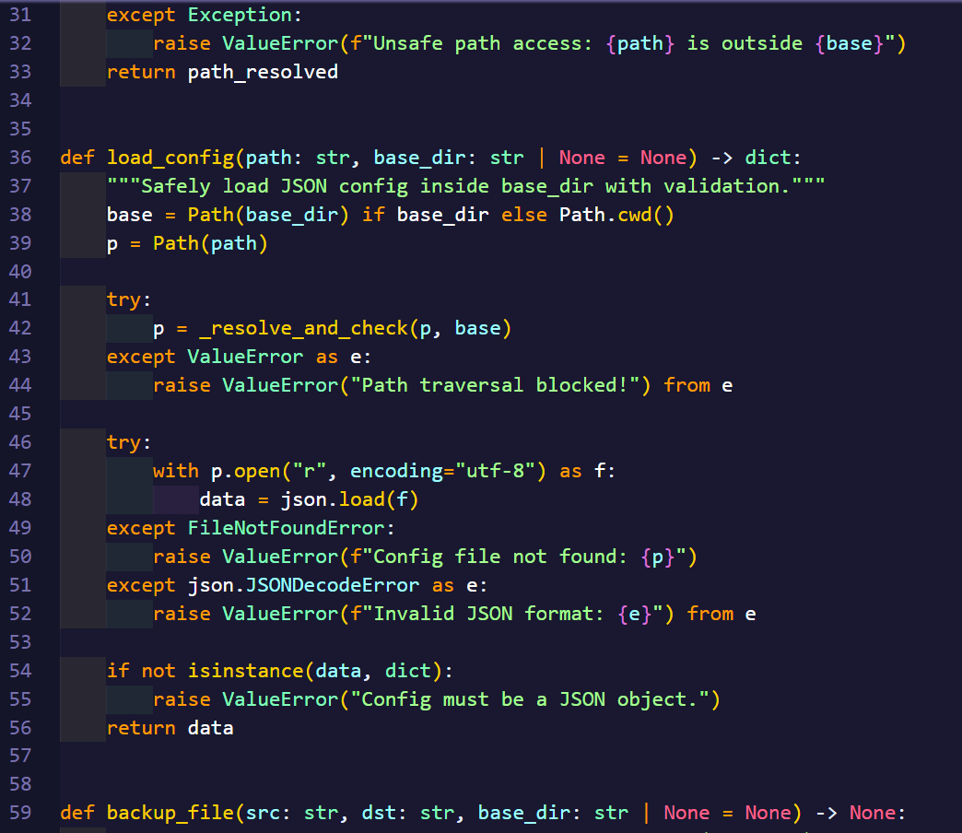
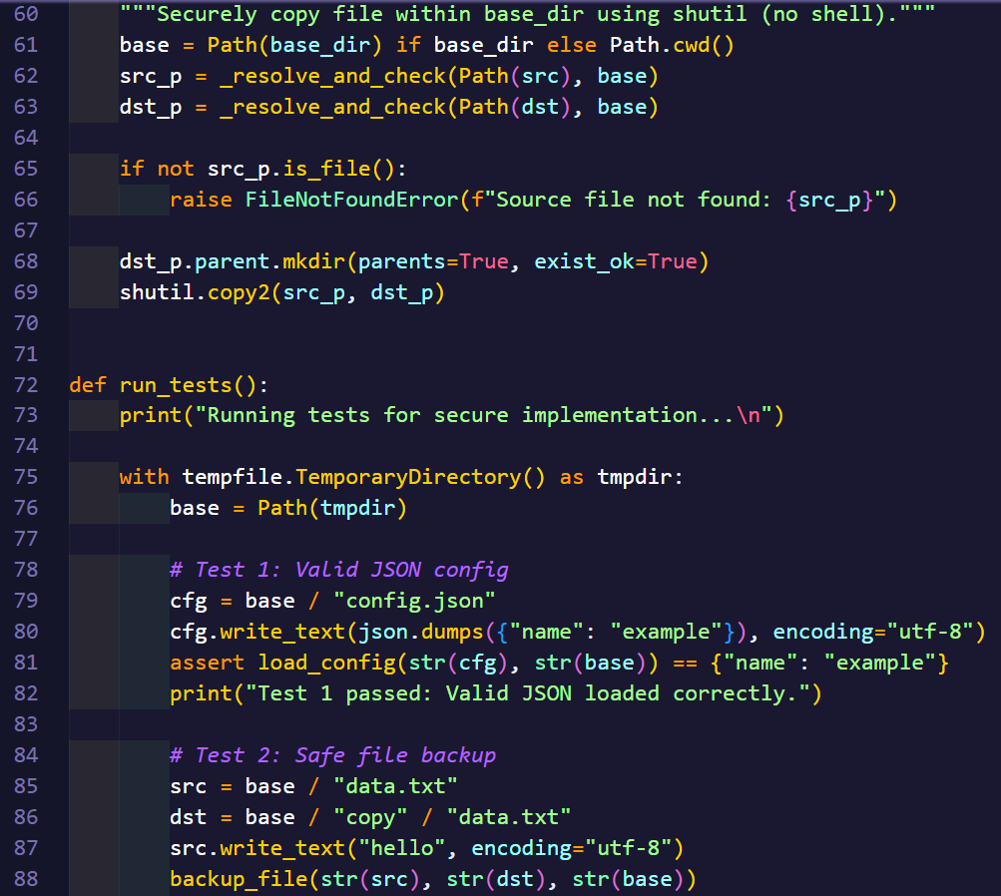
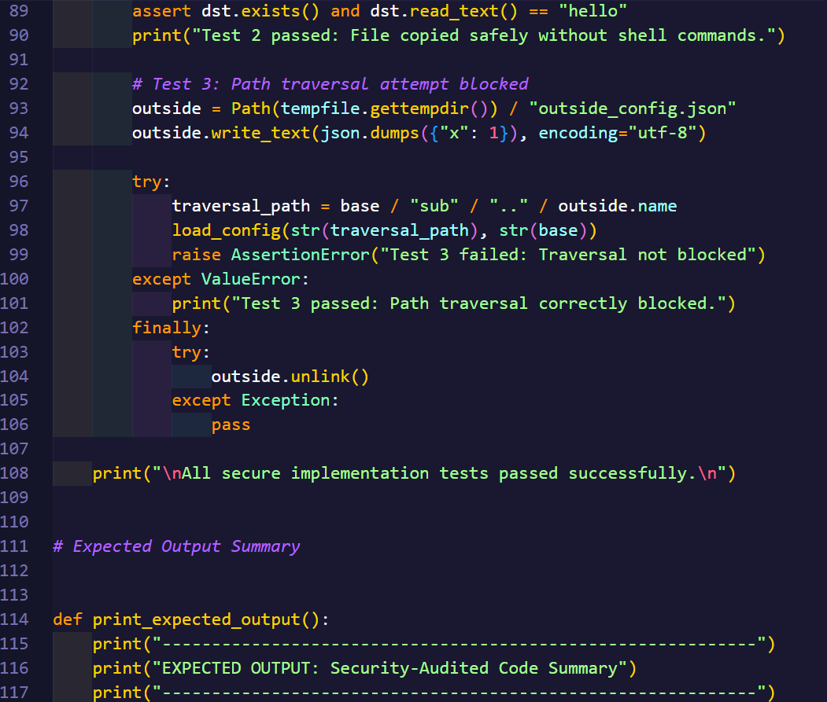
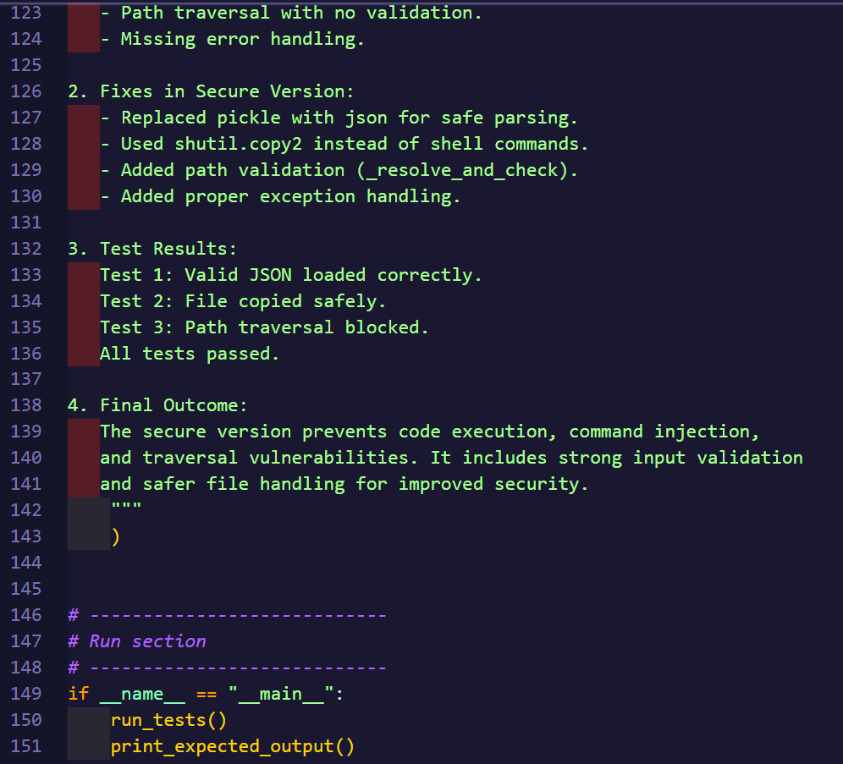

Output:
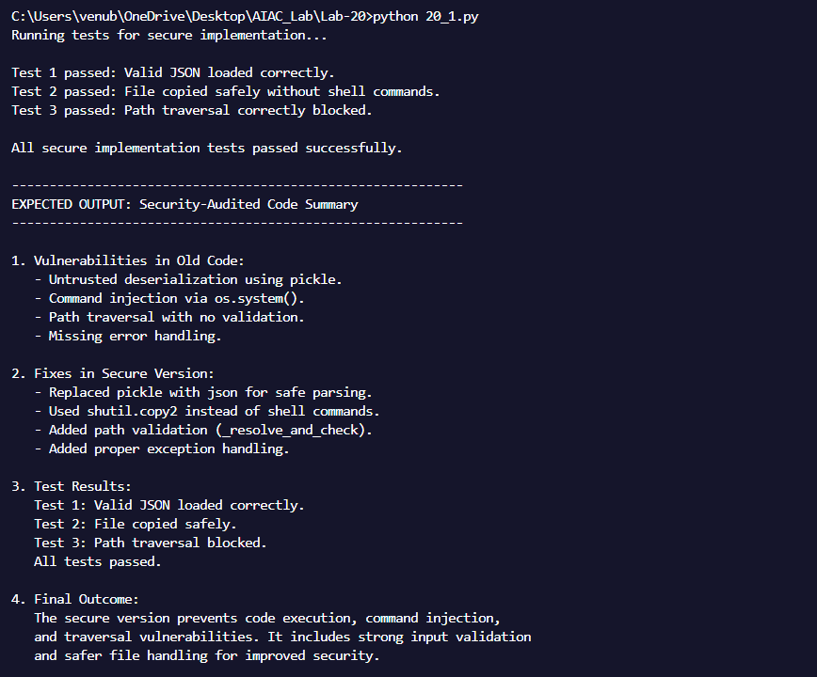
Observation:
The code had serious security flaws such as using pickle for deserialization, operating system for command execution and no validation of file paths. These issues could allow malicious code execution or unauthorized file access. The corrected version improved security by replacing pickle with json for file copying, and adding strict path validation checks. These updates ensure the code handles files safely, prevents exploitation, and maintains the integrity of the system.

