TITLE:
File Upload and Malware Scanning System
NAMES:
RITHIKA.K- 2403A510G9
VARSHITHA.P- 2403A510G8
SRIKRUTHI.CH- 2403A510H0
ABISHEKH- 2403A510H1

INTRODUCTION:
In the digital era, the rapid exchange of files through web applications poses a serious threat of malware infections and cyberattacks. Organizations and users often lack accessible and transparent tools to detect malicious files before they spread within networks.
This project, “Flask-Based Virus Scanner Using ClamAV,” provides a secure and lightweight web application that enables users to upload and scan files for potential viruses or malware in real time. Built on the Python Flask framework and integrated with ClamAV, an open-source antivirus engine, it offers a robust and educational demonstration of web-based file scanning, quarantine management, and threat handling mechanisms.
The system provides an easy-to-use interface for uploading files, runs automated antivirus checks, and manages infected files through quarantine. It can be deployed locally or in a controlled server environment, making it ideal for educational, testing, or organizational use.

OBJECTIVE OF THE PROJECT:
The main objective of this project is to design and implement a secure, web-based virus scanner that allows users to upload and check files for malware using ClamAV.
Specific Objectives:
- To build a simple and secure file upload system using Flask.
- To integrate the ClamAV antivirus engine for real-time malware detection.
- To automatically quarantine infected files and record scan details in a database.
- To implement a lightweight AI-based policy engine for risk classification and response recommendations.
- To provide a clean, transparent interface for viewing scan history and managing quarantined files.
- To create an educational model for demonstrating web security and file handling concepts.

ABSTRACT:
This project introduces a Flask-based web application integrated with ClamAV for virus detection. It enables users to upload files securely and checks them in real time using ClamAV’s signature-based scanning engine.
When a file is uploaded, the system performs file sanitization, calculates its hash, and then scans it for viruses using ClamAV’s command-line tools. Clean files are stored safely, while infected ones are quarantined automatically, along with detailed metadata and recommendations from a rule-based AI policy engine.
The application maintains an audit trail of all scans using a SQLite database, ensuring transparency and traceability. A web dashboard allows users to view scan results, manage quarantined files, and perform administrative checks.
This project demonstrates the integration of cybersecurity practices, AI-driven decision rules, and Flask web development, providing a valuable learning tool for students and researchers interested in file security automation.

FLOWCHART:
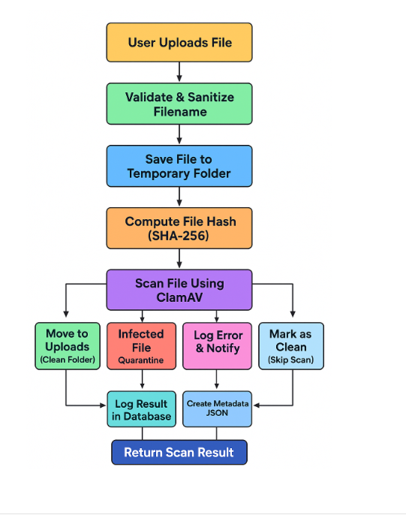

🟧 1. User Uploads File
- The process starts when a user uploads a file (like a PDF, image, or document) via a web form.
- The backend (Flask app) receives this file.

🟩 2. Validate & Sanitize Filename
- The system checks the uploaded filename to:
  - Remove harmful characters.
  - Prevent directory traversal attacks (like ../../etc/passwd).
- Example: convert ../../../virus.exe → virus.exe.

🟦 3. Save File to Temporary Folder
- The cleaned file is stored temporarily (e.g., uploads/temp/) before scanning.
- This ensures unscanned files don’t mix with safe ones.

🟦 4. Compute File Hash (SHA-256)
- The file’s SHA-256 hash (a unique digital fingerprint) is computed.
- Purpose:
  - Detect duplicate uploads.
  - Keep integrity records.
  - Use for caching (if the same file was already scanned before).

🟪 5. Scan File Using ClamAV
- The file is scanned using ClamAV, an open-source antivirus engine.
- ClamAV checks for viruses, malware signatures, or suspicious patterns.

🟩🟥🟧🟦 6. Decision Paths After Scan
Based on scan results, four possible actions occur:
🟩 Clean File
- If no virus is found:
  - File is moved from temporary to the main uploads/clean/ folder.
  - A clean record is logged in the database.
🟥 Infected File
- If ClamAV detects a virus:
  - File is moved to quarantine (e.g., uploads/quarantine/).
  - It’s marked as infected.
  - Logged in the database for admin review.
🟧 Log Error & Notify
- If scanning fails or ClamAV throws an error:
  - The system logs the issue.
  - Sends a notification to the admin.
  - Generates a metadata JSON file with scan details (filename, error, timestamp, etc.).
🟦 Mark as Clean (Skip Scan)
- If the hash already exists in the database as a clean file, the system skips re-scanning and marks it as clean.

🟩 7. Log Result in Database
- Scan results (file name, hash, status, timestamp) are stored in a database.
- Helps track upload history and detect repeated malware.

🟦 8. Return Scan Result
- The backend sends a response back to the user (via API or webpage):
  - ✅ Clean — File uploaded successfully.
  - ❌ Infected — File blocked/quarantined.
  - ⚠️ Error — Something went wrong during the scan.

METHOD USED:
The development of this project involved the following methodologies:
a. Technology Stack
- Backend: Python 3 with Flask framework
- Antivirus Engine: ClamAV (via command-line or pyclamd library)
- Database: SQLite3
- Frontend: HTML, CSS (Jinja2 templates)
- Security Tools: File sanitization, SHA-256 hashing
b. Implementation Steps
- File Upload Module:
Users upload files through a web interface. Flask validates and securely saves the files in a temporary directory.
- Scanning Module:
The system invokes ClamAV’s clamscan command using Python’s subprocess module to perform the scan.
- Threat Detection & Classification:
The app parses ClamAV’s output to determine infection status. Infected files are moved to quarantine with JSON-based metadata.
A rule-based AI module classifies threats and suggests response actions (e.g., quarantine, delete, or monitor).
- Database Logging:
Each scan (filename, hash, timestamp, status, and result) is stored in SQLite for future reference.
- User Interface & Reporting:
Flask renders scan history and quarantine management pages for users and administrators.
- Testing and Validation:
The EICAR test file was used to validate ClamAV integration and ensure accurate virus detection.

CODE:
INDEX HTML:
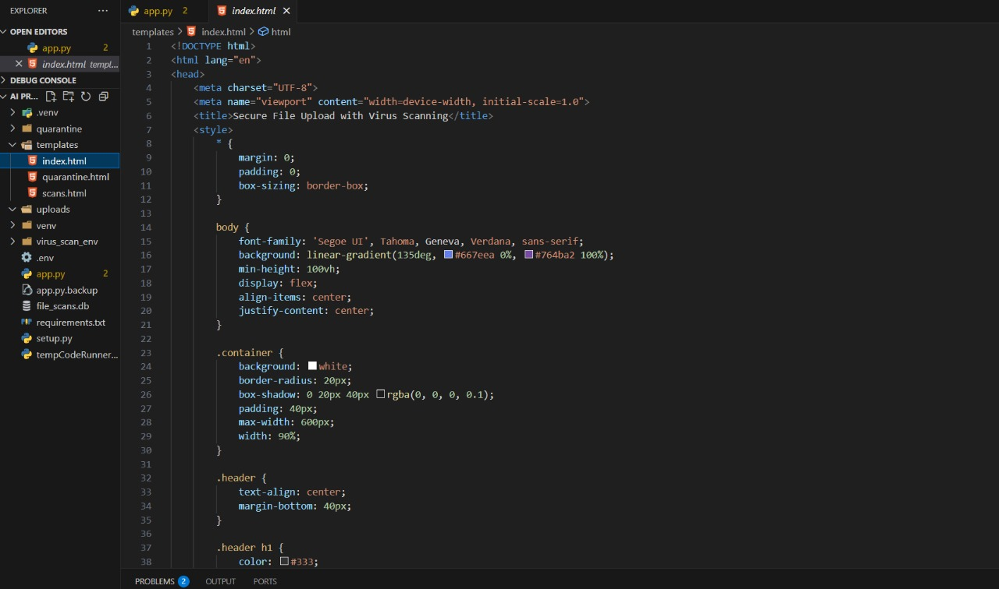
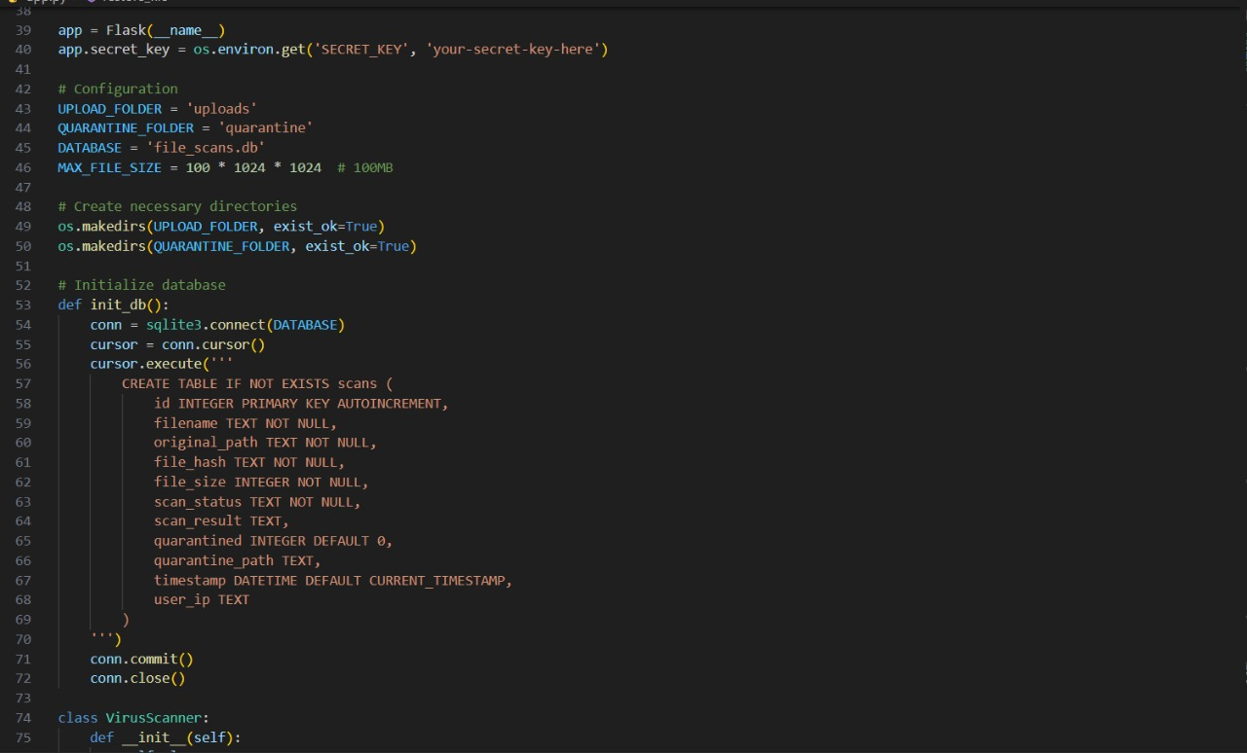
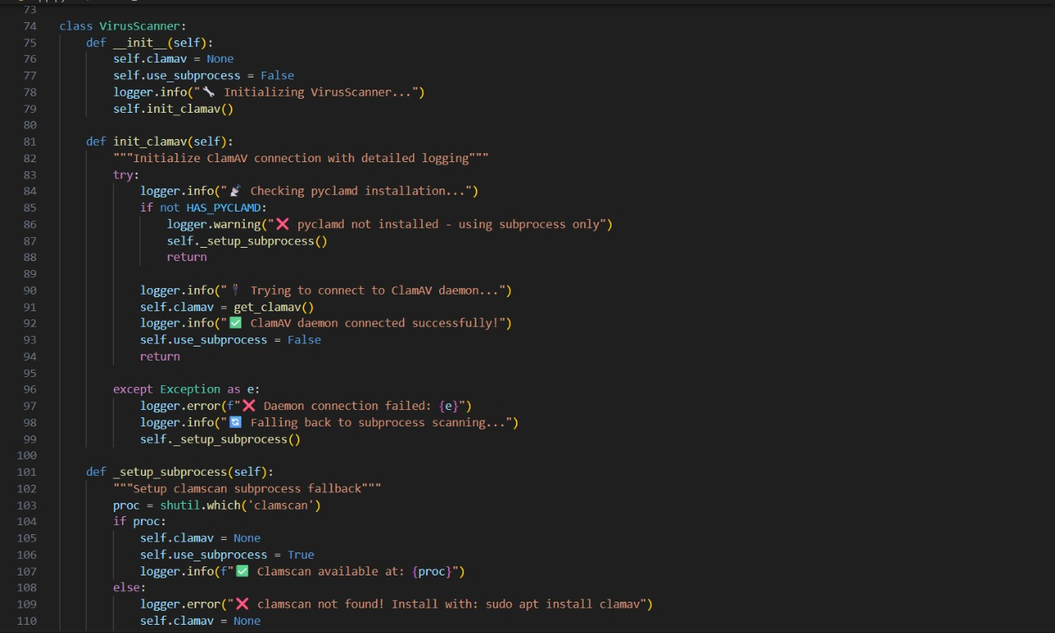
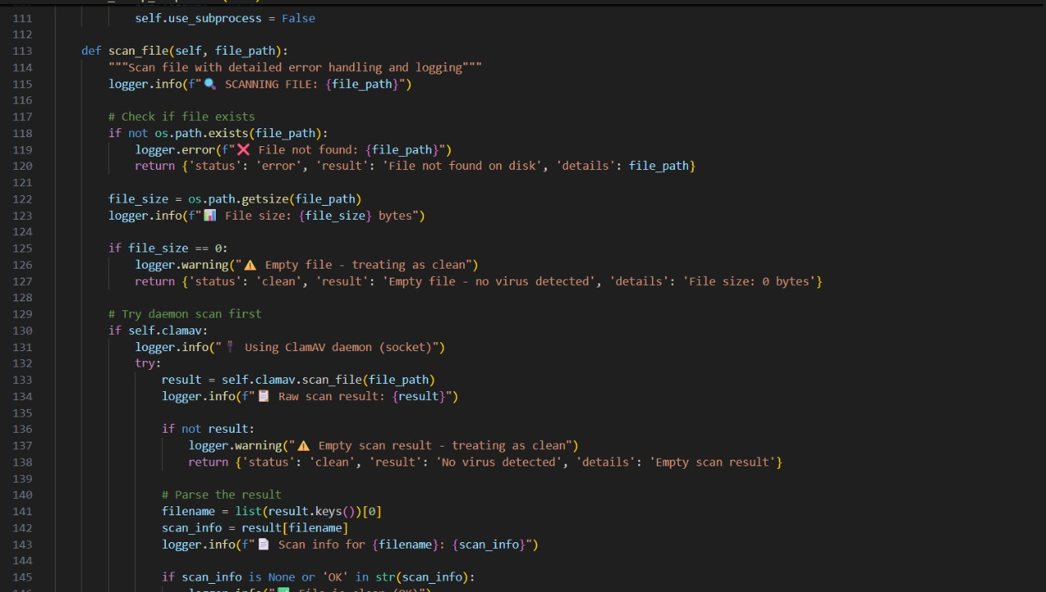
Output:
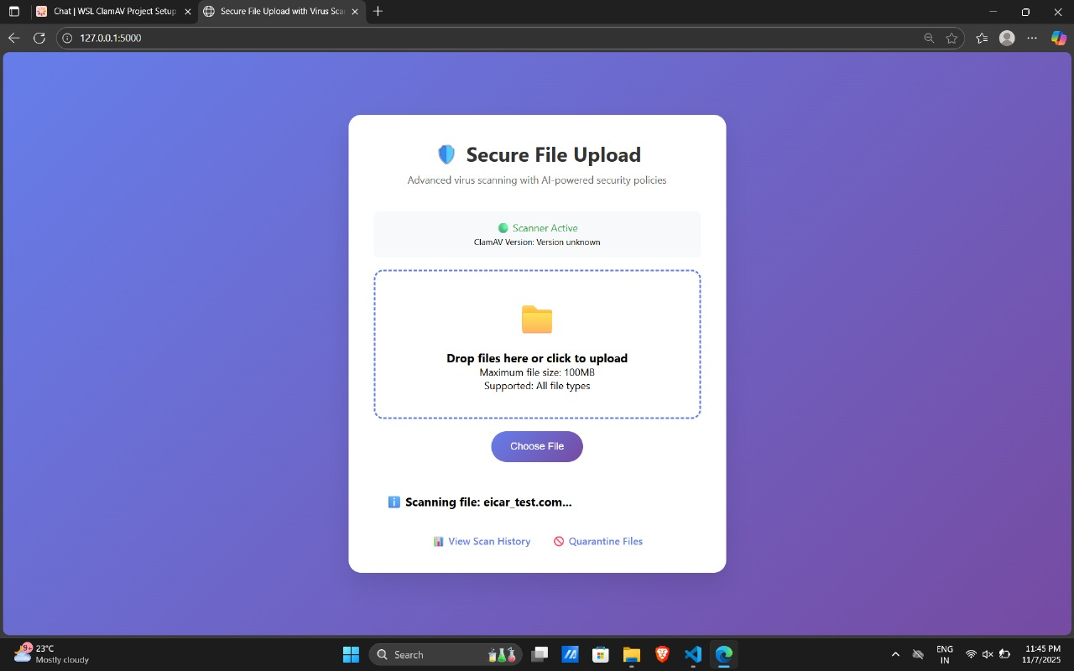
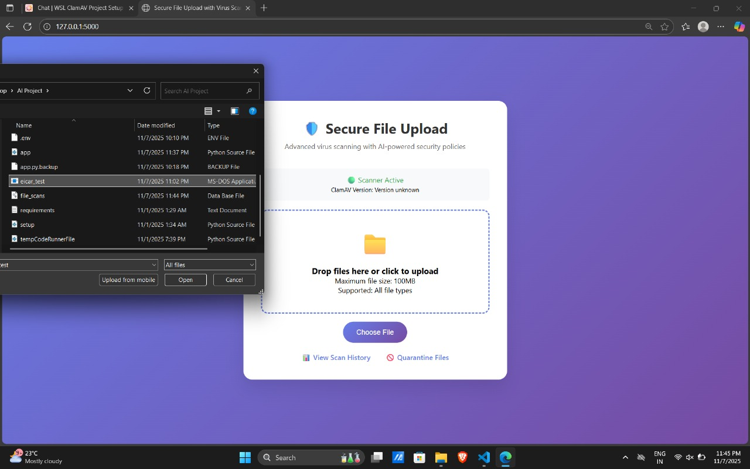
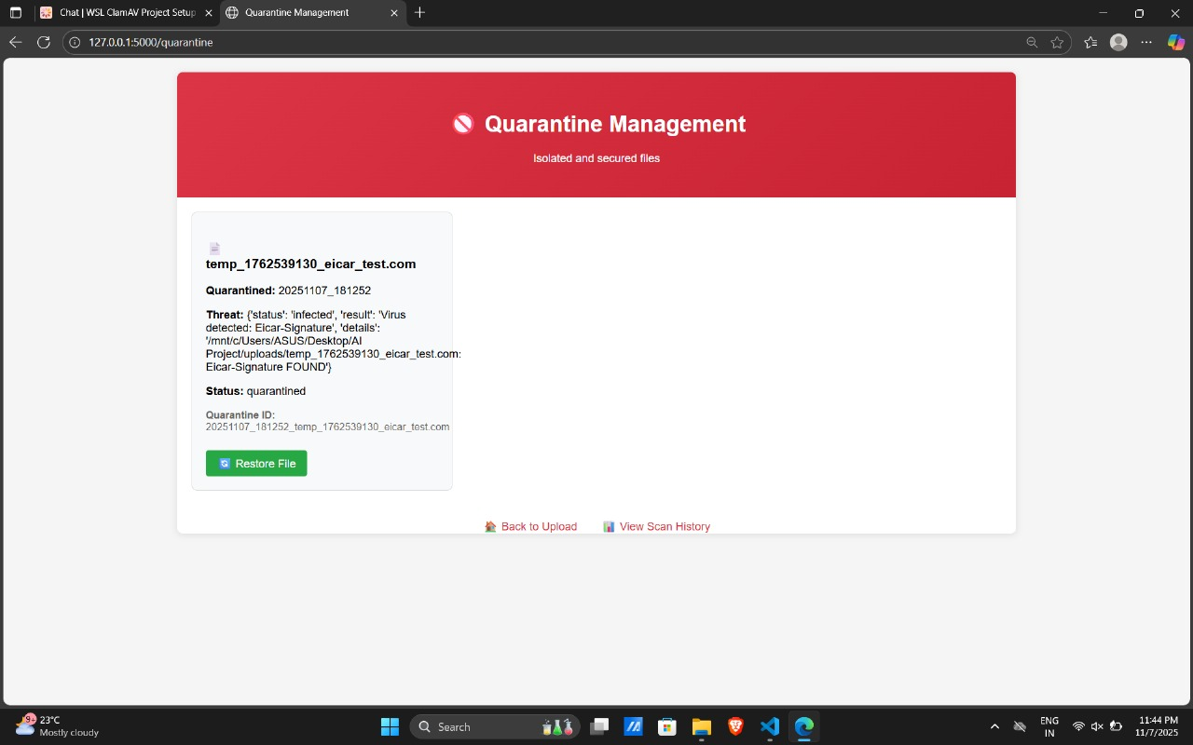
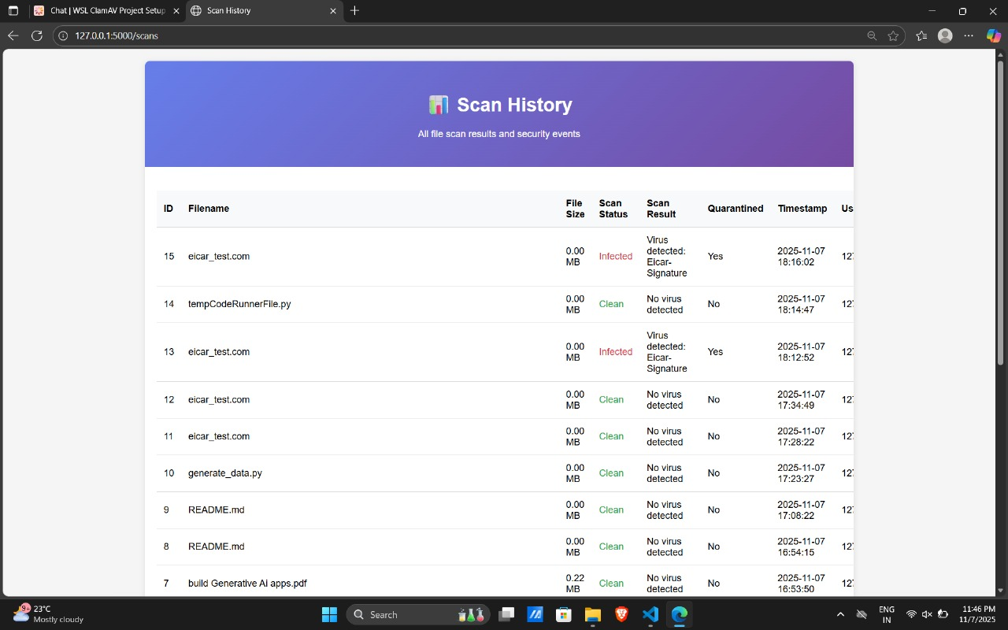

FINAL REPORT:
System Overview
The system provides an interactive web interface where users can upload files. Flask routes handle user Trequests, while ClamAV performs the actual virus detection. Results are displayed instantly, with infected files securely quarantined.
Modules Implemented
- File Upload Module:
Handles secure upload and temporary storage of user files.
- Virus Scanning Module:
Integrates with ClamAV for real-time virus scanning and output parsing.
- Database Management:
Maintains detailed logs for compliance and reporting.
- Quarantine System:
Isolates infected files and stores metadata.
- AI Policy Engine:
Suggests threat responses using rule-based logic.
- Notification & Reporting:
Displays scan results and logs alerts in the web interface.
Testing and Validation
- Clean File Test: Uploaded benign files (e.g., .txt) — results marked “Clean.”
- EICAR Test: Uploaded the standard EICAR test file — successfully detected and quarantined.
- Performance Test: Handled multiple uploads (under 100MB) with consistent results.
Security Measures
- Sanitization via secure_filename()
- Limited file size and format restrictions
- Hash-based duplicate detection
- Error handling for missing or corrupted files

REFERENCES:
CHATGPT, YOUTUBE, W3 SCHOOLS,vscode,cursor AI
CONCULSION OF THE PROJECT:
The Flask-Based Virus Scanner using ClamAV successfully demonstrates the integration of cybersecurity and web development technologies to create a practical, secure, and educational application. The system effectively detects and quarantines malicious files uploaded through a web interface, ensuring data integrity and system protection.
By combining the Flask framework for web interaction with ClamAV for antivirus scanning, the project achieves a reliable and transparent file security workflow. It also incorporates features like secure file handling, database logging, quarantine management, and rule-based AI policy suggestions, providing a comprehensive approach to malware detection and response.
Through testing with safe and simulated virus files (such as the EICAR test), the application proved to be accurate, efficient, and robust under various conditions. It not only serves as a functional virus scanning solution but also as a valuable learning tool for students and professionals exploring Flask development, file security, and system integration concepts.
In conclusion, this project fulfills its objectives of providing a lightweight, self-hosted virus scanning web application while emphasizing secure programming practices and real-world applicability. With further enhancements—such as multi-file scanning, user authentication, and cloud deployment—it can evolve into a powerful and production-ready antivirus gateway for organizations and personal use.

