WEEK 3 – ADVANCED DATA ANALYSIS AND VISUALIZATION IN LOGISTICS
Logistics Data Analysis Internship
Prepared by: Sri Lakshmi

1. Objective
This task focuses on exploring logistics data using Python, calculating descriptive statistics and correlations, creating visualizations, and interpreting the resulting patterns. The analysis uses the illustrative logistics dataset prepared for the preprocessing stage and focuses on delivery time, shipment distance, shipment weight, transportation cost, inventory level, and shipment mode.

2. Dataset and EDA Approach
The dataset contains shipment-level records with numerical and categorical logistics variables. Missing numerical values are filled using the median before exploratory calculations. The analysis includes descriptive statistics, grouped comparisons, distributions, a relationship plot, and correlation analysis.

3. Descriptive Statistics
Variable | Count | Mean | Std | Min | Max
Distance_km | 12.00 | 525.00 | 347.63 | 120.00 | 1200.00
Shipment_Weight_kg | 12.00 | 748.33 | 627.82 | 80.00 | 2000.00
Delivery_Time_days | 12.00 | 6.17 | 6.83 | 1.20 | 25.00
Transportation_Cost | 12.00 | 13500.00 | 8637.02 | 4500.00 | 30000.00
Inventory_Level | 12.00 | 279.17 | 212.67 | 60.00 | 700.00

4. Visualization 1 – Average Delivery Time by Shipment Mode
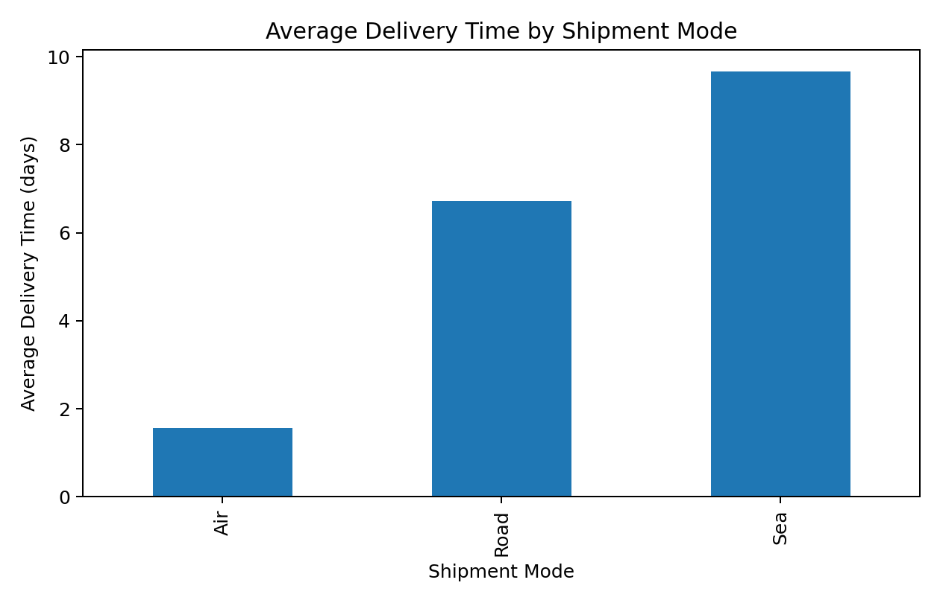
A bar chart compares average delivery time across categorical shipment modes. In this illustrative sample, Air has the lowest average delivery time and Sea the highest. These results describe this sample only.

5. Visualization 2 – Distribution of Delivery Times
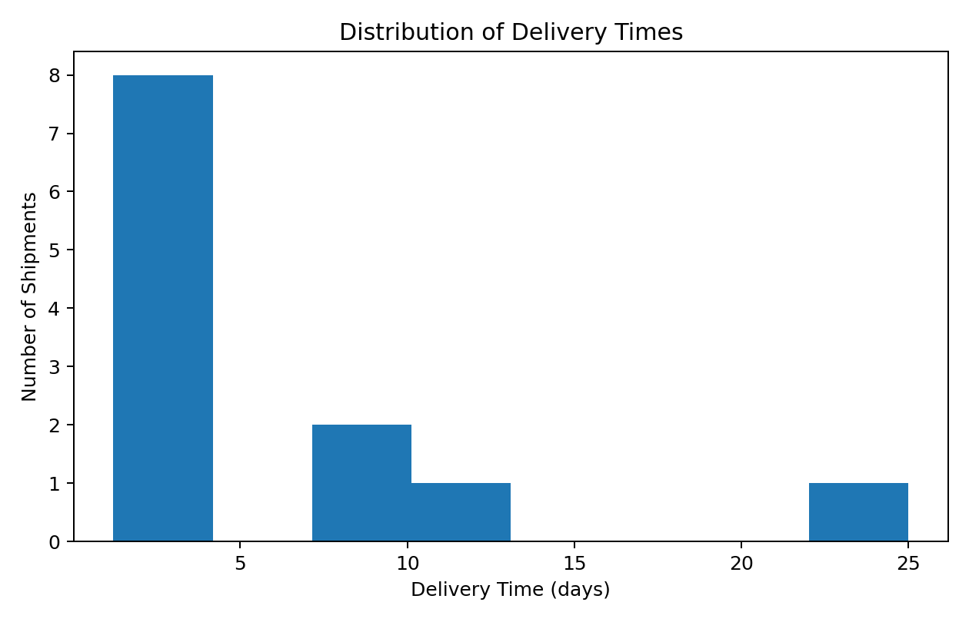
The histogram shows the concentration and spread of delivery times and makes longer delivery observations visible. Such observations can be investigated as possible bottlenecks while considering legitimate operational reasons.

6. Visualization 3 – Distance vs Transportation Cost
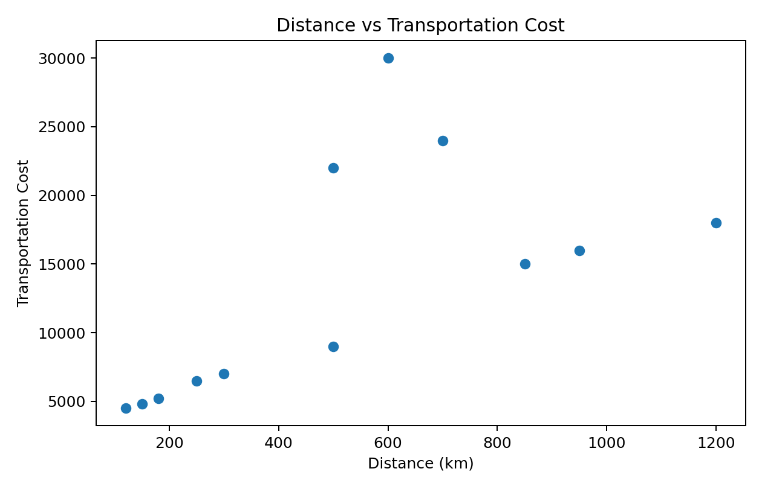
The scatter plot examines whether longer shipment distances are associated with higher transportation costs. Shipment weight and mode may also influence cost, so distance should not be considered alone.

7. Visualization 4 – Correlation Matrix
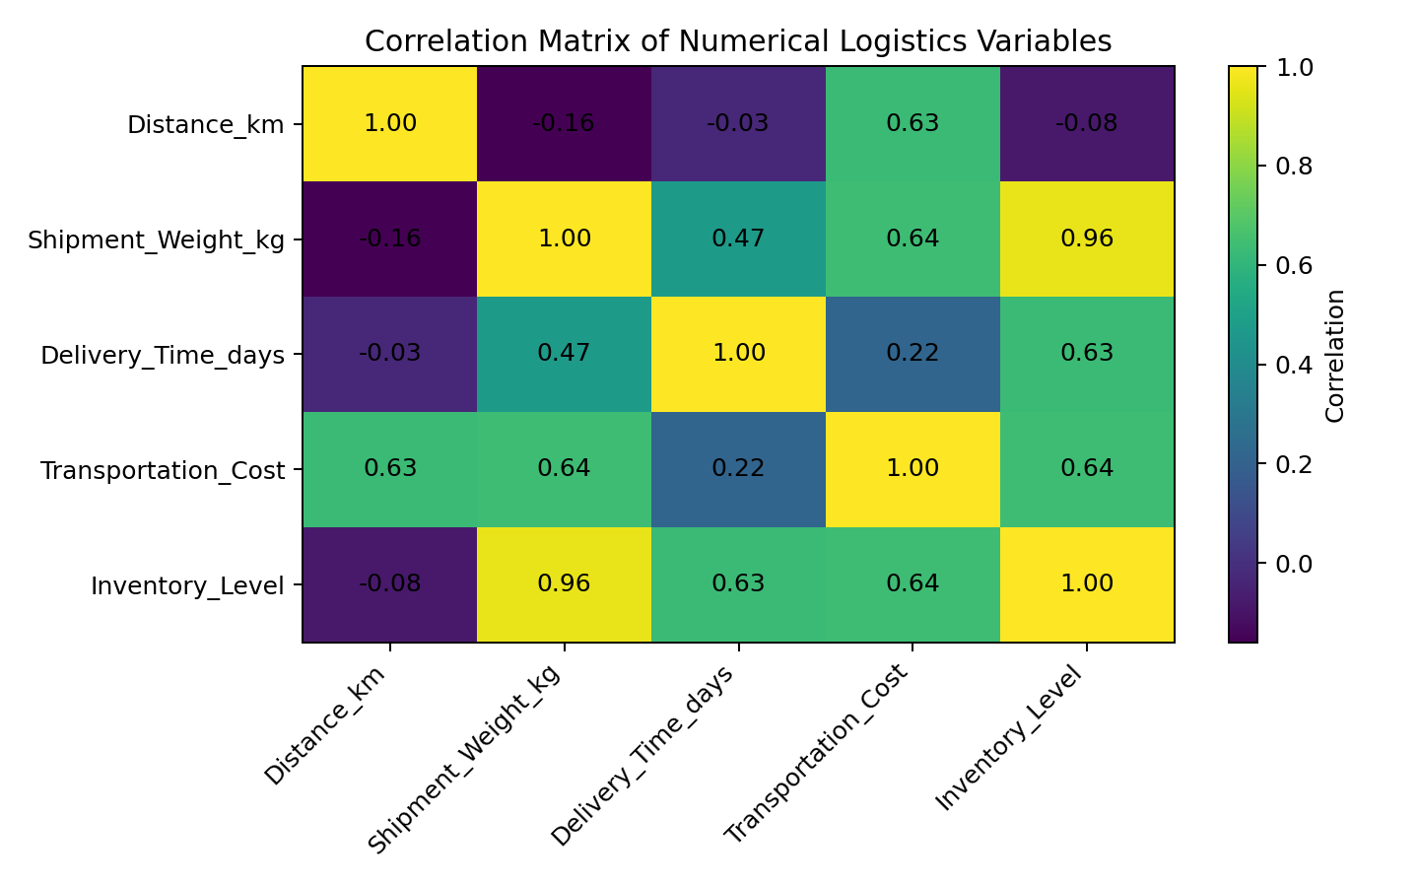
The correlation matrix summarizes linear associations among numerical variables and can guide further investigation. Correlation does not establish causation, and this small illustrative sample is intended for exploratory learning.

8. Python Code Used
import pandas as pd
import matplotlib.pyplot as plt
df = pd.read_csv("week2_logistics_sample_data.csv")
num_cols = ["Distance_km", "Shipment_Weight_kg",
"Delivery_Time_days", "Transportation_Cost",
"Inventory_Level"]
for col in num_cols:
df[col] = df[col].fillna(df[col].median())
print(df[num_cols].describe())
print(df[num_cols].corr())
mode_delivery = df.groupby("Shipment_Mode")["Delivery_Time_days"].mean()
mode_delivery.plot(kind="bar")
plt.show()
plt.hist(df["Delivery_Time_days"], bins=8)
plt.show()
plt.scatter(df["Distance_km"], df["Transportation_Cost"])
plt.show()

9. Analytical Insights and Recommendations
- Shipment mode is useful for comparing delivery performance in the sample.
- Long delivery observations should be investigated as possible operational bottlenecks while considering business context.
- Transportation cost should be analyzed together with distance, shipment weight, and shipment mode.
- Correlation analysis can guide further investigation but should not be interpreted as causal evidence.
- A larger representative dataset would be needed for stronger operational conclusions.

10. Conclusion
The Week 3 task demonstrates an exploratory analysis workflow using Python. Descriptive statistics, grouped comparisons, histograms, scatter plots, and correlation analysis provide multiple views of logistics performance and create a foundation for predictive modeling and optimization.

