Week 4 Task: Predictive Modeling and Optimization in Logistics Systems
Logistics Data Analyst Internship
Prepared by: Sri Lakshmi

1. Objective
Build a predictive model to forecast logistics delivery time and use the prediction to support optimization decisions.

2. Problem Definition and Data Simulation
A hypothetical dataset of 400 shipment records was generated with a fixed random seed. Features are shipment mode, distance, shipment weight, transportation cost and inventory level. The target is delivery time in days. The dataset is illustrative and does not represent real company operations.

3. Model Selection and Implementation
Linear Regression, Decision Tree Regressor and Random Forest Regressor were implemented. Shipment mode was one-hot encoded and the data was divided into 80% training and 20% testing sets using random_state=42.

4. Evaluation Results
Model | MAE | RMSE | R²
Linear Regression | 2.005 | 2.596 | 0.977
Decision Tree | 1.008 | 1.389 | 0.993
Random Forest | 0.812 | 1.104 | 0.996
The held-out test set shows that Random Forest has the lowest RMSE among the tested models. Metrics are illustrative because the dataset is simulated.
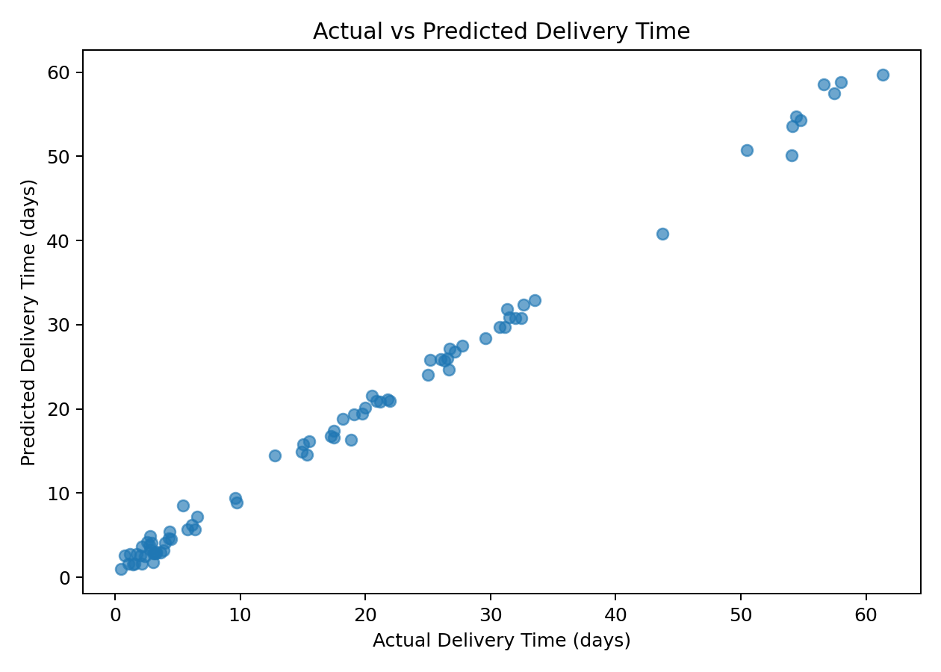
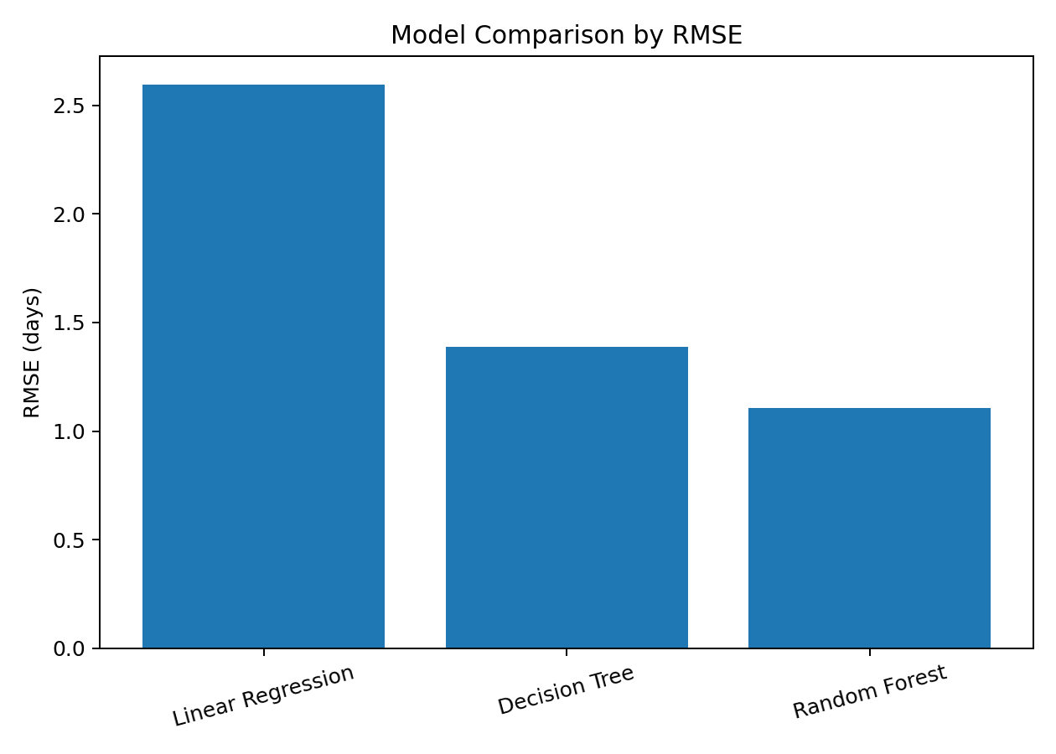

5. Cross-Validation
Model | 5-Fold CV MAE | 5-Fold CV R²
Linear Regression | 1.956 | 0.970
Decision Tree | 1.057 | 0.991
Random Forest | 0.794 | 0.995
Five-fold cross-validation was used to check model consistency across multiple training and validation splits.

6. Feature Importance
Random Forest feature importance was examined to understand which variables contributed most to prediction within the simulated dataset. Importance is model-specific and does not imply causation.
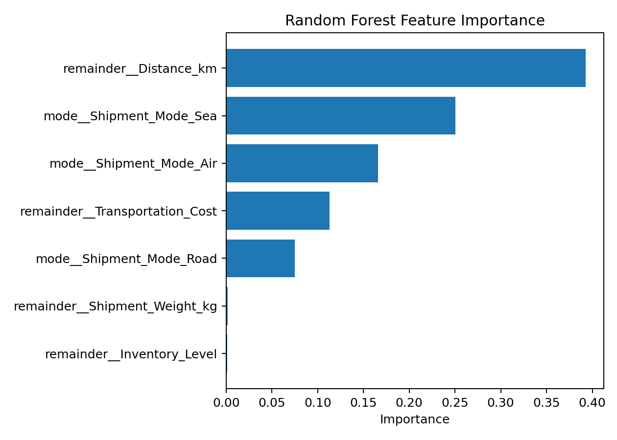

7. Optimization Strategy
For a 900 km, 500 kg shipment with inventory level 400, shipment modes were compared under a transportation-cost budget of ₹2,500.
Mode | Estimated Cost | Predicted Delivery (days)
Road | ₹1,647.50 | 15.86
Air | ₹5,877.50 | 2.88
Sea | ₹1,017.50 | 28.41
Under this constraint, the selected feasible option is Road, because it has the lowest predicted delivery time among the feasible candidates. This is a simple heuristic rather than a full mathematical optimization model.

8. Recommendations
- Use predictions to flag potentially delayed shipments early.
- Compare shipment modes using predicted time and transportation cost together.
- Prioritize alternatives for shipments with strict delivery requirements.
- Monitor important shipment variables as more operational data becomes available.
- Retrain and validate the model periodically when real logistics data is collected.

9. Conclusion
The project demonstrates an end-to-end logistics predictive analytics workflow covering data simulation, model training, evaluation, cross-validation and cost-aware optimization. All records, costs and results are simulated for academic/internship demonstration.

