YUVA INTERNSHIP – WEEK 1
Data Science Project Planning and Strategy Design
Hypothetical Project: Student Academic Performance Prediction and Analysis Using Python

1. Project Background
Student academic performance is influenced by factors such as attendance, study hours, previous academic performance, assignment completion, and assessment results. Institutions can use data science to analyze these factors systematically and identify patterns associated with academic outcomes. The proposed hypothetical project, Student Academic Performance Prediction and Analysis Using Python, demonstrates how a complete data science workflow can be planned to study student performance and develop a predictive model.
The motivation is to transform student-related data into meaningful insights that could support early identification of students who may require additional academic support. Python is selected as the primary technology because it provides libraries for data manipulation, visualization, statistical analysis, and machine learning. This is a planning exercise, so no real dataset is required for Week 1.

2. Project Objectives
- Define a structured data science approach for analyzing student academic performance.
- Identify relevant variables useful for understanding and predicting academic outcomes.
- Plan data collection, cleaning, exploratory analysis, and feature preparation.
- Select suitable machine learning approaches for predicting an academic performance measure.
- Define appropriate evaluation metrics for assessing model performance.
- Generate interpretable insights that could support academic monitoring and decision-making.
- Document the complete workflow using Python-based tools and libraries.

3. Project Scope
In Scope
- Planning a hypothetical student-performance dataset containing academic and behavioral attributes.
- Data quality checks, missing-value handling, duplicate detection, and data-type validation.
- Exploratory data analysis using descriptive statistics and visualizations.
- Feature engineering and preparation of variables for modeling.
- Development planning for regression or classification models depending on the target variable.
- Model evaluation and comparison using predefined metrics.
- Documentation of findings, limitations, and possible recommendations.
Out of Scope
- Collecting or publishing personally identifiable student information.
- Making high-stakes decisions about students based only on an automated prediction.
- Deploying the model as a production system during this planning phase.
- Replacing teachers, counselors, or institutional academic policies with the model.

4. Methodology and Strategy
4.1 Problem Definition
Define the prediction target and intended use. The target may be a final score or a performance category.
4.2 Data Collection
Plan variables such as attendance percentage, study hours, previous marks, assignment scores, internal assessment scores, and the selected target. Data would be collected only with appropriate permission and privacy safeguards.
4.3 Data Cleaning
Check missing values, duplicate records, inconsistent formats, invalid ranges, and incorrect data types. Handle missing values using an appropriate strategy and investigate unusual values.
4.4 Exploratory Data Analysis
Use descriptive statistics and visualizations to understand distributions, relationships, trends, and possible outliers. Examples include histograms, box plots, scatter plots, correlation analysis, and category-based comparisons.
4.5 Feature Engineering
Encode categorical variables, scale numerical variables where required, and create meaningful derived features when justified by the data.
4.6 Model Development
Split prepared data into training and testing sets. Candidate models may include Linear Regression for a numerical target and Logistic Regression or Decision Tree models for categorical outcomes.
4.7 Evaluation
For regression, consider MAE, MSE/RMSE, and R-squared. For classification, consider accuracy, precision, recall, F1-score, and a confusion matrix.
4.8 Interpretation and Reporting
Summarize relevant patterns, model results, limitations, and potential uses. Correlation should not be treated as proof of causation.

5. Strategic Project Workflow
The workflow below represents the planned end-to-end data science process.
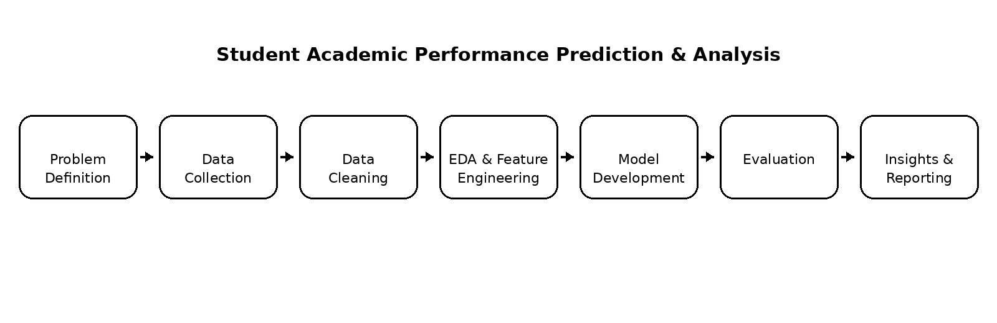

6. Timeline and Work Allocation
The planned workload is approximately 34 hours, within the requested 30–35 hour range.
Phase | Planned Work | Hours
1 | Problem understanding, project planning and requirements | 3
2 | Data collection strategy and data dictionary planning | 4
3 | Data cleaning and preprocessing strategy | 5
4 | Exploratory data analysis and visualization planning | 5
5 | Feature engineering and model-input preparation | 3
6 | Model selection and development planning | 6
7 | Evaluation strategy and interpretation planning | 4
8 | Documentation, workflow diagram and final review | 4
 | TOTAL | 34

7. Tools and Technologies
Tool | Planned Use
Python | Primary programming language.
Jupyter Notebook | Interactive analysis, experimentation, documentation, and visualization.
Pandas | Data loading, manipulation, cleaning, and tabular analysis.
NumPy | Numerical operations and array-based computation.
Matplotlib | Core data visualizations.
Seaborn | Statistical visualizations and exploratory analysis.
Scikit-learn | Preprocessing, model development, selection, and evaluation.
Git/GitHub | Optional version control and project documentation.

8. Expected Outcomes
- A complete and logically organized data science project plan.
- A clearly defined workflow from problem definition through reporting.
- A planned analytical dataset structure and data-quality strategy.
- Exploratory insights into relationships between student attributes and academic outcomes when data becomes available.
- A suitable machine learning model selection and evaluation strategy.
- A documented approach that can be extended into technical implementation.

9. Anticipated Challenges and Mitigation Strategies
Challenge | Mitigation
Missing/incomplete data | Define required fields, measure missingness, and use suitable imputation or exclusion rules.
Inconsistent formats | Standardize formats and validate ranges and data types.
Class imbalance | Inspect target distribution and use suitable metrics or resampling where necessary.
Overfitting | Use train/test separation, cross-validation where appropriate, and justified model complexity.
Data privacy | Avoid personally identifiable information and use authorized, anonymized data.
Misinterpretation of correlations | Clearly distinguish association from causation and report limitations.
Model interpretability | Prefer interpretable approaches where appropriate and communicate limitations.

10. Evaluation Strategy
The project plan will be evaluated based on completeness, clarity, logical organization, understanding of the data science lifecycle, quality of the proposed methodology, feasibility of the 30–35 hour work plan, and clarity of the workflow diagram. When technical implementation is performed later, the model will additionally be evaluated using metrics appropriate to the selected prediction problem.

11. Conclusion
This Week 1 plan establishes a structured strategy for a hypothetical Student Academic Performance Prediction and Analysis project using Python. It covers the data science lifecycle from problem definition and data collection planning through preprocessing, exploration, modeling, evaluation, and reporting. The planned 34-hour schedule provides a practical allocation of effort across each stage. The project also considers data quality, privacy, model reliability, and interpretation challenges.

12. Report Submission Description
This report presents a comprehensive project plan and strategy for a hypothetical data science project titled Student Academic Performance Prediction and Analysis Using Python. The purpose is to demonstrate how a data science professional would plan an end-to-end analytical and machine learning project before technical implementation. The report explains the project background and motivation, defines objectives, and identifies the scope and limitations. It describes a structured methodology covering problem definition, data collection, data cleaning, exploratory data analysis, feature engineering, model development, evaluation, interpretation, and reporting. A strategic workflow diagram visually represents the planned process. A 34-hour timeline allocates work across planning, data preparation, analysis, modeling, evaluation, and documentation. Python and libraries including Pandas, NumPy, Matplotlib, Seaborn, and Scikit-learn are identified as the main tools. Expected outcomes include a clear project structure, an analytical strategy, meaningful insights when data becomes available, and an evaluation framework for predictive models. Potential challenges such as missing data, inconsistent formats, class imbalance, overfitting, privacy, and interpretation of correlations are addressed with mitigation strategies. Overall, the report provides a practical foundation for later technical implementation while emphasizing structured and responsible data science practices.

