YUVA INTERN – WEEK 4 TASK REPORT
Supervised Learning Model Implementation
Trainee: Srilakshmi
Internship: Virtual Data Science with Python Trainee
Problem Type: Binary Classification
Dataset: Breast Cancer Wisconsin (Diagnostic) Dataset
Model: Logistic Regression

1. Problem Definition
The objective is to build a supervised machine-learning model that predicts the binary diagnosis target from numerical measurements of cell nuclei. Logistic Regression was selected as a baseline classification algorithm because it is designed for binary outcomes, is computationally efficient, and provides an interpretable starting point for classification.

2. Dataset Preparation
The dataset contains 569 observations and 30 numerical predictor features. The target variable is binary. The data was split into training and testing sets using an 80:20 ratio with stratification so that the class proportions were preserved as closely as possible.
StandardScaler was used to standardize the numerical predictors. The scaler and Logistic Regression model were combined in a Scikit-learn Pipeline. This ensures that scaling is learned from training data only and prevents information from the test set from leaking into model training.

3. Model Implementation
Logistic Regression was trained on the standardized training data. The model learns a relationship between the input features and the probability of belonging to the binary target classes. The trained model was then used to generate predictions for the unseen test set.

4. Evaluation Metrics
Metric | Test Result
Accuracy | 0.9825
Precision | 0.9861
Recall | 0.9861
F1 Score | 0.9861
Accuracy measures the proportion of correct predictions. Precision measures the proportion of predicted positive cases that are actually positive. Recall measures how many actual positive cases are correctly identified. The F1 score combines precision and recall into a single measure and is useful when both types of error matter.

5. Confusion Matrix
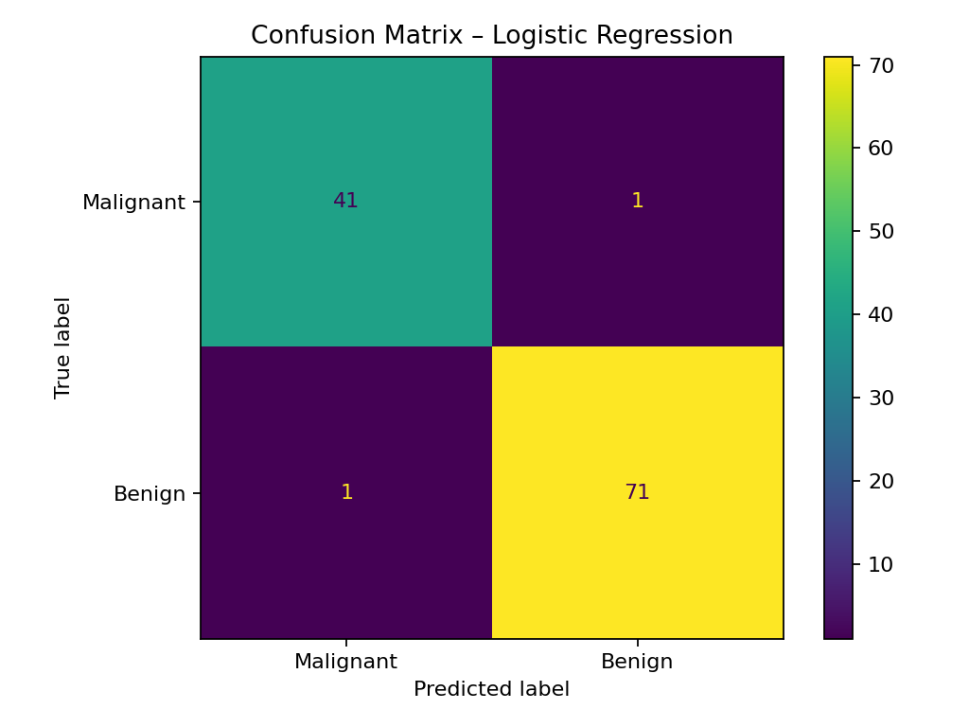
Figure 1. Confusion matrix showing the number of correct and incorrect predictions for the two classes. The matrix provides more detailed information than accuracy alone by showing how predictions are distributed across classes.

6. Cross-Validation
Five-fold stratified cross-validation was performed on the training data. The training set was divided into five folds, with each fold used once as a validation set while the remaining folds were used for training. Stratification was used to maintain similar class proportions across folds.
Fold | Accuracy
1 | 0.9670
2 | 0.9890
3 | 0.9780
4 | 0.9890
5 | 0.9670
Mean | 0.9780
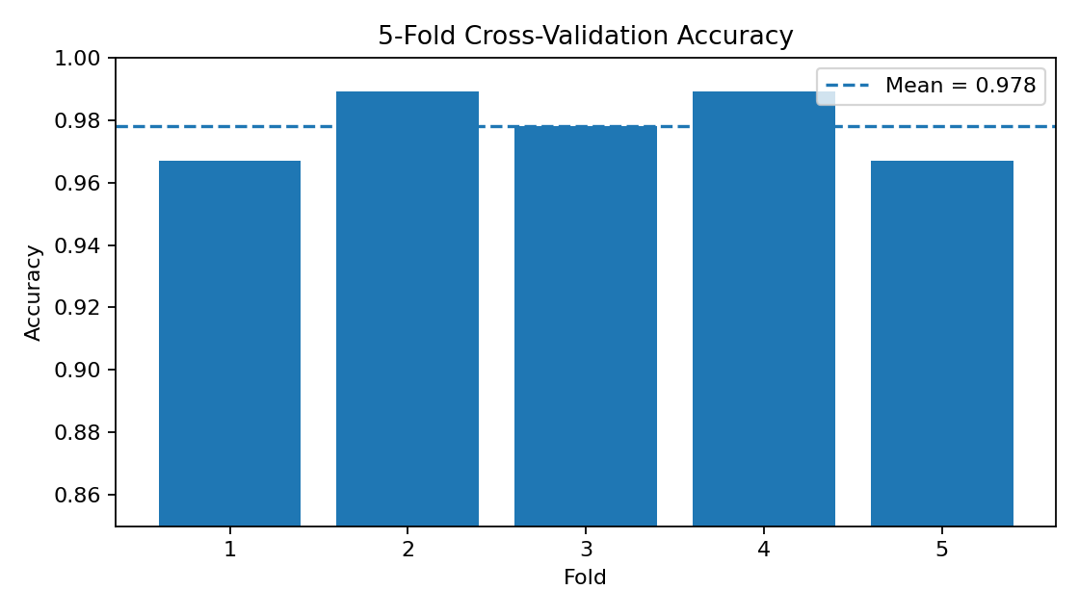
Figure 2. Accuracy obtained across five cross-validation folds.

7. Performance Analysis
The Logistic Regression model achieved a test accuracy of 0.9825, precision of 0.9861, recall of 0.9861, and F1 score of 0.9861. The mean five-fold cross-validation accuracy on the training data was 0.9780 with a standard deviation of 0.0098. Comparing cross-validation performance with the held-out test result provides a basic check of whether the model behaves consistently across different subsets.

8. Strengths of the Model
- Simple and efficient binary classification algorithm.
- Provides an interpretable baseline for supervised learning.
- Works well with standardized numerical features.
- Pipeline-based preprocessing makes the workflow reproducible and reduces data leakage risk.
- Cross-validation provides a more reliable estimate of performance than a single split alone.

9. Limitations and Possible Improvements
- Logistic Regression mainly captures linear relationships in the transformed feature space.
- Complex nonlinear relationships may require alternative algorithms.
- Feature selection or dimensionality-reduction techniques could be investigated to reduce redundancy among correlated predictors.
- Other supervised models such as Decision Trees, Random Forest, Support Vector Machines, or Gradient Boosting could be compared using the same validation strategy.
- Hyperparameter tuning could be performed to investigate whether model performance can be improved.

10. Conclusion
This project demonstrated a complete supervised-learning workflow using Python and Scikit-learn. The problem was defined as binary classification, the data was split using stratification, numerical features were standardized, Logistic Regression was trained, and performance was evaluated using accuracy, precision, recall, F1 score, a confusion matrix, and five-fold cross-validation. The resulting model provides a reproducible baseline that can be compared with more complex algorithms in future work.

