YUVA INTERN – WEEK 1 TASK REPORT
Data Acquisition, Cleaning, and Preprocessing using Python
Trainee: Srilakshmi
Internship: Virtual Data Science with Python Trainee
Dataset: Breast Cancer Wisconsin (Diagnostic) Dataset
Dataset source: UCI Machine Learning Repository; accessed through scikit-learn’s public dataset loader.

1. Introduction
This report demonstrates a complete data acquisition, cleaning, and preprocessing workflow using Python. The Breast Cancer Wisconsin (Diagnostic) dataset was selected because it is a public structured dataset containing numerical measurements and a binary diagnosis target. The workflow covers data-quality inspection, missing values, duplicate records, outlier detection, outlier treatment, and numerical standardization so the data is prepared for later analysis and machine-learning work.

2. Dataset Acquisition
The dataset was acquired reproducibly with load_breast_cancer() from scikit-learn. The underlying dataset is the Breast Cancer Wisconsin (Diagnostic) dataset associated with the UCI Machine Learning Repository. Initial size: 569 rows × 32 columns. The dataset contains 30 numerical predictor features and a binary target. A readable diagnosis column was added for interpretation.

3. Initial Data Exploration
Initial checks found 0 missing values and 0 duplicate rows. Data types, dimensions, and feature distributions were inspected before preprocessing. Because there were no missing values, no artificial imputation was performed. This keeps the workflow evidence-based rather than changing valid data unnecessarily.
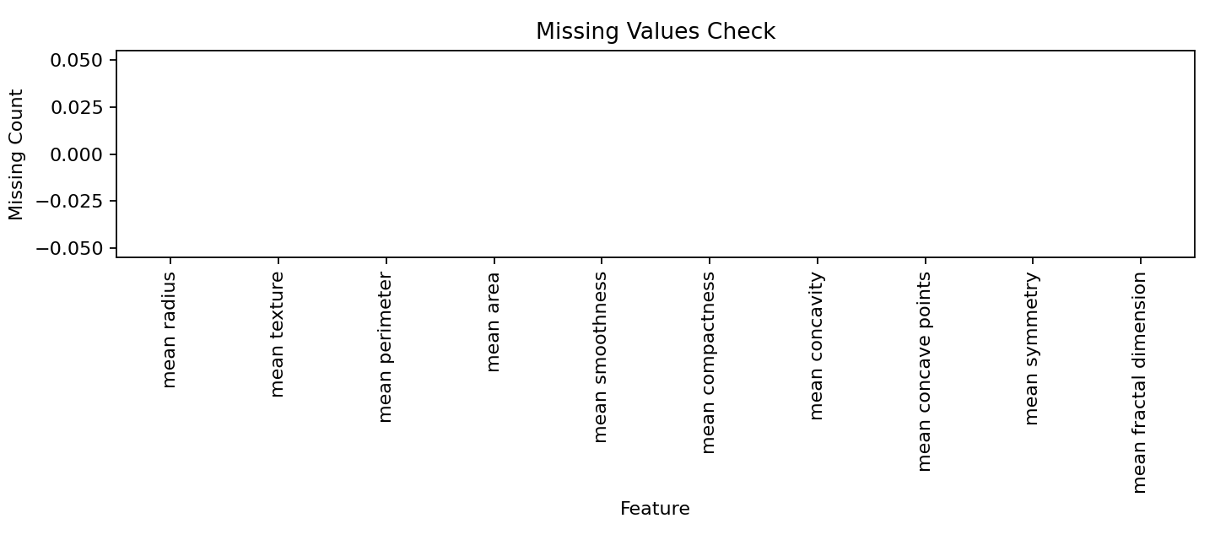
Figure 1. Missing-value check. No missing values were present.

4. Data Cleaning
Duplicate records were checked and removed with drop_duplicates(). The check found no duplicates. Missing values were checked before replacement; because none were present, no mean, median, or mode imputation was needed.

5. Outlier Detection and Treatment
Potential outliers were identified using the Interquartile Range (IQR) rule. For every numerical feature, Q1 and Q3 were calculated and observations outside Q1 − 1.5×IQR and Q3 + 1.5×IQR were counted. Extreme values were capped at these IQR limits instead of deleting complete observations. This reduces the influence of unusually large or small measurements while retaining the records.
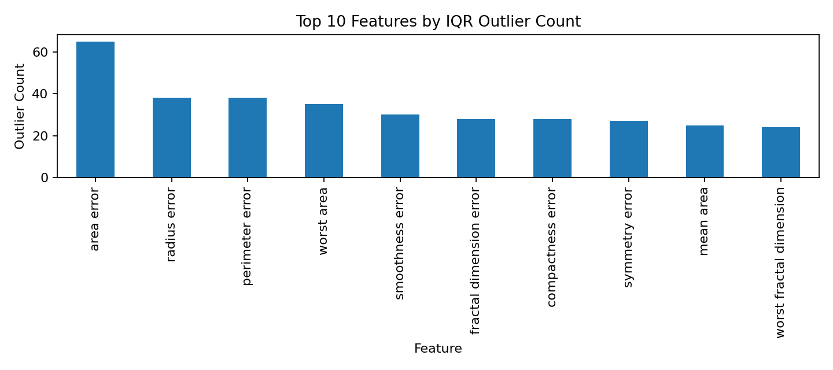
Figure 2. Top numerical features by IQR-based outlier count.

6. Data Preprocessing
The 30 numerical predictor features were standardized with StandardScaler. Standardization places features on a comparable scale with approximately zero mean and unit variance. This is useful for scale-sensitive methods such as K-Means and K-Nearest Neighbors and can also improve numerical stability in other models.
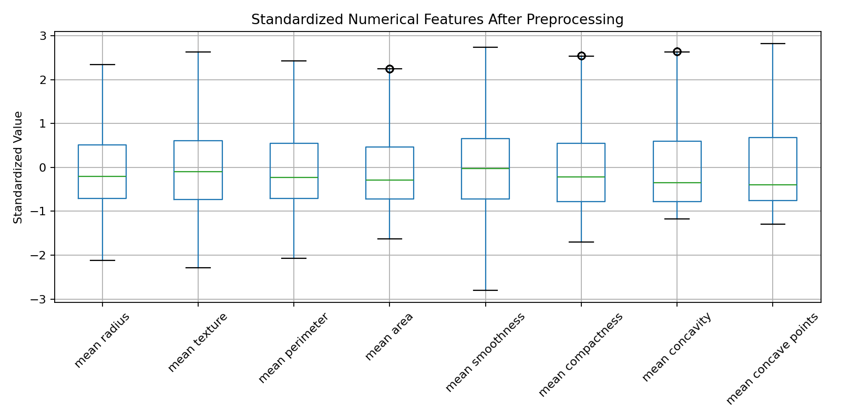
Figure 3. Standardized numerical features after preprocessing.

7. Summary of Data Quality Decisions
Issue Checked | Finding | Action Taken
Missing values | 0 missing values | No imputation required
Duplicate records | 0 duplicate rows | No duplicate rows removed
Outliers | IQR outliers detected | Values capped at IQR limits
Numerical scale | Features have different ranges | Standardized using StandardScaler
Target | Binary diagnosis | Readable diagnosis labels added

8. Challenges and How They Were Addressed
- Different numerical features have different scales, so standardization was used before scale-sensitive analysis.
- The dataset had no missing values, so no artificial values were introduced.
- Potential outliers were handled using IQR capping instead of deleting complete observations.
- The workflow was kept reproducible by using scikit-learn’s public dataset loader and a separate Python script.

9. Impact of Preprocessing on Subsequent Analysis
The preprocessing improves consistency for later exploratory analysis and machine learning. Missing-value checks prevent unexpected errors, duplicate checks prevent repeated records from affecting results, and outlier capping reduces the influence of extreme measurements. Standardization makes numerical predictors comparable, which is particularly useful for distance- and scale-sensitive methods. A limitation is that capping changes extreme values, so both original and processed data should be retained for traceability.

10. Reproducibility
A separate Python script is included with this submission. It performs dataset acquisition, quality checks, duplicate handling, missing-value handling, IQR-based outlier capping, standardization, and CSV export. The workflow can be rerun to reproduce the processed dataset.

11. Conclusion
This task demonstrated a structured Python data-preparation pipeline. The public Breast Cancer Wisconsin (Diagnostic) dataset was inspected for missing values, duplicates, and outliers, followed by appropriate cleaning and standardization. The processed dataset is prepared for further exploratory analysis and machine-learning tasks. The main lesson is that preprocessing decisions should be based on evidence from the dataset and documented for transparency and reproducibility.

