YUVA INTERN – WEEK 2 TASK REPORT
Exploratory Data Analysis and Visualization
Trainee: Srilakshmi
Internship: Virtual Data Science with Python Trainee
Dataset: Breast Cancer Wisconsin (Diagnostic) Dataset
Libraries: Pandas, Matplotlib, Seaborn, NumPy

1. Introduction
This Week 2 project performs Exploratory Data Analysis (EDA) and visualization on the Breast Cancer Wisconsin (Diagnostic) dataset. The purpose of EDA is to understand the structure, distribution, relationships, and patterns within the data before applying machine-learning models. The analysis uses Python libraries including Pandas, Matplotlib, Seaborn, and NumPy.

2. Dataset and Initial Analysis
The dataset contains 569 observations and 32 columns after adding a readable diagnosis label. It contains numerical measurements describing characteristics of cell nuclei along with a binary diagnosis target. The initial analysis included checking dimensions, data types, missing values, duplicate records, and descriptive statistics.
Missing values found: 0. Duplicate rows found: 0.

3. Descriptive Statistics
Descriptive statistics such as count, mean, standard deviation, minimum, quartiles, and maximum were calculated for the numerical variables. These statistics help identify the typical range of measurements and the amount of variation.
Feature | Mean | Std. Dev. | Maximum
mean radius | 14.13 | 3.52 | 28.11
mean texture | 19.29 | 4.30 | 39.28
mean perimeter | 91.97 | 24.30 | 188.50
mean area | 654.89 | 351.91 | 2501.00

4. Class Distribution
The diagnosis distribution contains 357 benign observations (62.74%) and 212 malignant observations (37.26%). This shows that the classes are not perfectly balanced, which is an important observation for future classification work.
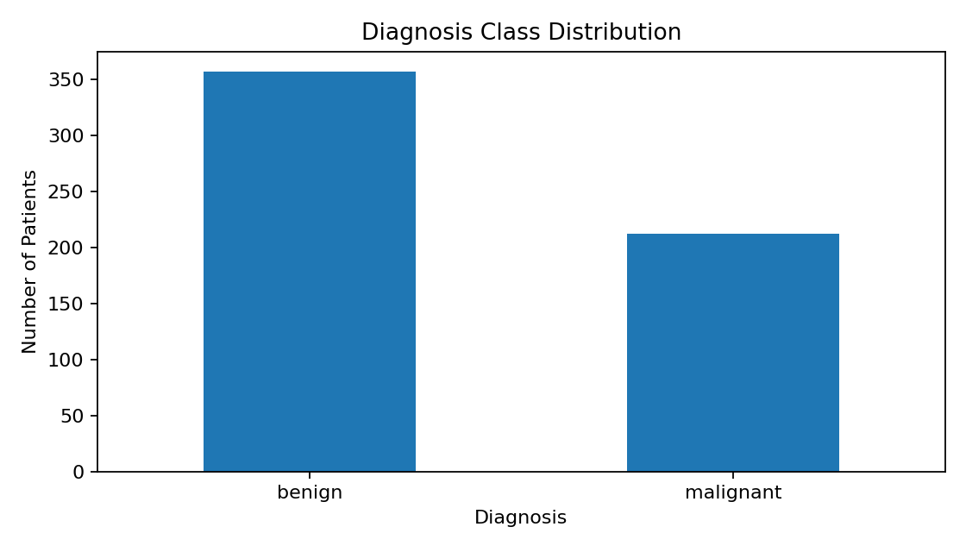
Figure 1. Distribution of diagnosis classes.

5. Distribution Analysis
A histogram was used to examine the distribution of mean radius. Histograms are useful for identifying the central range, spread, and shape of a numerical variable.
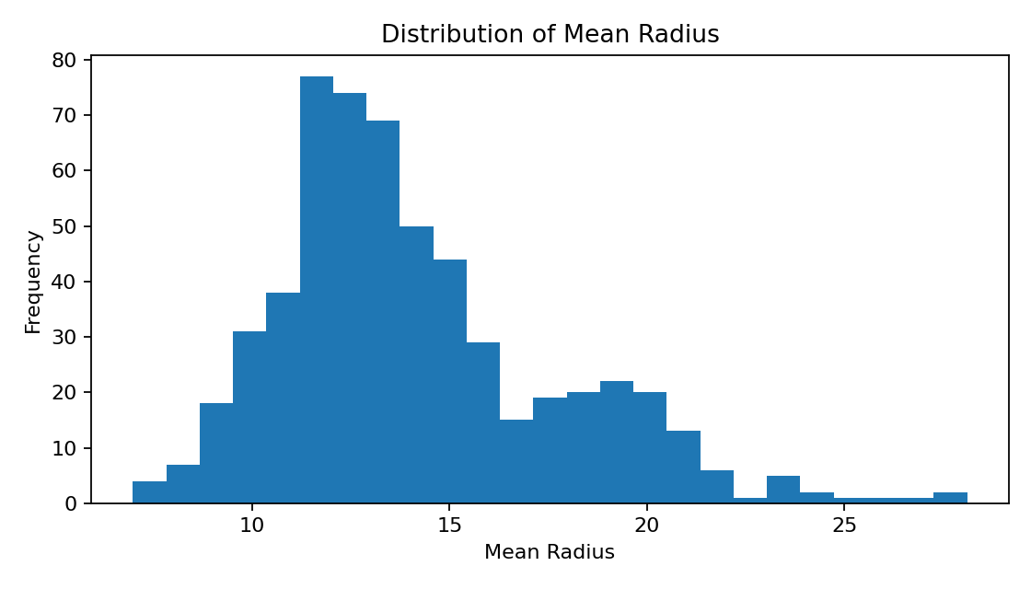
Figure 2. Distribution of mean radius.

6. Relationship Between Features
A scatter plot was created for mean radius and mean perimeter, with points separated by diagnosis. The plot shows a strong positive relationship: observations with larger mean radius generally also have larger mean perimeter. This is reasonable because both measurements describe related geometric properties of the cell nuclei.
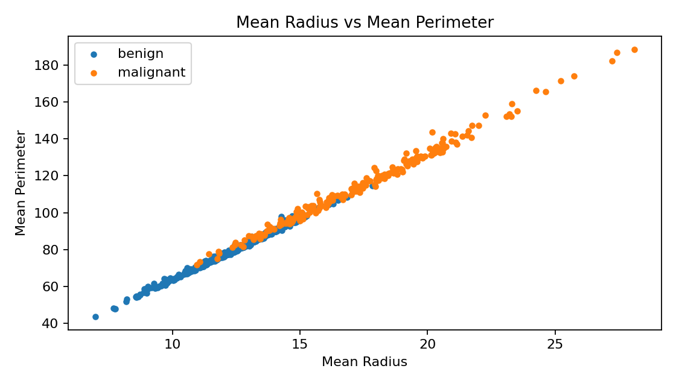
Figure 3. Mean radius versus mean perimeter.

7. Correlation Analysis
A correlation matrix was calculated for the numerical variables. Correlation measures the strength and direction of a linear relationship between two numerical variables. The heatmap makes groups of strongly related features easier to identify.
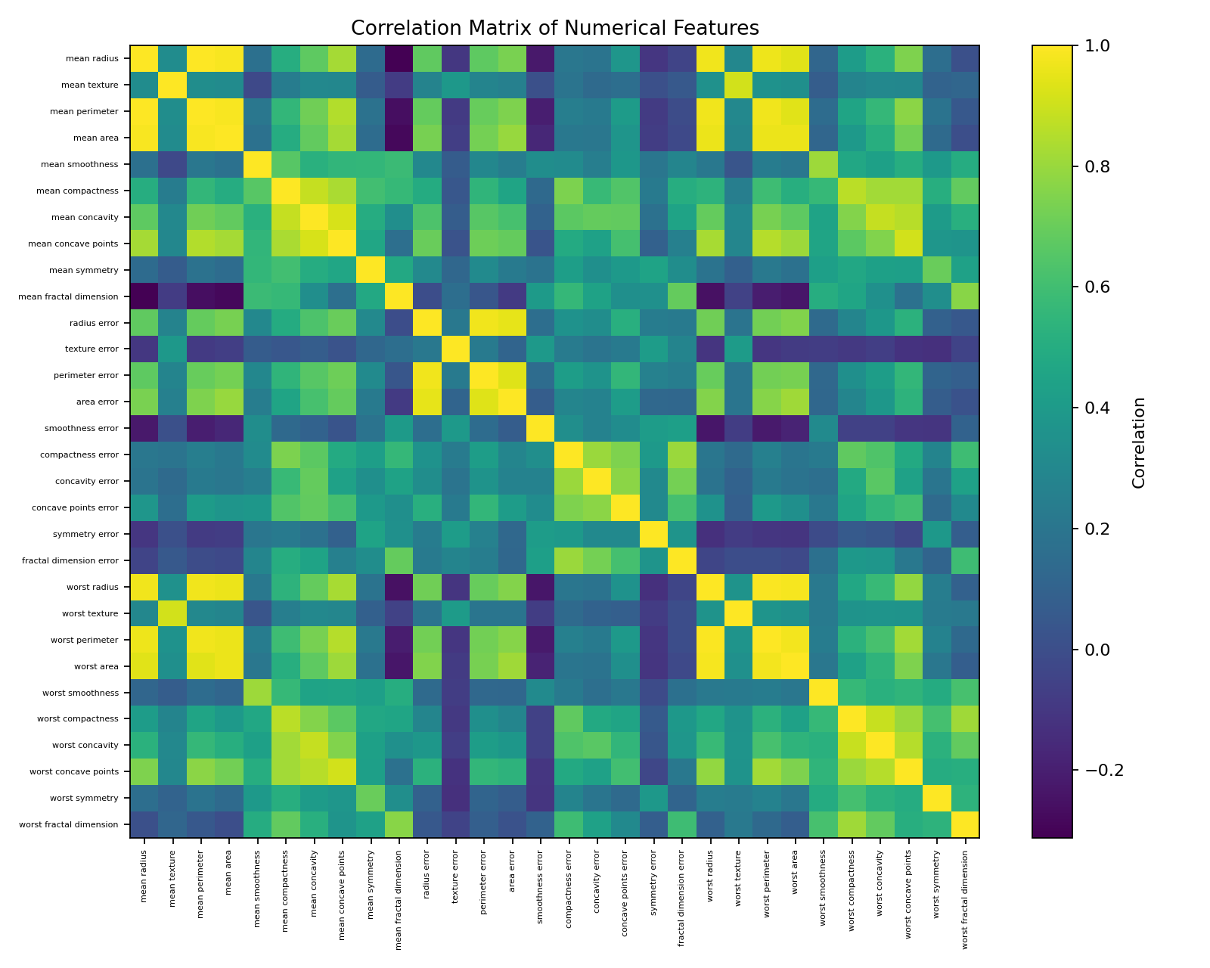
Figure 4. Correlation matrix of numerical features.
Examples of the strongest absolute correlations observed:
- mean radius ↔ mean perimeter: correlation = 0.998
- worst radius ↔ worst perimeter: correlation = 0.994
- mean radius ↔ mean area: correlation = 0.987
- mean perimeter ↔ mean area: correlation = 0.987
- worst radius ↔ worst area: correlation = 0.984

8. Grouped Feature Comparison
Group-wise averages were calculated to compare selected numerical measurements between benign and malignant observations.
Feature | Benign Mean | Malignant Mean
mean radius | 12.15 | 17.46
mean perimeter | 78.08 | 115.37
mean area | 462.79 | 978.38

9. Data Transformations and Aggregations
The dataset was loaded from CSV using Pandas. A readable diagnosis label was created from the original binary target for easier interpretation. Descriptive statistics were generated using describe(), class frequencies were calculated using value_counts(), and group-wise means were calculated using groupby(). No unnecessary aggregation or deletion of observations was performed for the EDA.

10. Key Findings and Interpretation
- The dataset contains 569 observations with a binary diagnosis target.
- Benign observations represent 62.74% of the dataset, while malignant observations represent 37.26%.
- Mean radius has a measurable spread across observations, making it suitable for distribution analysis.
- Mean radius and mean perimeter show a strong positive relationship, indicating that these geometric measurements tend to increase together.
- The correlation matrix reveals multiple groups of strongly associated numerical features, which may indicate redundancy and should be considered in later modeling.
- The class distribution is not perfectly balanced, so future classification evaluation should consider more than accuracy alone.

11. Conclusion
The EDA process provided a clear understanding of the dataset before machine-learning modeling. Basic statistics described the numerical variables, class-distribution analysis showed the target balance, histograms explained feature distributions, scatter plots showed relationships between variables, and the correlation matrix identified strong associations among predictors. These findings provide useful direction for the next stages of the data-science workflow, while keeping the interpretations descriptive rather than treating correlations as causal relationships.

