YUVA INTERN – WEEK 3 TASK REPORT
Unsupervised Learning and Clustering Analysis
Trainee: Srilakshmi
Internship: Virtual Data Science with Python Trainee
Dataset: Breast Cancer Wisconsin (Diagnostic) Dataset
Primary algorithm: K-Means Clustering
Comparison method: Agglomerative (Hierarchical) Clustering

1. Introduction
This project applies unsupervised learning techniques to segment observations into groups based on similarities in their numerical measurements. The Breast Cancer Wisconsin (Diagnostic) dataset is used as a public dataset. The diagnosis target is deliberately not used as an input to clustering, because the objective of unsupervised learning is to discover structure without relying on known class labels.

2. Dataset and Preprocessing
The dataset contains 569 observations and 30 numerical predictor features used for clustering. Before applying clustering, the numerical features were standardized using StandardScaler. Standardization is important for K-Means because the algorithm is distance-based and variables with larger numerical scales could otherwise dominate the distance calculations.

3. Methodology – K-Means
K-Means was selected as the primary clustering algorithm because it is a widely used unsupervised learning method for partitioning observations into a specified number of clusters. The algorithm assigns observations to the nearest centroid and iteratively updates the centroids until the assignments stabilize.
Candidate values of k from 2 through 6 were evaluated. The silhouette score was used to compare the quality of the resulting partitions. A higher silhouette score generally indicates that observations are relatively well matched to their own cluster and separated from other clusters.
Number of clusters (k) | Silhouette score
2 | 0.3434
3 | 0.3144
4 | 0.2833
5 | 0.1582
6 | 0.1604
Based on the highest silhouette score among the tested values, k = 2 was selected for the final K-Means model.
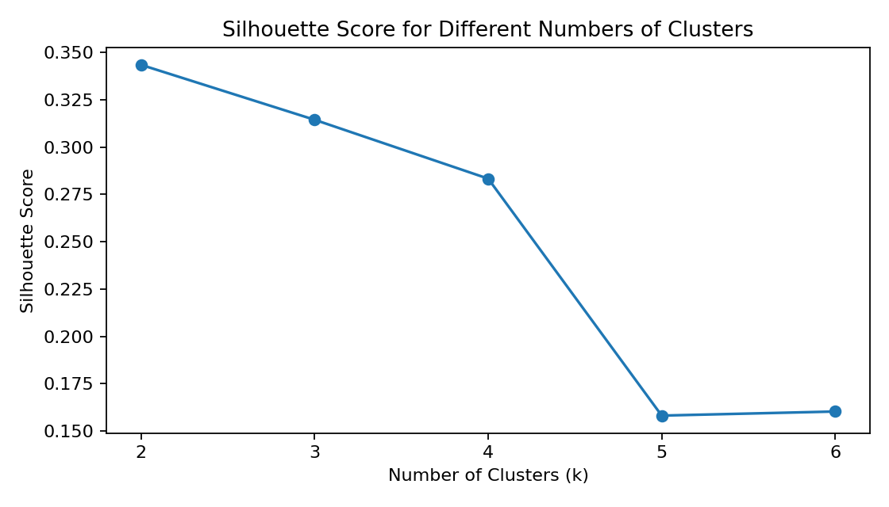
Figure 1. Silhouette scores for candidate numbers of clusters.

4. K-Means Results
The final K-Means model was trained with k = 2, random_state = 42, and n_init = 10. The resulting cluster assignments were added to the analysis dataset.
Cluster | Number of observations
0 | 375
1 | 194
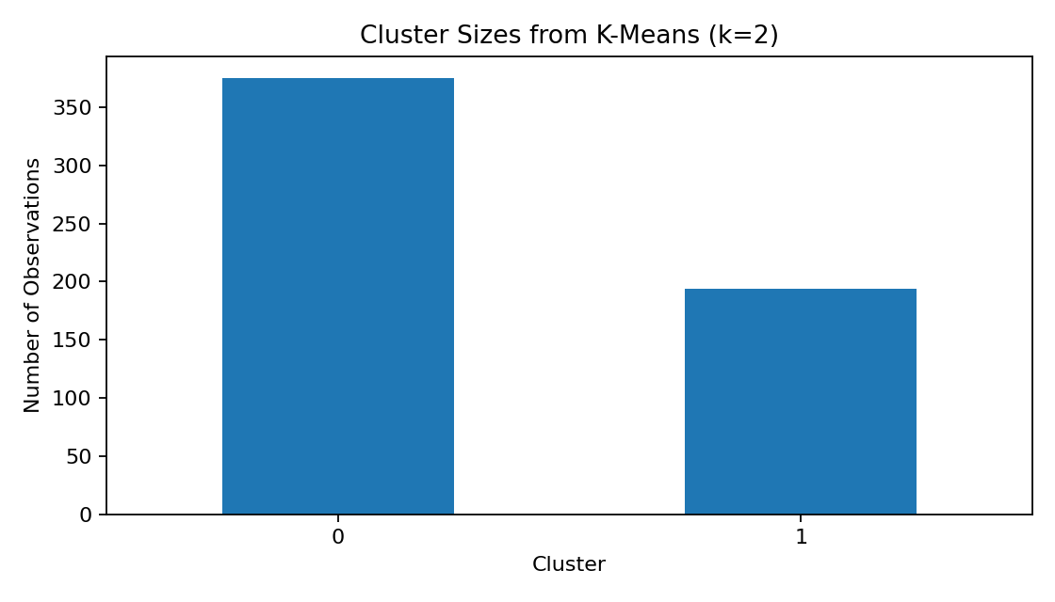
Figure 2. Number of observations assigned to each cluster.

5. Cluster Visualization with PCA
PCA was used only as a visualization technique to reduce the standardized 30-dimensional feature space to two principal components. The first two components together explain approximately 63.24% of the variance. The K-Means cluster labels were then plotted in this two-dimensional representation.
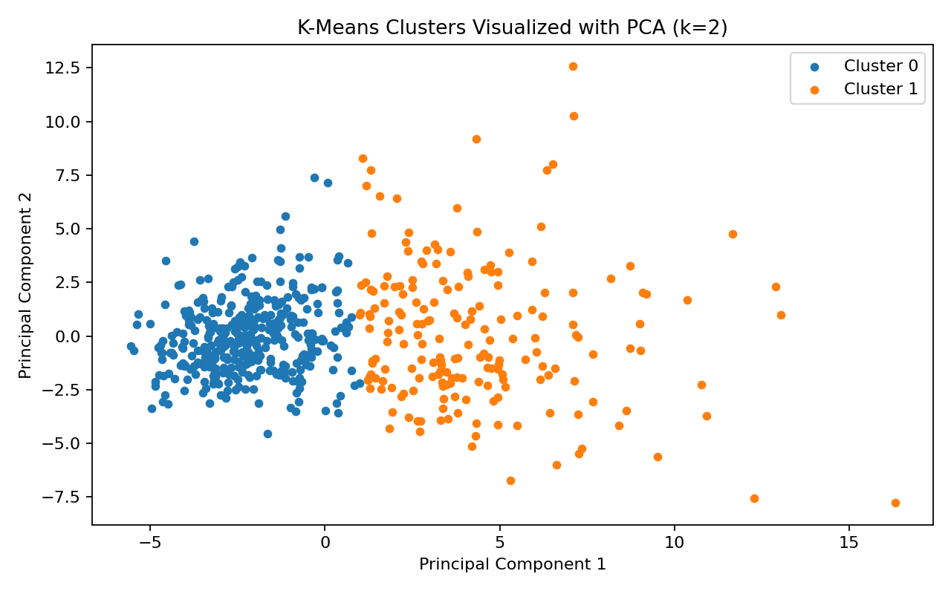
Figure 3. K-Means clusters represented using the first two principal components.

6. Cluster Characteristics
Cluster characteristics were examined using group-wise means. The cluster number itself has no inherent meaning; therefore, the groups are described by their average feature measurements rather than being given medical labels.
Cluster | Mean radius | Mean perimeter | Mean area
0 | 12.43 | 79.82 | 486.77
1 | 17.41 | 115.45 | 979.86

7. Hierarchical Clustering Comparison
Agglomerative hierarchical clustering was also evaluated for k values from 2 through 5. Silhouette scores were calculated for comparison with the K-Means results. This provides an additional unsupervised-learning perspective and helps demonstrate that different algorithms can produce different segmentation structures.
Clusters | Hierarchical silhouette score
2 | 0.3394
3 | 0.3301
4 | 0.2982
5 | 0.2434
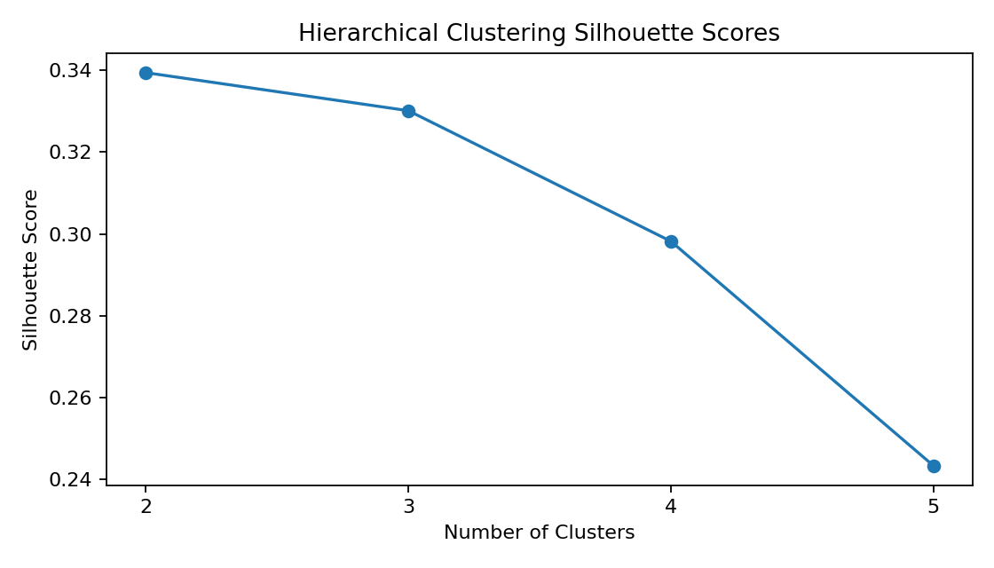
Figure 4. Silhouette scores for hierarchical clustering.

8. Business/Research Implications
In a research setting, clustering can be used to discover naturally occurring groups of observations and identify patterns that may deserve further investigation. For this dataset, the clusters summarize observations according to similarity across multiple cell-measurement features. Such segmentation can support exploratory research and feature analysis, but the clusters should not be interpreted as clinical diagnoses. Any medical interpretation would require domain validation and appropriate supervised or clinical analysis.

9. Conclusion
This project demonstrated an end-to-end unsupervised learning workflow. The numerical features were standardized, multiple candidate values of k were evaluated using silhouette scores, K-Means was applied using the selected k, and PCA was used to visualize the resulting groups. Cluster sizes and feature means were examined to understand cluster characteristics. Hierarchical clustering was also evaluated as a comparison. The workflow provides a reproducible foundation for further unsupervised analysis.

