**Lab1**

**Challenge1**

**Challenge: Find the Weekday with the Lowest Temperature**

**1. Using the filter and sort capabilities in Excel Online, filter the data so that only weekdays (Monday to Friday) are shown, and sort the data so that the first row contains data for the weekday with the lowest temperature**

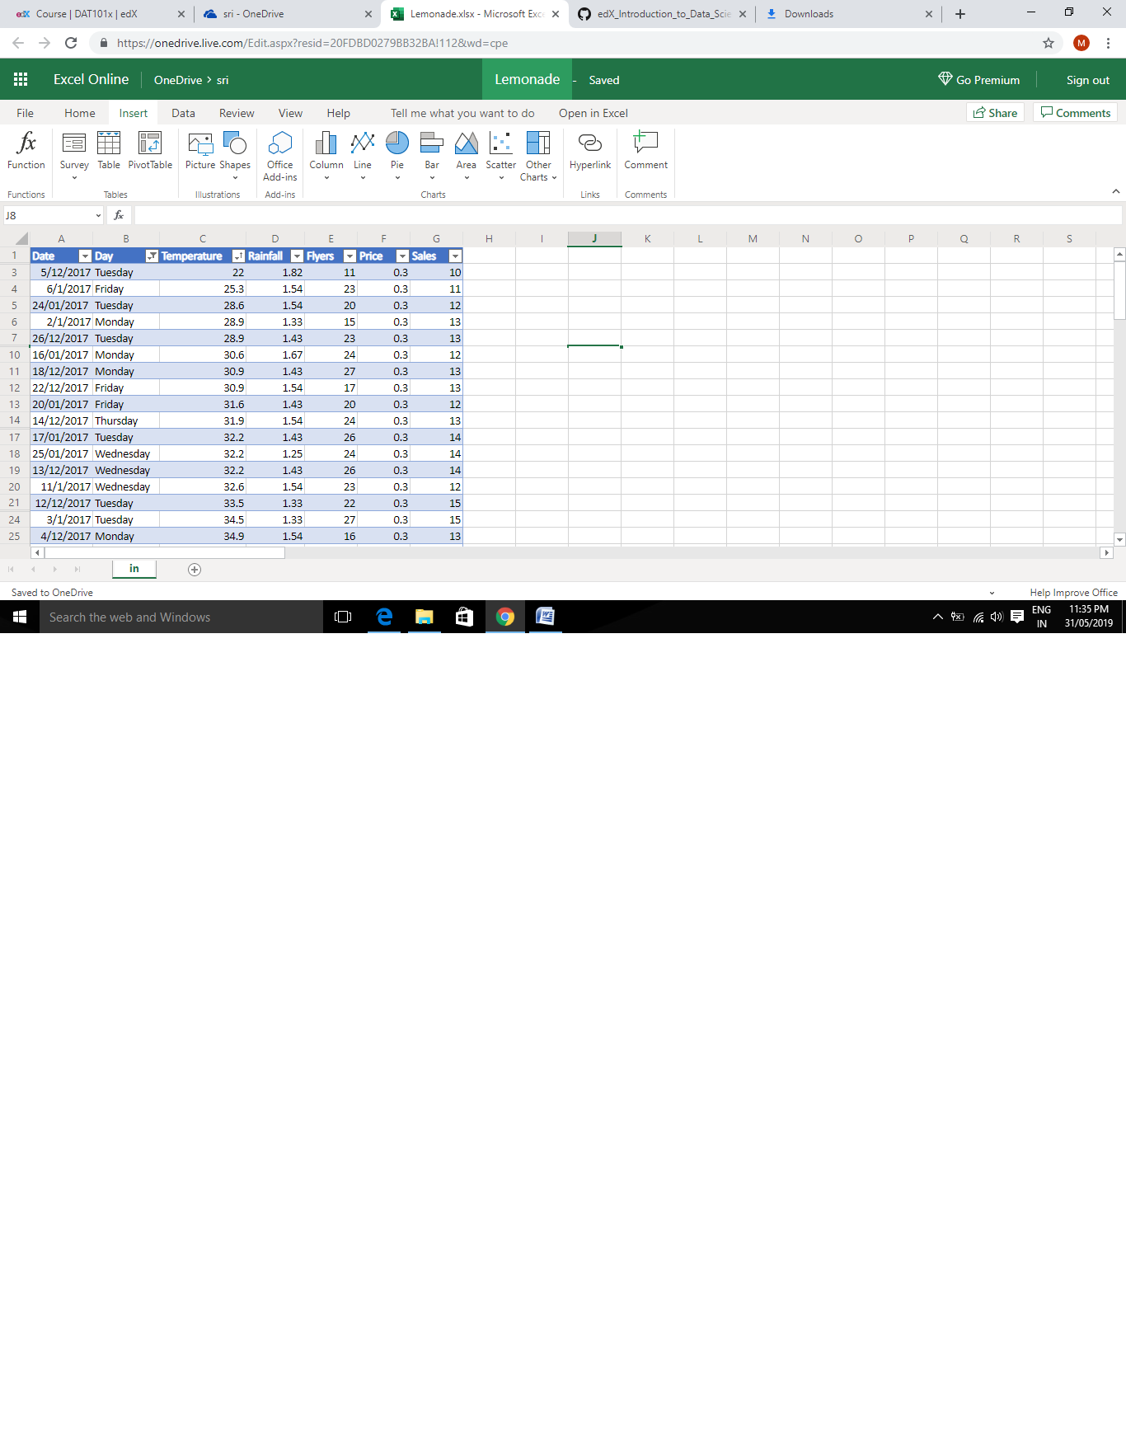

**Solution –**

**WEEKDAY—TUESDAY**

**TEMPERATURE---22**

**Challenge2**

**Challenge: Find the Total Number of Flyers Distributed**

1. **Add a cell under the Flyers column that contains the total number of flyers Rosie distributed. Format this column using the Comma Style (,) number format so that the total is formatted like 00,000.00.**

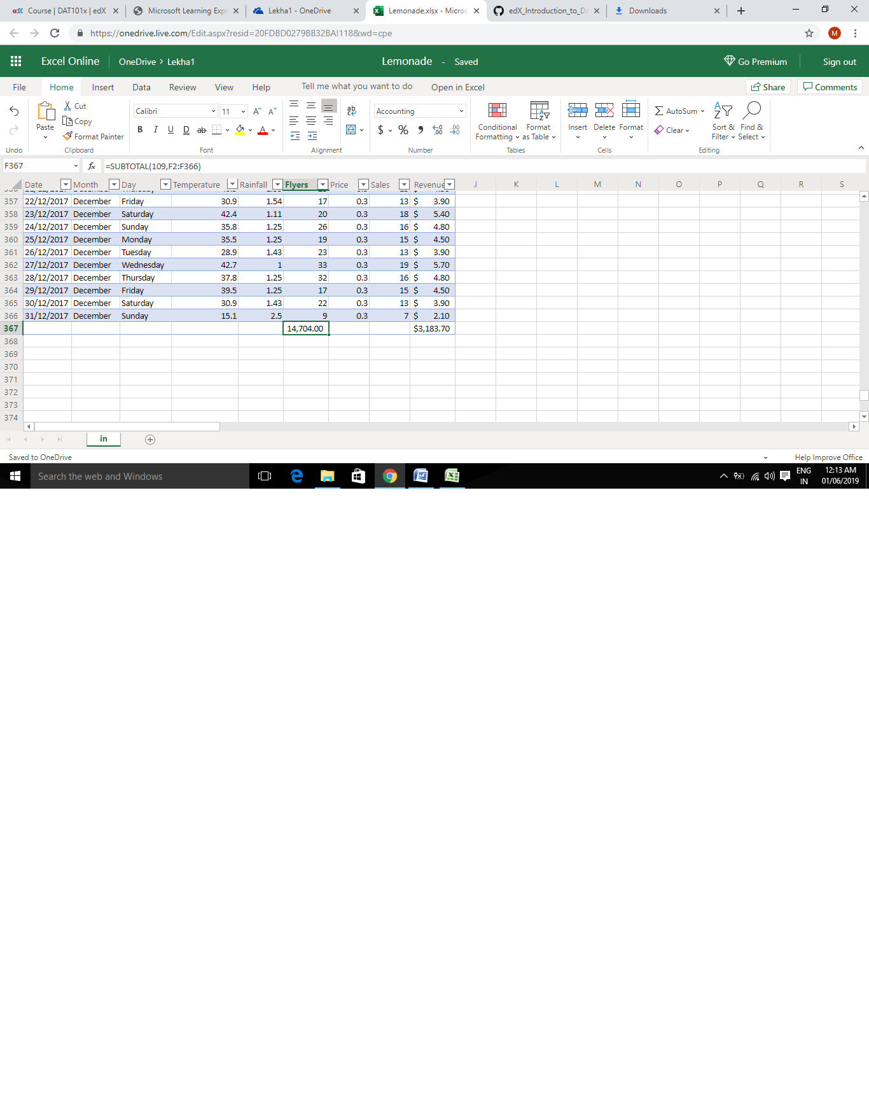

**SOLUTION:**

**TOTAL AMOUNT OF FLYERS---14,704.00**

**2. Note the total amount for the year, and then filter the data to find the number of flyers distributed in the month of January. Don’t forget to clear the filter when you’re done**!

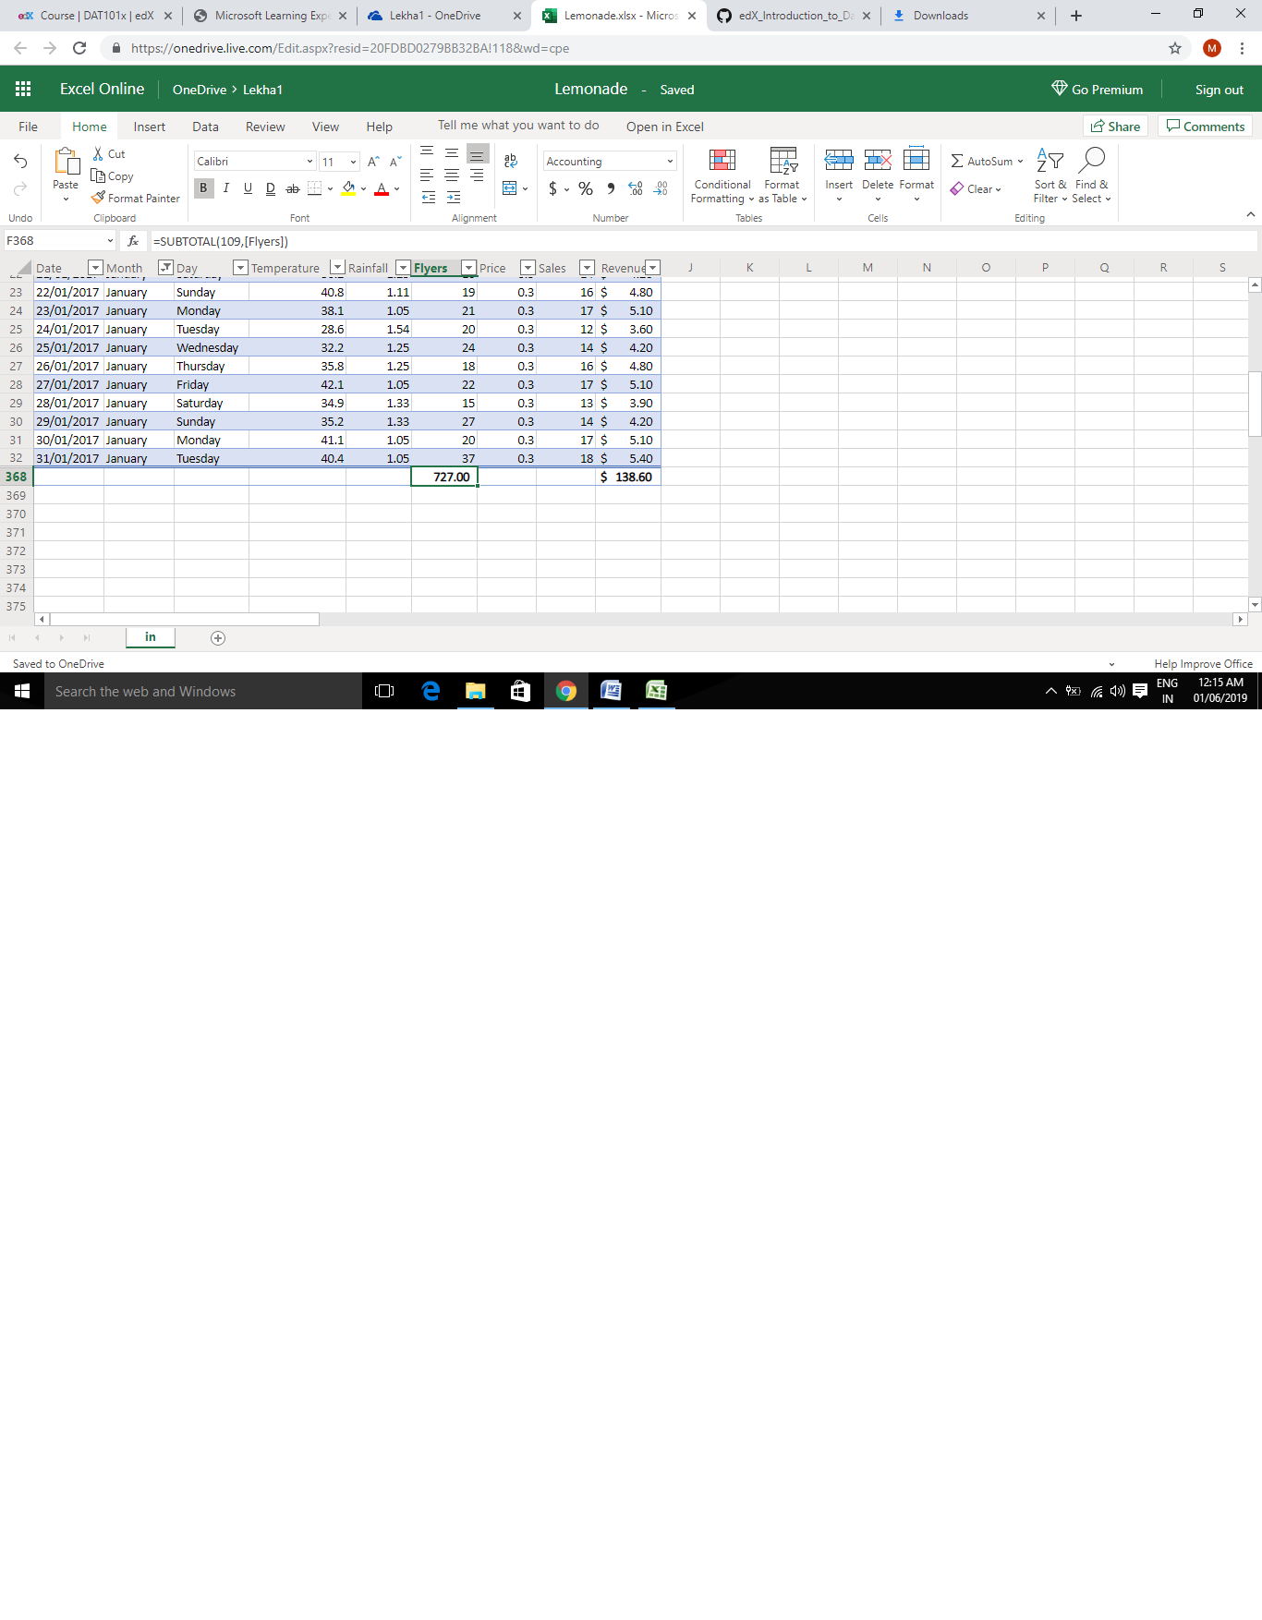

**SOLUTION—**

**TOTAL FYLERS IN JANUARY---727.00**