**LAB3**

**CHALLENGE1**

**Challenge: Analyze Temperature Statistics**

1. Calculate the mean, median, mode, population variance, and population standard deviation of  temperature.

2. Create a histogram and a box and whiskers chart for temperature to visualize the distribution.

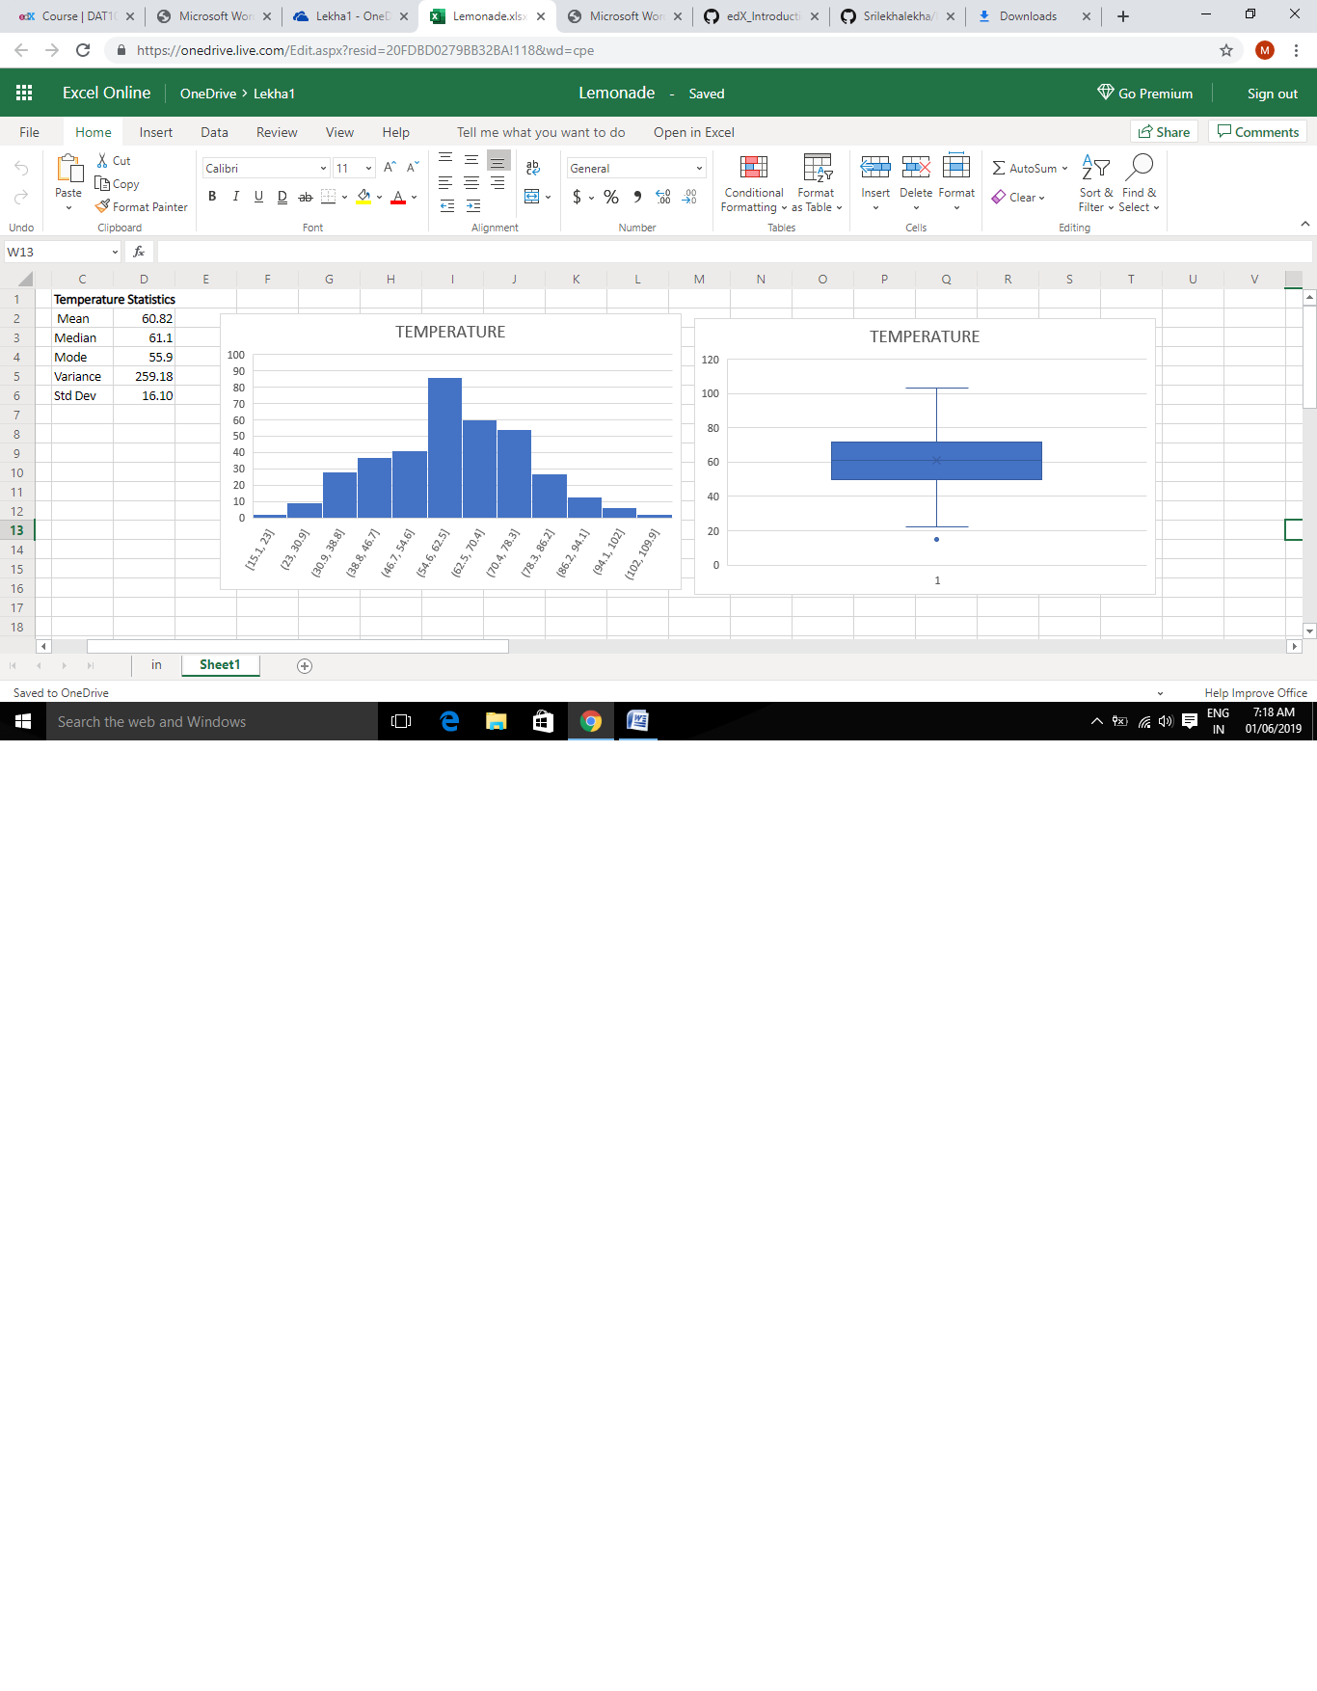

**CHALLENGE2**

**Challenge: Analyze Temperature Samples**

1. Create a sampling distribution based on 290 samples of mean Temperature. Each sample should  be based on 40 random observations.

2. Calculate the mean of the temperature sampling distribution.

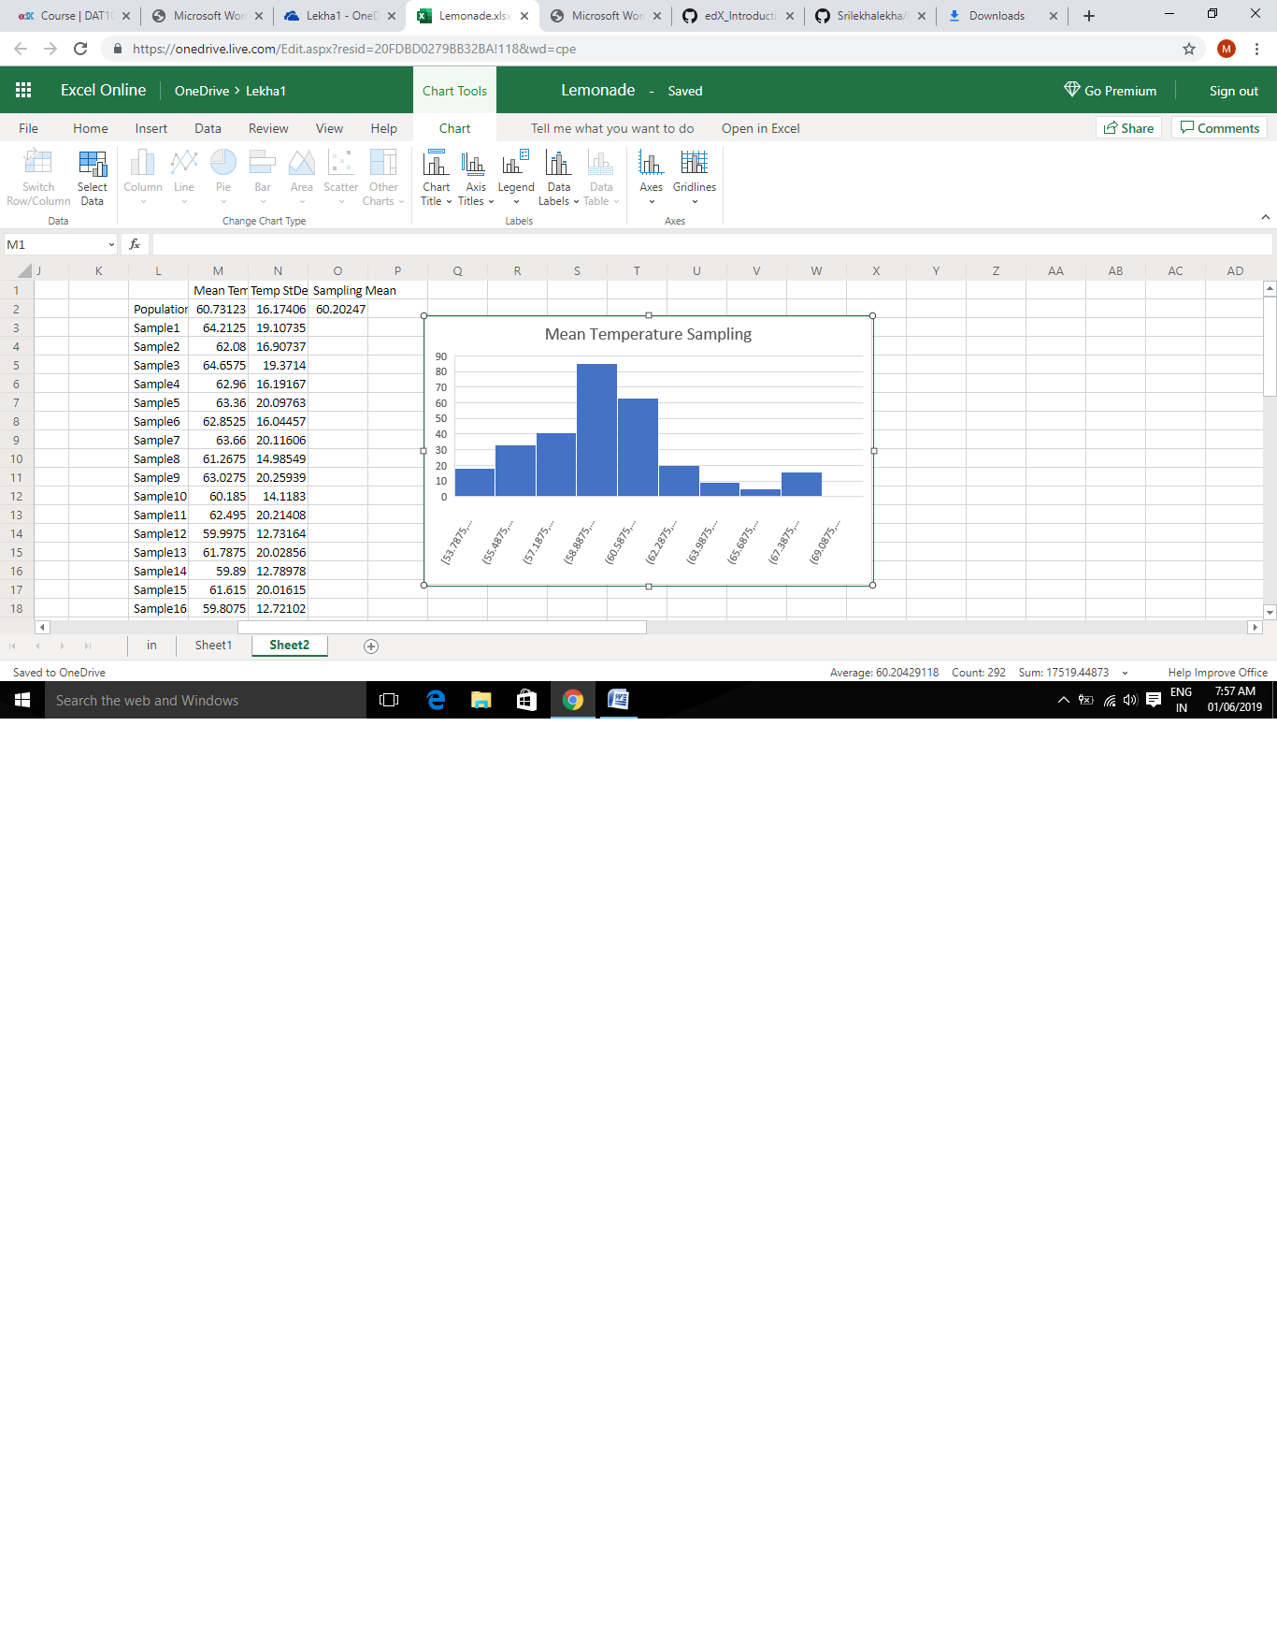

**SOLUTION---**

**SAMPLING MEAN OF TEMPERATURE----60.20247 which is very much close to original mean of temperature**.

**CHALLENGE3**

**Challenge: Calculate Rainfall / Sales Correlation**

1. Calculate the correlation between Rainfall and Sales.

2. What does the correlation indicate?

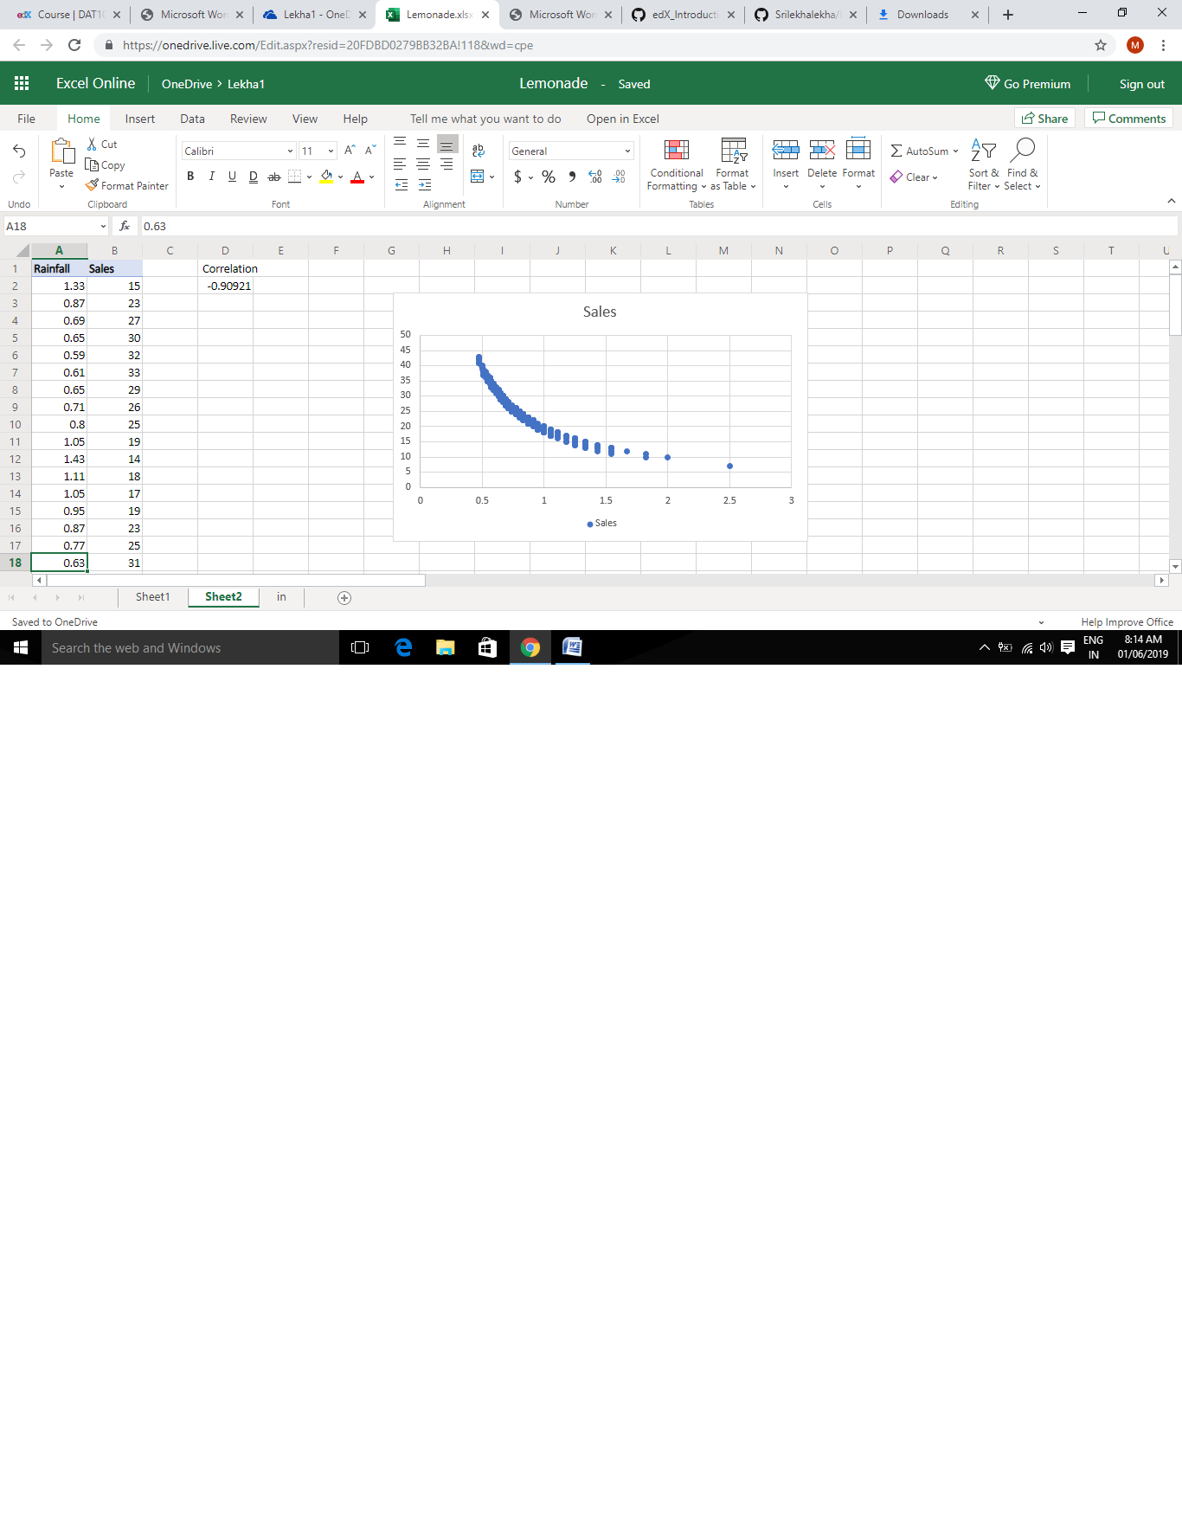

**SOLUTION—**

**CORRELATION VALUE--- -0.90921 which is almost very near to -1 indicates NEGATIVE** **CORRELATION**