**LAB4**

**Challenge 1**

**Challenge**

**Try predicting sales for today and tomorrow if Rosie increases the number of flyers to 100.**

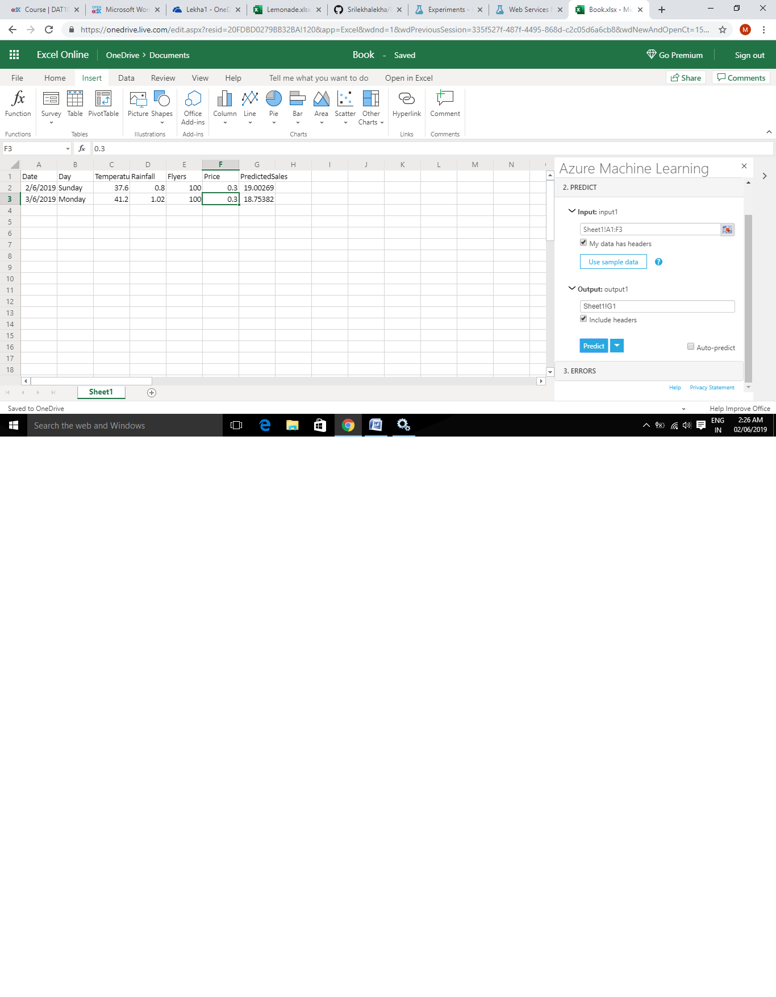

**Challenge 2**

**Challenge**

**Adjust the threshold by dragging the slider, and observe the effect on the model metrics**.

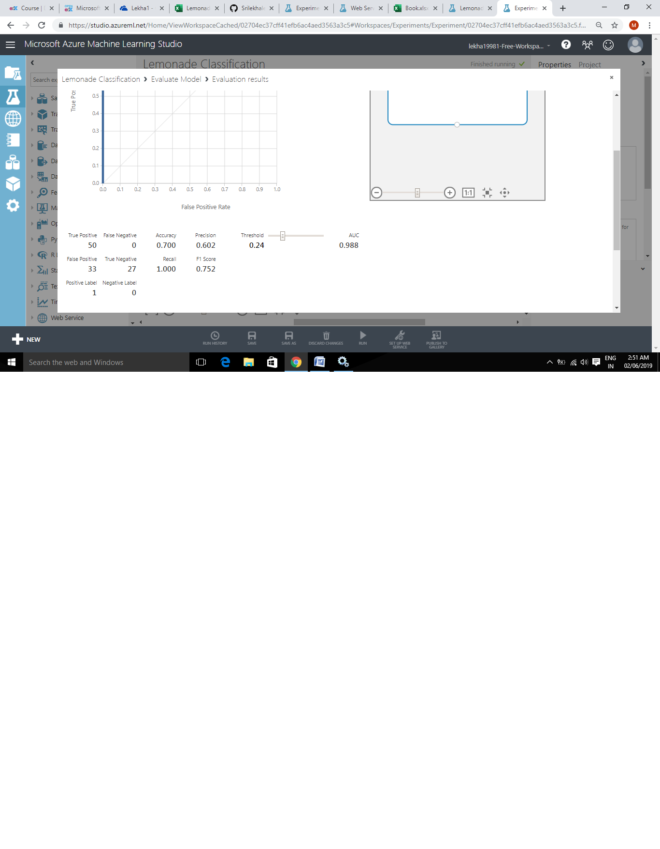

**If we decrease threshold by dragging the slider to left ,It will increase TP , FP and decrease FN ,TN**

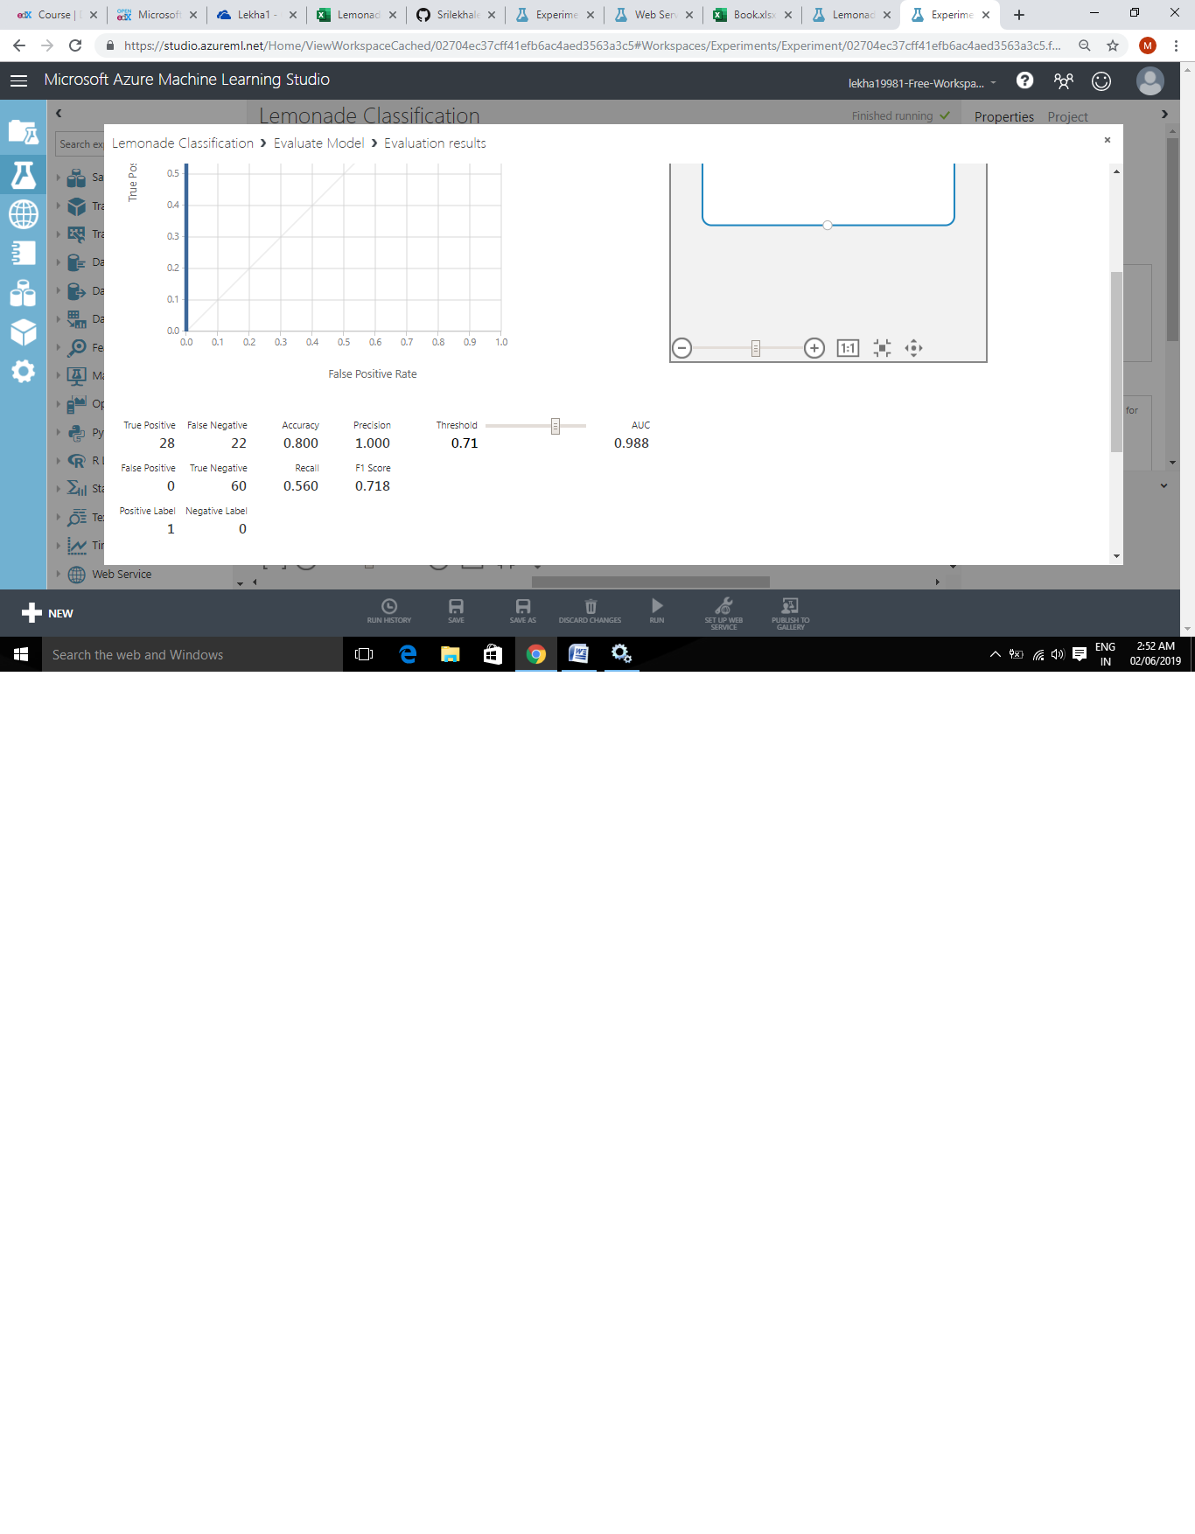

**If we increase threshold by dragging the slider ,It will decrease TP , FP and increase FN ,TN**

**Challenge3**

**Challenge**

**Note the Assignments value indicating the cluster to which customer 1 (Marva Cardenas) is  assigned.**

