Hands-on 1:

Data Structures and Algorithms
Exercise 2: E-commerce Platform Search Function :

Product.java
package EcomSerachFunction;
import java.util.Comparator;
import java.util.List;
import java.util.ArrayList;
import java.util.Collections;
public class Product {
String prductName;
String category;
int productId;
List<Product> listForLinearSearch;
List<Product>listForBinarySearch;
public Product(){
listForLinearSearch=new ArrayList<>();
listForBinarySearch=new ArrayList<>();
}
public Product(String name , String category , int id){
this.prductName=name;
this.category=category;
this.productId=id;
}
public void addProduct(Product product){
listForBinarySearch.add(product);
listForLinearSearch.add(product);
}
//Linear Search
public Product searchProductUsingLinearSearch(int id ){
for(Product product: listForLinearSearch){
if(product.productId==id){
return product;
}
}
return null;
}
//Binary Search
public Product searchProductUsingBinarySearch(int id){
Collections.sort(listForBinarySearch , Comparator.comparingInt(p->p.productId));
int start=0;
int end=listForBinarySearch.size()-1;
while(start<end){
int mid=start+(end-start)/2;
int mi Productid=listForBinarySearch.get(mid).productId;
if(midProductId==id){
return listForBinarySearch.get(mid);
}else if(midProductId<id){
start=mid+1;

}else if(midProductId>id){
end=mid-1;
}

}
return null;

}
//Printing Product
public static void printProduct(Product product){
if(product==null){
System.out.println("Product not found");
}
System.out.println("Product Id : "+product.productId);
System.out.println("Product Name : "+product.prductName);
System.out.println("Product Category : "+product.category);
}
}

Main.java
package EcomSerachFunction;

public class Main {
public static void main(String[]args){
Product store=new Product();
Product product1=new Product("Laptop" , "Electronics" , 1);
Product product2=new Product("Mobile Phone" , "Electronics" , 2);
Product product3=new Product("Charger" , "Electronics" , 3);
Product product4=new Product("Shoe" , "Fashion" , 10);

store.addProduct(product1);
store.addProduct(product2);
store.addProduct(product3);
store.addProduct(product4);
System.out.println("Product search using Linear search O(n) :");
Product product=store.searchProductUsingLinearSearch(1);
Product.printProduct(product);
System.out.println();
System.out.println("Product searched using Binary search O(logn) :");
Product secondProduct=store.searchProductUsingBinarySearch(3);
Product.printProduct(secondProduct);

}
}

OUTPUT:
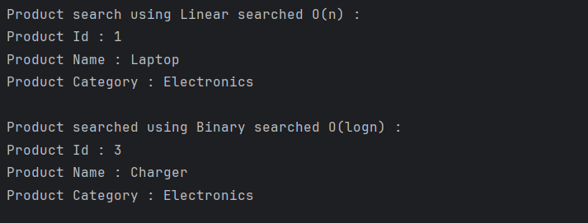

Analysis:
- Binary search is more efficient (O(log n)) than linear search (O(n)) for large datasets, making it ideal for fast product lookups on an e-commerce platform.
- Binary search requires sorted data, so it’s best used when products are pre-sorted or rarely modified; otherwise, linear search is simpler for small or dynamic datasets.
Exercise 7: Financial Forecasting :

FinancialForecast.java
public class FinancialForecast {

public static double forecastValue(int year, double initialValue, double annualGrowthRate) {
if (year == 0) {
return initialValue;
}
return forecastValue(year - 1, initialValue, annualGrowthRate) * (1 + annualGrowthRate);
}

public static void main(String[] args) {
double startingValue = 10000; // ₹10,000
double growthRate = 0.10; // 10% annual growth
int forecastYears = 5;

double result = forecastValue(forecastYears, startingValue, growthRate);
System.out.printf("Forecasted Value after %d years: Rs : %.2f\n", forecastYears, result);
}
}

OUTPUT:



Analysis :
- Time Complexity: The recursive algorithm has a time complexity of O(n), where n is the number of years, since it makes one recursive call per year.

