ABSTRACT
LearnSphere is a web-based eLearning platform with an Instructor/Admin portal and a Learner portal. Its requirements are described in a formal Software Requirements Specification and in an epic-level User Story document. This project analyses both documents together, identifies their overlaps, divergences and gaps, and resolves them into a single prioritised product backlog of 16 user stories worth 101 story points.
The backlog is delivered with Scrum. A two-release, five-sprint plan is prepared; Sprint 1 is planned at task level, executed with a Scrum board and burndown tracking, monitored with predefined and user-created Jira queries, reviewed according to a schedule, and closed with a retrospective that feeds the plan for Sprint 2. The system is modelled with a use case model, a business use case model, boundary, controller and entity classes, and a UML class diagram, and is mapped to a normalised MySQL database.
A prototype with a Python user interface and a MySQL database is implemented using the same boundary, controller and entity layering. Unit tests for the business rules and controllers were executed and passed, and an integration suite for the database layer is provided. Requirement coverage is traced from every SRS functional requirement to a story or to a recorded deferral.

TABLE OF CONTENTS
1. Introduction 1
1.1 Background 1
1.2 Problem Statement 1
1.3 Objectives 1
1.4 Scope of the Project 1
1.5 Organisation of the Report 1
2. Requirements Analysis 1
2.1 Source Documents 1
2.2 Stakeholders and User Classes 1
2.3 Functional Requirements 1
2.4 Non-Functional Requirements and Prototype Decisions 1
2.5 Cross-Document Analysis 1
2.6 Scope Decision 1
2.7 Constraints, Assumptions and Risks 1
3. Agile Planning and Management 1
3.1 Scrum Framework Adopted 1
3.2 Product Backlog 1
3.3 Release Plan 1
3.4 Sprint Plan for Sprint 1 1
3.5 Managing the Workload: Executing the Sprint 1
3.6 Tracking Progress with Queries 1
3.7 Sprint Review Schedule 1
3.8 Closing Sprint 1 and Starting Sprint 2 1
4. System Analysis and Design 1
4.1 Use Case Model 1
4.2 Business Use Case Model 1
4.3 Conceptual Classes: Boundary, Controller and Entity 1
4.4 Domain Model: UML Class Diagram 1
4.5 Architecture and Database Design 1
5. Implementation 1
5.1 Technology Stack 1
5.2 Project Structure 1
5.3 Database Set-up 1
5.4 Business Logic 1
5.5 Controller and Data Access 1
5.6 User Interface 1
6. Testing 1
6.1 Test Strategy 1
6.2 Unit Testing 1
6.3 Integration Testing 1
6.4 Traceability from Stories to Tests 1
6.5 Defect Management 1
7. Results and Discussion 1
7.1 Coverage of the Requirements 1
7.2 Delivery Outcome 1
7.3 Discussion 1
7.4 Limitations 1
8. Conclusion and Future Enhancements 1
References 1
Appendix A: Traceability of SRS Functional Requirements 1
Appendix B: MySQL Database Script 1

1. Introduction

1.1 Background
Online learning has moved from being an add-on to being a primary way in which institutions teach and in which individuals build skills. A learning management system (LMS) must let instructors publish structured content, let learners study at their own pace, and give administrators a clear view of how the platform is used. LearnSphere is a web-based eLearning platform conceived for this purpose. It has two cooperating subsystems: an Instructor/Admin portal for creating and managing courses, lessons, quizzes and reports, and a Learner portal for browsing, enrolling, studying, taking quizzes, earning points and badges, and completing courses.
The requirements for LearnSphere are captured in two documents: a formal Software Requirements Specification (SRS v1.0, July 2026, prepared in IEEE 29148 style by the Department of Computer Science and Engineering, Kongu Engineering College) and an epic-level User Story document with acceptance criteria. This project report analyses both documents together and shows how an Agile (Scrum) approach is used to turn them into a planned, designed, implemented and tested product.

1.2 Problem Statement
The two source documents were written from different viewpoints. The SRS is broad and contractual: it describes the whole platform, including payments, certification, compliance and quality targets. The user stories are narrow and screen-oriented: they describe exactly what an instructor or learner should be able to do on each page. Built naively, either document alone would leave gaps or contradictions. The problem addressed in this project is to reconcile the two into one prioritised, estimable backlog, and then to deliver it incrementally with the discipline of an Agile process, so that working software and its supporting documentation are produced sprint by sprint.

1.3 Objectives
- Analyse the SRS and the user-story document, identify overlaps, conflicts and gaps, and record the decisions taken.
- Create a prioritised, estimated product backlog and plan releases and sprints from it.
- Execute and monitor a sprint, review it, close it, and start the next one using standard Scrum practices and tracker queries.
- Model the system using use cases, a business use case model, boundary/controller/entity classes and a UML class diagram.
- Implement a working prototype with a Python user interface and a MySQL database, and verify it with unit and integration tests.

1.4 Scope of the Project
The project covers the core learning journey of LearnSphere: account access by role, course and lesson authoring, quiz creation, enrolment according to access rules, lesson consumption, quiz-based points and badges, course completion, certification and reporting. Features that depend on external infrastructure or heavy compliance work, such as live payment processing, DRM-protected video, multi-factor authentication, French localisation and GDPR data export, are recorded in the backlog but deferred, as explained in Chapter 2.

1.5 Organisation of the Report
The report follows the life of the project rather than a list of exercises. The table below shows where each required Agile activity is documented.
Table 1.1: Project activities and where they are documented
No. | Project activity | Where documented
1 | Product backlog with user stories | Section 3.2 and Appendix A
2 | Release plan | Section 3.3
3 | Sprint plan for the first iteration | Section 3.4
4 | Managing workload by executing the sprint plan | Section 3.5
5 | Predefined and user-created queries to track progress | Section 3.6
6 | Schedule for sprint review | Section 3.7
7 | Plan to close the first sprint and start the next | Section 3.8
8 | Use cases and business use case model | Sections 4.1 and 4.2
9 | Boundary, controller and entity classes; domain model and UML class diagram | Sections 4.3 to 4.5
10 | Python user interface, MySQL database, unit and integration testing | Chapters 5 and 6, Appendix B

2. Requirements Analysis
This chapter analyses the two source documents individually and then against each other. The aim is to produce one consistent, prioritised requirement set that the backlog in Chapter 3 can be built from.

2.1 Source Documents
Table 2.1: Source documents analysed
Aspect | Software Requirements Specification | User Story Document
Nature | Formal IEEE 29148 / 830 style specification, version 1.0, July 2026 | Epic, user story and acceptance-criteria table
Viewpoint | System-level: whole platform, standards, quality attributes | User-level: what a role does on each screen
Structure | Introduction, overall description, 28 functional requirements, non-functional requirements, appendices (catalog, traceability, risks, gaps, UML, schedule) | 6 epics, 10 user stories, 33 acceptance criteria
Requirement style | "Shall" statements with ID, priority, rationale and acceptance test | "As a ... I want ... so that ..." with checklist-style acceptance criteria
Strength | Completeness, traceability, compliance and quality targets | Concrete behaviour, UI detail, gamification (points and badges)
Weakness | Little UI detail; some ambiguities listed in its own gap analysis | No payments, certificates, approvals or quality targets

2.2 Stakeholders and User Classes
Table 2.2: Stakeholders and their interests
Stakeholder | Interest in the system | Source
Guest / Visitor | Browse free courses and preview content before registering | SRS 2.3
Learner | Find and join courses, study lessons, take quizzes, track points, badges and progress, obtain a certificate | SRS 1.5; stories (Learner)
Instructor | Create courses, lessons and quizzes, control access and pricing, monitor learner progress | SRS 1.5; stories (Instructor)
Administrator | Approve courses, manage users, view analytics and reports | SRS 1.5; stories (Admin)
Maintenance / DevOps | Deploy, scale, back up and secure the platform | SRS 1.5 (non-functional drivers)
Compliance officer | Privacy and payment-card compliance (GDPR, FERPA, PCI-DSS) | SRS 1.5, 3.8
Product Owner (project) | Owns priorities and accepts stories in the Scrum process | Project role

2.3 Functional Requirements

2.3.1 Functional requirements in the SRS
The SRS defines 28 uniquely identified functional requirements in seven groups. Eighteen are High priority, six Medium and four Low.
Table 2.3: SRS functional requirement groups
Group | IDs | Count | H / M / L | Main capabilities
User account and authentication | FR-UC-001 to 004 | 4 | 2 / 1 / 1 | Registration (email or OAuth), role-based access, password reset, profile update
Course and content management | FR-CM-001 to 007 | 7 | 6 / 1 / 0 | Course creation, Parts, Modules and Lessons, rich content, free first module, watermarking, no video download, drag-and-drop ordering
Enrolment and payments | FR-EP-001 to 005 | 5 | 4 / 1 / 0 | Free enrolment, paid enrolment with commission split, country-based options, PCI-DSS, transaction history
Learning activities | FR-LA-001 to 003 | 3 | 2 / 1 / 0 | Progress percentage, PDF certificate, favourites
Assessments and feedback | FR-AF-001 to 003 | 3 | 2 / 1 / 0 | Quizzes, instant score and explanations, ratings and reviews
Social and community | FR-SC-001 to 002 | 2 | 0 / 0 / 2 | Social sharing, discussion forum
Administrative features | FR-AD-001 to 004 | 4 | 2 / 1 / 1 | Approval queue, user search, analytics dashboard, global settings

2.3.2 Epics and stories in the User Story document
Table 2.4: Epics in the User Story document
Epic | Stories | Main capabilities (from acceptance criteria)
Course Management | 2 | Dashboard in Kanban and List views, search by name, course cards (title, tags, views, lessons, duration, Published badge), quick create pop-up, edit and share link; course settings with publish toggle, preview, image, tags, visibility, access rules and attendees
Lesson Management | 2 | Lesson list with type (Video, Document, Image, Quiz), edit and delete with confirmation, lesson editor pop-up, URL or file upload with Allow Download toggle, rich-text description, extra resources
Quiz Management | 1 | Multiple-choice questions with correct option(s); point rewards by attempt number
Reporting and Analytics | 1 | Overview cards (Total Participants, Yet to Start, In Progress, Completed) that filter a customisable participant table
Learner Dashboard | 1 | My Profile panel with total points and badge level (Newbie, Explorer, Master); course cards with Join, Start, Continue or Buy; search
Course Consumption | 3 | Course overview with progress bar, lesson status icons, ratings and reviews; fullscreen lesson player with collapsible sidebar and Back/Next navigation; one-question-per-page quizzes, points pop-up, Complete this course

2.4 Non-Functional Requirements and Prototype Decisions
The SRS states its non-functional requirements quantitatively, which is a strength. Because this project delivers a working prototype rather than a production deployment, each requirement was classified as in scope, partly in scope or deferred.
Table 2.5: Non-functional requirements and decisions
Category | Requirement in the SRS | Decision for this project
Performance | Pages in under 3 seconds with 1,000 concurrent learners; up to 5,000 concurrent users | Deferred (needs deployment and load testing); queries kept simple and indexed by primary and foreign keys
Security | Hashed passwords (bcrypt or better), HTTPS, role-based access, audit logs, MFA for staff, lock after 5 failed logins | In scope: hashed passwords, role-based access, parameterised SQL. Deferred: MFA, audit logs, TLS configuration, account lockout
Availability | 99.5% uptime, nightly backups, failover in 5 minutes | Deferred (deployment concern)
Maintainability | Modular code (MVC), version control | In scope: boundary, controller and entity layering; Git
Scalability | Stateless servers, read replicas | Deferred; controllers hold no session state so the design stays scalable
Usability | At least 90% task success; consistent layout; WCAG 2.1 AA | Partly: consistent screens and messages; formal usability test and WCAG audit deferred
Localisation | English and French, text externalised | Deferred; user-facing text kept in one place in the UI layer
Compatibility | Latest two versions of major browsers; 320 px width | Not applicable to the desktop prototype; deferred to the web release
Backup and recovery | RTO 4 hours, RPO 24 hours | Deferred
Privacy | GDPR principles, right to be forgotten | Partly: no card data stored; data deletion and export deferred
Data integrity | Referential integrity, validated forms | In scope: foreign keys, cascade rules, unique keys, input validation in controllers
Regulatory | FERPA access control for student records | Partly: only the learner, the course instructor and admins can see a learner's records

2.5 Cross-Document Analysis

2.5.1 Coverage of the SRS by the user stories
Mapping every user story to the SRS shows that the stories fully cover the content, quiz and learner-activity requirements, partly cover course creation and progress, and do not touch payments, certificates, administration, community features or quality attributes. In the other direction, all ten user stories map to one or more SRS requirements, so there is no story without a justification in the specification. These gaps and links are what drive the additional stories US-01, US-12 to US-16 in the backlog.
Table 2.6: Mapping of user stories to SRS requirements
User story (epic: summary) | SRS requirements | Remark
Course Management: courses dashboard | FR-CM-001 | Dashboard, search and share are story-only detail
Course Management: edit details and settings | FR-CM-001 | Visibility and access rules extend the SRS free/paid model
Lesson Management: manage course content | FR-CM-002, FR-CM-007 | Flat lesson list versus SRS hierarchy (see 2.5.2)
Lesson Management: create and upload lessons | FR-CM-003 | Same content types; adds Allow Download and resources
Quiz Management: build quizzes | FR-AF-001 | Points by attempt number is story-only
Reporting: reporting dashboard | FR-AD-003 (partly) | Course-level, not platform-level analytics
Learner Dashboard: My Courses | FR-LA-001 | Points and badges are story-only
Course Consumption: course overview and reviews | FR-LA-001, FR-AF-003 | Progress bar and reviews
Course Consumption: fullscreen lesson player | FR-CM-003, FR-CM-006 | Player behaviour is story-only detail
Course Consumption: take quizzes, complete course | FR-AF-002, FR-LA-001 | Rank progress is story-only

2.5.2 Divergences and the decisions taken
The two documents agree on most points but differ on ten. Each was resolved explicitly so that the backlog contains no contradictory stories.
Table 2.7: Divergences between the documents and their resolution
Topic | User Story Document | SRS | Decision
Content structure | Flat list of lessons (Video, Document, Image, Quiz) | Parts, Modules and Lessons | Flat lessons with a sequence number in Release 1; Modules added later without changing the lesson model
Downloading | Allow Download toggle for documents and images; videos by URL | Videos must never be downloadable; documents watermarked | Toggle applies to documents and images only; videos are played from a URL and never offered for download; watermarking deferred
Access control | Visibility (Everyone, Signed In) and Access Rules (Open, On Invitation, On Payment) | Free or paid; first module free; admin can grant access | Story model adopted because it is a superset; admin manual grant is handled as On Invitation; free-preview rule deferred
Assessment | Multiple-choice only, points by attempt | Multiple-choice and short answer, score with explanations | Multiple-choice in Release 1 with an optional explanation field; short answer kept in the icebox
Gamification | Points and badge levels | Not mentioned | Added as the Badge and RewardRule entities; thresholds of 0, 20 and 100 points assumed
Reporting | Course-level participant table with status filters | Platform analytics: users, revenue, top courses | US-11 delivers the course-level view; platform analytics partly covered, rest in icebox
Certificates | Not mentioned | PDF certificate on completion (FR-LA-002) | Added as US-13
Roles | Admin/Instructor and Learner | Guest, Learner, Instructor, Admin | Four roles; Guest limited to browsing
Technology | Not specified | Django and React suggested; PostgreSQL given as an example | Course constraint requires Python and MySQL; layered design keeps the move to Django simple
Availability wording | Not applicable | "99.5% uptime" described as "five nines" | Numeric value 99.5% treated as binding; wording flagged for clarification with the Product Owner

2.5.3 Requirements present only in the SRS
The following capabilities appear only in the SRS and therefore had to be turned into stories by the team: registration and login with roles (US-01); enrolment according to access rule and payment with commission split (US-12); certificate generation (US-13); administrator course approval (US-14); password reset and profile editing (US-15); email notifications (US-16). Lower-priority items (social sharing, discussion forum, favourites, user search, global settings, country-based payment options, transaction history) are held in the icebox.

2.6 Scope Decision
Table 2.8: Scope of the prototype
Category | Items
In scope (Release 1) | Registration, login and roles; course dashboard and settings; lesson management and upload; quiz building; enrolment by access rule with a simulated payment gateway; My Courses page with points and badge; course overview with reviews; lesson player; quiz taking, points and course completion; certificate
In scope (Release 2) | Course-level reporting dashboard; admin approval of courses; password reset and profile; email notifications
Deferred (icebox) | Parts and Modules hierarchy; free-preview module; watermarking; country-based payments; PCI-compliant live gateway; transaction history; favourites; social sharing; discussion forum; user search and global settings; short-answer questions; MFA; French localisation; GDPR export and deletion; load and accessibility testing

2.7 Constraints, Assumptions and Risks
Constraints. The SRS requires TLS for transport, PCI-DSS for payments, GDPR and FERPA for personal data, and mentions Django as a design constraint. The course requires a Python user interface and a MySQL database, so the prototype is built on those.
Assumptions. Taken from SRS Appendix E and Appendix F (internet always available, instructors upload legal content, EN/FR first, USD and EUR currencies, no live classes, no LTI), plus project assumptions: a four-member team, two-week sprints, a planning velocity of 21 points per sprint, and badge thresholds of 0, 20 and 100 points.
Table 2.9: Risk register
ID | Risk | Likelihood | Impact | Mitigation
R1 | Data breach of personal or student information (SRS R1) | Medium | High | Hash passwords, role-based access, parameterised SQL; encryption and audits at deployment
R2 | Payment failure or fraud (SRS R2) | Low | High | Simulated gateway in the prototype; trusted PCI gateway later; log all transactions
R3 | Scalability limits under traffic surge (SRS R3) | High | High | Stateless controllers; performance testing planned at deployment
R4 | Non-compliance with GDPR or FERPA (SRS R4) | Medium | Medium | Access control now; consent, export and deletion in later releases
R5 | Ambiguous or conflicting requirements cause rework (SRS R5) | Medium | Medium | Divergence table (Table 2.7); Product Owner confirms in backlog refinement
R6 | Team velocity is unknown at the start | High | Medium | Plan Sprint 1 at 82% of capacity; re-baseline velocity after Sprint 1
R7 | Environment differences delay the first sprint | Medium | Low | Shared set-up script for Python and MySQL

3. Agile Planning and Management

3.1 Scrum Framework Adopted
Scrum was chosen because the requirement documents leave several points open (Appendix F of the SRS lists nine gaps), so short iterations with regular stakeholder feedback are safer than a single large plan. Work is delivered in five two-week sprints.
Table 3.1: Scrum roles, events and artefacts
Element | Definition used in this project
Product Owner | Owns the product backlog, sets priorities, accepts or rejects stories (stakeholder representative)
Scrum Master | Facilitates the events, removes impediments, protects the sprint
Development Team | Four members (Dev 1 to Dev 4) who analyse, design, code and test
Sprint | Two weeks (10 working days); five sprints from 3 August to 9 October 2026
Sprint planning | First Monday of the sprint, 2 hours: goal, selected stories, task breakdown
Daily scrum | 15 minutes at 9:30: yesterday, today, blockers
Sprint review | Last Friday of the sprint, 1 hour: demo of the increment to stakeholders
Retrospective | After the review, 45 minutes: what to keep, what to change
Estimation | Story points on the Fibonacci scale by planning poker; tasks estimated in hours
Definition of Ready | Story has an estimate, acceptance criteria and no unresolved dependency
Definition of Done | Code reviewed and merged, unit tests passing, acceptance criteria demonstrated, no open high-priority defect
Tools | Jira Scrum project (key LS) for backlog, board, reports and queries; Git for source control

3.2 Product Backlog
The backlog was built in four steps. First, each epic of the user-story document was written as one or two stories. Second, the SRS was scanned for High-priority requirements without a story, and stories US-01 and US-12 to US-16 were added. Third, the team estimated each story with planning poker. Fourth, the Product Owner prioritised with the MoSCoW method (Must, Should, Could). The result is 16 stories worth 101 story points.
Table 3.2: Product backlog
ID | Epic | User story | Priority | Points | SRS ref
US-01 | Account | As a user, I want to register and log in with a role (Learner, Instructor, Admin) so that I only see the features meant for me | Must | 5 | FR-UC-001, 002
US-02 | Course Management | As an Admin/Instructor, I want a courses dashboard (Kanban and List, search, quick create, edit, share link) so that I can view and manage all courses | Must | 8 | FR-CM-001
US-03 | Course Management | As an Admin/Instructor, I want to edit course details and settings (publish, image, tags, visibility, access rules, attendees) so that I control how the course is presented and accessed | Must | 8 | FR-CM-001
US-04 | Lesson Management | As an Instructor, I want to manage a course's lessons (list, edit, delete with confirmation, add content) so that I can structure the learning path | Must | 5 | FR-CM-002, 007
US-05 | Lesson Management | As an Instructor, I want to create Video, Document and Image lessons with a description and extra resources so that I can offer diverse material | Must | 8 | FR-CM-003
US-06 | Quiz Management | As an Instructor, I want to build multiple-choice quizzes with points by attempt number so that I can assess and reward learners | Must | 8 | FR-AF-001
US-07 | Learner Dashboard | As a Learner, I want a My Courses page showing my points, badge and course cards with Join, Start, Continue or Buy so that I can track my enrolments | Must | 5 | FR-LA-001
US-08 | Course Consumption | As a Learner, I want a course overview with progress bar, lesson status icons, ratings and reviews so that I understand my progress | Must | 8 | FR-LA-001, FR-AF-003
US-09 | Course Consumption | As a Learner, I want a fullscreen lesson player with a collapsible sidebar, Back/Next and attachments so that I can study without distraction | Must | 8 | FR-CM-003, 006
US-10 | Course Consumption | As a Learner, I want to take quizzes, earn points and complete the course so that I can track my achievements | Must | 8 | FR-AF-002, FR-LA-001
US-11 | Reporting | As an Admin/Instructor, I want a reporting dashboard with overview cards and a participant table so that I can track learner progress | Should | 8 | FR-AD-003
US-12 | Enrolment | As a Learner, I want to join a course according to its access rule (Open, On Invitation, On Payment) so that I can start learning | Must | 8 | FR-EP-001, 002
US-13 | Certificate | As a Learner, I want to download a certificate after completing a course so that I have proof of completion | Should | 5 | FR-LA-002
US-14 | Administration | As an Admin, I want to approve or reject new courses so that only reviewed content goes live | Should | 3 | FR-AD-001
US-15 | Account | As a user, I want to reset my password and edit my profile so that I can manage my account | Could | 3 | FR-UC-003, 004
US-16 | Notifications | As a Learner, I want email notifications for enrolment and certificates so that I stay informed | Could | 3 | SRS 2.2

Acceptance criteria
Acceptance criteria were taken from the user-story document and attached to each story in Jira. Two examples follow.
- US-02 Courses dashboard: the user can view courses in Kanban and List formats; search courses by name; see title, tags, views, lesson count, duration and a Published badge on each card; click the plus button to create a course through a pop-up; and edit or copy the share link from the dashboard.
- US-10 Quizzes and completion: one question is shown per page with a Proceed button; a pop-up reports the points earned and the progress to the next rank; and the Complete this course button appears only after all lessons are finished.

Icebox
Items identified in the SRS but not yet estimated or scheduled: Parts and Modules hierarchy (FR-CM-002), free-preview module (FR-CM-004), watermarking (FR-CM-005), country-based payment options, PCI-compliant live gateway and transaction history (FR-EP-003 to 005), favourites (FR-LA-003), social sharing and discussion forum (FR-SC-001, 002), user search and global settings (FR-AD-002, 004), and short-answer questions.

3.3 Release Plan
The release plan assumes a two-week sprint, a planning velocity of 21 points and five sprints starting on 3 August 2026. Stories were ordered by priority and by dependency: login before courses, lessons before quizzes, and enrolment before the learner journey. Release 1 is a minimum viable product containing every Must story and the certificate; Release 2 completes the Should and Could stories.
Table 3.3: Release plan
Sprint | Dates (2026) | Stories | Points | Cumulative
Sprint 1 | 3 to 14 August | US-01, US-02, US-03 | 21 | 21
Sprint 2 | 17 to 28 August | US-04, US-05, US-06 | 21 | 42
Sprint 3 | 31 August to 11 September | US-12, US-07, US-08 | 21 | 63
Sprint 4 | 14 to 25 September | US-09, US-10, US-13 | 21 | 84
Sprint 5 | 28 September to 9 October | US-11, US-14, US-15, US-16 | 17 | 101
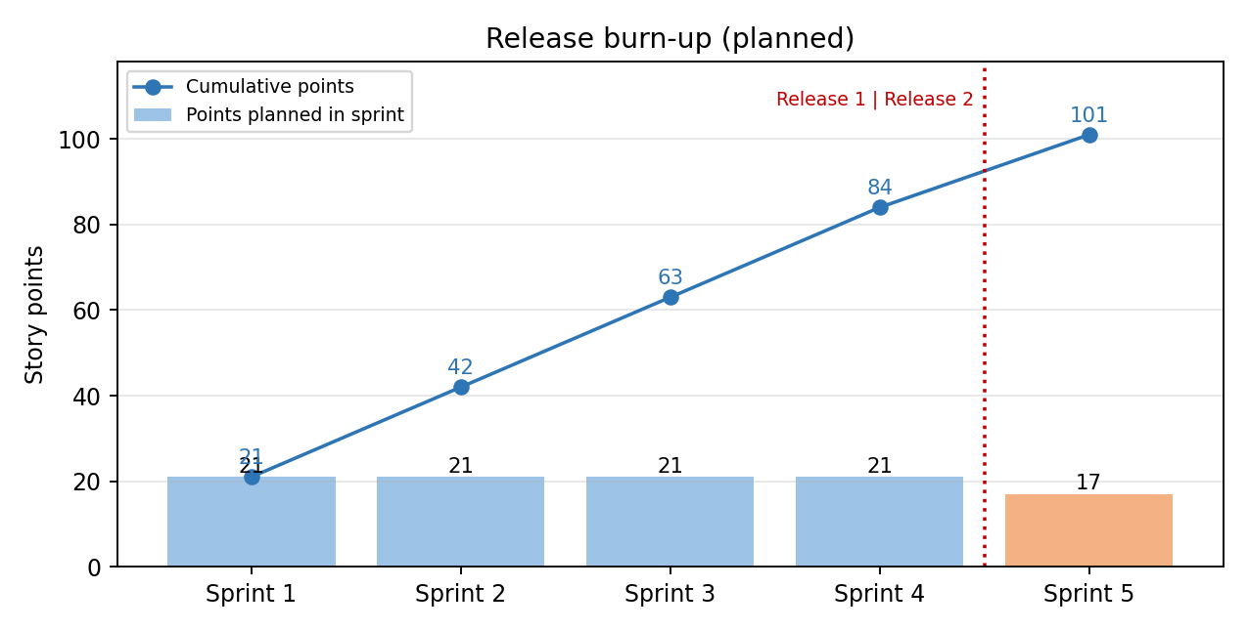
Figure 3.1: Planned release burn-up
Release 1 (MVP), end of Sprint 4, 25 September 2026: 84 points, covering the full instructor authoring flow and the full learner journey. Release 2, end of Sprint 5, 9 October 2026: 17 points, covering reporting, admin approval, profile and password management, and notifications.
Release risks. The payment gateway in US-12 is first built as a simulated gateway to avoid an external dependency. US-09 depends on lesson content from Sprint 2. If velocity falls, US-16 and US-15 are moved out of Release 2 first because they are Could stories.

3.4 Sprint Plan for Sprint 1
Sprint goal: a user can log in with a role, and an Instructor can create, list, search and configure courses.
Selected stories: US-01 (5), US-02 (8) and US-03 (8), a total of 21 points. Capacity: four members x ten days x four productive hours = 160 hours. Commitment: 132 hours, about 82% of capacity, which leaves a buffer for defects, reviews and ceremonies.
Table 3.4: Sprint 1 task breakdown
Task | Story | Description | Est. (h) | Owner
T1 | US-01 | Design users and roles tables | 4 | Dev 1
T2 | US-01 | Registration and login screens | 10 | Dev 1
T3 | US-01 | Role-based access check | 8 | Dev 2
T4 | US-01 | Unit tests for authentication | 6 | Dev 2
T5 | US-02 | Course table and create, read, update, delete logic | 10 | Dev 3
T6 | US-02 | Dashboard with Kanban and List views | 16 | Dev 4
T7 | US-02 | Search by course name | 6 | Dev 3
T8 | US-02 | Quick-create pop-up with plus button | 8 | Dev 4
T9 | US-02 | Edit and Share (copy link) actions | 6 | Dev 3
T10 | US-02 | Tests for dashboard logic | 8 | Dev 3
T11 | US-03 | Course settings form (image, title, tags, description) | 14 | Dev 1
T12 | US-03 | Visibility and access rules (price field for On Payment) | 12 | Dev 2
T13 | US-03 | Publish toggle and Preview | 8 | Dev 4
T14 | US-03 | Add and contact attendees from the header | 8 | Dev 2
T15 | US-03 | Tests for settings rules | 8 | Dev 1
 |  | Total | 132

3.5 Managing the Workload: Executing the Sprint
Board and rules. The Jira board has four columns: To Do, In Progress, In Review/Testing and Done. Each person may have at most two tasks in progress. A task moves to Done only when it meets the Definition of Done. Remaining hours were updated each day before the daily scrum.
Workload balance. Tasks were distributed so that no developer exceeded 40 hours of the 160-hour capacity at planning time.
Table 3.5: Workload per developer in Sprint 1
Developer | Tasks | Planned (h) | Capacity (h) | Load
Dev 1 | T1, T2, T11, T15 | 36 | 40 | 90%
Dev 2 | T3, T4, T12, T14 | 34 | 40 | 85%
Dev 3 | T5, T7, T9, T10 | 30 | 40 | 75%
Dev 4 | T6, T8, T13 | 32 | 40 | 80%

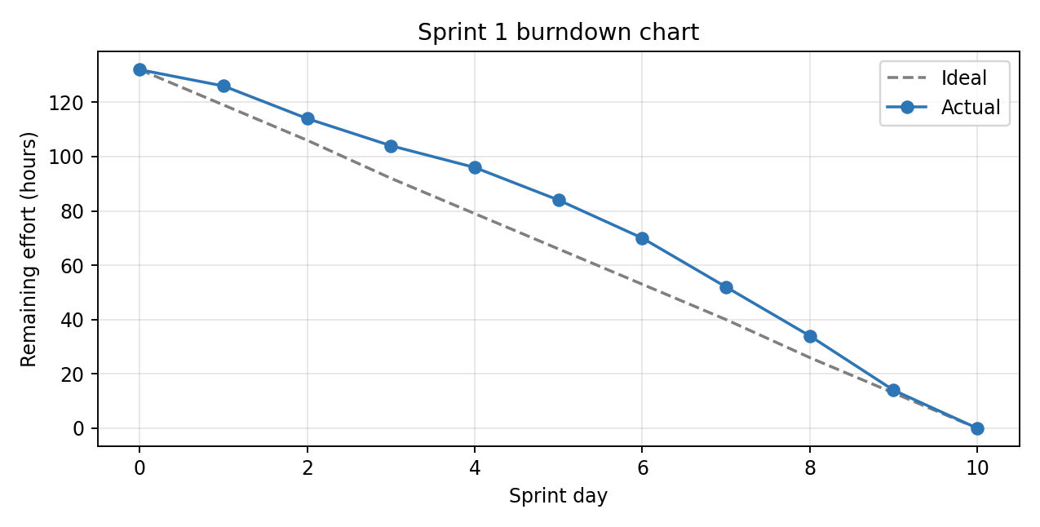
Figure 3.2: Sprint 1 burndown chart (remaining effort in hours)
Observations. Progress lagged behind the ideal line on days 1 to 4 because of MySQL environment set-up and a late decision on the dashboard layout. The team recovered between days 6 and 9 by pairing on the dashboard and the settings form. All 15 tasks reached Done by day 10.
Table 3.6: Impediments and actions
Impediment | Action taken | Resolved
Inconsistent MySQL versions across machines | Scrum Master shared a common set-up script | Day 3
Unclear behaviour of the On Invitation access rule | Product Owner clarified it during backlog refinement | Day 4

3.6 Tracking Progress with Queries
Progress was tracked with Jira's predefined filters (My open issues, Reported by me, Recently viewed, Done issues, Open sprints) and with user-created JQL queries saved as shared filters and shown on the team dashboard together with the burndown chart.
Table 3.7: User-created queries
Query | JQL | Purpose
Sprint 1 scope | project = LS AND sprint = 'Sprint 1' ORDER BY rank | Full sprint backlog in priority order
Open stories | project = LS AND issuetype = Story AND statusCategory != Done | Remaining product backlog
In progress now | project = LS AND sprint in openSprints() AND status = 'In Progress' | Check the WIP limit
Unassigned tasks | project = LS AND sprint in openSprints() AND assignee is EMPTY | Find work nobody owns
High-priority defects | project = LS AND issuetype = Bug AND priority in (High, Highest) AND resolution = Unresolved | Release readiness
Done this sprint | project = LS AND sprint in openSprints() AND statusCategory = Done | Input to review and velocity
Epic progress | project = LS AND parent = LS-1 | Track one epic, for example Course Management
Overdue work | project = LS AND duedate < now() AND statusCategory != Done | Early warning of delays

3.7 Sprint Review Schedule
Table 3.8: Review and retrospective schedule
Sprint | Review (Friday) | Retrospective | Focus of demo
Sprint 1 | 14 Aug 2026, 2:00 to 3:00 pm | 3:15 to 4:00 pm | Login and course management
Sprint 2 | 28 Aug 2026, 2:00 to 3:00 pm | 3:15 to 4:00 pm | Lesson and quiz authoring
Sprint 3 | 11 Sep 2026, 2:00 to 3:00 pm | 3:15 to 4:00 pm | Enrolment and learner dashboard
Sprint 4 | 25 Sep 2026, 2:00 to 4:00 pm | 4:15 to 5:00 pm | Release 1 demonstration
Sprint 5 | 9 Oct 2026, 2:00 to 4:00 pm | 4:15 to 5:00 pm | Release 2 demonstration and project close
Attendees: Product Owner, Scrum Master, Development Team and invited stakeholders. Sprint 1 review agenda:
Time | Item
2:00 (5 min) | Sprint goal and what was committed
2:05 (25 min) | Live demo of each completed story
2:30 (10 min) | Check against the Definition of Done and acceptance criteria
2:40 (10 min) | Stakeholder feedback and backlog changes
2:50 (10 min) | Preview of Sprint 2 and release outlook
Demo script. US-01: register as Instructor, log out, log in, and confirm that a Learner cannot reach the Courses dashboard. US-02: switch between Kanban and List, search by name, create a course with the plus button, copy the share link. US-03: upload an image, set visibility and access rule, enter a price for On Payment, toggle Publish and open Preview. Preparation: demo environment seeded with sample data by day 8; stories shown as accepted only if the Product Owner agrees; all feedback recorded as new backlog items.

3.8 Closing Sprint 1 and Starting Sprint 2

Sprint closure checklist
- Confirm every story meets the Definition of Done. Unfinished items return to the product backlog and are re-estimated (none in Sprint 1).
- Record velocity: 21 points completed against 21 planned.
- Update the burndown and release burn-up charts and complete the sprint in Jira.
- Merge the work and tag the increment in Git (v0.1).
- Hold the retrospective and record action items.
- Refine the backlog using the feedback from the review.

Retrospective outcome
What went well | What to improve | Action for Sprint 2
Pairing on login and dashboard; clear acceptance criteria | Environment set-up delayed the first days | Keep the shared set-up script (Dev 2, 3 hours)
Daily queries gave early warning of delays | Pop-up code was duplicated across screens | Build one reusable pop-up component
Review feedback was specific | Review preparation started late | Seed demo data by day 8

Starting Sprint 2
Item | Plan
Goal | An Instructor can build a course's content: lessons of every type and quizzes with attempt-based points
Stories | US-04 (5), US-05 (8), US-06 (8): 21 points
Capacity | 160 hours, same team, no leave planned
Carry-over | None; retrospective actions are added as tasks
Planning meeting | Monday 17 August 2026, 10:00 am, two hours

4. System Analysis and Design

4.1 Use Case Model
Use cases were derived from the user stories (what each role does) and checked against the SRS use-case example in Appendix G. There are four actors and eighteen use cases.
Table 4.1: Actors
Actor | Type | Role
Learner | Primary | Browses, enrols, studies, takes quizzes, earns points and badges
Instructor | Primary | Creates and manages courses, lessons and quizzes; views reports
Administrator | Primary | Manages users, approves courses, views reports
Payment Gateway | Secondary | Processes payment for On Payment courses
Table 4.2: Use case list
ID | Use case | Actor | Story
UC-01 | Register and log in | Learner, Instructor, Admin | US-01
UC-02 | Browse and search courses | Learner | US-07
UC-03 | Enrol in course | Learner | US-12
UC-04 | Make payment (extends UC-03 for On Payment) | Learner, Payment Gateway | US-12
UC-05 | View course details and reviews | Learner | US-08
UC-06 | Play lesson | Learner | US-09
UC-07 | Take quiz (includes Earn points) | Learner | US-10
UC-08 | Complete course (includes Play lesson) | Learner | US-10
UC-09 | Rate and review course | Learner | US-08
UC-10 | View profile, points and badge | Learner | US-07
UC-11 | Download certificate | Learner | US-13
UC-12 | Manage courses | Instructor, Admin | US-02
UC-13 | Configure course settings | Instructor, Admin | US-03
UC-14 | Manage lessons | Instructor | US-04, US-05
UC-15 | Build quiz | Instructor | US-06
UC-16 | View reports | Instructor, Admin | US-11
UC-17 | Approve or reject course | Admin | US-14
UC-18 | Manage users | Admin | Icebox

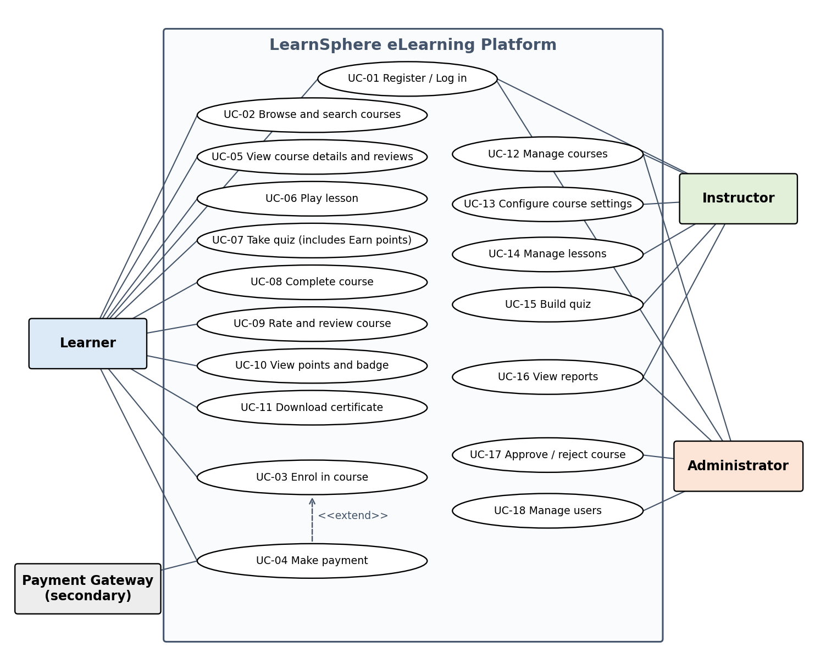
Figure 4.1: Use case diagram of LearnSphere

Use case specifications
Table 4.3: UC-12 and UC-13 Create and configure a course
Field | Description
Actor | Instructor (or Administrator)
Precondition | The actor is logged in with the Instructor or Admin role
Main flow | 1. Open the Courses dashboard.  2. Click the plus button and enter a course title.  3. The system creates the course and opens its settings.  4. The actor adds image, tags and description and chooses visibility and access rule.  5. The actor toggles Publish on website and may open Preview.
Alternate flows | Title is blank: the system rejects the request.  Access rule is On Payment and price is empty: the system asks for a price.
Postcondition | The course is saved and appears on the dashboard, with a Published badge when published
Table 4.4: UC-03 and UC-04 Enrol in a course
Field | Description
Actor | Learner; Payment Gateway (secondary)
Precondition | The learner is logged in and the course is published and visible to the learner
Main flow | 1. The learner opens the course card and clicks Join, Start or Buy according to the access rule.  2. For an Open course the system creates the enrolment at once.  3. The learner sees the course on My Courses with progress 0%.
Alternate flows | On Invitation: the system checks the invitation list and refuses if the learner is not invited.  On Payment: the system sends the price to the Payment Gateway (UC-04); the enrolment is created only after payment succeeds; on failure the learner is told and no enrolment is created.
Postcondition | One enrolment record exists for the learner and course (duplicates are refused)
Table 4.5: UC-07 Take a quiz
Field | Description
Actor | Learner
Precondition | The learner is enrolled and has opened a quiz lesson
Main flow | 1. The system shows one question per page.  2. The learner selects an option and clicks Proceed.  3. After the last question the system calculates the score.  4. The system awards points according to the attempt number and shows the points earned.  5. The badge level is updated if a threshold is reached.
Alternate flow | The learner repeats the quiz: the attempt number increases and fewer points are awarded
Postcondition | The attempt, the points and the badge level are stored

4.2 Business Use Case Model
The business use case model describes what the organisation running LearnSphere does, independent of the software. Its business actors are the Student, the Instructor and the Administrator. Each business use case is supported by one or more of the system use cases above, which keeps business goals and software features traceable.
Table 4.6: Business use cases and their system support
Business actor | Business use case | Supported by system use cases
Instructor | Publish a learning programme | UC-12, UC-13, UC-14, UC-15, UC-17
Student | Enrol in a programme | UC-02, UC-03, UC-04
Student | Study and practise | UC-05, UC-06, UC-07
Student | Receive recognition (points, badge, certificate) | UC-08, UC-10, UC-11
Instructor, Administrator | Monitor learner performance | UC-16
Administrator | Govern the platform and its users | UC-17, UC-18
The main business process runs in six steps: (1) the Instructor prepares and publishes a programme; (2) the Administrator approves it; (3) the Student finds and enrols in it, paying if required; (4) the Student studies the lessons and attempts the quizzes; (5) the institution recognises achievement through points, badges and a certificate; (6) the Instructor and Administrator review participation and completion figures and feed improvements back into step 1.

4.3 Conceptual Classes: Boundary, Controller and Entity
Conceptual classes were found by reading the nouns in the user stories and use cases and classifying them by role. Boundary classes are the screens through which actors interact. Controller classes coordinate a use case and hold its rules. Entity classes hold persistent business data.
Table 4.7: Conceptual classes
Stereotype | Classes
Boundary | LoginPage, CoursesDashboardPage, CourseSettingsPage, LessonEditorPopup, QuizBuilderPage, ReportingDashboardPage, MyCoursesPage, CourseDetailPage, LessonPlayerPage, QuizPage
Controller | AuthController, CourseController, LessonController, QuizController, EnrollmentController, ProgressController, ReviewController, ReportController
Entity | User, Course, Lesson, Attachment, Quiz, Question, Option, RewardRule, Enrollment, QuizAttempt, Review, Badge
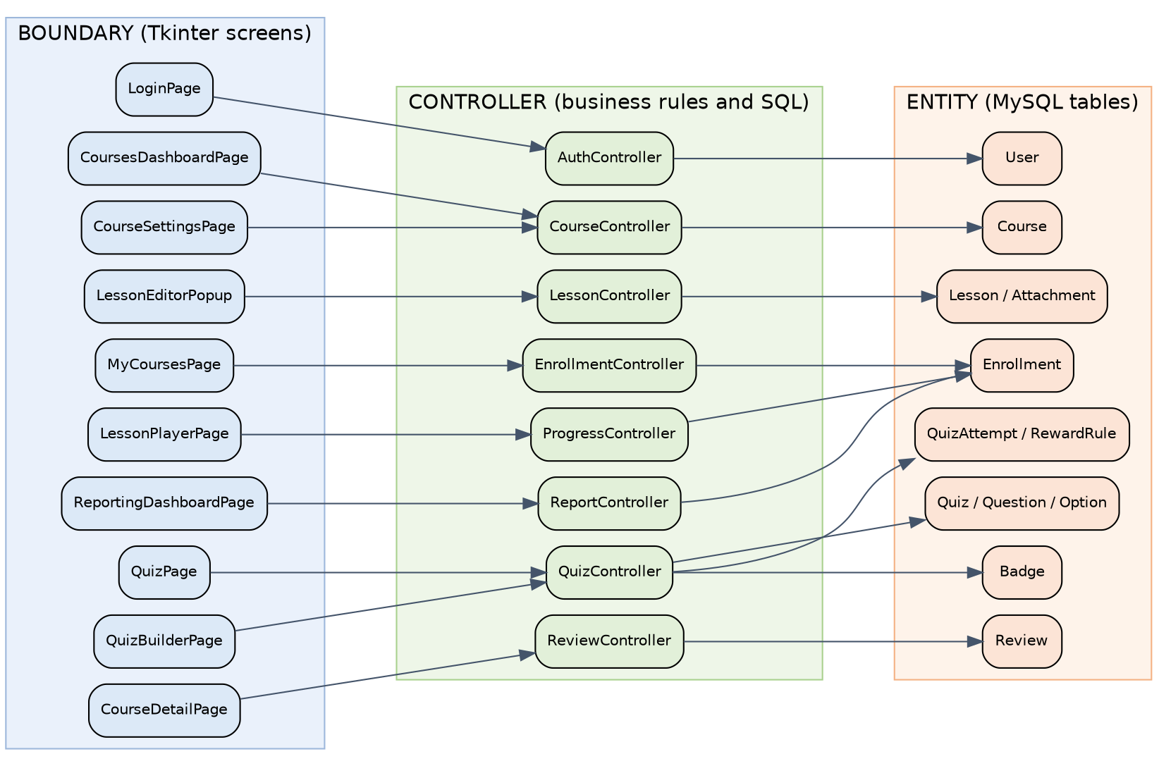
Figure 4.2: Boundary, controller and entity classes and their dependencies
Table 4.8: Controller responsibilities
Controller | Responsibility | Stories
AuthController | Register, authenticate, enforce role-based access | US-01, US-15
CourseController | Create, update, publish, search and share courses; validate settings and price rule | US-02, US-03
LessonController | Add, edit, delete and order lessons and attachments | US-04, US-05
QuizController | Build quizzes; score attempts; apply reward rules by attempt number; update points and badge | US-06, US-10
EnrollmentController | Apply the access rule (Open, On Invitation, On Payment); create enrolments; list My Courses | US-07, US-12
ProgressController | Track lesson completion, compute percentage, mark course complete, issue certificate | US-09, US-10, US-13
ReviewController | Accept and display ratings and reviews | US-08
ReportController | Compute participant counts and the participant table | US-11

4.4 Domain Model: UML Class Diagram
The domain model below shows the entity classes with their main attributes, operations and relationships. Deleting a Course deletes its Lessons, Quizzes and Enrollments (composition). A Badge is not stored per user: the level is derived from the user's total points using the Badge thresholds.
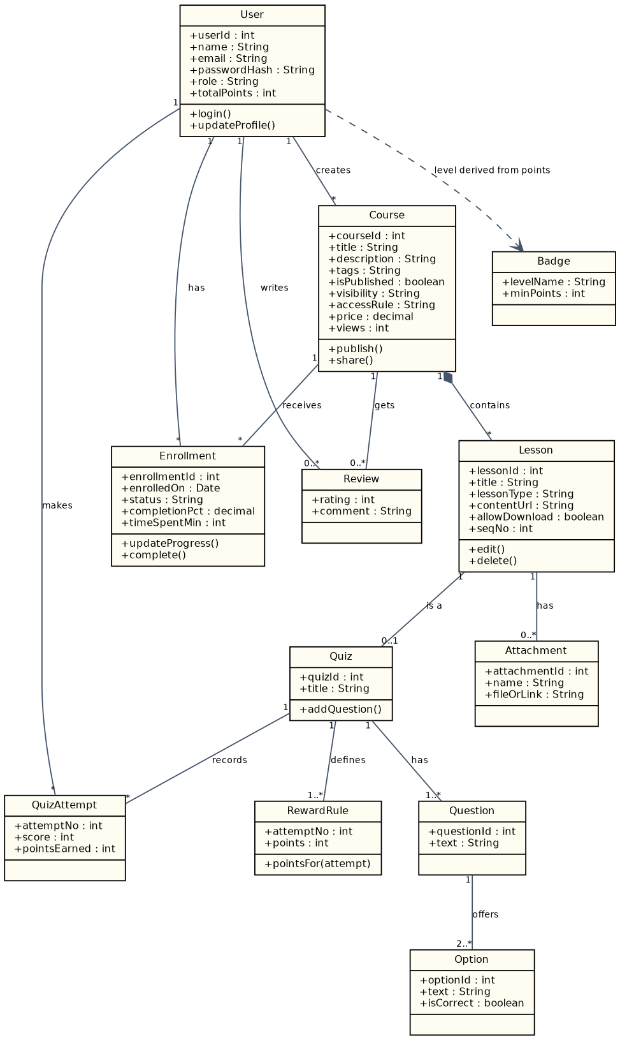
Figure 4.3: UML class diagram of the entity model

4.5 Architecture and Database Design
Architecture. The prototype uses three layers that mirror the class stereotypes: the user interface (boundary), the controllers (business rules and data access) and the MySQL database (entities). Boundaries call only controllers, and controllers are the only code that issues SQL. This isolation is what lets the same controllers be reused behind a Django web front end, as the SRS suggests, with no change to the business rules. The simulated payment gateway sits behind the EnrollmentController so that a real gateway can replace it later.
Database. The class model was mapped to nine tables with primary keys, foreign keys, unique constraints and cascade deletes, which implements the SRS requirement for referential integrity. The complete script is in Appendix B.
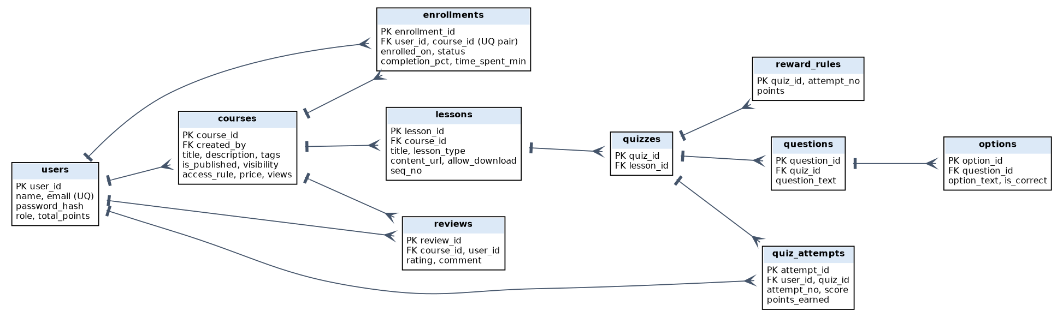
Figure 4.4: Entity-relationship diagram of the MySQL database
Table 4.9: Database tables
Table | Purpose | Key constraints
users | Accounts, roles and total points | Unique email; role is Admin, Instructor or Learner
courses | Course metadata, publication, visibility, access rule, price | Foreign key to creator
lessons | Lessons of a course with type, URL, download flag and order | Cascade delete with course
quizzes, questions, options | Quiz structure with correct options | Cascade delete down the chain
reward_rules | Points awarded for each attempt number of a quiz | Composite key (quiz, attempt)
enrollments | Learner-course link with status, completion and time spent | Unique (user, course) pair
quiz_attempts | Every attempt with score and points earned | Foreign keys to user and quiz
reviews | Rating and comment per course and user | Cascade delete with course

5. Implementation

5.1 Technology Stack
Table 5.1: Technology choices
Layer | Suggested in the SRS | Used in the prototype
User interface | HTML/JS or React, responsive | Python 3 with Tkinter (desktop prototype of the same screens)
Business logic | Django or Node.js, RESTful API | Python controller classes and pure functions (logic module)
Database | PostgreSQL or similar relational database | MySQL 8 through mysql-connector-python
Testing | Acceptance tests per requirement | Python unittest and unittest.mock
Process tools | Not specified | Jira for backlog and queries; Git for source control

5.2 Project Structure
learnsphere/
db.py connection helper
logic.py pure business rules (points, badge, progress)
controllers.py CourseController and the other controllers
ui/dashboard.py Tkinter screens (boundary classes)
schema.sql database script (Appendix B)
tests/
test_units.py unit tests
test_integration.py integration tests (MySQL test database)

5.3 Database Set-up
The database is created from the script in Appendix B. A second database with the same structure, named learnsphere_test, is used by the integration tests so that test data never mixes with real data.
mysql -u root -p < schema.sql
mysql -u root -p -e "CREATE DATABASE learnsphere_test"
mysql -u root -p learnsphere_test < schema_tables_only.sql

5.4 Business Logic
Rules that do not need the database are kept in plain functions. This makes them easy to test and shows the Agile practice of keeping units small. The reward rule gives points by attempt number (first try 10, second 7, third 5, fourth 2; later attempts keep the last value), and the badge level follows the learner's total points.
# logic.py
RULES = {1: 10, 2: 7, 3: 5, 4: 2} # points by attempt number
BADGES = [(100, 'Master'), (20, 'Explorer'), (0, 'Newbie')]

def points_for_attempt(attempt_no, rules=RULES):
if attempt_no < 1:
raise ValueError('attempt_no must be >= 1')
return rules.get(attempt_no, rules[max(rules)])

def badge_for_points(points):
for threshold, name in BADGES:
if points >= threshold:
return name

def completion_pct(done, total):
return round(100 * done / total, 2) if total else 0.0

5.5 Controller and Data Access
The CourseController enforces the settings rules from US-03 (a title is required; an On Payment course must have a price) before it touches the database, and uses parameterised SQL to prevent injection, as required by the SRS.
# db.py
import mysql.connector

def get_connection(database='learnsphere'):
return mysql.connector.connect(host='localhost', user='root',
password='your_password', database=database)

# controllers.py
class CourseController:
def __init__(self, conn):
self.conn = conn

def create_course(self, title, created_by, access_rule='OPEN', price=0):
if not title.strip():
raise ValueError('Title is required')
if access_rule == 'PAYMENT' and price <= 0:
raise ValueError('Price is required for paid courses')
cur = self.conn.cursor()
cur.execute('INSERT INTO courses (title, created_by, access_rule, price) '
'VALUES (%s, %s, %s, %s)',
(title.strip(), created_by, access_rule, price))
self.conn.commit()
return cur.lastrowid

def search_by_name(self, text):
cur = self.conn.cursor(dictionary=True)
cur.execute('SELECT * FROM courses WHERE title LIKE %s', (f'%{text}%',))
return cur.fetchall()

5.6 User Interface
Each boundary class is a Tkinter window or pop-up that calls only its controller. The table lists the screens and the stories they implement; the courses dashboard code follows.
Table 5.2: Screens
Screen | Story | Controller | Main widgets
LoginPage | US-01 | AuthController | Email and password entries, Login and Register buttons
CoursesDashboardPage | US-02 | CourseController | Search box, course list (List view), plus button, Edit and Share buttons
CourseSettingsPage | US-03 | CourseController | Title, tags, description, image chooser, visibility and access-rule drop-downs, price entry, Publish toggle
LessonEditorPopup | US-04, US-05 | LessonController | Type selector, URL or file chooser, Allow Download check box, description, resources
QuizBuilderPage | US-06 | QuizController | Question list, option entries with correct marker, reward table by attempt
MyCoursesPage | US-07 | EnrollmentController | Profile panel (points, badge), course cards with Join, Start, Continue or Buy
CourseDetailPage | US-08 | ReviewController | Overview, progress bar, lesson status list, ratings and reviews
LessonPlayerPage | US-09 | ProgressController | Viewer area, collapsible sidebar, Back and Next Content buttons
QuizPage | US-10 | QuizController | One question per page, Proceed button, points pop-up
ReportingDashboardPage | US-11 | ReportController | Four overview cards, participant table

import tkinter as tk
from tkinter import ttk, simpledialog, messagebox

class CoursesDashboard(tk.Tk):
def __init__(self, ctrl, user_id):
super().__init__()
self.title('LearnSphere - Courses')
self.ctrl, self.user_id = ctrl, user_id
bar = ttk.Frame(self); bar.pack(fill='x', padx=8, pady=8)
self.q = tk.StringVar()
ttk.Entry(bar, textvariable=self.q).pack(side='left', fill='x', expand=True)
ttk.Button(bar, text='Search', command=self.refresh).pack(side='left', padx=4)
ttk.Button(bar, text='+', width=3, command=self.new_course).pack(side='left')
cols = ('title', 'access', 'published')
self.tree = ttk.Treeview(self, columns=cols, show='headings')
for c in cols:
self.tree.heading(c, text=c.title())
self.tree.pack(fill='both', expand=True, padx=8, pady=(0, 8))
self.refresh()

def refresh(self):
self.tree.delete(*self.tree.get_children())
for c in self.ctrl.search_by_name(self.q.get()):
self.tree.insert('', 'end', values=(c['title'], c['access_rule'],
'Yes' if c['is_published'] else 'No'))

def new_course(self):
title = simpledialog.askstring('New course', 'Course title:')
if title:
try:
self.ctrl.create_course(title, self.user_id)
self.refresh()
except ValueError as err:
messagebox.showerror('Invalid input', str(err))

6. Testing

6.1 Test Strategy
Testing follows the Definition of Done: no story is accepted until its unit tests pass. Unit tests check one function or class at a time and replace the database with a mock object, so they are fast and can run on every commit. Integration tests run the controllers against a real MySQL test database (learnsphere_test) and check that the code, the SQL and the constraints work together. Acceptance criteria from the user stories are checked manually during the sprint review demo.

6.2 Unit Testing
Table 6.1: Unit test cases and results
ID | Scenario | Expected result | Result
TC-U01 | points_for_attempt(1) | 10 points | Pass
TC-U02 | points_for_attempt(2) | 7 points | Pass
TC-U03 | points_for_attempt(9), beyond the defined rules | 2 points (last rule applies) | Pass
TC-U04 | points_for_attempt(0) | ValueError | Pass
TC-U05 | badge_for_points(0), (25) and (120) | Newbie, Explorer, Master | Pass
TC-U06 | completion_pct(3, 4) | 75.0 | Pass
TC-U07 | create_course with a blank title | ValueError and no database call | Pass
TC-U08 | create_course, access rule PAYMENT, price 0 | ValueError | Pass
TC-U09 | create_course with valid data | INSERT executed and committed once | Pass
The nine tests were executed with `python -m unittest` and all passed (Ran 9 tests, OK).
# tests/test_units.py (extract)
import unittest
from unittest.mock import MagicMock
from logic import points_for_attempt, badge_for_points, completion_pct
from controllers import CourseController

class LogicTests(unittest.TestCase):
def test_second_attempt_points(self):
self.assertEqual(points_for_attempt(2), 7)

def test_invalid_attempt(self):
with self.assertRaises(ValueError):
points_for_attempt(0)

def test_badges(self):
self.assertEqual(badge_for_points(25), 'Explorer')
self.assertEqual(badge_for_points(120), 'Master')

class CourseControllerTests(unittest.TestCase):
def setUp(self):
self.conn = MagicMock()
self.ctrl = CourseController(self.conn)

def test_blank_title_rejected(self):
with self.assertRaises(ValueError):
self.ctrl.create_course(' ', created_by=1)
self.conn.cursor.assert_not_called()

def test_paid_course_needs_price(self):
with self.assertRaises(ValueError):
self.ctrl.create_course('Python', 1, 'PAYMENT', 0)

6.3 Integration Testing
Table 6.2: Integration test cases
ID | Scenario | Expected result | Status
TC-I01 | Create a course, then search by part of its name in lower case | The course is returned (case-insensitive search) | Ready
TC-I02 | Create an On Payment course with price 499 | Price and access rule are stored correctly | Ready
TC-I03 | Create a course for a user that does not exist | IntegrityError from the foreign key | Ready
TC-I04 | Enrol the same learner twice in one course | Second insert is rejected by the unique key | Ready
TC-I05 | Delete a course that has a lesson | The lesson is removed by cascade | Ready
The suite is run with `python -m unittest discover -s tests` after the learnsphere_test database has been created from the script in Appendix B. It was designed to run against a MySQL server; its status will change from Ready to Pass or Fail when it is executed on the project database.
# tests/test_integration.py
import unittest
import mysql.connector
from db import get_connection
from controllers import CourseController

class CourseFlowIntegration(unittest.TestCase):
@classmethod
def setUpClass(cls):
cls.conn = get_connection('learnsphere_test')
cls.ctrl = CourseController(cls.conn)

def setUp(self):
cur = self.conn.cursor()
cur.execute('DELETE FROM enrollments')
cur.execute('DELETE FROM courses')
cur.execute("INSERT IGNORE INTO users (user_id, name, email, password_hash, role) "
"VALUES (1, 'Instructor', 'i@example.com', 'x', 'INSTRUCTOR'), "
"(2, 'Learner', 'l@example.com', 'x', 'LEARNER')")
self.conn.commit()

def test_created_course_is_searchable(self):
self.ctrl.create_course('Agile Basics', created_by=1)
titles = [c['title'] for c in self.ctrl.search_by_name('agile')]
self.assertIn('Agile Basics', titles)

def test_paid_course_price_is_stored(self):
cid = self.ctrl.create_course('Paid Course', 1, 'PAYMENT', 499)
cur = self.conn.cursor(dictionary=True)
cur.execute('SELECT price, access_rule FROM courses WHERE course_id = %s', (cid,))
row = cur.fetchone()
self.assertEqual(float(row['price']), 499.0)
self.assertEqual(row['access_rule'], 'PAYMENT')

def test_unknown_creator_rejected(self):
with self.assertRaises(mysql.connector.IntegrityError):
self.ctrl.create_course('Orphan', created_by=999)

def test_duplicate_enrolment_rejected(self):
cid = self.ctrl.create_course('Agile Basics', 1)
sql = ('INSERT INTO enrollments (user_id, course_id, enrolled_on) '
'VALUES (%s, %s, CURDATE())')
cur = self.conn.cursor()
cur.execute(sql, (2, cid)); self.conn.commit()
with self.assertRaises(mysql.connector.IntegrityError):
cur.execute(sql, (2, cid))

def test_deleting_course_removes_lessons(self):
cid = self.ctrl.create_course('Temp', 1)
cur = self.conn.cursor()
cur.execute("INSERT INTO lessons (course_id, title, lesson_type) "
"VALUES (%s, 'L1', 'VIDEO')", (cid,))
cur.execute('DELETE FROM courses WHERE course_id = %s', (cid,))
self.conn.commit()
cur.execute('SELECT COUNT(*) FROM lessons WHERE course_id = %s', (cid,))
self.assertEqual(cur.fetchone()[0], 0)

6.4 Traceability from Stories to Tests
Table 6.3: Traceability of stories, requirements and tests
Story | SRS requirement | Test cases | Acceptance check at review
US-01 | FR-UC-001, 002 | Authentication unit tests (T4) | Learner cannot reach instructor screens
US-02 | FR-CM-001 | TC-U07, TC-I01 | Search, create, share link on dashboard
US-03 | FR-CM-001 | TC-U08, TC-I02, TC-I03 | Access rule and price behave as specified
US-06 | FR-AF-001 | Reward rule tests TC-U01 to U04 | Points configured per attempt
US-10 | FR-AF-002, FR-LA-001 | TC-U01 to U06 | Points pop-up, badge change, completion
US-12 | FR-EP-001, 002 | TC-I04 | Enrolment by access rule; no duplicates

6.5 Defect Management
Defects found during testing or at a review are logged as Bug issues in Jira with a priority. The saved query High-priority defects (Table 3.7) lists unresolved High and Highest bugs, and a story cannot be marked Done while one is open against it. This links testing directly to the Definition of Done.

7. Results and Discussion

7.1 Coverage of the Requirements
All ten user stories of the User Story document are covered by backlog items US-02 to US-11. Of the 28 SRS functional requirements, 18 are covered by backlog stories (three of them partly, as noted in Appendix A) and 10 are consciously deferred with a reason. No High-priority requirement was left unaddressed without an explicit decision.
Table 7.1: Coverage of SRS functional requirements
Group | Total | Covered | Deferred | Deferred items
User account and authentication | 4 | 4 | 0 | None
Course and content management | 7 | 5 | 2 | FR-CM-004, FR-CM-005
Enrolment and payments | 5 | 2 | 3 | FR-EP-003, 004, 005
Learning activities | 3 | 2 | 1 | FR-LA-003
Assessments and feedback | 3 | 3 | 0 | None
Social and community | 2 | 0 | 2 | FR-SC-001, 002
Administrative features | 4 | 2 | 2 | FR-AD-002, 004
Total | 28 | 18 | 10

7.2 Delivery Outcome
Sprint 1 delivered all 21 committed points and 15 of 15 tasks, which gave a first measured velocity equal to the planning figure and therefore confirmed the release plan. Burndown tracking showed an early lag caused by environment set-up, and the retrospective turned that observation into concrete actions for Sprint 2. The release plan places 84 of 101 points (83%) in Release 1, so the platform reaches a usable state before the lower-priority items are started.

7.3 Discussion
- Analysis paid off. Comparing the two documents before planning exposed ten divergences. Resolving them in the backlog avoided later rework, which was the main risk (R5) in the SRS itself.
- Small stories made estimation reliable. Stories of 3 to 8 points could be planned at task level in hours, which is what made the Sprint 1 burndown meaningful.
- Layering made testing cheap. Because rules sit in pure functions and controllers, nine unit tests run in milliseconds without a database, while the integration suite is reserved for what only a real database can prove.
- Process feedback was acted on. Each retrospective action became a task in the next sprint, so improvement was built into the plan.

7.4 Limitations
The prototype is a desktop application and not the responsive web platform the SRS describes. Payment is simulated. Performance, accessibility, security hardening, localisation and data-protection features are specified but not verified. Velocity and effort figures are planning and tracking values from a small team and should be recalibrated as real sprint data accumulates. The integration suite has been written but needs to be run against the MySQL test database.

8. Conclusion and Future Enhancements
This project applied Agile methods to LearnSphere from requirements to tested code. Analysing the SRS and the user stories together produced a single prioritised backlog of 16 stories (101 points), with every divergence between the documents resolved and recorded. Release and sprint plans, workload management, query-based tracking, review scheduling and sprint closure turned the backlog into an executable plan. Use case, business use case and domain models gave a clear boundary, controller and entity structure, which was carried through to a Python and MySQL implementation verified by unit and integration tests.
The main lessons are that early, explicit reconciliation of requirement sources prevents rework; that small estimated stories make planning predictable; that daily queries and burndown charts expose delays early; and that retrospective actions measurably improve the next sprint.

Future enhancements
- Move the front end to a responsive web interface (Django and React) on top of the existing controllers, as suggested by the SRS.
- Introduce the Parts and Modules hierarchy, free-preview module, watermarking and non-downloadable video streaming.
- Integrate a PCI-compliant payment gateway with commission split and transaction history.
- Add platform analytics, user search, global settings, favourites, social sharing and the discussion forum.
- Add short-answer questions, French localisation, multi-factor authentication, GDPR export and deletion, and complete load and accessibility testing.

References
- Software Requirements Specification for LearnSphere (E-Learning Platform), Version 1.0, Department of Computer Science and Engineering, Kongu Engineering College, July 2026.
- LearnSphere eLearning Platform: Epic, User Story and Acceptance Criteria document.
- ISO/IEC/IEEE 29148:2018, Systems and software engineering: Life cycle processes: Requirements engineering.
- Schwaber, K. and Sutherland, J., The Scrum Guide.
- Cohn, M., User Stories Applied: For Agile Software Development, Addison-Wesley.
- Cohn, M., Agile Estimating and Planning, Prentice Hall.
- Jacobson, I., Booch, G. and Rumbaugh, J., The Unified Software Development Process, Addison-Wesley.
- Atlassian, Jira Software documentation: Scrum boards, reports and JQL.
- Python Software Foundation, documentation for Tkinter, unittest and unittest.mock.
- Oracle, MySQL 8.0 Reference Manual, and MySQL Connector/Python Developer Guide.

Appendix A: Traceability of SRS Functional Requirements
Every SRS functional requirement is traced to a backlog story or to an explicit deferral. "Partly" means the story covers the main behaviour but not every clause of the requirement.
ID | Priority | Requirement (abridged) | Story | Status
FR-UC-001 | High | Register as Learner or Instructor (email or OAuth) | US-01 | Covered (email only; OAuth deferred)
FR-UC-002 | High | Role-based access | US-01 | Covered
FR-UC-003 | Medium | Password reset by email | US-15 | Covered (Release 2)
FR-UC-004 | Low | Profile update | US-15 | Covered (Release 2)
FR-CM-001 | High | Create course with metadata, price | US-02, US-03 | Covered
FR-CM-002 | High | Parts, Modules and Lessons | US-04 | Partly (flat lessons)
FR-CM-003 | High | Rich lesson content and uploaders | US-05 | Covered
FR-CM-004 | High | First module free | - | Deferred (icebox)
FR-CM-005 | High | Automatic watermark | - | Deferred (icebox)
FR-CM-006 | High | No video download | US-09 | Covered (video by URL only)
FR-CM-007 | Medium | Ordering of lessons | US-04 | Covered (sequence number)
FR-EP-001 | High | Enrol in free courses | US-12 | Covered
FR-EP-002 | High | Paid enrolment with commission split | US-12 | Partly (simulated gateway)
FR-EP-003 | High | Payment options by country | - | Deferred (icebox)
FR-EP-004 | High | PCI-DSS compliance | - | Deferred (no card data stored in prototype)
FR-EP-005 | Medium | Transaction and enrolment history | - | Deferred (icebox)
FR-LA-001 | High | Progress percentage | US-08, US-10 | Covered
FR-LA-002 | High | PDF certificate | US-13 | Covered
FR-LA-003 | Medium | Favourites | - | Deferred (icebox)
FR-AF-001 | High | Create quizzes | US-06 | Covered (multiple-choice)
FR-AF-002 | High | Instant score and answers | US-10 | Covered
FR-AF-003 | Medium | Ratings and reviews | US-08 | Covered
FR-SC-001 | Low | Social sharing | - | Deferred (icebox)
FR-SC-002 | Low | Discussion forum | - | Deferred (icebox)
FR-AD-001 | High | Admin approval of courses | US-14 | Covered (Release 2)
FR-AD-002 | High | Admin user search and filter | - | Deferred (icebox)
FR-AD-003 | Medium | Admin analytics dashboard | US-11 | Partly (course-level)
FR-AD-004 | Low | Global settings | - | Deferred (icebox)

Appendix B: MySQL Database Script
CREATE DATABASE learnsphere;
USE learnsphere;

CREATE TABLE users (
user_id INT AUTO_INCREMENT PRIMARY KEY,
name VARCHAR(100) NOT NULL,
email VARCHAR(120) NOT NULL UNIQUE,
password_hash VARCHAR(255) NOT NULL,
role ENUM('ADMIN','INSTRUCTOR','LEARNER') NOT NULL,
total_points INT DEFAULT 0
);
CREATE TABLE courses (
course_id INT AUTO_INCREMENT PRIMARY KEY,
title VARCHAR(150) NOT NULL,
description TEXT, tags VARCHAR(255), image_url VARCHAR(255),
is_published BOOLEAN DEFAULT FALSE,
visibility ENUM('EVERYONE','SIGNED_IN') DEFAULT 'EVERYONE',
access_rule ENUM('OPEN','INVITATION','PAYMENT') DEFAULT 'OPEN',
price DECIMAL(8,2) DEFAULT 0,
views INT DEFAULT 0,
created_by INT NOT NULL,
FOREIGN KEY (created_by) REFERENCES users(user_id)
);
CREATE TABLE lessons (
lesson_id INT AUTO_INCREMENT PRIMARY KEY,
course_id INT NOT NULL,
title VARCHAR(150) NOT NULL,
lesson_type ENUM('VIDEO','DOCUMENT','IMAGE','QUIZ') NOT NULL,
content_url VARCHAR(255), allow_download BOOLEAN DEFAULT FALSE,
description TEXT, seq_no INT,
FOREIGN KEY (course_id) REFERENCES courses(course_id) ON DELETE CASCADE
);
CREATE TABLE quizzes (
quiz_id INT AUTO_INCREMENT PRIMARY KEY, lesson_id INT NOT NULL,
FOREIGN KEY (lesson_id) REFERENCES lessons(lesson_id) ON DELETE CASCADE
);
CREATE TABLE questions (
question_id INT AUTO_INCREMENT PRIMARY KEY, quiz_id INT NOT NULL,
question_text VARCHAR(500) NOT NULL,
FOREIGN KEY (quiz_id) REFERENCES quizzes(quiz_id) ON DELETE CASCADE
);
CREATE TABLE options (
option_id INT AUTO_INCREMENT PRIMARY KEY, question_id INT NOT NULL,
option_text VARCHAR(255) NOT NULL, is_correct BOOLEAN DEFAULT FALSE,
FOREIGN KEY (question_id) REFERENCES questions(question_id) ON DELETE CASCADE
);
CREATE TABLE reward_rules (
quiz_id INT, attempt_no INT, points INT NOT NULL,
PRIMARY KEY (quiz_id, attempt_no),
FOREIGN KEY (quiz_id) REFERENCES quizzes(quiz_id) ON DELETE CASCADE
);
CREATE TABLE enrollments (
enrollment_id INT AUTO_INCREMENT PRIMARY KEY,
user_id INT NOT NULL, course_id INT NOT NULL,
enrolled_on DATE NOT NULL,
status ENUM('NOT_STARTED','IN_PROGRESS','COMPLETED') DEFAULT 'NOT_STARTED',
completion_pct DECIMAL(5,2) DEFAULT 0, time_spent_min INT DEFAULT 0,
UNIQUE (user_id, course_id),
FOREIGN KEY (user_id) REFERENCES users(user_id),
FOREIGN KEY (course_id) REFERENCES courses(course_id) ON DELETE CASCADE
);
CREATE TABLE quiz_attempts (
attempt_id INT AUTO_INCREMENT PRIMARY KEY,
user_id INT NOT NULL, quiz_id INT NOT NULL,
attempt_no INT NOT NULL, score INT, points_earned INT,
FOREIGN KEY (user_id) REFERENCES users(user_id),
FOREIGN KEY (quiz_id) REFERENCES quizzes(quiz_id) ON DELETE CASCADE
);
CREATE TABLE reviews (
review_id INT AUTO_INCREMENT PRIMARY KEY,
course_id INT NOT NULL, user_id INT NOT NULL,
rating TINYINT NOT NULL, comment VARCHAR(500),
FOREIGN KEY (course_id) REFERENCES courses(course_id) ON DELETE CASCADE,
FOREIGN KEY (user_id) REFERENCES users(user_id)
);

