KONGU ENGINEERING COLLEGE
DEPARTMENT OF COMPUTER SCIENCE AND ENGINEERING
JIRA SCRUM LAB
DETAILED REPORT OF EXPERIMENTS 1–10
Using the Alumnex Connect Scrum Project in Jira
━━━━━━━━━━━━━━━━━━━━━━━━━━━━━━━━━━━━━━━━━━━━━━━━
Submitted by: Sriman Kumar V
Register number: 24CSR301
Department: Computer Science and Engineering
Institution: Kongu Engineering College, Perundurai
Project: Alumnex Connect
Jira project: ACS — Alumnex Connect - Scrum
Academic year: 2026–2027
Report snapshot date: 14 October 2026
Prepared from Jira issue exports, sprint/release metadata, repository source review and recorded test output.

Document Control
Field | Value
Report title | Detailed Report of Jira Scrum Experiments 1–10
Jira project | ACS — Alumnex Connect - Scrum (project ID 10033)
Jira board | ACS board (board ID 34)
Evidence snapshot | 14 October 2026; current live state may change after the snapshot
Primary repository | https://github.com/SrimanKumarV/FSD/tree/master/alumni-connect-website-main
Live application entry point | https://alumnex-connect.onrender.com
Backend health endpoint configured in source | https://alumnex-backend-9y5t.onrender.com/api/health
Report scope | All ten faculty experiment topics, Jira evidence, source mapping, test results, limitations and export appendix
Evidence format | Structured Jira issue/JQL/sprint/version exports and embedded model diagrams; the report does not mislabel exported tables as browser screenshots

Executive Summary
This report documents the ten Jira Scrum experiments using the separate ACS project created for the Alumnex Connect lab. The report was prepared from current Jira issue records and JQL counts, sprint and release-version metadata, a study of the public GitHub repository, the deployment metadata available through Render, the recorded Python/MySQL lab test log, and the Alumnex-specific use-case/domain diagrams.
The Jira snapshot contains 46 issues: 4 Epics, 10 experiment Tasks, 15 product Stories and 17 Subtasks. At the snapshot, 19 issues are Done, 6 are In Progress and 21 are To Do. The ten experiment tasks are split between seven Done (Experiments 1–7) and three In Progress (Experiments 8–10). The master portfolio Epic, ACS-28, remains In Progress.
The product backlog now represents Alumnex Connect itself: a React frontend, Node.js/Express API, MongoDB/Mongoose persistence, Socket.IO/Redis real-time communication, AI career routes and a Capacitor Android wrapper. The 15 planned product Stories total 71 proposed points. These point values are educational planning estimates; they are not measured team velocity, and story status does not imply a feature has shipped.
Important scope distinction
The faculty Experiment 10 asks for a Python UI and MySQL database. The existing Alumnex Connect project is React / Node.js / Express / MongoDB. A separate Python/MySQL registration/login lab has been prepared to address the coursework requirement without falsely claiming that Python/MySQL is the production Alumnex stack.

The following external evidence items remain open: a successful real-MySQL run, a live interactive smoke test of the deployed demo, native saved JQL filters, and the final attachment of rendered UML files inside Jira. The report marks these clearly rather than asserting unverified completion.

Contents
- 1. Introduction and Evidence Method
- 2. Project and Jira Environment
- 3. Experiment 1 — Product Backlog with Stories
- 4. Experiment 2 — Release Plan
- 5. Experiment 3 — Sprint Planning
- 6. Experiment 4 — Execute the Sprint and Manage Workload
- 7. Experiment 5 — JQL Queries and Project Tracking
- 8. Experiment 6 — Sprint Review Schedule
- 9. Experiment 7 — Close Sprint 1 and Start the Next Sprint
- 10. Experiment 8 — Business Use Cases and Use-Case Model
- 11. Experiment 9 — Boundary/Control/Entity Roles and UML Domain Model
- 12. Experiment 10 — Python UI, MySQL, Unit and Integration Testing
- 13. Overall Results and Remaining Work
- Appendix A — Jira Export Summary
- Appendix B — Complete Jira Issue Export
- Appendix C — JQL Definitions and Results
- Appendix D — Source and Evidence Links

1. Introduction and Evidence Method

1.1 Objectives
- Perform and document the ten faculty-prescribed experiments using Jira Scrum capabilities and a separate ACS project.
- Build a product backlog with epics, user stories, acceptance criteria, priority and proposed story-point estimates grounded in Alumnex Connect modules.
- Configure releases, execute sprint lifecycle operations, record planning/review/retrospective evidence and show practical JQL query examples.
- Develop Alumnex-specific use-case and conceptual domain models based on repository source files and actual application modules.
- Document the separate Python/MySQL coursework lab and its actual test results, identifying the live database test that remains pending.

1.2 Source and evidence method
The Jira issue inventory and JQL results were read from the connected Atlassian site on 14 October 2026. Direct browse links are given for each experiment record. Project sprint data and release version data were read separately because issue search alone does not prove sprint or version lifecycle state. The repository was studied through the GitHub connector, including README, backend routes/models/services, frontend route map and workflow/test files. Render service metadata was used only as deployment-state evidence; it was not treated as proof of interactive functionality.
This report uses three kinds of evidence: (1) Jira configuration/record evidence, (2) source-code and test-file evidence, and (3) executed test output from the separate Python lab. The categories are not interchangeable. For example, the presence of a route in source is not proof that the corresponding external OAuth, push or calendar integration works against production services.

1.3 Status terminology
Term | Meaning in this report
Jira task Done | The Jira documentation/configuration exercise was recorded as completed. It does not imply every Alumnex feature is implemented or production-tested.
In Progress | The Jira experiment record is materially prepared but a stated evidence or practical step remains.
To Do | A planned or external verification step has not been performed.
Verified count | A count returned from a JQL query at the stated snapshot time; counts can change later.
Proposed story points | Planning estimates for the lab backlog; not completed effort or historical velocity.
Live / deployed | Deployment metadata reports a service/deploy live; this does not prove a successful browser-based user journey.

2. Project and Jira Environment

2.1 Jira project configuration
Property | Exported value
Site | https://srimankumar06.atlassian.net
Project name | Alumnex Connect - Scrum
Project key | ACS
Project ID | 10033
Board | ACS board; board ID 34
Portfolio Epic | ACS-28 — Alumnex Connect — Scrum Lab Experiments 1–10
Total issues | 46
Product Stories | 15
Planned product Story points | 71
Existing KAN project | Separate Kanban project; not used for this Scrum experiment set

2.2 Actual Alumnex Connect technology and capability areas
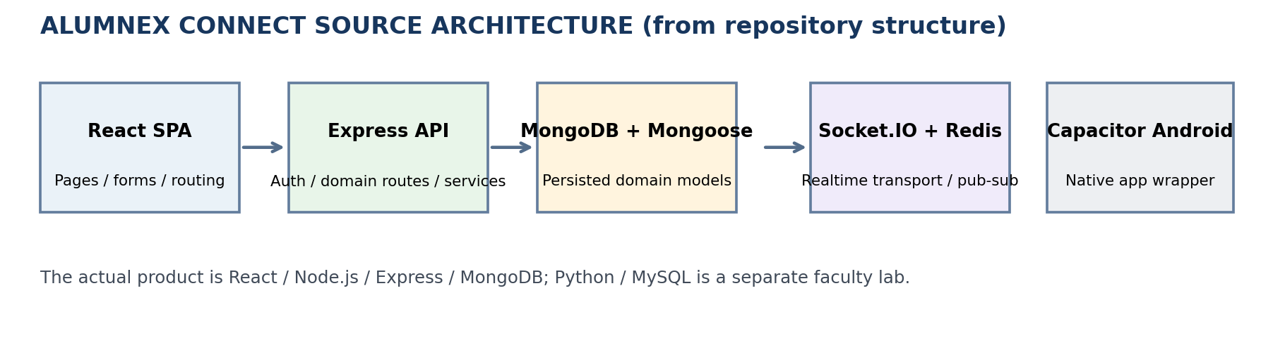
Figure 1. Source-derived architecture overview for Alumnex Connect. This is a report diagram based on repository structure, not a screenshot of the live running application.
The repository represents a multi-module alumni/student ecosystem rather than a simple student records application. The backend mounts route modules for authentication, users, mentorship, jobs, events, forum, contests, messages, admin, notifications, developer activity, leaderboards, projects, institutions, tasks, AI, Tech Hub, business, Activity Hub and Google Calendar. Mongoose models represent persisted entities; the React frontend routes correspond to user-facing pages; the backend has Jest/Supertest tests and the GitHub workflow defines backend tests, a frontend build, and Playwright smoke tests.
Capability | Representative source evidence | Backlog mapping
Identity & profile | backend/routes/auth.js, users.js; backend/models/User.js | ACS-1; ACS-12, ACS-13, ACS-37
Mentorship & career | backend/routes/mentorship.js; services/mentorshipService.js; routes/jobs.js | ACS-2; ACS-14, ACS-15, ACS-17, ACS-43
Developer intelligence | frontend/src/pages/DevPulse.js, ActivityHub.js; routes/devActivity.js, activity.js | ACS-3; ACS-16
Messaging & notifications | routes/messages.js, notifications.js; Socket.IO handler; Redis adapter setup | ACS-3; ACS-18
Events & calendar | routes/events.js, googleCalendar.js; GoogleCalendarConnection/Event models | ACS-3; ACS-19
Community / projects / contests | routes/forum.js, tech-hub.js, projects.js, contests.js, leaderboard.js | ACS-3; ACS-39, ACS-40, ACS-41
Mobile / push | Capacitor dependencies, .github/workflows/build-apk.yml, FCM service | ACS-3; ACS-42
Governance | routes/admin.js; auth middleware; incident/report models | ACS-1; ACS-38

2.3 Repository and deployment evidence
Repository root | README | Backend server | Frontend route map | CI workflow | Live demo | Backend health
Render service metadata reported the frontend and backend deployments as live from a commit dated 11 October 2026; GitHub check-runs for that deployment commit showed the Android build job completed successfully, while a separate Cloudflare Pages check failed. Direct interactive access to the live demo could not be retrieved from the report-generation runtime due to a DNS/cache fetch failure. Therefore, this report does not claim that every page or external integration was manually exercised.

3. Experiment 1 — Create a Product Backlog with Stories
Jira record: ACS-4 — Experiment 1: Product Backlog and Story Refinement. Status in the exported Jira snapshot: Done. The experiment created a source-grounded product backlog in project ACS and linked the ten-experiment portfolio under ACS-28.

3.1 Objective and approach
The goal was to define a backlog representing the working product domain shown in the repository. A generic course/enrolment/examination backlog would not match Alumnex Connect, so the backlog was reorganised into identity/profile/governance; mentorship/career; and developer-intelligence/community capabilities. Each Story is written from a user perspective and includes testable acceptance criteria, priority, a parent Epic, release grouping label and a proposed estimate.

3.2 Product Epics
Jira key | Epic | Purpose
ACS-1 | Identity, Profiles and Governance | Registration, auth, profiles, connections, admin approval and moderation.
ACS-2 | Mentorship and Career Opportunities | Mentorship lifecycle, job applications, AI career help, institution/business directory.
ACS-3 | Developer Intelligence and Community Engagement | DevPulse/activity, messaging/notifications, events/calendar, forums, projects, contests and mobile.

3.3 Product user-story register
Story | Title | Parent | Release group | Priority | Points | Status
ACS-12 | User Registration and Email Verification | ACS-1 | Release 1.0 | Medium | 5 | In Progress
ACS-13 | Secure Login, OAuth and Session Lifecycle | ACS-1 | Release 1.0 | Medium | 3 | In Progress
ACS-37 | Profiles, Connections and Role-Aware Access | ACS-1 | Release 1.0 | High | 5 | To Do
ACS-38 | Admin Governance, Moderation and Analytics | ACS-1 | Release 1.0 | High | 8 | To Do
ACS-14 | Mentorship Requests, Matching and Reviews | ACS-2 | Release 1.1 | Medium | 5 | To Do
ACS-15 | Career Opportunities and Application Tracking | ACS-2 | Release 1.1 | Medium | 3 | To Do
ACS-17 | AI Career Support and Resume Analysis | ACS-2 | Release 1.1 | Medium | 5 | To Do
ACS-43 | Institution and Business Directory | ACS-2 | Release 1.1 | Medium | 3 | To Do
ACS-16 | DevPulse, Developer Profiles and Activity Goals | ACS-3 | Release 1.2 | Medium | 5 | To Do
ACS-18 | Real-Time Messaging and Notification Preferences | ACS-3 | Release 1.2 | Medium | 3 | To Do
ACS-19 | Events and Google Calendar Synchronization | ACS-3 | Release 1.2 | Medium | 3 | To Do
ACS-39 | Forum and Tech Hub Knowledge Sharing | ACS-3 | Release 1.2 | Medium | 5 | To Do
ACS-40 | Project Showcase and Collaboration | ACS-3 | Release 1.2 | Medium | 5 | To Do
ACS-41 | Competitive Contests and Leaderboards | ACS-3 | Release 1.2 | Medium | 5 | To Do
ACS-42 | Capacitor Mobile App and Native Push Delivery | ACS-3 | Release 1.2 | High | 8 | To Do

The initial scope sums to 71 proposed points. Release 1.0 contains 21 points, Release 1.1 contains 16 points, and Release 1.2 contains 34 points. These are estimates for planning practice, not historical velocity or a statement that the Stories have been delivered.

3.4 Example user story and acceptance criteria
Example — ACS-12: User Registration and Email Verification
As a student/member, I need a validated registration and email-verification flow so that my account can be created and verified safely. Acceptance criteria include field validation; safe handling of duplicate/invalid account requests; email verification/resend flow; optional two-factor verification where enabled; and test evidence for both positive and negative paths.

Source mapping for the example: backend/routes/auth.js provides registration, email verification and verification-related routes; backend/services/authService.js contains authentication service logic; backend/models/User.js represents stored user data; and frontend/src/pages/auth/Register.js is the front-end registration entry. These links establish source traceability, while the actual end-to-end registration journey still requires live runtime testing.

3.5 Result and evidence
- Created three product Epics (ACS-1, ACS-2, ACS-3) and 15 product Stories.
- Each Story has a user outcome, acceptance criteria, priority and proposed Story Point estimate.
- Parent relationships assign Stories to the relevant product Epic.
- Release labels group stories into three proposed releases because standard Fix Version assignment was not available through the connected editing interface.
- Current status is still a backlog snapshot: only ACS-12 and ACS-13 are In Progress; the remaining 13 product Stories are To Do.
Experiment 1 conclusion: The backlog design and Jira records are complete. The Done status applies to backlog preparation, not to implementation of all 15 product Stories.

4. Experiment 2 — Determine the Release Plan
Jira record: ACS-5 — Experiment 2: Release Plan. Status: Done. The release plan was based on dependencies and user-facing value in the actual Alumnex Connect product: identity and access first, career workflows next, then developer/community engagement.

4.1 Release plan
Planned version / ID | Focus | Stories | Points | Jira state
Release 1.0 — Identity and Profile Foundations (10037) | Registration, email verification, login/OAuth/session lifecycle, profile/connections and admin governance. | ACS-12, 13, 37, 38 | 21 | Unreleased
Release 1.1 — Mentorship and Career Enablement (10038) | Mentorship requests/matching/reviews, jobs/applications, AI career help, institution/business directory. | ACS-14, 15, 17, 43 | 16 | Unreleased
Release 1.2 — Developer Intelligence and Community (10039) | DevPulse/activity, messaging/notifications, events/calendar, forum/Tech Hub, projects, contests, mobile/push. | ACS-16, 18, 19, 39–42 | 34 | Unreleased
Total planned backlog |  | 15 Stories | 71 | Not a commitment

4.2 How the releases were decided
1. Release 1.0 focuses on account access and ownership because profile, mentorship, career and activity features depend on authenticated member identities and role permissions.
2. Release 1.1 expands value through mentorship and employment workflows. These capabilities depend on users/profiles and require service-level validation of matching/application state and appropriate authorization.
3. Release 1.2 brings together activity and developer data, notifications, community content, events/calendar and the Android wrapper. This scope has more external/provider dependencies and should be released only after integration and device checks.

4.3 Jira version configuration and limitation
Jira project ACS contains version records with IDs 10037, 10038 and 10039. Their names/descriptions were updated and all remain unreleased. The story groups use explicit labels release-1.0, release-1.1 and release-1.2. The team-managed project metadata available through the connected operation did not permit standard Fix Version updates, so the labels are used as grouping—not represented as native issue Fix Version assignments.

4.4 Evidence
- ACS-5 stores the release strategy and traceability links to Stories.
- Jira release metadata confirms three unreleased versions.
- ACS-8/ACS-30 queries return 4, 4 and 7 Stories for release groups 1.0, 1.1 and 1.2, respectively.
- Release dates have not been committed and no version is marked released.

5. Experiment 3 — Write the Sprint Plan
Jira record: ACS-6 — Experiment 3: Sprint Planning for Alumnex Connect. Status: Done. The Scrum board is ACS board (ID 34). The record contains the historical Sprint 1 setup and the active Sprint 2 plan.

5.1 Sprint 1 — Accounts
Planning field | Jira export / recorded value
Sprint ID / name | 1 — Sprint 1 - Accounts
State | Closed
Goal | Deliver an initial student-account increment by preparing and validating registration and login.
Selected Stories | ACS-12 Registration (5 points); ACS-13 Login (3 points)
Planned load | 8 proposed points (course-lab capacity assumption, not historical velocity)
Dates planned | 13–20 October 2026
Actual lifecycle | Started and closed on 13 October 2026; 0 of 2 Stories accepted
Interpretation | Lifecycle exercise completed; the intended product increment was not accepted.

5.2 Sprint 2 — Alumnex Core
Planning field | Jira export / recorded value
Sprint ID / name | 2 — Sprint 2 — Alumnex Core
State | Active
Start / end | 13 October 2026 to 20 October 2026; Jira timestamps correspond to 09:30–18:00 IST
Goal | Deliver a testable vertical slice across registration/email verification, login/profile access, mentorship requests and career opportunity/application handling.
Scope | ACS-12 (5), ACS-13 (3), ACS-14 (5), ACS-15 (3)
Planned load | 16 points; proposed planning load, not measured velocity
Current statuses | 2 In Progress (ACS-12, ACS-13); 2 To Do (ACS-14, ACS-15); 0 Done
Assignment | Four Stories assigned to SRIMAN VEL in the current snapshot

5.3 Planning method
- Choose a bounded sprint goal that can be demonstrated and tested, rather than trying to finish every module in the portfolio.
- Use existing acceptance criteria and define dependencies before starting work.
- Break work into implementation/testing tasks without assuming subtasks imply feature acceptance.
- Track the sprint goal alongside per-Story status and story-point estimates.
- Use the Definition of Ready and Definition of Done recorded in ACS-33 as the proposed lab guardrails.

6. Experiment 4 — Manage Workload by Executing the Sprint Plan
Jira record: ACS-7 — Experiment 4: Sprint Execution and Workload Management. Status: Done as the Jira execution/documentation exercise. The record documents the sprint lifecycle, assignments, breakdown and the distinction between planned work and verified product acceptance.

6.1 Execution controls recorded
Control | Current evidence / meaning
Sprint scope | Active Sprint 2 contains ACS-12 to ACS-15; 16 proposed points.
Work states | ACS-12 and ACS-13 are In Progress; ACS-14 and ACS-15 are To Do; no active-sprint Story is Done.
Task decomposition | ACS-22–ACS-27 split registration/login work into validation, endpoint contract, credential verification, session/token review and test planning/cases; ACS-34 records offline lab tests; ACS-35 tracks live MySQL.
Workload ownership | The four Sprint 2 Stories are assigned; related technical tasks are visible as subtasks under their parent work.
Acceptance integrity | Sprint 1 ended with 0/2 Stories accepted. Stories were not falsely set Done without acceptance evidence.
Product source/test grounding | Repository contains auth/service/role tests, mentorship service tests, job service tests, Activity Hub reliability tests, Google Calendar tests, mobile OAuth and FCM token handling tests.

6.2 Sprint status snapshot
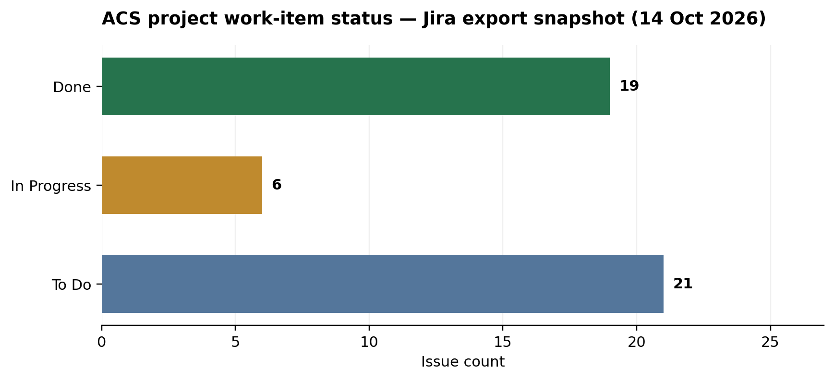
Figure 2. Work-item status distribution computed from the Jira issue export at the report snapshot. This is a report-generated chart of exported fields, not a screenshot of Jira’s board UI.
The status distribution is a project-wide snapshot, not a sprint burndown chart. It should not be interpreted as delivery velocity or percent-complete for Alumnex features. The 46 issues include experiment records and administrative/follow-up subtasks as well as product backlog Stories.

6.3 Workload operating procedure
4. At the start of each working day, inspect the active sprint and each assigned Story’s acceptance criteria.
5. Each contributor reports work completed, next action and blocker. Update status only when the related work state has changed.
6. When coding work is finished, run the appropriate tests. Distinguish unit tests, offline integration tests, database integration tests, external-provider checks and device tests.
7. During review, compare the output to the acceptance criteria and DoD; move only accepted Stories to Done.
8. For blocked items, record the dependency as a child issue and preserve the unresolved state until the dependency is verified.

6.4 Result
The sprint was operated using real Jira status fields, assignments, estimates and child tasks. The recorded issue completion state is honest: the workflow/documentation experiment is Done, while the product increment is not represented as shipped or accepted. The source repository README reports 56 backend tests, but the report does not present that count as a fresh test run; it is a claim from the README.

7. Experiment 5 — Use Predefined and User-Created Queries
Jira record: ACS-8 — Experiment 5: JQL Queries. Status: Done for query execution/documentation. ACS-29, ACS-30 and ACS-31 divide the examples into sprint/status, release/experiment, and backlog/defect queries. Five links in the issue Web links section open direct JQL searches.

7.1 Predefined and custom JQL set
Purpose | JQL query | Exported count
All ACS project issues | project = ACS | 46
Product backlog stories | project = ACS AND issuetype = Story | 15
Active sprint scope | project = ACS AND Sprint in openSprints() | 4
Active sprint incomplete | project = ACS AND Sprint in openSprints() AND statusCategory != Done | 4
Active sprint completed | project = ACS AND Sprint in openSprints() AND statusCategory = Done | 0
Unresolved bugs | project = ACS AND issuetype = Bug AND statusCategory != Done | 0
Release 1.0 label group | project = ACS AND labels = "release-1.0" | 4
Release 1.1 label group | project = ACS AND labels = "release-1.1" | 4
Release 1.2 label group | project = ACS AND labels = "release-1.2" | 7
Experiment 8 label | project = ACS AND labels = "experiment-8" | 1
Experiment 9 label | project = ACS AND labels = "experiment-9" | 1
Experiment 10 label | project = ACS AND labels = "experiment-10" | 1

7.2 How to interpret the counts
- project = ACS returns 46 issues as of the snapshot, including experiment tasks, product Stories, Epics and subtasks.
- project = ACS AND issuetype = Story returns 15 user Stories, the product backlog used in release planning.
- Sprint in openSprints() returns four active Sprint 2 Stories. All four are incomplete at the snapshot.
- The release labels return 4, 4 and 7 Stories. These are grouping labels because native Fix Version assignment was not available via the connected edit tool.
- The unresolved Bug query returns zero issues. This means there are no matching Jira Bug issues in this project snapshot; it does not prove there are no defects in the product.

7.3 Predefined query links and user-created saved filters
ACS-8 includes direct query launchers named Product Stories, Active Sprint, Active Sprint Incomplete, Release 1.0 Stories and Unresolved Bugs. These links open searches with the stated JQL. They are not the same as Jira’s native saved filters. The connected operation set did not expose a filter-create operation, so the native “Save as” action remains an external UI step tracked in ACS-44.
Reproduction instructions
Open Jira Issue Search, paste a query from the table, run it, and choose “Save as” to make a reusable native filter. Verify the filter owner and sharing level. Do not describe a query link as a saved filter until the filter exists in Jira.

8. Experiment 6 — Prepare a Schedule for Reviewing the Sprint
Jira record: ACS-9 — Experiment 6: Sprint Review. Status: Done for agenda and review-planning records. Child issue ACS-36 has the review agenda and due date set to 20 October 2026.

8.1 Review setup
Field | Recorded plan
Review topic | Sprint 1 — Accounts outcome and Sprint 2 work
Planned due date | 20 October 2026
Suggested time | 16:30–17:00 IST, subject to confirmation
Jira child record | ACS-36 — Sprint Review — Agenda and Date
Stakeholders | Faculty/Product Owner, Scrum team, demonstrator/reviewer
Invitation state | No calendar invitation or attendance was established by the Jira operation; time is proposed only.
Sprint 1 result to present | 0 of 2 Stories accepted; no verified product increment was available at closure.

8.2 Proposed 30-minute agenda
Time | Activity | Expected outcome
0–5 min | Restate sprint goal and selected stories | Common scope and acceptance criteria.
5–15 min | Demonstrate only currently working Alumnex flows | Evidence of actual behavior; no mocked-up feature presented as live.
15–20 min | Review acceptance criteria against tests/results | Accepted/not-accepted decisions.
20–25 min | Collect faculty/Product Owner feedback | New backlog items and priority changes.
25–30 min | Record outcome and next actions | Decision log and follow-up task owners.

8.3 Review checklist
- Authentication: registration, email verification, login, OAuth callback and role-gated routes.
- Mentorship: mentor discovery/request and state transitions with safe test accounts.
- Career: job discovery/application and invalid/duplicate response handling.
- DevPulse, activity, chat, notifications and Google Calendar: use actual database and provider responses where available.
- Cross-cutting behavior: owner isolation, user-safe errors, empty/loading states, and desktop/mobile rendering.
Experiment 6 conclusion
The review agenda and proposed date are recorded. The meeting itself is not claimed to have occurred, and the 16:30–17:00 time must be confirmed by faculty/team.

9. Experiment 7 — Close Sprint 1 and Start the Next Sprint
Jira record: ACS-10 — Experiment 7: Sprint Closure and Next Sprint. Status: Done. The native Jira Scrum lifecycle was used to close Sprint 1 and start Sprint 2; the retrospective and DoR/DoD records are retained as related work.

9.1 Sprint lifecycle record
Lifecycle attribute | Sprint 1 — Accounts | Sprint 2 — Alumnex Core
Sprint ID | 1 | 2
Jira state | Closed | Active
Goal | Initial student-account registration/login increment | Testable Alumnex vertical slice across registration/login, mentorship and career application workflows
Planned points | 8 | 16
Selected Stories | ACS-12, ACS-13 | ACS-12, ACS-13, ACS-14, ACS-15
Actual completion snapshot | 0 of 2 Stories accepted | 0 of 4 Stories Done; 2 In Progress and 2 To Do
Dates | 13–20 Oct planned; closed 13 Oct | 13–20 Oct planned; active at snapshot

9.2 Retrospective and improvements
ACS-32 records the Sprint 1 retrospective. The central observation is that the sprint lifecycle was demonstrated, but the product increment was not accepted. Improvements include aligning the lab backlog to real Alumnex modules, preparing integration setup earlier, recording test output before review, tracking OAuth/provider/device dependencies, and separating the production stack from the faculty Python/MySQL lab.
ACS-33 documents proposed Definition of Ready and Definition of Done guardrails. A Story should be Ready only when its outcome and acceptance criteria are clear, its parent/priority/estimate/dependencies are documented, and the source/test path is identified. A Story should be Done only when acceptance criteria are satisfied and test evidence exists for the feature claimed, including real external dependencies where required.

9.3 Interpretation
This experiment shows a genuine Jira lifecycle transition. Closing a sprint is not the same as accepting all scope. The honest result of Sprint 1 was 0/2 Stories accepted, and Sprint 2 remains active with four planned Stories incomplete.

10. Experiment 8 — Identify Use Cases and Develop a Business Use-Case Model
Jira record: ACS-11 — Experiment 8: Alumnex Connect Business Use-Case Model. Status: In Progress. The textual and Mermaid source model is in Jira. The rendered diagram file is in the companion artifact package; attaching the binary directly to Jira is tracked in ACS-46.

10.1 System boundary
The use-case model treats Alumnex Connect as the system boundary for the React web/mobile client and Express backend. MongoDB/Mongoose is an internal persistence component, not a human actor. External identity/email/calendar/developer/AI/push providers are shown only where source modules describe integrations; inclusion in the model is not a claim that credentials or production connectivity were verified.

10.2 Actors
Actor | Primary interactions with the system
Student / Member | Register/sign in, maintain profile, find mentors, request mentoring, search/apply to jobs, use AI career tools, view DevPulse/activity, communicate and use events/community functions.
Alumni / Mentor | Maintain professional profile and availability, respond to mentorship requests, manage sessions/milestones, review mentees and manage job opportunities where authorized.
Administrator | Approve users/mentors, manage roles/status, moderate content, inspect analytics/system incidents and send admin notifications.
Institution / Business | Participate in the directory/institutional and business capabilities where configured.
Google / GitHub OAuth | External identity provider for supported OAuth sign-in paths.
Email / OTP provider | Supports verification, account recovery and optional 2FA delivery flows.
Developer APIs | External sources for developer profiles/activity (e.g. GitHub, LeetCode, Codeforces where supported).
AI model providers | Groq / Gemini provider paths for AI career assistance when configured.
Google Calendar | Connect/list calendars, read/write/sync events and provide schedule context.
Web Push / FCM | Browser and Android notification delivery boundaries.

10.3 Use-case inventory
- Identity and access: registration, login, OAuth completion, role selection, email verification, password recovery/change, optional 2FA, refresh and logout.
- Member network: search/view profiles, update own profile, connect/follow, accept/decline requests and manage status/presence.
- Mentorship: discover mentor, request/auto-assign mentor, change status, schedule session, manage milestones/notes, cancel and review.
- Career: browse internal/external openings, save/apply to a job, manage application status and use resume analysis/job match/mock-interview features.
- Developer momentum: manage developer profile, sync activity, goals/preferences, view timeline/streaks/analytics/insights and export/delete own data.
- Communication: start conversations, send/read/search messages, manage groups and read/subscribe/unsubscribe/register notifications/devices.
- Events/calendar: register for events, manage event state where authorized, connect Google Calendar, manage settings/calendars/events, sync and obtain schedule context.
- Community and portfolio: forum feed/search/comments/reports, Tech Hub questions/replies, project showcase, contests/leaderboards and directory search.
- Governance: approve and verify users, assign roles, suspend accounts, moderate content, view admin analytics and investigate incidents.

10.4 Use-case model figure
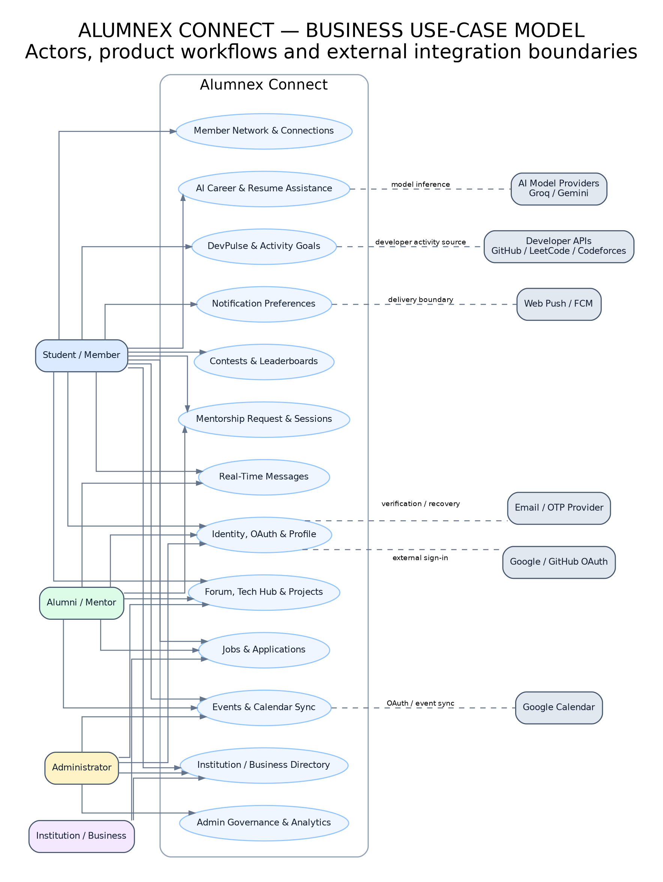
Figure 3. Alumnex Connect business use-case model. Rendered from the companion package’s source-derived diagram; its binary has not yet been attached to Jira.

10.5 Relationships and controls
Authentication and authorization act as preconditions for restricted actions. Mentorship requests interact with mentorship/session/review entities and may trigger notifications. Job applications link a user to a job. Developer activity sync writes activity records and goal-related state. Messaging uses persisted records plus Socket.IO transport; Redis adapter configuration supports cross-instance pub/sub. Calendar workflows use Google OAuth and user-specific connection/event state. AI workflows call external providers and must handle provider failures safely.
Experiment 8 conclusion
The actors, system boundary, use-case inventory and Mermaid source have been documented in Jira. The experiment is kept In Progress until the diagram export is attached and the visual evidence is available directly on the Jira issue.

11. Experiment 9 — Conceptual Classes, Boundary/Control/Entity and UML Class Diagram
Jira record: ACS-20 — Experiment 9: Alumnex Connect Conceptual Classes and UML Domain Model. Status: In Progress. The model is grounded in the actual Mongoose model folder, React page routes and Express route/service modules.

11.1 Boundary classes
Boundary roles represent the interaction surfaces already present in the React application; they are conceptual role labels and not necessarily separate class declarations. Representative surfaces include Login/Register, Profile/Network, Mentorship, Jobs/Resume Analyzer, DevPulse/Activity Hub, Chat/Notifications, Events/Calendar, Forum/Tech Hub/Projects, Contests and Admin.

11.2 Control classes/modules
The Control layer uses existing Express route modules and services rather than inventing a separate MVC controller class for every page. Authentication/users, mentorship, jobs/AI, activity/developer data, messages/notifications, events/Google Calendar, forum/Tech Hub/projects/contests/institutions/business and admin routes coordinate requests, validation, authorization, business logic and persistence.

11.3 Entity classes
Domain group | Representative entities | Key responsibilities
Identity / mentorship | User, MentorshipRequest, Mentorship, MentorshipSession, MentorReview, MentorReward | Identity/role/profile, request lifecycle, sessions and feedback.
Career / applications | Job, JobApplication, JobOpportunity | Job details, applications, status and applicant/job association.
Developer / activity | DevProfile, ActivityGoal, ActivityRecord | External platform identity, goals, activity history and trust/source data.
Messaging / notifications | Message, ChatGroup, Notification, NotificationDevice, ReminderPreference | Conversations, recipient-scoped notices, device and delivery preferences.
Events / calendar | Event, GoogleCalendarConnection, GoogleCalendarEvent | Event lifecycle and per-user Google Calendar connection/sync records.
Community / governance | ForumPost, Project, Contest, Business, TechHub entities, Report, AdminIncident | Member content, portfolio links, contest workflows, moderation and incidents.

11.4 Conceptual relationships
- One User can act as student and/or mentor across multiple mentorship requests/relationships.
- A Mentorship can have sessions and feedback records; reward totals are associated with mentor outcomes.
- One Job can have multiple JobApplication records; each application is associated with one applicant and one job.
- A User owns developer profile/activity/goals and notification preferences/device registrations.
- Messages have sender/recipient context and may belong to a conversation/group; notifications have a recipient and may refer to a related event/action.
- A user-specific GoogleCalendarConnection relates a member to a calendar provider; GoogleCalendarEvent stores external event identity/sync context.
- User-owned ForumPost and Project records use author/owner references to establish edit/delete boundaries.

11.5 UML domain model figure
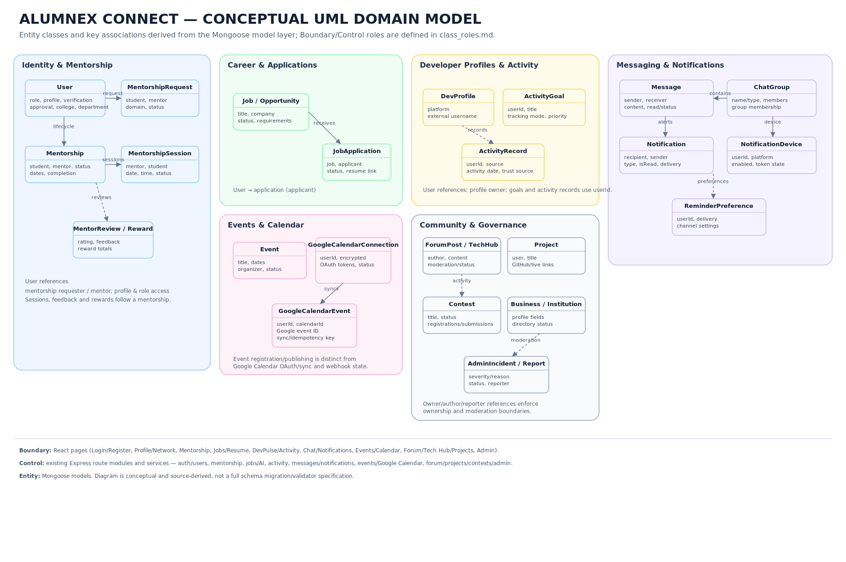
Figure 4. Alumnex Connect conceptual UML domain model. This is a source-derived conceptual model, not an exact export of every Mongoose validator/index or a database migration diagram.

11.6 Limitations
The model provides a useful conceptual view of entity groups and associations; it does not replace inspection of full Mongoose schema definitions for constraints, indexes, reference policies or optional fields. The diagram export remains pending attachment to ACS-20; ACS-46 tracks both Experiment 8 and 9 diagram attachments.
Experiment 9 conclusion
The Boundary/Control/Entity classification and UML source have been prepared from Alumnex Connect. The Jira task remains In Progress until the rendered UML file is attached for easy in-issue inspection.

12. Experiment 10 — Python UI, MySQL Database, Unit and Integration Testing
Jira record: ACS-21 — Experiment 10: Alumnex Source Study, Python/MySQL Lab and Testing. Status: In Progress. This experiment has two distinct contexts that must be kept separate: the actual Alumnex Connect production codebase and the Python/MySQL coursework lab built for the faculty’s stated requirement.

12.1 Actual Alumnex Connect stack
Layer | Repository evidence / technology
Web UI | React 18, React Router, React Query, TailwindCSS, Framer Motion and Recharts.
API / backend | Node.js and Express route modules/services.
Persistence | MongoDB Atlas or configured MongoDB URI through Mongoose models.
Realtime | Socket.IO and Redis adapter/pub-sub configuration.
AI / external APIs | Groq/Gemini provider paths and developer-platform integrations where configured.
Mobile | Capacitor Android wrapper and FCM/notification integration.
Testing / CI | Backend Jest/Supertest tests; frontend build; Playwright smoke workflow defined in .github/workflows/test.yml.

The actual project does not use Python/MySQL as its production UI/database stack. Therefore the Python/MySQL sample is presented as a separate educational lab, not as a claim about Alumnex’s production implementation.

12.2 Python/MySQL coursework lab structure
File / component | Role
python_mysql_lab/app.py | Python WSGI application with HTML home/register/login UI, JSON health/register/login routes, request parsing and database injection seam.
python_mysql_lab/validation.py | Required-field, email-normalization and password validation.
python_mysql_lab/security.py | PBKDF2-HMAC-SHA256 password hashing and verification helpers.
python_mysql_lab/schema.sql | Creates the dedicated acs_student_lab database and users table with unique email and password_hash columns.
tests/test_unit.py | Unit tests for validation, email normalization, hash verification and malformed hash handling.
tests/test_wsgi_integration.py | Offline request-to-data-access tests using an in-memory fake database.
tests/test_mysql_integration.py | Opt-in live MySQL registration/login test; skipped unless RUN_MYSQL_INTEGRATION=1 and connection settings are provided.
setup_xampp.md | Windows/XAMPP steps for configuring MySQL and recording the successful test output.

12.3 Database design
The sample schema is deliberately small and isolated from any production database. It uses the database name acs_student_lab and table users. The primary key is an auto-incrementing BIGINT; full_name is required; email is unique; password_hash stores a hash rather than a plain-text password; created_at records creation time.
CREATE DATABASE IF NOT EXISTS acs_student_lab
CHARACTER SET utf8mb4 COLLATE utf8mb4_unicode_ci;
USE acs_student_lab;
CREATE TABLE IF NOT EXISTS users (
id BIGINT UNSIGNED NOT NULL AUTO_INCREMENT PRIMARY KEY,
full_name VARCHAR(120) NOT NULL,
email VARCHAR(254) NOT NULL UNIQUE,
password_hash VARCHAR(255) NOT NULL,
created_at TIMESTAMP NOT NULL DEFAULT CURRENT_TIMESTAMP
);

12.4 Security and validation design
- Use parameterized SQL rather than interpolating user input into SQL statements.
- Normalize email before validation and persistence; reject missing name, invalid email, and passwords outside allowed length rules.
- Reject duplicate emails through both application checks and a database UNIQUE constraint.
- Use PBKDF2-HMAC-SHA256 password hashes; never save or render the plain-text password.
- Return generic login failures and user-safe server errors; do not return raw database exception details.
- Use environment variables for connection configuration and run only against a dedicated educational database.

12.5 Actual test run and results
Test category | Result | Coverage
Unit tests | 8 passed | Email normalization, valid/invalid email, missing name, password limits, hash verification and malformed hash.
Offline WSGI integration | 7 passed | Home/health routes, registration/duplicate handling, invalid payload before DB access, successful/failed login, unknown user, simulated DB outage, HTML escaping.
Live MySQL integration | 1 skipped | Real registration/login persistence test was not run because a reachable/configured MySQL server and connector were unavailable in the execution environment.
Total | 16 discovered; 15 passed; 1 skipped; 0 failures | Recorded in test-results.txt on 14 October 2026.

Actual test command
Run from python_mysql_lab: PYTHONPATH=. python -m unittest discover -s tests -v

The offline suite is successful within its scope, but the skipped test means real MySQL connectivity and persistence remain unverified. A fake database validates request flow and SQL contract behavior; it does not substitute for the actual MySQL server integration criterion.

12.6 Steps to complete the real MySQL integration
1. On Windows, start MySQL from XAMPP Control Panel.
2. Open phpMyAdmin and execute schema.sql to create the separate acs_student_lab database/table.
3. Install requirements with python -m pip install -r requirements.txt.
4. Set DB_HOST, DB_PORT, DB_NAME=acs_student_lab, DB_USER and DB_PASSWORD in the test PowerShell session. Use a local least-privilege educational account; do not use the production database.
5. Set RUN_MYSQL_INTEGRATION=1 and PYTHONPATH=. then run python -m unittest tests.test_mysql_integration -v.
6. Save the real console output and attach/comment it in ACS-35. Mark ACS-35 and ACS-21 Done only if the live test passes.

12.7 Acceptance checklist
Requirement | Status at snapshot | Evidence
Alumnex source stack researched | Complete | Repository routes/models/README and architecture notes linked in ACS-21 and ACS-28.
Python user interface prepared | Complete for separate lab | python_mysql_lab/app.py.
MySQL schema prepared | Complete; not live-verified | python_mysql_lab/schema.sql.
Unit tests executed | Complete | 8 unit test cases passed within 16-test suite.
Offline WSGI integration tests executed | Complete | 7 route/SQL-contract tests passed.
Real MySQL integration test | Pending | ACS-35, To Do; one test skipped in latest run.
Live Alumnex UI smoke test | Pending | ACS-45, To Do; runtime could not load the demo host.
Experiment 10 overall | In Progress | Do not claim full completion until live MySQL test passes.

Experiment 10 conclusion
The code, schema, unit tests and offline integration tests are prepared and recorded. A full completion claim is not supported until the test runs successfully against a real MySQL instance and its output is attached to ACS-35.

13. Overall Results and Remaining Work

13.1 Experiment completion snapshot
No. | Faculty topic | Issue | Status | Summary of evidence
1 | Product backlog with stories | ('ACS-4', 'https://srimankumar06.atlassian.net/browse/ACS-4') | Done | Backlog includes 3 product Epics and 15 Stories, acceptance criteria, priority, proposed estimates and release groups.
2 | Release plan | ('ACS-5', 'https://srimankumar06.atlassian.net/browse/ACS-5') | Done | 3 unreleased Jira versions; stories grouped by release labels; 71 proposed points total.
3 | Sprint planning | ('ACS-6', 'https://srimankumar06.atlassian.net/browse/ACS-6') | Done | Sprint 1 planned; Sprint 2 active with a goal, scope and 16 proposed points.
4 | Execute sprint/manage workload | ('ACS-7', 'https://srimankumar06.atlassian.net/browse/ACS-7') | Done | Sprint lifecycle/workload documentation and task breakdown recorded; Sprint 1 accepted 0/2 Stories.
5 | Queries to track progress | ('ACS-8', 'https://srimankumar06.atlassian.net/browse/ACS-8') | Done for execution/docs | JQL results and five query launch links; native saved filters still a manual UI action.
6 | Schedule sprint review | ('ACS-9', 'https://srimankumar06.atlassian.net/browse/ACS-9') | Done for agenda | Agenda and proposed 20 Oct date stored; no calendar invitation/attendance claimed.
7 | Close first/start next sprint | ('ACS-10', 'https://srimankumar06.atlassian.net/browse/ACS-10') | Done | Sprint 1 closed, Sprint 2 active; retrospective and DoR/DoD records.
8 | Use cases and model | ('ACS-11', 'https://srimankumar06.atlassian.net/browse/ACS-11') | In Progress | Alumnex-specific model source in Jira; binary image attachment pending.
9 | Conceptual classes and UML | ('ACS-20', 'https://srimankumar06.atlassian.net/browse/ACS-20') | In Progress | Source-derived model and Boundary/Control/Entity notes; binary attachment pending.
10 | Python UI + MySQL + testing | ('ACS-21', 'https://srimankumar06.atlassian.net/browse/ACS-21') | In Progress | Offline tests pass; one live MySQL test skipped and demo UI runtime check pending.

13.2 Outstanding practical items
Follow-up | Jira key | Current state | Required close-out evidence
Save native JQL filters | ACS-44 | To Do | Save five JQL searches as native filters in Jira UI; record filter names/URLs and sharing settings.
Live demo smoke test | ACS-45 | To Do | Use authorized test account and record results per route/flow, with screenshots or safe console/network excerpt.
Attach UML exports | ACS-46 | To Do | Attach use_case_model.png/svg to ACS-11 and domain_model.png/svg to ACS-20; verify files show in Jira attachments.
Run actual MySQL test | ACS-35 | To Do | Run live integration against local dedicated MySQL/XAMPP schema, save successful console output and attach/comment it.
Confirm review meeting | ACS-36 | Due date set; meeting not confirmed | Confirm time with faculty/team and record actual attendance/outcome after meeting.

13.3 Conclusion
The Jira Scrum experiment set is organised around an authentic Alumnex Connect product model, with three product Epics, 15 product Stories, staged release groups, two Sprint lifecycle records, JQL evidence and source-derived use-case/domain models. The report preserves the actual exported status snapshot and distinguishes the completed Jira documentation exercises from unverified product or external-integration behavior. The remaining To Do tasks are specifically identified so that practical confirmation can be completed and documented before the report is treated as fully closed.

Appendix A — Jira Export Summary
The tables below are exported from Jira reads on 14 October 2026. They are report-formatted structured extracts, not direct browser screenshots. Issue keys link to their live Jira browse pages.
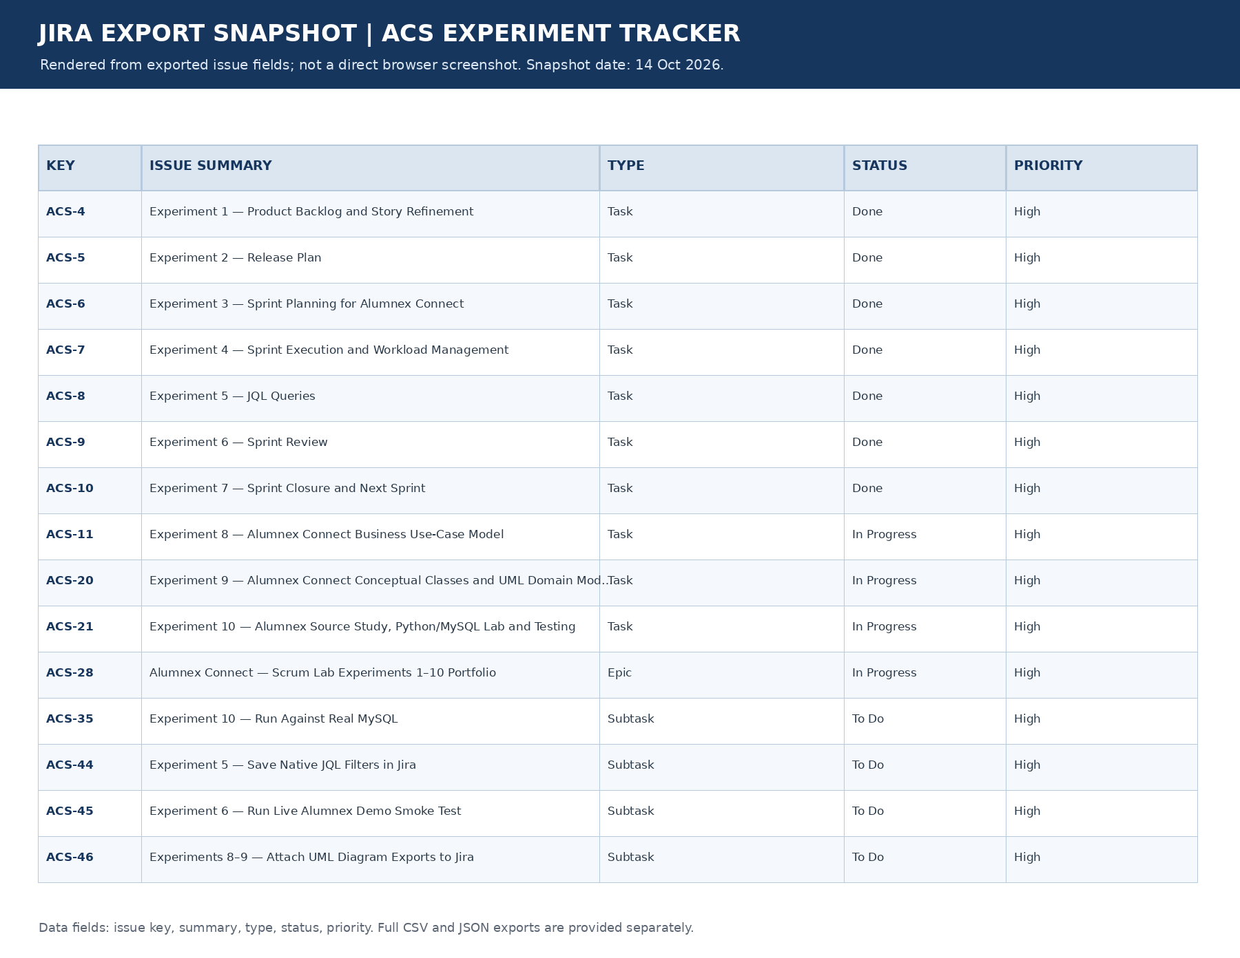
Figure 5. Selected Jira experiment issue records rendered from exported fields. This figure is an evidence visualization, not a direct screenshot of the Jira UI.
JQL purpose | Query | Count
All ACS project issues | project = ACS | 46
Product backlog stories | project = ACS AND issuetype = Story | 15
Active sprint scope | project = ACS AND Sprint in openSprints() | 4
Active sprint incomplete | project = ACS AND Sprint in openSprints() AND statusCategory != Done | 4
Active sprint completed | project = ACS AND Sprint in openSprints() AND statusCategory = Done | 0
Unresolved bugs | project = ACS AND issuetype = Bug AND statusCategory != Done | 0
Release 1.0 label group | project = ACS AND labels = "release-1.0" | 4
Release 1.1 label group | project = ACS AND labels = "release-1.1" | 4
Release 1.2 label group | project = ACS AND labels = "release-1.2" | 7
Experiment 8 label | project = ACS AND labels = "experiment-8" | 1
Experiment 9 label | project = ACS AND labels = "experiment-9" | 1
Experiment 10 label | project = ACS AND labels = "experiment-10" | 1

A.1 Jira workflow counts
Status | Count | Meaning
Done | 19 | Jira issue status Done, across experiment records, subtasks and backlog issues.
In Progress | 6 | Work is actively tracked; includes ACS-11, ACS-20, ACS-21, two Sprint 2 Stories and portfolio Epic ACS-28.
To Do | 21 | Unstarted backlog work or external verification subtasks.
Total | 46 | All issues returned by project = ACS in the export query.

A.2 Sprint export
Field | Sprint 1 (ID 1) | Sprint 2 (ID 2)
Name | Sprint 1 - Accounts | Sprint 2 — Alumnex Core
State | Closed | Active
Start | 13 Oct 2026, 09:00 IST | 13 Oct 2026, 09:30 IST
End planned | 20 Oct 2026, 18:00 IST | 20 Oct 2026, 18:00 IST
Completion timestamp | 13 Oct 2026, 09:13 IST (Jira recorded completeDate) | Not complete
Planned points | 8 | 16
Result | 0/2 Stories accepted | 4 assigned Stories; 2 In Progress, 2 To Do, 0 Done

A.3 Release version export
Version ID | Version name | Release label | Stories | Points | Released
10037 | Release 1.0 — Identity and Profile Foundations | release-1.0 | 4 | 21 | No
10038 | Release 1.1 — Mentorship and Career Enablement | release-1.1 | 4 | 16 | No
10039 | Release 1.2 — Developer Intelligence and Community | release-1.2 | 7 | 34 | No

Appendix B — Complete Jira Issue Export
The CSV/JSON files linked with this report provide this same structured issue inventory. Fields are: issue key, issue type, summary, status, priority, assignee display name, parent key, Story point estimate where applicable, created/updated timestamps and browse URL. A blank field means the particular export read did not return a value or the field is not applicable; it is not filled by assumption.
Key | Type | Summary | Status | Priority | Assignee | Parent | Pts
ACS-1 | Epic | Identity, Profiles and Governance | To Do | High | subhadharanis.24cse | — | —
ACS-2 | Epic | Mentorship and Career Opportunities | To Do | High | SRIMATHI D 24CSR302 | — | —
ACS-3 | Epic | Developer Intelligence and Community Engagement | To Do | High | THIRUMURUGAN A 24CSR330 | — | —
ACS-4 | Task | Experiment 1 — Product Backlog and Story Refinement | Done | High | SRIMAN VEL | ACS-28 | —
ACS-5 | Task | Experiment 2 — Release Plan | Done | High | SRIMATHI D 24CSR302 | ACS-28 | —
ACS-6 | Task | Experiment 3 — Sprint Planning for Alumnex Connect | Done | High | SRIMATHI D 24CSR302 | ACS-28 | —
ACS-7 | Task | Experiment 4 — Sprint Execution and Workload Management | Done | High | THIRUMURUGAN A 24CSR330 | ACS-28 | —
ACS-8 | Task | Experiment 5 — JQL Queries | Done | High | THIRUMURUGAN A 24CSR330 | ACS-28 | —
ACS-9 | Task | Experiment 6 — Sprint Review | Done | High | SRIMAN VEL | ACS-28 | —
ACS-10 | Task | Experiment 7 — Sprint Closure and Next Sprint | Done | High | subhadharanis.24cse | ACS-28 | —
ACS-11 | Task | Experiment 8 — Alumnex Connect Business Use-Case Model | In Progress | High | subhadharanis.24cse | ACS-28 | —
ACS-12 | Story | User Registration and Email Verification | In Progress | Medium | SRIMAN VEL | ACS-1 | 5
ACS-13 | Story | Secure Login, OAuth and Session Lifecycle | In Progress | Medium | SRIMAN VEL | ACS-1 | 3
ACS-14 | Story | Mentorship Requests, Matching and Reviews | To Do | Medium | SRIMAN VEL | ACS-2 | 5
ACS-15 | Story | Career Opportunities and Application Tracking | To Do | Medium | SRIMAN VEL | ACS-2 | 3
ACS-16 | Story | DevPulse, Developer Profiles and Activity Goals | To Do | Medium | subhadharanis.24cse | ACS-3 | 5
ACS-17 | Story | AI Career Support and Resume Analysis | To Do | Medium | THIRUMURUGAN A 24CSR330 | ACS-2 | 5
ACS-18 | Story | Real-Time Messaging and Notification Preferences | To Do | Medium | THIRUMURUGAN A 24CSR330 | ACS-3 | 3
ACS-19 | Story | Events and Google Calendar Synchronization | To Do | Medium | SRIMAN VEL | ACS-3 | 3
ACS-20 | Task | Experiment 9 — Alumnex Connect Conceptual Classes and UML Domain Model | In Progress | High | subhadharanis.24cse | ACS-28 | —
ACS-21 | Task | Experiment 10 — Alumnex Source Study, Python/MySQL Lab and Testing | In Progress | High | THIRUMURUGAN A 24CSR330 | ACS-28 | —
ACS-22 | Subtask | Registration — Define validation and duplicate checks | Done | Medium | SRIMAN VEL | ACS-21 | —
ACS-23 | Subtask | Registration — Implement and document endpoint contract | Done | Medium | SRIMAN VEL | ACS-21 | —
ACS-24 | Subtask | Registration — Unit and integration test plan | Done | Medium | SRIMAN VEL | ACS-21 | —
ACS-25 | Subtask | Login — Credential verification | Done | Medium | SRIMAN VEL | ACS-21 | —
ACS-26 | Subtask | Login — Session/token behavior | To Do | Medium | SRIMAN VEL | ACS-13 | —
ACS-27 | Subtask | Login — Authentication test cases | Done | Medium | SRIMAN VEL | ACS-21 | —
ACS-28 | Epic | Alumnex Connect — Scrum Lab Experiments 1–10 Portfolio | In Progress | High | SRIMAN VEL | — | —
ACS-29 | Subtask | JQL — Sprint Scope and Status Queries | Done | High | THIRUMURUGAN A 24CSR330 | ACS-8 | —
ACS-30 | Subtask | JQL — Release and Experiment Queries | Done | Medium | subhadharanis.24cse | ACS-8 | —
ACS-31 | Subtask | JQL — Backlog and Defect Queries | Done | Medium | SRIMATHI D 24CSR302 | ACS-8 | —
ACS-32 | Subtask | Sprint 1 Retrospective and Improvements | Done | Medium | THIRUMURUGAN A 24CSR330 | ACS-10 | —
ACS-33 | Subtask | Definition of Ready and Definition of Done | Done | High | SRIMATHI D 24CSR302 | ACS-10 | —
ACS-34 | Subtask | Experiment 10 — Offline Test Evidence | Done | High | SRIMAN VEL | ACS-21 | —
ACS-35 | Subtask | Experiment 10 — Run Against Real MySQL | To Do | High | subhadharanis.24cse | ACS-21 | —
ACS-36 | Subtask | Sprint Review — Agenda and Date | Done | High | SRIMATHI D 24CSR302 | ACS-9 | —
ACS-37 | Story | Profiles, Connections and Role-Aware Access | To Do | High | SRIMAN VEL | ACS-1 | 5
ACS-38 | Story | Admin Governance, Moderation and Analytics | To Do | High | subhadharanis.24cse | ACS-1 | 8
ACS-39 | Story | Forum and Tech Hub Knowledge Sharing | To Do | Medium | SRIMATHI D 24CSR302 | ACS-3 | 5
ACS-40 | Story | Project Showcase and Collaboration | To Do | Medium | srimanlumar06 | ACS-3 | 5
ACS-41 | Story | Competitive Contests and Leaderboards | To Do | Medium | SRIMATHI D 24CSR302 | ACS-3 | 5
ACS-42 | Story | Capacitor Mobile App and Native Push Delivery | To Do | High | SRIMAN VEL | ACS-3 | 8
ACS-43 | Story | Institution and Business Directory | To Do | Medium | subhadharanis.24cse | ACS-2 | 3
ACS-44 | Subtask | Experiment 5 — Save Native JQL Filters in Jira | To Do | High | — | ACS-8 | —
ACS-45 | Subtask | Experiment 6 — Run Live Alumnex Demo Smoke Test | To Do | High | — | ACS-9 | —
ACS-46 | Subtask | Experiments 8–9 — Attach UML Diagram Exports to Jira | To Do | High | — | ACS-20 | —

Appendix C — Direct Jira and Source Links
Jira key | Issue / evidence record | Status
ACS-28 | Alumnex Connect — Scrum Lab Experiments 1–10 Portfolio | In Progress
ACS-4 | Experiment 1 — Product Backlog and Story Refinement | Done
ACS-5 | Experiment 2 — Release Plan | Done
ACS-6 | Experiment 3 — Sprint Planning for Alumnex Connect | Done
ACS-7 | Experiment 4 — Sprint Execution and Workload Management | Done
ACS-8 | Experiment 5 — JQL Queries | Done
ACS-9 | Experiment 6 — Sprint Review | Done
ACS-10 | Experiment 7 — Sprint Closure and Next Sprint | Done
ACS-11 | Experiment 8 — Alumnex Connect Business Use-Case Model | In Progress
ACS-20 | Experiment 9 — Alumnex Connect Conceptual Classes and UML Domain Model | In Progress
ACS-21 | Experiment 10 — Alumnex Source Study, Python/MySQL Lab and Testing | In Progress
ACS-35 | Experiment 10 — Run Against Real MySQL | To Do
ACS-36 | Sprint Review — Agenda and Date | Done
ACS-44 | Experiment 5 — Save Native JQL Filters in Jira | To Do
ACS-45 | Experiment 6 — Run Live Alumnex Demo Smoke Test | To Do
ACS-46 | Experiments 8–9 — Attach UML Diagram Exports to Jira | To Do

C.1 Repository files reviewed
- Repository: https://github.com/SrimanKumarV/FSD/tree/master/alumni-connect-website-main
- README: https://github.com/SrimanKumarV/FSD/blob/master/alumni-connect-website-main/README.md
- Alumnex project report: https://github.com/SrimanKumarV/FSD/blob/master/alumni-connect-website-main/Alumnex_Connect_Project_Report.md
- Backend server: https://github.com/SrimanKumarV/FSD/blob/master/alumni-connect-website-main/backend/server.js
- Auth routes: https://github.com/SrimanKumarV/FSD/blob/master/alumni-connect-website-main/backend/routes/auth.js
- Mentorship routes: https://github.com/SrimanKumarV/FSD/blob/master/alumni-connect-website-main/backend/routes/mentorship.js
- Jobs routes: https://github.com/SrimanKumarV/FSD/blob/master/alumni-connect-website-main/backend/routes/jobs.js
- Activity routes: https://github.com/SrimanKumarV/FSD/blob/master/alumni-connect-website-main/backend/routes/activity.js
- Google Calendar routes: https://github.com/SrimanKumarV/FSD/blob/master/alumni-connect-website-main/backend/routes/googleCalendar.js
- GitHub CI workflow: https://github.com/SrimanKumarV/FSD/blob/master/alumni-connect-website-main/.github/workflows/test.yml
- Live demo: https://alumnex-connect.onrender.com
- Backend health route: https://alumnex-backend-9y5t.onrender.com/api/health

C.2 Companion exports and evidence files
Included separately with the report:
- ACS_Jira_Export_2026-10-14.csv — issue data extract for spreadsheet review.
- ACS_Jira_Export_2026-10-14.json — structured snapshot of issues, JQL result counts, sprint records and version records.
- ACS_Scrum_Experiments_Artifacts.zip — source package for the Python/MySQL lab, test result log, Alumnex-specific use-case/domain diagram exports and diagram sources.

