DESIGN DOCUMENTATION

Automotive Multi-ECU CAN Communication System with Crash Detection Module

1. Introduction
Modern vehicles use multiple Electronic Control Units (ECUs) to control and monitor various automotive functions such as engine management, braking systems, infotainment, transmission control, battery monitoring, and safety systems. These ECUs communicate with each other using the Controller Area Network (CAN) protocol.
This project implements an Automotive Multi-ECU CAN Communication System with a Crash Detection Module using the STM32F407G Discovery Board. The crash detection module uses a KY-002 shock sensor to detect sudden vibration or impact conditions. When a crash event is detected, the STM32 microcontroller activates a warning LED and buzzer while transmitting a CAN message over the CAN bus using the TJA1050 CAN transceiver module.
The CAN communication is monitored using CANeasy software to simulate communication between multiple automotive ECUs.

2. Project Objective
The objectives of this project are:
- To simulate an automotive multi-ECU CAN communication network
- To detect crash events using the KY-002 shock sensor
- To process crash events using EXTI interrupt mechanism
- To activate LED and buzzer alerts during crash detection
- To transmit crash status through CAN communication
- To monitor CAN messages using CANeasy software
- To demonstrate embedded automotive communication architecture

3. System Overview
The project simulates a vehicle CAN network consisting of multiple ECUs.
ECU Name | Function
Engine ECU | Engine parameter monitoring
ABS ECU | Brake system monitoring
Body Control Module (BCM) | Vehicle body electronics
Infotainment ECU | Display and multimedia system
Transmission ECU | Gear and transmission monitoring
Battery ECU | Battery monitoring system
Crash Detection ECU | Crash sensing and CAN transmission
The Crash Detection ECU is implemented using the STM32F407G-DISC1 development board.

4. Hardware Components
Sl No | Component | Purpose
1 | STM32F407G-DISC1 Discovery Board | Main microcontroller
2 | KY-002 Shock Sensor | Crash and vibration detection
3 | TJA1050 CAN Transceiver Module | CAN bus communication
4 | LED | Crash indication
5 | Buzzer | Audio alert
6 | Jumper Wires | Hardware connections
7 | Breadboard | Circuit prototyping
8 | USB Cable | Power supply and programming

5. Software Requirements
Software | Purpose
STM32CubeIDE | Firmware development
CANeasy | CAN message monitoring
Embedded C | Firmware programming
STM32 HAL Library | Peripheral configuration

6. Pin Configuration
Component | STM32 Pin | Description
KY-002 Shock Sensor | PA0 | EXTI interrupt input
LED | PD14 | Crash indication output
Buzzer | PA5 | Audio alert output
CAN TX | PD1 | CAN transmission
CAN RX | PD0 | CAN reception

7. Working Principle
During normal operation, the KY-002 shock sensor continuously monitors vibration conditions. The sensor output is connected to PA0 configured as an EXTI interrupt input.
When vibration or sudden impact occurs:
KY-002 sensor detects vibration.
EXTI interrupt is triggered on PA0.
STM32 processes the crash event.
LED connected to PD14 starts blinking continuously.
Buzzer connected to PA5 activates for a few seconds.
CAN frame is transmitted using CAN ID 0x100.
CAN data byte 0x01 is sent indicating crash detection.
CANeasy monitors and displays the CAN message.
During normal condition:
CAN data byte 0x00 indicates normal status.
8. CAN Communication Design

8.1 CAN Configuration
Parameter | Value
CAN Protocol | CAN 2.0
CAN Transceiver | TJA1050
CAN ID | 0x100
Data Length | 1 Byte
Communication Type | Broadcast
CAN Speed | 500 kbps

8.2 CAN Data Format
CAN ID | Data Byte | Meaning
0x100 | 0x00 | Normal Condition
0x100 | 0x01 | Crash Detected

9. Finite State Machine (FSM)
The Crash Detection ECU operates using the following states:
State | Description
IDLE | System initialization state
MONITORING | Monitoring sensor input
CRASH_DETECTED | Crash identified through EXTI interrupt
ALERT_TRANSMISSION | LED blinking, buzzer activation, and CAN transmission

10. Block Diagram

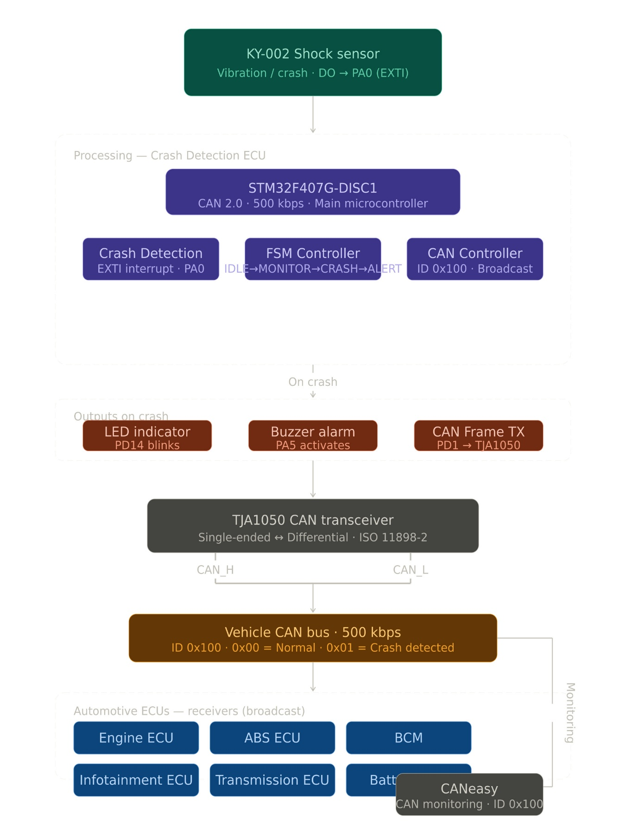

11. Flowchart
START
↓
Initialize GPIO, CAN, EXTI
↓
Monitor KY-002 Sensor
↓
Crash Detected?
┌───────No────────┐
↓ ↑
Yes │
↓ │
Trigger EXTI │
↓ │
Blink LED │
↓ │
Activate Buzzer │
↓ │
Transmit CAN Frame │
↓ │
Return to Monitoring

12. Software Architecture
File Name | Function
main.c | Main application
gpio.c | GPIO configuration
can.c | CAN communication
exti.c | External interrupt handling
crash_handler.c | Crash detection logic
13. Testing and Validation
Test ID | Test Description | Expected Result
T1 | Sensor vibration test | EXTI interrupt triggered
T2 | LED test | LED blinks continuously
T3 | Buzzer test | Buzzer activates
T4 | CAN transmission test | CAN ID 0x100 transmitted
T5 | CAN data validation | 0x01 transmitted during crash
T6 | CANeasy monitoring | Message visible in CANeasy

14. Advantages
Real-time crash detection
Fast CAN communication
Interrupt-based event handling
Simple embedded implementation
Automotive communication simulation
Low-cost hardware implementation
Internship-level automotive project

15. Future Scope
Real airbag deployment module integration
Multiple crash sensor support
GPS emergency notification
GSM-based accident alert system
Integration with additional ECUs
Advanced automotive diagnostics
CAN FD implementation

16. Conclusion
This project successfully demonstrates an Automotive Multi-ECU CAN Communication System with Crash Detection Module using the STM32F407G Discovery Board. The system detects vibration using the KY-002 shock sensor and processes crash events using EXTI interrupt handling. During crash detection, LED blinking and buzzer activation are performed while a CAN message is transmitted through the TJA1050 CAN transceiver.
The project demonstrates the fundamentals of automotive embedded systems, CAN communication, interrupt handling, and ECU interaction, making it suitable for internship-level automotive embedded applications.

