

SMART FOOD ORDERING SYSTEM

A PROJECT REPORT
Submitted by

DHARANISRI R | (732721205013)
MOHAMMED NOUWAF V | (732721243031)
NAVANEETHA C | (732721104036)
SARVESH S | (732721104042)
in partial fulfillment for the award of the degree
of
BACHELOR OF ENGINEERING IN
COMPUTER SCIENCE AND ENGINEERING

SRI SHANMUGHA COLLEGE OF ENGINEERING AND TECHNOLOGY (AN AUTONOMOUS)
SANKARI-637 304.

ANNA UNIVERSITY:CHENNAI 600 025
APRIL 2025

BONAFIDE CERTIFICATE

Certified that this project report “ SMART FOOD ORDERING SYSTEM ” is the bonafide work of DHARANISRI R (732721205013) , MOHAMMED NOUWAF V (732721243031), NAVANEETHA C (732721104036) , SARVESH S (732721104036) who
carried out the project work under my supervision.

SIGNATURE SIGNATURE

Mr.SARAVANAKUMAR PICHUMANI,M.Tech.,(PhD) Dr.P.NANDHINI, M.E.,Ph.D., SUPERVISOR, HEAD OF THE DEPARTMENT, ASSISTANT PROFESSOR,
DEPARTMENT OF CSE, DEPARTMENT OF CSE,

SRI SHANMUGHA COLLEGE OF SRI SHANMUGHA COLLEGE OF
ENGINEERING AND TECHNOLOGY, ENGINEERING AND TECHNOLOGY,
SANKARI – 637 304 SANKARI – 637 304

Submitted for the University project Viva-Voce Examination held on ……………..

Internal Examiner External Examiner

DECLARATION

We affirm that the project work titled “SMART FOOD ORDERING SYSTEM” being submitted in partial fulfillment for the award of Bachelor of Engineering degree is the original work carried out by us. It has not formed the part of any other project work submitted forward of any degree or diploma, either in this or any university.

DHARANISRI R (732721502014) MOHAMMED NOUWAF V (732721243031) NAVANEETHA C (732721104036)
SARVESH S (732721104042)

(SIGNATURE OF THE CANDIDATE) 1)
2)

3)

4)

I certify that the declaration made above by the candidates is true.

(Signature of the Supervisor) Mr.SARAVANAKUMAR PICHUMANI,M.Tech.,(PhD)

ACKNOWELDGEMENT

First and foremost, our thanks to the lord almighty, the great architect of the universe, who has blessed us to complete this project.
We wish our heartfelt thanks to our respected founder and Chairman of Sri Shanmugha College of Engineering and Technology Thiru K. SHANMUGAM and the Vice Chairman of Sri Shanmugha College of Engineering and Technology Mr. S. PRABAHAR, B.E., for giving as an opportunity and facilities for the completion of this project at this institution.
We wish to express our deep sense of gratitude to Executive Director
Mr. A. THIRUMOORTHY, M.E., for providing an opportunity to work on this project.
We are expressing our extreme gratitude and heartfelt thanks to the respect Principal Dr.R.PALANICHAMY,B.Sc.,B.Tech.,M.Tech(IITM).,M.B.A.,Ph.D., of the college facilities to do this project effectively for allowing us to have extensive use.
We would like to express our profound interest and sincere gratitude to our respected Head of the Department Dr. P. NANDHINI, M.E., Ph.D., for her valuable guidance and constant support in the successful completion of the project.
We feel proud and honored in extending our sincere thanks to our project Guide Mr.M.SARAVANAKUMAR PICHUMANI,M.E., for being more informative and providing guidelines regarding this project all the time. Finally, we thank our friends and family members for their kind completion of our project.

ABSTRACT

In today’s fast-paced academic environment, time efficiency and convenience play a crucial role in student life. Traditional food ordering in college canteens often results in long queues, delays, and manual inefficiencies. This project introduces a Smart Food Ordering System tailored specifically for college campuses, aiming to digitize and automate the food ordering experience for both students and canteen staff. The system enables students to place orders through a mobile application, select their preferred pickup time, and choose a payment method — either cash or online payment . Orders are automatically sent to the canteen staff, who manage availability, update order statuses in real time, and ensure seamless delivery with OTP-based verification. The solution ensures minimal waiting time, prevents overcrowding during peak hours, and enhances the overall efficiency of canteen operations. Built using Flutter for the frontend, Node.js with Express.js for the backend, and MySQL for data management, the system also integrates webscoket technology to provide real-time status updates. The modular design ensures a clear separation of roles for admin, staff, and users, making it scalable and adaptable for campus-wide implementation. This solution not only reduces manual workload and student wait time but also enhances transparency, operational control, and the overall efficiency of the canteen ecosystem. The modular design ensures scalability, allowing future integration with multiple shops or hostels if required.

TABLE OF CONTENTS

CHAPTER NO | TITLE | PAGE
 | ABSTRACT | v
 | LIST OF FIGURES | viii
1 | INTRODUCTION | 1
 | 1.1OBJECTIVE | 2
 | 1.2 AIM | 2
2 | LITERATURE SURVEY | 3
3 | SYSTEM STUDY | 5
 | 3.1 EXISTING SYSTEM | 5
 | 3.2 DISADVANTAGES OF  EXISTING SYSTEM | 6
 | 3.3 PROBLEM STATEMENT | 7
 | 3.4 PROPOSED SYSTEM | 7
 | 3.5 ADVANTAGES OF PROPOSED SYSTEM | 9
4 | METHODOLOGY | 11
 | 4.1 EXISTING METHODS | 11
 | 4.2 PROPOSED METHODS | 12
5 | SYSTEM DESIGN | 15
 | 5.1 INPUT DESIGN | 15
 | 5.2 OUTPUT DESIGN | 17

 | 5.3 BLOCK DIAGRAM | 19
 | 5.4 ACTIVITY DIAGRAM | 20
 | 5.5 SEQUENCE DIAGRAM | 21
 | 5.6 DATAFLOW DIAGRAM | 22
 | 5.7 USECASE DIAGRAM | 23
6 | IMPLEMENTATION | 24
 | 6.1 TECHNOLOGY  IMPLEMENTATION | 24
 | 6.2 IMPLEMENTATION | 25
 | 6.3 DESCRIPTION | 25
7 | SCOPE OF FUTURE ENHANCEMENT | 29
8 | CONCLUSION | 31
9 | REFERENCE | 32
10 | APPENDIX | 33
 | 10.1 CODE | 33
 | 10.2 SCREENSHOTS | 38

LIST OF FIGURES

FIGURE NO | NAME | PAGE NO
5.3 | Block diagram | 19
5.4 | Activity diagram | 20
5.5 | Sequence diagram | 21
5.6 | Dataflow diagram | 22
5.7 | Usecase diagram | 23
10.2.1 | Home page | 38
10.2.2 | Registration page | 38
10.2.3 | Login page | 39
10.2.4 | Shop page | 39
10.2.5 | Menu page | 40
10.2.6 | Cart page | 40
10.2.7 | Checkout page | 41
10.2.8 | Order status page | 41
10.2.9 | Admin dashboard | 42
10.2.10 | Availability page | 42
10.2.11 | Canteen orders page | 43

CHAPTER 1 INTRODUCTION
Dining at the college canteen is a routine for students and staff, but long queues during busy hours cause delays and frustration. To solve this, we developed the Smart Food Ordering System, a mobile application for Sri Shanmugha Educational Institutions canteen, making food ordering quick and convenient.
The system allows users to browse the menu, select items, and place orders from their smartphones, eliminating the need to wait in line. It is built using Flutter (mobile app), Node.js (backend), and MySQL (database), ensuring smooth performance on android. Users can track their orders in real-time and receive notifications when their food is ready, reducing confusion and wait times.
For canteen staff, the system provides a digital platform to manage orders efficiently. Staff can view and process orders, update their status and maintain an organized workflow. The admin panel allows menu updates, price changes, and order management, ensuring flexibility and efficiency.
One of the standout features of this system is its real-time order tracking. Instead of manually checking with the canteen staff, users receive live updates about their orders, improving transparency and reducing wait times. This feature enhances the overall dining experience and ensures smooth communication between customers and canteen staff.
Another important aspect of this system is secure authentication. To use the app, students and staff need to log in with their credentials. This ensures that only authorized users can place orders. The system also keeps a record of all transactions, making it easy to track order history and analyze sales trends. This data can help the canteen management understand which food items are most popular and improve their services accordingly.
Overall, the Smart Food Ordering System enhances canteen efficiency by reducing queues, minimizing wait times, and optimizing orders with real-time tracking and secure management

OBJECTIVE

The main objective of this report is to explain how the Smart Food Ordering System improves food ordering and service in the campus dining facility at Sri Shanmugha Educational Institutions. The specific goals are:
- To make the food ordering process easier for students and staff by allowing them to browse the menu, place orders and view order status using a mobile app.
- To reduce waiting time and help the campus food service run more smoothly and quickly.
- To help users stay informed about their orders through live order tracking, reducing confusion during busy times.
- To support the food service team in managing orders, updating food availability, and modifying prices easily.
- To ensure system security by allowing only authorized users (students and staff) to log in and place orders.
- To identify any problems in the system and suggest ways to improve its performance and user experience in the future

AIM

The aim of this project is to develop a smart food ordering system that makes the ordering process faster and more convenient for students and staff within the college campus. It helps users place food orders easily through a mobile application and allows the food service team to manage those orders smoothly. This system is designed to reduce long queues, improve service speed, and enhance the overall dining experience through real- time updates and secure access.

CHAPTER 2 LITERATURE SURVEY

Smart Canteen Management System: Enhancing Efficiency through Digital Solutions by Kumar, A., &Sharma R.(2020).
This study explores the implementation of digital food ordering systems in university canteens, analyzing their impact on reducing waiting times and improving service efficiency. The research highlights the benefits of automated order processing and real- time order tracking.

Mobile Application-Based Food Ordering Systems: A Comparative Analysis by Lee, H., & Park, J. (2019).
This paper compares various mobile-based food ordering applications, evaluating their usability, functionality, and impact on customer satisfaction. It provides insights into best practices for designing user-friendly food ordering apps.

IOT and Cloud-Based Smart Canteen System for Universities by Singh, V., & Patel, M. (2021).
This study examines how IOT and cloud technologies can improve food ordering processes in university canteens. The research emphasizes the role of cloud databases in handling orders efficiently and ensuring real-time synchronization between users and canteen staff.

Improving user experience in food ordering applications: A UX Design Perspective by Wong, K., &Tan L.(2018).
This paper investigates key user experience (UX) principles for food ordering applications, focusing on interface design, ease of use, and customer engagement. The findings help in designing an intuitive and efficient smart food ordering system.

Digital Payment Integration in Food Ordering Systems: A Case Study by Mehta, S., & Roy P.(2020).
This research explores the integration of various digital payment methods, including mobile wallets and UPI, in food ordering systems. It evaluates the impact of seamless payment options on user convenience and transaction security.

Automating Canteen Operations: A Step Towards Smart Campus Solutions by Reddy, N., & Gupta, D.(2022).
This study discusses the automation of canteen services using mobile apps, focusing on reducing manual work, minimizing order mismanagement, and enhancing overall efficiency. It highlights real-world case studies where automation has improved service speed and accuracy.

CHAPTER 3 SYSTEM STUDY
  - EXISTING SYSTEM

- In-Person Ordering Only
In the current system, students and staff are required to physically go to the canteen to place their food orders. There is no option to order through a mobile app or any online platform. As a result, long queues form during peak hours like lunch breaks, which wastes time and causes frustration among users. This also leads to congestion in front of the canteen counter.

- No Real-Time Updates
Once an order is placed, there is no way for users to track its progress. They have to wait around the counter or keep asking the food service team for updates. This creates confusion and makes the space more crowded, especially when multiple users are waiting for their turn without knowing the actual status of their orders.

- Manual Order Handling
Currently, orders are either taken verbally or written down on paper by the food service staff. During busy times, this manual process leads to human errors such as forgotten orders, mixed-up items, or incorrect quantities. This reduces service efficiency and creates dissatisfaction among users.

- Lack of Stock Visibility
There is no system in place to show real-time food availability to users. They may select an item and wait in line, only to be told later that it is no longer available. This results in disappointment and wasted time, both for customers and the canteen workers who have to explain repeatedly.

- No Order Records
The existing system does not maintain a digital record of orders. This means that the canteen management cannot review past transactions to check what food items are most liked, how much of each item is sold, or track complaints related to wrong or missing orders. It also prevents the use of data for improving future services.

- Pre-Booking Feature
Users are unable to book their meals in advance. Everyone has to come and stand in line during busy hours to place an order. This results in a lot of time being wasted in waiting, and it reduces the productivity of both students and staff who could use that time more effectively.

DISADVANTAGE OF EXISTING SYSTEM
    - Students must stand in long queues to order food, wasting valuable time. This leads to frustration, especially during short breaks. Students do not know when their food will be ready after ordering. This causes confusion and overcrowding near the counter
    - The canteen only accepts cash, making payments slow and inconvenient. Students often struggle to find change, delaying the process.
    - Handling cash and giving change takes extra time, leading to long queues. This slows down service, especially during peak hours.

    - Staff struggle to manage multiple orders at the same time. This leads to confusion, delays, and mistakes in food delivery.
    - The canteen does not track demand, so food runs out quickly. Many students are left disappointed when their favorite items are unavailable.
    - Due to poor planning, extra food is sometimes prepared and wasted. This leads to unnecessary costs and loss for the canteen. A proper demand tracking system can help reduce wastage.
    - Too many students visit the canteen at the same time. This makes it difficult to manage orders and creates chaos. A scheduled ordering system can help reduce overcrowding.

PROBLEM STATEMENT

At Sri Shanmugha Educational Institutions, students and staff face difficulties while ordering food from the canteen due to the lack of a digital system. The current process is time-consuming and does not offer any smart solution to manage orders, avoid delays, or track food preparation status.During peak hours, the canteen staff struggles to handle a large number of orders efficiently, which leads to long waiting times and confusion. There is also no option for digital payments, advance booking, or real-time updates. This affects both user satisfaction and the smooth functioning of the canteen.

PROPOSED SYSTEM

The proposed Smart Food Ordering System is designed to transform the traditional food ordering process within Sri Shanmugha Educational Institutions into a more efficient, reliable, and user-friendly digital experience. This system eliminates the need for long queues and manual order handling by enabling students and staff to place orders directly through a mobile application. With the traditional system, users typically spend around 15 to 20 minutes waiting in line and collecting their orders, especially during lunch breaks or
peak hours. In contrast, the proposed system allows users to complete their order within 2

to 3 minutes via the app and receive their food within the designated pickup time. This results in nearly an 80% reduction in waiting time, improving user satisfaction and canteen workflow.

Key Enhancements in the Proposed System:
    - Digital Ordering through Mobile App:
Built using Flutter, the application provides a smooth user interface for browsing menus, selecting items, and placing orders. The app is compatible with Android , making it accessible for a wide range of users [4].
    - Order Scheduling with Pickup Time:
Users can schedule a pickup time while ordering. The system ensures that the food is ready after 10 minutes, reducing unnecessary crowding at the food counter.
    - Real-Time Order Tracking:
The system updates the status of the order through stages—Confirmed → Preparing
→ Ready for Pickup → Delivered—keeping users informed and reducing confusion [3].
    - Availability Management:
The application displays only available food items based on real-time stock updates managed by the food service team. This prevents customers from ordering unavailable items and improves overall inventory control [1].
    - Secure Login and Access Control:
Only authorized users (students and staff) can log in using their credentials. This ensures secure access and prevents unauthorized ordering [2].
    - Flexible Payment Methods:
The system supports both Google Pay (GPay) and cash payments, allowing users to choose their preferred payment method at checkout [5].

    - Efficient Backend Management:
Built with Node.js and Express.js for the backend and MySQL for the database, the system provides the food management team with a reliable interface to view orders, manage menu items, and update food availability instantly [4].
    - Improved Workflow for Food Service Team:
The cafeteria staff can view incoming orders in real time, update order statuses with a single click, and manage availability without relying on paper or manual tracking [2].
    - Better Communication & Transparency:
The real-time tracking and notification system bridges the communication gap between the users and the kitchen staff, creating a transparent ordering process [3][6].

ADVANTAGES OF PROPOSED SYSTEM
    - Saves valuable time for students and staff :
The system allows users to plan their meals ahead without having to waste time in queues. This helps them focus on other important activities like attending classes, studying, or relaxing
    - Smooth Food Collection Process :
After placing the order through the app, users can arrive at the canteen at the selected pickup time and simply collect their food. Since the food is already being prepared, this speeds up the process, reduces crowding, and ensures that users get their meals on time.
    - Simple Login System for Better Control :
Only registered and authorized users such as students and staff can use the app. This ensures that the system is not misused by outsiders. It also keeps a clear record of who placed what order, which adds an extra level of control and accountability.
    - Better Planning for Daily Orders :
Over time, the system collects useful data like how many people order each item and when. This helps the food service team prepare the right amount of food, avoid waste,

and make sure popular items are always available. It also helps with stock planning and cost control.
    - Supports Smart Campus Goals
Introducing a digital food ordering system aligns with the institution’s vision of becoming a smart campus. It promotes the use of technology in daily life and enhances the overall infrastructure and service standards of the college.
    - Customizable Menu Updates:
The canteen staff can easily update the menu, modify prices, and mark items as available or unavailable in real time. This ensures that students always have access to an up-to-date menu, preventing confusion and disappointment due to out-of-stock items.

CHAPTER 4 METHODOLOGY

EXISTING METHODS

The current food ordering process followed at Sri Shanmugha Educational Institutions canteen is entirely manual. It lacks the support of technology, resulting in slow service, confusion, and delays, especially during peak hours. The complete flow of how the system currently works is explained below
    - Menu Display
In the current system, the available food items for the day are displayed either on a board at the canteen entrance or informed verbally by the food service team. There is no digital or printed menu accessible beforehand. Students and staff must come to the canteen to see what items are being served.
    - Order Placement
Once users reach the canteen, they join the queue to place their order. They need to speak directly with the staff at the counter and tell them which food items they want. This method requires users to be physically present and wait their turn during busy hours, which is common during lunch and break times.
    - Order Entry
The canteen staff usually remember the order or write it down on paper or a notebook. There is no system to store or manage orders digitally. Each order is handled manually, and the kitchen staff starts preparing the order as soon as it is taken.
    - Payment Process
Payments are handled in cash at the time of order placement. There are no digital payment options like UPI, and receipts are rarely provided. This step is handled entirely by the cashier or the staff member at the counter.

    - Food Preparation
After the order is received and the payment is made, the kitchen staff prepares the food. The preparation is done in the same order as the requests come in. There is no fixed waiting time, and the process depends on the rush and complexity of the food items.
    - Order Collection
Once the food is prepared, the staff calls out the student’s or staff member’s name or food item. Users must stay near the counter to hear their call and collect the food themselves. There is no notification system to alert them about the food readiness.
    - Lack of Record Maintenance
The current system does not maintain any history of orders. There is no record of what items were ordered, how many were sold, or how much revenue was collected daily. The staff manually calculates the sales at the end of the day, which makes tracking and analysis difficult.

PROPOSED METHODS

To address the limitations of the current manual food ordering process at Sri Shanmugha Educational Institutions, a Smart Food Ordering System is proposed. This system transforms the traditional canteen workflow into a digitized, real-time platform that minimizes waiting time, reduces human error, and improves overall service efficiency for both users and canteen staff.
Unlike the manual system where students and staff typically spend 15 to 20 minutes standing in queues to place and collect orders, the proposed system enables them to order food via a mobile application and pick it up in just 2 to 3 minutes. This drastically cuts down the waiting period by approximately 80–85%, making food access faster and more convenient.

To support these functionalities, the system is built using modern technologies. The mobile app is developed using Flutter, allowing it to run on both Android and iOS platforms. The backend is handled by Node.js and Express.js, which manage the business logic and server-side operations through RESTful APIs. All user, menu, and order data is stored in a MySQL database. Real-time updates, such as order status tracking, are powered by web socket technology, enabling instant communication between the user and staff apps [3][5]. The features of the proposed system include:

Key features of the proposed system:

User Registration and Login:
Students and staff will register using their college ID and mobile number. After successful registration, they can log in using a secure authentication system. This ensures that only authorized users can access the platform.

Digital Menu and Food Selection:
The system will feature a real-time digital menu displaying food items, prices and availability. Users can browse the menu, select their desired food items and add them to their cart. This eliminates the need for physical menu boards and ensures that only available items are displayed [4][6].

Order Customization and Pre-Ordering:
Users can customize their orders and pre-order food for a specific time. This feature helps reduce peak-hour congestion and allows the canteen to manage food preparation efficiently [6].

Digital Payment Integration:
The system will support multiple payment methods, including UPI and cash- on-delivery options. This will reduce the reliance on cash transactions and speed up the payment process [1].

Real-Time Order Tracking:
After placing an order, users can track their order status (Order Placed → Preparing → Ready for Pickup) in real-time. Notifications will be sent when the food is ready for collection, eliminating the need for customers to wait in queues.[5]

Order Management for Canteen Staff:
Canteen staff will have a dedicated panel to receive and manage orders digitally. They can update order statuses, mark items as out of stock and optimize food preparation based on real-time demand.[4]

Admin Dashboard for Canteen Management:
An admin panel will allow canteen managers to add, update, or remove food items, monitor sales trends and manage overall operations effectively.[6]

OTP-Based Order Pickup Verification:
To ensure secure food collection, an OTP system will be implemented. Users must show a unique OTP at the counter before collecting their order, reducing the risk of order mix-ups[2].

CHAPTER 5 SYSTEM DESIGN

INPUT DESIGN

Input design focuses on how data is entered into the system to ensure that users can interact effectively and accurately. It involves structuring user forms and interfaces to make data input smooth and error-free.

User Registration Form
A clean and user-friendly registration interface will be developed for students, faculty, and canteen staff. During registration, users must enter their name, college ID, email address, phone number and a secure password. Validation will be implemented to ensure the correctness of data (e.g., format of email, uniqueness of ID). This step is crucial for verifying identity and preventing unauthorized access.

Login Form
Registered users can securely log in using their college ID or email and password.
The login system includes backend authentication to ensure valid credentials. Once authenticated, users are redirected to their specific dashboard based on their role (User, Staff or Admin).

Digital Menu & Food Selection
This section displays the current menu with food item names, prices, images, and availability status. Users can browse through categorized food items, view their descriptions and select items they wish to order. The menu is dynamically updated in real-time based on availability controlled by the canteen staff.

Cart Management Form
The cart allows users to view selected items along with their prices and quantity.
Users can increase or decrease the quantity of each item or remove them entirely. The cart also displays the total bill and offers options to proceed to checkout or continue browsing.

Order Checkout Page
Before confirming the order, users must choose a preferred pickup time (immediate or scheduled) and select a payment method (Cash or GPay). Once the order is submitted, a unique OTP is generated and shared with both the user and canteen staff to verify order pickup securely.

Canteen Staff Order Management Panel
Canteen staff have access to a dedicated dashboard where they can view real-time incoming orders. Each order includes user details, selected food items, and special instructions. Staff can update order statuses: from "Confirmed" → "Preparing" → "Ready for Pickup." This ensures seamless workflow and communication.

Order History & Tracking
Users can track their order in real-time via a timeline view. They receive updates when the order moves through various stages. Additionally, all past orders are stored and can be viewed later, allowing for repeat orders or reference.

Admin Menu Management
Admins can manage the menu through a dedicated panel. They can add new items, edit details (name, price, description), or mark items as unavailable. This dynamic system ensures that users only see up-to-date food options.

OUTPUT DESIGN

Output design determines how the system responds to user interactions and how data is presented to users in a useful format. It is essential for delivering real-time feedback and clarity.

User Dashboard
Upon login, users are presented with a dashboard tailored to their needs. It shows available canteens, a live menu, recent orders and notifications about order progress or food availability. The design is clean, intuitive, and responsive.

Digital Menu Display
The menu is visually organized with categories, thumbnails of food items, and pricing. Users can click on each item for more details and can easily add them to the cart. Availability is clearly marked to avoid confusion.

Cart & Checkout Page
This page displays all items selected by the user, including quantity, individual prices and total cost. It allows easy modification before final order placement. The checkout process includes choosing the payment method and pickup timing.

Order Confirmation Page
Once an order is confirmed, a summary is shown with all order details: items, total price, estimated pickup time and chosen payment method. An OTP for verification is also displayed here.

Order Tracking Screen
Users can view a live status bar or timeline that updates in real-time as the canteen staff progresses through the order. Status changes (Confirmed, Preparing , Ready for Pickup) are pushed as notifications.

Canteen Staff Dashboard
Staff see a categorized order list new, preparing and completed. They can update each order status and mark unavailable items. This panel ensures smooth kitchen operations and user communication.

Admin Panel for Menu Management
The admin panel gives complete control over the menu system. Admins can add, edit, or remove food items. They also get visibility into sales, trends and can manage stock based on user demand.

BLOCK DIAGRAM
Add, update
,delete food
Add availability
ADMIN
Cafeteria
View menu with availability
User

  - ACTIVITY DIAGRAM
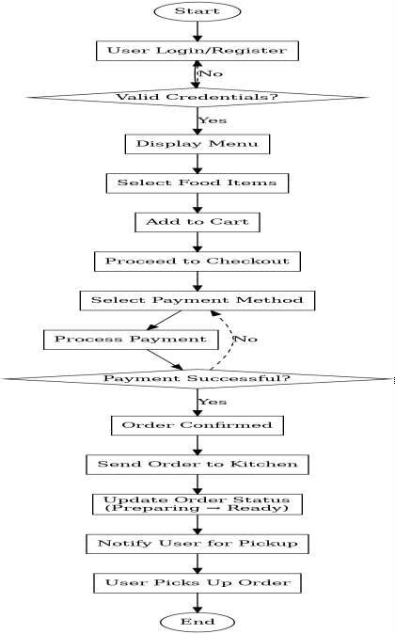
Fig.No:5.4 Activity diagram

SEQUENCE DIAGRAM

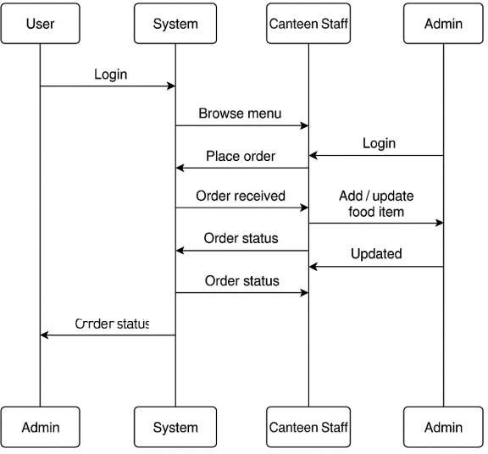

Fig.No:5.5 Sequence diagram

DATAFLOW DIAGRAM

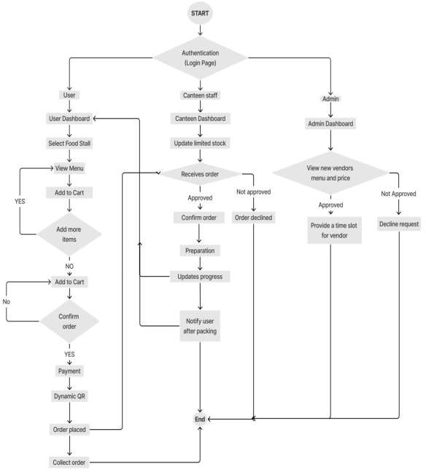

Fig.No:5.6 Dataflow diagram

USE CASE DIAGRAM

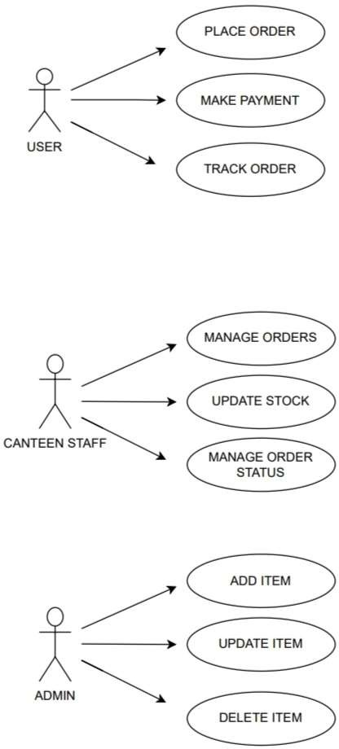

Fig.No:5.7 Usecase diagram

CHAPTER 6 IMPLEMENTATION

TECHNOLOGY IMPLEMENTATION

    - Backend – Node.js with Express.js:
The server-side logic is implemented using Node.js with the Express.js framework. It handles API requests, user authentication, food ordering, and data processing efficiently.
    - Database – MySQL:
MySQL is used to store and manage data such as user details, food items, orders, OTPs, and stock availability. Tables are structured with proper relationships to ensure data accuracy and quick access.
    - Frontend (User App) – Flutter:
The user interface is developed using Flutter to provide a cross-platform mobile experience. It allows students and faculty to view menus, place orders, and track them in real-time with a smooth and responsive design.
    - Frontend (Admin & Staff Panels) – HTML, CSS, JavaScript:
Admin and canteen staff dashboards are developed using basic web technologies for easy access via browser. These panels help manage menus, food stock, and order status.
    - WebSocket for Real-Time Updates:
WebSocket enables live updates between server and client, allowing real-time order tracking, stock availability changes, and instant notifications without refreshing the app.
    - Authentication & Role-Based Access:
Secure login with password encryption and role-based access is used to differentiate between students, staff, and admin, ensuring proper control and data security.

    - Payment Integration:
The system supports both Google Pay (UPI) and Cash on Pickup, allowing users to choose their preferred payment method during checkout.
    - OTP Verification System:
After order placement, a unique OTP is generated and sent to the user and canteen staff. This OTP is verified at the time of food pickup to ensure secure delivery.

IMPLEMENTATION
- User Registration & Secure Authentication
- Interactive Digital Menu & Food Browsing
- Cart System & Custom Order Configuration
- Checkout & Payment Integration
- Order Status Tracking & Real-time Alerts
- Canteen Staff Workflow Management
- Administrative Menu Control Panel

DESCRIPTION

User registration and secure authentication:

This module handles user registration, login, and authentication. Students, faculty, and canteen staff must create an account using their college ID, mobile number, and password. Once registered, users can log in to access the system securely.

Features:
New users register using their details (name, mobile number, email, college ID). Secure login with password encryption.
Role-based access control (Student/Faculty, Cafeteria Staff , Admin ). Forgot Password or Reset Password functionality.

- Interactive Digital Menu & Food Browsing :
A digital menu is presented to users with organized categories such as snacks, meals, and beverages. Each item includes detailed information and real-time availability. Users can browse and make informed decisions before placing an order.
Features:
  - Categorized items for easier browsing.
  - Live stock status to prevent over-ordering.
  - Description of ingredients and pricing.
  - Menu dynamically controlled by staff/admin.

Cart System & Custom Order Configuration:
Users can add desired items to their cart and customize their orders by modifying item quantities or scheduling pickup times. The cart acts as a temporary order summary and prepares data for checkout.

Features:
  - Modify quantity or remove items instantly.
  - Real-time price calculation with tax estimates.
  - Option to apply offers or discount codes.
  - Support for scheduling order pickup.

Checkout & Payment Integration:
This module processes the final order confirmation, allows payment selection, and generates a unique 4-digit OTP to validate order pickup. It ensures a smooth and secure transaction flow.

Features:
  - Checkout with Google Pay (UPI) or Cash on Delivery.
  - Users select a delivery time
  - Order summary generated with estimated preparation time.
  - OTP generated and sent to both user and canteen staff for verification

Order Status Tracking & Real-time Alerts:
Once an order is placed, users are kept updated about its status using a visual timeline. The status updates help users track their orders efficiently and reduce congestion at the pickup counter.

Features :
  - Live updates: Order Placed → Confirmed → Preparing → Ready.
  - In-app notifications at each stage.
  - View complete order history for previous transactions.
  - Estimated wait time display based on kitchen load.

Canteen Staff Workflow Management:
A dedicated staff panel is used to monitor and manage orders. The staff can mark orders as confirmed, in progress, or ready for delivery. They can also adjust stock levels based on inventory.

Features:
  - Receive and manage incoming orders in real time.
  - Update food stock availability on-the-go.
  - Control order flow based on pickup schedules.
  - OTP verification at pickup to ensure secure handover.

ADMIN MENU MANAGEMENT:

Canteen staff can add, update, or remove food items in the system's digital menu. They can manage pricing, and descriptions to keep the menu up to date.

Features:
  - Add new food items with name, price, availability, and description.
  - Update menu details based on ingredient availability.
  - Delete food items if they are no longer available.

CHAPTER 7 FUTURE ENHANCEMENTS

Customizable Add-Ons
To enhance the overall food ordering experience, future versions of the system can introduce a feature that allows users to customize their food according to their taste preferences. This includes options to select the spice level (such as mild, medium, or spicy) add extra toppings (like sauces, or vegetables), and choose side dishes (like salad).

Live Order Tracking with Notifications
Enhance the real-time order tracking system with push notifications, allowing users to receive updates on order status changes and estimated preparation time. Users will be notified at every stage, such as order confirmation, food preparation and readiness for pickup.

QR Code-Based Order Pickup
Introduce a QR code system where users receive a unique QR code after order confirmation, which can be scanned at the canteen for a seamless pickup experience. This feature will minimize errors in order collection and speed up the distribution process. Canteen staff can scan the QR code using a mobile device to instantly verify the order and mark it as completed. This also eliminates the need for verbal confirmation, preventing mix-ups.

Integration with Multiple Payment Gateways
Expand payment options by integrating additional gateways like UPI, credit/debit cards, and digital wallets for a more flexible payment experience.This will make the system accessible to all users, ensuring a seamless and secure transaction process. Additionally, users can be given the option to save their preferred payment method, allowing one-click payments for faster checkouts.

Feedback and Rating System
Introduce a review system where users can rate food items and provide feedback , helping canteen staff improve food quality and service. Users can give star ratings and leave comments on individual dishes, allowing the canteen to identify popular and underperforming menu items. AI-based sentiment analysis can also be implemented to analyze trends in customer satisfaction and suggest improvements based on common feedback themes.

Pre-Order and Subscription Plans
Enable students and staff to pre-order meals for a week or month in advance, reducing last-minute rush and improving inventory planning. A subscription-based model can allow users to choose daily, weekly, or monthly meal plans, ensuring they get their preferred food on time without the hassle of ordering repeatedly. This will also help the canteen staff manage stock and reduce food wastage. Additionally, automated reminders for upcoming orders can be included to ensure timely meal collection.

CHAPTER 8 CONCLUSIONS
The Smart Food Ordering System developed for Sri Shanmugha Educational Institutions successfully transforms the traditional food ordering experience into a modern, efficient, and user-centric process. This project was conceptualized to resolve the common issues faced by students and staff, such as long queues, delayed service, and inefficient communication between users and canteen staff. By introducing a digital platform that integrates Flutter for the frontend, Node.js for the backend, and MySQL for database management, the system brings a seamless technological solution tailored specifically for campus use.
The system’s user-friendly interface ensures that students and staff can easily browse menus, place orders, and make secure digital payments. Real-time order tracking further enhances the user experience by keeping them informed about their order status at every stage. This eliminates unnecessary waiting and allows for better time management during lunch and break hours. For the canteen staff, the system provides a centralized dashboard to manage incoming orders, update item availability, and monitor stock efficiently, thereby reducing errors and improving service speed.
In addition, the system introduces features like OTP verification for order pickup, menu customization, and scheduled ordering, all of which contribute to a more organized canteen environment. Overall, the Smart Food Ordering System meets its objectives by offering a smart, scalable, and practical solution to campus food service challenges. It bridges the gap between technology and daily student life while improving operational efficiency for canteen management. This project lays a strong foundation for future expansions, such as AI-based food suggestions, feedback systems, and integration with hostel meal plans or loyalty programs, making it a long-term asset for the institution.

REFERENCES:

CHAPTER 9 REFERENCES

- Adithya,R.,Singh.A, & Pathan.s,(2017).”Online food ordering system”.International journal of computer applications. https://www.ijcaonline.org/archives/volume180/number6/28805-2017916046

- Kamble.O(2019).”online food ordering system”.International journal of advanced research in computer and communication engineering.
https://ijarcce.com/papers/online-food-ordering-system/

- Rahmab.H,&Ashraf.M,(2019),”A review of the usable food delivery apps”.International journal of engineering research and technology.
https://www.ijert.org/research/a-review-of-the-usable-food-delivery-apps- JERTV8IS120052.pdf

- Wong.S.J, (2019).”Restaurant ordering systems”. Bachelor’s Thesis, Universiti Tunkun Abdul rahman.
http://eprints.utar.edu.my/3448/1/fyp_IA_2019_WSJ_1506513.pdf

- https://developer.amazonservices.com/success-stories?utm_source=chatgpt.com

- https://medium.com/design-bootcamp/ux-case-study-on-swiggy-e4c328ae7969

CODING
AUTHCONTROLLER.JS
const db = require('../config/db'); const bcrypt = require("bcryptjs");

CHAPTER 10 APPENDIX

const jwt = require("jsonwebtoken");
const User = require("../models/userModel"); const dotenv = require("dotenv");
const otpGenerator = require('otp-generator'); const sendOTP = require('../config/email');
dotenv.config();exports.registerStudent = (req, res) => {
const { name, email, phone, password, confirmPassword } = req.body; if (!email.endsWith('@shanmugha.edu.in')) {
return res.status(400).json({ message: 'Email must be from shanmugha.edu.in domain' });
}
registerUser('students', name, email, phone, password, confirmPassword, res);
};
exports.registerStaff = (req, res) => {
const { name, email, phone, password, confirmPassword } = req.body; registerUser('canteen_staff', name, email, phone, password, confirmPassword, res);
};

const registerUser = (table, name, email, phone, password, confirmPassword, res) => {
if (!/^\d{10}$/.test(phone)) {
return res.status(400).json({ message: 'Phone number must be 10 digits' });
}
if (password.length < 8) {
return res.status(400).json({ message: 'Password must be at least 8 characters long' });}
if (password !== confirmPassword) {
return res.status(400).json({ message: 'Passwords do not match' });} bcrypt.hash(password, 10, (err, hashedPassword) => {
if (err) return res.status(500).json({ message: 'Error hashing password' }); const otp = otpGenerator.generate(6, { upperCase: false, specialChars: false
});
const sql = `INSERT INTO ${table} (name, email, phone, password, otp, is_verified) VALUES (?, ?, ?, ?, ?, false)`;
db.query(sql, [name, email, phone, hashedPassword, otp], (err, result) => { if (err) return res.status(500).json({ message: 'Email already exists' }); sendOTP(email, otp)
.then(() => res.json({ message: 'Registration successful. OTP sent to email.', email }))
.catch(() => res.status(500).json({ message: 'Failed to send OTP' }));
});});};
exports.verifyOTP = (req, res) => { const { email, otp } = req.body;
const studentSql = `SELECT otp FROM students WHERE email = ?`; db.query(studentSql, [email], (err, studentResults) => {

if (err) {
console.error('Database error:', err);
return res.status(500).json({ message: 'Database error while verifying OTP'
});
}if (studentResults.length > 0) {
if (studentResults[0].otp === otp) {
const updateStudentSql = `UPDATE students SET is_verified = true WHERE email = ?`;
db.query(updateStudentSql, [email], (err, result) => { if (err) {
console.error('Error updating student verification:', err);
return res.status(500).json({ message: 'Error updating verification status' });
}
return res.json({ message: 'Student email verified successfully' });
});
} else {
return res.status(400).json({ message: 'Invalid OTP' });
}
} else {
const staffSql = `SELECT otp FROM canteen_staff WHERE email = ?`; db.query(staffSql, [email], (err, staffResults) => {
if (err) {
console.error('Database error:', err);
return res.status(500).json({ message: 'Database error while verifying OTP'
});
}
if (staffResults.length > 0) {

// If OTP matches for staff, update verification status if (staffResults[0].otp === otp) {
const updateStaffSql = `UPDATE canteen_staff SET is_verified = true WHERE email = ?`;
db.query(updateStaffSql, [email], (err, result) => { if (err) {
console.error('Error updating staff verification:', err);
return res.status(500).json({ message: 'Error updating verification status'
});}
return res.json({ message: 'Canteen staff email verified successfully' });
});
}

AUTH ROUTE.JS
const express = require("express");
const authController = require("../controllers/authController"); const router = express.Router();
const app=express();
const cors = require('cors'); app.use(cors()); app.use(express.json());
router.post('/register/student', authController.registerStudent); router.post('/register/canteenstaff', authController.registerStaff); router.post('/verify-otp', authController.verifyOTP); router.post('/login', authController.loginUser); router.post('/resetpassword', authController.resetPassword); module.exports = router;

SERVER.JS
const express = require("express"); const dotenv = require("dotenv"); const cors = require("cors");
dotenv.config();const db = require("./config/db");
const app = express();
const foodRoutes = require("./routes/foodRoute"); const shopRoutes = require('./routes/shopRoutes'); app.use(cors());
app.use(express.json());
app.use("/api/auth", require("./routes/authRoutes")); app.use('/api/shop', shopRoutes); app.use("/api/food", foodRoutes);
app.use("/api/orders", require("./routes/orderRoute")); const PORT = process.env.PORT || 3000; app.listen(PORT, () => {
console.log(`Server running on port ${PORT}`);
});

  - SCREENSHOTS:

HOME PAGE:
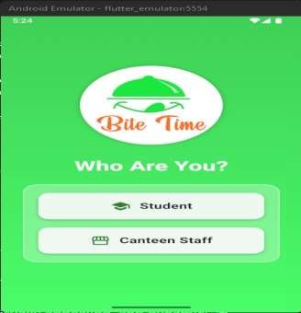

REGISTER PAGE:
Fig.No:10.2.1 Home Page

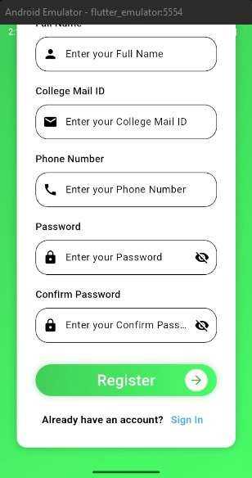
Fig.No:10.2.2 Register page for user and cafeteria staff

LOGIN PAGE:
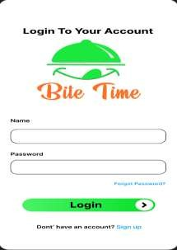

SHOP PAGE:
Fig.No:10.2.3 Login page

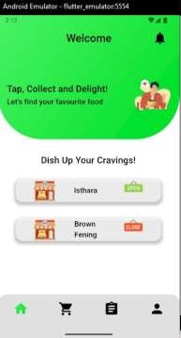

Fig.No:10.2.4 Users view shop details

MENU PAGE:
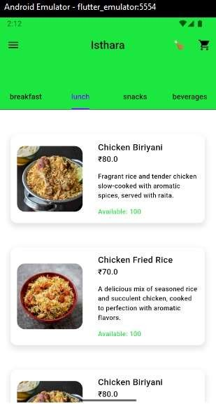

CART PAGE:
Fig. No: 10.2.5 Users view menu with availability

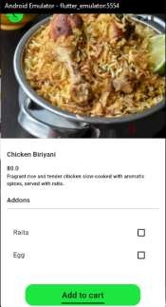

Fig.No:10.2.6 Add to cart page

CHECKOUT PAGE:
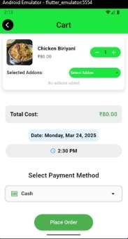

Fig.No:10.2.7 Order process page

ORDER STATUS PAGE:
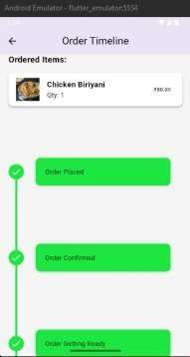

Fig.No:10.2.8 Order status page to know their order preparation level

ADMIN DASHBOARD:
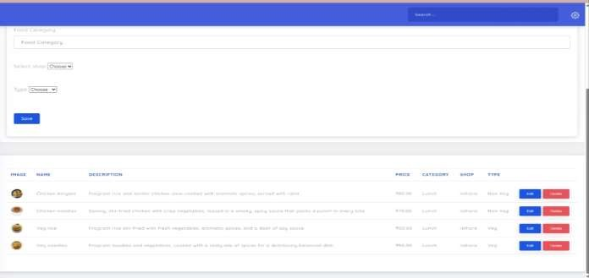

Fig.No:10.2.9 Admin can add, delete ,update food

AVAILABILITY PAGE:
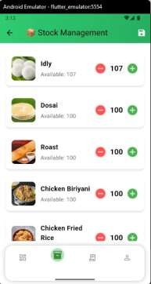
Fig.No:10.2.10 Cafeteria staff add the availability of the food items

CANTEEN ORDERS PAGE:

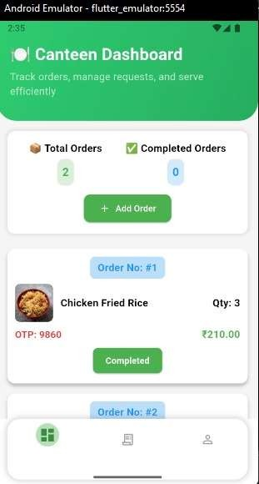
Fig.No:10.2.11 Cafeteria staff receive the orders from users

