INTERNSHIP REPORT

BACHELOR OF TECHNOLOGY

In

Information Technology
by

A SRINITHESH

Reg. No.: 732721205051

Under Supervision of Mrs. kiruthika,

Idm Techpark, Erode- 638011

(Duration: 17th july, 2023 to 28th July, 2023)



DEPARTMENT OF Information Technology

Sri shanmugha college of engineering and technology
(An Autonomous Institution)

sankari, salem.

DEPARTMENT OF INFORMATION AND TECHNOLOGY
SRI SHANMUGHA COLLEGE OF ENGINEERING AND TECHNOLOGY
(An Autonomous Institution)
Sankari,salem.



CERTIFICATE

This is to certify that the “Internship report” submitted by A.SRINITHESH (Regd. No.: 732721205051) is work done by him and submitted during 2021 – 2025 academic year, in partial fulfillment of the requirements for the award of the degree of BACHELOR OF TECHNOLOGY in INFORMATION TECHNOLOGY, at IDM TECHPARH, ERODE.

College Internship Coordinator
PROF. RAMYA
.

CERTIFICATE

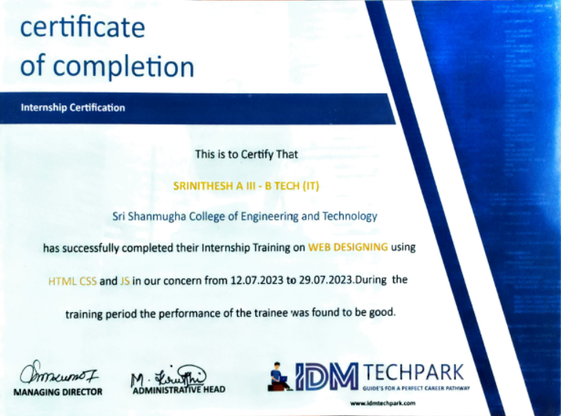

ACKNOWLEDGEMENT

First I would like to thank Mrs.kiruthika, IDM TECHPARK erode for giving me the opportunity to do an internship within the organization.

I also would like all the people that worked along with me IDM TECHPARK erode with their patience and openness they created an enjoyable working environment.

It is indeed with a great sense of pleasure and immense sense of gratitude that I acknowledge the help of these individuals.

I would like to thank my Head of the Department MUTHUKARNAN for his constructive criticism throughout my internship.

I would like to thank Prof.RAMYA, College internship coordinator
Department of IT for their support and advices to get and complete internship in above said organization.

I am extremely great full to my department staff members and friends who helped me in successful completion of this internship.

ABSTRACT

Full stack web development could be a pace growing branch of CSE sector because of its successive step towards making the long run in the IT industry. Full stack developers manage the rear end (backend) and front- end development of web site or an online application. They handle the info, clients, system engineering and style. Full stack developer is in demand since of their skills and mastery of web development, due to this vast demand the remuneration of full stack developers is additionally high as compared to alternative jobs. Full stack developer in the main works on web stack, native application stack or mobile stack. Since, they accompany each server-side development and clientside development, full stack developers head the arrange of action and keep a track of the progress of the project. Within the finish of the paper, we will clearly outline Vision, Challenges and Future scope of Full Stack Web Development..

Organisation Information

IDM TECHPARK is a Leading IT Training Institute in coimbatore and Erode. In terms of computer education and training IDM TECHPARK is known for excellence in quality and for consistently delivering placement-oriented training. IDM TECHPARK does not provide just only a piece of computer knowledge, it also develops an ability on programming skillset. IDM TECHPARK offers Industrial and Summer Training in JAVA, Oracle, PHP/MYSQL, ASP.net, Web Designing, and Graphic Designing etc for B.tech, MCA, BCA, B.E. students. Here, students get knowledge about computer programming and training through IT experts, we provide a guideline as well so that students can make the right decision for their carrier. IDM TECHPARK offers professional and specialized IT Training.

Vision & Mission of Idm Techpark

In our capacity as a development and worldwide certificate training firm, to deliver quality, proactive solutions & services to markets internationally while providing others with cost-effective, responsive services, and in doing so, to satisfy the needs of our clients. Honesty, innovation, and quality enable us to lead in the creation of customer value. We are aware of the competition and consistently strive to outperform them. At Idm Techpark, fulfilling client expectations is our top goal.

Learning Objectives/Internship Objectives

- Internships are generally thought of to be reserved for college students looking to gain experience in a particular field. However, a wide array of people can benefit from Training Internships in order to receive real world experience and develop their skills.

- An objective for this position should emphasize the skills you already possess in the area and your interest in learning more

- Internships are utilized in a number of different career fields, including architecture, engineering, healthcare, economics, advertising and many more.

- Some internship is used to allow individuals to perform scientific research while others are specifically designed to allow people to gain first-hand experience working.

- Utilizing internships is a great way to build your resume and develop skills that can be emphasized in your resume for future jobs. When you are applying for a Training Internship, make sure to highlight any special skills or talents that can make you stand apart from the rest of the applicants so that you have an improved chance of landing the position.

WEEKLY OVERVIEW OF INTERNSHIP ACTIVITIES

1st WEEK | DATE | DAY | NAME OF THE TOPIC/MODULE COMPLETED
 | 17/07/23 | Monday | Introduction of full stack
 | 18/07/23 | Tuesday | Basics of html
 | 19/07/23 | Wednesday | Continuing on html
 | 20/07/23 | Thursday | Basics of cascading style sheet
 | 21/07/23 | Friday | Continuing of cascading style sheet
 | 22/07/23 | Saturday | Basics of bootstrap

2nd WEEK | DATE | DAY | NAME OF THE TOPIC/MODULE COMPLETED
 | 24/07/23 | Monday | Continuing on bootstrap
 | 25/07/23 | Tuesday | Basics of javascript
 | 26/07/23 | Wednesday | Continuing javascript
 | 27/07/23 | Thursday | Basics of react js
 | 28/07/23 | Friday | Certificate distribution
 | 29/07/23 | Saturday

INTRODUCTION

Full stack web development is the scenario of acting on each, the front-end and back-end of a program. It is a term largely used for those operating in web development. The developers have background on making program and user expertise for front-end, and even have robust information in an exceedingly programing language that's used for handling the logic of the appliance, therefore back-end. Full stack could be a layer of software system or web development consisting of the front-end and also the back-end parts of associate application. Front-end is what the users can see or act with on your application. Back-end part is what users don't see, like application's logic, database, server, etc. A fullstack web developer is comfortable operating with each, back-end and front-end technologies that build a web site or application perform properly.

2.HTML

HTML (Hypertext Markup Language) stands as the backbone of web content and structure. Employing a system of tags, it dictates how browsers display text, images, links, and multimedia on web pages. This language encompasses fundamental elements like headings, paragraphs, lists, and forms. HTML5, the latest iteration, brings forth advanced features like video, audio, and canvas for dynamic content creation. Semantic tags like <header>, <nav>, and <footer> enhance accessibility and offer a more meaningful structure to web documents, aiding search engine optimization.
Web developers use HTML in tandem with CSS for styling and JavaScript for interactivity, fostering dynamic and engaging user experiences. The constant evolution of HTML caters to contemporary demands, from mobile responsiveness to intricate application development. Despite the proliferation of complex technologies, HTML's core essence endures, ensuring the seamless creation and dissemination of information across the digital landscape.

<!DOCTYPE html>
<html>
<head>
<title>Sample Page</title>
</head>
<body>
<h1>Hello, World!</h1>
<p>This is a sample HTML page.</p>
</body>
</html>

3.CASCADIND STYLE SHEET

CSS (Cascading Style Sheets) is pivotal in shaping the visual presentation and layout of web content. By applying styles to HTML elements, it determines colors, fonts, spacing, and positioning, enabling a consistent and captivating user experience. Selectors target specific elements for styling, while properties control aspects like size, borders, and transitions. CSS3 introduced transformative capabilities like gradients, animations, and responsive design through media queries.
With the separation of content and design, CSS promotes modularity and maintainability in web development. It facilitates customization for various devices and screen sizes, contributing to responsive and adaptive design principles. Moreover, CSS preprocessors like Sass and LESS extend its capabilities, enabling variables, functions, and nesting for streamlined coding. The synergy between HTML, CSS, and JavaScript forms the cornerstone of modern web development, culminating in visually appealing, functional, and user-centric websites and applications.

Basic Styling:
h1 {
color: blue;
font-family: Arial, sans-serif;
}

Background and Border:
.box {
background-color: #f0f0f0;
border: 1px solid #ccc;
padding: 10px;
}

Text Styling:
a {
text-decoration: underline;
color: #007bff;
}
a:hover {
color: #0056b3;
}
.bold-italic {
font-weight: bold;
font-style: italic;
}

Flexbox Layout:
flex-container {
display: flex;
justify-content: space-between;
align-items: center;
}

4.bootstrap

Bootstrap is a popular open-source front-end framework that simplifies and accelerates web development. Developed by Twitter, it offers a comprehensive set of pre-designed HTML, CSS, and JavaScript components, such as navigation bars, modals, forms, and more. This framework follows a responsive design approach, ensuring seamless adaptation to various screen sizes and devices.
Bootstrap's grid system aids in creating structured layouts, while its utility classes enable quick styling adjustments. Its extensive library of customizable themes and templates empowers developers to create visually appealing websites with minimal effort. Moreover, Bootstrap streamlines cross-browser compatibility, reducing compatibility issues. With its robust documentation and active community, Bootstrap remains a go-to solution for both novice and experienced developers, enabling them to efficiently craft modern and responsive web interfaces.

Example code:
<!DOCTYPE html>
<html>
<head>
<title>Bootstrap Navbar</title>
<!-- Include Bootstrap CSS -->
<link rel="stylesheet" href="https://maxcdn.bootstrapcdn.com/bootstrap/4.5.2/css/bootstrap.min.css">
</head>
<body>
<nav class="navbar navbar-expand-lg navbar-light bg-light">
<a class="navbar-brand" href="#">My Website</a>
<button class="navbar-toggler" type="button" data-toggle="collapse" data-target="#navbarNav" aria-controls="navbarNav" aria-expanded="false" aria-label="Toggle navigation">
<span class="navbar-toggler-icon"></span>
</button>
<div class="collapse navbar-collapse" id="navbarNav">
<ul class="navbar-nav">
<li class="nav-item active">
<a class="nav-link" href="#">Home <span class="sr-only">(current)</span></a>
</li>
<li class="nav-item">
<a class="nav-link" href="#">About</a>
</li>
<li class="nav-item">
<a class="nav-link" href="#">Services</a>
</li>
<li class="nav-item">
<a class="nav-link" href="#">Contact</a>
</li>
</ul>
</div>
</nav>

<!-- Include Bootstrap JS and jQuery -->
<script src="https://code.jquery.com/jquery-3.5.1.slim.min.js"></script>
<script src="https://cdn.jsdelivr.net/npm/@popperjs/core@2.9.3/dist/umd/popper.min.js"></script>
<script src="https://maxcdn.bootstrapcdn.com/bootstrap/4.5.2/js/bootstrap.min.js"></script>
</body>
</html>

5. JAVA SCRIPT

JavaScript (JS) is a versatile and widely-used programming language that brings interactivity and dynamic behavior to websites and web applications. Primarily executed in web browsers, it enables manipulation of HTML and CSS, creating responsive interfaces and real-time updates. JavaScript's flexibility is reflected in its ability to handle user interactions, form validation, animations, and asynchronous operations like fetching data from servers without reloading the page.
With the advent of modern frameworks like React, Angular, and Vue, JavaScript has expanded its reach beyond the browser, enabling the development of complex single-page applications. Its ecosystem encompasses libraries, tools, and package managers, fostering efficient coding practices. The Node.js runtime extends JavaScript's utility to server-side scripting, facilitating full-stack development. JavaScript's continuous evolution and community-driven innovation have solidified its role as a pivotal tool for creating rich, interactive, and powerful web experiences.

Example code:

<!DOCTYPE html>
<html>
<head>
<title>JavaScript Example</title>
</head>
<body>
<button id="myButton">Click Me!</button>
<p id="output"></p>

<script>
// Get the button element by its ID
var button = document.getElementById("myButton");

// Add a click event listener to the button
button.addEventListener("click", function() {
// Get the output element by its ID
var output = document.getElementById("output");

// Update the output text when the button is clicked
output.textContent = "Button clicked!";
});
</script>
6. REACT JS

React.js, commonly known as React, is a JavaScript library developed by Facebook for building modern user interfaces. It introduces a component-based architecture where UI elements are encapsulated into reusable components. This declarative approach allows developers to efficiently manage and update complex UIs by describing how they should look at any given time, abstracting away the underlying manipulation of the DOM.
React's Virtual DOM optimizes performance by minimizing direct interaction with the actual DOM, resulting in faster updates and rendering. It supports a unidirectional data flow, ensuring predictable and manageable state management. React's ecosystem includes tools like JSX for embedding HTML-like syntax within JavaScript, and it's often used in conjunction with other libraries and frameworks for full application development.
React's popularity is attributed to its speed, modularity, and vibrant community, empowering developers to build interactive and responsive web applications with ease.

import React, { useState } from 'react';
function CounterApp() {
// State to track the counter value
const [counter, setCounter] = useState(0);
// Function to increment the counter
const incrementCounter = () => {
setCounter(counter + 1);
};
return (
<div>
<h1>React Counter App</h1>
<p>Counter: {counter}</p>
<button onClick={incrementCounter}>Increment</button>
</div>
);
}
export default CounterApp;

To use this component, you would typically include it in your main application file:

import React from 'react';
import ReactDOM from 'react-dom';
import CounterApp from './CounterApp';
ReactDOM.render(<CounterApp />, document.getElementById('root'));

