**Created and inserted data into table**

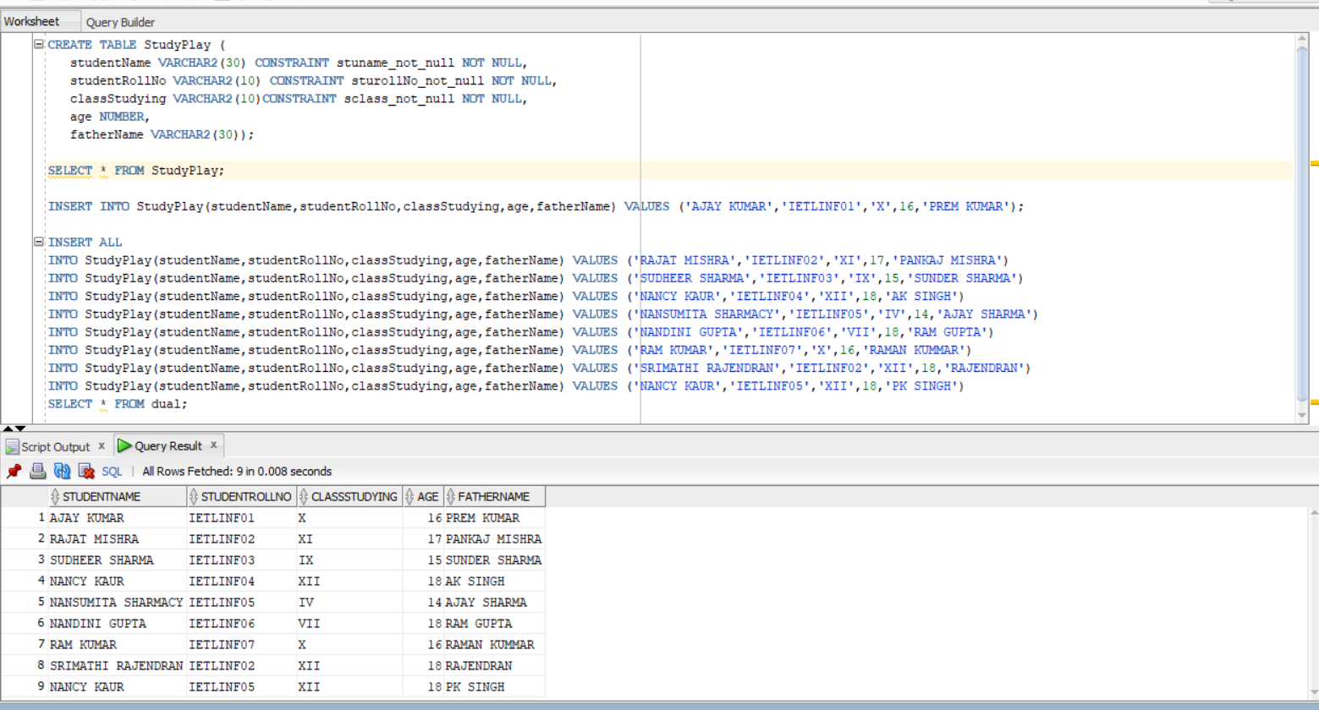

**Query to find total number of student in each class**

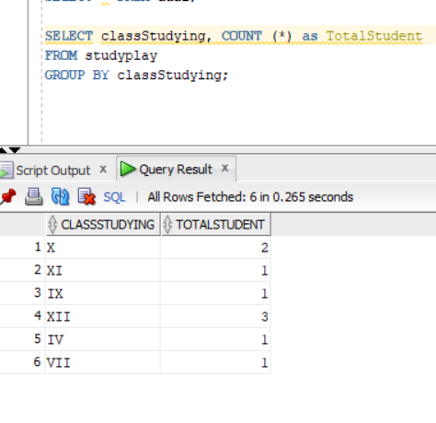

**Average age of student in each class**

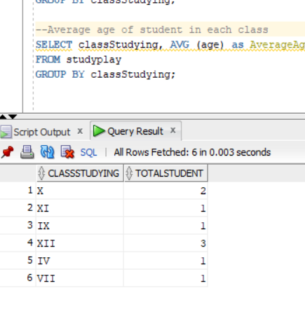

**Number of students having same roll no**

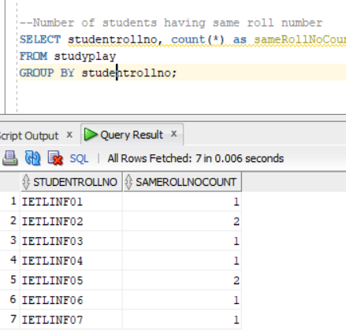

**Duplicate name of the student from the table**

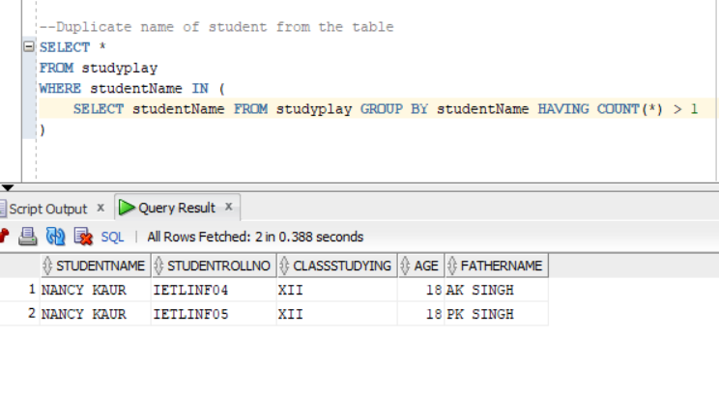

**Created the same table in target DB from admin**

create table INFA_REP.t_StudyPlay as select * from INFA_DOM.StudyPlay where 1=2;





