Spatial and Spectral Analysis of Hand versus Foot Motor Imagery EEG: ICA-Based Preprocessing and CSP+LDA Classification for Subject S023
BCI4NAT Seminar Report, Summer Semester 2026
Dataset: S023_hand_vs_foot (PhysioNet EEG Motor Movement/Imagery Dataset, Task 4, imagined hand vs. foot movement)
Authors:
Srimonchaari Padmanabhan Babu, Matrikelnummer 5012061
Andrew David Flavian Kanickairaj, Matrikelnummer 5008579
Individual contributions:
Both authors contributed equally to data preprocessing, classifier implementation, and analysis. S. Padmanabhan Babu led the Methods and Code sections; A. Kanickairaj led the Results, Discussion, and literature review. Both authors reviewed and approved the final report.

Introduction
BCI systems classify mental states from EEG: attention, workload, emotion, and motor imagery are all examples of internal states that produce a measurable, distinguishable EEG signature without any external behaviour. This project focuses on motor imagery, the mental state of rehearsing a movement without performing it: imagining opening a fist rather than doing it. It qualifies as a mental state in this sense because no muscle activity is involved, yet it still engages much of the same cortical machinery as real movement, which is why it has become a standard control signal for brain–computer interfaces (BCIs). This matters for people who have lost the ability to move, whether from spinal cord injury, ALS, or stroke. A BCI that distinguishes between different imagined movements offers them a way to communicate or control a device without any physical output. That is the practical motivation behind this project: a small-scale version of the same classification problem a real assistive BCI would need to solve.
The EEG signature most associated with motor imagery is event-related desynchronisation, or ERD: a drop in the power of the mu (roughly 8–13 Hz) and beta (roughly 13–30 Hz) rhythms over sensorimotor cortex during the imagery period (Pfurtscheller & Lopes da Silva, 1999). This is a frequency-domain signature, not a time-domain one, and that distinction matters for which feature fits the mental state. An event-related potential (ERP) approach looks for a fixed, time-locked waveform after a stimulus, which suits a brief, stereotyped response but not something sustained and self-paced like imagining a movement, with no single sharp onset to lock a waveform to. What is consistent instead is a shift in ongoing rhythmic power over the whole imagery period, which is what a frequency-domain, band-power measure like ERD captures. ERD is not instantaneous: it builds up gradually after the cue and stays suppressed for as long as the imagery is sustained, followed by a beta rebound, or event-related synchronisation, once the task ends (Pfurtscheller & Lopes da Silva, 1999). The resting mu/beta rhythm reflects a relatively synchronised, idling cortical state, and engaging the motor system, even just by imagining a movement, desynchronises that activity. Where this suppression shows up on the scalp depends on which body part is involved. The motor cortex is organised somatotopically: different regions of the precentral gyrus map onto different body parts, with the hand area lying more laterally and the foot/leg area lying close to the midline. That is the basis for telling hand imagery apart from foot imagery using EEG, not by decoding movement directly, but by picking up on which patch of sensorimotor cortex desynchronises more strongly. Feature extraction methods built around this idea, most notably Common Spatial Patterns, work well for this kind of two-class problem (Müller-Gerking et al., 1999; Ramoser et al., 2000).
This project uses EEG recordings from participant S023 of the PhysioNet EEG Motor Movement/Imagery dataset (Schalk et al., 2004), specifically the imagined hand-versus-foot condition. We preprocess the data in EEGLAB, extract CSP features, classify them with linear discriminant analysis in BCILAB, and evaluate the result with cross-validation. The research question:
Can EEG signals recorded during imagined hand and foot movement be reliably distinguished using a CSP+LDA classifier, and does the spatial pattern of the underlying EEG activity match what is expected from the somatotopic organisation of motor cortex?
Our hypothesis, based on the ERD literature above, is that hand and foot imagery are both classifiable and spatially distinct. First, hand and foot imagery will produce different mu/beta ERD topographies. Foot imagery should show a stronger effect closer to the midline (around Cz); hand imagery a comparatively stronger effect over the lateral central electrodes (C3/C4). Second, a CSP+LDA classifier trained on this data will classify the two conditions well above the chance level of roughly 51%. A real, spatially separable neural signal should be learnable even from a small number of trials.

Methods

Experimental Paradigm
The data come from the PhysioNet EEG Motor Movement/Imagery dataset, a large public collection of recordings from 109 participants performing motor execution and motor imagery tasks under the BCI2000 system (Schalk et al., 2004). Subject S023 completed the imagined hand-versus-foot condition, called task 4 in the original study protocol. A target appears either at the top or the bottom of a screen. When it is at the top, the participant imagines opening and closing both fists; at the bottom, moving both feet. No actual movement happens at any point; the task is purely motor imagery. Each trial begins with the target’s appearance; the next cue follows exactly 8.2 s later, a fixed interval confirmed directly from the recording’s own event timestamps rather than assumed. Runs alternate between the two conditions in a pseudo-randomised order so participants cannot anticipate which imagery task is coming next. Rest periods between runs give the participant a chance to recover attention before the next block.

Data Acquisition
EEG was recorded with a 64-channel montage following the international 10-10 electrode system, using the BCI2000 acquisition system at a sampling rate of 160 Hz (Schalk et al., 2004), as specified in the original PhysioNet documentation. The dataset for this project came already converted to EEGLAB format: a .set file (metadata, channel locations, event markers) and a matching .fdt file (the raw continuous data).

Dataset
The file used, S023_hand_vs_foot.set, contains continuous EEG with three types of event markers: T0 for resting periods between trials, T1 for the onset of hand-imagery trials, and T2 for foot-imagery trials. The recording is 369 s (6.2 min) long and consists of 3 concatenated runs of 123 s each, joined at two boundary events (confirmed directly from the event structure, not assumed). Each run contributes 15 trials at a fixed 8.2 s cue-to-cue spacing, for 45 trials total across the recording: 23 hand, 22 foot. That is close enough to 50/50 that no class-balancing step was needed before training the classifier.

EEG Preprocessing
All preprocessing was done in EEGLAB. Parameters below are reported following the level of detail recommended for EEG studies by Keil et al. (2013): reference scheme, filter cutoffs, epoch window, and baseline correction are all stated explicitly rather than left implicit. The steps ran in this order: re-referencing to the average of all channels; a zero-phase FIR filter combining a 7 Hz high-pass cutoff (removing slow drift below the mu band) with a 30 Hz low-pass cutoff (removing high-frequency noise above the beta band), applied as a single band-pass operation via pop_eegfiltnew; a 50 Hz notch filter for line noise; resampling to 100 Hz; and finally independent component analysis (ICA, extended infomax algorithm) on the continuous, filtered data. The 7–30 Hz passband was chosen to keep the mu and beta rhythms while removing everything else. The 100 Hz resampling rate is more than enough, since nothing of interest for this task lives above 30 Hz.
Average-referencing a 64-channel recording removes one degree of freedom from the data, which EEGLAB reported as a data rank of 63 rather than 64 going into the ICA step. This is expected and not a problem; it just means ICA returned 63 components rather than 64.
We inspected the resulting components using their scalp topographies, activity time courses, and power spectra. One complication is worth stating plainly. The data had already been band-pass filtered to 7–30 Hz before ICA ran, so no component’s spectrum can show the classic broadband or low-frequency-dominated shape a raw eye-blink or muscle artifact would normally have outside that band; that information was filtered out before ICA ever saw the data. What survives, and what we checked, is each component’s spectral shape within the 7–30 Hz band: whether it has a narrow rhythmic peak or is comparatively flat and broadband. Figure 1 shows this for all four components discussed below.
On that basis we removed two components. IC6 and IC15 both showed a small, sharply-bounded focal topography over the left temporal area, distinct from the smoother, broader pattern typical of a cortical source, with sharp, spike-like time courses rather than continuous brain-rhythm fluctuation, together pointing to muscle (EMG) artifact rather than cortical signal. Their within-band spectra were mixed: IC15 is close to flat and broadband, the shape expected from muscle activity, supporting removal; IC6 shows a moderate 10–11 Hz peak, so its spectral evidence alone is less clear-cut and the decision rests mainly on topography and time course.
We kept two other components as genuinely brain-like. IC1 showed a smooth, broad posterior topography with, by a clear margin, the sharpest peak of all four components (around 10 Hz, a textbook posterior alpha rhythm) and a waxing-and-waning time course rather than sharp transients, the strongest spectral evidence for any component in this set. IC4 had a smooth, central topography over roughly the sensorimotor area, an anatomically sensible location for a task-related component, and a time course similarly free of spike-like transients; its within-band spectrum is fairly flat, so unlike IC1 its case for being kept rests mainly on topography and time course rather than spectral shape.
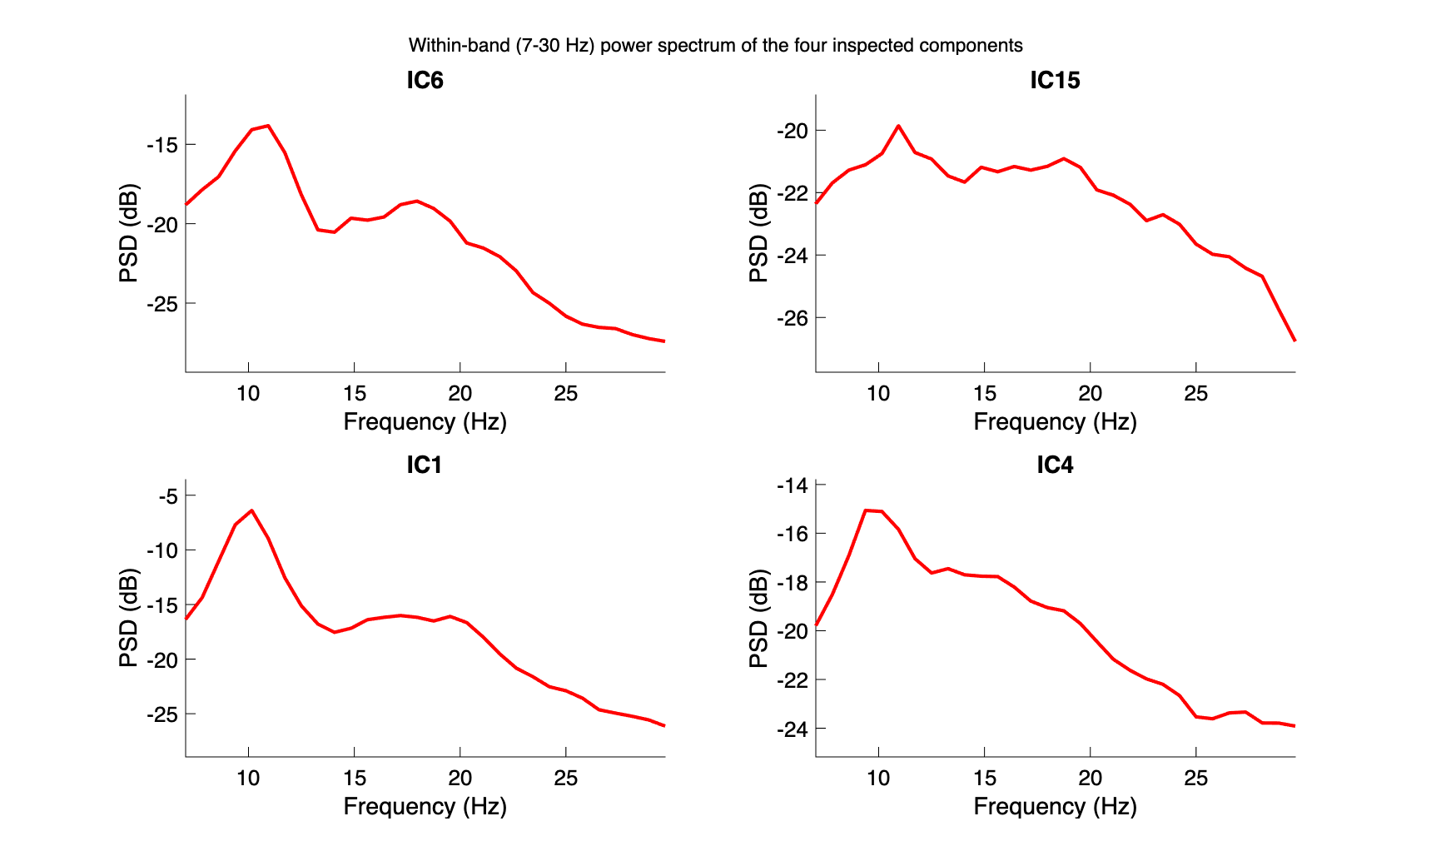
Within-band (7–30 Hz) power spectrum of the four inspected independent components, subject S023. IC1 (kept) shows a sharp, prominent peak near 10 Hz. IC15 (removed) is close to flat with no clear peak. IC6 (removed) and IC4 (kept) both show weaker, broader spectral structure, so for these two the topography and time-course evidence above carries more weight than spectral shape alone.
After component removal, the cleaned continuous dataset was saved separately (before epoching), as required for submission. Epochs were then extracted from $−0.5$ to $3.5$ s relative to cue onset: half a second before the cue as a baseline period, and three seconds of imagery afterwards. Each epoch was baseline-corrected against the $−500$ to $0$ ms window. Worth flagging honestly: an early version of our pipeline additionally tried to crop each epoch down to just the post-cue analysis window using EEGLAB’s pop_select on already-epoched data, which silently corrupted the event labels (caught by checking trial counts before and after: 23 hand / 22 foot dropped to essentially one usable trial). The fix was to keep the full epoch and take the analysis sub-window as a plain array slice later in the pipeline instead.

BCI Approach
At a high level, BCI classification means turning a continuous, noisy brain signal into a single discrete decision: given one trial’s EEG, output one of a fixed set of labels, here hand or foot. That decision is what a real BCI would act on, e.g. to move a cursor left or right, since the raw voltage traces on their own are not usable as a control signal. Getting from raw EEG to that decision takes two steps, feature extraction and classification, and BCILAB was used for both.
Feature extraction and classification were both done through BCILAB, using its CSP paradigm (Common Spatial Patterns) with linear discriminant analysis as the learner. In BCILAB, the whole pipeline is declared as one nested configuration block, an Approach, rather than as separate calls:
{’CSP’, ’SignalProcessing’, {’EpochExtraction’, [0.5 3.5]},
’Prediction’, {’FeatureExtraction’, {’PatternPairs’, 3},
’MachineLearning’, {’Learner’, ’lda’}}}
The outer ’CSP’ selects the paradigm; SignalProcessing controls what BCILAB does to the raw signal before feature extraction, here restricted to just epoch extraction, since filtering, referencing, and ICA were already done in EEGLAB and re-running them would be redundant; and Prediction nests the feature extraction settings (three CSP pattern pairs) inside the classifier settings (LDA as the learner). This single block is what bci_train takes as its Approach argument, and is where the feature-extraction/classifier choice is actually made, not just described. The choice of feature follows directly from the EEG signature described in the Introduction: motor imagery shows up as ERD, a change in mu/beta band power, and CSP is built for exactly this kind of band-power feature. It learns a set of spatial filters, each a weighted combination of the 64 channels. Projecting the data through a filter produces a single signal whose variance should differ as much as possible between the two classes. Band power and signal variance are the same quantity here, since both are computed from the same band-passed 7–30 Hz signal. So a filter that maximises variance for hand trials and minimises it for foot trials is picking out exactly the spatial pattern of band-power difference between the two conditions, which is the ERD contrast we are trying to classify. We used three CSP pattern pairs, giving six spatial filters and six log-variance features per trial: the log of the variance of each filtered signal, one number per filter per trial. This is a fairly standard choice for a dataset of this size, since using many more filters risks overfitting with only 45 trials available.
LDA was the classifier, again through BCILAB (ml_trainlda), with its default regularisation setting. Given the six log-variance features for a trial, LDA finds a linear boundary through that six-dimensional feature space, chosen to best separate the hand trials from the foot trials seen during training. Concretely, BCILAB’s LDA does not hand back a bare label directly: for each trial it returns a discrete score for every class (how strongly the trial’s features favour hand versus foot), and the hard prediction is the class with the higher score, i.e. the argmax over those two scores. This is also how the pooled confusion matrix in Section 3.2 was built, by taking the argmax of each fold’s per-trial scores rather than reading off a pre-computed label. The output is still, in the end, a single predicted label per trial, hand or foot, plus the fold-by-fold statistics reported in Section 3.2. We tried turning regularisation off to get a plain, unregularised LDA and it made results slightly worse, not better, so we kept the default.

Classifier Training
The classifier was trained on the T1 (hand) and T2 (foot) markers directly, using BCILAB’s bci_train function with a 5-fold cross-validation scheme. With 45 trials split roughly evenly between classes, each fold had around nine test trials. The two classes were close to balanced (23 vs. 22). So the theoretical chance level is just the proportion of the larger class: 23/45, or 51.11%.

Results

EEG Patterns of Hand vs. Foot Motor Imagery
Before looking at classifier performance, it is worth checking whether the data contain the kind of signal motor imagery is supposed to produce, rather than just trusting the classification number on its own. Figure 3 shows event-related desynchronisation (ERD): the percentage drop in power during the imagery period relative to a 0.5 s pre-cue baseline, at three electrodes over the sensorimotor strip, C3, Cz, and C4. The imagery window used, 0.5 to 3.5 s after the cue, was chosen to capture the sustained portion of the ERD response rather than its onset. ERD typically takes a moment to build up after a cue, and this dataset’s trials run long enough to support that. Figure 3 pools ERD over that whole 3 s window; Figure 2 below breaks it down further into three sub-windows to show how it develops over time.
The clearest difference between conditions shows up at Cz, in the mu band (8–13 Hz): hand imagery shows strong desynchronisation there, around 83% ERD (higher ERD% means a larger power drop from baseline), while foot imagery shows a comparatively weaker drop, around 75% ERD. This is the opposite of what our hypothesis predicted, a stronger foot-related signal at Cz based on the medial position of the leg and foot representation in motor cortex (Pfurtscheller & Lopes da Silva, 1999). C3 and C4 show a smaller, noisier version of the same pattern, with neither condition consistently beating the other. Figure 4 shows the same pattern as scalp topography: in the mu band, the foot map has a localised teal/blue dip in ERD% right over the central midline, while the hand map stays strongly desynchronised (yellow) across nearly the whole scalp including that region, confirming it is foot imagery that shows the spatially localised weak point at the midline, not hand. The beta-band maps are more similar between conditions, consistent with the smaller, noisier C3/C4 difference described above.
Figure 2 splits the 0.5–3.5 s imagery window into three roughly one-second sub-windows (early, mid, late) and repeats the same baseline-relative mu-band ERD% calculation at Cz for each. Hand ERD% rises from 79.8% early to a peak of 88.0% in the middle of the window, then falls back to 80.2% late. Foot ERD% is highest early at 82.1%, then drops and stays lower for the rest of the window, at 73.5% mid and 73.7% late. So neither condition shows a flat, sustained effect across the full window: hand’s desynchronisation builds up and peaks mid-imagery, while foot’s is strongest right after the cue and fades. So the pooled full-window numbers in Figure 3 are an average over a response that is not constant in time.
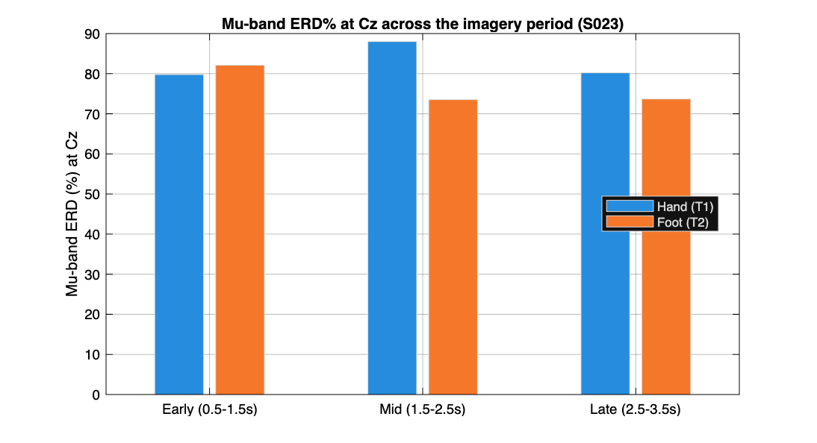
Mu-band (8–13 Hz) ERD% at Cz, split into early (0.5–1.5 s), mid (1.5–2.5 s), and late (2.5–3.5 s) sub-windows of the imagery period, hand versus foot, subject S023.
One limitation is worth stating clearly rather than glossing over. The absolute ERD percentages here (roughly 65–100% depending on channel and frequency) are on the high end even for this kind of task; Pfurtscheller & Lopes da Silva (1999) note that ERD magnitude is sensitive to exactly this kind of methodological choice, since the percentage is computed relative to a baseline period and depends on how reliably that baseline power is estimated. We traced our own values to the short baseline window (0.5 s, 51 samples at the 100 Hz sampling rate used here), which makes the baseline power-spectral-density estimate noisier and biased upward; a related bug with mismatched FFT window sizes between the baseline and imagery calculations made this worse before we caught and partially fixed it, bringing values down from a physiologically implausible 90–100% into a more believable but still-elevated range. The pattern of differences between hand and foot, the finding we care about, should still be trustworthy, since the same bias affects both conditions equally, but the specific percentage values should not be read as precisely comparable to numbers from studies using longer baseline periods.
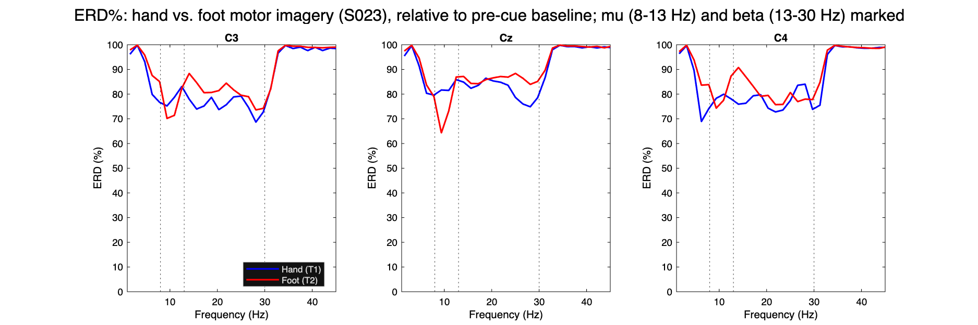
ERD% (percent power drop relative to a 0.5 s pre-cue baseline) at electrodes C3, Cz, and C4 for hand (blue) versus foot (red) motor imagery, subject S023. Vertical dotted lines mark the mu (8–13 Hz) and beta (13–30 Hz) band edges. Hand shows a stronger mu-band ERD% at Cz than foot does.
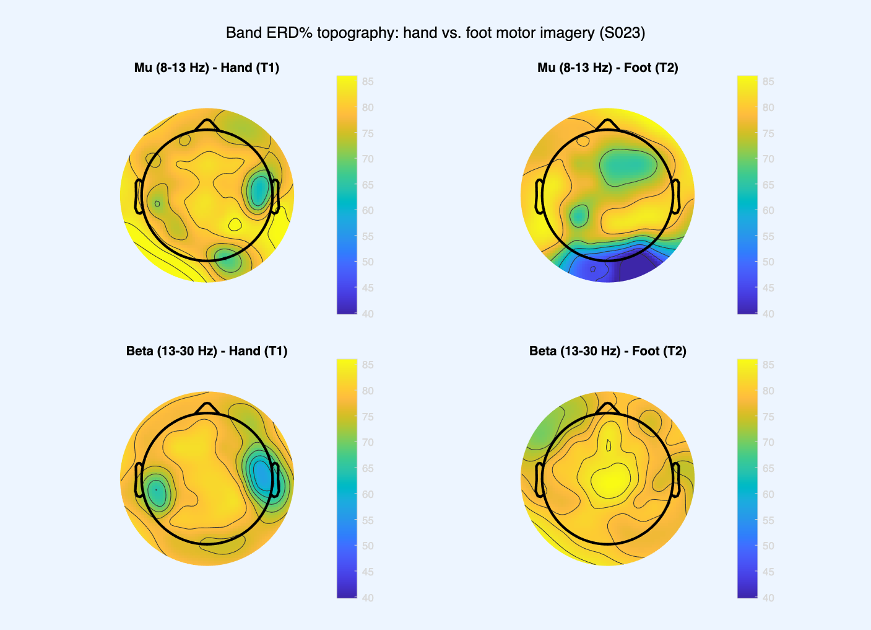
Scalp topography of mu- and beta-band ERD% for hand versus foot motor imagery, subject S023.

BCI Model Validation
The CSP+LDA classifier, trained and evaluated through BCILAB’s bci_train with 5-fold cross-validation, reached an accuracy of 62.22% (misclassification rate 0.3778). Getting a trustworthy number here took more work than expected: BCILAB’s cross-validation fold assignment is supposed to be seeded internally by default, but in practice it was not landing on the same split from run to run even with that default in place, so we stopped relying on it. Instead the 5-fold split is now generated directly in our own script with a seeded randperm and handed to bci_train as an explicit list of train/test index pairs, which removes BCILAB’s internal fold-assignment logic from the picture entirely. We confirmed this is exactly reproducible by rerunning the full pipeline six times in a row and checking that both the fold indices and the resulting confusion matrix came out identical every time.
The theoretical chance level, given the 23/22 class split, is 51.11%: the accuracy a classifier gets for free by always predicting the larger class, computed directly from the class proportions without touching the data. The empirical chance level is different. Rather than being computed, it is estimated by repeatedly shuffling the class labels at random, retraining and re-evaluating the classifier on each shuffled version, and looking at the resulting distribution of accuracies (a permutation test). Since shuffling destroys any real association between the EEG features and the true class, this distribution shows what accuracy the same pipeline would achieve by chance alone given this specific data and procedure, not just the class split, making it a stricter baseline that can catch cases where a pipeline beats the theoretical chance level only because of some artifact in the data or procedure. Estimating it was optional in the assignment and was not run here, so the theoretical value of 51.11% is what the 62.22% result is compared against: 11.11 percentage points above chance, meaning the classifier performs better than random guessing on this data, though not by a wide margin.
Table 1 shows the pooled confusion matrix across all 5 folds, built directly from each fold’s per-trial predictions rather than from averaged rates. Of 23 hand trials, 13 were correctly classified as hand and 10 were misclassified as foot (56.5% correct). Of 22 foot trials, 15 were correctly classified as foot and 7 were misclassified as hand (68.2% correct). The classifier does somewhat better on foot imagery than hand imagery, but the two are closer together than in earlier debugging runs of this pipeline, where a stale random seed had been producing a wider and inconsistent split between the two classes’ accuracy. Table 2 summarises these rates alongside the overall accuracy and chance level. Per-fold misclassification rates had a mean of 0.378 and a median of 0.333 (standard deviation 0.169), reflecting the same source of spread as before: each fold has only about nine test trials, so one wrong prediction moves a fold’s error rate by more than ten percentage points.
Table 1: Pooled confusion matrix, 5-fold cross-validation, BCILAB CSP+LDA (all 45 trials, one prediction per trial from its held-out fold).
 |  | Predicted
 |  | Hand | Foot
Actual | Hand | 13 | 10
 | Foot | 7 | 15
Table 2: Classifier performance, 5-fold cross-validation, BCILAB CSP+LDA.
Metric | Value
Accuracy | 62.22%
Theoretical chance level | 51.11%
Hand trials correctly classified | 56.5% (13/23)
Foot trials correctly classified | 68.2% (15/22)
Hand trials misclassified as foot | 43.5% (10/23)
Foot trials misclassified as hand | 31.8% (7/22)
Misclassification rate, mean $±$ SD | $0.378±0.169$
For comparison, we also implemented the same CSP+LDA pipeline directly in MATLAB rather than through BCILAB’s built-in functions, mainly as a sanity check on the BCILAB result. That version reached a noticeably higher accuracy, averaging around 87% across repeated random 5-fold splits. The gap was not caused by class imbalance, fold randomness, or LDA regularisation settings, all tested directly. The actual cause was a difference in how the two implementations estimate the class covariance matrices CSP is built on: BCILAB pools all trials of a class together before computing one covariance matrix, while our manual version computes a covariance per trial, normalises each one, and averages them, closer to the original CSP formulation described by Ramoser et al. (2000). Both are legitimate approaches, but not numerically the same, especially with only 45 trials, and they gave visibly different spatial filters when compared directly (essentially zero correlation between the two sets of weights). Since the assignment requires BCILAB functions specifically, the 62.22% figure is what we report as the main result; the manual pipeline’s higher number is mentioned here as a cross-check, not an alternative result to pick from.
Figure 5 shows the six spatial patterns (three pattern pairs) learned by the BCILAB model. Most patterns are focal rather than spread diffusely across the whole scalp: patterns 1, 2, and 5 show tight, localised weighting over temporal and bilateral fronto-central regions. That suggests the classifier is picking up on localised activity, not a global artifact such as a shift in the reference or a slow drift. Patterns 3, 4, and 6 are more bilateral or spread across a wider region, which is less textbook but not unexpected: with only 45 trials, some of that is likely the CSP algorithm fitting to whatever happened to separate the two classes best in this small sample, not picking out only the "true" motor-cortex signal. Not every pattern lines up neatly with the classic C3/Cz/C4 sensorimotor sites a larger, cleaner dataset would be expected to show more clearly. So we would treat these patterns as broadly consistent with a real neural signal, not as a precise localisation of it.
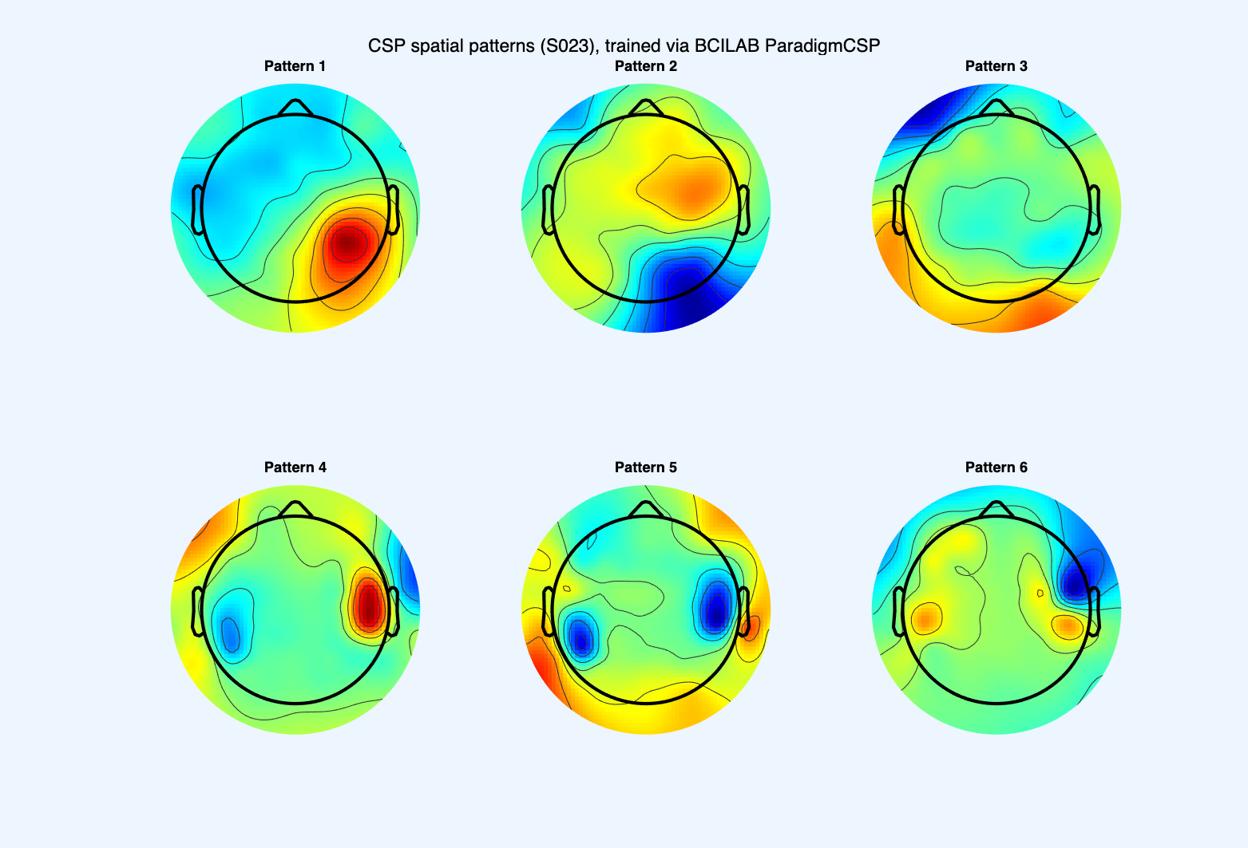
CSP spatial patterns (6 filters, 3 pattern pairs) learned by the trained model, subject S023.

Discussion
The research question asked two things: whether EEG recorded during imagined hand and foot movement can be reliably told apart with a CSP+LDA classifier, and whether the underlying spatial pattern matches what the somatotopic organisation of motor cortex would predict. The answer to the first part is yes, with caveats. The answer to the second part is no: the spatial pattern we found runs opposite to what somatotopic organisation would predict for this subject.
On the classification side, the BCILAB CSP+LDA pipeline reached 62.22% accuracy against a chance level of 51.11%. That is above chance, and consistent with the first half of our hypothesis: a real, spatially separable signal should be learnable from this data even with only 45 trials. It is not an especially high accuracy by the standards of the motor-imagery literature, where numbers in the 80–90% range are common for two-class problems. But those studies typically have more trials per participant, and sometimes more channels or a longer recording session to work with. Given the constraints here, 62.22% is a modest result, above chance but only by around 11 points, which is a narrower margin than we expected going in.
On the spatial side, the ERD results in Section 3.1 do not support the second half of our hypothesis. We predicted foot imagery would show a stronger effect near the midline (Cz) and hand a stronger effect laterally (C3/C4); Cz showed the opposite (hand’s ERD% clearly exceeding foot’s), and neither electrode showed the predicted lateral advantage for hand either. This is a genuine miss, not a partial success. We would not take it as evidence against somatotopic organisation in general, since a single subject and 45 trials is a thin basis for testing something as broad as cortical topography, but our specific prediction about where hand versus foot signals would be strongest was wrong for this subject and this dataset.
A few limitations are worth stating explicitly, beyond what is already noted in Methods and Results. First, this is a single-subject analysis and says nothing about generalisation to a different person with different scalp anatomy, a different resting mu rhythm, or less consistency at the task. Second, the ERD magnitudes in Section 3.1 are inflated by the short pre-cue baseline window, as already discussed there; the direction and relative size of the hand-versus-foot difference should still be trustworthy, but the absolute percentages should not be read too literally. Third, the gap between the BCILAB result (62.22%) and our manual CSP+LDA cross-check (around 87%), traced to how the two implementations estimate class covariance matrices, is a reminder that "the accuracy" of a BCI pipeline depends on implementation choices that matter on a small dataset; 62.22% is what this implementation achieves, not a ceiling on the data. Fourth, several runs of what we thought was the same seeded pipeline (Section 3.2) produced different confusion matrices, because BCILAB’s internal fold-seeding did not pin down the split as documented; generating it ourselves fixed it.
If we were continuing this project, the most obvious next step would be more trials, or data from more of the 109 PhysioNet participants, so the classifier is not trained and evaluated on such a small sample. A cross-subject classifier would also be more realistic, since a real assistive-BCI system ideally would not need retraining per user. Running the empirical chance level would give a more rigorous baseline, and re-running ICA before the band-pass filter would fix the diagnostic-information problem from Section 2.4.
As for a real-world application, the obvious one is the motivation given in the Introduction: an assistive interface for people who cannot move but can still imagine movement. A hand-versus-foot classifier is a minimal example, but the same approach scales to more imagined movements, the direction most practical BCI systems go in.

References
Keil, A., Debener, S., Gratton, G., Junghöfer, M., Kappenman, E. S., Luck, S. J., Luu, P., Miller, G. A., & Yee, C. M. (2013). Committee report: Publication guidelines and recommendations for studies using electroencephalography and magnetoencephalography. Psychophysiology, 51(1), 1–12.
Müller-Gerking, J., Pfurtscheller, G., & Flyvbjerg, H. (1999). Designing optimal spatial filters for single-trial EEG classification in a movement task. Clinical Neurophysiology, 110(5), 787–798.
Pfurtscheller, G., & Lopes da Silva, F. H. (1999). Event-related EEG/MEG synchronization and desynchronization: Basic principles. Clinical Neurophysiology, 110(11), 1842–1857.
Ramoser, H., Müller-Gerking, J., & Pfurtscheller, G. (2000). Optimal spatial filtering of single trial EEG during imagined hand movement. IEEE Transactions on Rehabilitation Engineering, 8(4), 441–446.
Schalk, G., McFarland, D. J., Hinterberger, T., Birbaumer, N., & Wolpaw, J. R. (2004). BCI2000: A general-purpose brain-computer interface (BCI) system. IEEE Transactions on Biomedical Engineering, 51(6), 1034–1043.

