AN

INDUSTRIAL ORIENTED MINI PROJECT
ON
MULTI CLASS IMAGE CLASSIFICATION USING TRANSFER LEARNING

Submitted by
E. Srinadh | - | 22UC1A0515
Abubaker. Ak | - | 22UC1A0501
B. Sai Sri Priya  Md. Afroz | -  - | 22UC1A0504  22UC1A0526
Under the guidance of
Ms. J. Shilpa
Assistant professor
Head of the Department,CSE



DEPARTMENT OF COMPUTER SCIENCE AND ENGINEERING

TALLA PADMAVATHI COLLEGE OF ENGINEERING
AUTONOMOUS

Approved by AICTE New Delhi, Affiliated to JNTUH
Somidi, Kazipet, Hanumakonda-506003

TALLA PADMAVATHI COLLEGE OF ENGINEERING

AUTONOMOUS

Approved by AICTE New Delhi, Affiliated to JNTUH
NAAC Accredited – ISO 9001:2015

Somidi, Kazipet, Hanumakonda-506003



BONAFIDE CERTIFICATE

This is to certify that the Project Report entitled “MULTI CLASS IMAGE CLASSIFICATION USING TRANSFER LEARNING” is a bonafide work carried out by E. Srinadh (22UC1A0515), Abubakar. AK (22UC1A0501), B. Sai Sri Priya (22UC1A0504) and Md. Afroz (22UC1A0256) under supervision of Ms. J. Shilpa Assistant Professor, COMPUTER SCIENCE AND ENGINEERING from Talla Padmavathi College of Engineering (Autonomous), Hanumakonda, affiliated to Jawaharlal Nehru Technological University Hyderabad, Hyderabad, Telangana during academic year 2024-2025.

Internal Guide Head of the Department

External Guide Principal/ TPCE

DECLARATION
We, E. Srinadh (22UC1A0515), Abubaker AK (22UC1A0501), B. Sai Sri Priya (22UC1A0504) and Md. Afroz (22UC1A0526) Third year students from Talla Padmavathi College of Engineering (Autonomous), Hanumakonda, affiliated to Jawaharlal Nehru Technological University, Hyderabad, Telangana, solemnly declare that this Project titled “MULTI-CLASS IMAGE CLASSIFICATION USING TRANSFER LEARNING” is a bonafide work carried out by us under the supervision of Ms.J.Shilpa, Assistant Professor, H.O.D of Computer Science and Engineering for the Award of Bachelor of Technology in Computer Science and Engineering.

We also declare that this project work does not constitute in part or full of any other works that have been earlier submitted to this university or any other institutions for the award of any degree/ diploma.

S.NO SIGNATURE | NAMES | ROLLNO
1 | E. Srinadh | 22UC1A0515
2 | Abubaker.Ak | 22UC1A0501
3 | B. Sai Sri Priya | 22UC1A0504
4 | Md. Afroz | 22UC1A0526

ACKNOWLEDGEMENT

We are grateful to our Chairman, Mr. Talla Mallesham, for providing us ambient learning experience at our institution.We are greatly thankful to our Director, Dr. Talla Vamshi, and Directrix Mrs. Talla Chaitanya, for their encouragement and valuable academic support in all aspects.We are thankful to our Principal, Dr. R. Velu, for his patronage towards our project and standing as a support in the need of the hour.We would like to acknowledge and express our sincere thanks to our guide Ms. J. Shilpa, Assistant Professor, HOD of Computer Science and Engineering for introducing the present topic and for the inspiring guidance, constructive criticism and valuable suggestions through-out our project work which have helped us in bringing out this proficient project.
We also thank all the faculty members of our institution for their kind and sustained support throughout our program of study.

E. Srinadh | - | 22UC1A0515
Abubaker.AK | - | 22UC1A0501
B. Sai Sri Priya | - | 22UC1A0504
Md. Afroz | - | 22UC1A0526

ABSTRACT

Our project aims to classify natural scenery images using artificial intelligence. Traditional methods face challenges like high computational cost, limited data augmentation, and the need for large datasets. To address these issues, we propose an improved system that uses data augmentation techniques such as rotation, brightness adjustment, and cropping to increase model accuracy and generalization. Instead of building large datasets, we fine-tune pre-trained deep neural networks for efficient training. We introduce a novel training criterion based on the error back propagation algorithm, focused on maximizing class separation and minimizing classification error. We also analyze cross-entropy loss to enhance performance.
The system is designed for flexibility, supporting custom model training, API integration, and variable input image sizes. Our results show improved classification accuracy, reduced reliance on manual feature extraction, and better adaptability for real-world natural scenery recognition.

INDEX

CONTENTS Page No

CHAPTER-1

Introduction 1
1.1 Over view of the Project 1
1.2 Benefits of the Project 1
1.3 Working of the Project 2

CHAPTER-2
Literature Survey 3

CHAPTER-3
System Analysis 4
3.1 Existing System 8
3.2 Proposed System 9
3.3 Algorithm 13
3.4 System Requirements 14

CHAPTER-4
System Design
4.1 System Architecture 15
4.2 UML Diagrams 16

CHAPTER-5
Software Specifications
5.1 Python Technology 21
5.2 Python Library 25
5.3 Machine Learning Overview 26

CHAPTER-6
System Implementation 31

CHAPTER-7
Testing
7.1 Manual Testing 33
7.2 System Testing 34
7.4 Types of Testing 34

CHAPTER-8
Result and Discussion 35

CHAPTER-9
Conclusion 39

CHAPTER-10
Future Scope 40
Bibliography 41
Appendix 42

CHAPTER-1

INTRODUCTION

Image classification is a key task in computer vision, with wide applications in fields like environmental monitoring and tourism. Classifying natural scenery images poses unique challenges due to variations in lighting, angles, and landscape types. Traditional machine learning models often require large datasets and manual feature extraction, making them less efficient. In this project, we use artificial intelligence and deep learning to automate and improve the classification process. By applying data augmentation and using pre-trained models, we reduce training time and enhance accuracy. Our approach offers a flexible, efficient solution for recognizing and categorizing natural scenery images with greater precision.
1.1 Overview of Multi-class Image Classification using Transfer Learning
This project presents an AI-based system for classifying natural scenery images. It addresses the limitations of traditional methods by using pre-trained deep learning models and data augmentation techniques to improve accuracy and flexibility. The model is trained using a refined backpropagation algorithm and cross-entropy analysis to reduce classification errors. The system supports custom input sizes, API integration, and real-time image recognition for practical applications.

1.2 Benefits of Using Multi-class Image Classification using Transfer Learning
The proposed system offers several key benefits. It improves classification accuracy by using data augmentation techniques that help the model learn from varied image conditions. By utilizing pre-trained deep learning models, the need for large datasets and extensive training is reduced. The system also minimizes classification errors through an advanced training method based on backpropagation and cross-entropy analysis. It supports flexible image input sizes, making it adaptable to different use cases. Additionally, API integration allows easy deployment in real-time applications, enhancing its usability in practical environments.

1.3 How Multi-class Image Classification using Transfer Learning Work:
The working of our project begins with the collection of natural scenery images from various sources. These images are then passed through a preprocessing phase, where data augmentation techniques such as rotation, cropping, zooming, and brightness adjustments are applied. This step increases the diversity of the training dataset, helping the model learn from different versions of the same image and improving its ability to generalize.
Next, important features are extracted from the images, either automatically by the deep learning model or through preprocessing layers. These features are then used to train a pre-trained deep neural network, which has already been trained on a large dataset and fine-tuned for our specific task. During training, we apply an optimized back propagation algorithm to minimize classification errors and maximize the separation between image categories. Cross-entropy is used as the loss function to measure how well the model is learning.
Finally, the trained model is tested on new images to classify them accurately. The system outputs both the predicted class and a confidence score, allowing for reliable, real-time image recognition.
Once the model is trained, it becomes capable of recognizing different types of natural scenery like forests, mountains, rivers, or beaches, even if the images vary in lighting or angle. This flexibility comes from the data augmentation and the use of a powerful pre-trained model. Instead of starting from scratch, we build on existing knowledge, which saves time and improves results. The model doesn’t just give a blind answer—it also shows how confident it is in its prediction, which is helpful in judging accuracy.
To make the system usable in real-world applications, we’ve also ensured it can work with different image sizes and can be connected to other platforms using APIs. Whether it is part of a mobile app, a web service, or a desktop tool, this model can fit in and start working right away. It’s fast, efficient, and designed to keep learning and improving as it processes more data over time.

CHAPTER-2

LITERATURE SURVEY

The “Multi-class Image Classification using Transfer Learning” by Niharika Gupta and Priya Nitin Khobragade, published in January 2023 in the International Journal for Research in Applied Science and Engineering Technology, explores the application of AI to classify natural scene images, with a specific focus on distinguishing between indoor and outdoor environments. This task is particularly challenging due to overlapping visual features in certain images, such as semi-open spaces or structures with large windows, which confuse standard classification models. To address this, the authors utilize transfer learning with a pre-trained AlexNet model, which they fine-tuned on a well-known dataset called the Intel Image Classification dataset. This dataset includes over 25,000 images spread across six categories: buildings, forests, glaciers, mountains, sea, and streets. A notable contribution of their work is the introduction of a novel loss function—M3CE (Maximum Interval Minimum Classification Error)—which, when combined with traditional cross-entropy loss, helps improve the model's ability to differentiate between visually similar scenes. Their approach showed improved classification accuracy and decision clarity, particularly when evaluated on standard datasets like MNIST and CIFAR-10, highlighting the effectiveness of their method. Although the exact performance metrics on the Intel dataset are not detailed in the abstract, their model showed clear advantages in learning efficiency and prediction precision. The paper demonstrates that transfer learning, coupled with innovative training strategies, can significantly enhance the performance of image classification tasks where traditional methods struggle due to feature ambiguity.
CHAPTER-3

SYSTEM ANALYSIS

Project Requirements Analysis:
Functional Requirements: define the essential tasks and features the system must perform. In this project, the system should take natural scene images as input and classify them into different categories such as indoor, outdoor, forest, or urban. It needs to use transfer learning to improve classification accuracy and provide results with confidence scores. For example, if a user uploads a forest image, the system should correctly identify it as “forest.” Additionally, it should support fine-tuning the model on new datasets and display performance metrics like accuracy, precision, and recall assessing effectiveness.
Design and Architecture:
The front end of the system provides a user-friendly interface for uploading images and displaying classification results, typically built using web technologies like HTML, CSS, and JavaScript or frameworks like React. The back-end handles image processing, model loading, and prediction using Python with frameworks such as Flask or DJango.
Security Considerations:
Security is vital to protect user data and system integrity. The system should ensure secure image uploads by validating and sanitizing inputs to prevent malicious files. Data privacy must be maintained, especially if storing user images. Secure communication protocols like HTTPS should be used to protect data in transit. Access controls and regular updates help prevent unauthorized access and vulnerabilities.
Data Handling:
Involves collecting, storing, and processing images securely and efficiently. Uploaded images are pre-processed resized and normalized before use. The dataset is carefully labeled and split into training, validation, and testing sets to ensure accurate model evaluation. Proper data management practices prevent data loss, maintain privacy, and enable smooth model training and inference.

Implementation Details:

Project Structure
The project is organized into several key files and directories:
app.py: The main Streamlit application file that handles the user interface and real-time classification.
train_model.py/train.py: The script responsible for training the animal classification model using TensorFlow and Keras.
animaldaset/: A directory containing the dataset for training the model, organized into subdirectories for each animal class.
requirements.txt: A file listing all the Python dependencies required for the project.
Model Training
The model is built using the MobileNetV2 architecture, a pre-trained convolutional neural network (CNN) from TensorFlow.
The training script (train.py) uses the ImageDataGenerator from Keras to load and preprocess the images from the dataset.
The model is trained for a specified number of epochs, and the trained model is saved as model.h5.
User Interface
The Streamlit app (app.py) provides a user-friendly interface with two main features:
Webcam Input: Users can take pictures using their webcam for real-time classification.
Image Upload: Users can upload images from their local machine for classification.
The app displays the top three predictions along with their confidence scores.
Image Preprocessing
Images captured from the webcam or uploaded by the user are preprocessed to match the input requirements of the model:
Resizing to 224x224 pixels.
Normalizing pixel values to the range [0, 1].
Converting the image to RGB format.
Model Loading and Prediction
The trained model is loaded using TensorFlow's load_model function.
The app uses the model to predict the class of the input image and displays the results to the user.

Error Handling
The app includes error handling to manage cases where the model file is not found or the dataset is not properly organized.
It also handles errors during image processing and prediction.
Dependencies
The project relies on several Python libraries, which are listed in requirements.txt. These include TensorFlow, Keras, Streamlit, OpenCV, NumPy, and others.
Deployment
The app can be run locally using Streamlit, allowing users to interact with it through a web browser.
Technologies Used:
Python
The primary programming language used to build the application.
TensorFlow
A deep learning framework used to build, train, and deploy the animal classification model.
Keras
A high-level neural network API that runs on top of TensorFlow, used for model definition and training.
Streamlit
A Python library for creating interactive web applications. It’s used to build the user interface for the animal classification app, allowing users to upload images or use their webcam for real-time classification.
Open CV (cv2)
A computer vision library used for image processing tasks, such as resizing and converting images to the format required by the model.
NumPy
A numerical computing library used for handling arrays and matrices, essential for image preprocessing and model predictions.
Pillow (PIL)
A library for opening, manipulating, and saving many different image file formats, used in image handling.
Scipy
A library used for scientific and technical computing, which may be required for certain image processing tasks.

Virtual Environment
A tool used to create isolated Python environments, ensuring that the project dependencies do not conflict with other projects.
Git
A version control system used to manage the project's source code and track changes.
Testing and Validation:
Unit Testing: Unit testing involves testing individual components like image preprocessing, model prediction, and API endpoints to ensure each works correctly. Tools like unittest or pytest in Python are commonly used.
Integration Testing:
Integration testing checks if different parts of the system work together smoothly. For example, it makes sure the image upload, processing, and prediction flow correctly from front end to back end.
Security Testing:
Security testing ensures the system is protected against threats like malicious file uploads, unauthorized access, and data breaches Documentation and Support:
User Documentation:
Provide clear instructions on how to use the system, including steps to upload images, view classification results, and interpret confidence scores. Also, include supported image formats, file size limits, and any usage guidelines.
Deployment and Maintenance:
Deployment Strategy:
Document the overall system architecture, including front end and back end components. Include setup instructions, environment configurations, model training procedures, API endpoints (if any), and guidelines for modifying or extending the project in the future.

3.1 EXISTING SYSTEM

PatternDefinition: Traditional multi-class image classification systems rely on predefined machine learning or deep learning models. These models often use fixed architectures and rules for learning image features and patterns across different classes.
Randomization: There is minimal randomness or adaptability in older systems. Data augmentation techniques like rotation or flipping are limited, leading to less variability and weaker generalization on unseen data.
Generation Process: The classification process involves extracting features manually or through standard CNN layers, followed by training a model to map these features to class labels. This process requires extensive tuning and high computational resources.
Constraints and Requirements: These systems typically require large, well-labeled datasets for training. They also suffer from constraints like fixed input image sizes, limited augmentation capabilities, and difficulty in handling overlapping features among classes.
Output: The final output is the predicted class label for the input image. However, the confidence and accuracy of predictions can be affected by limited feature extraction and high computational demands.
Example of an Existing Image Classification System:
Let’s say the old system uses a traditional deep learning model with basic feature
extraction and no transfer learning:
Pattern: Fixed CNN architecture trained from scratch
Data input: Requires high-resolution images of a fixed size
Randomization: Limited data augmentation (e.g., basic rotation or flipping)
Given these parameters, a classified image might output a label like:
Forest with 60% confidence.
Limitations of Existing Image Classification Systems:
High Computational Cost: Training deep models from scratch consumes extensive time and resources.
Limited Data Augmentation: Reduces the model’s ability to generalize .
Feature Extraction: Traditional methods struggle with complex scenes where features overlap or blend.
Fixed input size image: Restricts model flexibility and may lead to loss of important details during resizing.

3.2 PROPOSED SYSTEM
System Overview
The proposed system is a multi-class image classification application that utilizes transfer learning to classify images into various categories. Instead of training a deep neural network from scratch, the system uses pre-trained models combined with image augmentation techniques to improve accuracy and reduce resource requirements. It is designed for both research and real-world deployment scenarios, offering flexibility, scalability, and customization.
KeyFeatures
Transfer Learning Integration
Uses pre-trained models like ResNet, VGG, or MobileNet for better performance with smaller datasets.
Allows fine-tuning of selected layers to adapt to domain-specific images.
Image Augmentation Support
Improves model generalization using techniques like rotation, cropping, brightness adjustment, flipping, and zoom.
Ensures the model can handle various image variations during real-world testing.
Training Flexibility
Custom training settings including batch size, epochs, and learning rate.
Support for multiple image classes with adjustable input formats.
User Preferences
Confidence Score Display
Outputs prediction confidence for each class to help in interpreting results.
Custom Model Training Option
Users can train on their own datasets by uploading labeled images.
Choice to retrain or fine-tune existing models.
API Integration
Supports RESTful API for integration into other systems or applications.
Enables remote image classification and automation.
Custom Input Image Size
Supports resizing images to match input requirements of different models.
Allows flexibility based on performance and memory considerations.

Security & Performance Features
Efficient Computation
Optimized model selection for faster inference without sacrificing accuracy.
Supports real-time processing on both CPU and GPU environments.
Common Error Handling
Detects and skips corrupted or unsupported image files during training and inference.
Model integrity
Ensures consistent results using a fixed random seed for reproducibility.
Additional Tools
Visualization Tools
Confusion matrix and classification reports for evaluating model performance.
Graphical display of accuracy and loss trends over training epochs.
Model Exporting
Supports exporting trained models to formats like .h5, .pt, or .onnx for deployment.
Design Considerations
User Interface (UI)
Clean, web-based interface with options for uploading images, adjusting model parameters,and
viewing results.
Supports drag-and-drop functionality and progress indicators during training.
User Experience (UX)
Instant feedback on classification output and model confidence.
Simple explanations of each parameter to help users understand their impact.
Performance
Scalability
Supports large datasets by using data generators and batch processing.
Expandable architecture to add more classes and improve accuracy with future data.

Implementation Steps
Research and Planning
Analyze available pre-trained models and select suitable ones for transfer learning
Prepare and organize image dataset into labeled classes.

Design
Create a flowchart and UI mockup for dataset upload, training, and prediction.
Decide augmentation methods and model settings.
Development
Develop scripts for image preprocessing, augmentation, model training, and evaluation.
Build the front-end UI and integrate it with back-end model logic.
Testing
Perform unit testing on preprocessing and classification functions.
Conduct integration testing across UI, API, and model.
Use sample datasets for User Acceptance Testing (UAT).
Deployment
Host the web app using platforms like Heroku or Streamlit.
Set up monitoring and log tracking for inference speed and accuracy
Documentation
Write user guides explaining how to use the application.
Document source code, training scripts, and system architecture for developers.
Technical Specifications
Feature | Details
Programming Languages | Python
Frameworks/Libraries | TensorFlow, Keras, OpenCV, NumPy, Streamlit
 | MobileNetV2 (used for Transfer Learning)
Image Augmentation  Deployment Platform  Model Output Format  Input Types Supported | Rotation, Zoom, Width Shift, Height Shift, Horizontal Flip  Streamlit (Local Deployment)  .h5 file (Keras model format)  Image Upload, Webcam Feed
User Interface | Streamlit Web App for real-time image classification

Future Enhancements
Real-time camera input for live classification.
Mobile app integration for on-device inference.
Active learning for continuous improvement based on user corrections.

3.3 ALGORITHM

In this project, we aim to build a multi-class image classification system using transferlearning, which improves model performance even on limited datasets. The system accepts images as input and classifies them into predefined categories with high accuracy. It also allows fine-tuning, image augmentation, and confidence-based output.
Step-by-Step Algorithm:
Convolutional Neural Network (CNN)
The core algorithm used for image classification is a Convolutional Neural Network. Specifically, the project utilizes the MobileNetV2 architecture, which is a pre-trained CNN model. CNNs are particularly effective for image recognition tasks due to their ability to automatically learn hierarchical features from images.
Transfer Learning
The project employs transfer learning, where a pre-trained model (MobileNetV2) is fine-tuned on your specific dataset. This approach leverages the knowledge gained from training on a large dataset (like Image Net) and applies it to a smaller, task-specific dataset, improving performance and reducing training time.
Image Augmentation
Techniques such as rotation, zoom, width/height shift, and horizontal flip are used to augment the training data. This helps in increasing the diversity of the training set, improving the model's ability to generalize to new, unseen images.
Gradient Descent
The training process likely uses an optimization algorithm like Adam (a variant of gradient descent) to minimize the loss function and update the model's weights during training.
Softmax Activation
The output layer of the model uses a softmax activation function to convert the raw logits into probabilities, allowing the model to predict the class of the input image.

3.4 SYSTEM REQUIREMENTS

Hardware Components:

Processor : Intel Core i5 or above

RAM : Minimum 8 GB (16 GB recommended for large datasets)

Hard Disk : 500 GB HDD or SSD

Graphics : NVIDIA GPU with CUDA support

Software Components:

Technology : Windows 10 / Linux / macOS

Programming Language : Python 3.8+

Libraries/Frameworks : Tensor Flow / Keras
Open-CV
Scikit-learn
Streamlit

CHAPTER-4

SYSTEM DESIGN
4.1 System Architecture
The Figure 4.1 illustrates the workflow of a Machine Learning (ML) classification system, highlighting the main stages from data collection to output generation.
Data Sampling and Collection Packet:
This is the initial stage where raw data is collected from various sources. It includes capturing and organizing data packets required for further processing.
Feature Extraction:
Once data is collected, relevant features are extracted. This step transforms raw data into a structured format that is suitable for ML algorithms, isolating the most significant variables.
ML Training Phase:
In this stage, the extracted features are used to train the ML model. This involves learning patterns and relationships in the training data to create an effective predictive model.
ML Testing Phase:
A separate portion of the data is used for testing. This step evaluates the performance of the model and ensures it generalizes well to unseen data.
ML Classification Model:
The core machine learning model built during the training phase is now used to classify or make predictions based on the input features.
Classification Output (Results):
The final output of the classification model is presented as results, which could include class labels, confidence scores, or probability distributions.

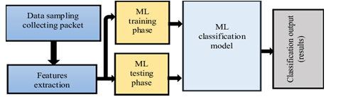

Figure 4.1 System Architect
4.2 UML DIAGRAMS:
Introduction:
The unified modeling language (UML)is general purpose, developmental, modeling language in the field of software engineering that is intended to provide standard way to visualize the design of a system. The unified modeling language (UML)offers a way to visualize system's architecture blueprints in a diagram (see image), including elements such as any activities individual components of the system and how they can interact with other software components. How the system will run, how entities interact with others components and interfaces) external user interface. The system design is the process of defining the architecture, components, modules, interfaces and data for a system to satisfy requirements. Systems design could be seen as the application of systems theory to product development. The design is broadly classified into two levels according to software engineering. They are high level design and low-level design. They are explained as follows. UML design modeling, which focuses on the behavioral modeling, implementation modeling and environmental model view. Use case diagram represent the functionality of the system from a user’s point of view use case are used during requirements elicitation and analysis to represent the functionality of the system. Use case focus on the behavior of the system from external point of view. Goals: The Primary goals in the design of the UML are: Provide users a ready-to-use, expressive visual modeling Language so that they can develop and exchange meaningful models. It also provides extendibility and specialization mechanisms to extend the core concepts, be independent of particular programming languages and development process. It provides a formal basis for understanding the modeling language also encourage the growth of OO tools market and integrate best practices.
In our project we have the following UML diagrams they are :
4.2.1 Use Case Diagram
4.2.2 Class Diagram
4.2.3 Sequence Diagram
4.2.4 Activity Diagram
4.2.1 USE CASE DIAGRAM:
A use case diagram in the Unified Modeling Language (UML) is categorized as a behavioral diagram, which is established through a use-case analysis. Its primary function is to provide a visual representation of the system functionalities, highlighting the actors involved, their objectives (depicted as use cases), and the interdependencies among these use cases as shown in FIG-4.2.1. The fundamental aim of a use case diagram is to indicate the system functions that are executed for each actor, along with the roles that the actors play within the system.
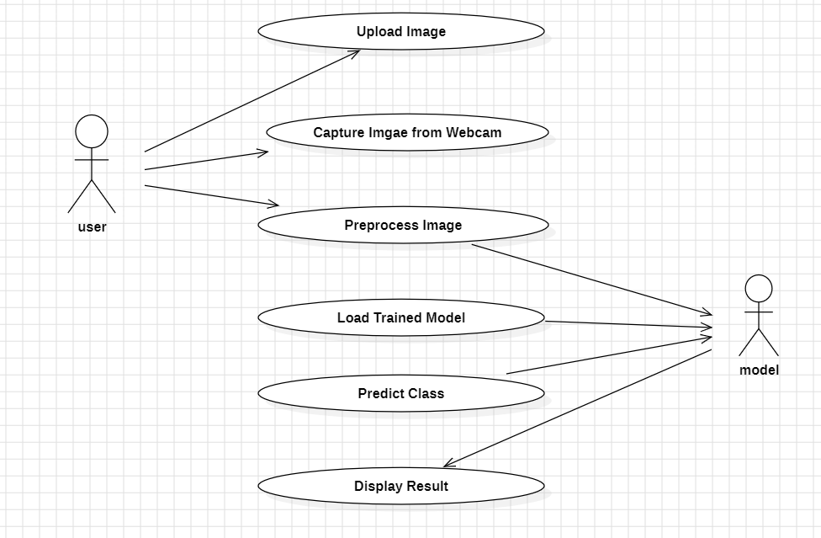

Figure:4.2.1 Usecase Diagram

CLASS DIAGRAM:
In the field of software engineering, a class diagram within the Unified Modeling Language (UML) serves as a static structure diagram that illustrates the architecture of a system as shown in FIG 4.2.2. It delineates the system classes, their respective attributes, methods, and the interrelations among these classes, thereby clarifying which class holds specific information.
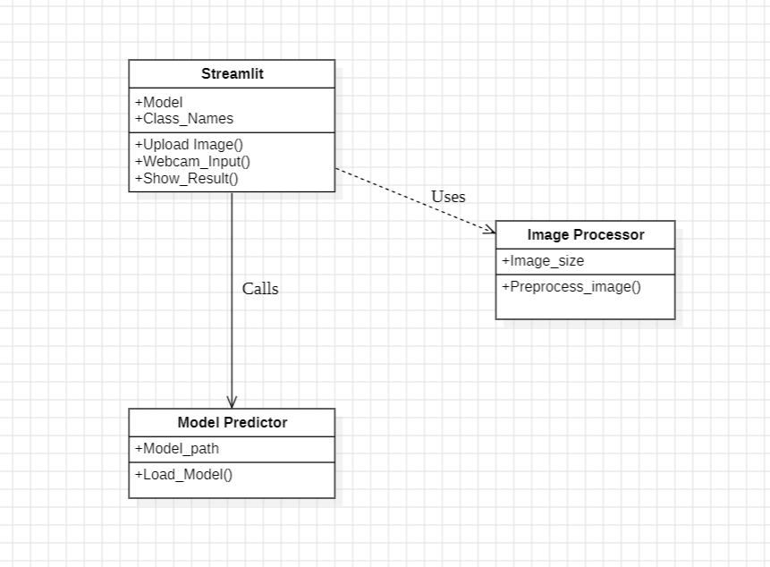

Figure.4.2.2 Class Diagram

SEQUENCE DIAGRAM:
This sequence diagram illustrates the flow of a multi-class image classification system. It involves three main entities: the User, Image Reader, and Classifier. The process begins when the User uploads an image or dataset. The Image Reader receives this input and processes the data. It then forwards the processed data to the Classifier, which analyzes it to determine class labels and associated confidence scores. These results are returned back to the Image Reader, which in turn sends the final class label and confidence score to the User as the final prediction. This diagram clearly outlines the step-by-step interactionanddataflow.
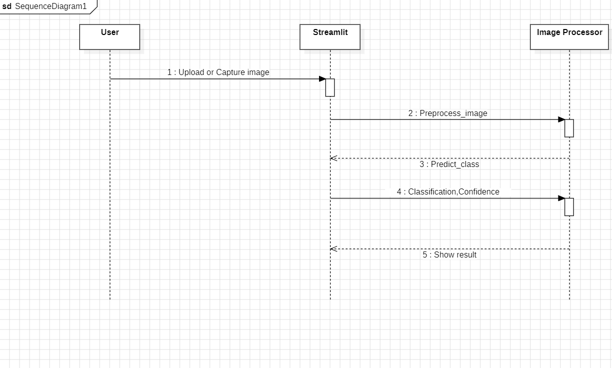

Figure.4.2.3 Sequence Diagram

4.2.4 ACTIVITY DIAGRAM:
This activity diagram illustrates the step-by-step workflow of a multi-class image classification process. It begins with the user inputting an image, followed by uploading it into the system. The image is then preprocessed to match the model’s input requirements. Next, a pertained model is loaded, which has been trained on a large dataset. The preprocessed image is fed into the model, which performs classification. Finally, the system outputs the predicted class label. This diagram provides a clear, linear representation of how an image progresses through various stages to reach its final classification output.

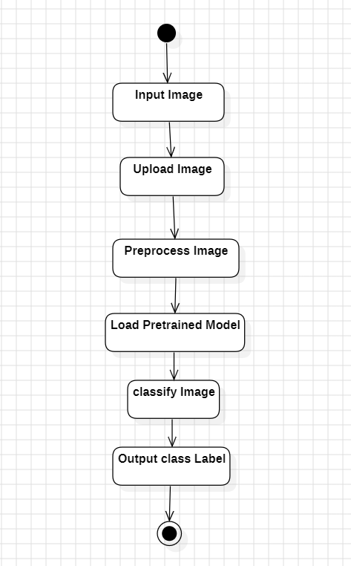

Figure.4.2.4 Activity diagram

CHAPTER-5

SOFTWARE SPCIFICATION

5.1 Python Technology
Currently, Python stands as the most widely used high-level, multi-purpose programming language. It accommodates both Object-Oriented and Procedural programming paradigms. Generally, Python code is more succinct than that written in languages like Java. The languages indentation requirement improves readability, enabling programmers to produce less code. Prominent technology firms such as Google, Amazon, Facebook, Instagram, Dropbox, and Uber utilize Python. A significant benefit of Python is its comprehensive standard library, which provides a diverse array of functionalities.

Python supports a wide range of applications across various domains, making it one of the most versatile programming languages. In the field of Machine Learning, Python is widely used for building predictive models and intelligent systems. It is also popular for developing GUI applications using frameworks like Kivy, Tkinter, and PyQt. For web development, Python offers robust web frameworks such as Django, which powers major platforms like YouTube, Instagram, and Dropbox. In the area of image processing, libraries like OpenCV and Pillow allow for advanced image manipulation and analysis. Python is also effective for web scraping, with tools like Scrapy, BeautifulSoup, and Selenium enabling automated data extraction from websites. Additionally, it supports various test frameworks for software testing and quality assurance. Python is even used in multimedia applications, handling tasks like audio and video processing with ease.
Advantages of Python
Extensive Libraries
Python downloads with an extensive library and it contain code for various purposes like regular expressions, documentation-generation, unit-testing, web browsers, threading, databases, CGI, email, image manipulation, and more. So, we don’t have to write the complete code for that manually.
Extensible
As we have seen earlier, Python can be extended to other languages. You can write some of your code in languages like C++ or C. This comes in handy, especially in projects.
Embeddable
Complimentary to extensibility, Python is embeddable as well. You can put your Python code in your source code of a different language, like C++.
Improved Productivity
The languages simplicity and extensive libraries render programmers more productive than languages like Java and C++ do. Also, the fact that you need to write less and get more things done.
IOT Opportunities
Since Python forms the basis of new platforms like Raspberry Pi, it finds the future for the Internet of Things. This is a way to connect the language with the real world.
Simple and Easy
When working with Java, you may have to create a class to print ‘Hello World’. But in Python, just a print statement will do. It is also quite easy to learn, understand, and code. This is why when people pick up Python, they have a hard time adjusting to other more verbose languages like Java.
Readable
Because it is not such a verbose language, reading Python is much like reading English. This is the reason why it is so easy to learn, understand, and code. It also does not need curly braces to define blocks, and indentation is mandatory. This further aids the readability of the code.
Object-Oriented
This language supports both the procedural and object-oriented programming paradigms. While functions help us with code reusability, classes and objects let us model the real world. A class allows the encapsulation of data and functions into one.
Free and Open-Source
Like we said earlier, Python is freely available. But not only can you download Python for free, but you can also download its source code, make changes to it, and even distribute it. It downloads with an extensive collection of libraries to help you with your tasks.
Portable
When you code your project in a language like C++, you may need to make some changes to it if 18 you want to run it on another platform. But it isn’t the same with Python. Here, you need to code only once, and you can run it anywhere. This is called Write Once Run Anywhere (WORA). However, you need to be careful enough not to include any system- dependent features.

Interpreted
Lastly, we will say that it is an interpreted language. Since statements are executed one by one, debugging is easier than in compiled languages.
Advantages of Python Over Other Languages
Almost all of the tasks done in Python requires less coding when the same task is done in other languages. Python also has an awesome standard library support, so you don’t have to search for any third-party libraries to get your job done. This is the reason that many people suggest learning Python to beginners.
Affordable
Python is free therefore individuals, small companies or big organizations can leverage the free available resources to build applications. Python is popular and widely used so it gives you better community support. The 2019 Git hub annual survey showed us that Python has overtaken Java in the most popular programming language category.
Python is for Everyone
Python code can run on any machine whether it is Linux, Mac or Windows. Programmers need to learn different languages for different jobs but with Python, you can professionally build web apps, perform data analysis and machine learning, automate things, do web scraping and also build games and powerful visualizations. It is an all- rounder programming language.
Disadvantages of Python
So far, we’ve seen why Python is a great choice for your project. But if you choose it, you should be aware of its consequences as well. Let us now see the downsides of choosing Python over another language.
Speed Limitations
We have seen that Python code is executed line by line. But since Python is interpreted, it often results in slow execution. This, however, isn’t a problem unless speed is a focal point for the 19 project. In other words, unless high speed is a requirement, the benefits offered by Python are enough to distract us from its speed limitations.
Weak in Mobile Computing and Browsers
While it serves as an excellent server-side language, Python is much rarely seen on the client-side. Besides that, it is rarely ever used to implement smart phone-based applications. One such application is called Carob knelled.
Design Restrictions
As you know, Python is dynamically-typed. This means that you don’t need to declare the type of variable while writing the code. It uses duck-typing. But wait, what is that? Well, it just means that if it looks like a duck, it must be a duck. While this is easy on the programmers during coding, it can raise run-time errors.
Underdeveloped Database Access Layers
Compared to more widely used technologies like JDBC (Java Data Base connectivity and ODBC (Open Data Base Connectivity), Python is database access layers are a bit underdeveloped. Consequently, it is less often applied in huge enterprises.
Simple
No, we’re not kidding. Python’s simplicity can indeed be a problem. Take my example. I don’t do Java, I’m more of a Python person. To me, its syntax is so simple that the verbosity of Java code seems unnecessary.
History of Python
What similarities exist between the alphabet and the programming language Python? Indeed, both commence with ABC. In the context of Python, ABC refers to the programming language developed in Amsterdam, Netherlands, at the Centrum Wiskunde & Informatica (CWI). ABC is a general-purpose programming language and environment, notable for its significant impact on the design of Python. Python was conceived in the late 1980s by Guido van Rossum, who was then involved in a project at CWI known as Amoeba, a distributed operating system. In an interview 20 with Bill Venners, van Rossum remarked: 'In the early 1980s, I was part of a team developing a language called ABC at CWI. I am uncertain about the extent to which people recognize ABC's influence on Python. I make an effort to acknowledge ABC's impact, as I owe much of my learning from that project and the individuals involved.' Subsequently, van Rossum elaborated: 'I recalled my experiences and some frustrations with ABC.
This prompted me to design a straightforward scripting language that incorporated some of ABC's advantageous features while eliminating its shortcomings. Thus, I began coding. I developed a simple virtual machine, parser, and runtime, along with my own interpretation of the various aspects of ABC that I appreciated. I established a fundamental syntax, utilized indentation for grouping statements instead of curly braces or begin-end blocks, and created a limited set of robust data types: a hash table (or dictionary, as it is referred to), a list, strings, and numbers.
5.2 Python Library
Python is an interpreted high-level programming language for general-purpose programming. Created by Guido van Rossum and first released in 1991, Python has a design philosophy that emphasizes code readability, notably using significant whitespace. Python features a dynamic type system and automatic memory management. It supports multiple programming paradigms, including object-oriented, imperative, functional and procedural, and has a large and comprehensive standard library.
Python is Interpreted − Python is processed at runtime by the interpreter. You do not need to compile your program before executing it. This is similar to PERL and PHP.
Python is Interactive − you can actually sit at a Python prompt and interact with the interpreter directly to write your programs.
Python also acknowledges that speed of development is important. Readable and terse code is part of this, and so is access to powerful constructs that avoid tedious repetition of code. Maintainability also ties into this may be an all but useless metric, but it does say something about how much code you have to scan, read and/or understand to troubleshoot problems or tweak behaviors.
This speed of development, the ease with which a programmer of other languages can pick up basic Python skills and the huge standard library is key to another area where Python excels. All 21 its tools have been quick to implement, saved a lot of time, and several of them have later been patched and updated by people with no Python background - without breaking.
Modules
Tensor Flow
Tensor Flow is a free and open-source software library for dataflow and differentiable programming across a range of tasks. It is a symbolic math library, and is also used for machine learning applications such as neural networks. It is used for both research and production at Google.
Tensor Flow was developed by the Google Brain team for internal Google use. It was released under the Apache 2.0 open-source license on November 9, 2015.
Keras
A high-level neural network API that runs on top of Tensor Flow. It simplifies the process of building and training deep learning models, making it easier to implement complex architectures.
Open-CV (cv2)
A computer vision library used for image processing tasks, such as resizing, color conversion, and normalization. It is essential for preparing images for model input.
NumPy
A numerical computing library used for handling arrays and matrices, which is crucial for image data manipulation and model predictions.
Streamlit
A Python library for creating interactive web applications. It is used to build the user interface and handle user interactions, such as image uploads and webcam input.
Scipy
A library used for scientific and technical computing, which may be required for certain image processing tasks.
Install Python Step-by-Step in Windows and Mac
Python a versatile programming language doesn’t come pre-installed on your computer devices. Python was first released in the year 1991 and until today it is a very popular high-level programming language. Its style philosophy emphasizes code readability with its notable use of great whitespace.
The object-oriented approach and language construct provided by Python enables programmers to write both clear and logical code for projects. This software does not come pre-packaged with Windows.
5.3 Machine Learning overview
Before we take a look at the details of various machine learning methods, let us start by looking at what machine learning is, and what it isn't. Machine learning is often categorized as a subfield of artificial intelligence, but I find that categorization can often be misleading at first brush. The study of machine learning certainly arose from research in this context, but in the data science application of machine learning methods, it is more helpful to think of machine learning as a means of building models of data. Fundamentally, machine learning involves building mathematical models to help understand data. "Learning" enters the fray when we give these models tunable parameters that can be adapted to observed data; in this way the program can be considered to be "learning" from the data. Once these models have been fit to previously seen data, they can be used to predict and understand aspects of newly observed data. I'll leave to the reader the more philosophical digression regarding the extent to which this type of mathematical, model-based "learning" is similar to the "learning" exhibited by the human brain. Understanding the problem setting in machine learning is essential to using these tools effectively.

Categories of Machine Leaning
At the most fundamental level, machine learning can be categorized into two main types: supervised learning and unsupervised learning.
Supervised learning involves somehow modeling the relationship between measured features of data and some label associated with the data; once this model is determined, it can be used to apply labels to new, unknown data. This is further subdivided into classification tasks and regression tasks: in classification, the labels are discrete categories, while in regression, the labels are continuous quantities.
Unsupervised learning involves modeling the features of a dataset without reference to any label, and is often described as "letting the dataset speak for itself." These models include tasks such as clustering and dimensionality reduction. Clustering algorithms identify distinct groups of data, while dimensionality reduction algorithms search for more succinct representations of the data.
Need for Machine Learning
Human beings, at this moment, are the most intelligent and advanced species on earth because they can think, evaluate and solve complex problems. On the other side, AI is still in its initial stage and haven’t surpassed human intelligence in many aspects. Then the question is that what is the need to make machine learn? The most suitable reason for doing this is, “to make decisions, based on data, with efficiency and scale”.
Lately, organizations are investing heavily in newer technologies like Artificial Intelligence, Machine Learning and Deep Learning to get the key information from data to perform several real world tasks and solve problems. We can call it data- driven decisions taken by machines, particularly to automate the process. These data- driven decisions can be used, instead of using programming logic, in the problems that cannot be programmed inherently. The fact is that we can’t do without human intelligence, but other aspect is that we all need to solve real-world problems with efficiency at a huge scale. That is why the need for machine learning arises.
Challenges in Machines Learning
While Machine Learning is rapidly evolving, making significant strides with cyber security and autonomous cars, this segment of AI as whole still has a long way to go. The reason behind is that ML has not been able to overcome number of challenges. The challenges that ML is facing currently are:
Quality of data
Having good-quality data for ML algorithms is one of the biggest challenges. Use of low-quality data leads to the problems related to data preprocessing and feature extraction.
Time-Consuming task
Another challenge faced by ML models is the consumption of time especially for data acquisition, feature extraction and retrieval.
Lack of specialist persons
As ML technology is still in its infancy stage, availability of expert resources is a tough job. No clear objective for formulating business problems − Having no clear objective and well-defined goal for business problems is another key challenge for ML because this technology is not that mature yet.
Issue of over fitting & under fitting
If the model is over fitting or under fitting, it cannot be represented well for the problem.
Curse of dimensionality
Another challenge ML model faces is too many features of data points. This can be a real hindrance.
Difficulty in deployment
Complexity of the ML model makes it quite difficult to be deployed in real life.
Applications of Machines Learning
Machine Learning is one of the most rapidly growing technologies, and according to researchers, we are currently in the golden era of Artificial Intelligence (AI) and Machine Learning (ML). It is increasingly being used to solve complex real-world problems that are difficult or impossible to address using traditional approaches. ML has a wide range of applications across various domains. Some of the prominent real-world applications include emotion and sentiment analysis, which help in understanding human emotions and opinions from text or speech. It is also used for error detection and prevention in systems, weather forecasting and prediction, and analyzing and forecasting stock market trends. Other key areas where ML is applied include speech synthesis and recognition, customer segmentation for targeted marketing, object recognition in images and videos, fraud detection in financial systems, and recommending products to customers in online shopping platforms. These applications demonstrate the transformative impact of ML in both daily life and industry. Stock market analysis and forecasting and that was the beginning of Machine Learning! In modern times, Machine Learning is one of the most popular (if not the most!) career choices. According to Indeed, Machine Learning Engineer is the Best Job of 2019 with a 344% growth and an average base salary of $146,085 per year.
But there is still a lot of doubt about what exactly is Machine Learning and how to start learning it? So this article deals with the Basics of Machine Learning and also the path you can follow to eventually become a full-fledged Machine Learning Engineer. How to start learning ML?
This is a rough roadmap you can follow on your way to becoming an insanely talented Machine Learning
Engineer. Of course, you can always modify the steps according to your needs to reach your desired end-goal.
Step 1 – Understand the Prerequisites
In case you are a genius, you could start ML directly but normally, there are some prerequisites that you need to know which include Linear Algebra, Multivariate Calculus, Statistics, and Python.
Learn Linear Algebra and Multivariate Calculus
Both Linear Algebra and Multivariate Calculus are important in Machine Learning. However, the extent to which you need them depends on your role as a data scientist. If you are more focused on application heavy machine learning, then you will not be that heavily focused on math as there are many common libraries available. But if you want to focus on R&D in Machine Learning, then mastery of Linear Algebra and Multivariate Calculus is very important as you will have to implement many ML algorithms from scratch.
Learn Statistics
Data plays a huge role in Machine Learning. In fact, around 80% of your time as an ML expert will be spent collecting and cleaning data. And statistics is a field that handles the collection, analysis, and presentation of data.
Some of the key concepts in statistics that are important are Statistical Significance, Probability Distributions, Hypothesis Testing, Regression, etc. Also, Bayesian Thinking is also a very important part of ML which deals with various concepts like Conditional Probability, Priors, and Posteriors, Maximum Likelihood, etc.
Learn Python
Some people prefer to skip Linear Algebra, Multivariate Calculus and Statistics and learn them as they go along with trial and error. But the one thing that you absolutely cannot skip is Python! While there are other languages you can use for Machine Learning like R, Scala, etc. In fact, there are many Python libraries that are specifically useful for Artificial Intelligence and Machine Learning such as Keras, TensorFlow, Scikit-learn, etc.

Step 2 – Learn Various ML Concepts
It is best to start with the basics and then move on to the more complicated stuff. Some of the basic concepts in ML are:
Terminologies of Machine Learning
Model
A model is a specific representation learned from data by applying some machine learning algorithm. A model is also called a hypothesis.
Feature
A feature is an individual measurable property of the data. A set of numeric features can be conveniently described by a feature vector. Feature vectors are fed as input to the model. For example, in order to predict a fruit, there may be features like color, smell, taste, etc.

CHAPTER-6

SYSTEM IMPLEMENTATION
Project Structure
app.py: The main Streamlit application file that handles the user interface and real-time classification.
train_model.py/train.py: The script responsible for training the animal classification model using Tensor Flow and Keras.
Animal dataset/: A directory containing the dataset for training the model, organized into subdirectories for each animal class.
requirements.txt: A file listing all the Python dependencies required for the project.
Model Training
Data Loading: The training script uses Keras' Image Data Generator to load and preprocess images from the dataset. This includes data augmentation techniques such as rotation, zoom, and horizontal flip to improve model robustness.
Model Architecture: The model is built using the MobileNetV2 architecture, a pre-trained convolution neural network (CNN) from Tensor Flow. Transfer learning is employed to fine-tune the model on the specific dataset.
Training Process: The model is trained for a specified number of epochs, with validation data used to monitor performance and prevent overfitting. The trained model is saved as model.h5.
User Interface
Streamlit App: The application is built using Streamlit, providing a user-friendly interface with two main features:
Webcam Input: Users can take pictures using their webcam for real-time classification.
Image Upload: Users can upload images from their local machine for classification.
Results Display: The app displays the top three predictions along with their confidence scores.
Image Preprocessing
Images captured from the webcam or uploaded by the user are preprocessed to match the input requirements of the model:
Resizing to 224x224 pixels.
Normalizing pixel values to the range [0, 1].
Converting the image to RGB format.
Model Loading and Prediction
The trained model is loaded using Tensor Flow's load model function.
The app uses the model to predict the class of the input image and displays the results to the user.
Error Handling
The app includes error handling to manage cases where the model file is not found or the dataset is not properly organized. It also handles errors during image processing and prediction.
Dependencies
The project relies on several Python libraries, which are listed in requirements.txt. These include Tensor Flow, Keras, Streamlit, Open-CV, NumPy, and others.
Deployment: The app is designed to run locally using Streamlit, allowing users to interact with it through a web browser.

CHAPTER-7

TESTING
7.1MANUALTESTING:
The various types of testing are
White Box Testing
Black Box Testing
Alpha Testing
Beta Testing
Win Runner load runner
White Box Testing:
This type of testing focused on checking how the code works internally. We looked into the functions used for image preprocessing, model loading, and classification. Each part of the code was tested to make sure it worked correctly for different scenarios, especially when it came to logical decisions like condition checks and branching.
Black Box Testing:
In this phase, we tested the system from the user’s point of view without looking at the internal code. We uploaded various images and observed whether the model returned the correct class label. This helped ensure that the functionality matched expectations, even with different image types and qualitie.
AlphaTesting:
Alpha testing is the software prototype stage when the software is the first able to run. It not has all the intended functionality, but it will have core functions and will be able to accept the input and generate outputs. An alpha test usually takes place in the developer’s offices on a separate system.
Beta Testing:
Alpha testing was done during the development phase, using a controlled environment. This helped us identify and fix early bugs related to image uploading, preprocessing, and model performance.
Win Runnerand Load Runner:
Once the main features were working, we shared the project with a few users for real-world testing. They tried uploading images from their own systems, and we gathered feedback on performance, accuracy, and any issues faced during classification.

7.2 SYSTEM TESTING
The goal of system testing was to make sure the entire setup—from uploading an image to getting a prediction—worked as a complete unit. We tested the project across different environments and ensured that every component interacted properly with the others. It confirmed that the system behaves as expected and meets user needs.
7.3 TYPES OF TESTS
Unit Testing:
We tested individual parts of the system, such as the image preprocessing functions and the model prediction method, to make sure they gave correct outputs. This helped us catch small errors early.
Integration Testing:
We checked how different components worked together—for example, whether the image uploading feature correctly passed data to the preprocessing module, and then to the model
for classification. It ensured that all parts of the system were connected properly.
Functional Test:
This test focused on checking if the main features were functioning as intended. We verified:
That valid images were accepted.
That the model correctly handled invalid or corrupted images.
That the output (predicted class label) matched the input image
System Test:
We ran the full workflow with real-world images to ensure everything worked end-to-end. This included checking the UI, model accuracy, and user experience.
Acceptance Testing:
At the final stage, we tested the project from a user’s perspective. The goal was to confirm that it met all the project requirements and delivered accurate and reliable results.
TestResults:All test cases passed successfully. The system was able to accurately classify images into the correct categories. No major bugs or issues were found during testing.

CHAPTER-8

RESULTS AND DISCUSSION

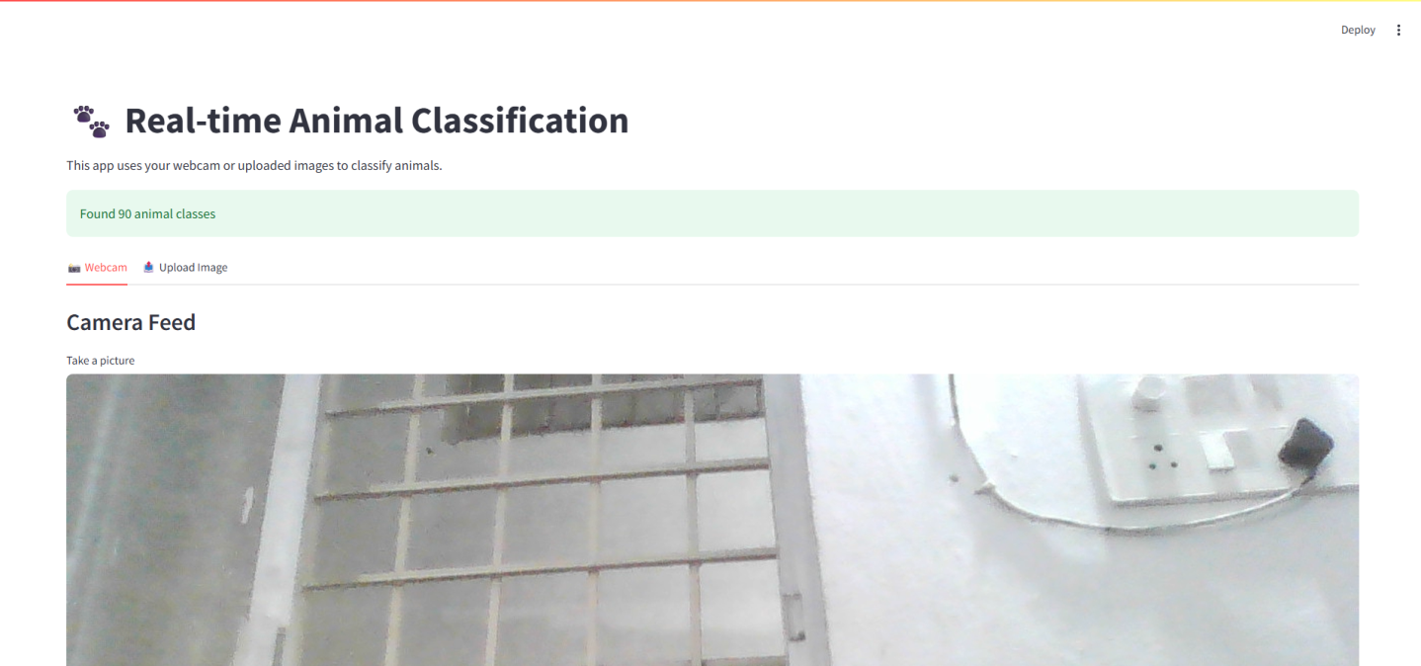

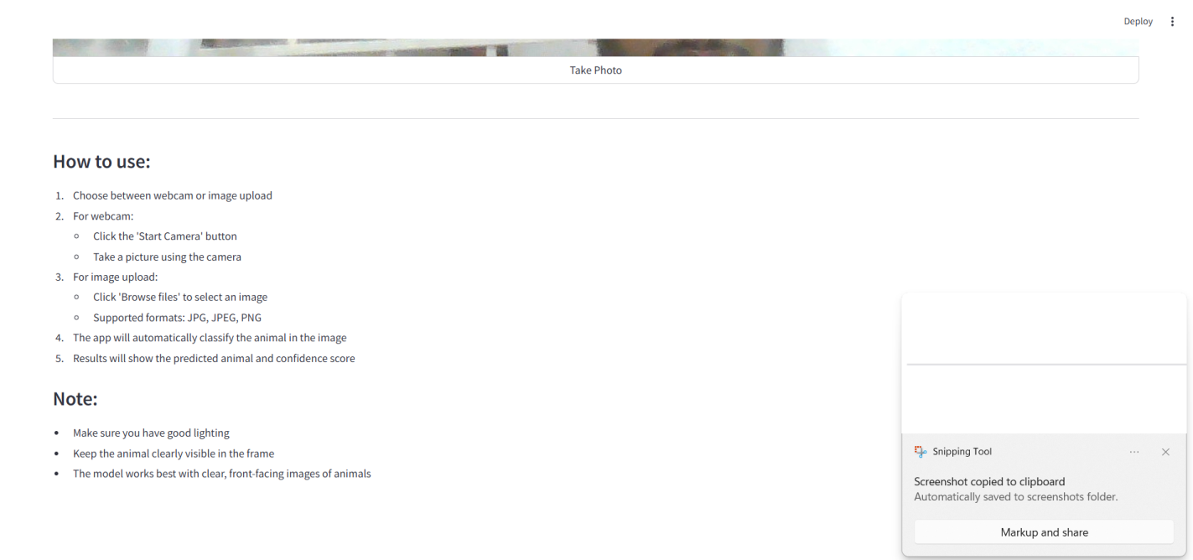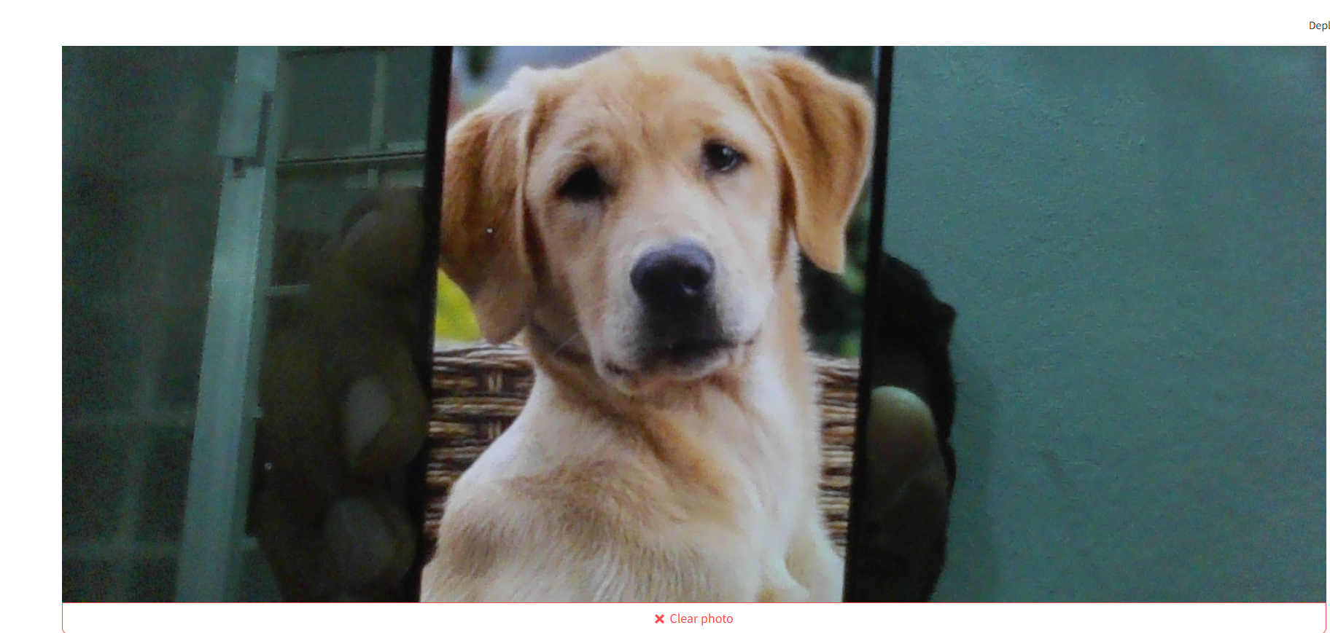

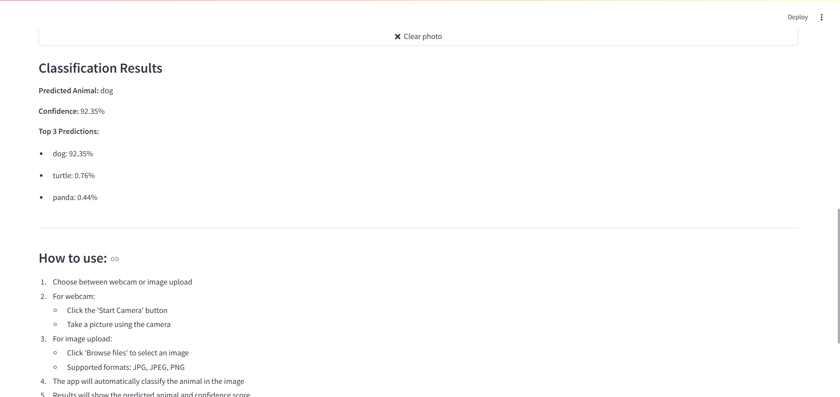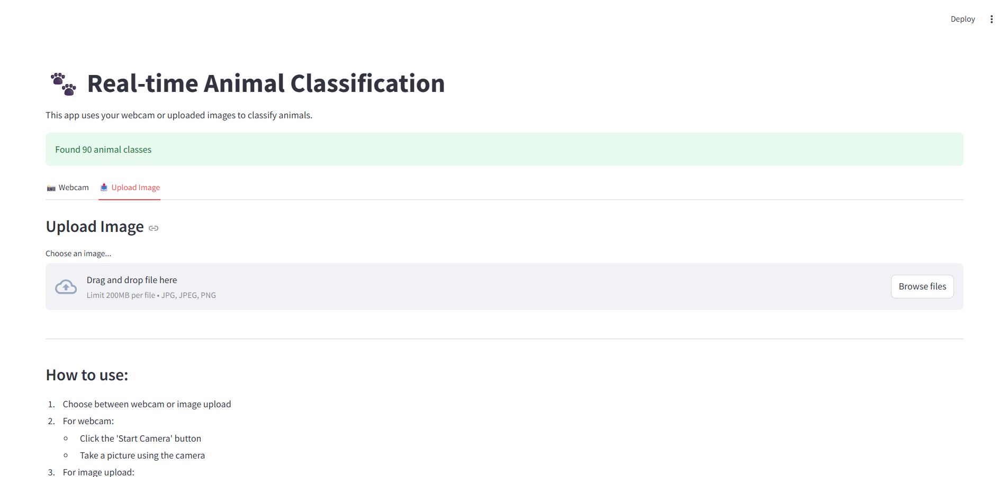

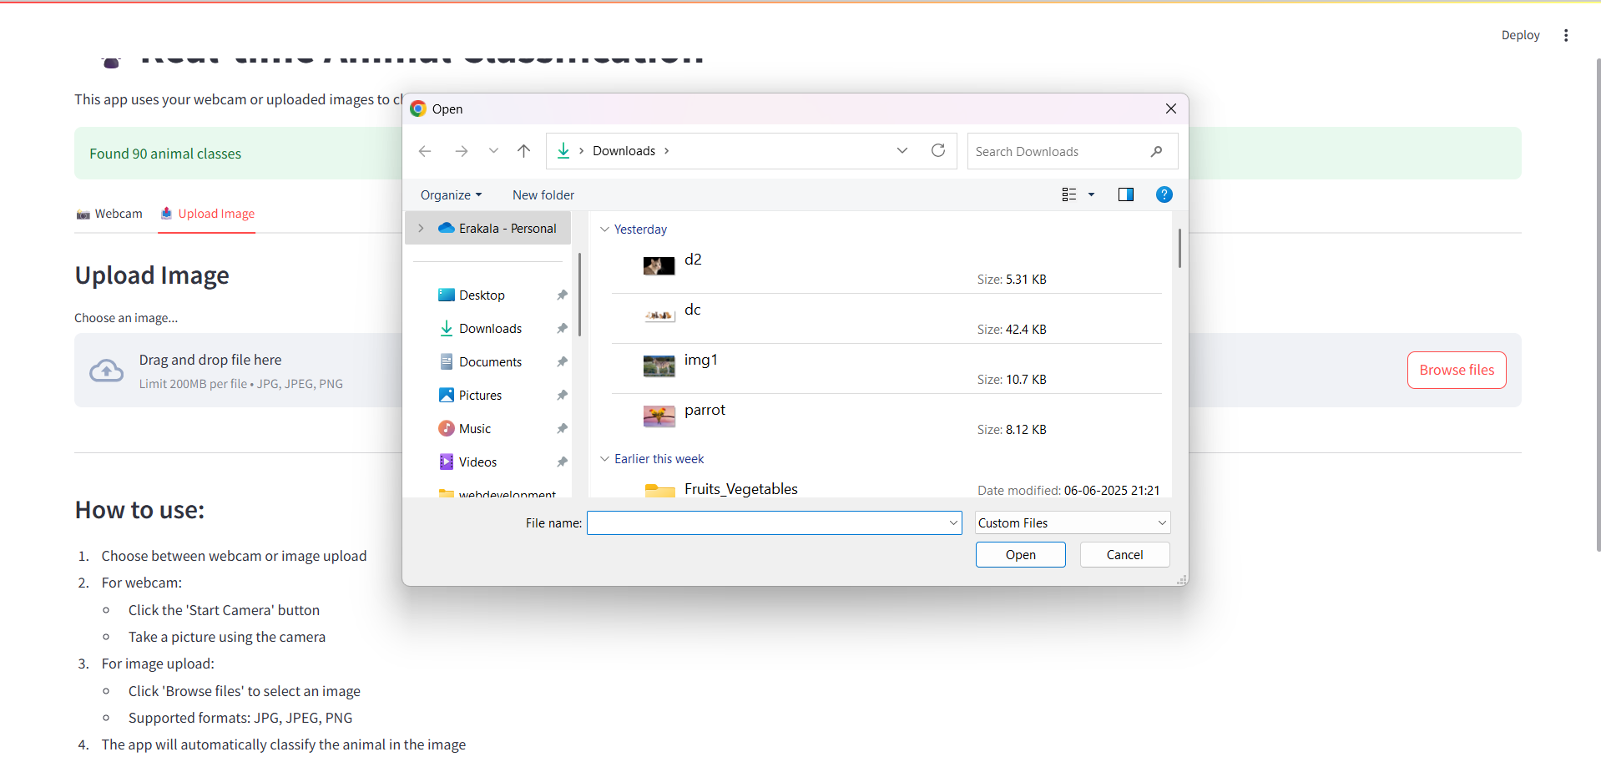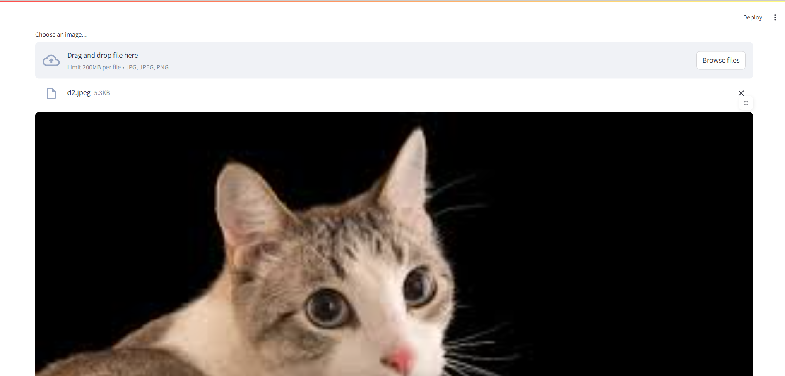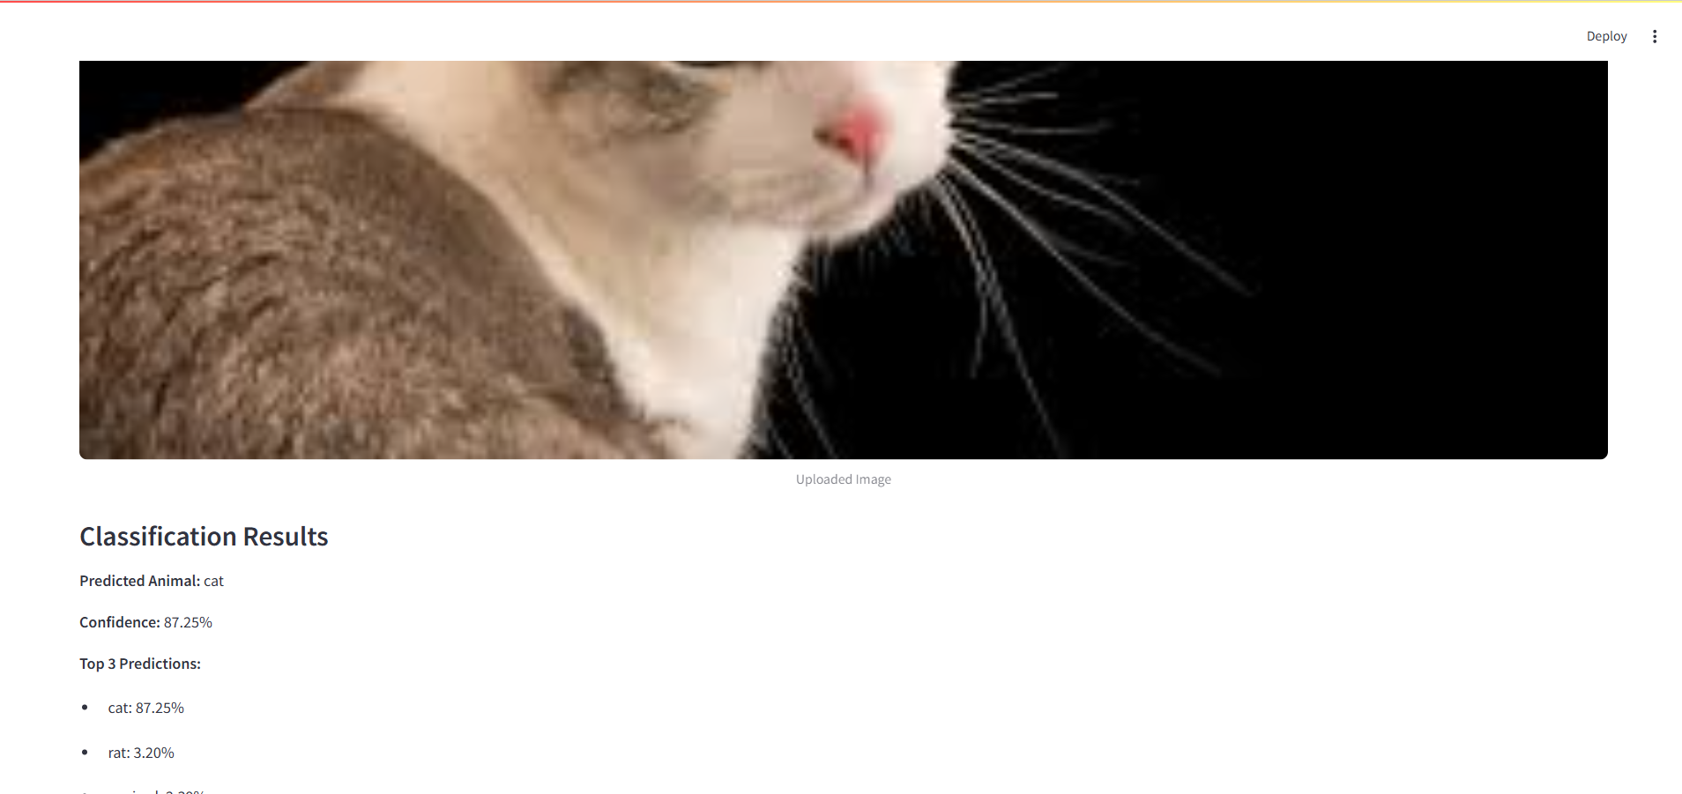

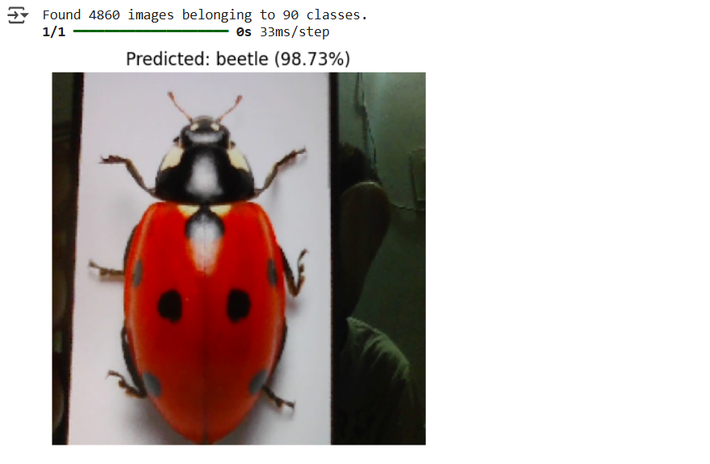
CHAPTER-9

CONCLUSION

Our project effectively implements a multi-class image classification system using transfer learning, significantly enhancing model accuracy through a well-structured training strategy. By leveraging pre-trained models such as ResNet or MobileNet, the system efficiently utilizes existing learned features, making it highly suitable even for smaller or limited datasets. This approach has demonstrated reliable performance across standard benchmark datasets, reinforcing its value and adaptability in real-world scenarios such as medical imaging, security, and automated labeling. The modularity of the system allows for easy integration into broader applications. Future enhancements may include fine-tuning on custom datasets, improving training time through hardware acceleration, and expanding the diversity of the dataset to support more classes, which can lead to even higher robustness and generalization in real-world deployments.

CHAPTER-10

FUTURE SCOPE

The future scope of our animal classification project is vast and promising, with numerous opportunities for development and expansion. We aim to enhance the model’s accuracy and efficiency by fine-tuning hyper parameters, exploring alternative neural network architectures, and utilizing more advanced pre-trained models. Sophisticated data augmentation techniques will be employed to diversify the training dataset, enabling better generalization to new, unseen images. Expanding the dataset to include more animal classes from various sources will improve the model’s versatility and performance across different environments. We also plan to optimize the Streamlit application for mobile devices, enabling users to access it on the go, and introduce a feedback feature that allows users to help refine the model over time. Future updates will support real-time video classification, benefiting wildlife monitoring and research, and integrate with IoT devices like sensors and cameras for automated animal tracking. Cloud deployment on platforms such as AWS or Google Cloud will ensure scalability and accessibility. We also intend to implement object detection for identifying multiple animals within a single frame and explore behavioral analysis using video data to provide insights into animal activities. Making the project open source will foster community contributions and collaboration with researchers and organizations, particularly in areas like wildlife conservation and agricultural monitoring. Additionally, we plan to create educational resources and tutorials to raise awareness and understanding of the technology, further amplifying its impact for both research and public engagement.

BIBLIOGRAPHY

Hu, Yao, Zhongming Jin, Yi Shi, Debing Zhang, Deng Cai, and Xiaofei He. "Large scale multi-class classification with truncated nuclear norm regularization." Neurocomputing 148 (January 2015)
Meng, Nan, Edmund Y. Lam, Kevin K. Tsia, and Hayden Kwok-Hay So. "Large-Scale Multi-Class Image-Based Cell Classification with Deep Learning." IEEE Journal of Biomedical and Health Informatics 23, no. 5 (September 2019)
Mai, Tien-Dung, Thanh Duc Ngo, Duy-Dinh Le, Duc Anh Duong, Kiem Hoang, and Shin’ichi Satoh. "Efficient large-scale multi-class image classification by learning balanced trees." Computer Vision and Image Understanding 156 (March 2017)
Do, Thanh‐Nghi, and François Poulet. "Latent‐lSVM classification of very high‐dimensional and large‐scale multi‐class datasets." Concurrency and Computation: Practice and Experience 31, no. 2 (June 30, 2017)
Fröhlich, Björn, Erik Rodner, Michael Kemmler, and Joachim Denzler. "Large-scale gaussian process multi-class classification for semantic segmentation and facade recognition." Machine Vision and Applications 24, no. 5 (January 4, 2013): 1043–53.
Panos, Aristeidis, Petros Dellaportas, and Michalis K. Titsias. "Large scale multi-label learning using Gaussian processes." Machine Learning 110, no. 5 (April 14, 2021): 965–87.
Qiang, Wenwen, Jinxin Zhang, Ling Zhen, and Ling Jing. "Robust weighted linear loss twin multi-class support vector regression for large-scale classification.
Ma, Jiajun, Shuisheng Zhou, Li Chen, Weiwei Wang, and Zhuan Zhang. "A sparse robust model for large scale multi-class classification based on K-SVCR." Pattern Recognition Letters 117 (January 2019): 16–23.
Bejiga, Mesay Belete, Farid Melgani, and Pietro Beraldini. "Domain Adversarial Neural Networks for Large-Scale Land Cover Classification
Wang, Gaihua, Lei Cheng, Jinheng Lin, Yingying Dai, and Tianlun Zhang. "Fine-grained classification based on multi-scale pyramid convolution networks
APPENDIX

import streamlit as st
import cv2
import numpy as np
import tensorflow as tf
from tensorflow.keras.models import load_model
import os

# ---------------------- Setup ----------------------

# Title of the app
st.set_page_config(page_title="Animal Classifier", layout="centered")
st.title("🦁 Real-Time Animal Image Classification")
st.markdown("This app uses your webcam to classify animals using a pre-trained deep learning model.")

# ---------------------- Load Model ----------------------

MODEL_PATH = "model.h5" # Make sure model.h5 is in the same folder
DATASET_DIR = "dataset/train" # Change this path to your dataset's train folder

try:
model = load_model(MODEL_PATH)
class_names = sorted(os.listdir(DATASET_DIR))
st.success("✅ Model loaded successfully!")
except Exception as e:
st.error(f"❌ Error loading model: {e}")
st.stop()

# ---------------------- Functions ----------------------

def preprocess_frame(frame):
"""Resize and normalize image for prediction"""
img = cv2.resize(frame, (224, 224)) # Assumes MobileNetV2 input
img = img / 255.0
return np.expand_dims(img, axis=0)

def predict(frame):
"""Run prediction on the frame"""
processed = preprocess_frame(frame)
prediction = model.predict(processed)
class_idx = np.argmax(prediction)
confidence = float(prediction[0][class_idx])
label = class_names[class_idx]
return label, confidence

# ---------------------- Streamlit Webcam UI ----------------------

run = st.checkbox('📸 Start Webcam')

FRAME_WINDOW = st.image([])

if run:
cap = cv2.VideoCapture(0)
st.info("Press 'Q' in webcam window to quit.")

while True:
ret, frame = cap.read()
if not ret:
st.warning("Failed to grab frame.")
break

frame = cv2.flip(frame, 1) # Mirror image
label, confidence = predict(frame)

# Display prediction on frame
text = f"{label} ({confidence*100:.2f}%)"
cv2.putText(frame, text, (10, 40), cv2.FONT_HERSHEY_SIMPLEX, 1, (0, 255, 0), 2)
FRAME_WINDOW.image(cv2.cvtColor(frame, cv2.COLOR_BGR2RGB))

if cv2.waitKey(1) & 0xFF == ord('q'):
break

cap.release()
cv2.destroyAllWindows()
else:
st.write("🛑 Webcam is off. Check the box to turn it on.")

import os
import numpy as np
import tensorflow as tf
from tensorflow.keras.preprocessing.image import ImageDataGenerator
from tensorflow.keras.applications import MobileNetV2
from tensorflow.keras.layers import Dense, Dropout, GlobalAveragePooling2D
from tensorflow.keras.models import Model
from tensorflow.keras.optimizers import Adam

# ---------------- CONFIG ----------------
IMG_SIZE = 224
BATCH_SIZE = 32
EPOCHS = 10
DATASET_DIR = "C:/Users/Srinadh/Desktop/project/animaldaset" # Ensure it contains 'train' and optionally 'val' folders

# ---------------- DATA LOADING ----------------
train_datagen = ImageDataGenerator(
rescale=1./255,
rotation_range=15,
zoom_range=0.2,
width_shift_range=0.1,
height_shift_range=0.1,
horizontal_flip=True,
validation_split=0.2 # 80% train, 20% validation
)

train_data = train_datagen.flow_from_directory(
os.path.join(DATASET_DIR, 'train'),
target_size=(IMG_SIZE, IMG_SIZE),
batch_size=BATCH_SIZE,
class_mode='categorical',
subset='training'
)

val_data = train_datagen.flow_from_directory(
os.path.join(DATASET_DIR, 'train'),
target_size=(IMG_SIZE, IMG_SIZE),
batch_size=BATCH_SIZE,
class_mode='categorical',
subset='validation'
)

# ---------------- MODEL ----------------
base_model = MobileNetV2(include_top=False, input_shape=(IMG_SIZE, IMG_SIZE, 3), weights='imagenet')
base_model.trainable = False # Freeze base model

x = base_model.output
x = GlobalAveragePooling2D()(x)
x = Dropout(0.3)(x)
x = Dense(128, activation='relu')(x)
predictions = Dense(train_data.num_classes, activation='softmax')(x)

model = Model(inputs=base_model.input, outputs=predictions)
model.compile(optimizer=Adam(learning_rate=0.0001),loss='categorical_crossentropy', metrics=['accuracy'])

# ---------------- TRAIN ----------------
model.fit(train_data, validation_data=val_data, epochs=EPOCHS)

# ---------------- SAVE ----------------
model.save("model.h5")
print("✅ model.h5 saved successfully.")

import os
import subprocess
import sys
import venv
import webbrowser

def run_command(command):
subprocess.run(command, shell=True, check=True)

def main():
# Step 1: Check if Python 3.10 is installed
try:
run_command("py -3.10 --version")
except subprocess.CalledProcessError:
webbrowser.open("https://www.python.org/downloads/release/python-3100/")
return

# Step 2: Create a virtual environment
venv_dir = "tf_env"
if not os.path.exists(venv_dir):
print("Creating virtual environment...")
venv.create(venv_dir, with_pip=True)

# Step 3: Activate the virtual environment
activate_script = os.path.join(venv_dir, "Scripts", "activate")
if not os.path.exists(activate_script):
print("Virtual environment activation script not found. Please check your setup.")
return

# Step 4: Upgrade pip
run_command(f"{activate_script} && python -m pip install --upgrade pip")

# Step 5: Install requirements
run_command(f"{activate_script} && pip install -r requirements.txt")

# Step 6: Run the training script
run_command(f"{activate_script} && python train_model.py/train.py")

if __name__ == "__main__":
main()
import os
import shutil

# Source and destination paths
source_dir = "animaldaset/animals/animals"
dest_dir = "animaldaset/train"

# Create destination directory if it doesn't exist
os.makedirs(dest_dir, exist_ok=True)

# Move each class folder to the train directory
for class_name in os.listdir(source_dir):
source_path = os.path.join(source_dir, class_name)
dest_path = os.path.join(dest_dir, class_name)

if os.path.isdir(source_path):
# If destination already exists, remove it first
if os.path.exists(dest_path):
shutil.rmtree(dest_path)
# Move the directory
shutil.move(source_path, dest_path)
print(f"Moved {class_name} to train directory")

print("Dataset reorganization complete!")

