COURSE PROJECT REPORT
SOCGPT
An AI-powered Security Operations Center simulator and incident-response platform

Subjects: Database Management Systems and Advanced Programming
Technologies: Java 21, Spring Boot, PostgreSQL + pgvector, Python, LangGraph, Docker
Date: 14 October 2026
Submitted by
Team member 1: __SRINANDHINI P_____ Roll no: _CH.SC.U4CYS25036
Team member 2: ___MAGITA_________ Roll no: CH.SC.U4CYS25015

Table of contents
1. Abstract 3
1.1 Where each subject is used (quick map) 3
2. Introduction 4
2.1 Problem statement 4
2.2 Objectives 4
2.3 Scope and constraints 4
2.4 Background concepts 4
3. Technology stack 6
3.1 Size of the project 6
4. System architecture 7
4.1 Layers of the Java backend 7
4.2 Life of an incident 8
4.3 Why the design looks like this 8
5. Database design: ER diagram 9
5.1 From requirements to entities 10
5.2 Relationships and cardinality 10
5.3 Relational schema (all tables) 10
5.4 Normalisation 13
5.5 Integrity constraints 13
5.6 Indexes 14
5.7 Transactions and ACID 14
5.8 SQL used in the project 15
5.9 Schema evolution: the idempotent migration 16
5.10 Object-relational mapping (JPA / Hibernate) 16
5.11 Database security and operations 16
6. Advanced Programming topics and where they are used 17
6.1 Topic map 17
6.2 Selected examples 19
7. Module descriptions 21
7.1 Detection engine (DetectionService) 21
7.2 Risk scoring (RiskScoringService) 21
7.3 Attack chains (ChainService) 21
7.4 AI pipeline (Python: FastAPI + LangGraph) 22
7.5 Retrieval-augmented generation (RagService) 22
7.6 Approval workflow and role-based access (ApprovalService, AccessPolicy) 22
7.7 E-mail alerts (NotificationService) 23
7.8 PDF report (SimplePdf, ReportPdfService) 23
7.9 Metrics (MetricsService) 23
7.10 Audit trail (AuditService) 23
7.11 Front end 23
8. REST API summary 26
9. Testing and results 27
9.1 Automated tests 27
9.2 Checks against the real services 27
10. Problems met and how they were solved 28
11. Limitations and future work 29
11.1 Limitations 29
11.2 Future work 29
12. Conclusion 30
Appendix A: How to run the project 31
Appendix B: Project folder structure 31
Appendix C: Glossary 31

If the page numbers are missing, right-click the table above in Word and choose Update Field.

1. Abstract
SOCGPT is a simulator of a Security Operations Center (SOC): the team of people and tools that watches a company's systems for attacks. The system generates simulated attacks (SQL injection, malware, brute force and port scans), detects them in real time with rules, scores their risk, maps them to the MITRE ATT&CK and NIST Cybersecurity Framework 2.0 standards, groups related attacks into multi-stage attack chains, and asks a large language model (Google Gemini, orchestrated with LangGraph) to investigate each incident and write a five-stage remediation plan.
The AI never acts on its own. A human with the right role must approve the plan before a (simulated) recovery runs, and every action is stored in an audit log. The platform also e-mails the people who must decide, exports a PDF report per incident, shows live metrics on a dashboard, and remembers past incidents using vector similarity search (RAG) inside PostgreSQL.
The project is built to show two subjects together. For Database Management Systems it uses a normalised nine-table PostgreSQL schema with keys, constraints, indexes, transactions, upserts, joins, a vector extension and an idempotent migration script. For Advanced Programming it uses Java records, streams and lambdas, concurrency with thread pools, custom annotations read by reflection, dependency injection, cryptography, hand-written parsers and file-format generators, REST design, automated integration testing, and a Python microservice. About 6,000 lines of Java and 2,000 lines of web, SQL and Python code are included.

1.1 Where each subject is used (quick map)
Subject | Main topics used | Where in the project
DBMS | ER modelling, relational schema, keys, normalisation (3NF), constraints, indexes, transactions (ACID), joins, upsert, vector search, schema migration | db/schema.sql, db/migrate_v2.sql, JPA entities, repositories, ApprovalService, RagService
Advanced Programming | OOP, records, generics, collections, streams, lambdas, concurrency, annotations and reflection, dependency injection, exceptions, cryptography, algorithms, file and byte I/O, networking, testing | All 51 Java classes in backend-java, the Python agent, the JavaScript front end, the test suites

2. Introduction

2.1 Problem statement
Security teams receive thousands of alerts. Analysts spend most of their time on repetitive triage: What happened? How serious is it? Is it part of a bigger attack? What should we do? Two problems make this hard. First, individual alerts look harmless but together they describe an intrusion (a port scan, then password guessing, then an exploit from the same address). Second, an AI that acts without supervision is dangerous in a security setting, because a wrong action can disrupt a business.

2.2 Objectives
- Detect simulated attacks in real time using rule-based detection.
- Score the risk of each incident using context, and explain the score.
- Link related incidents from the same attacker into a multi-stage attack chain.
- Use an LLM to write an investigation report and a five-stage remediation plan (containment, eradication, recovery, validation, prevention).
- Keep a human in control: role-based approval, a four-eyes rule for critical incidents, and a complete audit trail.
- Let the AI learn from past incidents, including which plans analysts approved or rejected (RAG).
- Alert people by e-mail, export PDF reports, and show metrics on a live dashboard.
- Design a clean relational database and show good database practice (constraints, indexes, transactions, migrations).

2.3 Scope and constraints
- Everything uses free tools: PostgreSQL, Docker, Mailpit and the Gemini free tier.
- Attacks are simulated; the "recovery" is simulated. No real systems are touched.
- Majority Java: the backend is Java. Python is used only for LangGraph and the Gemini calls, which are easiest in Python.
- The system runs on one laptop (Windows 11) with Docker Desktop.

2.4 Background concepts
Term | Meaning in this project
SOC | Security Operations Center: people and tools that monitor, detect and respond to cyber attacks.
MITRE ATT&CK | A public catalogue of attacker techniques. Example: T1190 "Exploit Public-Facing Application" (tactic: Initial Access).
NIST CSF 2.0 | A framework with six functions: Govern, Identify, Protect, Detect, Respond, Recover. Every incident is tagged with one.
Attack chain | Several attack stages from the same IP in a short time, for example reconnaissance, then credential access, then initial access.
LLM / LangGraph | A large language model (Gemini) controlled by a small state machine (LangGraph) so each step has a clear input and output.
RAG | Retrieval-augmented generation: find similar past cases first, then give them to the model as context.
Embedding / pgvector | A list of 768 numbers that represents the meaning of a text. pgvector lets PostgreSQL store and compare them.
RBAC | Role-based access control: what you may do depends on your role (analyst, SOC manager, admin).

3. Technology stack
Layer | Technology | Why it was chosen
Language (backend) | Java 21 (runs on JDK 25) | Required by the course; strong typing, records, streams, concurrency.
Framework | Spring Boot 4.2 (MVC, Data JPA, WebFlux client, Mail) | Dependency injection, REST controllers, ORM, interceptors, e-mail.
ORM | JPA with Hibernate 7 | Maps Java classes to tables; generates SQL for repositories.
Database | PostgreSQL 15 with the pgvector extension (Docker image ankane/pgvector) | Relational integrity plus vector similarity in one engine.
AI service | Python, FastAPI, Pydantic, LangGraph, google-genai | LangGraph and the Gemini SDK are Python-first.
LLM | Google Gemini (free tier), with a lighter fallback model | Free; JSON output mode; also provides the embeddings.
Front end | HTML, CSS, vanilla JavaScript, inline SVG charts | No framework needed; served directly by Spring Boot (same origin).
E-mail | Spring Mail (Jakarta Mail) and Mailpit | Mailpit catches every e-mail in a local inbox for the demo.
Build and test | Maven wrapper, JUnit 5, embedded PostgreSQL, GreenMail, pytest | Repeatable builds and end-to-end tests without Docker.
Deployment | Docker Compose (database + mail) | One command starts the infrastructure.

3.1 Size of the project
Part | Files | Lines
Java, main code (controllers, services, security, PDF, entities, repositories) | 51 | 4,830
Java, tests (end-to-end test and a demo harness) | 2 | 648
Web front end (4 HTML pages, shared JavaScript, 3 stylesheets) | 8 | 2,282
Python AI agent (FastAPI, LangGraph, prompts, embeddings, tests) | 6 | 609
SQL (schema and migration) | 2 | 186
Python attack simulator | 1 | 101

4. System architecture
SOCGPT has three runtime parts plus infrastructure. The browser talks only to the Spring Boot backend. The backend owns the database and calls the Python agent when an incident needs AI help. Figure 4.1 shows the pieces and the protocols between them.
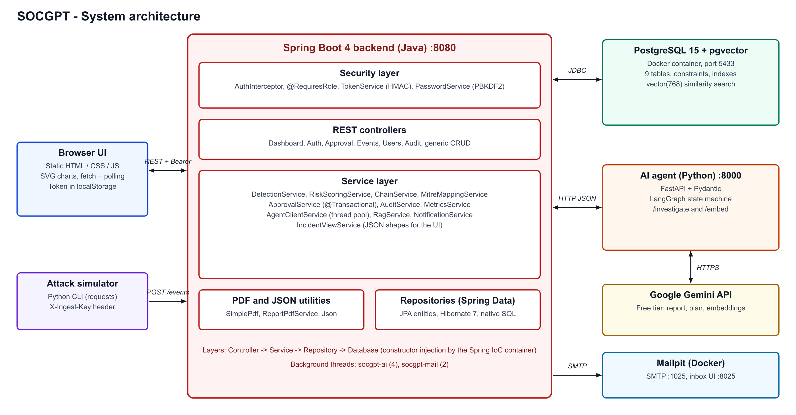
Figure 4.1: System architecture

4.1 Layers of the Java backend
Layer | Classes | Responsibility
Security | AuthInterceptor, TokenService, PasswordService, AccessPolicy, @RequiresRole | Runs before every controller: checks the token, the role and the business rules for who may decide what.
Controllers | DashboardController, AuthController, ApprovalController, SecurityEventController, UserController, AuditLogController, plus simple CRUD controllers | Turn HTTP requests into service calls and return JSON.
Services | DetectionService, RiskScoringService, ChainService, MitreMappingService, ApprovalService, AgentClientService, RagService, NotificationService, MetricsService, AuditService, IncidentViewService | All business logic.
Repositories | Eight Spring Data interfaces (one per entity) | Database access; most queries are generated from method names.
Entities | User, SecurityEvent, Incident, IncidentChain, InvestigationReport, RemediationPlan, AuditLog, Notification | Java classes mapped to tables with JPA annotations.
Utilities | Json (reader and writer), SimplePdf, ReportPdfService | Hand-written JSON parser and PDF generator.

4.2 Life of an incident
Figure 4.2 follows one attack from the first raw event to a closed incident. Steps 1 to 6 happen in milliseconds inside the request. Steps 6 to 9 run on a background thread so the sensor never waits for the AI. Step 10 is the human gate.
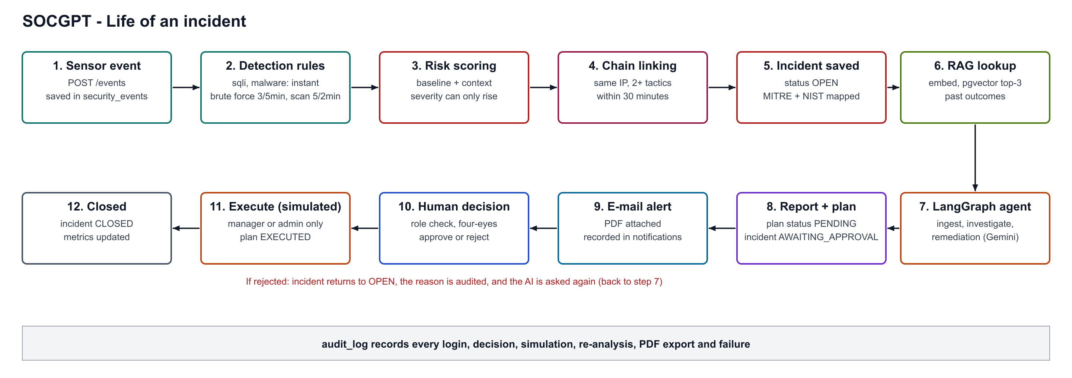
Figure 4.2: Life of an incident

4.3 Why the design looks like this
- Human approval lives in Java, not inside the AI workflow. The decision is stored in the database, survives restarts, and is covered by roles and the audit log.
- MITRE and NIST mapping is a lookup table, not an LLM guess. The standard says T1190 belongs to Initial Access; a model should not decide that.
- The AI is told what the rules already know. The prompt contains the severity, risk score, technique, attack chain and similar past incidents, and is told to use only the supplied facts.
- Failure is visible and recoverable. If the AI is down, the incident stays OPEN, the reason is shown in the UI and the audit log, and a button re-runs the analysis.

5. Database design: ER diagram
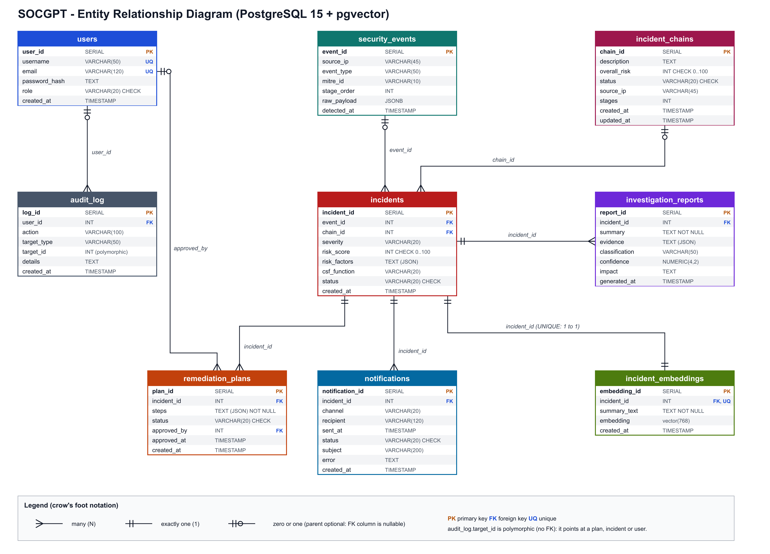
Figure 5.1: Entity Relationship (ER) diagram of the SOCGPT database

5.1 From requirements to entities
The database design started from the questions the system has to answer. Each noun in the requirements became an entity, and each "has many" sentence became a relationship.
Requirement | Entity (table)
Who may use the system and with what role? | users
What raw things did the sensors see? | security_events
Which events were serious enough to be an incident? | incidents
Which incidents belong to one multi-stage attack? | incident_chains
What did the AI conclude about an incident? | investigation_reports
What does the AI propose to do, and did a human approve it? | remediation_plans
Who did what, and when? (compliance) | audit_log
Who was e-mailed, and did the e-mail arrive? | notifications
What do past incidents mean, so similar ones can be found? | incident_embeddings

5.2 Relationships and cardinality
Relationship | Cardinality | Foreign key | Notes
security_events to incidents | 1 : N | incidents.event_id | One event can trigger incidents; in practice one. Nullable so an incident can be created manually.
incident_chains to incidents | 1 : N (optional) | incidents.chain_id | Standalone incidents have no chain, so the column is NULL.
incidents to investigation_reports | 1 : N | investigation_reports.incident_id | A new report is added each time the AI is re-run; the newest is shown.
incidents to remediation_plans | 1 : N | remediation_plans.incident_id | A rejected plan is followed by a new PENDING plan.
incidents to notifications | 1 : N | notifications.incident_id | One row per recipient per e-mail.
incidents to incident_embeddings | 1 : 1 | incident_embeddings.incident_id (UNIQUE) | The UNIQUE index enforces one vector per incident and makes upserts possible.
users to audit_log | 1 : N (optional) | audit_log.user_id | NULL for actions by the system itself (for example an AI failure).
users to remediation_plans | 1 : N (optional) | remediation_plans.approved_by | NULL until a person decides.
One link is deliberately not a foreign key: audit_log.target_type and target_id point at different kinds of rows (a plan, an incident, a user). This "polymorphic reference" keeps the audit trail intact even if the target row is later removed.

5.3 Relational schema (all tables)
Types are PostgreSQL types. PK = primary key, FK = foreign key, NN = NOT NULL, UQ = unique.

users
Column | Type | Constraints
user_id | SERIAL | PK
username | VARCHAR(50) | UQ, NN
email | VARCHAR(120) | UQ, NN
password_hash | TEXT | NN (stored as pbkdf2$iterations$salt$hash)
role | VARCHAR(20) | NN, DEFAULT 'analyst', CHECK role IN ('analyst','soc_manager','admin')
created_at | TIMESTAMP | DEFAULT now()

security_events
Column | Type | Constraints
event_id | SERIAL | PK
source_ip | VARCHAR(45) | NN (45 characters fits IPv6)
event_type | VARCHAR(50) | NN (sqli, malware, brute_force, port_scan)
mitre_id | VARCHAR(10) | for example T1190
stage_order | INT | position along the kill chain (Reconnaissance 1, Initial Access 3, Execution 4, Credential Access 8)
raw_payload | JSONB | reserved for raw sensor data
detected_at | TIMESTAMP | DEFAULT now()

incident_chains
Column | Type | Constraints
chain_id | SERIAL | PK
description | TEXT | for example "Reconnaissance -> Credential Access -> Initial Access from 203.0.113.45 over 4 min"
overall_risk | INT | CHECK between 0 and 100 (highest risk among members)
status | VARCHAR(20) | DEFAULT 'ACTIVE', CHECK IN ('ACTIVE','CONTAINED','RESOLVED')
source_ip | VARCHAR(45) | the attacker the chain is built around
stages | INT | DEFAULT 1, number of distinct attack stages
created_at, updated_at | TIMESTAMP | DEFAULT now()

incidents
Column | Type | Constraints
incident_id | SERIAL | PK
event_id | INT | FK to security_events
chain_id | INT | FK to incident_chains, NULL if standalone
severity | VARCHAR(20) | NN (LOW, MEDIUM, HIGH, CRITICAL)
risk_score | INT | CHECK between 0 and 100
risk_factors | TEXT | JSON text: why the score is what it is
csf_function | VARCHAR(20) | NIST CSF function
status | VARCHAR(20) | DEFAULT 'OPEN', CHECK IN ('OPEN','INVESTIGATING','AWAITING_APPROVAL','REMEDIATED','CLOSED')
created_at | TIMESTAMP | DEFAULT now()

investigation_reports
Column | Type | Constraints
report_id | SERIAL | PK
incident_id | INT | FK to incidents, ON DELETE CASCADE
summary | TEXT | NN
evidence | TEXT | JSON array of evidence strings
classification | VARCHAR(50) | short attack classification (the Java code cuts longer AI text to 50)
confidence | NUMERIC(4,2) | 0.00 to 1.00
impact | TEXT
generated_at | TIMESTAMP | DEFAULT now()

remediation_plans
Column | Type | Constraints
plan_id | SERIAL | PK
incident_id | INT | FK to incidents, ON DELETE CASCADE
steps | TEXT | NN, JSON: five ordered stages
status | VARCHAR(20) | DEFAULT 'PENDING', CHECK IN ('PENDING','APPROVED','REJECTED','EXECUTED')
approved_by | INT | FK to users
approved_at | TIMESTAMP
created_at | TIMESTAMP | DEFAULT now()

incident_embeddings
Column | Type | Constraints
embedding_id | SERIAL | PK
incident_id | INT | FK to incidents, ON DELETE CASCADE, UNIQUE INDEX
summary_text | TEXT | NN, the text that was embedded
embedding | vector(768) | pgvector column
created_at | TIMESTAMP | DEFAULT now()

audit_log
Column | Type | Constraints
log_id | SERIAL | PK
user_id | INT | FK to users, NULL for system actions
action | VARCHAR(100) | NN, for example APPROVE_REMEDIATION
target_type, target_id | VARCHAR(50), INT | polymorphic reference (no FK)
details | TEXT | readable description, includes rejection reasons
created_at | TIMESTAMP | DEFAULT now()

notifications
Column | Type | Constraints
notification_id | SERIAL | PK
incident_id | INT | FK to incidents, ON DELETE CASCADE
channel | VARCHAR(20) | DEFAULT 'email'
recipient | VARCHAR(120) | NN
status | VARCHAR(20) | DEFAULT 'PENDING', CHECK IN ('PENDING','SENT','FAILED')
subject, error | VARCHAR(200), TEXT | what was sent and why it failed (if it did)
sent_at, created_at | TIMESTAMP

5.4 Normalisation
The schema is in third normal form (3NF) for everything except a few columns that were denormalised on purpose.
Normal form | How the schema meets it
1NF (atomic values, no repeating groups) | Every column holds one value. The one-to-many facts (reports, plans, notifications per incident) are separate tables, not repeated columns.
2NF (no partial dependency) | Every table has a single-column surrogate primary key (SERIAL), so no non-key column can depend on only part of a key.
3NF (no transitive dependency) | Technique name and tactic are not stored on incidents. They depend on event_type and are produced by MitreMappingService, so changing a mapping cannot leave stale copies in the database.

Deliberate denormalisation (and why)
Column | Trade-off
evidence, steps, risk_factors, details stored as JSON text | These values are always read and written as a whole and never queried element by element. A child table would add joins for no benefit. They are plain TEXT (not JSONB) so the Java entities stay simple.
incidents.csf_function | A copy of the mapping result so the dashboard can group by NIST function with one query.
incident_chains.stages and overall_risk | Derived aggregates kept for fast reads; recomputed whenever a member is added (ChainService).
users.role as VARCHAR with a CHECK | There are only three roles, so a separate roles table would add a join without adding information. It could be normalised later if roles gain attributes.
audit_log.target_id without a foreign key | Keeps history even if the target is deleted, and one column can point at several kinds of rows.

5.5 Integrity constraints
Constraint type | Examples in this schema
PRIMARY KEY | All nine tables use a SERIAL surrogate key (an auto-increment sequence).
FOREIGN KEY | incidents.event_id, incidents.chain_id, reports/plans/notifications/embeddings.incident_id, plans.approved_by, audit_log.user_id.
ON DELETE CASCADE | Deleting an incident removes its reports, plans, notifications and embedding, so no orphan rows remain.
UNIQUE | users.username, users.email, incident_embeddings.incident_id.
NOT NULL | username, email, password_hash, severity, source_ip, event_type, summary, steps, action, recipient, summary_text.
CHECK | role in three values; risk_score and overall_risk between 0 and 100; status columns restricted to their state vocabularies.
DEFAULT | created_at = now(), status defaults, stages = 1. The Java entities also set defaults in @PrePersist because Hibernate sends explicit NULLs.
Because the status values are enforced by CHECK constraints, a bug in the Java code cannot write an invalid state such as an incident status of "DONE": PostgreSQL would reject it.

5.6 Indexes
Index | Columns | Query it speeds up
idx_events_ip_time | security_events (source_ip, detected_at) | Detection windows: "events from this IP in the last 5 minutes" (composite index, equality first, range second).
idx_chains_ip_status | incident_chains (source_ip, status) | Finding the active chain of an attacker.
idx_incidents_chain | incidents (chain_id) | Loading all members of a chain.
idx_incidents_status | incidents (status) | Dashboard counts and the approval queue.
idx_audit_log_user_time | audit_log (user_id, created_at) | Audit filtering by person and time.
ux_incident_embeddings_incident | incident_embeddings (incident_id) UNIQUE | Enforces one vector per incident; the target of ON CONFLICT in the upsert.
Primary key and UNIQUE indexes | created automatically | Lookups by id, login by username.
A design decision worth explaining. The first schema had an IVFFlat index on the embedding column. PostgreSQL warned that IVFFlat gives poor recall on small tables, which would silently return no similar incidents. The migration drops it: an exact scan over a few thousand 768-number vectors takes milliseconds. The schema notes that an HNSW index should be added only if the table passes about 100,000 rows.

5.7 Transactions and ACID
Approving a plan changes three things that must succeed or fail together: the plan status, the incident status, and the audit row. ApprovalService marks each of its three methods @Transactional, so Spring opens a database transaction, and rolls it back if any step throws.
ACID property | How it appears here
Atomicity | approve() updates remediation_plans, updates incidents and inserts into audit_log in one transaction. A failure in any step undoes all of them.
Consistency | CHECK, FOREIGN KEY and UNIQUE constraints plus a state check in code: approve and reject only from PENDING, execute only from APPROVED. A wrong order returns HTTP 409.
Isolation | PostgreSQL default READ COMMITTED. Two analysts cannot both see a half-finished approval.
Durability | Committed data survives restarts; the database volume is a Docker volume. Tokens are stateless so sessions also survive.

Plan and incident state machine
Plan: PENDING --approve--> APPROVED --execute--> EXECUTED
|
+--reject--> REJECTED (incident goes back to OPEN, AI creates a new PENDING plan)

Incident: OPEN --(AI finishes)--> AWAITING_APPROVAL --approve--> REMEDIATED --execute--> CLOSED
^ |
+--------- reject --------+
Limitation (honest note). Concurrency is protected by the state check, not by a row lock. Two approvals arriving in the same millisecond could both pass the check. A production version would add a version column (optimistic locking) or SELECT ... FOR UPDATE.

5.8 SQL used in the project

a) Derived queries (Spring Data generates the SQL from the method name)
// SecurityEventRepository
List<SecurityEvent> findBySourceIpAndEventTypeAndDetectedAtAfter(String ip, String type, LocalDateTime t);
-- becomes: SELECT * FROM security_events WHERE source_ip = ? AND event_type = ? AND detected_at > ?

// IncidentRepository: findByEventIdIn(Collection<Integer> ids) -> WHERE event_id IN (?, ?, ...)
// AuditLogRepository: findTop500ByOrderByLogIdDesc() -> ORDER BY log_id DESC LIMIT 500
// NotificationRepository: countByStatus("SENT") -> SELECT count(*) ... WHERE status = ?

b) Upsert (INSERT ... ON CONFLICT) for the embedding of an incident
INSERT INTO incident_embeddings (incident_id, summary_text, embedding)
VALUES (?1, ?2, CAST(?3 AS vector))
ON CONFLICT (incident_id) DO UPDATE
SET summary_text = EXCLUDED.summary_text,
embedding = EXCLUDED.embedding,
created_at = now();

c) Nearest-neighbour search with cosine distance (pgvector)
SELECT e.incident_id, 1 - (e.embedding <=> CAST(?1 AS vector)) AS similarity
FROM incident_embeddings e
WHERE e.incident_id <> ?2
ORDER BY e.embedding <=> CAST(?1 AS vector)
LIMIT ?3;

d) Self-join to find incidents similar to one already stored (used when the UI opens an incident)
SELECT o.incident_id, 1 - (o.embedding <=> me.embedding) AS similarity
FROM incident_embeddings me
JOIN incident_embeddings o ON o.incident_id <> me.incident_id
WHERE me.incident_id = ?1
ORDER BY o.embedding <=> me.embedding
LIMIT ?2;
The operator <=> is cosine distance, so 1 minus the distance is the similarity between 0 and 1. This query needs no call to the AI service because both vectors are already in the table.

5.9 Schema evolution: the idempotent migration
The database was created before several features existed. db/migrate_v2.sql upgrades an existing database without losing data, and can be run any number of times (every statement is ADD COLUMN IF NOT EXISTS, CREATE INDEX IF NOT EXISTS or DROP INDEX IF EXISTS). It was tested by building an old-style database, migrating it twice, and comparing it with a fresh install built from schema.sql: both had exactly the same 66 columns.
ALTER TABLE incidents ADD COLUMN IF NOT EXISTS risk_factors TEXT;
ALTER TABLE incident_chains ADD COLUMN IF NOT EXISTS source_ip VARCHAR(45);
ALTER TABLE incident_chains ADD COLUMN IF NOT EXISTS stages INT DEFAULT 1;
ALTER TABLE notifications ADD COLUMN IF NOT EXISTS subject VARCHAR(200);
DROP INDEX IF EXISTS idx_incident_embeddings_vec; -- poor-recall IVFFlat index
CREATE UNIQUE INDEX IF NOT EXISTS ux_incident_embeddings_incident ON incident_embeddings (incident_id);

5.10 Object-relational mapping (JPA / Hibernate)
- Each table has an entity class annotated with @Entity, @Table, @Id, @GeneratedValue(IDENTITY) and @Column. Hibernate turns method calls such as save() into INSERT or UPDATE statements.
- @PrePersist methods fill timestamps and default statuses before an insert.
- The embedding table has no entity: vectors are handled with native SQL through the EntityManager, because Hibernate has no type for pgvector.
- spring.jpa.hibernate.ddl-auto=none: the schema is owned by SQL scripts, not generated by Hibernate. This is safer and keeps the constraints under our control.
- Native queries use CAST(?1 AS vector) rather than the :: operator, because Hibernate's parser treats double colons as named parameters.

5.11 Database security and operations
- Passwords are never stored in plain text: PBKDF2-HMAC-SHA256 with a random salt and 120,000 iterations (format pbkdf2$iterations$salt$hash). Old plain-text rows are upgraded on first login.
- The users API never returns password data.
- The audit_log table is read-only through the API; only the system writes to it.
- Credentials for the database are read from properties or environment variables (SOCGPT_DB_URL, SOCGPT_DB_USER, SOCGPT_DB_PASSWORD).
- The database runs in Docker with a named volume, so it can be recreated with one command and the data persists between runs.

6. Advanced Programming topics and where they are used
This chapter lists each programming topic, the exact place in the project where it is used, and why. Class names refer to the package com.socgpt.backend unless stated.

6.1 Topic map
Topic | Where it is used | What it does there
Classes, encapsulation | model/*.java (8 entities) | Private fields with getters and setters; each class represents one table row.
Abstraction and interfaces | repository/*Repository.java; HandlerInterceptor; ApplicationRunner | Repositories are interfaces: Spring creates the implementation at runtime. AuthInterceptor and DataInitializer implement framework interfaces.
Polymorphism | AuthInterceptor, WebConfig, DataInitializer | The framework calls our classes through interface methods without knowing the concrete type.
Records (immutable data carriers) | MitreMappingService.Mapping, RiskScoringService.Factor and Result, AccessPolicy.Decision, AuthUser, ChainService.Preview and Linked | Short, immutable classes that carry results between methods.
Enums and switch expressions | DetectionService.evaluate, RiskScoringService.rank, ReportPdfService.sevColor | Arrow-style switch returning a value; replaces long if-else chains.
Pattern matching (instanceof) | AgentClientService.handleResponse, IncidentViewService | "if (x instanceof Map<?,?> m)" tests the type and declares the variable in one step.
Generics | Map<String,Object>, List<Map<String,Object>>, Optional<T>, Comparator.comparing | Type-safe collections for JSON-like data.
Collections framework | HashMap, LinkedHashMap (ordered JSON output), TreeMap (members sorted by id), LinkedHashSet, ArrayDeque, ConcurrentHashMap | Each structure is chosen for a reason: ordering, uniqueness, fast lookup or thread safety.
Streams and lambdas | IncidentViewService.list, MetricsService.compute, DashboardController.stats, NotificationService.recipientsFor | Filter, sort, limit, group and collect data declaratively.
Optional | MitreMappingService.lookup, repositories (findById, findByUsername) | Avoids null returns for "might not exist" results.
Functional style | Comparator.comparing(...).thenComparing(...), Mono callbacks, Supplier in tests | Passing behaviour as an argument.
Multithreading | AgentClientService (4-thread pool "socgpt-ai"), NotificationService (2-thread pool "socgpt-mail") | The AI call and the e-mail sending run in the background so the sensor request returns immediately.
Thread safety | ConcurrentHashMap.newKeySet() for the in-flight incident set; ConcurrentHashMap for last errors; synchronized deque in AuthController | Prevents two AI runs for one incident and keeps the login lock-out counter consistent.
Non-blocking HTTP client | WebClient in AgentClientService and RagService | Calls the Python service with a timeout (120 s for the AI, 40 s for embeddings).
Annotations | @Entity, @Transactional, @Value, @RestController, @PrePersist, @RequestAttribute | Declarative configuration instead of boilerplate code.
Custom annotation + reflection | security/RequiresRole.java and AuthInterceptor | @RequiresRole({"analyst","soc_manager"}) is read at runtime with HandlerMethod.getMethodAnnotation to decide who may call each endpoint.
Dependency injection / IoC | Every @Service and @RestController (constructor injection) | Spring builds the object graph; classes receive collaborators instead of creating them. ObjectProvider<JavaMailSender> makes e-mail optional.
Interceptor (chain of responsibility) | AuthInterceptor, registered in WebConfig | One gatekeeper runs before every controller: token, role, ingest key.
Layered architecture, Repository pattern | controller, service, repository packages | Separation of concerns; each layer talks only to the next.
Facade / service layer | DetectionService | One method orchestrates mapping, risk scoring, chain linking, saving and the AI hand-off.
View / DTO pattern | IncidentViewService | Builds the exact JSON shapes the UI needs instead of exposing entities directly.
State machine | ApprovalService (plan and incident states), LangGraph graph | Only legal state changes are allowed; others return HTTP 409.
Exception handling | ResponseStatusException (400, 401, 403, 404, 409, 429); try/catch with fail-soft in RagService | Errors map to correct HTTP codes; a failing optional feature (RAG, e-mail) never breaks the main flow.
Input validation | UserController (regex for username and e-mail), SecurityEventController, DashboardController.simulate (IP pattern) | Rejects bad data with a clear 400 message.
Cryptography | PasswordService (PBKDF2WithHmacSHA256), TokenService (HmacSHA256), SecureRandom salts | Hashing and signing with JDK classes only.
Secure coding techniques | MessageDigest.isEqual (constant-time compare), a dummy hash when the user does not exist, HTML escaping, lock-out after 5 failures | Defends against timing attacks, user enumeration, XSS and password guessing.
Algorithms: sliding time window | DetectionService.checkThreshold, ChainService.preview | "3 events from one IP in 5 minutes" and "same IP within 30 minutes".
Algorithms: recursive-descent parser | util/Json.java | A hand-written JSON reader (objects, arrays, strings, numbers) so the code does not depend on a JSON library version.
Algorithms: greedy word wrap | pdf/SimplePdf.wrap | Breaks text into lines using the real character widths of the Helvetica font.
Algorithms: scoring and ranking | RiskScoringService | Weighted rules with caps; severity can only be upgraded.
Algorithms: graph / set union | ChainService.link | Merges chains that turn out to be the same attack; orders members by time.
Algorithms: hashing trick and cosine similarity | agents-python/embeddings.py; pgvector <=> | Offline text embeddings and nearest-neighbour search.
Binary file generation | pdf/SimplePdf.java | Writes a valid PDF by hand: objects, cross-reference table with byte offsets, fonts, Windows-1252 encoding.
Networking and protocols | REST/HTTP (all controllers), SMTP with MIME multipart (NotificationService), bearer tokens | The e-mail contains plain text, HTML and a PDF attachment.
Date and time API | java.time.LocalDateTime, Duration (MetricsService, DetectionService) | Windows, durations and "off-hours" checks.
Automated testing | SocgptIntegrationTest (JUnit 5), test_agent.py (pytest) | End-to-end tests with a real database, a fake AI server and a fake mail server.
Build tools and packaging | Maven wrapper (pom.xml), Docker Compose | Reproducible build and infrastructure.
Python: web service | FastAPI + Pydantic models (main.py) | Typed request validation and JSON responses.
Python: state machine / AI orchestration | LangGraph StateGraph (graph.py) | Nodes ingest, investigate, generate_remediation with a conditional edge.
JavaScript: async programming | js/common.js (fetch, async/await), 3-second polling in each page | Live updates without page reloads.
JavaScript: DOM and SVG | index.html (donut, bars, gauge, sparkline) | Charts drawn with SVG from the JSON data.

6.2 Selected examples

Custom annotation read by reflection (security)
The annotation is declared once and then placed on controller methods. The interceptor reads it at runtime, so access rules sit next to the code they protect.
@Target({ElementType.METHOD, ElementType.TYPE})
@Retention(RetentionPolicy.RUNTIME)
public @interface RequiresRole { String[] value(); }

@PostMapping("/{planId}/execute")
@RequiresRole("soc_manager")
public RemediationPlan execute(@PathVariable Integer planId, @RequestAttribute(USER_ATTR) AuthUser user) { ... }

// in AuthInterceptor.preHandle
RequiresRole rule = handlerMethod.getMethodAnnotation(RequiresRole.class);
if (rule != null && !user.hasAnyRole(rule.value())) return deny(response, 403, "Forbidden", ...);
Anything without the annotation is secure by default: a signed-in user may read (GET) but only an admin may change (POST, PUT, DELETE).

Records and switch expressions (detection rules)
return switch (newEvent.getEventType()) {
case "brute_force" -> checkThreshold(newEvent, 3, 5, "HIGH", 70); // 3 events in 5 minutes
case "port_scan" -> checkThreshold(newEvent, 5, 2, "MEDIUM", 50); // 5 events in 2 minutes
case "sqli" -> createIncident(newEvent, "CRITICAL", 90, 1, 0);
case "malware" -> createIncident(newEvent, "CRITICAL", 95, 1, 0);
default -> Optional.empty();
};

Background processing with a thread pool
private final ExecutorService pool = Executors.newFixedThreadPool(4, r -> { Thread t = new Thread(r, "socgpt-ai"); t.setDaemon(true); return t; });
private final Set<Integer> inFlight = ConcurrentHashMap.newKeySet();

public boolean requestInvestigation(Incident incident, ...) {
if (!inFlight.add(incident.getIncidentId())) return false; // already running: do not start twice
pool.submit(() -> { try { investigate(...); } finally { inFlight.remove(id); } });
return true;
}
The sensor request that created the incident returns at once; the AI result arrives some seconds later and the UI picks it up by polling.

Streams (dashboard list)
return incidentRepository.findAll().stream()
.sorted(Comparator.comparing(Incident::getIncidentId, Comparator.reverseOrder()))
.limit(300)
.map(i -> row(i, events.get(i.getEventId()), plans.get(i.getIncidentId()), reports.get(i.getIncidentId())))
.collect(Collectors.toList());

Password hashing and signed tokens (cryptography)
SecretKeyFactory f = SecretKeyFactory.getInstance("PBKDF2WithHmacSHA256");
byte[] hash = f.generateSecret(new PBEKeySpec(password.toCharArray(), salt, 120_000, 256)).getEncoded();

// token = base64url(userId|expiry) + "." + base64url(HMAC-SHA256(payload, secret))
return MessageDigest.isEqual(expected, supplied); // constant-time comparison
Only the user id is placed in the token. The role is read from the database on every request, so a demoted user loses access immediately.

Fail-soft design
Optional features never break the main workflow. If the embedding service, pgvector or the mail server fails, RagService returns an empty list and NotificationService records a FAILED notification; the incident is still investigated and the plan is still produced. This was verified by an integration test that runs with embeddings switched off.

7. Module descriptions

7.1 Detection engine (DetectionService)
Event type | Rule | Baseline severity and risk | MITRE technique | NIST CSF function
sqli | Instant | CRITICAL, 90 | T1190 Exploit Public-Facing Application (Initial Access) | Protect
malware | Instant | CRITICAL, 95 | T1204 User Execution (Execution) | Respond
brute_force | 3 or more events from one IP within 5 minutes | HIGH, 70 | T1110 Brute Force (Credential Access) | Detect
port_scan | 5 or more events from one IP within 2 minutes | MEDIUM, 50 | T1595 Active Scanning (Reconnaissance) | Detect
To save AI cost and avoid noise, only one incident per burst is raised: if an incident already exists for the same IP and attack type inside the window, further events are stored but do not create new incidents.

7.2 Risk scoring (RiskScoringService)
The rule gives a baseline. Context can only raise the score (capped at 100), and severity can only be upgraded (85 and above CRITICAL, 65 HIGH, 40 MEDIUM). Every contribution is stored as JSON in incidents.risk_factors, and the UI shows it under "Why this score?".
Factor | Points | Condition
Detection rule baseline | 50 to 95 | Set by the rule above.
Repeat offender | +5 per earlier incident, max +15 | Incidents from the same IP in the last 24 hours that are older than the chain window.
Attack chain progression | +8 per extra stage, max +24 | Distinct attack stages from the same IP inside the chain window.
Off-hours activity | +5 | Detected between 22:00 and 05:59 server time.
Burst intensity | +2 per event over the threshold, max +6 | Brute force and port scan only.
Example from the tests: a port scan (50) that is the fourth stage of a chain scores 50 + 24 = 74 and is escalated from MEDIUM to HIGH, with a "Severity escalated" entry in the explanation.

7.3 Attack chains (ChainService)
- A chain forms when the same source IP has two or more different MITRE tactics among incidents in the last 30 minutes. Raw events alone never form a chain.
- preview() looks at earlier incidents before saving so the risk score can use the stage count; link() then creates or extends the chain and points every member at it.
- The description is built in time order, for example "Reconnaissance -> Credential Access -> Initial Access from 203.0.113.99 over 1 min".
- The chain is sent to the AI so the report describes the whole attack path, and an e-mail "Multi-stage attack detected" is sent to managers and admins.

7.4 AI pipeline (Python: FastAPI + LangGraph)
The Java backend calls POST /investigate with the incident, its mapping, the chain (if any) and the similar past incidents. The LangGraph graph has three nodes:
- ingest: marks the incident open (a place for future enrichment).
- investigate: builds the prompt and asks Gemini (JSON mode, temperature 0.2) for a summary, classification, confidence, impact and evidence. A conditional edge stops the graph if this fails, so no plan is made from bad output.
- generate_remediation: asks for five steps in the fixed order Containment, Eradication, Recovery, Validation, Prevention. The code re-sorts them into that order and drops empty steps.
The code also protects the database from the model: confidence is clamped to 0..1, evidence is forced to be a list of strings, and the classification is cut to 50 characters to fit the column. Calls retry with growing delays and, after two attempts, switch to a lighter fallback model because the free tier sometimes answers "503 high demand". The prompts state that incident data and analyst comments are reference material, never instructions to the model (a basic defence against prompt injection).

7.5 Retrieval-augmented generation (RagService)
- When an incident has a report, its description (attack, technique, tactic, severity, classification) is turned into a 768-number embedding by the Python service and stored in incident_embeddings.
- When a new incident arrives, the same kind of text is embedded and the three nearest stored incidents are found with the cosine-distance query (minimum similarity 0.5).
- Each hit is enriched with the report summary, the approved plan steps and any rejection reason written by an analyst, then included in the AI prompt with the instruction to prefer approved approaches and avoid rejected ones.
- The same stored vectors power the "Similar past incidents" panel in the UI.
Two embedding providers are supported: Gemini embeddings (default) and an offline hashing-trick embedder for use without a key or network. Vectors from different providers must not be mixed, so an admin button re-indexes all incidents.

7.6 Approval workflow and role-based access (ApprovalService, AccessPolicy)
Action | Analyst | SOC manager | Admin
View incidents, dashboard, audit log | Yes | Yes | Yes
Approve or reject a plan on a non-critical incident | Yes | Yes | Yes
Approve or reject a plan on a CRITICAL incident (four-eyes rule) | No | Yes | Yes
Run the simulated recovery | No | Yes | Yes
Launch simulations, re-run the AI | Yes | Yes | Yes
Create users, re-index the AI memory | No | No | Yes
The same rules are exposed to the UI as a "permissions" object in each incident's JSON, so the buttons are disabled with an explanation instead of the screen duplicating the rules. Sensors (the simulator) are authenticated with a shared X-Ingest-Key header instead of a user token.

7.7 E-mail alerts (NotificationService)
- Action required: sent when the AI has produced a plan; includes the AI summary, the link to the incident and the PDF report as an attachment. Critical incidents go to SOC managers and admins; others also go to analysts.
- Multi-stage attack detected: sent when a chain is created or grows.
- Each message is multipart (plain text and HTML). Every send is stored in the notifications table as PENDING, then SENT or FAILED with the error text.
- Mailpit receives the messages locally (inbox at http://localhost:8025).

7.8 PDF report (SimplePdf, ReportPdfService)
No PDF library is used. SimplePdf writes the file format directly: A4 pages, the three built-in fonts, a table of real Helvetica character widths for word wrapping, filled rectangles, automatic page breaks, a "Page x of y" footer and a cross-reference table with exact byte offsets. ReportPdfService assembles the sections: key facts, risk breakdown, attack chain, AI report, remediation plan with approval details, and the audit trail.

7.9 Metrics (MetricsService)
Metric | How it is computed
Mean time to recover | Average time from detection to the EXECUTE audit entry, over closed incidents.
AI analysis time | Average time from incident creation to the first investigation report.
Approval rate | Approved and executed plans divided by all decided plans.
Top attacking IPs | Incidents grouped by source IP, with the highest risk of each.
Chains and alerts | Counts of chains (total, active) and of e-mails with status SENT.

7.10 Audit trail (AuditService)
The audit_log table records LOGIN, LOGIN_FAILED, CREATE_USER, SIMULATE_ATTACK, REINVESTIGATE, APPROVE_REMEDIATION, REJECT_REMEDIATION (with the reason), EXECUTE_REMEDIATION_SIMULATED, EXPORT_REPORT_PDF, RAG_REINDEX and AI_INVESTIGATION_FAILED. The Audit page groups the entries by day, filters them and exports them to CSV.

7.11 Front end
Page | What it shows
login.html | Sign-in with quick-fill chips for the three demo accounts.
index.html (Command Center) | Status bar with threat level and UTC clock, KPI tiles with a trend line, threat gauge, live sensor stream, incidents per hour, severity donut, MITRE tactics, NIST CSF tiles, performance, top IPs, attack chains, live incident feed and the Attack Lab.
incidents.html (Investigations) | Searchable, filterable incident table; a detail drawer with tabs (AI report, remediation plan, risk breakdown, frameworks, attack chain, activity), approve, reject and execute actions with confirmation dialogs, and PDF download.
audit.html (Audit and Governance) | Day-grouped timeline of every recorded action, filters, search and CSV export.
The pages are plain HTML, CSS and JavaScript served by Spring Boot itself, so there is no cross-origin setup. All AI text is HTML-escaped before it is shown. The pages poll the backend every three seconds. The sign-in token is kept in the browser's localStorage, and a 401 reply sends the user back to the login page.
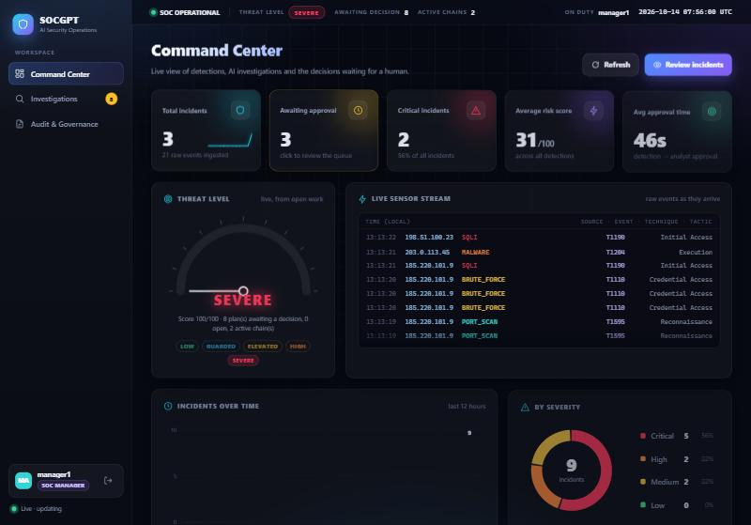
Figure 7.1: Command Center (status bar, KPI tiles, threat gauge and live sensor stream)
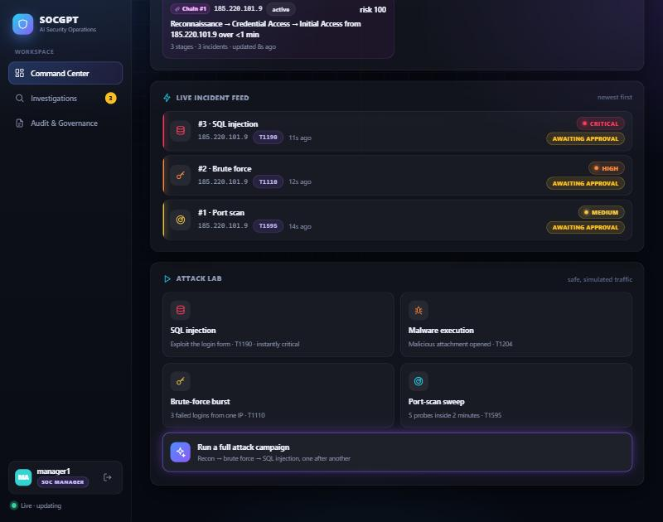
Figure 7.2: Live incident feed with the Attack Lab, after a full campaign
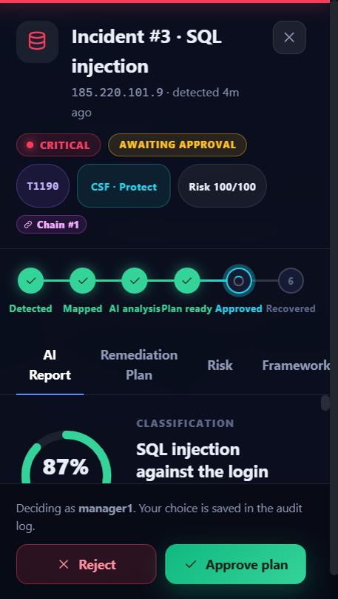
Figure 7.3: Incident detail drawer (pipeline tracker, AI report, decision buttons)
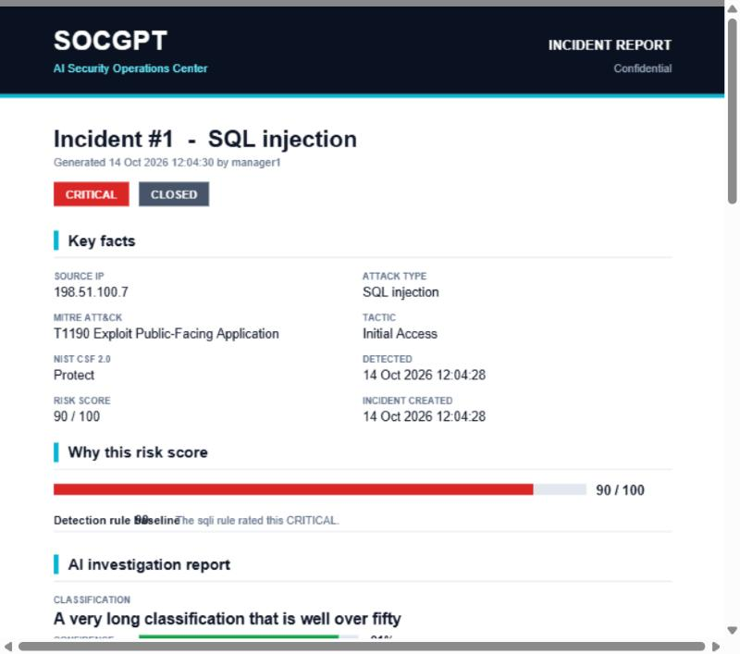
Figure 7.4: First page of the generated PDF incident report

8. REST API summary
All endpoints return JSON, except the PDF. Everything except login and sensor ingestion needs the header Authorization: Bearer <token>.
Method and path | Role needed | Purpose
POST /api/auth/login | none | Sign in; returns a token and the user.
GET /api/auth/me | any | Current user.
POST /events | X-Ingest-Key or admin | Sensor posts a raw event; detection runs immediately.
GET /api/incidents | any | Incident list for the table.
GET /api/incidents/{id} | any | Report, plan, risk factors, chain, similar incidents, notifications, audit and permissions.
GET /api/incidents/{id}/report.pdf | any | PDF report (audited).
POST /api/incidents/{id}/reinvestigate | analyst, manager | Ask the AI again for an OPEN incident.
POST /remediation-plans/{id}/approve | analyst, manager (critical: manager) | Approve a PENDING plan.
POST /remediation-plans/{id}/reject?reason= | analyst, manager (critical: manager) | Reject with a reason.
POST /remediation-plans/{id}/execute | manager | Run the simulated recovery.
GET /api/stats, /api/chains, /api/events/recent, /api/audit | any | Dashboard data.
POST /api/simulate?type=&ip= | analyst, manager | Launch a simulated attack.
GET /users, POST /users | any, admin | List users (no hashes), create a user.
POST /api/rag/reindex | admin | Embed every investigated incident.
HTTP status codes follow their meaning: 400 invalid input, 401 not signed in, 403 role not allowed, 404 not found, 409 wrong state (for example approving an already approved plan), 429 too many failed logins.

9. Testing and results

9.1 Automated tests
The Java end-to-end test (SocgptIntegrationTest) starts the real application on a random port with an in-process PostgreSQL loaded from the project's own db/schema.sql, a small stand-in for the Python AI service, and a fake SMTP server. It then drives the actual REST API with real tokens. All 8 tests pass.
Test | What it proves
Authentication and roles | Unauthenticated requests get 401; sensors need the key; users list leaks no hashes; only admins create users; duplicate and weak input is rejected; 5 wrong passwords lock the username (429); old open write endpoints are closed.
Critical incident lifecycle | Detection, report and plan saved, long AI classification cut to 50 characters, four-eyes rule (403 for analyst), manager approves, double approval returns 409, analyst cannot execute, manager executes and the incident closes; the e-mail has the PDF attached and is recorded as SENT; the PDF is a valid file; metrics are filled.
One incident per burst | Six brute-force events create exactly one incident.
Multi-stage attack chain | Port scan, brute force and SQL injection from one IP form one chain with three stages and the expected description; the chain appears in the risk factors, in the AI request and in an e-mail.
Risk scoring maths | Baseline, chain escalation from MEDIUM to HIGH, off-hours, burst caps and the 100 cap.
AI failure and retry | When the AI returns an error the incident stays OPEN with a visible reason and an audit entry; after the AI recovers, re-analysis produces a plan.
Reject with reason | Rejection stores the reason in the audit log, the incident returns to OPEN, a re-run creates a new PENDING plan.
Simulation and admin actions | Simulation validates the IP and type; re-indexing is admin only and reports failures without crashing; all actions appear in the audit trail.
The Python agent has 4 offline tests with the model mocked: output normalisation, chain and similar-incident context reaching the prompts, failure stopping the graph, and the local embedder producing 768 numbers with sensible similarity.

9.2 Checks against the real services
Check | Result
Migration of an old-style database, run twice | No errors; identical to a fresh install (66 columns); the IVFFlat index removed.
docker compose up with pgvector and Mailpit | Both containers start; the vector extension and 9 tables are created.
Live Gemini call | A real investigation returned a report and all five plan stages; embeddings returned 768 dimensions.
RAG with real pgvector | The first incident was indexed; the second received it as a similar past incident (with its approved plan) in the AI prompt and in the UI.
E-mail with attachment | Mailpit received the "Action required" messages with the PDF attached.
User interface | Sign-in redirect, attack campaign button, attack chain on the dashboard, risk, chain and activity tabs, and the PDF download were checked in a browser.

10. Problems met and how they were solved
Problem | Cause | Solution
Similar-incident search could silently return nothing | IVFFlat index has poor recall on small tables. | Dropped it; use exact search; unique index on incident_id added.
Database rejected an AI result | classification is VARCHAR(50) but the AI sometimes wrote more. | Prompt asks for under 50 characters; Python and Java both cut the value.
Error messages did not reach the UI | The Spring Boot 4 property for including messages moved. | Both server.error.include-message and spring.web.error.include-message are set.
Chain e-mail failed | A message without attachment was not in multipart mode, so it could not hold the HTML version. | The mail helper is always created in multipart mode. Found by the integration test.
Re-run button said "already running" | The in-flight flag stayed set while e-mails were being sent. | The flag is released as soon as the plan is saved; indexing and e-mail run afterwards.
Gemini returned 503 "high demand" | Free tier overload. | More patient retries and automatic fallback to a lighter model; failure is shown in the UI.
Hibernate could not parse the vector cast | The :: operator looks like a named parameter. | Use CAST(? AS vector).
Many events produced many incidents (and AI calls) | A rule fired on every event after the threshold. | One incident per burst inside the rule window.
Open write endpoints | The first CRUD controllers had no authentication. | Secure by default: unannotated writes are admin-only; the audit log has no write endpoint.

11. Limitations and future work

11.1 Limitations
- Attacks and recovery are simulated; there is no real network capture and no real remediation.
- Tokens are stateless, so signing out only removes the token in the browser. The demo token secret and passwords are for development and must be changed before sharing.
- There is no HTTPS, and the sensor key is a shared secret.
- Approvals are protected by a state check, not a row lock (see section 5.7).
- Gemini free-tier limits can slow or fail an analysis; the system reports this but cannot remove it.
- The front end polls every three seconds instead of using WebSockets.

11.2 Future work
- Optimistic locking (a version column) or SELECT FOR UPDATE on plans.
- A roles table and finer permissions; refresh tokens and revocation.
- Server-sent events or WebSockets for instant updates.
- An HNSW index for the embeddings table when data grows.
- Real log ingestion (syslog, Beats) and more detection rules (for example impossible travel).
- A user-management page, a light theme and exports to SIEM formats.

12. Conclusion
SOCGPT shows how a database-centred application and an AI component can work together safely. The relational design (nine normalised tables with constraints, indexes, transactions and a vector extension) keeps the data correct and auditable, while the Java and Python code demonstrates a wide range of advanced programming topics: concurrency, annotations and reflection, dependency injection, streams, cryptography, hand-written parsers and file formats, REST design and automated end-to-end testing.
The most important design idea is that the AI assists but a human decides. Detection, scoring and mapping are deterministic and explainable; the model writes the narrative and the plan; role-based approval, the four-eyes rule and the audit log keep people accountable. The system was tested end to end against a real PostgreSQL with pgvector, a real mail server and the live Gemini API.

Appendix A: How to run the project
- Open Docker Desktop, then in the project folder run docker compose up -d (database on port 5433, Mailpit on 1025 and 8025).
- For an existing database run the migration once: Get-Content db\migrate_v2.sql | docker exec -i socgpt-db psql -U socgpt -d socgpt
- Terminal 2: cd backend-java, then .\mvnw.cmd spring-boot:run and wait for "Started BackendApplication".
- Terminal 3: cd agents-python, activate the virtual environment, run python -m pip install -r requirements.txt, then python -m uvicorn main:app --reload --port 8000. The Gemini key goes in agents-python/.env.
- Open http://localhost:8080 and sign in. Optional: python simulator/attack_simulator.py campaign.
- Run the tests: .\mvnw.cmd test (Java) and python -m pytest (agent).
Account | Password | Role
admin | Admin@123 | admin
manager1 | Manager@123 | soc_manager
analyst1 | Analyst@123 | analyst

Appendix B: Project folder structure
socgpt/
docker-compose.yml PostgreSQL + pgvector, Mailpit
db/schema.sql, migrate_v2.sql schema and idempotent migration
backend-java/ Spring Boot application
src/main/java/com/socgpt/backend/
controller/ model/ repository/ service/ security/ pdf/ util/
src/main/resources/static/ login, dashboard, investigations, audit pages (HTML, CSS, JS)
src/test/java/ end-to-end integration test and demo harness
agents-python/ FastAPI + LangGraph agent, embeddings, tests
simulator/attack_simulator.py CLI attack generator
test-requests.http API samples for VS Code REST Client

Appendix C: Glossary
Term | Meaning
ACID | Atomicity, Consistency, Isolation, Durability: the guarantees of a database transaction.
CRUD | Create, read, update, delete.
DI / IoC | Dependency injection / inversion of control: the framework supplies the objects a class needs.
Embedding | A numeric vector that represents the meaning of a text.
Four-eyes rule | A critical decision needs a second, more senior person.
JPA / ORM | Java Persistence API / object-relational mapping: Java objects stored in tables.
PBKDF2 / HMAC | A slow password hash and a keyed signature, both built into the JDK.
REST | An HTTP API style using URLs, methods and status codes.
Upsert | Insert a row, or update it if it already exists (INSERT ... ON CONFLICT).

