**Project : Pizza Sales Analysis**

**Table of Contents:**

* [Problem Statement](https://github.com/yogeshkasar778/Sales_insights_of_data_analysis-AtliQ_Hardware/edit/main/README.md#problem-statement-)
* [Data Analysis using MySQL](https://github.com/yogeshkasar778/Sales_insights_of_data_analysis-AtliQ_Hardware/edit/main/README.md#data-analysis-using-mysql-)
* Data Cleaning
* [Build Dashboard Or a Report](https://github.com/yogeshkasar778/Sales_insights_of_data_analysis-AtliQ_Hardware/edit/main/README.md#build-dashboard-or-a-report) using Power BI
* [Tools, Software and Libraries](https://github.com/yogeshkasar778/Sales_insights_of_data_analysis-AtliQ_Hardware/edit/main/README.md#tools-software-and-libraries-)
* [References](https://github.com/yogeshkasar778/Sales_insights_of_data_analysis-AtliQ_Hardware/edit/main/README.md#references-)

**Problem Statement**

**KPI’s REQUIREMENT**

We need to analyze key indicators for our pizza sales data to gain insights into our business performance. Specifically, we want to calculate the following metrics:

1. Total Revenue: The sum of the total price of all pizza orders.
2. Average Order Value: The average amount spent per order, calculated by dividing the total revenue by the total number of orders.
3. Total Pizzas Sold: The sum of the quantities of all pizzas sold.
4. Total Orders: The total number of orders placed.
5. Average Pizzas Per Order: The average number of pizzas sold per order, calculated by dividing the total number of pizzas sold by the total number of orders.

**CHARTS REQUIREMENT**

We would like to visualize various aspects of our pizza sales data to gain insights and understand key trends. We have identified the following requirements for creating charts:

**1. What days and times do we tend to be busiest:** Based on the bar chart for Top 5 Busiest Hours and the line chart for Top 10 Busiest Days, it shows peak orders around midday and evening, with a spike on November 27th.

**2. How many pizzas are we making during peak periods:** The bar chart of hour-wise order counts indicates production needs of around 2,000–2,500 pizzas during peak hours in per month.

**3. What are our best and worst-selling pizzas:** The bar charts for Top and Bottom 5 Pizzas by Quantity and Revenue identify the most and least popular pizzas based on quantity sold and total sales revenue.

**4. What's our average order value**: The card visual at the top shows an Average Order Value of ₹38.31 calculated from total revenue and order count.

**5. How well are we utilizing our seating capacity? (we have 15 tables and 60 seats):** The Table Utilization matrix calculates daily seating usage percentages, with figures well above 100%, pointing to overcapacity and suggesting an urgent need for expansion.

**Data Analysis using MySQL**

Utilized MySQL for data extraction and calculation of key metrics such as Total Revenue, Average Order Value, Total Pizzas Sold, Total Orders, and Average Pizzas Per Order.

**DATA IMPORT**

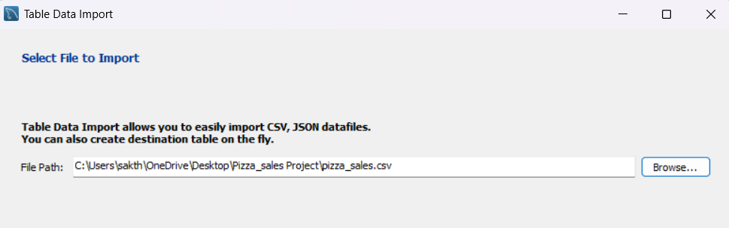

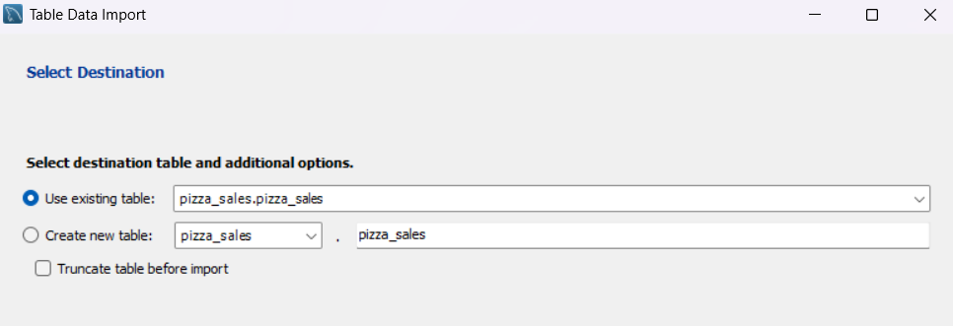

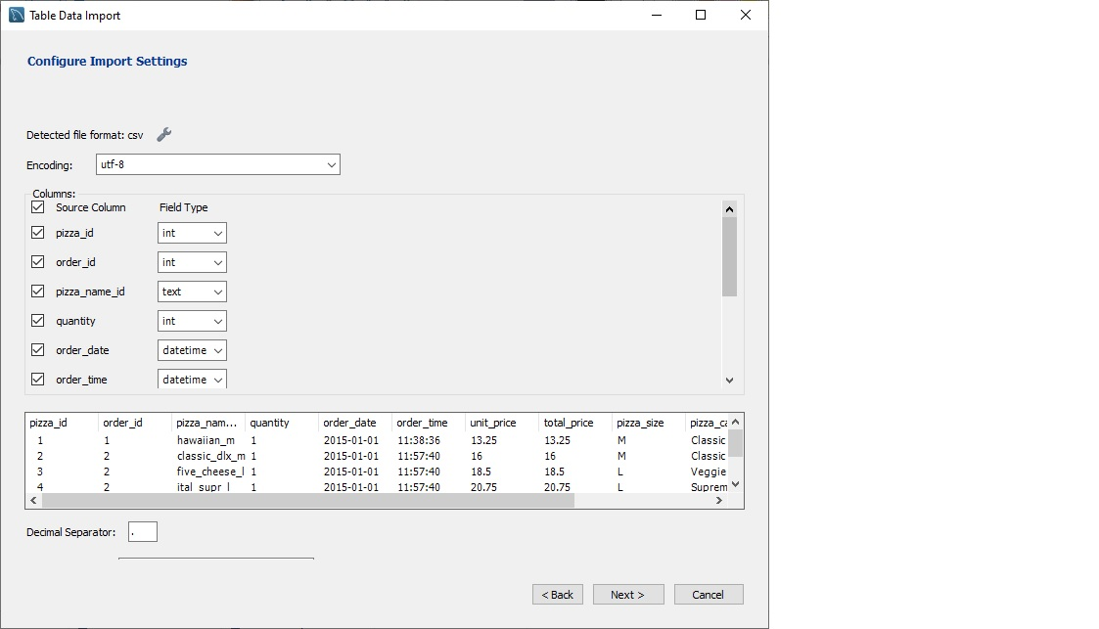

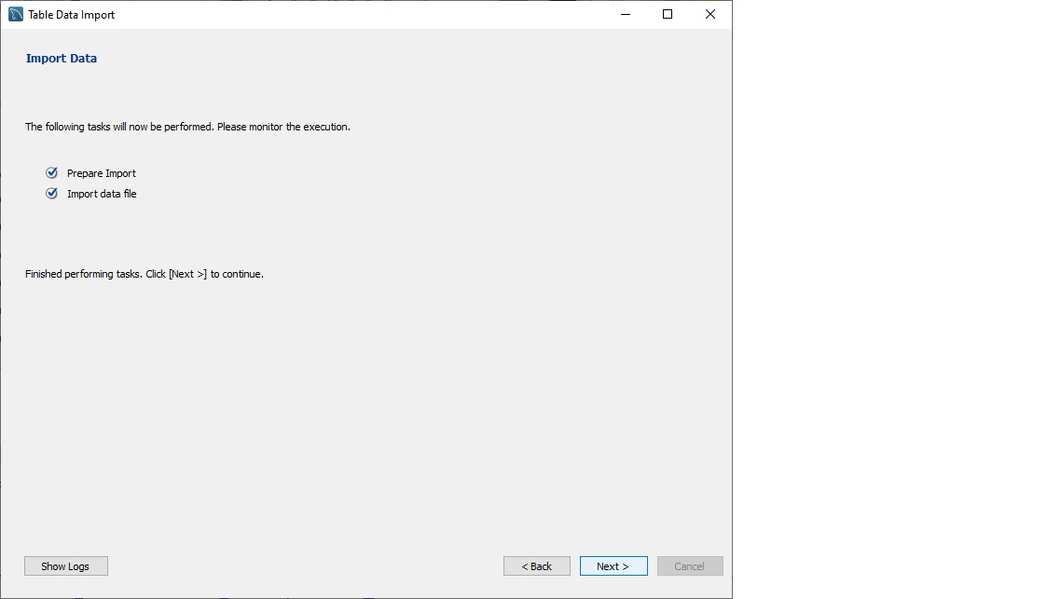

ANALYSIS OF DIFFERENT SQL STATEMENT ON DATA BASE

1. **KPI’s**
2. **Total revenue**

select sum(total_price) as total_revenue from pizza_sales;

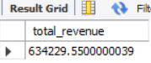

1. **Average order value**

select sum(total_price) / count(distinct order_id) as avg_order_value from pizza_sales;

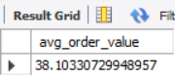

1. **Total pizza sold**

select sum(quantity) as total_pizza_sold from pizza_sales;

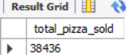

1. **Total orders**

select count(distinct order_id) as total_order from pizza_sales;

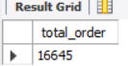

1. **Average pizzas per order**

select round(sum(quantity) / count(distinct order_id), 2) as avg_pizza_per_order from pizza_sales;

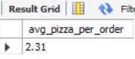

1. **What days and times do we tend to be busiest?**
2. **Top 10 busiest hours (across all days)**

select

date_format(str_to_date(order_time, '%H:%i:%s'), '%H:00') as hour_slot,

count(*) as orders_count

from pizza_sales

group by hour_slot

order by orders_count desc

limit 10;

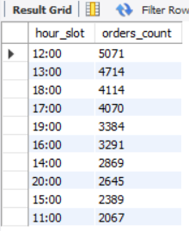

1. **Busiest days**

select

str_to_date(order_date, '%d-%m-%Y') as order_day,

count(*) as orders_count

from pizza_sales

group by order_day

order by orders_count desc

limit 10;

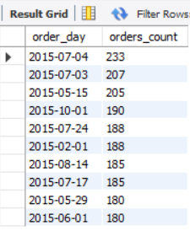

1. **How many pizzas are we making during peak periods?**

select

date_format(str_to_date(order_time, '%H:%i:%s'), '%H:00') as hour_slot,

sum(quantity) as total_pizzas

from pizza_sales

where date_format(str_to_date(order_time, '%H:%i:%s'), '%H') in ('11', '12', '13')

group by hour_slot;

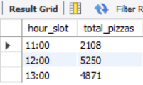

1. **What are our best and worst-selling pizzas?**
2. **Best-selling pizzas**

select

pizza_name,

sum(quantity) as total_sold

from pizza_sales

group by pizza_name

order by total_sold desc

limit 5;

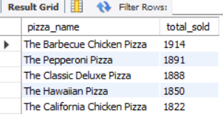

1. **Worst-selling pizzas**

select

pizza_name,

sum(quantity) as total_sold

from pizza_sales

group by pizza_name

order by total_sold asc

limit 5;

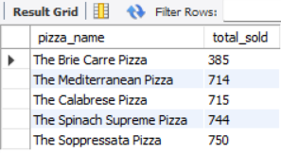

1. **What's our average order value?**

**Average order value (assuming each order_id is a separate order)**

select

avg(order_total) as avg_order_value

from (

select

order_id,

sum(total_price) as order_total

from pizza_sales

group by order_id

) as order_summary;

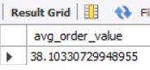

1. **How well are we utilizing our seating capacity? (we have 15 tables and 60 seats)**

**Peak hourly table usage**

select

str_to_date(order_date, '%d-%m-%Y') as order_day,

date_format(str_to_date(order_time, '%H:%i:%s'), '%H:00') as hour_slot,

count(distinct order_id) as tables_occupied,

round((count(distinct order_id) / 15) * 100, 2) as table_utilization_percent

from pizza_sales

group by order_day, hour_slot

order by table_utilization_percent desc

limit 10;

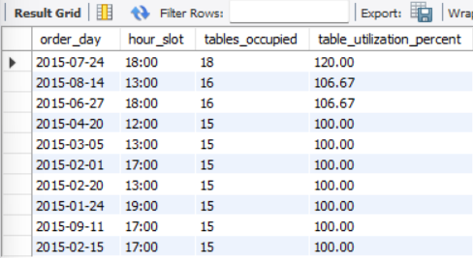

***NOTE***

If you want to apply the pizza_category or pizza_size filters to the above queries you can use WHERE clause. Follow some of below examples

SELECT pizza_name, COUNT(DISTINCT order_id) AS Total_Orders FROM pizza_sales

WHERE pizza_category = 'Classic' GROUP BY pizza_name ORDER BY Total_Orders ASC LIMIT 5;

**Data Cleaning**

Pizza size category we have in our database is abbreviated and for dashboard we need it in full expanded form. For eg. L= large, M= medium etc, so we will create an alias to temporary change its name in required format.

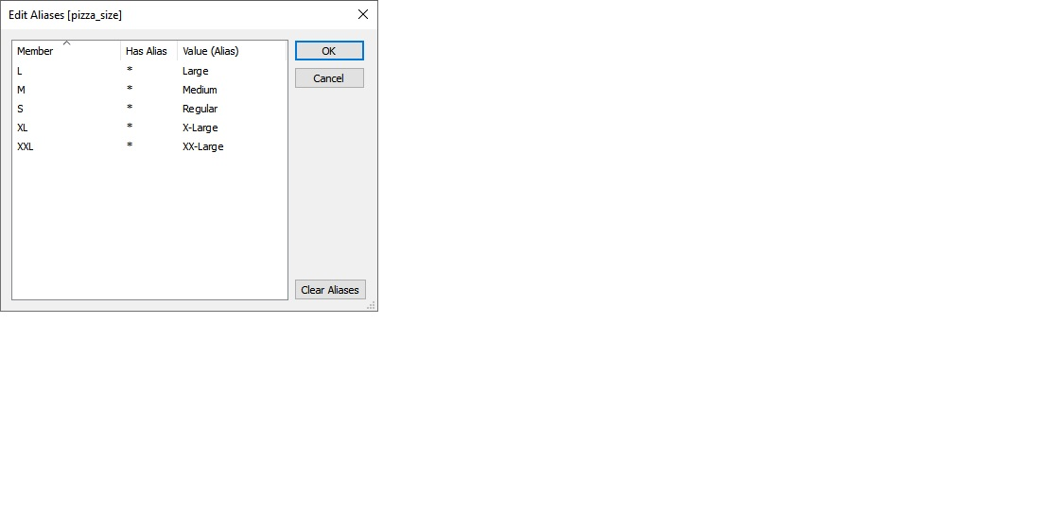

**Build Dashboard or a Report using Power BI**

Created a comprehensive dashboard in PowerBI featuring key metrics and charts, including Hourly Trend, Weekly Trend, Sales by Category, Sales by Size, Total Pizzas Sold by Category, Top 5 Best Sellers, and Bottom 5 Worst Sellers.

KPI’S

* **Total Revenue** sum([order id])
* **Total Orders** countdistinct([order id])
* **Average Order Value** [total revenue] / [total orders]
* **Total Pizzas Sold** SUM([quantity])
* **Average Pizzas Per Order** [total pizzas sold] / [total orders]

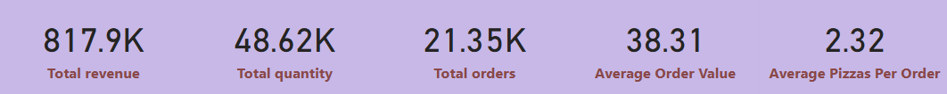

KEY INSIGHTS

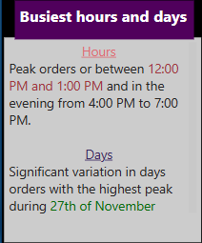

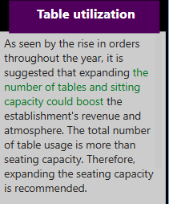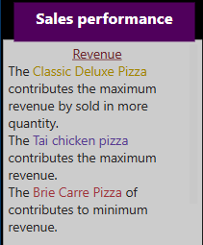

DASHBOARD

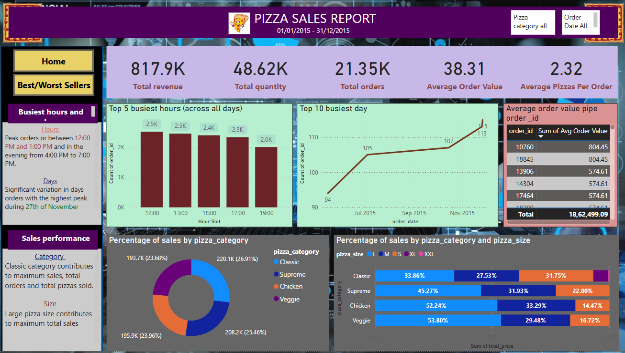

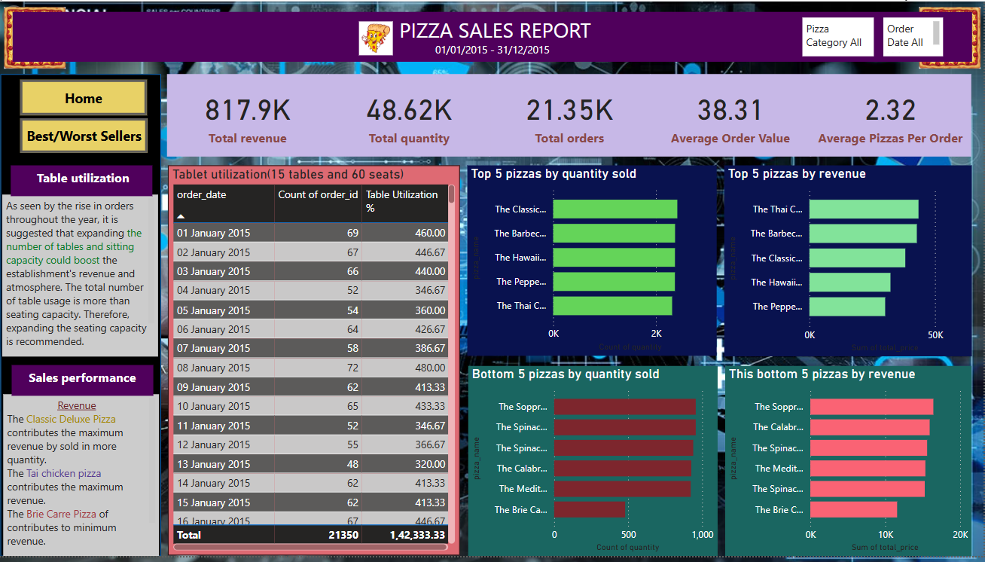

**Tools, Software, and Libraries**

* **MySQL Workbench** **8.0.36**

for data analysis and storage

* **Power BI Desktop 2025**

for dashboard creation and visualization

* **Excel version 2021**  
  for initial data exploration and manipulation

**References**

* <https://www.youtube.com/@datatutorials1>
* https://topmate.io/data_tutorial