1.

OUTPUT:

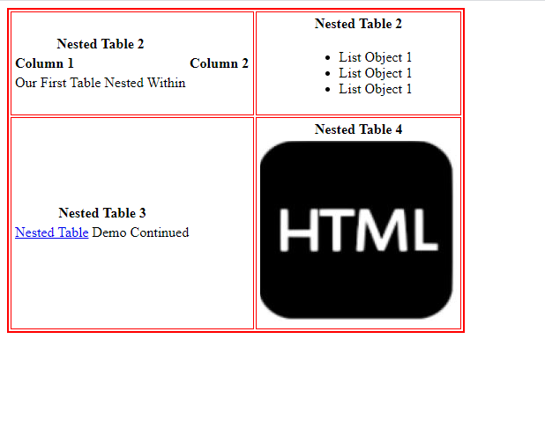

CODE:

<!DOCTYPE html>

<html>

    <head>

        <title>

            Done by Srinath R - CB.EN.U4CSE17361

        </title>

    </head>

    <body>

            <table border = "2px" bordercolor = "#FF0000">

                <tr align = "center">

                    <td>

                        <table>

                            <tr align = "center" colspan = "2">

                                <td>

                                    <strong> Nested Table 2</strong>

                                </td>

                            </tr>

                            <tr>

                                <td><b>Column 1</b></td>

                                <td><b>Column 2</b></td>

                            </tr>

                            <tr colspan = "2"><td>Our First Table Nested Within</td></tr>

                        </table>

                    </td>

                    <td>

                        <table>

                            <th align = "center">Nested Table 2</th>

                            <tr>

                                <td>

                                    <ul>

                                    <li>List Object 1</li>

                                    <li>List Object 1</li>

                                    <li>List Object 1</li>

                                    </ul>

                                </td>

                            </tr>

                        </table>

                    </td>

                </tr>

                <tr>

                    <td>

                        <table>

                            <th align = "center"><b>Nested Table 3</b></th>

                            <tr>

                                <td>

                                    <a href = "www.google.com">Nested Table</a> Demo Continued

                                </td>

                            </tr>

                        </table>

                    </td>

                    <td>

                        <table>

                            <tr>

                                <th align = "center"><b>Nested Table 4</b></th>

                            </tr>

                            <tr><td><img src = "html.JPG" alt = "Image"></td></tr>

                        </table>

                    </td>

                </tr>

            </table>

    </body>

</html>

2.

OUTPUT:

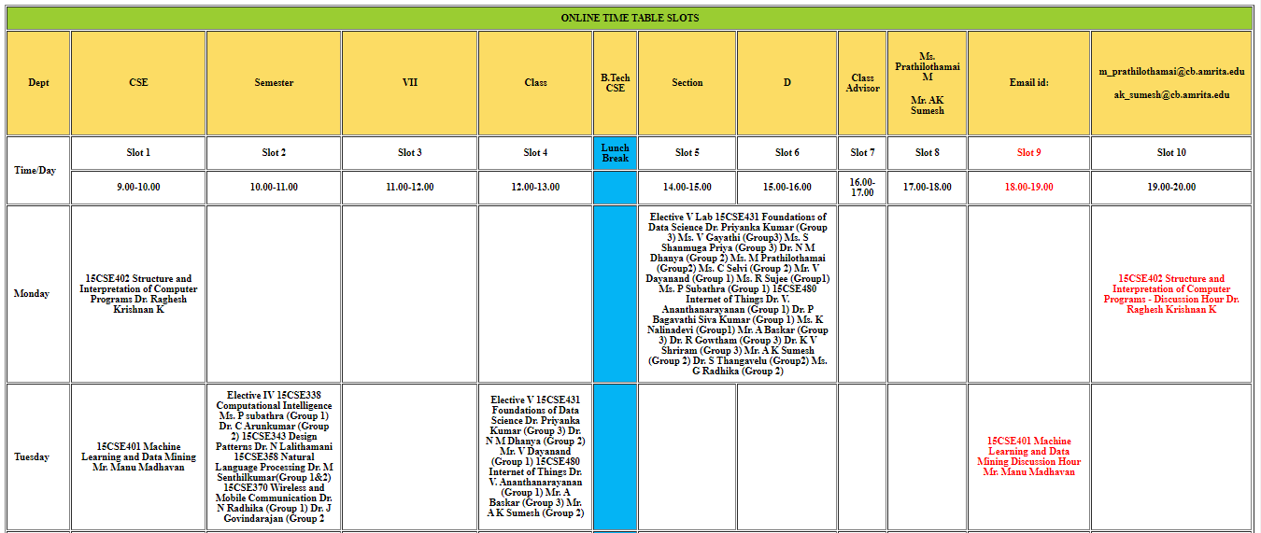

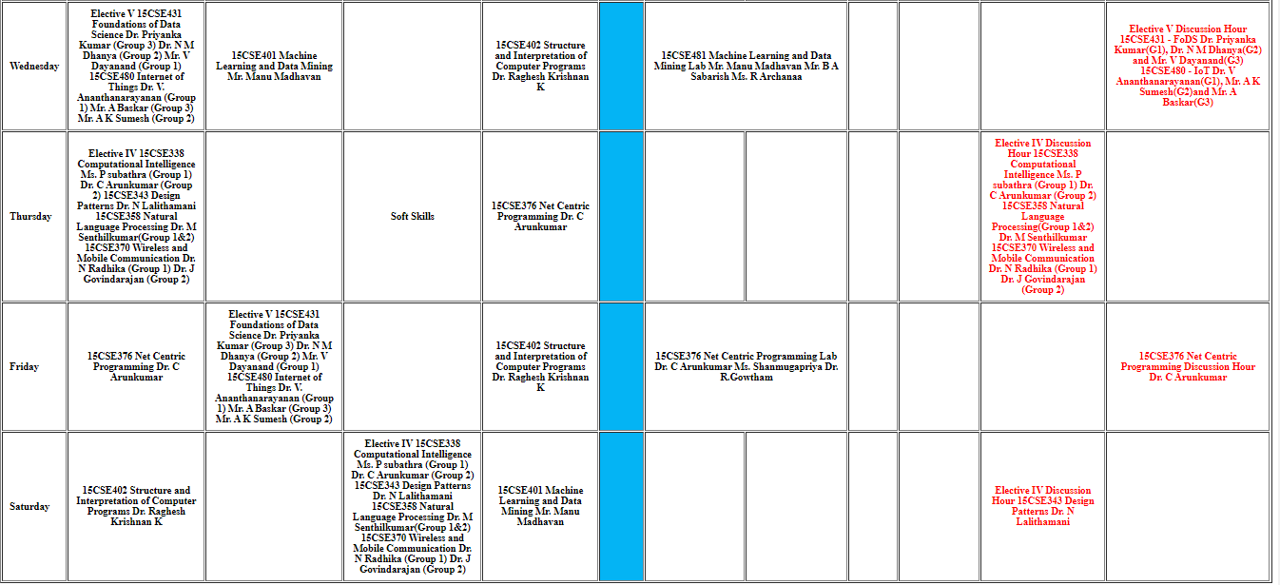

CODE:

<!DOCTYPE html>

<html>

    <head>

        <title>

            Done by Srinath R - CB.EN.U4CSE17361

        </title>

    </head>

    <body>

        <table border = "1" cellpadding = "10" style = "width: 100%;">

            <colgroup>

                <col style="width:200px;" />

            </colgroup>

            <thead>

                <tr style="background-color:yellowgreen;">

                    <th style="width: 100%;" colspan="50">

                        ONLINE TIME TABLE SLOTS

                    </th>

                </tr>

                <tr style="background-color:#fcdc64;">

                    <th>

                        Dept

                    </th>

                    <th>

                        CSE

                    </th>

                    <th>

                        Semester

                    </th>

                    <th>

                        VII

                    </th>

                    <th>

                        Class

                    </th>

                    <th>

                        B.Tech CSE

                    </th>

                    <th>

                        Section

                    </th>

                    <th>

                        D

                    </th>

                    <th>

                        Class Advisor

                    </th>

                    <th>

                        <h4>Ms. Prathilothamai M</h4>

                        <h4>Mr. AK Sumesh</h4>

                    </th>

                    <th>

                        Email id:

                    </th>

                    <th>

                        <h4>m_prathilothamai@cb.amrita.edu</h4>

                        <h4>ak_sumesh@cb.amrita.edu</h4>

                    </th>

                </tr>

            </thead>

            <tbody>

                <tr>

                    <td rowspan="2">

                        <b>Time/Day</b>

                    </td>

                    <th>

                        Slot 1

                    </th>

                    <th>

                        Slot 2

                    </th>

                    <th>

                        Slot 3

                    </th>

                    <th>

                        Slot 4

                    </th>

                    <th style="background-color:#04b4f4 ;">

                        Lunch Break

                    </th>

                    <th>

                        Slot 5

                    </th>

                    <th>

                        Slot 6

                    </th>

                    <th>

                        Slot 7

                    </th>

                    <th>

                        Slot 8

                    </th>

                    <th style="color: red;">

                        Slot 9

                    </th>

                    <th>

                        Slot 10

                    </th>

                </tr>

                <th>

                    9.00-10.00

                </td>

                <th>

                    10.00-11.00

                </th>

                <th>

                    11.00-12.00

                </th>

                <th>

                    12.00-13.00

                </th>

                <th style="background-color: #04b4f4;">

                </th>

                <th>

                    14.00-15.00

                </th>

                <th>

                    15.00-16.00

                </th>

                <th>

                    16.00-17.00

                </th>

                <th>

                    17.00-18.00

                </th>

                <th  style="color: red;">

                    18.00-19.00

                </th>

                <th>

                    19.00-20.00

                </th>

                <tr>

                    <td>

                        <b>Monday</b>

                    </td>

                    <th>

                        15CSE402

                        Structure and Interpretation of

                        Computer Programs

                        Dr. Raghesh Krishnan K

                    </th>

                    <th>

                    </th>

                    <th>

                    </th>

                    <th>

                    </th>

                    <th style="background-color: #04b4f4;">

                    </th>

                    <th colspan="2">

                        Elective V Lab

                        15CSE431

                        Foundations of Data Science

                        Dr. Priyanka Kumar (Group 3)

                        Ms. V Gayathi (Group3)

                        Ms. S Shanmuga Priya (Group 3)

                        Dr. N M Dhanya (Group 2)

                        Ms. M Prathilothamai (Group2)

                        Ms. C Selvi (Group 2)

                        Mr. V Dayanand (Group 1)

                        Ms. R Sujee (Group1)

                        Ms. P Subathra (Group 1)

                        15CSE480

                        Internet of Things

                        Dr. V. Ananthanarayanan (Group 1)

                        Dr. P Bagavathi Siva Kumar (Group 1)

                        Ms. K Nalinadevi (Group1)

                        Mr. A Baskar (Group 3)

                        Dr. R Gowtham (Group 3)

                        Dr. K V Shriram (Group 3)

                        Mr. A K Sumesh (Group 2)

                        Dr. S Thangavelu (Group2)

                        Ms. G Radhika (Group 2)</th>

                    <th>

                    </th>

                    <th>

                    </th>

                    <th>

                    </th>

                    <th  style="color: red;">

                        15CSE402 Structure and

                        Interpretation of

                        Computer Programs -

                        Discussion Hour

                        Dr. Raghesh Krishnan K </th>

                    <!-- <th>

                    </th> -->

                </tr>

                <tr>

                    <td>

                        <b>Tuesday</b>

                    </td>

                    <th>

                        15CSE401

                        Machine Learning and Data Mining

                        Mr. Manu Madhavan

                    </th>

                    <th>

                        Elective IV

                        15CSE338

                        Computational Intelligence

                        Ms. P subathra (Group 1)

                        Dr. C Arunkumar (Group 2)

                        15CSE343

                        Design Patterns

                        Dr. N Lalithamani

                        15CSE358

                        Natural Language Processing

                        Dr. M Senthilkumar(Group 1&2)

                        15CSE370

                        Wireless and Mobile

                        Communication

                        Dr. N Radhika (Group 1)

                        Dr. J Govindarajan (Group 2

                    </th>

                    <th >

                    </th>

                    <th>

                        Elective V

                        15CSE431

                        Foundations of Data Science

                        Dr. Priyanka Kumar (Group 3)

                        Dr. N M Dhanya (Group 2)

                        Mr. V Dayanand (Group 1)

                        15CSE480

                        Internet of Things

                        Dr. V. Ananthanarayanan (Group

                        1)

                        Mr. A Baskar (Group 3)

                        Mr. A K Sumesh (Group 2)

                    </th>

                    <th style="background-color: #04b4f4;">

                    </th>

                    <th>

                    </th>

                    <th>

                    </th>

                    <th>

                    </th>

                    <th>

                    </th>

                    <th  style="color: red;">

                        15CSE401

                        Machine Learning and

                        Data Mining

                        Discussion Hour

                        Mr. Manu Madhavan </th>

                    <th>

                    </th>

                </tr>

                <tr>

                    <td>

                        <b>Wednesday</b>

                    </td>

                    <th>

                        Elective V

                        15CSE431

                        Foundations of Data Science

                        Dr. Priyanka Kumar (Group 3)

                        Dr. N M Dhanya (Group 2)

                        Mr. V Dayanand (Group 1)

                        15CSE480

                        Internet of Things

                        Dr. V. Ananthanarayanan (Group 1)

                        Mr. A Baskar (Group 3)

                        Mr. A K Sumesh (Group 2)

                    </th>

                    <th>

                        15CSE401

                        Machine Learning and Data

                        Mining

                        Mr. Manu Madhavan

                    </th>

                    <th>

                    </th>

                    <th>

                        15CSE402

                        Structure and Interpretation of

                        Computer Programs

                        Dr. Raghesh Krishnan K

                    </th>

                    <th style="background-color: #04b4f4;">

                    </th>

                    <th colspan="2">

                        15CSE481

                        Machine Learning

                        and Data Mining Lab

                        Mr. Manu Madhavan

                        Mr. B A Sabarish

                        Ms. R Archanaa

                    </th>

                    <th>

                    </th>

                    <th>

                    </th>

                    <th>

                    </th>

                    <th  style="color: red;">

                        Elective V Discussion

                        Hour

                        15CSE431 - FoDS

                        Dr. Priyanka Kumar(G1),

                        Dr. N M Dhanya(G2) and

                        Mr. V Dayanand(G3)

                        15CSE480 - IoT

                        Dr. V

                        Ananthanarayanan(G1),

                        Mr. A K Sumesh(G2)and

                        Mr. A Baskar(G3) </th>

                    <!-- <th>

                    </th> -->

                </tr>

                <tr>

                    <td>

                        <b>Thursday</b>

                    </td>

                    <th>

                        Elective IV

                        15CSE338

                        Computational Intelligence

                        Ms. P subathra (Group 1)

                        Dr. C Arunkumar (Group 2)

                        15CSE343

                        Design Patterns

                        Dr. N Lalithamani

                        15CSE358

                        Natural Language Processing

                        Dr. M Senthilkumar(Group 1&2)

                        15CSE370

                        Wireless and Mobile Communication

                        Dr. N Radhika (Group 1)

                        Dr. J Govindarajan (Group 2)

                    </th>

                    <th>

                    </th>

                    <th>

                        Soft Skills

                    </th>

                    <th>

                        15CSE376

                        Net Centric Programming

                        Dr. C Arunkumar

                    </th>

                    <th style="background-color: #04b4f4;">

                    </th>

                    <th>

                    </th>

                    <th>

                    </th>

                    <th>

                    </th>

                    <th>

                    </th>

                    <th  style="color: red;">

                        Elective IV Discussion

                        Hour

                        15CSE338

                        Computational

                        Intelligence

                        Ms. P subathra (Group

                        1)

                        Dr. C Arunkumar (Group

                        2)

                        15CSE358

                        Natural Language

                        Processing(Group 1&2)

                        Dr. M Senthilkumar

                        15CSE370

                        Wireless and Mobile

                        Communication

                        Dr. N Radhika (Group 1)

                        Dr. J Govindarajan

                        (Group 2) </th>

                    <th>

                    </th>

                </tr>

                <tr>

                    <td>

                        <b>Friday</b>

                    </td>

                    <th>

                        15CSE376

                        Net Centric Programming

                        Dr. C Arunkumar

                    </th>

                    <th>

                        Elective V

                        15CSE431

                        Foundations of Data Science

                        Dr. Priyanka Kumar (Group 3)

                        Dr. N M Dhanya (Group 2)

                        Mr. V Dayanand (Group 1)

                        15CSE480

                        Internet of Things

                        Dr. V. Ananthanarayanan (Group

                        1)

                        Mr. A Baskar (Group 3)

                        Mr. A K Sumesh (Group 2)

                    </th>

                    <th>

                    </th>

                    <th>

                        15CSE402

                        Structure and Interpretation of

                        Computer Programs

                        Dr. Raghesh Krishnan K

                    </th>

                    <th style="background-color: #04b4f4;">

                    </th>

                    <th colspan="2">

                        15CSE376

                        Net Centric Programming Lab

                        Dr. C Arunkumar

                        Ms. Shanmugapriya

                        Dr. R.Gowtham</th>

                    <th>

                    </th>

                    <th>

                    </th>

                    <th>

                    </th>

                    <th  style="color: red;">

                        15CSE376

                        Net Centric

                        Programming

                        Discussion Hour

                        Dr. C Arunkumar </th>

                    <!-- <th>

                    </th> -->

                </tr>

                <tr>

                    <td>

                        <b>Saturday</b>

                    </td>

                    <th>

                        15CSE402

                        Structure and Interpretation of

                        Computer Programs

                        Dr. Raghesh Krishnan K

                    </th>

                    <th>

                    </th>

                    <th>

                        Elective IV

                        15CSE338

                        Computational Intelligence

                        Ms. P subathra (Group 1)

                        Dr. C Arunkumar (Group 2)

                        15CSE343

                        Design Patterns

                        Dr. N Lalithamani

                        15CSE358

                        Natural Language Processing

                        Dr. M Senthilkumar(Group

                        1&2)

                        15CSE370

                        Wireless and Mobile

                        Communication

                        Dr. N Radhika (Group 1)

                        Dr. J Govindarajan (Group 2)

                    </th>

                    <th>

                        15CSE401

                        Machine Learning and Data Mining

                        Mr. Manu Madhavan

                    </th>

                    <th style="background-color: #04b4f4;">

                    </th>

                    <th>

                    </th>

                    <th>

                    </th>

                    <th>

                    </th>

                    <th>

                    </th>

                    <th  style="color: red;">

                        Elective IV

                        Discussion Hour

                        15CSE343

                        Design Patterns

                        Dr. N Lalithamani

                    </th>

                    <th>

                    </th>

                </tr>

            </tbody>

        </table>

    </body>

</html>

3.

OUTPUT:

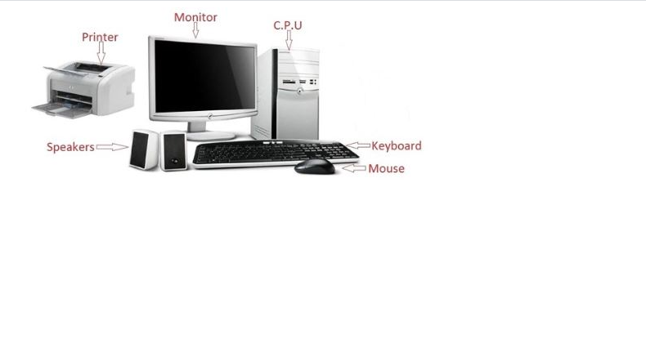

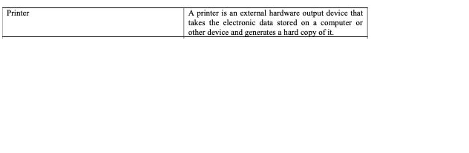

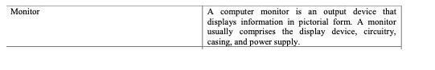

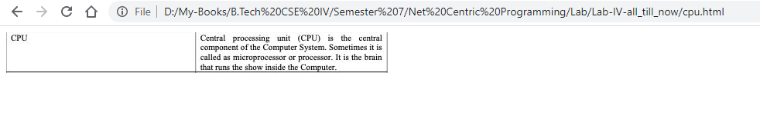

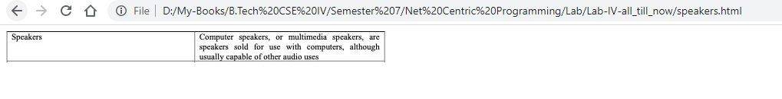

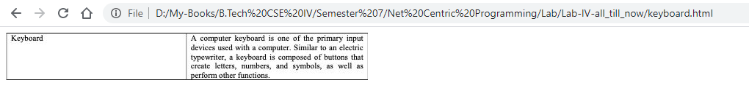

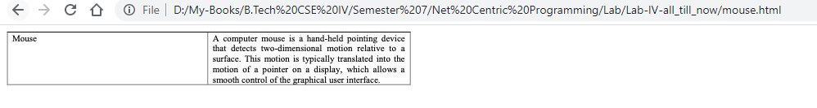

CODE:

<!DOCTYPE html>

<html>

    <head>

        <title>

            Done by Srinath R - CB.EN.U4CSE17361

        </title>

    </head>

    <body>

        <img src="computer.JPG" alt="Computer" usemap="#map">

        <map name="map">

            <area shape="rect" coords="313,51,386,160" href="cpu.html" alt="">

            <area shape="rect" coords="169,31,296,143" href="monitor.html" alt="">

            <area shape="rect" coords="35,29,159,136" href="printer.html" alt="">

            <area shape="rect" coords="138,145,223,203" href="speakers.html" alt="">

            <area shape="poly" coords="234,168,233,198,349,193,380,178,405,188,437,183,408,163" href="keyboard.html" alt="">

            <area shape="poly" coords="354,196,357,205,381,206,406,201,390,186,364,188" href="mouse.html" >

        </map>

    </body>

</html>

4.

OUTPUT:

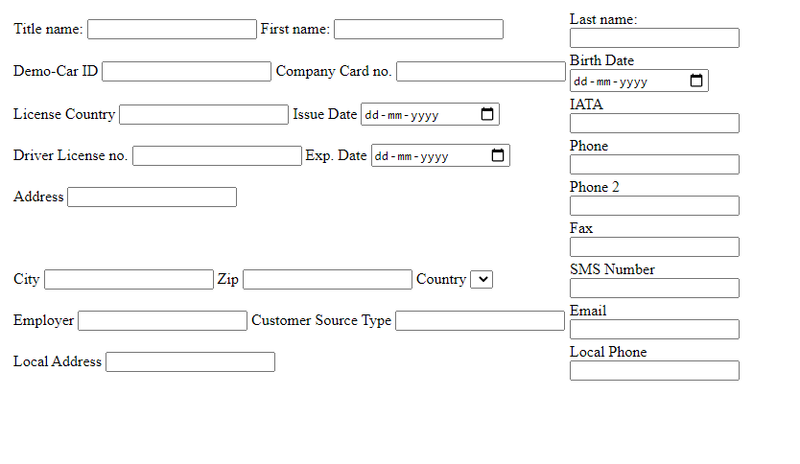

CODE:

<!DOCTYPE html>

<html>

    <head>

        <title>

            Done by Srinath R - CB.EN.U4CSE17361

        </title>

    </head>

    <body>

        <form action="">

            <table bordercolor="#ffffff">

                    <tr>

                        <td>

                            <label for="">Title name:</label>

                            <input type="text" >

                            <label for="">First name:</label>

                            <input type="text">

                        </td>

                        <td>

                            <label for="">Last name:</label><br>

                            <input type="text" ><br>

                        </td>

                    </tr>

                    <tr>

                        <td>

                            <label for="">Demo-Car ID</label>

                            <input type="text" >

                            <label for="">Company Card no.</label>

                            <input type="text" >

                        </td>

                        <td>

                            <label for="">Birth Date</label><br>

                            <input type="date"><br>

                        </td>

                    </tr>

                    <tr>

                        <td>

                            <label for="">License Country</label>

                            <input type="text" >

                            <label for="">Issue Date</label>

                            <input type="date" >

                        </td>

                        <td>

                            <label for="">IATA</label><br>

                            <input type="number" ><br>

                        </td>

                    </tr>

                    <tr>

                        <td>

                            <label for="">Driver License no.</label>

                            <input type="text" >

                            <label for="">Exp. Date</label>

                            <input type="date" >

                        </td>

                        <td>

                            <label for="">Phone</label><br>

                            <input type="number" ><br>

                        </td>

                    </tr>

                    <tr>

                        <td>

                            <label for="">Address</label>

                            <input type="text" >

                        </td>

                        <td>

                            <label for="">Phone 2</label><br>

                            <input type="number" ><br>

                        </td>

                    </tr>

                    <tr>

                        <td>

                        </td>

                        <td>

                            <label for="">Fax</label><br>

                            <input type="number" ><br>

                        </td>

                    </tr>

                    <tr>

                        <td>

                            <label for="">City</label>

                            <input type="text" >

                            <label for="">Zip</label>

                            <input type="text" >

                            <label for="">Country</label>

                            <select name="" id=""></select>

                        </td>

                        <td>

                            <label for="">SMS Number</label><br>

                            <input type="number" ><br>

                        </td>

                    </tr>

                    <tr>

                        <td>

                            <label for="">Employer</label>

                            <input type="text" >

                            <label for="">Customer Source Type</label>

                            <input type="text" >

                        </td>

                        <td>

                            <label for="">Email</label><br>

                            <input type="email" ><br>

                        </td>

                    </tr>

                    <tr>

                        <td>

                            <label for="">Local Address</label>

                            <input type="text" >

                        </td>

                        <td>

                            <label for="">Local Phone</label><br>

                            <input type="text" ><br>

                        </td>

                    </tr>

                </table>

            </form>

    </body>

</html>