Analytical Problem Solving
Warehouse Delivery Robot Path Planning

A.PEAS Description
Component | Description
Performance Measure | Reach the destination using minimum movements while avoiding blocked cells.
Environment | 5 × 5 warehouse grid containing free and blocked cells.
Actuators | Move the robot Up, Down, Left, or Right.
Sensors | Detect the current position, destination, blocked cells, and free cells.

Performance Measure
- Reach the package destination.
- Avoid blocked cells.
- Minimize the number of movements.
- Complete the delivery safely.
Environment
The environment is a 5 × 5 warehouse grid containing free cells and blocked cells.
Actuators
The robot can move Up, Down, Left, and Right.
Sensors
The robot can identify the current position, blocked cells, free cells, and goal position.

B. Goal-Based Agent
The most suitable agent for this problem is a Goal-Based Agent.
The robot has a specific goal of reaching (5,5) from the starting position (1,1). It must select a sequence of movements that leads to the destination while avoiding blocked cells.
Therefore, a goal-based agent is suitable because the robot selects actions based on achieving its specified goal.

C. Search Problem Formulation
Initial State
(1,1)
Goal State
(5,5)
Actions
{Up, Down, Left, Right}
Diagonal movement is not allowed.
Transition Model
The transition model determines the new position after an action.
Examples:
(1,1) + Right → (1,2)
(1,1) + Down → (2,1)
The robot cannot move into a blocked cell.
Path Cost Function
Every movement has a cost of 1.
Path Cost = Number of movements × 1
For 8 movements:
Total Cost = 8 × 1 = 8

D. Breadth-First Search (BFS)
BFS explores nodes level by level using a queue. Since every movement has the same cost of 1, BFS finds the shortest path.
The action order used is:
Right → Down → Left → Up
BFS Step-by-Step Expansion

Step | Expanded Node | Queue After Expansion
1 | (1,1) | (1,2), (2,1)
2 | (1,2) | (1,3), (2,1)
3 | (2,1) | (1,3), (3,1)
4 | (1,3) | (1,4)
5 | (3,1) | (1,4), (3,2), (4,1)
6 | (1,4) | (1,5), (3,2)
7 | (3,2) | (1,5), (4,1)
8 | (4,1) | (1,5), (5,1)
9 | (1,5) | (5,1), (2,5)
10 | (5,1) | (2,5), (5,2)
11 | (2,5) | (5,2), (3,5)
12 | (5,2) | (3,5), (5,3)
13 | (3,5) | (5,3), (4,5)
14 | (5,3) | (4,5), (5,4)
15 | (4,5) | (5,4)
16 | (5,4) | (5,5)
17 | (5,5) | Goal reached

Final BFS Path
(1,1) → (1,2) → (1,3) → (1,4) → (1,5) → (2,5) → (3,5) → (4,5) → (5,5)
Total Cost
BFS Path Cost = 8

E. Depth-First Search (DFS)
DFS explores one path as deeply as possible before backtracking. It uses a stack.
The action order used is:
Right → Down → Left → Up
DFS Step-by-Step Expansion
Step | Expanded Node | Stack
1 | (1,1) | (2,1), (1,2)
2 | (1,2) | (2,1), (1,3)
3 | (1,3) | (2,1), (1,4)
4 | (1,4) | (2,1), (1,5)
5 | (1,5) | (2,1), (2,5)
6 | (2,5) | (2,1), (3,5)
7 | (3,5) | (2,1), (4,5)
8 | (4,5) | (2,1), (5,5)
9 | (5,5) | Goal reached

Final DFS Path
(1,1) → (1,2) → (1,3) → (1,4) → (1,5) → (2,5) → (3,5) → (4,5) → (5,5)
Total Cost
DFS Path Cost = 8

Program for BFS and DFS
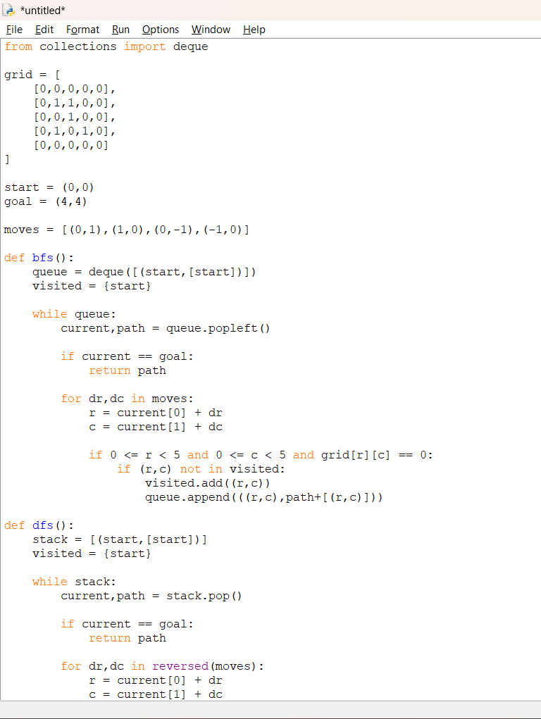

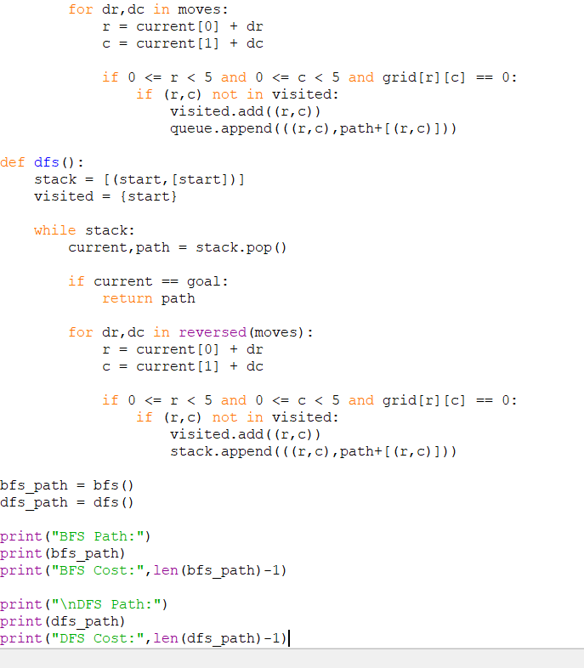

Output:
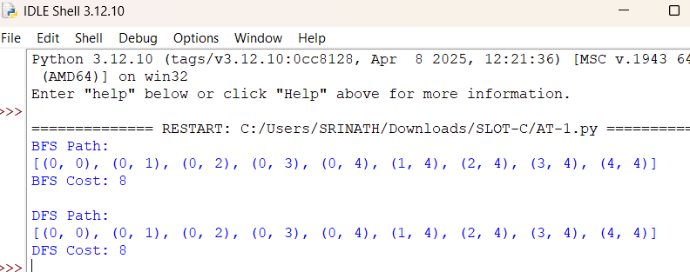

F.BFS and DFS Comparison
Criteria | BFS | DFS
Completeness | Complete | Complete for finite search space with visited states
Optimality | Optimal when all step costs are equal | Not guaranteed to be optimal
Time Complexity | O(bᵈ) | O(bᵐ)
Space Complexity | O(bᵈ) | O(bm)
Data Structure | Queue | Stack
Search Method | Level by level | Depth first
Shortest Path | Guaranteed | Not guaranteed

Where:
- b = Branching factor
- d = Depth of the shallowest solution
- m = Maximum search depth
Suitable Algorithm
BFS is more suitable for this warehouse delivery problem because every movement has a uniform cost of 1. BFS explores the grid level by level and guarantees the shortest path.
Therefore, BFS is preferred because it can:
- Reduce travel distance.
- Reduce delivery time.
- Reduce energy consumption.
- Improve warehouse efficiency.

Conclusion
The warehouse delivery robot was successfully modeled as a goal-based intelligent agent. The search problem was formulated and solved using BFS and DFS. Both methods obtained a path from (1,1) to (5,5) with a total cost of 8 for the selected traversal order. Since all movements have equal cost, BFS is more suitable because it guarantees the shortest path.

