# **Abstract**

# **Project Description**

Maggie Maylin clinical hypnotherapy is a small and private business owned by Single person. The clients for the clinic are mostly by the seeing the information on the internet. We as a Team are developing a fully functional website with a rich interface and contains all the information of the counselling services which are offered by Maggie Maylin. The website is responsive and is compatible for all the devices.

The website has a dashboard, where the client can login with a default username and password and can make changes on different web pages. The goal is to increase her clients to generate more revenue by the means of updating her website to give a more modern feel.

# **About the Client**

Maggie Maylin is a fully qualified and certified supervisor with both the Australian Counselling Association and Australian Association of Clinical Hypnotherapy and Psychotherapy. She was a vice president of Australian Association of clinical Hypnotherapy and Psychotherapy. Maggie can bring a depth of experience from both hypnotherapy and counselling having an extensive 30-year career in working with people in counselling and hypnotherapy. Hypnotherapy can be effective in managing areas to do with anxiety, stress, depression, trauma, smoking etc..

# **Team Work Allocation**

|  |  |
| --- | --- |
| Srinath Mupparsi | 1. Creating Layout for project and Prototypes 2. Design Implementation and Creating Webpages 3. Coding in Javascript and Implementing other Functionalities. 4. Creating User Stories and checking whether the developing methodology is followed. 5. Documentation and Helping Team in development |
| Keshav Ishwar | 1. Creating User Stories 2. Designing the web Pages 3. Arranging meetings with Clients and arranging group meetings 4. Performing Testing on different Browsers 5. Documentation and Helping Team |
| Karthik Nekkarganti | 1. Prioritizing User Stories 2. Designing other pages and Navigation 3. Scheduling the Alpha release Dates and preparing beta release user stories and prioritizing. 4. Creating Test Cases and Performing. 5. Documentation and Helping Team |

Table: 01 – Distribution of work

# **Alpha Release**

Alpha release, the initial development of the project. Iterations were followed for the development and regular meeting were done with the client and updated the work. The requirements were taken and prioritized accordingly. Before Alpha release we had met the client for 3 times and asked for the feedback.

## **Proposed for Alpha release**

|  |  |
| --- | --- |
| **User Story** | **Description** |
| Home (Landing page) | As a website visitor, I need home and landing page with main menu, header, footer and page content. |
| Affiliations | Affiliations will be displayed on the top of the main page |
| Contact | Customers can see the contact info at all the times |
| Videos | Clients shorts clips will be displayed on the main page and about us page also |
| Contact with email | Client will receive appointment when the customer fills the contact form. |
| News and articles | All recent news and articles are present on the main page of the client. |
| Admin login | additional feature which is present on the bottom of the screen where client can login with only one password. |
| Admin Dashboard | A feature to edit content on main page and as well as on other pages too. |

Table 02: Alpha Release Requirements

## **Delivered Alpha Release**

According to the agreement, Initial Alpha release requirement which were proposed was delivered. The feedback was taken and added those requirements for the beta release.

## **Features**

**Home Page(Landing Page)** : This is the landing page of all the other pages. This page contains affiliations, short video about the client, news & Articles, linked to admin login at the bottom of the page.

**Counselling & hypnosis:** this is a base page of all the different types of counselling services pages. Each page contains a brief description of what exactly the service about followed by how to get rid of it.

**Contact with email:** In this page there is an input form for the customers who want to get in touch with the client through email.

**Admin Dashboard:** At the bottom of home page(landing Page) there is a button as admin login, this link will allow admin to see the dashboard to change content and to manage database.

**News and Articles:** There is a section on home page which has the slider functionality, displays all the latest news & articles published on Hypnotherapy only when client adds them to the database.

## **Screenshots**

**Home Page** – Contact Details, Navigation Bar and Branding the Client.

The first section of this Page contains client affiliations, created by using showcase function in bootstrap. This brands the business, as well as client. Additionally all links to other pages are also provided in Navigation Bar.

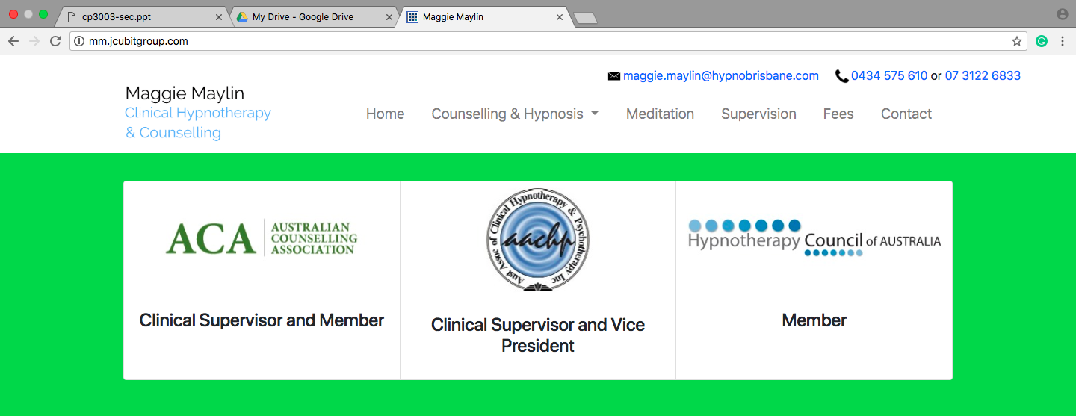

Fig 01: Home Page Section 1

**Home Page** – About the Client

This section contains a short video of the client explaining about what hypnotherapy or hypnosis is and next to it there is a column which shows clients experience. The Nav-bar is static, which give a modern look of easy navigation.

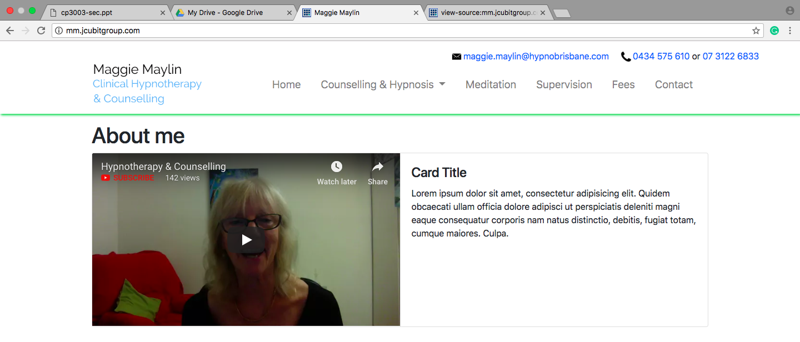

Fig 02: About Me and Experience

**Home Page** – News & Articles

This has a slider functionality with all the latest news and articles this is made through Bootstrap and Javascript languages.

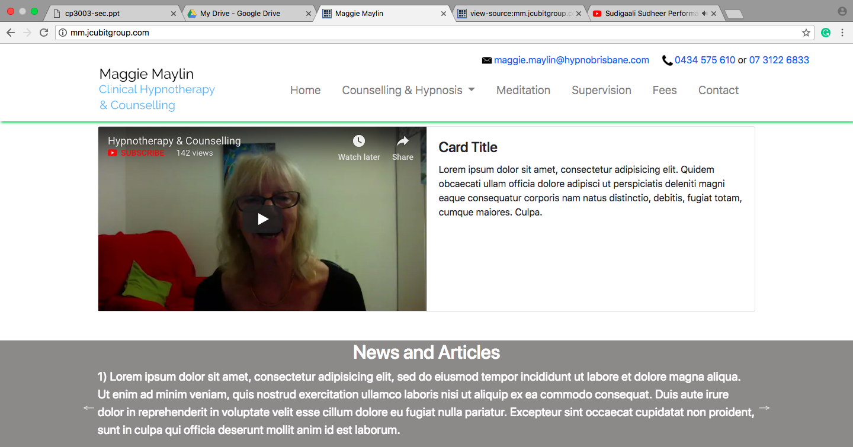

Fig 03- News & Articles Section Slider

**Home Page** – Footer and Admin Login

The footer contains copy rights and also the link to the admin dashboard. In next release the footer also has Quick Links, Address of the clinic etc..

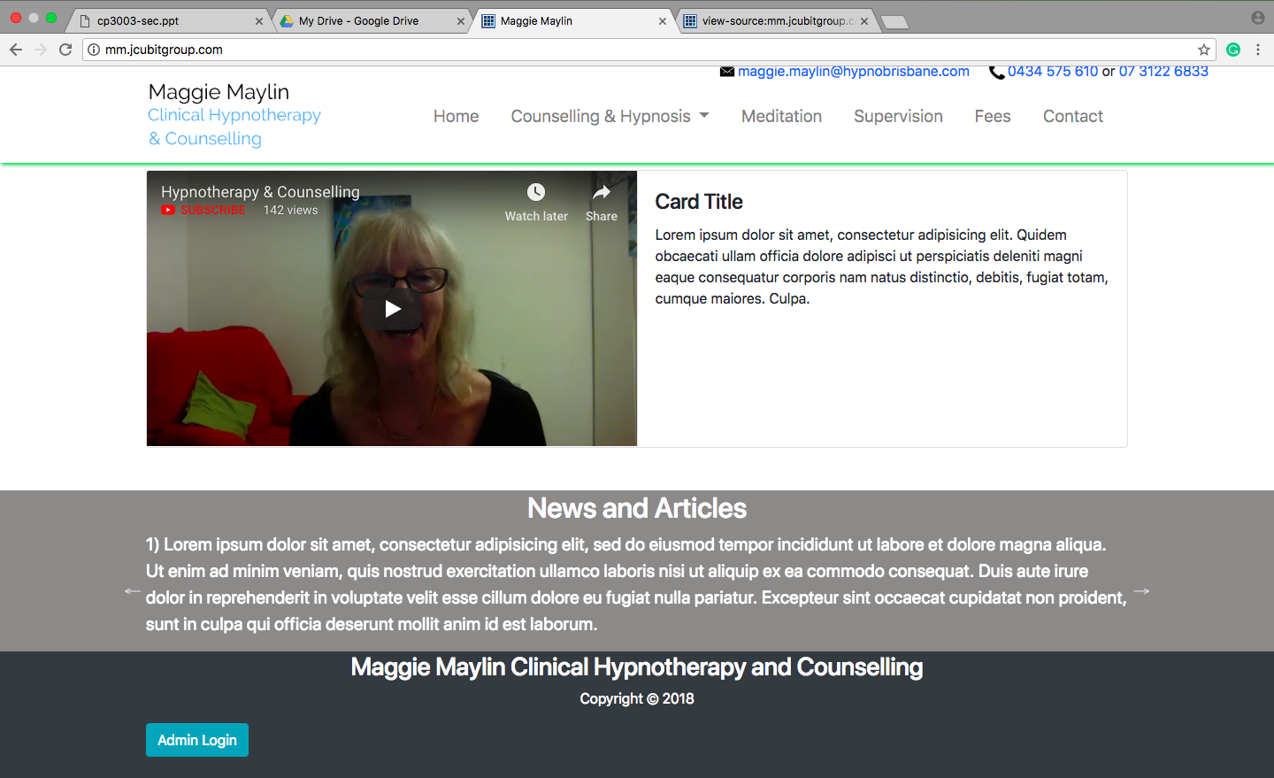

Fig 04 – Footer

Admin Login button has a bootstrap modal on click the button the modal pops up and will ask for username and password. As of now the default username and password are ‘admin’ and ‘password’.

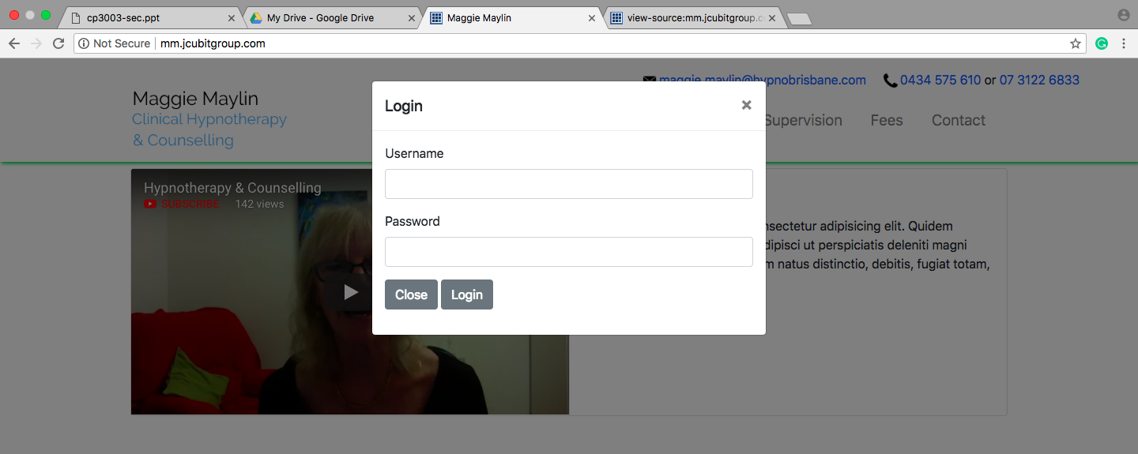Fig 05 – Admin Login Modal

**Counselling & Hypnosis**

This page has links to all types counselling pages, which contain a short description.

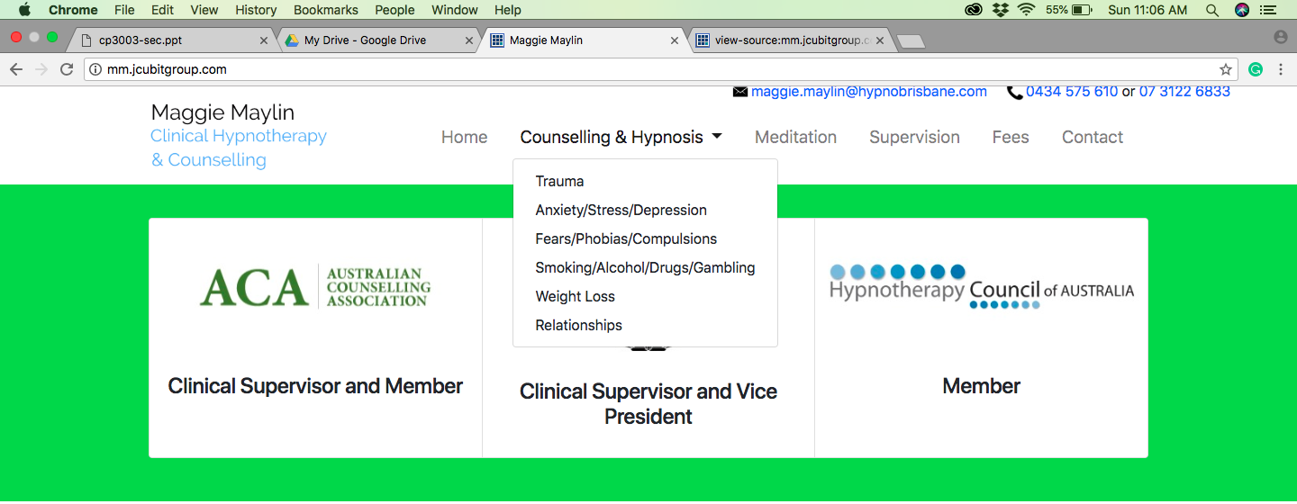

Fig 06 - Other Pages link

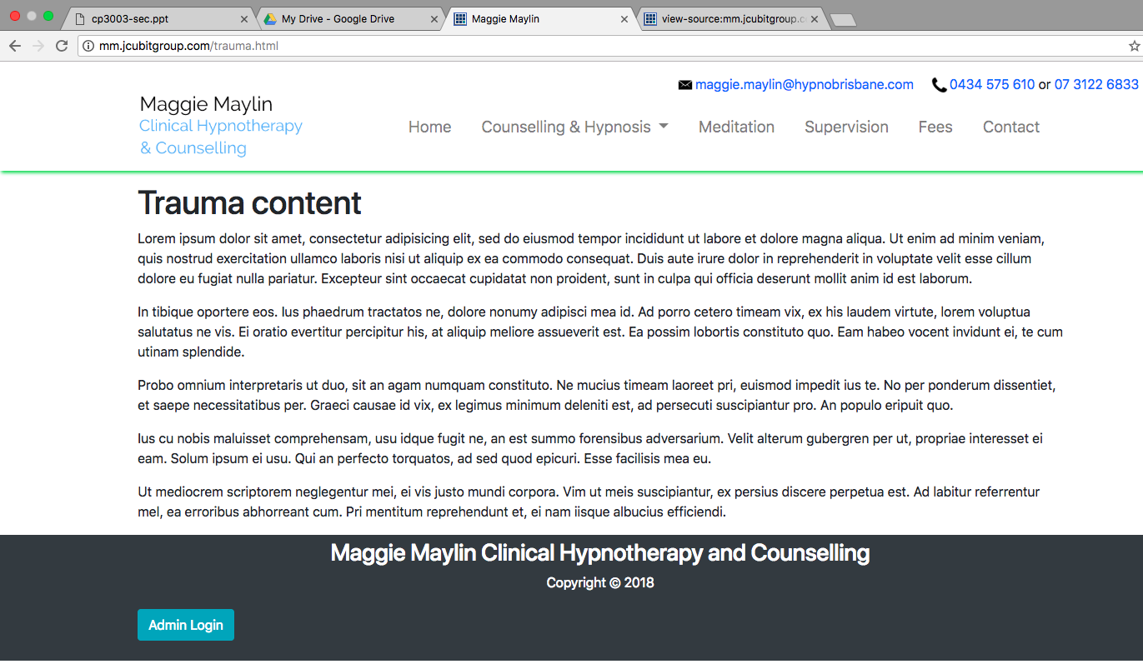

**Contact Page**

Contains a form, on click submit button with go directly to clients email address with all the details which is been filled.

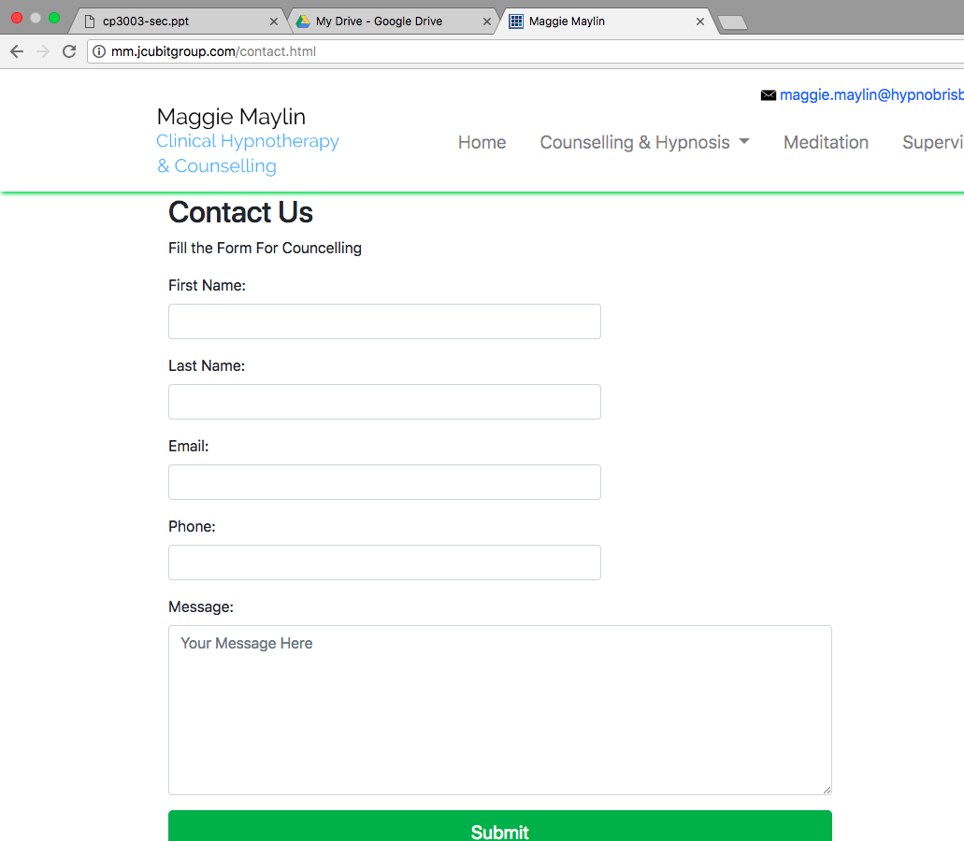

Fig 08 – Contact us Page form

# **Responsiveness**

The pages designed were fully responsive this is because as there is a vast growth in technology and many people are using mobile phones, tablets etc.. more rather than desktops and laptops.

This responsive design can make the website look attractive in a small width device and also can increase the customers and reputation of the business.

**Home Page** - Responsive

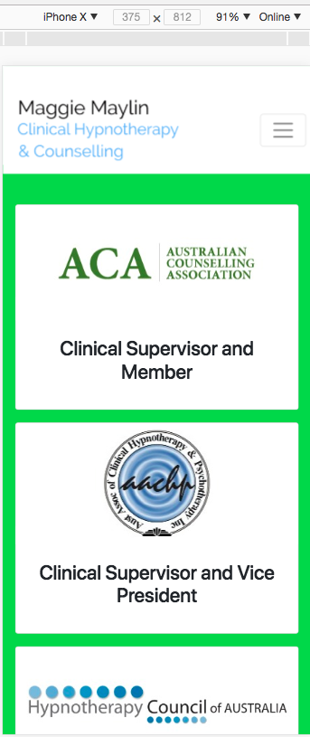

Fig – 09 Responsive on IPhone X

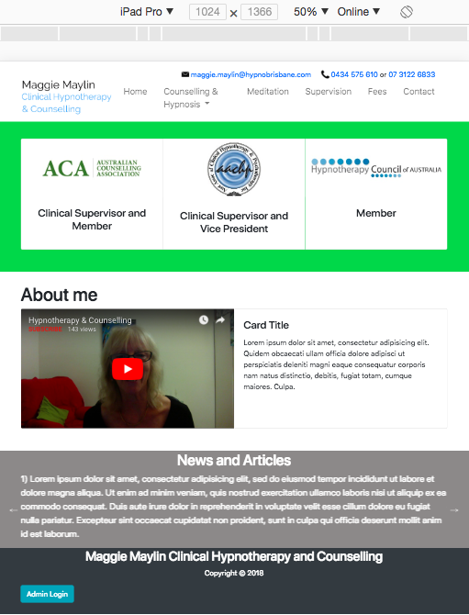

Fig 10 – Responsive on ipad Pro

**Contact Form Responsiveness**

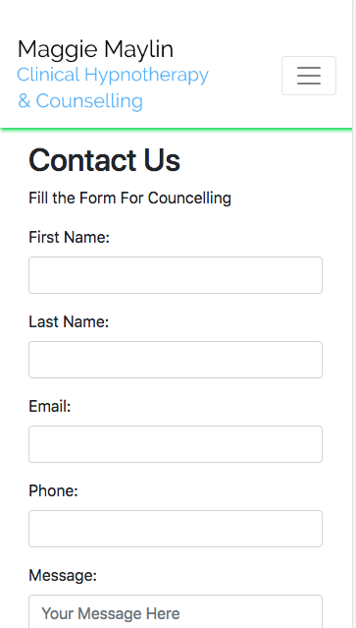

Fig 11 – Contact Form on Mobile Phone

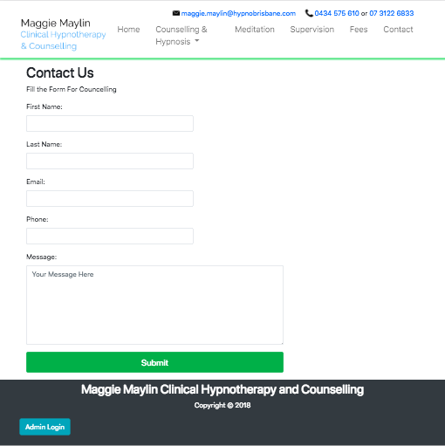

Fig 12 – Contact Form on Ipad Pro

# **Admin login**

This page is designed for admin, where she can login and it redirects to dashboard. The default username and password as of now is ‘admin’ and ‘password’

Dash board contains information of all the pages data and which is also connected to database. The client can make changes in the dashboard which can replicate on the main page. Client can add/remove/edit content, in addition to that client can add/remove videos and testimonials as well.

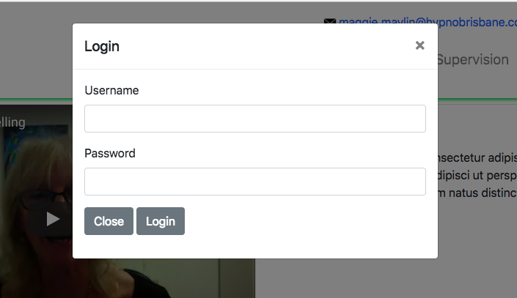

Fig 13 - Admin Login

**Admin Dashboard**

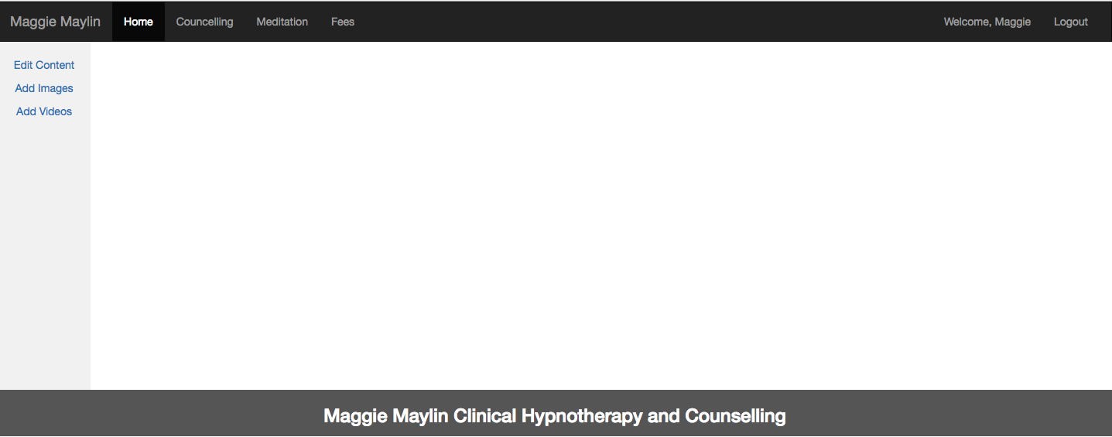

Fig 14 – Admin Dashboard

# **Client Review on Alpha Release**

# **Changes in Alpha Release**

# **Design Changes**

# **Infrastructure & Environment**

The Languages chosen for the development of the project were:

1. HTML 5
2. Bootstrap
3. CSS
4. Javascript
5. Xampp Server For Testing in Local Pc.
6. WinSCP for Publishing in university domain

## **Development Environment**

1. Brackets
2. Atom

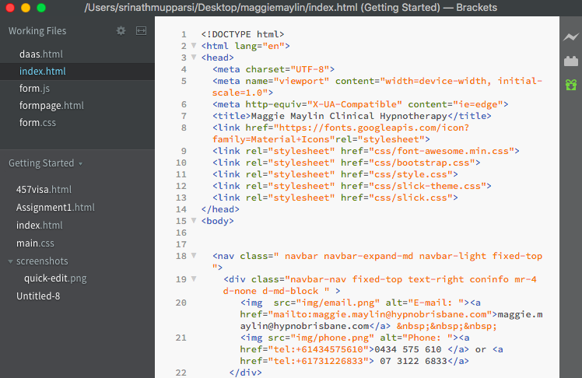

Fig - Brackets Development Tool

## **Bootstrap Code**

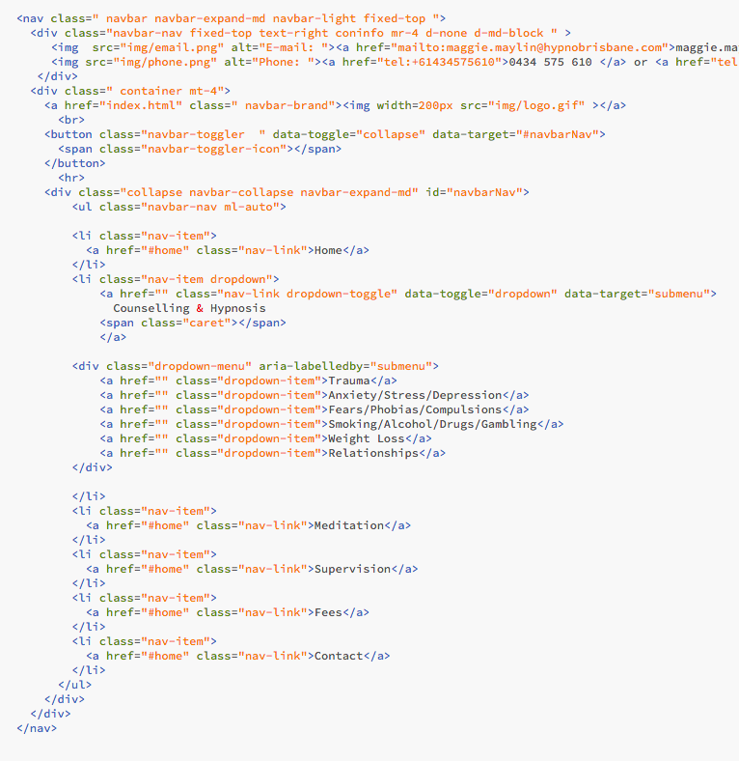

Fig - Bootstrap Code

## **Javascript Code**

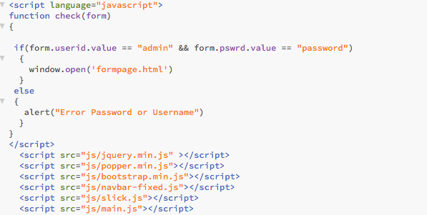

Fig - Javascript Code

## **HTML Code**

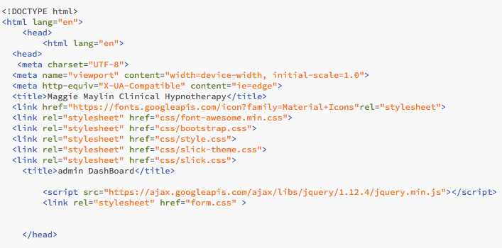

Fig – Html Code

## **CSS Code**

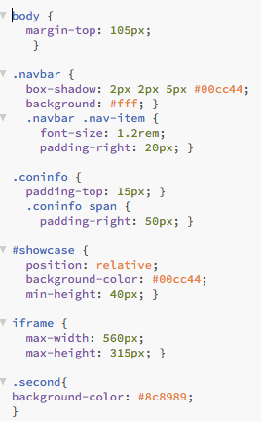

Fig - CSS Code

# **Proposed Beta Release**

After the Feedback from client on the alpha release there were some changes which are added to beta release and prioritized it according to the client review.

|  |  |  |
| --- | --- | --- |
| **Contact Info Display** | As a Client, I need my contact info needs to be displayed bigger | 10 |
| **Logo and menu display** | As a Client, I need The logo and menu options to be separated | 10 |
| **The background colour of News and Affiliations** | As a Client, I need to change the colour and want a similar font which I have on my business card | 10 |
| **Affiliation section need to be smaller** | As a Client, I need my affiliations to be displayed smaller on the homepage | 20 |
| **Dynamic content** | As a User, I need to view the elements of my website dynamically | 20 |
| **Add/remove/edit elements for admin** | As a Client, I need to edit my content on all pages | 30 |