Infosys Springboard Virtual Internship 7.0
Completion Report

Team Details
Batch Number | Batch 2
Start Date | 20 July 2026
Name | SRINATH M
Internship Duration | 8 Weeks (20 July 2026 – 11 September 2026)

1. Project Title
Project Name: WebCoding Platform for Coding Practice and Performance Assessment
The project focuses on developing a web-based platform that provides a structured environment for coding practice and performance assessment. It is designed to support users in solving programming problems, submitting solutions, and interacting with a system that manages coding-related information.

2. Project Objective
The primary goal of this internship was to design, build, and deploy a secure, full-stack coding practice and assessment platform where learners can solve algorithmic problems, submit solutions in multiple languages, and receive instant, automated evaluation. WebCoding lets a user write a solution in Java, Python, C++, or JavaScript and get a per-test-case verdict back — pass/fail, execution time, and memory usage — powered by a Docker-based sandboxed execution engine running behind the scenes.
This work is directly aligned with what Infosys Springboard aims to achieve at scale: it removes the manual effort of reviewing code submissions one by one, gives learners a clear picture of their progress through streak calendars and leaderboards, and demonstrates how untrusted, user-submitted code can be executed safely with strict resource isolation, without ever putting the host system at risk.

3. Project description in detail
Project WebCoding is a full-stack coding practice and performance assessment platform, built with Spring Boot (Java) and Spring Security on the backend and React.js on the frontend. It lets users browse a categorized problem bank, write their solution inside an integrated Monaco code editor, submit it for evaluation inside an isolated Docker container, and track their performance over time through a personal dashboard and platform-wide leaderboard.
3.a. Key capabilities built into the platform:
- A structured problem bank with PostgreSQL schema (users, problems, test_cases, submissions, submission_results, leaderboard_entries) managed through Flyway migrations.
- Spring Security 6 JWT authentication with user registration, login, an admin role for problem management, and submission rate limiting (max 5 submissions per problem per minute per user).
- A sandboxed code execution engine — each submission runs as a per-language Docker container (openjdk:17, python:3.11, gcc:latest) with strict resource limits (512 MB memory, 5-second CPU timeout).
- Compilation-error handling that captures syntax and type errors as a separate failure response before any test cases run.
- Automated test-case evaluation comparing stdout against expected output with whitespace normalization, recording pass/fail, execution time, and memory per test case.
- A submission lifecycle covering pending → running → accepted / wrong-answer / time-limit-exceeded / memory-limit-exceeded / runtime-error, with full test-case-level detail stored per submission.
- A leaderboard system ranking users by problems solved (weighted by difficulty), acceptance rate, and fastest accepted submission — with global, weekly, and language-specific views.
- A hint and editorial system: step-by-step hints revealed on demand, with a full editorial solution unlocked after a configurable number of failed attempts.
- A React.js frontend with Monaco Editor integration, a split-pane problem-solving interface, a filterable problem browser (difficulty, topic tag, search), and a personal progress dashboard (streak calendar, language breakdown, recent submissions, leaderboard rank).
- An admin panel for problem creation, test-case management, difficulty tagging, and platform usage analytics.
3.b. Technology Stack
Category | Technologies Used
Backend | Java, Spring Boot, Spring Security, Spring Data JPA
Frontend | HTML, CSS, JavaScript, React/Next.js
Database | PostgreSQL
Database Migration | Flyway
Authentication | JWT and BCrypt
Code Editor | Monaco Editor
Code Execution | Docker
API documentation | SpringDoc OpenAPI /Swagger
API Testing | Postman
Development Tools | Visual Studio Code, IntelliJ IDEA, pg\Admin, GitHub

4. Timeline Overview
Week | Activities Planned | Activities Completed
Week 1 | Requirement analysis, system architecture, technology selection, and UI wireframing. | The project requirements were analysed, the system architecture was planned, and the technology stack was finalized. Initial API specifications and UI wireframes were also prepared.
Week 2 | Database modelling, schema design, and Flyway migration setup. | PostgreSQL was configured, the required database entities and relationships were identified, and Flyway migrations were created. JPA entity mappings were also established.
Week 3 | Authentication system, Spring Security, and JWT implementation. | User registration and login functionality was implemented. BCrypt password hashing and stateless JWT authentication were configured using Spring Security.
Week 4 | Core code execution engine and Docker sandboxing pipeline. | The DockerManager and ContainerCleanupService were developed. Restricted execution was configured using CPU, memory, and network limitations.
Week 5 | Monaco Editor integration, problem workspace, submission evaluation, analytics, and progress dashboards. | The Monaco Editor was integrated into the coding workspace. Automated output comparison and verdict logic were implemented. Progress dashboards, submission history, difficulty analysis, and bookmarking features were also developed.
Week 6 | Project documentation. | The project report was prepared, including the project objective, technology stack, architecture, implementation details, challenges, screenshots, and learning outcomes.
Week 7 | PPT preparation and mentor review. | A PowerPoint presentation was prepared and presented to the mentors and reviewers. The project workflow, architecture, and major features were explained.
Week 8 | Final presentation and live project demonstration. | The final presentation was delivered to the reviewers. The working platform was demonstrated through a live project demo, including problem selection, code execution, submission, and result evaluation.

5a. Key Milestones
Milestone | Description | Date Achieved
Milestone 1: Project Kickoff | Requirement gathering was completed, the system architecture was finalized, and the initial technology stack and development plan were established. | 12-07-2026
Milestone 2: Prototype/First Draft | A working prototype was developed with the Monaco Editor connected to the Spring Boot backend. The prototype allowed simple code execution through the platform. | 28-07-2026
Milestone 3: Mid-Term Review | The Docker-based execution engine was integrated with automated test-case evaluation. JWT authentication and protected API access were also implemented. | 10-08-2026
Milestone 4: Final Submission | The major platform modules were completed, including the problem dashboard, coding workspace, submission evaluation, analytics features, admin functionality, and project documentation. | 28-08-2026

5b. Project execution details
The project was executed using a systematic and iterative development approach. The work progressed through requirement analysis, system design, backend development, database integration, frontend development, testing, documentation, and presentation.
5b.1. Requirement Analysis
The initial requirements of the coding platform were studied and documented.
- The main purpose of the platform was identified.
- Functional requirements were defined.
- User and administrator roles were considered.
- The major modules of the platform were identified.
- The expected workflow for code execution and submission evaluation was planned.
5b.2. System Architecture
The overall architecture was designed to separate the frontend, backend, database, and code execution components.
- The frontend provides the user interface.
- The backend manages business logic and REST APIs.
- PostgreSQL stores users, problems, submissions, and related data.
- Spring Security manages authentication and authorization.
- Docker provides an isolated environment for code execution.
- APIs enable communication between the frontend and backend.
5b. 3. Backend Implementation
The backend was developed using Spring Boot.
- REST APIs were created for different platform modules.
- Service classes were used to implement business logic.
- Repository interfaces were used for database operations.
- DTOs were used to transfer data between the frontend and backend.
- Exception handling was included for managing errors.
- Swagger UI was used for API documentation and testing.
5b. 4. Database Implementation
PostgreSQL was used as the relational database.
- Database tables were created for the main application of entities.
- Relationships between users, problems, submissions, and test cases were defined.
- JPA entities were mapped to the database tables.
- Flyway was used to manage database schema changes.
- Database migrations helped maintain consistency between the application and the database.
5b. 5. Authentication and Authorization
The authentication and authorization module was implemented using Spring Security and JWT.
- Registration and login APIs were developed.
- Passwords were secured using BCrypt encryption.
- JWT tokens were generated after successful login.
- Protected endpoints required valid authentication.
- Role-based access was implemented to differentiate user and administrator permissions.
5b. 6. Code Execution Pipeline
The code execution pipeline was developed to run and evaluate submitted programs securely.
- Submitted source code was received by the backend.
- The execution engine initiated the code execution process.
- Docker containers were used to isolate program execution.
- Standard input, standard output, and error output were captured.
- The program output was compared with the expected output.
- A final verdict was generated based on the execution result.
5b. 7. Date-Wise Technical Chronicle (Sprint Milestones)
- 20/07/26 to 26/07/26 (Orientation & Scoping): Internship kickoff, technical requirements formulation, Git repository initialization, and full-stack environment verification.
- 27/07/26 to 02/08/26 (Milestone 1 Completion: 02/08/26): Milestone 1 completed on 02/08/26. Delivered complete frontend navigation, problem directory, and code workspace.
- 03/08/26 to 09/08/26 (Backend Engine & Queues): Constructed problem CRUD controllers, test case evaluation logic, and Redis queue pipelines.
- 10/08/26 to 16/08/26 (Milestone 2 Completion: 16/08/26): Milestone 2 completed on 16/08/26. Deployed secure multi-language sandboxed runner and test harness.
- 17/08/26 to 23/08/26 (Full System Integration): Implemented live leaderboard caching via Redis, refined user profile statistics, and connected submission evaluation telemetry.
- 24/08/26 to 30/08/26 (Milestone 3 Completion: 30/08/26): Milestone 3 completed on 30/08/26. Integrated live leaderboard caching, submission telemetry, and user profiles.
- 31/08/26 to 06/09/26 (Performance Tuning & QA): Conducted container isolation penetration tests, optimized PostgreSQL connection pooling, and validated sandbox watchdogs.
- 07/09/26 to 11/09/26 (Milestone 4 Completion: 11/09/26): Milestone 4 completed on 11/09/26. Final production Docker packaging, security audits, technical documentation, and project sign-off.

6. Snapshots / Screenshots
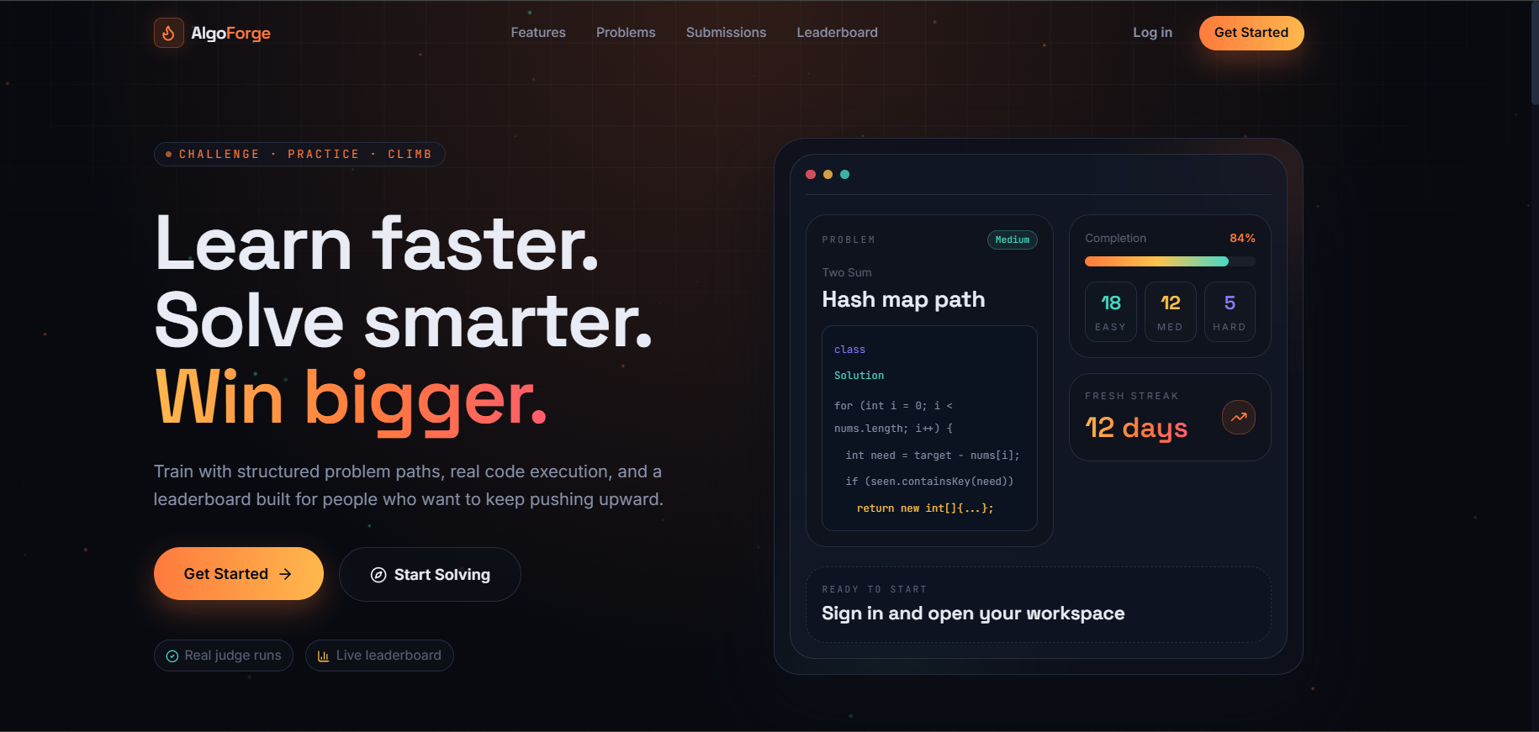 Fig 6.1: Hero Landing Page

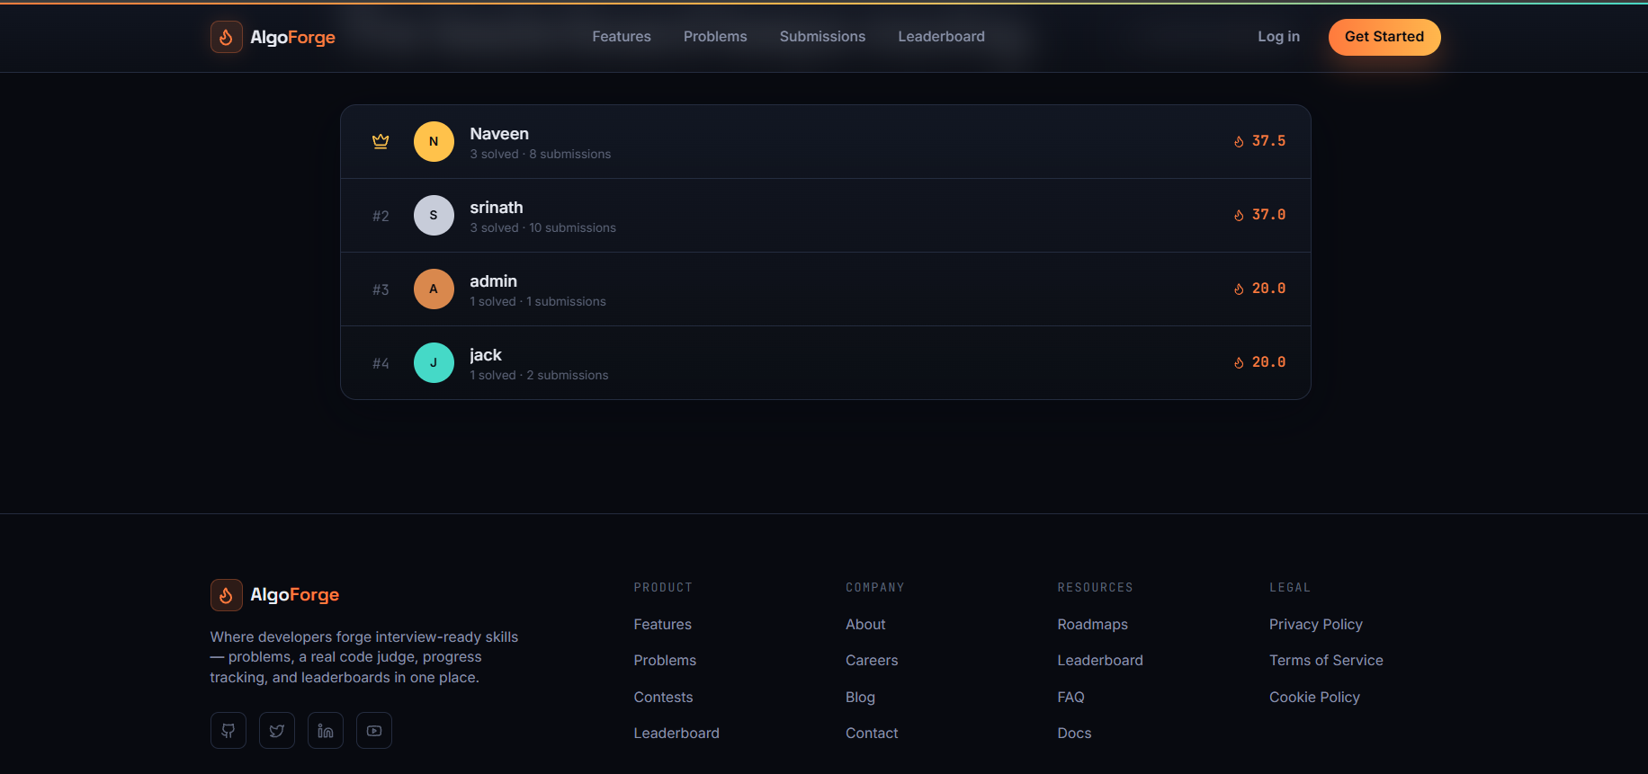
Fig 6.2: Landing Page Footer
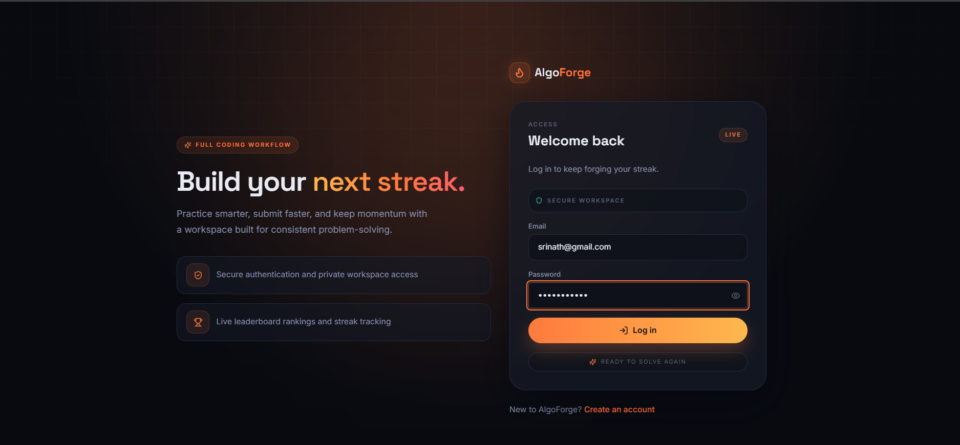
Fig 6.3: User Authentication Portal
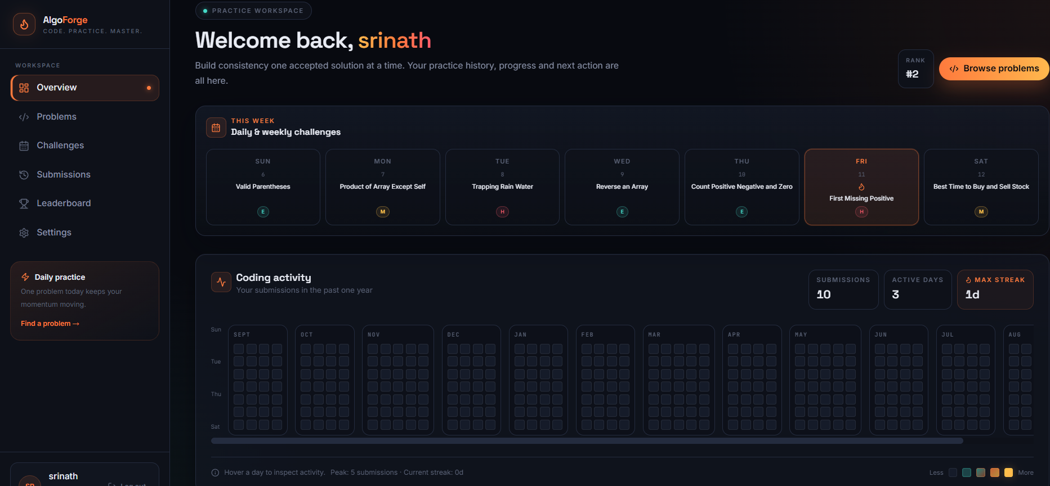
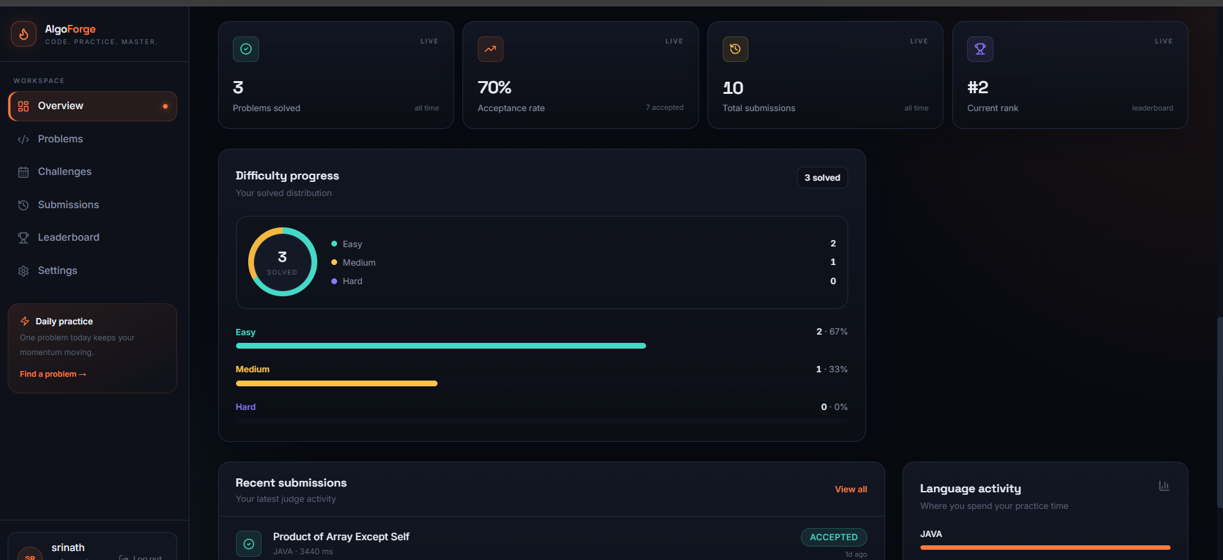
Fig 6.4: User Portal DashBoard
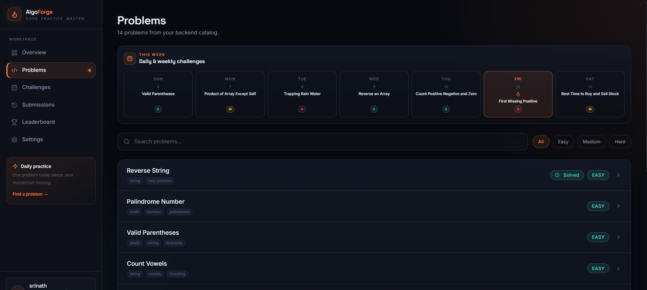 Fig 6.5: Problem Catalogue & Directory
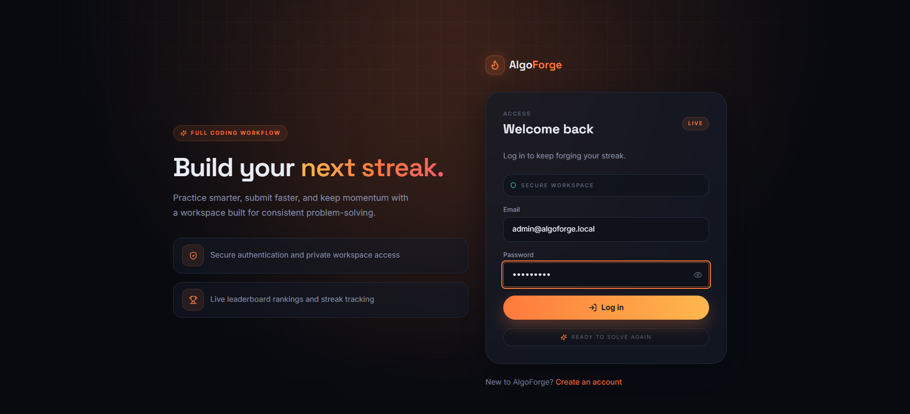 Fig 6.6: Admin Authentication Code
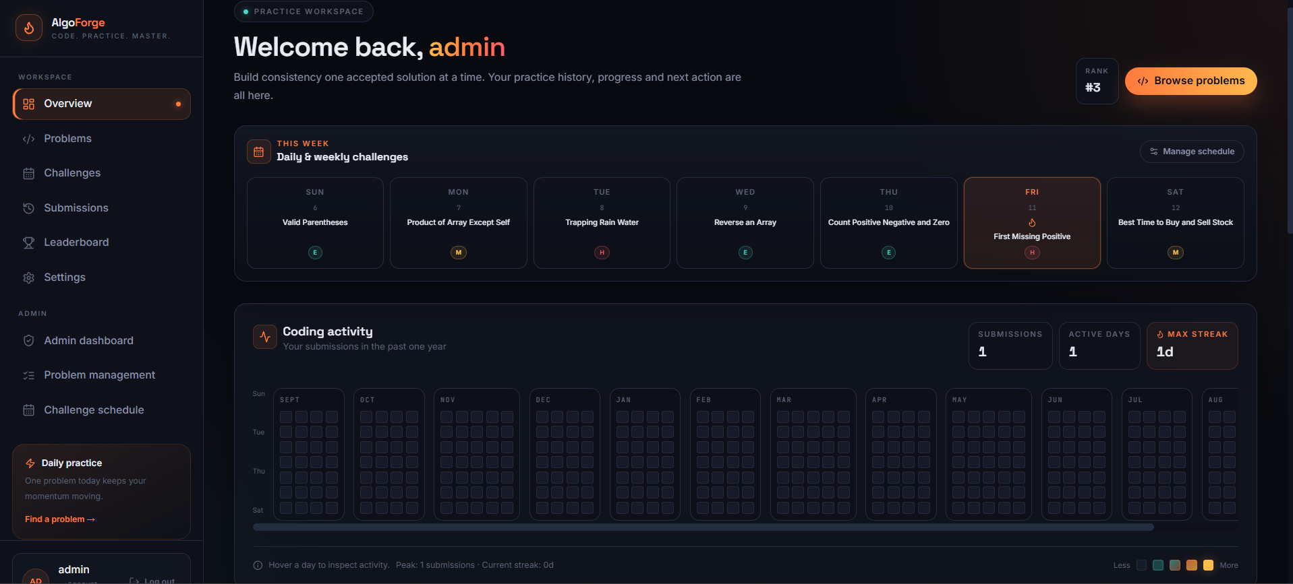 Fig 6.7: Admin Portal

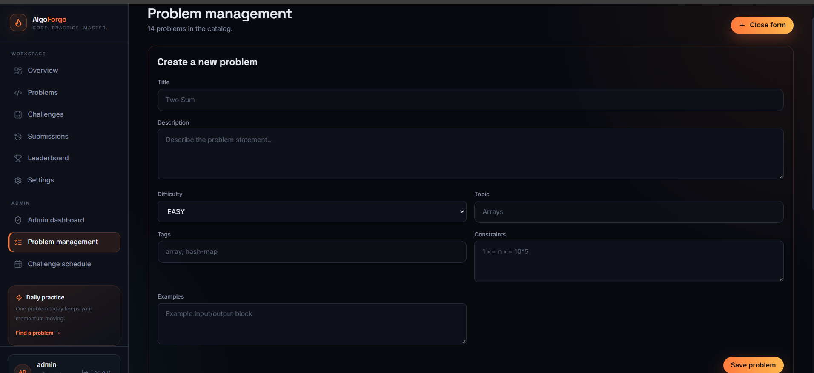 Fig 6.8: System Resource Metrics
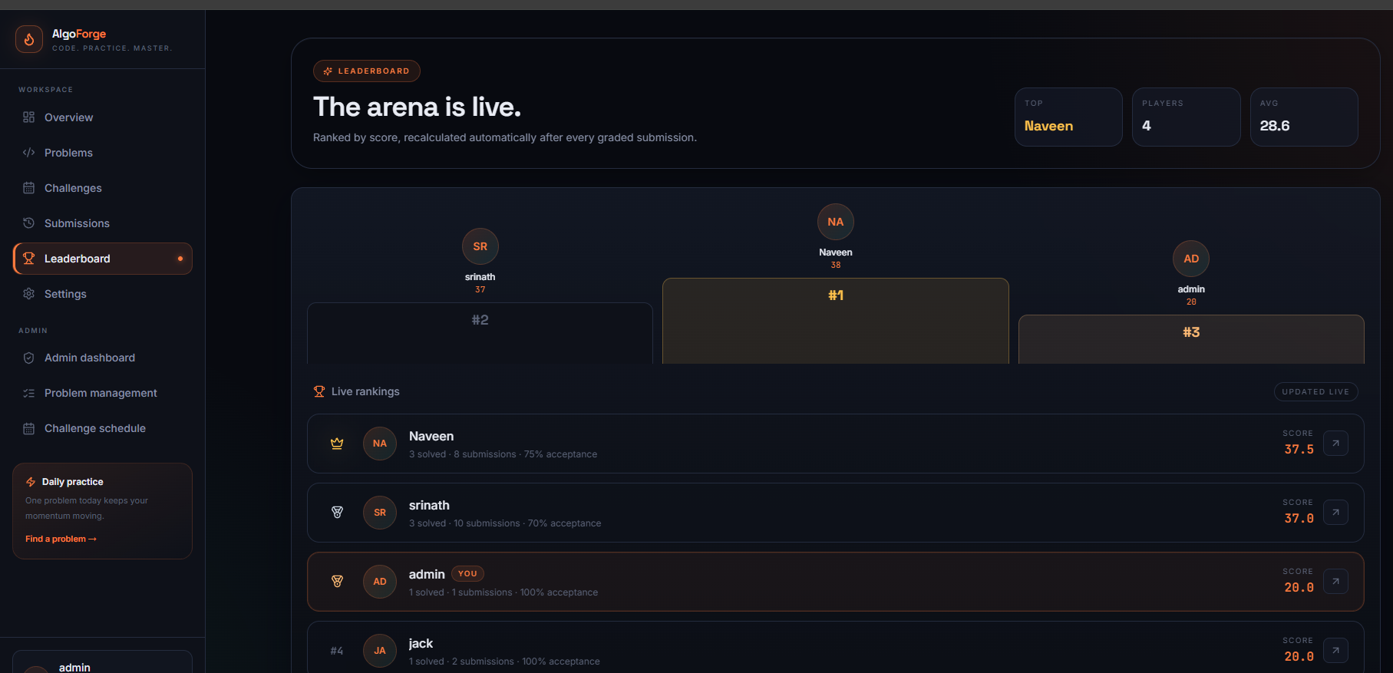 Fig 6.9: Global Competitive Leaderboard
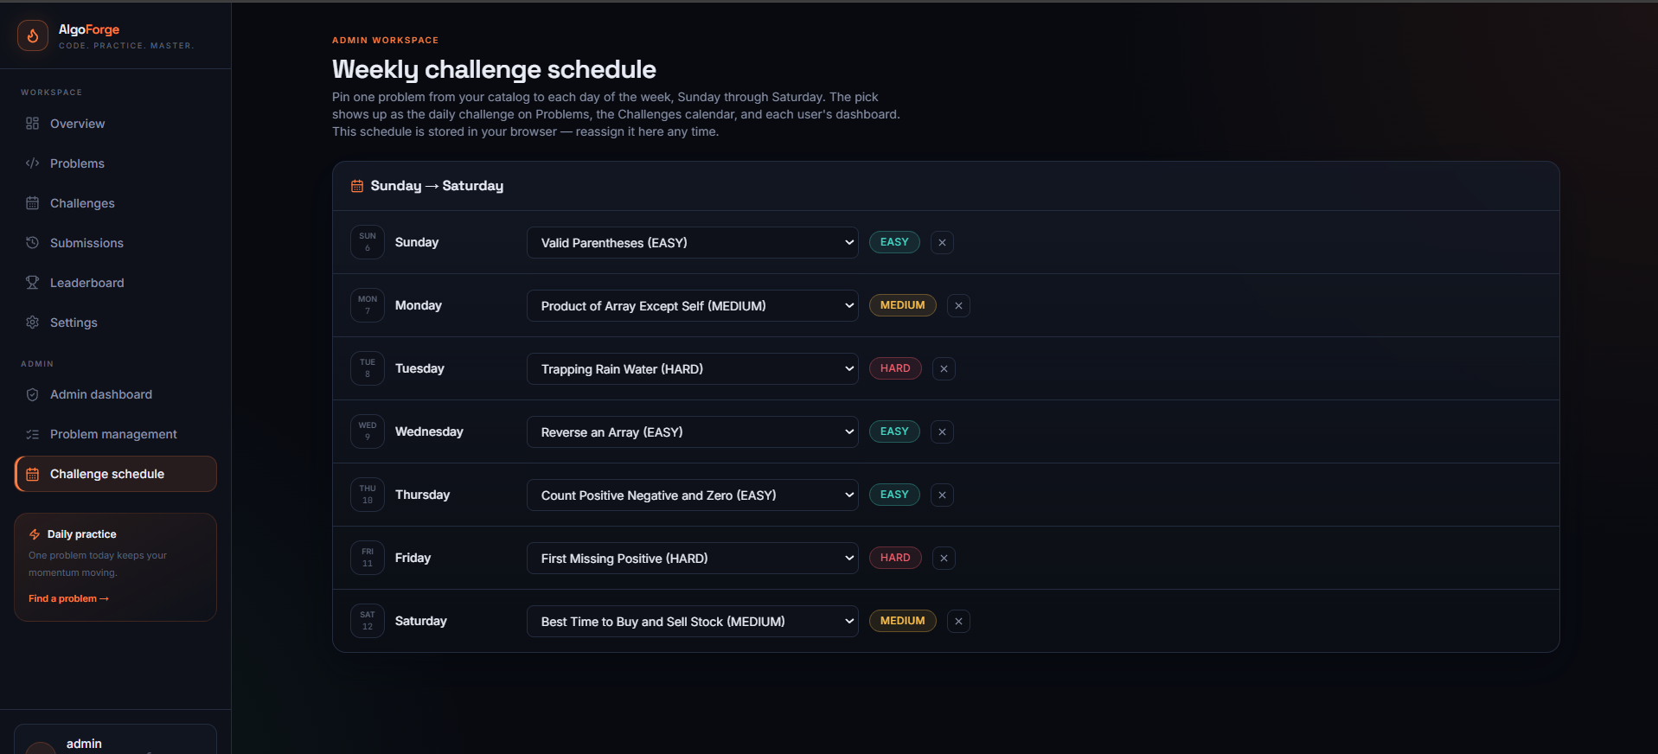
Fig 6.10 : Weekly challenge schedule

7. Challenges Faced
7.1.Backend and frontend Integration
One of the challenges was connecting the frontend with the Spring Boot backend.
- API URLs had to be configured correctly.
- The frontend and backend were running on different ports.
- CORS configuration was required to allow communication.
- Authentication headers had to be handled correctly.
This was addressed by configuring the backend APIs, verifying request URLs, and testing the communication through the browser and Postman
7.2. Database Schema Management
Maintaining consistency between the database schema and JPA entities was another challenge.
- Database tables had to match the entity definitions.
- Changes to the schema required proper migration management.
- Flyway migrations were used to apply database changes in a controlled manner.
- Database validation helped identify missing or mismatched columns.
7.3. Secure Code Execution
Running user-submitted code required careful handling because the code could contain infinite loops, excessive memory usage, or harmful operations
- Docker containers were used for isolated execution.
- CPU and memory restrictions were applied.
- Network access was restricted.
- Execution cleanup was implemented to remove completed containers.
7.4. Authentication and Authorization
Running user-submitted code required careful handling because the code could contain infinite loops, excessive memory usage, or harmful operations
- Login responses had to be handled correctly.
- JWT tokens had to be stored and sent with protected requests.
- Public endpoints such as registration and login had to remain accessible.
- Role-based access rules were configured for protected operations.
7.5. Code Evaluation
The platform needed to distinguish between different execution outcomes.
- Program output had to be compared with expected output.
- Compilation errors and runtime errors had to be handled.
- Time and memory limits had to be considered.
- Appropriate verdicts had to be displayed to users.
7.6. Time Management and Team Coordination
Completing multiple modules within the internship timeline requires proper planning.
- Tasks were divided into team members.
- Progress was reviewed regularly.
- Development, testing, documentation, and presentation activities were scheduled.
- Team communication was maintained to resolve technical issues and complete milestones.

8. Learnings & Skills Acquired
8.1 Technical Skills
During the internship, the following technical skills were developed:
- Spring Boot application development.
- REST API design and implementation.
- Spring Security and JWT authentication.
- BCrypt password hashing.
- Spring Data JPA and entity relationships.
- PostgreSQL database management.
- Flyway database migrations.
- Frontend development using HTML, CSS, JavaScript, and React/Next.js.
- Monaco Editor integration.
- Docker containerization.
- Automated code execution and evaluation.
- API testing using Postman.
- API documentation using Swagger UI.
- Git and GitHub for version control.
8.2 Domain Knowledge
The project helped in understanding:
- Online coding judge architecture.
- Code execution and test-case evaluation.
- Database modelling and entity relationships.
- Authentication and authorization.
- Secure execution of untrusted code.
- Performance tracking and analytics.
- Frontend-backend integration.
- Full-stack application development
8.3 Soft skills
The internship also improved the following soft skills:
- Project planning and milestone tracking.
- Team coordination and communication.
- Technical documentation.
- Problem-solving and debugging.
- Presentation and demonstration skills.
- Time management.
- Explaining technical concepts clearly.
- Working collaboratively under deadlines.

9. Testimonials from team
The internship provided me with practical exposure to full-stack development and helped me understand how different technologies work together in a real-world project.
Working on the coding platform improved my knowledge of backend development, database integration, authentication, frontend design, and automated code evaluation. Developing the project from the initial requirements to a working platform also strengthened my problem-solving, teamwork, and project-management skills.
Overall, the experience enhanced my technical knowledge and increased my confidence in developing and presenting a complete software project.

10. Conclusion
The eight-week Infosys Springboard Virtual Internship gave me the opportunity to contribute to the development of a Web Platform for Coding Practice and Performance Assessment.
Through this project, I gained practical experience in frontend development, backend services, database management, authentication, code execution, and performance tracking. I also worked with technologies such as Spring Boot, PostgreSQL, Spring Security, JWT, Flyway, Docker, and Monaco Editor.
The challenges encountered during development helped me improve my debugging, problem-solving, teamwork, and technical communication skills. Overall, this internship strengthened my understanding of full-stack development and prepared me for future academic projects and a career in software development.

11. Acknowledgements

I’m sincerely grateful to Infosys Springboard for providing me with the opportunity to undertake this virtual internship. My heartfelt thanks go to my mentors and coordinators for their continuous guidance, valuable technical feedback, and support throughout the project. I would also like to thank the faculty and review panel for their constructive feedback, encouragement, and support during every stage of the internship.

