YUVAINTERN
MACHINE LEARNING-BASED NETWORK
INTRUSION DETECTION SYSTEM
WEEK 6 – FINAL REPORT AND COMPREHENSIVE ANALYSIS
Machine Learning Engineer Internship

Intern: Mannava Srinath
Branch: Computer Science and Engineering
Institution: Methodist College of Engineering and Technology, Hyderabad
Dataset: UNSW-NB15 Testing Set
Execution Environment: Python / Google Colab / scikit-learn
Project Repository: Srinath77-del/network-intrusion-detection-ml

Final Internship Deliverable

TABLE OF CONTENTS
Section | Correct page
Executive Summary | 4
1. Project Overview | 4
1.1 Project Vision | 4
1.2 Problem Statement | 4
1.3 Objectives | 5
1.4 Importance for a Machine Learning Engineer | 5
2. Methodological Recap | 5
2.1 End-to-End Workflow | 5
2.2 Dataset and Data Understanding | 5
2.3 Attack Category Analysis | 6
3. Data Preprocessing and Feature Engineering | 7
3.1 Data Quality | 7
3.2 Leakage Prevention and Feature Exclusion | 7
3.3 Numerical Feature Analysis | 8
3.4 Outlier Analysis | 8
3.5 Correlation and Redundancy | 8
3.6 Categorical Features and Encoding | 8
3.7 Leakage-Safe Preprocessing | 9
4. Model Implementation | 9
4.1 Candidate Models | 9
4.2 Train-Test Strategy | 9
4.3 Week 3 Model Results | 10
5. Model Evaluation and Validation | 10
5.1 Formal Evaluation Results | 10
5.2 Why These Metrics Matter | 11
5.3 Confusion Matrix and Error Analysis | 11
5.4 Cross-Validation Stability | 12
5.5 Overfitting and Generalization | 14
6. Model Optimization and Experimental Analysis | 14
6.1 Baseline for Optimization | 14
6.2 Optimization Approaches Considered | 14
6.3 Initial Randomized Search | 15
6.4 Controlled Hyperparameter Experiments | 15
6.5 Experimental Interpretation | 16
6.6 Selected Configuration and Limitation | 16
7. Comprehensive Results and Project-Level Analysis | 16
7.1 Recorded Performance Across Weekly Stages | 16
7.2 Overall Final Evidence | 17
7.3 What the Results Mean | 17
8. Challenges and Solutions | 17
9. Lessons Learned | 18
10. Recommendations and Future Work | 19
10.1–10.8 | 19
11. Final Conclusion | 20
12. Project Repository and Reproducibility | 20
13. Submission Description | 21
14. References | 21
Appendix A – Key Final Project Values | 22
Appendix B – Interpretation Notes | 23

Executive Summary
This final report consolidates the six-week Machine Learning Engineer internship project on a Machine Learning-Based Network Intrusion Detection System using the UNSW-NB15 testing-set file. The project was planned as an end-to-end machine learning lifecycle covering problem definition, dataset research, data understanding, preprocessing, feature engineering, model implementation, evaluation, validation, optimization, and final analysis. The practical objective was to classify network traffic into Normal and Attack classes while keeping the workflow reproducible and avoiding target leakage.
The analyzed file contained 82,332 records and 45 columns. After removing the unique id field, the attack_cat field that directly reveals the binary target, and the label target itself, 42 input features remained: 39 numerical and three categorical features (proto, service, and state). The file contained no missing values and no duplicate rows. One-hot encoding of the categorical variables produced a 190-feature transformed representation. A stratified 80/20 split produced 65,865 training records and 16,467 testing records.
Model implementation compared a Decision Tree with a Random Forest. The Random Forest was selected as the stronger model based on the Week 3 measurements, reaching 97.69% accuracy and 97.89% F1-score, while also reducing false negatives compared with the Decision Tree. Week 4 provided the formal evaluation analysis for the Random Forest, reporting 97.63% accuracy, 98.44% precision, 97.24% recall, 97.84% F1-score, and 99.71% ROC-AUC. Five-fold stratified validation produced a mean F1-score of 97.93% with very small variation across folds.
Week 5 focused on optimization. An initial RandomizedSearchCV run used 15 candidates with three-fold cross-validation, producing 45 fits and a best cross-validation F1-score of 0.9777. Because the computation was time-consuming, four controlled configurations were subsequently evaluated on a validation subset while the original test set remained untouched. Experiment 3 was the best controlled configuration with a validation F1-score of 0.9790, an improvement of 0.0016 over the baseline validation score. This was a validation result only; the optimized configuration was not evaluated on the untouched test set, so no final test-set improvement is claimed.
1. Project Overview
1.1 Project Vision
The project vision was to design a practical, reproducible machine learning workflow capable of identifying malicious network traffic. The Week 1 plan defined the project as a binary classification problem in which network-flow observations are classified as Normal or Attack. The planned lifecycle connected research and problem understanding with data analysis, preprocessing, model development, evaluation, optimization, and documentation.
1.2 Problem Statement
Modern networks generate large volumes of traffic, making exhaustive manual analysis difficult. Network traffic also contains complex patterns and attackers continuously change their techniques. The project therefore addresses the problem of automatically analyzing network-flow characteristics and classifying traffic as normal or malicious using machine learning.
1.3 Objectives
Understand the network intrusion detection problem and define measurable project goals.
Use a public cybersecurity benchmark and understand its structure and limitations.
Perform data-quality analysis, feature analysis, preprocessing, and feature engineering.
Implement baseline and ensemble tree-based classifiers.
Evaluate models using accuracy, precision, recall, F1-score, confusion matrix, and ROC-AUC.
Investigate validation stability, error types, and overfitting.
Optimize the selected Random Forest through controlled hyperparameter experiments.
Maintain reproducible notebooks, reports, and documentation through GitHub.
1.4 Importance for a Machine Learning Engineer
The project demonstrates that a Machine Learning Engineer's responsibility is broader than training a classifier. A useful ML workflow requires understanding the business or security problem, validating the data, preventing leakage, designing reproducible preprocessing, selecting appropriate metrics, testing generalization, analyzing errors, managing computational constraints, documenting decisions, and communicating limitations. In intrusion detection, this is particularly important because false negatives represent attacks that were not detected and false positives can create unnecessary security alerts.
2. Methodological Recap
2.1 End-to-End Workflow
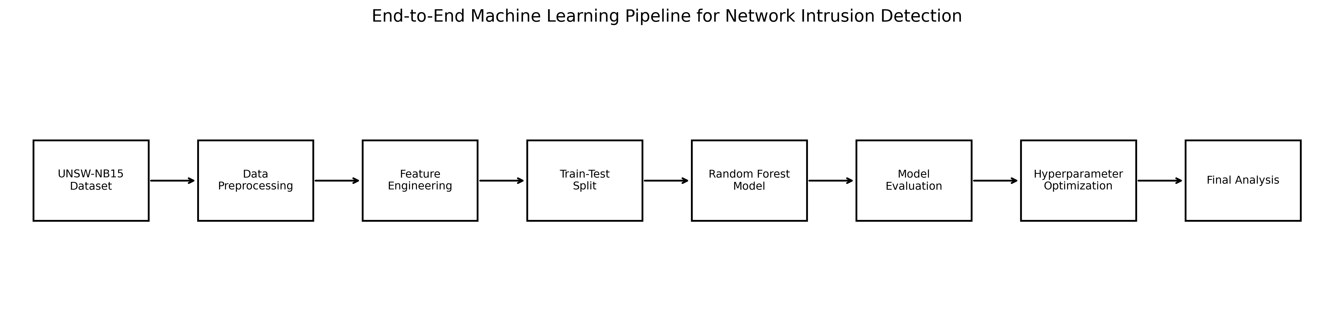
Figure 1. End-to-end machine learning pipeline used across the internship.
The final workflow connects the weekly tasks into one lifecycle: dataset loading and understanding, data-quality analysis, preprocessing and feature engineering, stratified train-test separation, Random Forest implementation, evaluation and validation, hyperparameter optimization, and final analysis.
2.2 Dataset and Data Understanding
The project used the UNSW_NB15_testing-set.csv file. The actual downloaded file analyzed during the internship contained 82,332 records and 45 columns. It contained 30 integer columns, 11 floating-point columns, and four object columns. The binary label contained 45,332 attack records (55.06%) and 37,000 normal records (44.94%).
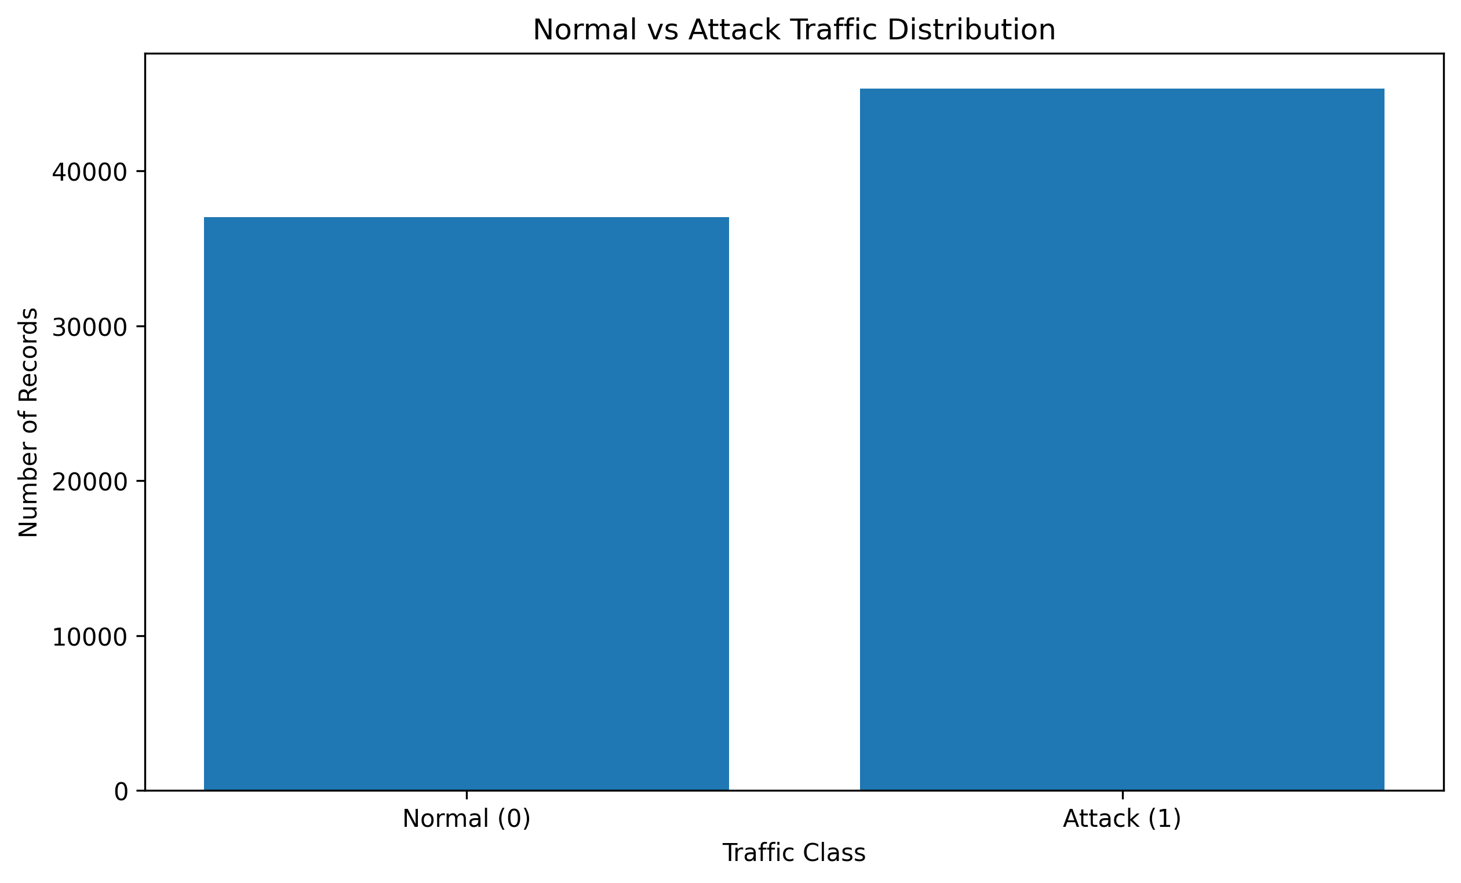
Figure 2. Distribution of Normal and Attack traffic in the analyzed file.
2.3 Attack Category Analysis
Although the final modeling task was binary, the attack_cat field was examined during data understanding. Normal traffic represented 37,000 records, followed by Generic with 18,871, Exploits with 11,132, Fuzzers with 6,062, DoS with 4,089, and Reconnaissance with 3,496. Rare categories included Analysis, Backdoor, Shellcode, and Worms; Worms had only 44 records. This uneven category distribution is important for any future multi-class extension.
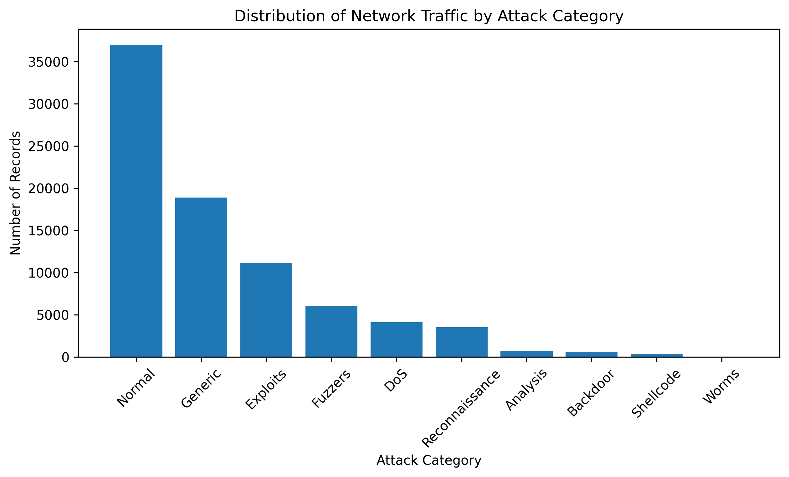
Figure 3. Distribution of network traffic by attack category.
3. Data Preprocessing and Feature Engineering
3.1 Data Quality
Check | Observed Result | Decision
Records | 82,332 | All records retained
Original columns | 45 | Feature roles reviewed
Missing values | 0 | No imputation required
Duplicate rows | 0 | No duplicate removal required
Attack records | 45,332 (55.06%) | Retain and use stratification
Normal records | 37,000 (44.94%) | Retain and use stratification
The absence of missing values simplified preprocessing because no imputation strategy was required for the analyzed file. The absence of duplicate rows also meant that no duplicate-removal step was necessary.
3.2 Leakage Prevention and Feature Exclusion
The id column had 82,332 unique values for 82,332 rows, so it was treated as a record identifier rather than a behavioral feature. The attack_cat column directly determined the binary label: Normal corresponded to label 0 and every listed attack category corresponded to label 1. Including attack_cat would therefore leak information about the target. Both id and attack_cat were excluded, while label was retained only as the target variable.
3.3 Numerical Feature Analysis
The 39 numerical inputs had substantially different scales and several highly skewed distributions. For example, sload ranged from 0 to 5.268×10^9, while sttl ranged from 0 to 255. Strong positive skew was observed in trans_depth (170.794), response_body_len (74.635), djit (60.562), dloss (54.466), sbytes (53.779), and dbytes (52.550). These results showed that network-flow variables could contain long right tails and extreme values.
3.4 Outlier Analysis
IQR-based screening identified many statistical outliers. The largest counts included dload with 18,112 flagged records (22.00%), ct_dst_src_ltm with 12,789 (15.53%), dbytes with 12,308 (14.95%), and smean with 11,928 (14.49%). These observations were not automatically deleted because extreme packet, byte, load, or timing values may represent genuine malicious behavior. Some zero-inflated variables can also produce IQR flags when both quartiles are zero. The project therefore preserved the observations and considered their modeling effect.
3.5 Correlation and Redundancy
Feature Pair | Correlation
dbytes – dloss | 0.997109
sbytes – sloss | 0.995027
is_ftp_login – ct_ftp_cmd | 0.994341
dpkts – dloss | 0.981506
ct_srv_src – ct_srv_dst | 0.977849
dpkts – dbytes | 0.976419
spkts – sloss | 0.973644
spkts – sbytes | 0.965750
ct_dst_ltm – ct_src_dport_ltm | 0.960401
swin – dwin | 0.960125
The correlation analysis demonstrated substantial redundancy among some variables. However, correlated features were not automatically removed because tree-based models can exploit nonlinear relationships and interactions. Correlation was therefore treated as evidence for candidate redundancy rather than as the sole feature-selection rule.
3.6 Categorical Features and Encoding
Feature | Unique Values | Most Frequent Category | Count
proto | 131 | tcp | 43,095
service | 13 | - | 47,153
state | 7 | FIN | 39,339
The three categorical inputs were proto, service, and state. One-hot encoding with handle_unknown='ignore' was used so that unseen categories would not cause prediction-time encoding failure. The 42 input features consisted of 39 numerical and three categorical features. The exploratory transformation produced 190 model-ready features.
Feature Stage | Count
Original columns | 45
Excluded id | 1
Excluded attack_cat | 1
Target label | 1
Model input features | 42
Numerical inputs | 39
Categorical inputs | 3
One-hot transformed features | 190
3.7 Leakage-Safe Preprocessing
The modeling workflow was designed around a scikit-learn Pipeline and ColumnTransformer. Numerical features were passed through for the tree-based models, while categorical variables were one-hot encoded. The final workflow fits data-dependent transformations on training data and applies the fitted transformation to held-out data. This separation is important because fitting preprocessing on the full dataset before splitting can allow information from evaluation data to influence the model.
4. Model Implementation
4.1 Candidate Models
Week 1 planned a Decision Tree as an interpretable baseline and Random Forest as the stronger ensemble candidate. The Decision Tree can model nonlinear rules and feature interactions and is relatively easy to interpret. Random Forest combines multiple decision trees and can reduce the variance associated with a single tree while capturing complex nonlinear patterns.
4.2 Train-Test Strategy
Subset | Records | Label 0 | Label 1
Training | 65,865 | 29,600 | 36,265
Testing | 16,467 | 7,400 | 9,067
A stratified 80/20 train-test split with random_state=42 was used. Stratification preserved the relative class distribution in both subsets. The held-out test set was reserved for model evaluation rather than hyperparameter selection.
4.3 Week 3 Model Results
Metric | Decision Tree | Random Forest
Accuracy | 95.97% | 97.69%
Precision | 97.52% | 98.40%
Recall | 95.10% | 97.39%
F1-Score | 96.30% | 97.89%
Random Forest outperformed the Decision Tree on every reported metric. Its recall increased by 2.29 percentage points and its F1-score increased by 1.59 percentage points. The Random Forest also reduced false negatives from 444 to 237 on the Week 3 test set, a reduction of 207 missed attack instances. Because false negatives are particularly important in intrusion detection, this evidence supported selecting Random Forest for the next stage.
5. Model Evaluation and Validation
5.1 Formal Evaluation Results
Metric | Week 4 Result
Accuracy | 97.63%
Precision | 98.44%
Recall | 97.24%
F1-Score | 97.84%
ROC-AUC | 99.71%
5-Fold Mean F1 | 97.93%
5-Fold F1 Std. Dev. | 0.07%
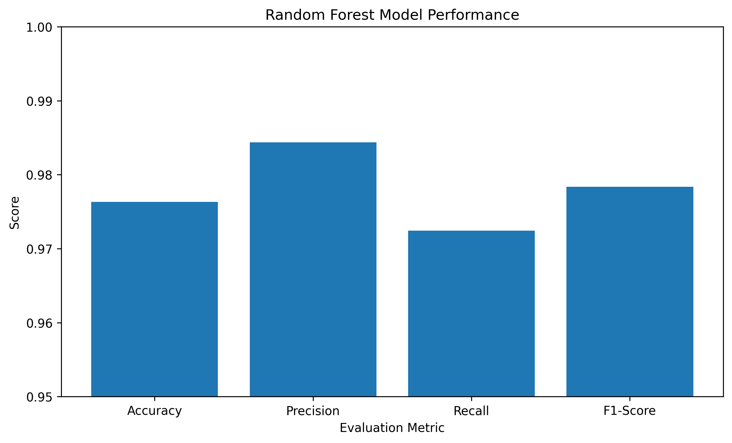
Figure 4. Random Forest performance across the main evaluation metrics.
5.2 Why These Metrics Matter
Accuracy measures overall correctness, but intrusion detection cannot rely on accuracy alone. Precision indicates how reliable the model's attack alerts are, recall indicates how many actual attacks are detected, and F1-score balances precision and recall. ROC-AUC summarizes the model's ability to distinguish the two classes across decision thresholds. The combination of these measures gives a more informative view of the security behavior of the classifier.
5.3 Confusion Matrix and Error Analysis
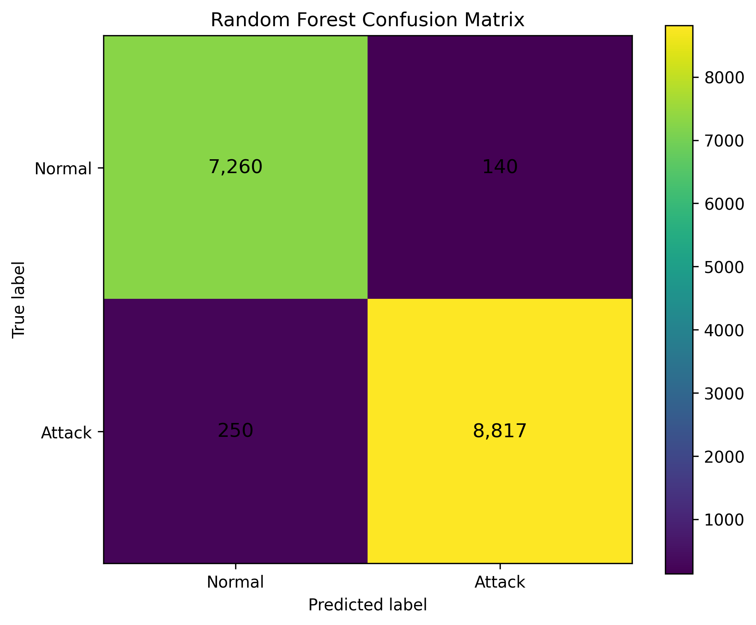
Figure 5. Confusion matrix from the Week 4 Random Forest evaluation.
Outcome | Count | Interpretation
True Negative | 7,260 | Normal traffic correctly classified as Normal
False Positive | 140 | Normal traffic incorrectly classified as Attack
False Negative | 250 | Attack traffic incorrectly classified as Normal
True Positive | 8,817 | Attack traffic correctly classified as Attack
The false positive rate was 1.89%, while the false negative rate was 2.76%. The false negative count is especially important because each false negative represents an attack that the classifier failed to identify. The model therefore shows strong overall performance while still leaving a meaningful security risk that future work should address.
5.4 Cross-Validation Stability
Fold | F1-Score
1 | 0.978327
2 | 0.979109
3 | 0.978926
4 | 0.980051
5 | 0.980294
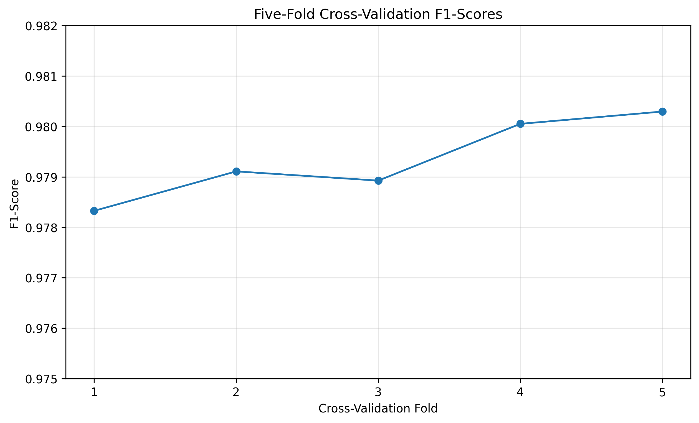
Figure 6. Five-fold stratified cross-validation F1-scores.
The five F1-scores range from 0.978327 to 0.980294, with a mean of 0.9793. Their small variation supports the conclusion that the evaluated Random Forest was stable across the validation folds.
5.5 Overfitting and Generalization
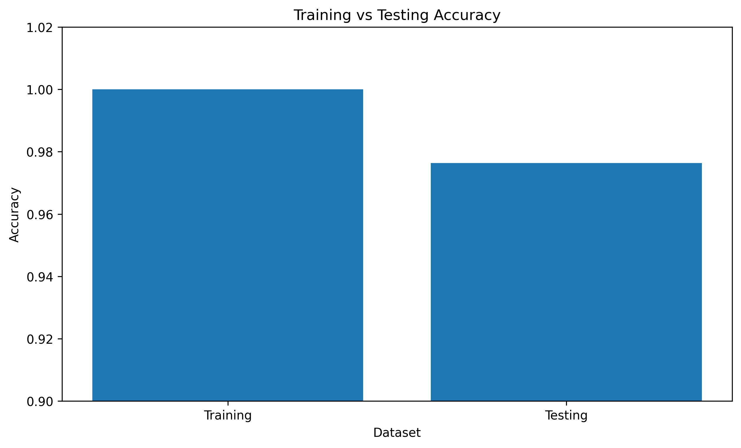
Figure 7. Training and testing accuracy comparison.
The Random Forest reached 100.00% training accuracy and 97.63% testing accuracy in the Week 4 evaluation, producing a 2.37 percentage-point gap. This is evidence of some overfitting, but the held-out test accuracy and recall remained high. The correct interpretation is therefore that the model generalizes strongly while still fitting the training data more closely than the unseen test data.
6. Model Optimization and Experimental Analysis
6.1 Baseline for Optimization
Metric | Week 5 Baseline
Accuracy | 97.52%
Precision | 98.30%
Recall | 97.18%
F1-Score | 97.74%
ROC-AUC | 99.71%
The Week 5 baseline used a Random Forest with 100 trees, random_state=42, and n_jobs=-1. It served as the control point for judging whether changes to model hyperparameters produced measurable validation gains.
6.2 Optimization Approaches Considered
Grid Search was considered for systematic evaluation of every combination in a predefined parameter grid. Random Search was considered more computationally practical because it samples configurations under a fixed budget. Bayesian Optimization was considered as an advanced approach that can use earlier trial results to select promising later configurations. In practice, the available compute made controlled experiments more appropriate for the main Week 5 analysis.
6.3 Initial Randomized Search
An initial RandomizedSearchCV experiment tested 15 candidates using three-fold cross-validation, resulting in 45 model fits. It produced a best cross-validation F1-score of 0.9777. The computation was time-consuming on the dataset, which motivated a controlled experimental design for clearer interpretation and more manageable runtime.
6.4 Controlled Hyperparameter Experiments
Configuration | Trees | Max Depth | Min Split | Min Leaf | Max Features | Validation F1
Baseline | 100 | Default | 2 | 1 | Default | 0.9774
Experiment 1 | 100 | 15 | 2 | 1 | sqrt | 0.9707
Experiment 2 | 100 | 20 | 2 | 1 | sqrt | 0.9788
Experiment 3 | 150 | 20 | 2 | 1 | sqrt | 0.9790
Experiment 4 | 150 | 25 | 2 | 2 | sqrt | 0.9780
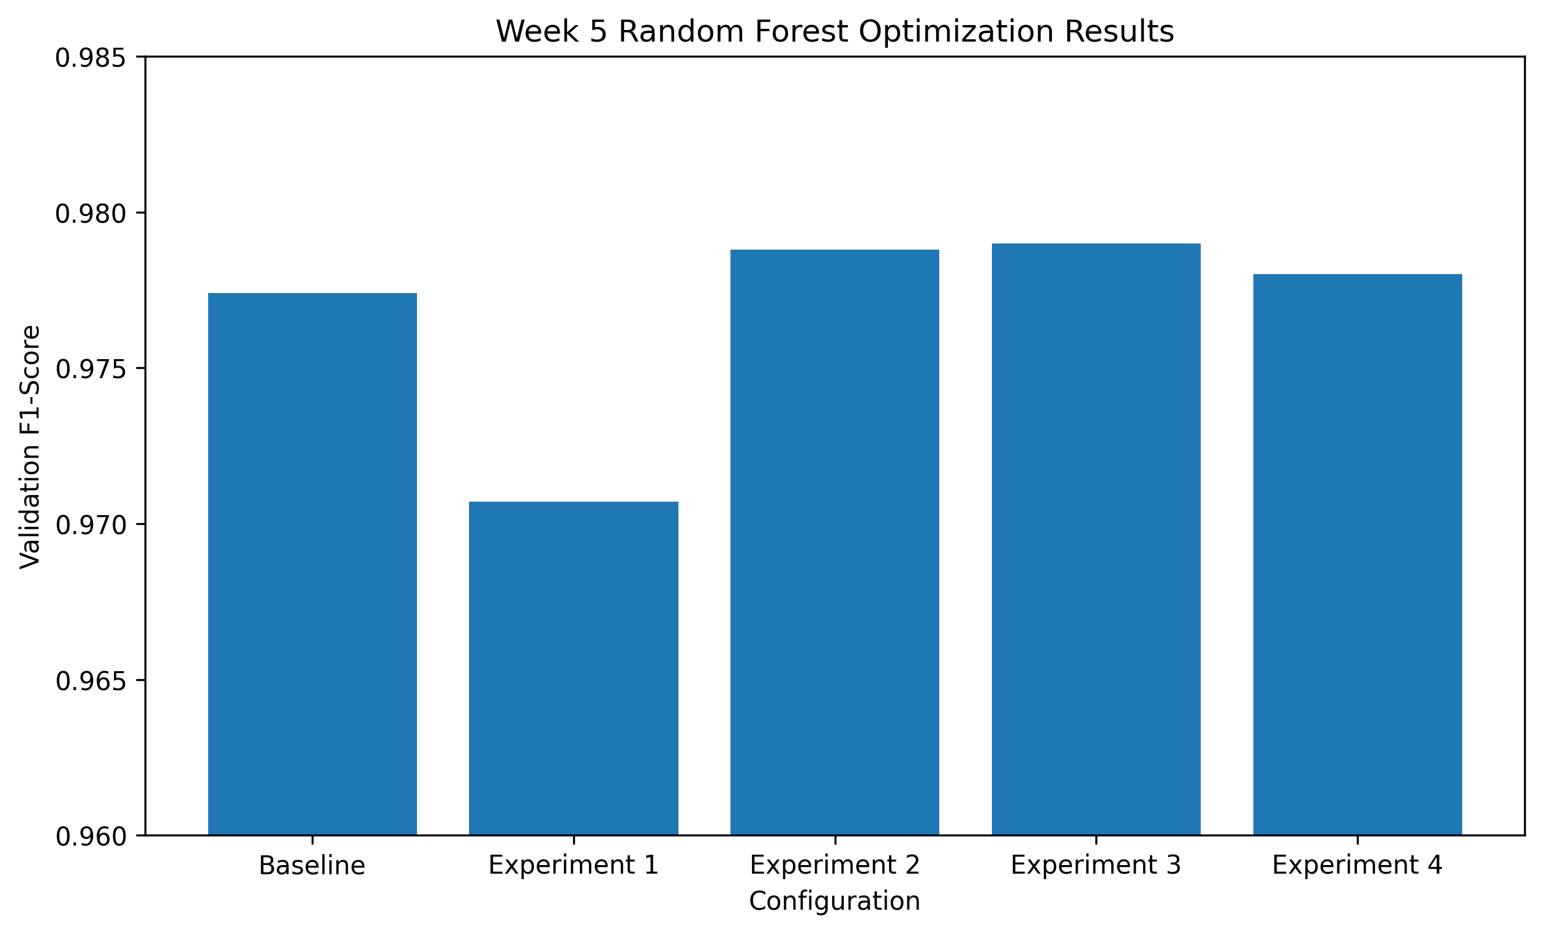
Figure 8. Validation F1-scores for the Week 5 controlled experiments.
6.5 Experimental Interpretation
Experiment 1 reduced the validation F1-score to 0.9707. The depth limit of 15 appears to have restricted the model's ability to represent the relationships required by the dataset. Experiment 2 increased maximum depth to 20 and reached 0.9788, exceeding the baseline. Experiment 3 then increased the number of trees from 100 to 150 while retaining maximum depth 20 and achieved the highest observed validation F1-score of 0.9790. Experiment 4 increased maximum depth to 25 and minimum leaf size to 2 but achieved 0.9780, below Experiment 3.
6.6 Selected Configuration and Limitation
Hyperparameter | Selected Value
n_estimators | 150
max_depth | 20
min_samples_split | 2
min_samples_leaf | 1
max_features | sqrt
Experiment 3 was selected because it had the highest validation F1-score. Its validation score of 0.9790 improved on the baseline validation score of 0.9774 by 0.0016, or 0.16 percentage points. Importantly, this was a validation improvement only. The optimized configuration was not evaluated on the untouched test set after selection. Therefore, the report does not claim that the optimized model improved the final test-set metrics.
7. Comprehensive Results and Project-Level Analysis
7.1 Recorded Performance Across Weekly Stages
Stage | Accuracy | Precision | Recall | F1-Score | ROC-AUC
Week 3 – Model Implementation | 97.69% | 98.40% | 97.39% | 97.89% | Not recorded
Week 4 – Model Evaluation | 97.63% | 98.44% | 97.24% | 97.84% | 99.71%
Week 5 – Optimization Baseline | 97.52% | 98.30% | 97.18% | 97.74% | 99.71%
The weekly results should be interpreted as recorded results from the corresponding project stages rather than as a forced monotonic progression. The Week 3 implementation reported the highest recorded F1-score of 97.89%, while the Week 4 formal evaluation reported 97.84% and the Week 5 baseline reported 97.74%. The differences are small, and the important conclusion is that performance remained consistently high while the later weeks added stronger validation, error analysis, and optimization methodology.
7.2 Overall Final Evidence
Evaluation Area | Result
Dataset records | 82,332
Original features | 45
Model input features | 42
Transformed features | 190
Missing values | 0
Duplicate rows | 0
Attack records | 45,332 (55.06%)
Normal records | 37,000 (44.94%)
Formal test accuracy | 97.63%
Formal test precision | 98.44%
Formal test recall | 97.24%
Formal test F1-score | 97.84%
Formal test ROC-AUC | 99.71%
Five-fold mean F1 | 97.93%
Five-fold F1 standard deviation | 0.07%
False positive rate | 1.89%
False negative rate | 2.76%
Best validation F1 | 97.90%
7.3 What the Results Mean
The project achieved a strong binary intrusion-detection result on the analyzed benchmark file. Precision of 98.44% means that predicted attack alerts were highly reliable in the formal evaluation, while recall of 97.24% shows that most attack instances were detected. The 97.84% F1-score demonstrates a strong balance between these two measures. The 99.71% ROC-AUC further supports strong class separation in the evaluated run. At the same time, 250 false negatives show why security applications require error analysis rather than relying on a single high accuracy value.
8. Challenges and Solutions
Challenge | Observed Issue | Response
Target leakage | attack_cat directly reveals the binary target | Excluded attack_cat from model inputs
Identifier leakage | id is unique for every row | Excluded id
Rare categories | Some categorical values have very low frequency | Retained categories and used robust one-hot encoding
Extreme values | Many IQR-based outlier flags | Preserved observations and avoided blind deletion
Feature redundancy | Several correlations above 0.90 | Used correlation as a screening signal, not automatic deletion
Computation | 45 RandomizedSearchCV fits were time-consuming | Used four controlled configurations
Runtime reset | Colab variables/models can be lost | Re-ran cells sequentially and maintained notebooks in GitHub
False negatives | Some attacks classified as Normal | Reported recall, FNR, confusion matrix, and future improvements
9. Lessons Learned
Data understanding must come before model training. Simple checks such as shape, data types, missing values, duplicates, class distribution, and feature cardinality directly affected later decisions.
Leakage prevention is a core engineering responsibility. Removing id and attack_cat prevented the model from receiving information that should not be available as predictive input.
High accuracy alone is not enough for intrusion detection. Precision, recall, F1-score, confusion matrix, and false-negative analysis provide a more useful security perspective.
Tree-based models can work well with mixed network-flow features without requiring aggressive scaling. A consistent preprocessing pipeline is still important for reproducibility and categorical handling.
Outliers should not automatically be treated as bad data. In cybersecurity, extreme traffic behavior can be the signal of interest.
Optimization requires controlled experiments. Some hyperparameter changes reduced performance, demonstrating that greater complexity does not automatically produce a better model.
Validation and test data have different roles. The Week 5 work reinforced the importance of keeping the final test set untouched during tuning.
Computational resources influence experimental design. A smaller, interpretable experiment can be more useful than a very large search that is difficult to execute or explain.
Documentation and version control are part of ML engineering. The project maintained notebooks, reports, and README documentation in GitHub so that the work could be reviewed and reproduced.
10. Recommendations and Future Work
10.1 Evaluate the Selected Optimized Configuration
The most immediate next step is to train the selected Experiment 3 configuration using the defined training workflow and evaluate it once on the untouched test set. This would establish whether the 0.16 percentage-point validation gain transfers to unseen data.
10.2 Compare Additional Classifiers
Future work should compare Random Forest with another suitable classifier, such as Gradient Boosting or XGBoost, using the same leakage-safe preprocessing and validation strategy. This would address the original project plan to support model selection with measured evidence.
10.3 Improve Validation Design
Repeated stratified cross-validation could provide a more robust estimate of variation. Hyperparameter selection could also use a nested validation strategy if the project is expanded into a more rigorous research experiment.
10.4 Investigate Class-Specific Error Costs
False negatives may be more costly than false positives in a security setting. Future experiments should therefore consider threshold analysis and cost-sensitive evaluation so that the model can be tuned around the operational consequences of missed attacks and excessive alerts.
10.5 Extend to Multi-Class Attack Detection
The current project performs binary Normal-versus-Attack classification. A future version could predict individual attack categories. The rare categories, especially Worms, would require careful validation because category frequencies are highly uneven.
10.6 Feature Selection and Explainability
The strong feature correlations identified during preprocessing justify further investigation into feature selection. Feature importance can also be expanded with model-agnostic explanation techniques, while remembering that model importance indicates predictive use rather than causation.
10.7 Independent and Real-World Validation
The project used the provided UNSW-NB15 testing-set file and therefore does not establish generalization to other networks, time periods, traffic distributions, or operational environments. Independent datasets and, eventually, carefully governed real-world network data should be used before considering production deployment.
10.8 Deployment Roadmap
A production-oriented system would require additional engineering beyond benchmark classification, including reliable feature extraction from live traffic, model serving, monitoring, drift detection, alert management, logging, model versioning, security controls, and a human review process. The internship project deliberately remained focused on the benchmark ML lifecycle rather than claiming production-grade security.
11. Final Conclusion
The six-week project successfully connected planning, data preparation, machine learning implementation, evaluation, validation, and optimization into a coherent ML engineering workflow. The project began by defining network intrusion detection as a binary classification problem and selecting UNSW-NB15 as the benchmark dataset. Practical data analysis then established the structure and quality of the actual testing-set file, including its 82,332 records, 45 columns, balanced-to-moderate binary class distribution, absence of missing values and duplicates, categorical structure, outliers, and feature redundancy.
The preprocessing stage produced a leakage-aware input design of 42 features, consisting of 39 numerical and three categorical variables, with one-hot encoding producing 190 transformed features. Model implementation demonstrated that Random Forest was stronger than the Decision Tree on the recorded Week 3 comparison, particularly in recall and F1-score. Formal Week 4 evaluation then showed 97.63% accuracy, 98.44% precision, 97.24% recall, 97.84% F1-score, and 99.71% ROC-AUC, with stable five-fold validation performance.
Optimization added an experimental perspective rather than simply increasing model complexity. The controlled experiments showed that some configurations reduced performance, while Experiment 3 produced the best validation F1-score of 0.9790. Because the optimized configuration was not evaluated on the untouched test set, the project correctly avoids claiming a final test improvement. This limitation is itself an important lesson in responsible ML experimentation.
Overall, the project demonstrates practical competency in the main stages of an ML lifecycle: defining a problem, understanding data, preventing leakage, engineering features, implementing models, selecting appropriate metrics, analyzing errors, validating generalization, optimizing hyperparameters, handling computational constraints, and documenting reproducible work. The recommended next step is to evaluate the selected optimized configuration on the untouched test set and then expand the comparison to additional classifiers and independent datasets.
12. Project Repository and Reproducibility
The project artifacts were maintained in the GitHub repository associated with the internship project. The repository contains the weekly reports, notebooks, README documentation, and the Week 6 final-analysis notebook. The workflow uses random_state=42 where applicable, a stratified train-test split, a consistent feature definition, and a scikit-learn preprocessing/model pipeline.
Artifact | Purpose
UNSW_NB15_Preprocessing.ipynb | Week 2 preprocessing and exploratory analysis
UNSW_NB15_Week3_Model_Implementation.ipynb | Model implementation and comparison
UNSW_NB15_Week4_Model_Evaluation.ipynb | Evaluation, validation, and error analysis
UNSW_NB15_Week5_Model_Optimization.ipynb | Hyperparameter experiments
UNSW_NB15_Week6_Final_Report_Analysis.ipynb | Final analysis and report figures
Srinath_week-01.docx to Srinath_week-05.docx | Weekly internship reports
Srinath_week-06.docx | Final comprehensive report
13. Submission Description
This Week 6 final report consolidates the complete Machine Learning-Based Network Intrusion Detection System project developed during my Machine Learning Engineer internship at YuvaIntern. The report presents the project from initial planning through data preparation, model implementation, evaluation, validation, optimization, and final analysis. The selected problem is binary network intrusion detection, where network traffic is classified as Normal or Attack using the UNSW-NB15 testing-set dataset.
The final analysis is based on the actual downloaded dataset containing 82,332 records and 45 columns. The report documents the data-quality findings, including zero missing values and zero duplicate rows, and explains the removal of the unique id field and the attack_cat field to prevent irrelevant information and target leakage. The resulting model input contains 42 features, including 39 numerical and three categorical variables. The categorical features proto, service, and state were one-hot encoded, producing a 190-feature transformed representation.
The report summarizes the model implementation stage, where Decision Tree and Random Forest were compared and Random Forest was selected as the stronger model based on measured results. It then presents the Week 4 evaluation results, including Accuracy of 97.63%, Precision of 98.44%, Recall of 97.24%, F1-Score of 97.84%, and ROC-AUC of 99.71%. Confusion-matrix analysis identifies 140 false positives and 250 false negatives, while five-fold stratified validation shows a mean F1-score of 97.93% with low variation across folds.
The optimization section summarizes the Week 5 baseline and controlled hyperparameter experiments. Experiment 3, using 150 trees, maximum depth 20, minimum samples split 2, minimum samples leaf 1, and sqrt feature selection, achieved the best validation F1-score of 0.9790 compared with the baseline validation F1-score of 0.9774. The report explicitly notes that this is a validation improvement and that the untouched test set was not used for tuning or post-selection evaluation. Finally, the report reflects on challenges, lessons learned, reproducibility, limitations, and future work such as independent validation, additional classifier comparison, broader controlled tuning, multi-class classification, and deployment-oriented engineering.
14. References
UNSW Research, The UNSW-NB15 Dataset, Australian Centre for Cyber Security / UNSW Canberra. Dataset information and citation guidance.
Moustafa, N. and Slay, J. (2015). UNSW-NB15: A Comprehensive Data Set for Network Intrusion Detection Systems. MilCIS 2015.
Moustafa, N. and Slay, J. (2016). The Evaluation of Network Anomaly Detection Systems: Statistical Analysis of the UNSW-NB15 Data Set and the Comparison with the KDD99 Data Set. Information Security Journal.
Pedregosa, F. et al. (2011). Scikit-learn: Machine Learning in Python. Journal of Machine Learning Research, 12, 2825–2830.
Python Software Foundation. Python Documentation.
pandas Documentation. Data analysis and DataFrame processing.
NumPy Documentation. Numerical computing.
Matplotlib Documentation. Visualization and plotting.
Appendix A – Key Final Project Values
The following values are included as a compact reference for review and presentation.
Item | Value
Dataset | UNSW-NB15 testing-set
Records | 82,332
Original columns | 45
Input features | 42
Numerical features | 39
Categorical features | 3
Transformed features | 190
Training records | 65,865
Testing records | 16,467
Formal test accuracy | 97.63%
Formal test precision | 98.44%
Formal test recall | 97.24%
Formal test F1-score | 97.84%
Formal test ROC-AUC | 99.71%
CV mean F1 | 97.93%
CV F1 standard deviation | 0.07%
False positive rate | 1.89%
False negative rate | 2.76%
Best validation F1 | 97.90%
Best validation configuration | 150 trees, depth 20, sqrt features
Appendix B – Interpretation Notes
1. Week 3, Week 4, and Week 5 contain results from their respective execution stages. The report preserves those recorded values rather than presenting a forced monotonic performance trend.
2. The Week 5 Experiment 3 score is a validation result. The selected configuration was intentionally not evaluated on the untouched test set after tuning, so a final test-set improvement is not claimed.
3. The 5-fold standard deviation is reported as approximately 0.07%, corresponding to the original recorded value of 0.000730; the later pandas display used a sample-standard-deviation convention that rounded to approximately 0.08%.

