Scenario 2:

Step 1 :

Create one docker file that will copy our index.html to the docker nginx server.

Step 2 :

Build the docker image.

Step 3 : push the docker image to the Docker hub repository.

Step 4 :

Create the Kubernetes yaml file for the application deployment. (i.e deployed the nginx image into Kubernetes cluster)

Step 5 :

Create the Service to access the nginx deployed index.html.

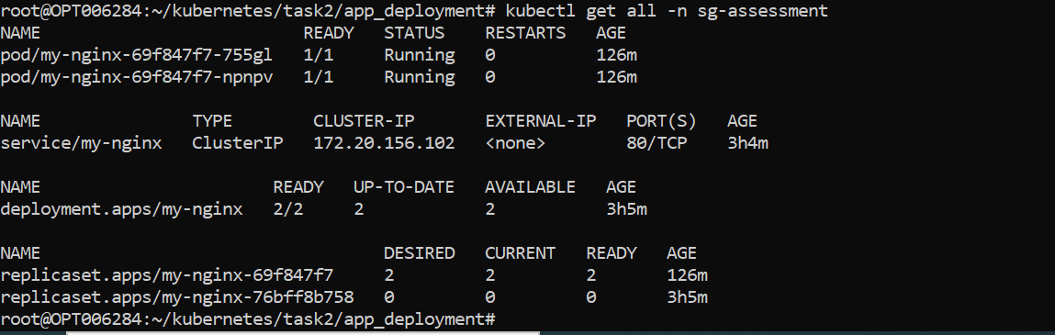

SQL Kubernetes deployment:

