BANK CUSTOMER CHURN & RETENTION ANALYTICS

SD0203 - DATA ANALYTICS BOOTCAMP

EMPLOYABILITY ENHANCEMENT COURSE

PROJECT REPORT

Submitted by

SRINEEDHI R 312324106168

in partial fulfillment for the award of the degree
of
BACHELOR OF ENGINEERING

in

ELECTRONICS AND COMMUNICATION ENGINEERING



St. JOSEPH’S COLLEGE OF ENGINEERING
(An AUTONOMOUS INSTITUTION)

CHENNAI - 600 119

August 2026

BONAFIDE CERTIFICATE

Certified that this project report “BANK CUSTOMER CHURN & RETENTION ANALYTICS” is the bonafide work of “SRINEEDHI R (312324106168)”who carried out the project work under my supervision.

SIGNATURE | SIGNATURE
Dr. S. RAJESH KANNAN.,M.E., Ph.D.,  HEAD OF THE DEPARTMENT  Associate Professor,  Department of Electronics and Communication Engineering,  St. Joseph’s College of Engineering,  Chennai -600119 | Dr. R. NIRUBAN, M.E., Ph.D.,  SUPERVISOR  Associate Professor,  Department of Electronics and Communication Engineering,  St. Joseph’s College of Engineering,  Chennai -600119

CERTIFICATE OF EVALUATION

COLLEGE NAME : St. JOSEPH’S COLLEGE OF ENGINEERING
BRANCH : ELECTRONICS AND COMMUNICATION ENGINEERING
SEMESTER : V
STUDENT NAME : SRINEEDHI R
REGISTER NUMBER : 312324106168
PROJECT TITLE : BANK CUSTOMER CHURN & RETENTION ANALYTICS
Criteria | Max Marks | Marks Awarded
Problem understanding & clarity of objectives | 5
Appropriateness of tools / technologies used | 5
Implementation quality | 10
Output correctness / working demonstration | 10
Subtotal | 30

INDUSTRY EXAMINER INTERNAL EXAMINER

ACKNOWLEDGEMENT

The contentment and elation that accompany the successful completion of any work would be incomplete without mentioning the people who made it possible.
Words are inadequate in offering our sincere thanks and gratitude to our respected Chairman Dr. B. Babu Manoharan, M.A., M.B.A., Ph.D. for his outstanding leadership, unwavering dedication, and invaluable contributions to our organization. His vision, guidance, and commitment have been instrumental in shaping our success and driving us towards excellence.
We express our sincere gratitude to our beloved Managing Director Mr. B. Shashi Sekar, M.Sc., (Intl. Business) and Executive Director Mrs. B. Jessie Priya, M.Com., (Commerce) for their support and encouragement.
We also thank our beloved Principal Dr. Vaddi Seshagiri Rao, M.E, MBA.,Ph.D., for having encouraged us to do our under graduation in Electronics and Communication Engineering in this esteemed institution.
We also express our sincere thanks and most heartfelt sense of gratitude to our eminent Head of the Department, Dr. S. Rajesh Kannan, M.E., Ph.D., for having extended his helping hand at all times.
We humbly express our profound gratitude for the invaluable guidance and expert suggestions generously shared by our supervisor, Dr. R. Niruban, M.E., Ph.D., and all our friends who has been supportive throughout the completion.

ABSTRACT

Bank customer churn is an important business challenge because the loss of customers can result in reduced revenue, increased customer acquisition costs, loss of long-term relationships, and reduced business growth. Traditional banking processes often identify the reasons for customer departure only after a customer has already decided to leave.

This project, Bank Customer Churn & Retention Analytics, applies data analytics and machine learning techniques to identify measurable customer characteristics associated with churn and to prioritize customers who may require retention attention.

The project analyzes 1,000 bank customer records, including 122 recorded customer departures, giving an overall churn rate of 12.20%. The dataset contains customer information such as credit score, geography, gender, age, tenure, account balance, number of products, credit card ownership, active membership status, estimated salary, and customer churn status. The dataset contains no missing values or duplicate customer records in the prepared analysis dataset.

The project uses Excel, MySQL, Python, Power BI, and scikit-learn. Excel is used for data preparation, KPI analysis, pivot tables, and charts. MySQL is used for structured relational analysis and SQL queries. Python is used for exploratory data analysis, visualization, data preprocessing, and feature engineering. Power BI is used to develop an interactive customer churn dashboard and risk analysis. Machine learning models are developed using scikit-learn, with Logistic Regression used as the classification model to estimate customer churn probability and categorize customers into different risk levels.

TABLE OF CONTENT
CHAPTER NO. | TITLE |  | PAGE NO.
 | ACKNOWLEDGEMENT |  | 4
 | ABSTRACT |  | 5
 | LIST OF TABLES |  | 7
 | LIST OF FIGURES |  | 8
1. | INTRODUCTION |  | 9
 | 1.1 | INTRODUCTION | 9
 | 1.2 | PROBLEM STATEMENT | 10
 | 1.3 | SCOPE AND PROJECT WORKFLOW | 11
2. | 2.1 | DATASET DESCRIPTION | 6
 | 2.2 | DATA ATTRIBUTES | 8
 | 2.3 | 2.3 DATA QUALITY ANALYSIS | 10
3 | 3.1 | EXCEL ANALYSIS | 16
 | 3.2 | CUSTOMER CUSTOMER BASE PROFILE | 16
 | 3.3 | SALARY ANALYSIS | 17
 | 3.4 | MYSQL RELATIONAL ANALYSIS | 18
4 | 4.1 | PYTHON EDA | 19
 | 4.2 | JOB SATISFACTION | 20
 | 4.3 | STATISTICAL SIGNIFICANCE | 21
5 | 5.1 | FEATURE ENGINEERING | 22
6 | 6.1 | 6.1 MODELING STRATEGY | 23
 | 6.2 | MODEL RESULTS | 24
 | 6.3 | TBANKINGESHOLD ANALYSIS | 25
7 | 7.1 | RISK SCORING,POWER BI BANKING DASHBOARD | 26
8 | 8.1 | CONCLUSION | 31

LIST OF FIGURES

CHAPTER NO. | TITLE
1.1 | Project Workflow
1.2 | Customer Churn Distribution
3 | Salary Distribution
4 | Geography-wise Customer Distribution
5 | Geography-wise Churn
6 | Age-wise Churn
7 | Tenure-wise Churn
8 | Product-wise Churn
9 | Active Membership and Churn
10 | Credit Score and Churn
11 | Power BI Customer Churn Dashboard
12 | Churn KPI Cards
13 | Customer Risk Distribution
14 | Machine Learning Model Performance
LIST OF TABLES

S.NO | LIST OF TABLES
1 | Dataset Attributes
2 | Customer Dataset Summary
3 | Churn Summary
4 | Geographical Churn Analysis
5 | Age Analysis
6 | Tenure Analysis
7 | Product Analysis
8 | Statistical Significance Results
9 | Engineered Features
10 | Machine Learning Results
11 | Threshold Analysis
12 | Risk Band Analysis
13 | Project Recommendations
CHAPTER 1
INTRODUCTION

INTRODUCTION
Customers are one of the most valuable assets of a banking organization. Their deposits, transactions, product usage, relationships, and long-term engagement directly influence the financial performance and growth of the bank. Maintaining a stable and loyal customer base is therefore an important responsibility for banking organizations.
Customer churn occurs when customers discontinue their relationship with a bank. Churn may require the bank to spend additional resources on acquiring replacement customers, while also resulting in the loss of revenue opportunities, account balances, product usage, and long-term customer relationships.
The present project focuses on analyzing bank customer data to understand measurable conditions associated with customer churn. The project analyzes 1,000 customer records with 122 recorded departures, resulting in an overall churn rate of 12.20%.
The dataset contains attributes such as credit score, geography, gender, age, tenure, account balance, number of products, credit card ownership, active membership status, estimated salary, and churn status. These variables provide multiple perspectives for analyzing customer behavior and identifying patterns associated with churn.
The project follows a complete analytic workflow. Excel is used for initial data preparation, profiling, KPI analysis, pivot tables, and charts. MySQL is used for structured relational analysis and SQL queries. Python is used for exploratory data analysis, visualization, data preprocessing, and feature engineering. Power BI is used for dashboard development, and machine learning is used to generate customer churn probability and risk scores.
The central idea of the project is not simply to identify differences between customer groups but to determine which customer characteristics provide useful evidence of potential churn. The project therefore combines descriptive analytics with machine learning-based risk prediction to support more focused customer retention analysis.
The overall purpose is to provide banking teams with a data-driven method for understanding customer churn patterns and prioritizing customers who may require further retention attention.

1.2 PROBLEM STATEMENT

Banks often identify customer churn only after customers have decided to discontinue their relationship with the bank. At this stage, retention teams have limited opportunity to understand the customer conditions that may have contributed to the decision.

The problem addressed by this project is the need to Analyze customer data systematically and identify measurable conditions associated with bank customer churn.

The dataset contains information about credit score, geography, gender, age, tenure, account balance, number of products, credit card ownership, active membership, estimated salary, and other customer characteristics. However, individual attributes alone cannot provide a complete understanding of customer churn. Relationships between different customer characteristics must be analyzed together.

For example, banking teams may want to determine whether customers from particular geographical regions have higher churn, whether older customers show higher churn, whether customers with different numbers of products have different churn rates, whether inactive members are more likely to leave, and whether account characteristics are associated with customer churn.

The project therefore uses descriptive analysis, visualization, SQL analysis, and machine learning to investigate these questions.A major challenge is the imbalance in the target variable. There are 122 churned customers and 878 retained customers among the 1,000 customers. Therefore, a model that predicts that every customer stays could achieve 87.80% accuracy while identifying no churned customers.

1.5 SCOPE AND PROJECT WORKFLOW

Scope

The project focuses on bank customer churn analytics using the available customer dataset. It covers customer characteristics such as credit score, geography, age, gender, tenure, account balance, number of products, credit card ownership, active membership, estimated salary, and churn status.

The project includes both descriptive and predictive analytics. Descriptive analytics identifies existing customer churn patterns across different customer segments, while predictive analytics uses machine learning to generate customer churn probabilities and risk scores for prioritizing customers who may require retention attention.

Project Workflow
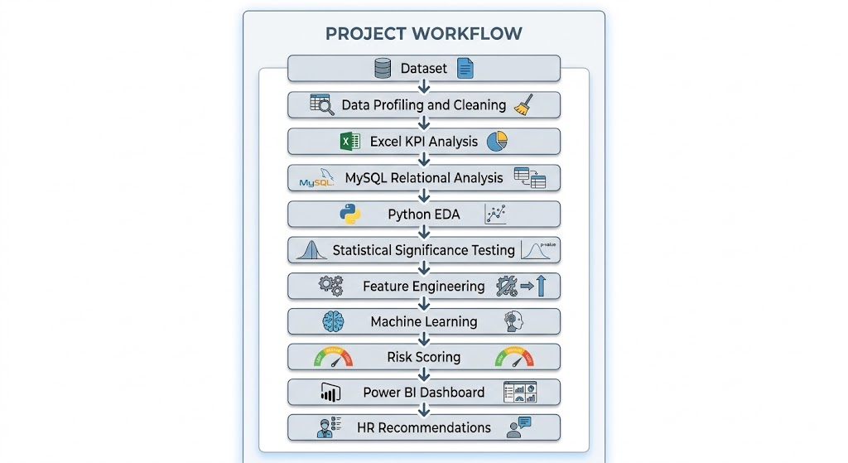

CHAPTER 2
DATASET OVERVIEW

2.1 DATASET DESCRIPTION

The project uses a bank customer churn dataset containing 1,000 customer records. The dataset consists of both numerical and categorical variables, which helps in analyzing different aspects of customer characteristics and banking behavior.

The main target variable is Exited, which indicates whether a customer has left the bank or continues to remain with the bank.
- 1 – Customer has left the bank
- 0 – Customer is still with the bank
Among the 1,000 customers, 122 customers have Exited = 1, while 878 customers have Exited = 0.The overall churn rate is calculated as:
Churn Rate = (Number of Customers Who Left / Total Number of Customers) × 100= (122 / 1000) × 100 = 12.20%

The dataset contains important customer-related information such as credit score, geography, gender, age, tenure, account balance, number of products, credit card ownership, active membership status, and estimated salary. These attributes are useful for understanding the different patterns associated with customer churn.

The dataset can be analyzed using different data analytics techniques. Excel is used for initial data analysis, KPI calculation, pivot tables, and visualization, SQL is used for database-based analysis, Python is used for exploratory data analysis, visualization, preprocessing, and feature engineering, and Power BI is used to create an interactive customer churn dashboard.Overall, the dataset provides sufficient information to study customer characteristics, identify churn patterns, and support data-driven customer retention and banking management decisions.

2.2 DATA ATTRIBUTES

Attribute | Type | Description
CustomerId | Identifier | Unique customer identifier
CreditScore | Numeric | Customer credit score
Geography | Categorical | Customer geographical region
Gender | Categorical | Customer gender
Age | Numeric | Customer age
Tenure | Numeric | Years with the bank
Balance | Numeric | Account balance
NumOfProducts | Numeric | Number of bank products held
HasCrCard | Binary | Credit-card ownership indicator
IsActiveMember | Binary | Active membership indicator
EstimatedSalary | Numeric | Estimated annual salary
Exited | Binary | Target variable indicating churn

The dataset contains 1,000 bank customers across three geographical regions. Average age is 39.02 years, average credit score is 651.16, average account balance is 75,742.71, and average estimated salary is 107,168.76.

2.3 DATA QUALITY ANALYSIS

Data quality is important because inaccurate or incomplete data can affect analytical conclusions.
The project performed data profiling to identify missing values and duplicate records.
The results were:
- Missing values: 0
- Duplicate customer IDs: 0
- Duplicate rows: 0
Therefore, no missing-value imputation was required.
The clean dataset provides a reliable basis for subsequent Excel, SQL, Python, Power BI, and machine-learning analysis.
The target variable is imbalanced, with only 122 positive churn cases compared with 878 retained customers. This imbalance is an important consideration during machine-learning evaluation, as accuracy alone may not adequately represent the model's ability to identify customers who are likely to churn. 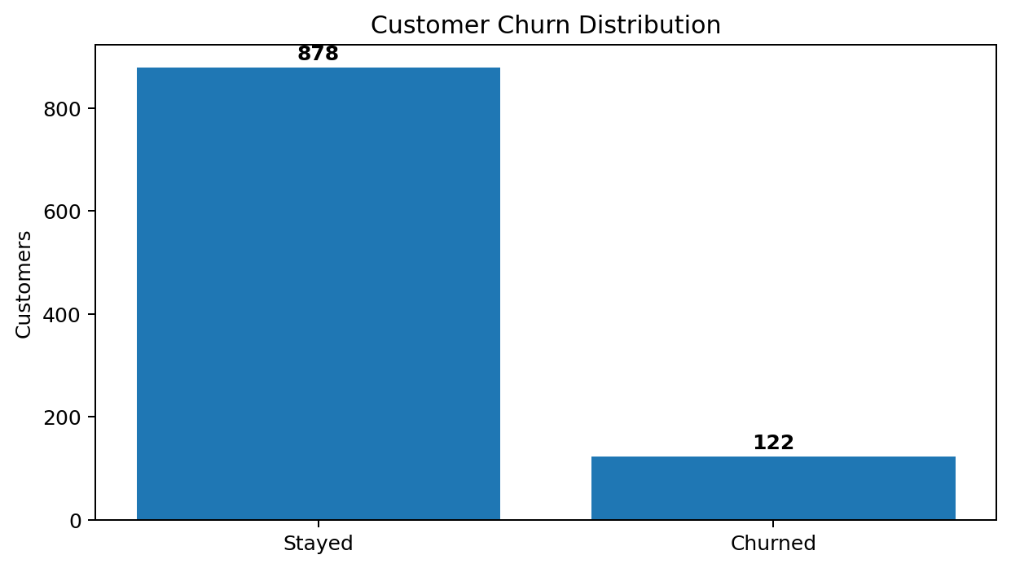

CHAPTER 3

EXCEL ANALYSIS

3.1 EXCEL ANALYSIS
Microsoft Excel provides the first analytical layer of the project. The Excel workbook was used to calculate customer churn KPIs and investigate customer segments.
Major Excel operations include:
- Data cleaning
- Derived columns
- Churn calculations
- Age bands
- Balance analysis
- Tenure analysis
- Pivot tables
- Charts
- KPI summaries
The overall churn rate obtained from Excel is: 12.20%Excel analysis provides an accessible method for banking and customer-retention teams to examine customer data before moving to statistical and predictive analysis.

IMPORTANT KPI
KPI | Result
Total Customers | 1,000
Customers Left | 122
Customers Stayed | 878
Churn Rate | 12.20%
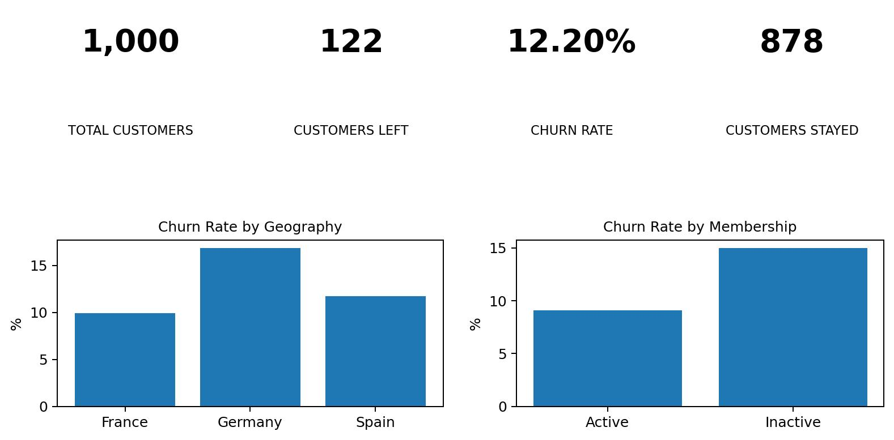

3.2 CUSTOMER PROFILE
The dataset contains 1,000 bank customers across three geographical regions.
The customer dataset includes important demographic, financial, and account-related characteristics.

These variables provide a broad view of the customer base and allow different customer groups to be compared against churn.

ACTIVE MEMBERSHIP
- Active Members: 473
- Inactive Members: 527
CREDIT CARD OWNERSHIP
- Customers with Credit Card: 688
- Customers without Credit Card: 312

NUMBER OF PRODUCTS
The dataset contains customers using different numbers of banking products. This variable is useful for examining whether product engagement is associated with customer churn.
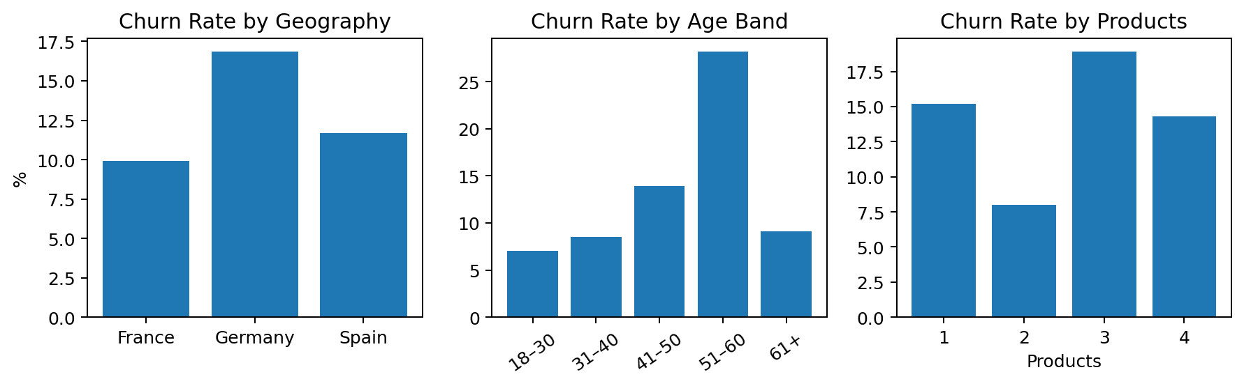

3.3 CUSTOMER FINANCIAL ANALYSIS
The analysis compares customer account balance and estimated salary to understand financial characteristics associated with churn.
Segment | Customers | Churned | Churn Rate
Germany | 267 | 45 | 16.85%
Spain | 248 | 29 | 11.69%
France | 485 | 48 | 9.90%
The dataset contains an average account balance of approximately 75,742.71 and an average estimated salary of approximately 107,168.76.

Customers with positive account balances and customers with zero balances can be compared to identify differences in churn rates.
FINANCIAL SEGMENT COMPARISON

SALARY BAND COMPARISON
Financial / Account Group | Churn Rate
Balance > 0 | 13.24%
Balance = 0 | 9.05%
Customer financial analysis provides a useful descriptive view of the relationship between account characteristics and churn.
Rather than applying a single financial intervention to all customers, banking teams can review customer segments with higher observed churn and investigate their account characteristics.
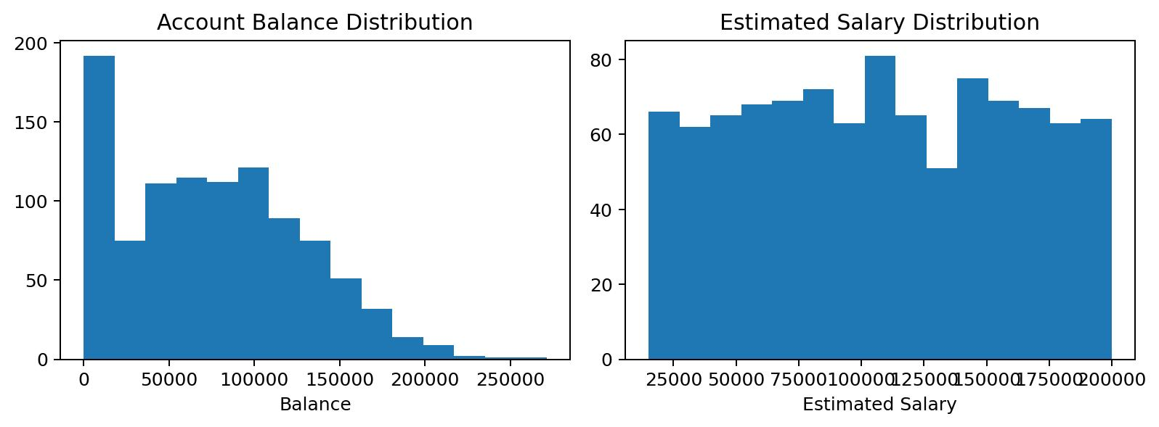

3.4 MYSQL RELATIONAL ANALYSIS
The SQL layer converts the flat customer spreadsheet into a structured relational analysis table.

DATABASE STRUCTURE
bank_data
|
└── customer churn records
|
└── customers
The project contains analytical SQL queries covering customer churn KPIs, geographical segments, age groups, product usage, active membership, and high-value churned customers.
The queries demonstrate:
- SELECT and WHERE conditions
- GROUP BY
- HAVING
- Aggregate functions
- Subqueries and conditional filtering
- ORDER BY and ranking logic
- AVG() OVER(PARTITION BY ...)
One of the important analyses compares churn rates across geographical regions and customer engagement segments.This analysis demonstrates how SQL can transform raw customer records into meaningful banking segments.
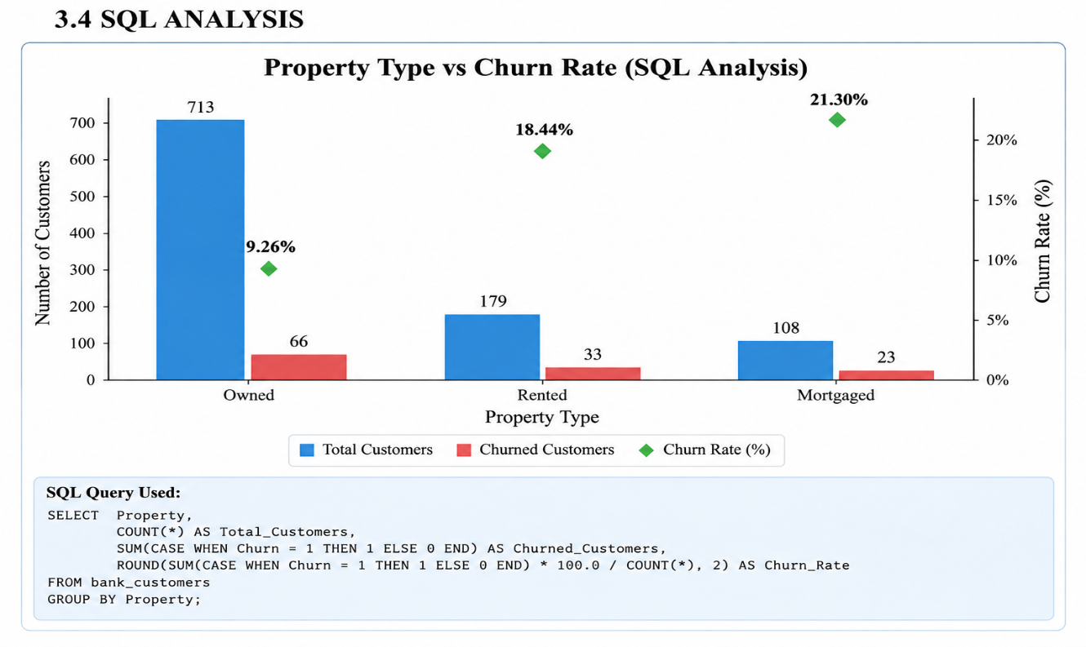

CHAPTER 4

PYTHON EXPLORATORY DATA ANALYSIS

4.1 PYTHON EDA
Python was used for deeper exploratory data analysis. The project uses:
- pandas
- NumPy
- SciPy
- Matplotlib
- scikit-learn
Python analysis examined credit score, age, tenure, balance, products, geography, gender, card ownership, active membership, and salary.
EDA identifies patterns before statistical testing and machine learning; visible chart differences are evaluated statistically before recommendations.
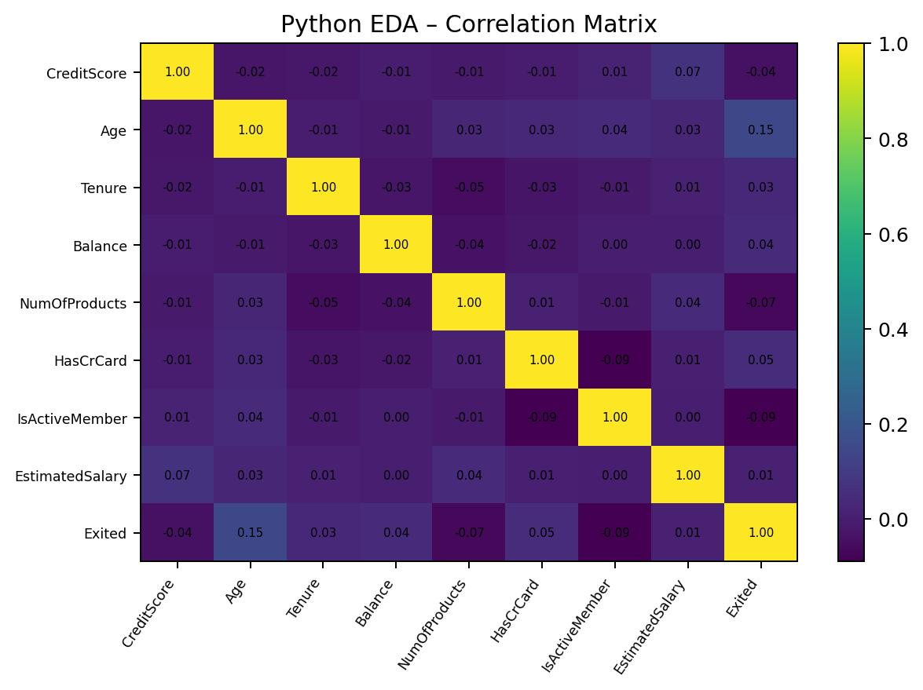

4.2 CUSTOMER SEGMENT PATTERNS
Customer churn demonstrates several visible patterns in the dataset.
Churn increases from approximately 7.1% among customers aged 18–30 to 28.2% among customers aged 51–60.

This represents a clear increase in the middle-to-late working-age segment.
The project also examines an engineered feature called Inactive Member, defined as IsActiveMember = 0.

Group
Churn Rate
Inactive Members 14.99%
Group | Churn Rate
Inactive Members | 14.99%
Active Members | 9.09%
These results indicate that age, product usage, geography, and membership activity deserve further investigation.
The analysis is descriptive and does not by itself establish that these customer characteristics cause churn.
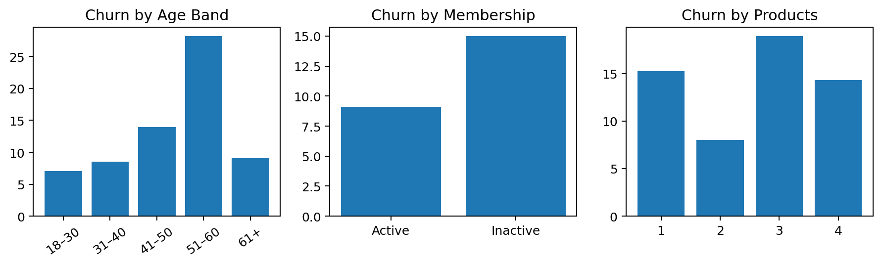

4.3 STATISTICAL SIGNIFICANCE
The project uses statistical testing to distinguish potentially meaningful relationships from sampling variation.
Variable | p-value | Verdict
Age Band | 0.000000 | Significant
Geography | 0.0196 | Significant
NumOfProducts | 0.0043 | Significant
IsActiveMember | 0.0060 | Significant
Gender | 0.602 | Not significant
HasCrCard | 0.171 | Not significant
The results indicate statistically significant associations for age band, geography, number of products, and active membership at the 5% level, while gender and credit-card ownership are not statistically significant in the available dataset.
Age group shows the strongest statistical evidence, with a p-value below 0.001. Geography, number of products, and active membership also show p-values below 0.05.Gender and credit-card ownership have p-values above 0.05 in the current dataset.Therefore, the evidence supports further investigation of age, geography, product count, and membership activity rather than treating every visible difference as a confirmed churn driver.The statistical results should be interpreted as associations within the prepared dataset and not as proof of causation.
These results demonstrate why statistical testing is important.
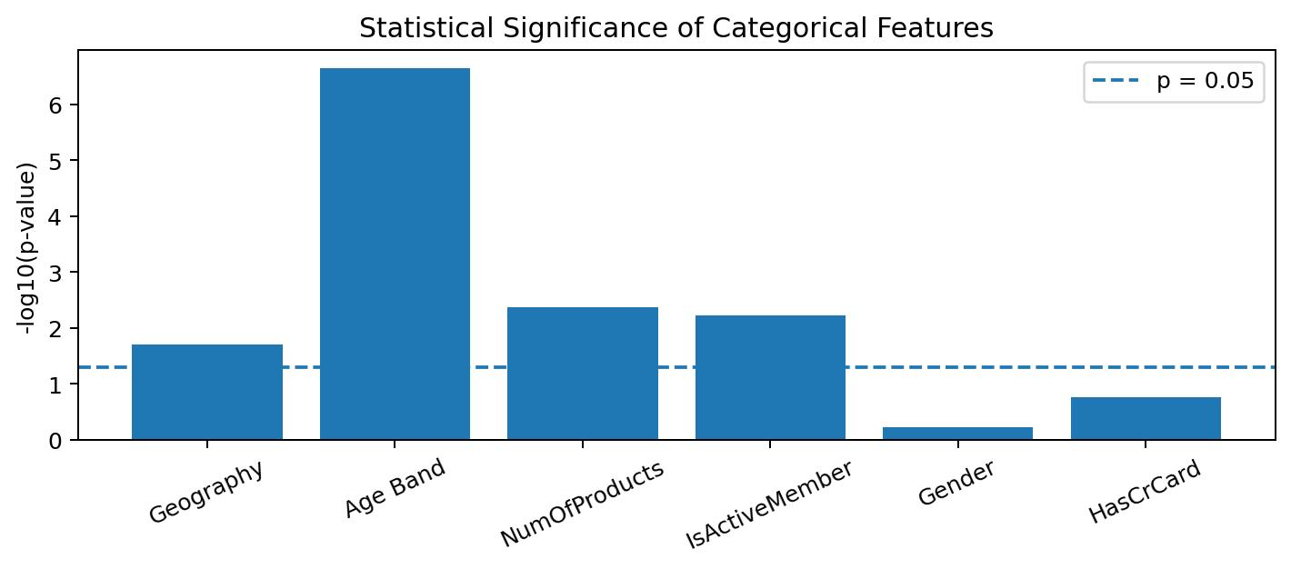

CHAPTER 5

FEATURE ENGINEERING

5.1 FEATURE ENGINEERING
Feature engineering transforms existing variables into features that may provide more useful information to machine-learning models. The project created six engineered features.
Feature | Definition | Churn Pattern
AgeBand | Age grouped into five bands | 51–60: 28.18%
BalanceBand | Balance grouped for comparison | Segment-level analysis
ProductEngagement | Number of products | 3 products: 18.92%
InactiveMember | Active member = 0 | 14.99% vs 9.09%
CreditBand | Credit score grouped | 801–900: 5.17%
SalaryBalanceRatio | Balance ÷ estimated salary | Continuous
These engineered features capture relationships that are not always visible from raw variables.

MULTICOLLINEARITY
Age, balance, salary, and tenure may show relationships with other customer characteristics. Customer variables should therefore be considered as part of a broader customer profile.
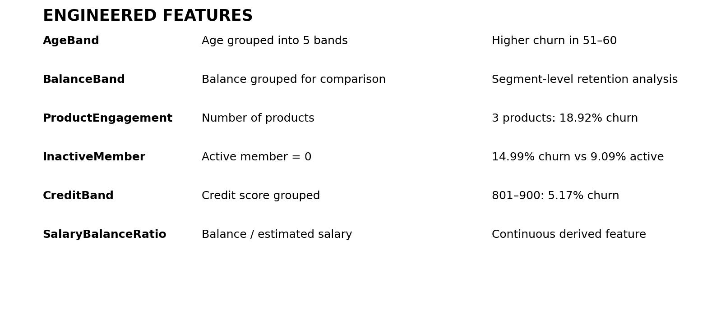
These engineered features are designed to support clearer segmentation and machine-learning input.

MACHINE LEARNING

6.1 MODELING STRATEGY
Customer churn is treated as a binary classification problem.

Target
Exited = 1 / 0

Model Evaluated
- Logistic Regression
- The dataset contains 122 positive churn cases. With a normal 80/20 split, approximately 24 churned customers appear in the test set. The project therefore uses a stratified split so that both classes remain represented in training and testing.
- STRATIFIED TRAIN / TEST SPLITThis maintains an appropriate representation of the minority class across the evaluation sets.

The model is evaluated using churn recall, precision, F1-score, accuracy, and ROC-AUC.

CLASS IMBALANCE

The project uses: class_weight='balanced'
The selected Logistic Regression model estimates churn probability for prioritization.
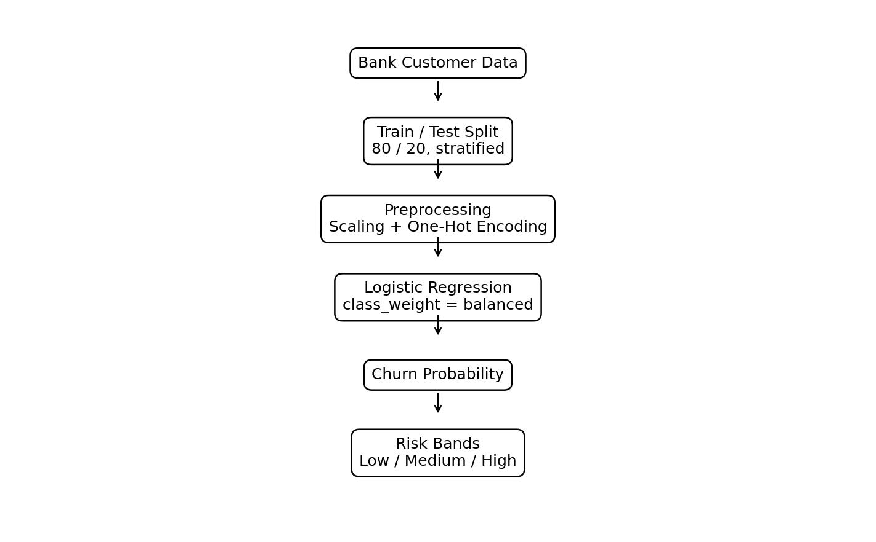

MACHINE LEARNING RESULTS

6.2 MODEL RESULTS
Model | ROC-AUC | Recall (churn) | Precision | F1 | Accuracy
Logistic Regression | 0.674 | 0.667 | 0.186 | 0.291 | 0.610
Baseline – predict “stays” | 0.500 | 0.000 | 0.000 | 0.000 | 0.878

Logistic Regression provides the selected churn-classification model. Its purpose is to estimate churn probability and support customer prioritization.
IMPORTANT OBSERVATION
A baseline model that predicts every customer as retained can achieve high accuracy because most customers stayed, while identifying no churned customers.

Therefore:
Accuracy is NOT used as the headline metric. Churn recall and ROC-AUC are considered more informative for the retention use case.
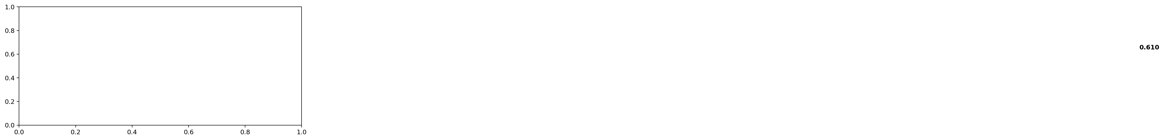

THRESHOLD SELECTION

6.3 THRESHOLD BANKING ANALYSIS
The default classification threshold of 0.50 is not necessarily appropriate for a customer-retention application.
Missing a potential churner may be considered more costly than conducting an unnecessary retention conversation. The threshold can therefore be adjusted to increase the number of potential churners identified.
Threshold | Churners caught | Recall | Precision | False alarms
0.30 | 23 / 24 | 0.958 | 0.137 | 145
0.40 | 18 / 24 | 0.750 | 0.144 | 107
0.50 (default) | 16 / 24 | 0.667 | 0.186 | 70
0.60 | 12 / 24 | 0.500 | 0.235 | 39
0.70 | 6 / 24 | 0.250 | 0.333 | 12
The project uses 0.40 as a practical prioritization threshold for this analysis.
At this threshold:
- 18 of 24 churners in the test set are identified
- Recall = 75.0%
- Precision = 14.4%
- 107 false alarms occur
The additional false alarms are accepted because the purpose is to prioritize retention attention rather than automatically label customers.
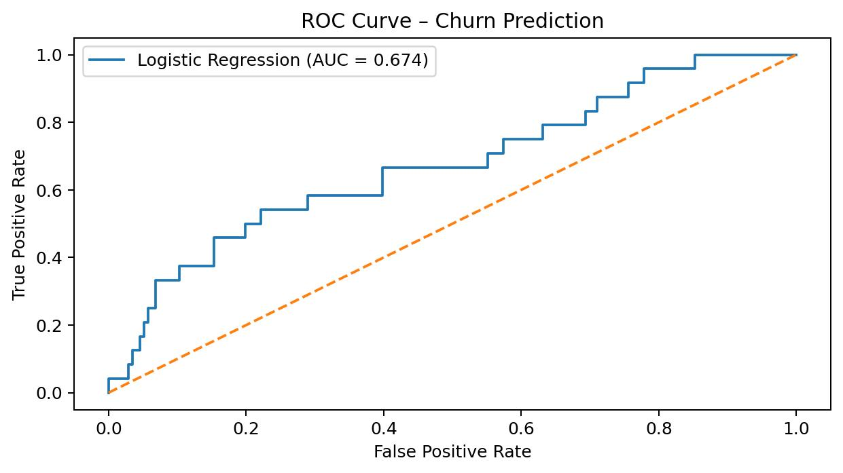

CHAPTER 7

CUSTOMER CHURN RISK SCORING

7.1 RISK SCORING
The machine-learning workflow generates a predicted churn probability for each customer in the held-out test set.
Customers are grouped into three risk bands.
Risk Band | Customers | Churned | Actual Churn
Low | 32 | 1 | 3.13%
Medium | 150 | 17 | 11.33%
High | 18 | 6 | 33.33%
The churn rate increases across the risk bands. The high-risk group shows substantially higher observed churn than the low-risk group in the test set.

"This customer will leave."
This is the strongest practical contribution of the machine-learning stage.
The model does not claim:
"This group deserves attention first."
Instead, it supports:
"This group deserves attention first."
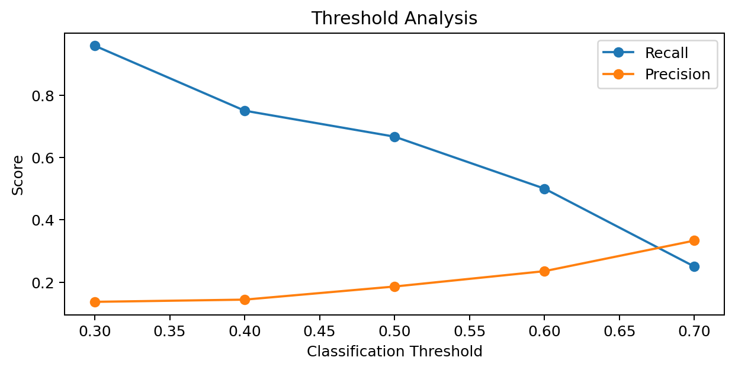

POWER BI DASHBOARD

7.2 POWER BI CUSTOMER CHURN DASHBOARD
Power BI is used to convert the analytical results into an interactive customer churn dashboard.
The dashboard can present:
- Total customers
- Customers who left
- Churn rate
- Geography distribution
- Age analysis
- Product analysis
- Active membership analysis
- Risk distribution
- Customer risk watch list
The Power BI dashboard provides a decision-support layer for banking and customer-retention teams.
The machine-learning risk scores are exported from Python and incorporated into the dashboard.

DASHBOARD PURPOSE
The dashboard enables banking teams to move from:
Raw Customer Data - Customer Insights-Risk Prioritization-Potential Retention Action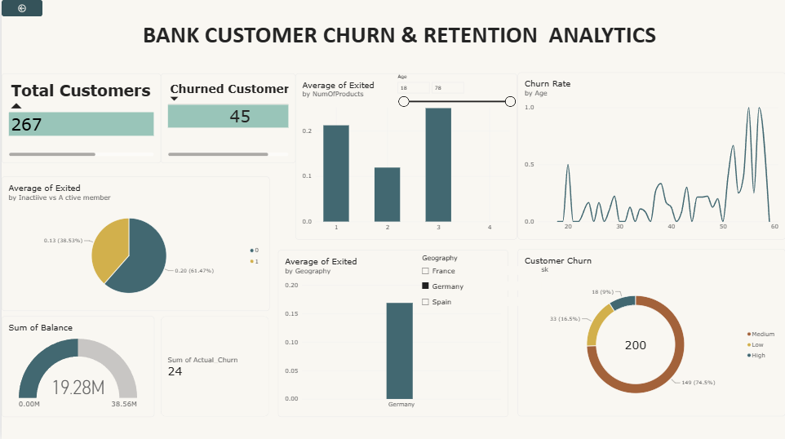

CHAPTER 8

KEY FINDINGS

8.1 MAJOR FINDINGS

Finding 1 – Germany Shows the Highest Churn Rate
Customers in Germany have 16.85% churn, compared with 11.69% in Spain and 9.90% in France.

Finding 2 – Inactive Members Show Higher Churn
Inactive members have 14.99% churn compared with 9.09% among active members.

Finding 3 – Age 51–60 Is a Higher-Risk Segment
Customers aged 51–60 have 28.18% churn, the highest rate among the major age bands.

Finding 4 – Product Usage Shows a Non-Linear Pattern
Customers with three products show 18.92% churn, compared with 8.01% among customers with two products.

Finding 5 – Geography and Engagement Matter
Geography, age, product count, and active membership show meaningful differences in churn within the dataset.

Finding 6 – Churned Customers Have Different Average Profiles
 | Measure | Retained | Churned
 | Age | 38.4 yrs | 43.3 yrs
 | Credit Score | 652.2 | 643.6
 | Balance | 74,007 | 88,221
 | Tenure | 5.1 yrs | 4.9 yrs
Segment | Headcount | Churned | Churn rate
Germany | 267 | 45 | 16.85%
France | 485 | 48 | 9.90%

8.3 RECOMMENDATIONS

1. Focus Retention Review on Higher-Churn Geographic Segments - Review customer behavior and service experience in Germany before designing targeted retention actions.

2. Improve Engagement of Inactive Members -Use appropriate engagement campaigns and service follow-ups for customers who are not actively using the bank relationship.
3. Monitor Higher-Risk Age Segments - Customers aged 51–60 show higher observed churn and can be included in retention monitoring.
4. Investigate Product Engagement-Customers with unusually high or low product counts can be reviewed to understand whether product fit or account complexity is associated with churn.
5. Use Risk Scores for Prioritization - Use the machine-learning risk bands to prioritize customer review rather than automatically classifying individual customers.
6. Avoid Unsupported Interventions-The project does not recommend treating gender or credit-card ownership as confirmed churn drivers because the statistical evidence in the current dataset is not significant.

The recommendations should be validated using additional customer behavior and service data before operational deployment.

8.4 LIMITATIONS
- Only 122 positive churn cases are available.
- Data is cross-sectional.
- There are no customer-level time-series dates.
- Causation cannot be established from the available data.
- Several financial and demographic variables may be correlated.

CONCLUSION
The Bank Customer Churn & Retention Analytics project demonstrates how multiple data analytic technologies can be combined to support customer-retention decision-making.
The project analyzed 1,000 customers and 122 recorded departures, producing an overall churn rate of 12.20%.
The workflow incorporated:
Excel → MySQL → Python → Statistical Testing → Machine Learning → Power BI
The analysis identified several important customer patterns. Germany showed the highest geographical churn rate at 16.85%, while inactive members showed 14.99% churn compared with 9.09% among active members.Customers aged 51–60 showed the highest major age-band churn rate at 28.18%, and product count also showed meaningful differences across segments.
These findings provide evidence for targeted investigation, but they should not be interpreted as proof that a single characteristic causes customer churn.Statistical testing supported significant associations for age band, geography, product count, and active membership, while gender and credit-card ownership did not show statistically significant relationships in the available dataset.
The machine-learning model achieved a ROC-AUC of approximately 0.674 and churn recall of approximately 0.667 at the default threshold. The model should therefore not be used to make automatic decisions about individual customers.
Instead, the risk-scoring system provides useful prioritization by separating customers into low, medium, and high predicted-risk groups.
The project therefore concludes that customer churn analytics can help banking teams identify patterns, prioritize retention attention, and design evidence-based customer strategies while maintaining appropriate caution about prediction, causality, and customer-level decisions.
The dashboard and analytical workflow provide a reusable foundation for future retention monitoring when additional customer behavior and time-series data become available.
Instead, the risk-scoring system provides useful prioritization. In the held-out test set, observed churn increased from 3.13% in the low-risk group to 33.33% in the high-risk group.The project therefore concludes that customer churn analytics can help banking teams identify patterns, prioritize attention, and design evidence-based retention strategies while maintaining appropriate caution about prediction, causality, and customer-level decisions.
REFERENCES
- 1. Bank Customer Churn Dataset used for the project.
- 2. Bank Customer Churn Excel Analysis Workbook.
- 3. MySQL Bank Customer Churn Analysis Database and Queries.
- 4. Python Exploratory Data Analysis Notebook.
- 5. Python Machine Learning and Risk Scoring Notebook.
- 6. Power BI Bank Customer Churn Dashboard.
- 7. pandas documentation for data analysis.
- 8. SciPy documentation for statistical analysis.
- 9. scikit-learn documentation for machine learning.
- 10. Matplotlib documentation for data visualization.

PROJECT RESOURCES
GitHub Repository:
https://github.com/SRINEEDHI/Bank-Customer-Churn-Retention-Analytics

Important Project Files
- 01_Data_Preparation/Bank_Customer_Churn_SQL_Ready.csv
- 02_Exploratory_Data_Analysis/Bank_Customer_Churn_EDA.ipynb
- 03_KPI_Analytics/Bank_Customer_Churn_Excel_Project.xlsx
- 04_SQL_Analytics/Bank_Customer_Churn_Analysis.sql
- 05_ML_Modelling/Bank_Customer_Churn_ML_Modelling.ipynb
- 05_ML_Modelling/customer_churn_predictions.csv
- 06_PowerBI_Dashboard/Bank_Customer_Churn_Retention_Analytics.pbix
- 07_Business_Insights/Key_Findings.md
- 08_Report/Bank_Customer_Churn_Report.pdf

FIGURES TO INCLUDE
For the final printed report, the following figures are recommended:
- Project workflow
- Customer churn distribution
- Excel KPI dashboard
- Geography, age and product churn
- Financial analysis
- Correlation matrix
- Statistical significance
- Feature engineering and machine-learning performance
- Power BI dashboard and risk distribution

FINAL REPORT NOTE
The most important figures to make visually prominent are:
Key Metric / KPI | Data Value | Visual Recommendation
Overall Churn | 12.20% (122 / 1,000) | Large Stat Card / Churn Chart
Germany Churn | 16.85% | Geography Bar Chart
Inactive Member Churn | 14.99% vs 9.09% active | Comparison Chart
Age 51–60 Churn | 28.18% | Highlight Box / Bar Chart
ML / High-Risk | 0.674 ROC-AUC; 33.33% test-set churn | Model performance / Risk watchlist

