

(Established under Karnataka Act No. 16 of 2013)

100-ft Ring Road, Bengaluru – 560 085, Karnataka, India

Internship Report on

“Diagnostics Automation”

Submitted by

Harshitha M (PES1UG20ECxxx)

Srinidhi B S (PES1UG20EC201)

# June – July 2023

## Under the Guidance of

Dr. Venkatarangan M J

Professor

Department of Electrical and Electronics

PES University

Bengaluru

Centre for Robotics, Automation and Intelligent Systems (cRAIS)

Room No. B-1212, 100 Feet Ring Road, BSK III Stage, Bangalore - 560085.



FACULTY OF ENGINEERING DEPARTMENT OF ELECTRICAL AND ELECTRONICS BACHELOR OF TECHNOLOGY

# CERTIFICATE

This is to certify that the Dissertation entitled

“Automation for Diagnostics Lab”

Is a Bonafide work carried out by

M Harshitha (PES1UG20EC106)

Srinidhi B S (PES1UG20EC201)

In partial fulfilment for the completion of __ semester course work in the Program of Study B. Tech in Electronics and Communication under rules and regulations of PES University, Bengaluru during the period June-July 2023. It is certified that all corrections/suggestions indicated for internal assessment have been incorporated in the report. The dissertation has been approved as it satisfies the internship requirements in respect of project work.

(Signature with date & Seal) (Signature with date & Seal)

Internal Guide Dr. Shikha Tripathi

Dr. Venkatarangan M J Director, cRAIS

Professor PES University

Dept. of Electrical and Electronics

Name of Examiner: Signature with date

1.

2.

3.

## DECLARATION

I, M Harshitha, hereby declare that the project entitled, “Automation for Diagnostics Lab,” is an original work done by me under the guidance of Dr. Venkatarangan M J, Dept. of Electrical and Electronics, and is being submitted in partial fulfilment of the requirements for completion of VII Semester course work in the Program of Study B. Tech in Electronics and Communication Engineering.

I, Srinidhi B S, hereby declare that the project entitled, “Automation for Diagnostics Lab,” is an original work done by me under the guidance of Dr. Venkatarangan M J, Dept. of Electrical and Electronics, and is being submitted in partial fulfilment of the requirements for completion of VII Semester course work in the Program of Study B. Tech in Electronics and Communication Engineering.

PLACE: BENGALURU

### DATE:

|  |  |  |
| --- | --- | --- |
| Name  (SRN)  Dept. |  | Name  (SRN)  Dept. |

## Acknowledgement

We take this opportunity to express our deepest sense of gratitude and sincere thanks to everyone who helped us to complete this work successfully. We express our sincere thanks to ***Dr. M.J. Venkatarangan****, Professor*, Department of Electrical and Electronics, PES University, Bengaluru and ***Dr. Sethuram D****, Professor*, Department of Mechanical Engineering, PES University, Bengaluru for providing us with all the necessary facilities and support. We would also like to express our sincere gratitude to ***Dr. Shikha Tripathi****, Chairperson*, Department of Electronics and Communication Engineering, PES University, Bengaluru. Finally, we thank our friends and team mates who contributed to the successful fulfilment of this project work.

**M Harshitha**

**Srinidhi B S**

## ABSTRACT

In various diagnostic labs, the archiving of test tube samples is effectively performed using automated machines. Our project aims to automate the process of archiving blood samples of Anand Diagnostic Lab, Bengaluru. To achieve this, a, four axis robotic arm (Dobot Magician) is programmed using python programming language and then integrated with image processing techniques.

Firstly, using a USB camera live feed data of the test tube samples placed in a test tube holder rack is captured. Using YoloV5 the test tubes are identified and the centroids of the test tubes are detected. With the help of the centroids, a matrix is generated in order to identify the presence of the test tube in the rack.

Next, the robotic arm (Dobot Magician) is commanded to attain the coordinate values of the centroids of test tube and perform the mechanism of pick and place. Once the test tubes are archived the details of the patient on each test tube is determined using a barcode scanner to scan the barcode placed on the surface of the test tubes and is connected with a LIS software.

Table of Contents

1 Introduction 7

2 Methodology 8

3 Conclusion and Future Scope 10

4 References 10

## 1 Introduction

The project of "Diagnostics lab automation" which is to be implemented in the Anand Diagnostics Laboratory is aimed at automating the process of archiving. After the sample is tested, the sample is stored for a fixed time period in cold storage, for re-tests and review. The test tubes are scanned in an LIS mapping each sample to a specific position in the corresponding tray whose code is also recorded, enabling one to trace back. The transfer is completed only if all tests assigned to the given sample have been completed.

The process of scanning and transferring the test tubes is currently being done manually. Our task is to automate the process of reducing human intervention effectively reducing error. The task is set to be performed by a robotic arm with 5 DOF. Image processing has been used to make the process efficient by reducing the number of work cycles to the number of test tubes present

IMAGE PROCESSING

BARCODE SCANNER

DOBOT MOVEMENTS

INTEGRATION

## 2 Methodology

1. Image Processing
2. Dobot Manipulation
3. Barcode Scanner
4. Integration

**I) IMAGE PROCESSING**

1. **Creating datasets** using roboflow.
2. YOLOv5 framework is used for **machine learning process** encompassing the stages of dataset testing, training, and validation.
3. **Centroid detection** using python code.
4. **Generation of matrix** using python code.

1. Creating datasets using roboflow

We have used multiple images of the racks containing the test tubes as datasets for training the model. The datasets are created using roboflow, a platform which provides functionalities like dataset organization and annotation to prepare datasets for training machine learning models.

2. YOLOv5 framework

YOLOv5 framework is used for machine learning process encompassing the stages of dataset testing, training, and validation. Each object (test tube) is labelled using bounding boxes, using OpenCV. The precise model used is YOLOv5x version2. A dataset of 85 images have been used. Optimum resizing as per blank spaces present in the image is chosen to be 400x400. Along with rotation, brightness and orientation variations, grayscale and shearing of bounding boxes have been introduced during augmentation (Total images 235).

3.Centroid detection using python code

The camera intrinsic matrix is calculated using a chess board. Using centres and focal lengths, by computing midpoint of intersection of perpendicular bisectors to bounding boxes, centroid is calculated.

4. Generation of matrix using python code

By providing pixel co-ordinates of first slot, i.e., origin, we can approximately determine the positions of successive slots using slot interval distance also provided. By checking for centroids at these poisons, a binary matrix is formed using 1 as a presence flag. Due to the video bring dynamic, there are a few errors which are compensated for using carefully computed offset thresholds.

II)**DOBOT MOVEMENTS**

1. Determination of co-ordinates of all slots.
2. Reading the binary matrix to locate slots in which test-tubes are present.
3. Pick and place.
4. Test tube manoeuvre to scan barcode.

DOBOT Magician is a multifunctional small-sized desktop robotic arm for practical training education, deploying multiple functions, such as 3D printing, laser engraving, etc. It has 4-axes of motion and 5 Degrees of Freedom. <insert images>

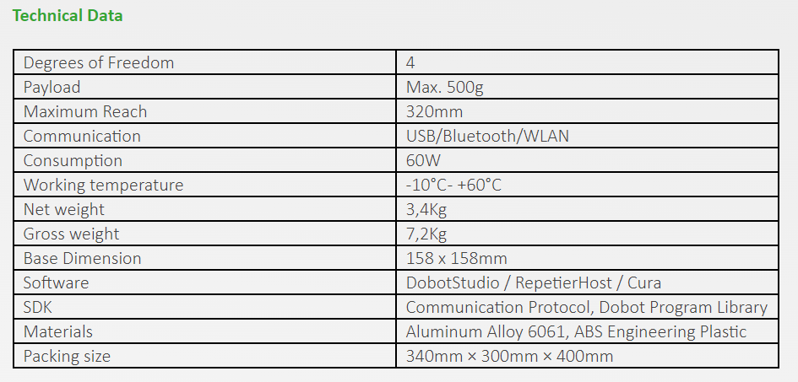

|  |  |
| --- | --- |
| Module | Version |
| Dobot Studio | 1.9.4 |
| Dobot Firmware | 3.7.0 |

The CP210x USB to UART COM Port driver was used for device operation. In this project, we have used the suction cup and air pump for pick and place operations. The signal (SW1 and GP1) and power lines of the pump were connected to the Dobot via EIO (Extended I/O) pins located at the base of the machine. The suction was interfaces with those on the forearm (slot1/GP3) articulated to Joint 4.

The controls were handled using the python script editor IDE provided in Dobot Studio. For additional python operations, the required library modules were added to the Ide path of Dobot Studio.

1. Determination of co-ordinates of all slots

Given that the Dobot was capable of linear motion in the x, y, and z axes, with 1 unit movement being about 0.35mm, we provided the coordinate values of the left-top most slot anointing it as the origin (ox, oy).  Additionally, the slot interval of 21 units for x and y axes were also provided. With the given information, the Dobot was able to compute the coordinates of any slot using indices provided.

x, y= ox+(i*ds), oy+ (j*ds)

where x and y are co-ordinate values of the slot, ox and oy origin coordinates, ds- the distance between slots being 21 units. For the movements of the z axes, the raised position for which the test tube is not an obstruction and lowering height at which it is securely placed for the given setup are provided and used via flagging.

2.Reading matrix to locate slots in which test-tubes are present and pick place

Reading the binary matrix which has been generated by the image processing segment, the indices of all the slots where a test-tube is present is noted. The methods mentioned in the section above, the coordinates of the test tube are determined and the test tube is picked up using the suction module. After the scanning mentioned in (section III) is completed, the tubes are placed in an adjacent tray using the same coordinate mapping mechanism mentioned above.

3.Test tube manoeuvre to scan barcode.

The scanner (Retsol LS500 barcode scanner) is a commercial scanner which can scan codes present virtually in front of it. In order to ensure the barcode (which is present on a single side of the tube) is captured, the joint4 placed above the suction cup is made to rotate in steps till the barcode is noted. Upon a successful scan, the sample is placed in the destination rack.

**IV)Integration**

The matrix generated by the image processing segment is written into a .txt file and retrieved by the Dobot Studio IDE using file handling. This is done in order to ensure persistence of data. In order to ensure compatibility, the required library modules were added to the Ide path of Dobot Studio. The three modules namely, image processing, barcode scanning and LIS access are integrated using modularity of python by importing them in cascade and then calling the required functions.

## 3 Conclusion and Future Scope

## Successfully automated the process of archiving of test tube samples using image processing and robotic arm and successfully integrated the two. The project can help to serve for industrial purposes in diagnostics.

Algorithms have been devised to detect the co-ordinates on the origin point on the tray, and detect irrespective of orientation of the rack as well as compute the slot interval reducing the number of fixed variables from six to two which is the offset of the x and y axes alone. This is impeded due to the input feed being a video live feed. Given the final application, in the “Gantry Bot” it has been deduced that a single image is sufficient for the purpose possibly reducing the need for complex machine learning algorithms. Attempts have been made in the same using techniques like image erosion.

The above process can be installed in a gantry which uses pick and place mechanism. The image processing techniques can be interfaced with the motors and end effectors of the gantry.

## 4 References

<https://blog.roboflow.com/introducing-bounding-box-level-augmentations/> <https://www.dobot-robots.com/service/download-center> <https://github.com/luismesas/pydobot> <https://forum.dobot.cc/t/importing-python-modules-to-dobotstudio-script-editor/136> <https://github.com/SERLatBTH/StarterGuide-Dobot-Magician-with-Python/blob/master/README.md> <https://electronicsworkshops.com/2020/08/10/object-detection-image-processing/>