BITS Pilani – Work Integrated Learning Programmes
M.Tech. Artificial Intelligence & Machine Learning
Course: AIMLCZG546 – Software Engineering for Machine Learning


Assignment 1
Work Title
Predictive Maintenance in Mobile Hydraulic Systems
GitHub repository Link: heavy-machinery-predictive-maintenance-pipeline
Group No. 105

Team Contribution Details

Sl. No | BITS ID | Student Name | Contribution (Qualitative) | Contribution (%)
1 | 2024AC05744 | Srinivasan R | Code refactoring into OOP modules (src/core, src/api), Model Registry design, architectural patterns, code review and system integration. | 100%
2 | 2024AC05100 | Vineet Kumar | Docker-based deployment of API + frontend, CI support, linting/formatting toolchain (black, isort, flake8) and lint reports. | 100%
3 | 2024AD05482 | Vibhav Sharma | Data-quality metrics module (schema validation, missing-value checks, PSI drift detection), production testing strategy write-up, report preparation. | 100%
4 | 2024AC05064 | Aman Kushwah | Model training/evaluation, FastAPI REST API, security layer, pytest test suite (unit, integration, ML training/inference and data-validation tests), documentation. | 100%

Contents
1. Introduction 4
2. Objective 1 — Implementation and Code Sharing 5
2.1 Task 1 — Refactoring ML application code using appropriate OOP and/or functional programming principles 5
(a) Pipe-and-Filter — src/ml/train.py 6
(b) Model Registry — src/core/model_registry.py 14
(d) Strategy-style retriever — src/rag/maintenance_advisor.py 17
(e) DTOs / typed contracts — src/api/server.py 22
DRY & SOLID principles 30
Notes about scalability in current implementation 30
2.2 Task 2 — Comparison on Research Code and Production Code 30
2.3 Task 3 — Error handling and logging 31
Which exceptions, where, and why 31
Logging — sample code and captured output 32
2.4 Task 4 — Code formatting and linting (before / after) 34
2.5 Task 5 — REST API design (FastAPI) 35
Endpoints and contracts 35
Exactly how to call it (commands) 43
Good-practice elements 46
3. Objective 2 — Quality Assurance 48
3.1 Task 6 — Test types implemented with pytest 48
For different test types: 49
Validation datasets — basis and criteria (review feedback) 61
3.2 Task 7 — ML-specific tests 61
3.3 Task 8 — Model-quality and data-quality metrics 74
3.4 Task 9 — Testing in production & security consideration 76
4. How to run 76
Running the QA suite 79
5. Evidence index (in repository) 79

1. Introduction
This assignment builds on our Assignment I system: an IoT-based predictive-maintenance application for mobile hydraulic systems (excavators, telehandlers, backhoe loaders). The system ingests fleet telemetry (pressure, flow, oil temperature, vibration, motor power, pump speed, cooling efficiency), predicts the health of four hydraulic components (cooler, valve, pump, accumulator) plus an overall stability flag, and serves the results through a FastAPI backend with a React frontend and a RAG-based maintenance advisor.
Assignment II focuses on two components:
- Implementation quality
- Testing/QA
This report walks through each requirement of the two objectives with evidence from the repository.
Repository layout (production package):
├── api_server.py # thin uvicorn entry point -> src/api/server.py
├── train_and_save.py # production training script -> model_registry/
├── src/
│ ├── api/server.py # FastAPI REST API (endpoints, schemas, status codes)
│ ├── core/model_registry.py # on-disk model registry w/ SHA-256 integrity
│ ├── core/pipeline.py # pipe-and-filter composition helpers
│ ├── ml/train.py # modular training pipeline
│ ├── quality/data_quality.py # schema / missing-value / drift metrics (NEW)
│ ├── rag/maintenance_advisor.py # TF-IDF retriever + advisor
│ └── security/security_layer.py # auth, validation, rate limit, audit
├── tests/
│ ├── test_predictive_maintenance.py # unit + integration tests
│ ├── test_ml_training.py # ML training tests (NEW)
│ ├── test_ml_inference.py # ML inference tests (NEW)
│ └── test_data_quality.py # data-validation tests (NEW)
├── notebook/105.ipynb # research notebook (Assignment I prototype)
├── data/hydraulic_fleet_telemetry.csv
├── docs/lint/ # before/after lint + pytest reports
└── docker-compose.yml, Dockerfile, frontend/

2. Objective 1 — Implementation and Code Sharing

2.1 Task 1 — Refactoring ML application code using appropriate OOP and/or functional programming principles
The application is decomposed into single-responsibility modules under src/, combining OOP (classes for stateful components) with functional style (pure functions for stateless computations):
Module | Responsibility | Principle / Pattern
src/ml/train.py | Data ingestion, preprocessing, model training | Pipeline pattern (sklearn.Pipeline + ColumnTransformer), pure main()
src/core/model_registry.py | Artifact registration + SHA-256 integrity index | Model Registry pattern, @dataclass ModelArtifact, single responsibility
src/api/server.py | REST inference service (basically REST APIs) | Layered architecture; Pydantic schemas as DTOs
src/rag/maintenance_advisor.py | Knowledge-base retrieval for repair guidance | Strategy-style retriever (TfidfRetriever), immutable Document dataclass
src/quality/data_quality.py | Schema, missing-value and drift metrics | Pure functions + DataQualityReport dataclass
One of the biggest key improvements done in the refactoring is the removal of façade i.e., removing plain wrapper code which is done to make sure functionality works, although in different directory and other files are referenced. Most other parts were already covered in Assignment 1 implementation, and further improvements were covered (like logging and enhanced error handling) in further parts of this assignment.
General improvements in the refactored code and the architecture/design patterns present here are as follows:

(a) Pipe-and-Filter — src/ml/train.py
Preprocessing and the classifier are composed as one sklearn Pipeline, so the exact same transformation learned at training time is replayed at inference time — eliminating training/serving skew, the most common production-ML bug.
File contents:
"""Canonical training pipeline for the hydraulic predictive-maintenance models.

Author: Group 105

This module is the single source of truth for training (the repo-root
`train_and_save.py` is a thin CLI wrapper around it — DRY).

Design notes:

1. Idempotent training — before retraining, artifact checksums are verified
against `model_registry/index.json`; up-to-date artifacts skip training
unless `force=True`.
2. Pipe-and-Filter — a `ColumnTransformer` + `Pipeline` separates
preprocessing from model logic so the exact transform is reused at
inference time.
3. Model Registry — artifacts are registered with SHA-256 checksums enabling
runtime integrity checks by the API.
4. Profiling & observability — every stage (load, impute, fit, evaluate,
save) is timed with `perf_counter`, peak memory is tracked with
`tracemalloc`, and the profile is logged and persisted into
`schema.json["training_profile"]`. `profile=True` additionally runs
cProfile and writes the top hotspots to `model_registry/training_profile.txt`.
Optional MLflow logging activates when `MLFLOW_TRACKING_URI` is set.
"""

from __future__ import annotations

import json
import logging
import os
import tracemalloc
from contextlib import contextmanager
from pathlib import Path
from time import perf_counter

import joblib
import numpy as np
import pandas as pd
from sklearn.compose import ColumnTransformer
from sklearn.ensemble import RandomForestClassifier
from sklearn.impute import SimpleImputer
from sklearn.metrics import accuracy_score, f1_score
from sklearn.model_selection import train_test_split
from sklearn.multioutput import MultiOutputClassifier
from sklearn.pipeline import Pipeline
from sklearn.preprocessing import OneHotEncoder, StandardScaler

from src.core.model_registry import ModelArtifact, ModelRegistry
from src.security.security_layer import compute_file_sha256

logging.basicConfig(
level=logging.INFO,
format="%(asctime)s [TRAIN] %(levelname)s %(message)s",
)
logger = logging.getLogger(__name__)

_here = Path(__file__).resolve().parent
# Find a reasonable repository root that contains the `data` directory.
ROOT = _here
for _ in range(4):
if (ROOT / "data" / "hydraulic_fleet_telemetry.csv").exists():
break
ROOT = ROOT.parent
DATA = ROOT / "data" / "hydraulic_fleet_telemetry.csv"
REGISTRY = ROOT / "model_registry"

NUMERIC_FEATURES = [
"operating_hours",
"pressure_mean_bar",
"pressure_std_bar",
"flow_mean_lpm",
"oil_temp_mean_c",
"vibration_rms_mms",
"motor_power_kw",
"pump_speed_mean_rpm",
"cooling_efficiency_pct",
]
CATEGORICAL_FEATURES = ["machine_type"]
TARGETS = ["cooler_condition", "valve_condition", "pump_leakage", "accumulator_pressure"]
RT_TARGET = "stability_flag"
NOISY_COLS = ["pressure_mean_bar", "flow_mean_lpm", "oil_temp_mean_c", "vibration_rms_mms"]

ARTIFACT_NAMES = ["condition_model.joblib", "stability_model.joblib", "schema.json"]

class StageTimer:
"""Collects wall-clock timings per pipeline stage (profiling requirement).

Usage:
timer = StageTimer()
with timer.stage("load_data"):
df = pd.read_csv(...)
timer.timings -> {"load_data": 0.41, ...}
"""

def __init__(self) -> None:
self.timings: dict[str, float] = {}

@contextmanager
def stage(self, name: str):
start = perf_counter()
try:
yield
finally:
elapsed = perf_counter() - start
self.timings[name] = round(elapsed, 4)
logger.info("Stage %-18s finished in %.3fs", name, elapsed)

def build_preprocessor() -> ColumnTransformer:
"""The shared preprocessing filter (Pipe-and-Filter pattern)."""
return ColumnTransformer(
transformers=[
("num", StandardScaler(), NUMERIC_FEATURES),
("cat", OneHotEncoder(handle_unknown="ignore"), CATEGORICAL_FEATURES),
]
)

def build_condition_model() -> Pipeline:
return Pipeline(
[
("prep", build_preprocessor()),
(
"clf",
MultiOutputClassifier(
RandomForestClassifier(
n_estimators=200, max_depth=12, random_state=42, n_jobs=-1
)
),
),
]
)

def build_stability_model() -> Pipeline:
return Pipeline(
[
("prep", build_preprocessor()),
(
"clf",
RandomForestClassifier(n_estimators=60, max_depth=6, random_state=42, n_jobs=-1),
),
]
)

def artifacts_up_to_date(registry: ModelRegistry) -> bool:
"""Idempotency guard: True when all artifacts exist and checksums match."""
for name in ARTIFACT_NAMES:
path = REGISTRY / name
if not path.exists():
return False
entry = registry.get(name)
if entry is None or entry.sha256 != compute_file_sha256(path):
return False
return True

def _log_mlflow_run(
condition_path: Path, stability_path: Path, schema_path: Path, cond_metrics: dict, rt_acc: float
) -> None:
mlflow_uri = os.getenv("MLFLOW_TRACKING_URI")
if not mlflow_uri:
logger.info("MLflow not configured; skipping MLflow logging")
return

try:
import mlflow
import mlflow.sklearn
except ImportError:
logger.warning("Mlflow is not installed; skipping MLflow logging")
return

experiment_name = os.getenv("MLFLOW_EXPERIMENT_NAME", "hydraulics-predictive-maintenance")
mlflow.set_tracking_uri(mlflow_uri)
mlflow.set_experiment(experiment_name)
with mlflow.start_run(run_name=os.getenv("MLFLOW_RUN_NAME", "train_and_save")):
mlflow.log_param("num_numeric_features", len(NUMERIC_FEATURES))
mlflow.log_param("num_categorical_features", len(CATEGORICAL_FEATURES))
mlflow.log_param("num_targets", len(TARGETS))
mlflow.log_metric("stability_accuracy", float(rt_acc))
for target, metrics in cond_metrics.items():
mlflow.log_metric(f"accuracy_{target}", float(metrics["accuracy"]))
mlflow.log_metric(f"macro_f1_{target}", float(metrics["macro_f1"]))
for path in (condition_path, stability_path, schema_path):
mlflow.log_artifact(str(path), artifact_path="model_registry")

def _train(timer: StageTimer) -> None:
"""The actual training run: load -> clean -> fit -> evaluate -> persist."""
with timer.stage("load_data"):
if not DATA.exists():
raise FileNotFoundError(
f"{DATA} missing — run merge_notebook.py to export the dataset."
)
df = pd.read_csv(DATA)

with timer.stage("impute"):
imputer = SimpleImputer(strategy="median")
df[NOISY_COLS] = imputer.fit_transform(df[NOISY_COLS])

X = df[NUMERIC_FEATURES + CATEGORICAL_FEATURES]
X_tr, X_te, ym_tr, ym_te, yr_tr, yr_te = train_test_split(
X, df[TARGETS], df[RT_TARGET], test_size=0.2, random_state=42, stratify=df[RT_TARGET]
)

condition_model = build_condition_model()
with timer.stage("fit_condition"):
condition_model.fit(X_tr, ym_tr)

with timer.stage("eval_condition"):
ym_pred_arr = np.asarray(condition_model.predict(X_te))
cond_metrics = {
t: {
"accuracy": round(float(accuracy_score(ym_te[t].to_numpy(), ym_pred_arr[:, i])), 4),
"macro_f1": round(
float(f1_score(ym_te[t].to_numpy(), ym_pred_arr[:, i], average="macro")), 4
),
}
for i, t in enumerate(TARGETS)
}

stability_model = build_stability_model()
with timer.stage("fit_stability"):
stability_model.fit(X_tr, yr_tr)

with timer.stage("eval_stability"):
rt_acc = accuracy_score(yr_te, stability_model.predict(X_te))

with timer.stage("save_artifacts"):
condition_path = REGISTRY / "condition_model.joblib"
stability_path = REGISTRY / "stability_model.joblib"
schema_path = REGISTRY / "schema.json"

joblib.dump(condition_model, condition_path)
joblib.dump(stability_model, stability_path)

schema = {
"numeric_features": NUMERIC_FEATURES,
"categorical_features": CATEGORICAL_FEATURES,
"machine_types": sorted(df["machine_type"].unique().tolist()),
"targets": TARGETS,
"rt_target": RT_TARGET,
"healthy_class": {
"cooler_condition": 100,
"valve_condition": 100,
"pump_leakage": 0,
"accumulator_pressure": 130,
},
"condition_metrics": cond_metrics,
"stability_accuracy": round(float(rt_acc), 4),
# timings so far; save_artifacts itself finishes after this write
"training_profile": dict(timer.timings),
}
schema_path.write_text(json.dumps(schema, indent=2), encoding="utf-8")

registry = ModelRegistry(REGISTRY)
artifact_types = {
"condition_model.joblib": "condition_model",
"stability_model.joblib": "stability_model",
"schema.json": "schema",
}
for name, kind in artifact_types.items():
registry.register(
ModelArtifact(
path=name,
sha256=compute_file_sha256(REGISTRY / name),
metadata={"type": kind},
)
)

_log_mlflow_run(condition_path, stability_path, schema_path, cond_metrics, float(rt_acc))

logger.info("Saved %s", ", ".join(ARTIFACT_NAMES))
for t, m in cond_metrics.items():
logger.info("%s acc=%.3f macroF1=%.3f", t, m["accuracy"], m["macro_f1"])
logger.info("stability_flag acc=%.3f", rt_acc)

def main(force: bool = False, profile: bool = False) -> None:
"""Train and persist both models.

Args:
force: retrain even when registry checksums say artifacts are current.
profile: additionally run cProfile and write the top-25 cumulative-time
hotspots to model_registry/training_profile.txt.
"""
logger.info("Train run started; force=%s profile=%s", force, profile)
REGISTRY.mkdir(parents=True, exist_ok=True)

if artifacts_up_to_date(ModelRegistry(REGISTRY)) and not force:
logger.info(
"Artifacts are up-to-date according to model_registry/index.json — skipping training."
)
return

timer = StageTimer()
tracemalloc.start()
total_start = perf_counter()

if profile:
import cProfile
import io
import pstats

profiler = cProfile.Profile()
profiler.enable()
_train(timer)
profiler.disable()
buffer = io.StringIO()
pstats.Stats(profiler, stream=buffer).sort_stats("cumulative").print_stats(25)
profile_path = REGISTRY / "training_profile.txt"
profile_path.write_text(buffer.getvalue(), encoding="utf-8")
logger.info("cProfile hotspots written to %s", profile_path)
else:
_train(timer)

total = perf_counter() - total_start
_, peak_bytes = tracemalloc.get_traced_memory()
tracemalloc.stop()

logger.info(
"Training complete in %.2fs (peak traced memory %.1f MB); stage timings: %s",
total,
peak_bytes / 1e6,
timer.timings,
)

The builder functions (build_preprocessor, build_condition_model, build_stability_model) are pure functions — no global state — which is what lets the idempotency tests retrain the same model twice and compare outputs byte-for-byte.
Here the pipe and filter architecture is shown this way:
The pipe-and-filter pattern is explicitly called out in the design notes and beautifully implemented:
1. The Preprocessing Filter (build_preprocessor())
This function creates the filter responsible for data transformation (scaling numeric features, encoding categorical ones).
2. The Pipes Connecting Filters (build_condition_model() & build_stability_model())
Here, the Pipeline acts as the pipe that connects:
- Filter 1: Data preprocessing (prep)
- Filter 2: Model classification (clf)
3. Reusability at Inference Time
The same build_preprocessor() is used in both models, ensuring identical transformations during training and inference - a key benefit of pipe-and-filter.
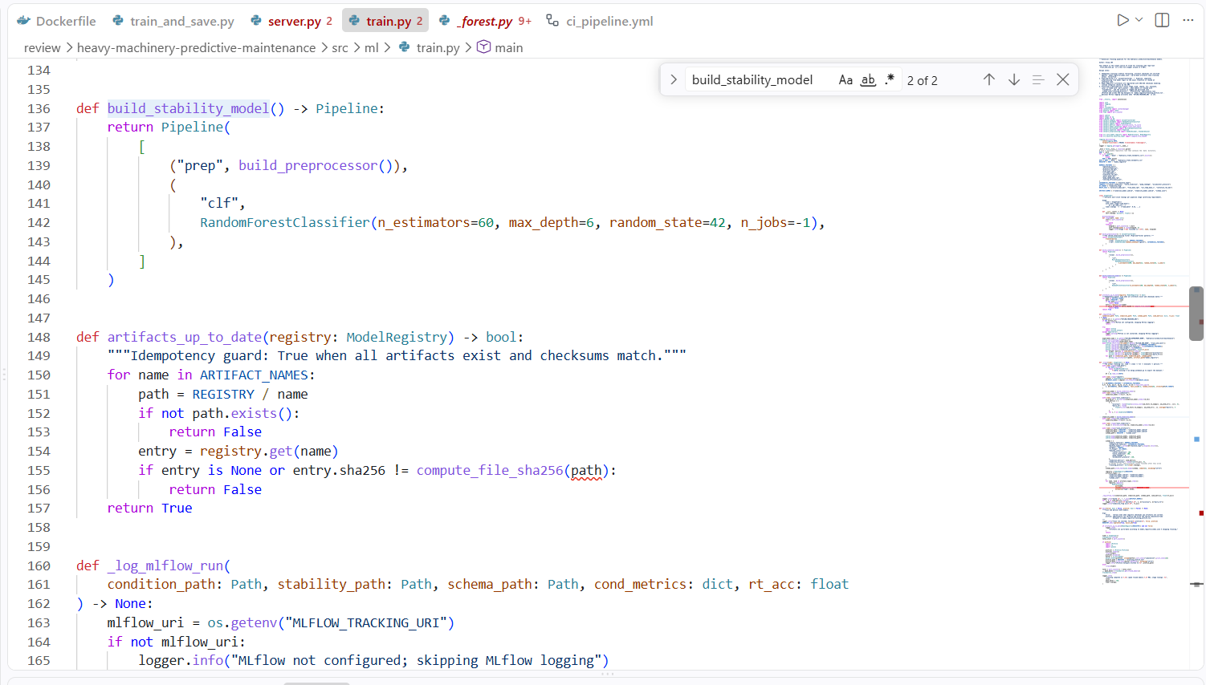

(b) Model Registry — src/core/model_registry.py
Trained artifacts are opaque binaries; without bookkeeping you cannot tell if the file being served is the file you trained. The registry maps each artifact to its SHA-256 in model_registry/index.json; the API refuses to start on a mismatch.
Please note that the DVC is used but separated from model_registry.py. This way, separation of concerns is ensured.
Code file src/core/model_registry.py:
"""On-disk Model Registry

Design notes:

- Purpose: provide a simple, file-backed model registry that maps artifact
filenames -> sha256 + metadata using `model_registry/index.json`.
- Pattern: Model Registry (lightweight) supporting idempotency checks and
runtime integrity verification by the API (compare saved sha256 with actual
file checksum).
- Responsibility: serialization of the index, simple get/register/list API.
Keep logic minimal to avoid coupling to remote stores; this module is easier
to unit-test and reason about because it has a single responsibility.
"""

from __future__ import annotations

import json
import logging
from dataclasses import dataclass
from pathlib import Path
from typing import Any

logging.basicConfig(
level=logging.INFO,
format="%(asctime)s [REGISTRY] %(levelname)s %(message)s",
)
logger = logging.getLogger(__name__)

@dataclass
class ModelArtifact:
path: str
sha256: str
metadata: dict[str, Any]

class ModelRegistry:
"""Minimal on-disk model registry for the hydraulic predictive-maintenance system."""

def __init__(self, registry_dir: str | Path = "model_registry") -> None:
self.registry_dir = str(registry_dir)
self.registry_path = Path(registry_dir)
self.registry_path.mkdir(parents=True, exist_ok=True)
self._index_file = self.registry_path / "index.json"

def register(self, artifact: ModelArtifact) -> None:
index = self._load_index()
index[artifact.path] = {
"sha256": artifact.sha256,
"metadata": artifact.metadata,
}
self._save_index(index)
logger.info("Registered artifact %s with sha256 %s", artifact.path, artifact.sha256[:12])

def get(self, path: str) -> ModelArtifact | None:
index = self._load_index()
entry = index.get(path)
if not entry:
return None
return ModelArtifact(path=path, sha256=entry["sha256"], metadata=entry["metadata"])

def list(self) -> dict[str, Any]:
return self._load_index()

def _load_index(self) -> dict[str, Any]:
if not self._index_file.exists():
return {}
with open(self._index_file, "r", encoding="utf-8") as f:
return json.load(f)

def _save_index(self, index: dict[str, Any]) -> None:
with open(self._index_file, "w", encoding="utf-8") as f:
json.dump(index, f, indent=2)

file dvc.yaml:
stages:
train_models:
cmd: python train_and_save.py
deps:
- train_and_save.py
- src/ml/train.py
- data/hydraulic_fleet_telemetry.csv
- src/core/model_registry.py
- src/security_layer.py
outs:
- model_registry/

Benefits of using this way:
- DVC controls when our training pipeline executes based on changes to code, data, and dependencies.
- Within each pipeline execution, the model registry provides a secondary idempotency check
- This two-layer approach ensures we only retrain when absolutely necessary, saving significant compute time
- The model registry is consulted on every training invocation (when DVC triggers the stage), but often prevents actual retraining through its checksum-based up-to-date check.

(d) Strategy-style retriever — src/rag/maintenance_advisor.py
TfidfRetriever mirrors a vector-DB collection interface (add/retrieve), so it can be swapped for ChromaDB or an embedding model without touching the advisor. Documents are immutable @dataclass value objects.
Code:
"""
maintenance_advisor.py — RAG "Maintenance Advisor" for the
Predictive-Maintenance-for-Mobile-Hydraulics system.

Author: Aman Kushwah (2024AC05064) — Group 105

When the predictive model flags a machine/component, this module retrieves the most
relevant repair procedure from the maintenance-manual knowledge base and returns it to
the technician. This is the *retrieval* half of a Retrieval-Augmented Generation (RAG)
workflow (retrieve -> ground -> advise).

Vector store note:
In production this would be backed by **ChromaDB** (a vector database) with sentence
embeddings. For this self-contained prototype we use a lightweight **TF-IDF + cosine
similarity** retriever (scikit-learn) so it runs on any laptop with zero heavy
dependencies or model downloads, while demonstrating the identical retrieve-by-similarity
pattern. Swapping in ChromaDB later only changes the Retriever class, not the interface.
"""

from __future__ import annotations

import json
import os
import re
import urllib.request
from dataclasses import dataclass
from pathlib import Path
from typing import List, Optional, Tuple

from sklearn.feature_extraction.text import TfidfVectorizer
from sklearn.metrics.pairwise import cosine_similarity

ROOT = Path(__file__).resolve().parent.parent.parent

DEFAULT_KB_PATH = str(ROOT / "data" / "hydraulic_maintenance_manual.md")

# OpenRouter (https://openrouter.ai) — optional LLM generation step of the RAG.
# If OPENROUTER_API_KEY is set, the retrieved procedure is passed to an LLM which
# writes a tailored recommendation (retrieve -> ground -> generate). Without a key,
# the system falls back to the retrieved text so it always runs offline.
OPENROUTER_URL = "https://openrouter.ai/api/v1/chat/completions"
# Primary model (overridable via env) + fallbacks tried in order when a free model
# is temporarily rate-limited (429) or unavailable.
OPENROUTER_MODEL = os.getenv("OPENROUTER_MODEL", "google/gemma-4-26b-a4b-it:free")
FALLBACK_MODELS = [
"google/gemma-4-26b-a4b-it:free",
"nvidia/nemotron-3-super-120b-a12b:free",
"google/gemma-4-31b-it:free",
"liquid/lfm-2.5-1.2b-instruct:free",
]

def _post_openrouter(api_key: str, model: str, prompt: str, timeout: int):
body = json.dumps(
{
"model": model,
"messages": [{"role": "user", "content": prompt}],
"temperature": 0.2,
}
).encode("utf-8")
req = urllib.request.Request(
OPENROUTER_URL,
data=body,
headers={
"Authorization": f"Bearer {api_key}",
"Content-Type": "application/json",
"HTTP-Referer": "https://github.com/Srini235/SE4ML_Assignment_01_Group105",
"X-Title": "Hydraulics Predictive Maintenance (Group 105)",
},
)
with urllib.request.urlopen(req, timeout=timeout) as resp:
data = json.load(resp)
return data["choices"][0]["message"]["content"].strip()

def generate_with_llm(
component: str, procedure_title: str, procedure_text: str, timeout: int = 40
) -> Optional[str]:
"""Ground an LLM (via OpenRouter) on the retrieved procedure and return a concise
technician recommendation. Returns None if no API key is set or all models fail
(caller then falls back to the retrieved procedure text).
"""
api_key = os.getenv("OPENROUTER_API_KEY")
if not api_key:
return None
prompt = (
"You are a hydraulic maintenance assistant for off-highway machines. "
f"The predictive model flagged the component '{component.replace('_', ' ')}'. "
"Using ONLY the maintenance procedure below as grounding, write a short (3-4 sentence), "
"actionable recommendation for the field technician. Do not invent part numbers.\n\n"
f"Procedure - {procedure_title}:\n{procedure_text}"
)
# try the primary model first, then the fallbacks (dedup, preserve order)
tried = []
for model in [OPENROUTER_MODEL] + FALLBACK_MODELS:
if model in tried:
continue
tried.append(model)
try:
text = _post_openrouter(api_key, model, prompt, timeout)
if text and len(text) > 20: # guard against safety-classifier junk
return text
except Exception:
continue
return None

@dataclass
class Document:
"""One retrievable maintenance procedure."""

title: str
text: str

def load_knowledge_base(path: str = DEFAULT_KB_PATH) -> List[Document]:
"""Parse the markdown manual into one Document per '## ' section."""
if not os.path.exists(path):
raise FileNotFoundError(f"knowledge base not found at {path}")
with open(path, "r", encoding="utf-8") as f:
raw = f.read()
docs: List[Document] = []
# split on level-2 headings; keep the heading as the title
for block in re.split(r"\n##\s+", raw):
block = block.strip()
if not block or block.startswith("#"):
continue
lines = block.splitlines()
title = lines[0].strip()
body = " ".join(ln.strip() for ln in lines[1:] if ln.strip())
if body:
docs.append(Document(title=title, text=f"{title}. {body}"))
return docs

class TfidfRetriever:
"""Lightweight vector retriever (TF-IDF + cosine similarity).

Interface mirrors a ChromaDB collection: `add` then `retrieve`.
"""

def __init__(self):
self._vectorizer = TfidfVectorizer(stop_words="english")
self._docs: List[Document] = []
self._matrix = None

def add(self, docs: List[Document]) -> "TfidfRetriever":
self._docs = list(docs)
self._matrix = self._vectorizer.fit_transform([d.text for d in self._docs])
return self

def retrieve(self, query: str, k: int = 1) -> List[Tuple[Document, float]]:
"""Return the top-k (document, similarity_score) for the query."""
if self._matrix is None:
raise RuntimeError("retriever is empty; call add() first")
q_vec = self._vectorizer.transform([query])
sims = cosine_similarity(q_vec, self._matrix)[0]
ranked = sorted(zip(self._docs, sims), key=lambda x: x[1], reverse=True)
return ranked[:k]

# Map each model target/flag to a natural-language query for retrieval.
COMPONENT_QUERIES = {
"cooler_condition": "cooler efficiency drop high oil temperature thermal load",
"valve_condition": "directional valve sticking switching fault pressure fluctuation",
"pump_leakage": "internal pump leakage falling flow rate volumetric efficiency",
"accumulator_pressure": "accumulator pre-charge pressure loss pump cycling",
"vibration": "high vibration cavitation loose mounting bearing wear",
"oil_debris": "oil contamination particle count debris filter replacement",
}

class MaintenanceAdvisor:
"""Ties the model's verdict to a concrete, retrieved repair procedure."""

def __init__(self, kb_path: str = DEFAULT_KB_PATH):
self.retriever = TfidfRetriever().add(load_knowledge_base(kb_path))

def advise(
self, flagged_component: str, extra_symptoms: str = "", k: int = 1, use_llm: bool = True
):
"""Retrieve the top-k procedures for a flagged component/symptom set.

If use_llm is True and OPENROUTER_API_KEY is set, the top procedure is passed to
an LLM (via OpenRouter) which writes a tailored recommendation; the result is added
as `llm_recommendation`. Otherwise the retrieved text is the guidance (offline).
"""
base_query = COMPONENT_QUERIES.get(flagged_component, flagged_component.replace("_", " "))
query = f"{base_query} {extra_symptoms}".strip()
hits = self.retriever.retrieve(query, k=k)
results = []
for rank, (doc, score) in enumerate(hits):
item = {
"procedure": doc.title,
"relevance": round(float(score), 3),
"guidance": doc.text,
}
if use_llm and rank == 0: # generate only for the top hit
llm = generate_with_llm(flagged_component, doc.title, doc.text)
if llm:
item["llm_recommendation"] = llm
results.append(item)
return results

(e) DTOs / typed contracts — src/api/server.py
Pydantic models (SensorReading, PredictionResponse, BatchPredictionRequest) are the API’s data-transfer objects: every request is validated and every response serialized against an explicit schema, which is also what powers the auto-generated Swagger docs.
Code:
"""
server.py — FastAPI backend for the Predictive-Maintenance web app.

Author: Aman Kushwah (2024AC05064) — Group 105

Serves the multi-output condition model + real-time stability model to the React
frontend, guarded by the application-wide security layer, and enriched with RAG
repair guidance (with optional OpenRouter LLM generation).

Run: uvicorn server:app --reload --port 8000
Docs: http://localhost:8000/docs
"""

import json
import logging
import os
from pathlib import Path
from time import perf_counter

import joblib
import pandas as pd
from fastapi import FastAPI, Header, HTTPException
from fastapi.middleware.cors import CORSMiddleware
from pydantic import BaseModel, Field

from src.core.model_registry import ModelRegistry
from src.rag.maintenance_advisor import MaintenanceAdvisor
from src.security.security_layer import (
HYDRAULIC_BOUNDS,
ApiKeyAuthenticator,
AuditTrail,
RateLimiter,
SecureInferenceGateway,
SecurityError,
compute_file_sha256,
validate_sensor_payload,
)

ROOT = Path(__file__).resolve().parents[2]
REGISTRY = ROOT / "model_registry"

logging.basicConfig(
level=logging.INFO,
format="%(asctime)s [API] %(levelname)s %(message)s",
)
logger = logging.getLogger(__name__)
COND_PATH = REGISTRY / "condition_model.joblib"
STAB_PATH = REGISTRY / "stability_model.joblib"
SCHEMA_PATH = REGISTRY / "schema.json"
API_KEY = os.getenv("HYDRAULICS_API_KEY", "fleet-ops-secret-key")

registry = ModelRegistry(REGISTRY)
logger.info("Loading model registry from %s", REGISTRY)
if not (COND_PATH.exists() and STAB_PATH.exists() and SCHEMA_PATH.exists()):
logger.error("Missing model artifacts in %s", REGISTRY)
raise RuntimeError("Models not found. Run: python train_and_save.py from the repository root")

try:
_condition_model = joblib.load(COND_PATH)
_stability_model = joblib.load(STAB_PATH)
except Exception as exc:
logger.exception("Failed to load model artifacts")
raise RuntimeError("Unable to load model artifacts") from exc

with open(SCHEMA_PATH, encoding="utf-8") as f:
SCHEMA = json.load(f)
NUMERIC = SCHEMA["numeric_features"]
FEATURES = NUMERIC + SCHEMA["categorical_features"]
TARGETS = SCHEMA["targets"]
HEALTHY = SCHEMA["healthy_class"]
_model_sha = compute_file_sha256(COND_PATH)

for artifact_name, path in [
("condition_model.joblib", COND_PATH),
("stability_model.joblib", STAB_PATH),
("schema.json", SCHEMA_PATH),
]:
entry = registry.get(artifact_name)
if entry is None:
logger.error("Model registry missing %s entry", artifact_name)
raise RuntimeError(f"Model registry missing {artifact_name} entry")
if entry.sha256 != compute_file_sha256(path):
logger.error("Registry SHA mismatch for %s", artifact_name)
raise RuntimeError(f"Registry SHA mismatch for {artifact_name}: artifact may be tampered")
logger.info("Verified %s integrity", artifact_name)

_auth = ApiKeyAuthenticator([API_KEY])
_rate = RateLimiter(max_calls=30, window_seconds=1.0)
_audit = AuditTrail()
_gateway = SecureInferenceGateway(_auth, _rate, _audit)
_advisor = MaintenanceAdvisor()
logger.info(
"API initialized with %s machine types and %d targets",
len(SCHEMA["machine_types"]),
len(TARGETS),
)

# human-readable severity ranking so we can pick the worst component to advise on
SEVERITY = {
"cooler_condition": {100: 0, 20: 2, 3: 3},
"valve_condition": {100: 0, 90: 1, 80: 2, 73: 3},
"pump_leakage": {0: 0, 1: 2, 2: 3},
"accumulator_pressure": {130: 0, 115: 1, 100: 2, 90: 3},
}

app = FastAPI(
title="Predictive Maintenance — Mobile Hydraulics API",
description="Group 105 · condition monitoring + stability + RAG repair advisor",
)
app.add_middleware(CORSMiddleware, allow_origins=["*"], allow_methods=["*"], allow_headers=["*"])

# Warm up both models at startup so the first real request hits steady-state latency
_warm = pd.DataFrame([[0] * len(NUMERIC) + [SCHEMA["machine_types"][0]]], columns=FEATURES)
try:
_condition_model.predict(_warm)
_stability_model.predict(_warm)
except Exception:
pass

class SensorReading(BaseModel):
operating_hours: float = Field(..., json_schema_extra={"example": 900})
pressure_mean_bar: float = Field(..., json_schema_extra={"example": 165})
pressure_std_bar: float = Field(..., json_schema_extra={"example": 6.5})
flow_mean_lpm: float = Field(..., json_schema_extra={"example": 7.2})
oil_temp_mean_c: float = Field(..., json_schema_extra={"example": 68})
vibration_rms_mms: float = Field(..., json_schema_extra={"example": 3.5})
motor_power_kw: float = Field(..., json_schema_extra={"example": 18})
pump_speed_mean_rpm: float = Field(..., json_schema_extra={"example": 1400})
cooling_efficiency_pct: float = Field(..., json_schema_extra={"example": 78})
machine_type: str = Field(..., json_schema_extra={"example": "Excavator"})

class ComponentResult(BaseModel):
component: str
predicted_class: int
status: str # "healthy" or "attention"

class PredictionResponse(BaseModel):
components: list[ComponentResult]
stability: str # "stable" / "unstable"
flagged_component: str | None
repair_procedure: str | None
repair_guidance: str | None
llm_recommendation: str | None
latency_ms: float

class BatchPredictionRequest(BaseModel):
readings: list[SensorReading] = Field(..., min_length=1, max_length=1000)

class BatchItemResult(BaseModel):
components: list[ComponentResult]
stability: str
flagged_component: str | None

class BatchPredictionResponse(BaseModel):
results: list[BatchItemResult]
count: int
latency_ms: float
latency_per_reading_ms: float

def _resolve_components(cond_pred) -> tuple[list[ComponentResult], str | None]:
"""Map raw condition-model classes to per-component results + worst offender."""
components, worst = [], None
worst_sev = 0
for i, target in enumerate(TARGETS):
cls = int(cond_pred[i])
healthy = cls == HEALTHY[target]
components.append(
ComponentResult(
component=target, predicted_class=cls, status="healthy" if healthy else "attention"
)
)
sev = SEVERITY.get(target, {}).get(cls, 0)
if not healthy and sev > worst_sev:
worst_sev, worst = sev, target
return components, worst

@app.get("/health")
def health():
return {
"status": "healthy",
"model_sha256": _model_sha[:12],
"targets": TARGETS,
"machine_types": SCHEMA["machine_types"],
"llm_enabled": bool(os.getenv("OPENROUTER_API_KEY")),
}

@app.post("/predict", response_model=PredictionResponse)
def predict(reading: SensorReading, x_api_key: str = Header(default=API_KEY)):
t0 = perf_counter()
payload = reading.model_dump()
machine_type = payload.pop("machine_type")
logger.info("Received prediction request for machine_type=%s", reading.machine_type)

# Filter 1 & 2: Security, Rate-Limiting, and Hydraulic Outlier Filtering
try:

def predict_fn(clean_payload):
return clean_payload

clean = _gateway.guarded_predict(
client_id="frontend",
api_key=x_api_key,
payload=payload,
predict_fn=predict_fn,
bounds=HYDRAULIC_BOUNDS,
)
except SecurityError as e:
logger.warning("Prediction blocked: %s", str(e))
raise HTTPException(status_code=400, detail=str(e))

clean["machine_type"] = machine_type
X = pd.DataFrame([[clean[c] for c in FEATURES]], columns=FEATURES)

# Filter 3 & 4: Model Registry Validation & Machine Learning Inference
cond_pred = _condition_model.predict(X)[0]
stability = "unstable" if int(_stability_model.predict(X)[0]) == 1 else "stable"
latency = round((perf_counter() - t0) * 1000, 2)

# Filter 5: Maintenance Advisor Severity Resolution & RAG Enrichment
components, worst = _resolve_components(cond_pred)

procedure = guidance = llm = None
if worst:
advice = _advisor.advise(worst, k=1)[0]
procedure, guidance = advice["procedure"], advice["guidance"]
llm = advice.get("llm_recommendation")

_audit.record("frontend", "predict", f"stability={stability} worst={worst}")
logger.info(
"Prediction completed: stability=%s worst=%s latency=%.2fms", stability, worst, latency
)

# Filter 6: Structured Prediction Response Compilation
return PredictionResponse(
components=components,
stability=stability,
flagged_component=worst,
repair_procedure=procedure,
repair_guidance=guidance,
llm_recommendation=llm,
latency_ms=latency,
)

@app.post("/predict/batch", response_model=BatchPredictionResponse)
def predict_batch(request: BatchPredictionRequest, x_api_key: str = Header(default=API_KEY)):
"""Vectorized fleet-scale inference: N readings, ONE model call per model.

Scalability path: per-row Python overhead (validation aside) is constant —
the heavy lifting is a single vectorized sklearn predict over the whole
frame, so throughput grows with batch size instead of request count. The
service itself is stateless (models are read-only after startup), so it
also scales horizontally behind a load balancer.
"""
t0 = perf_counter()
n = len(request.readings)
logger.info("Received batch prediction request with %d readings", n)

try:
_auth.authenticate(x_api_key)
_rate.check("frontend-batch")
rows = []
for i, reading in enumerate(request.readings):
payload = reading.model_dump()
machine_type = payload.pop("machine_type")
try:
clean = validate_sensor_payload(payload, bounds=HYDRAULIC_BOUNDS)
except SecurityError as e:
raise SecurityError(f"reading[{i}]: {e}") from e
clean["machine_type"] = machine_type
rows.append([clean[c] for c in FEATURES])
except SecurityError as e:
logger.warning("Batch prediction blocked: %s", str(e))
raise HTTPException(status_code=400, detail=str(e))

X = pd.DataFrame(rows, columns=FEATURES)
cond_preds = _condition_model.predict(X) # one vectorized call for all N rows
stab_preds = _stability_model.predict(X)

results = []
for cond_pred, stab in zip(cond_preds, stab_preds):
components, worst = _resolve_components(cond_pred)
results.append(
BatchItemResult(
components=components,
stability="unstable" if int(stab) == 1 else "stable",
flagged_component=worst,
)
)

latency = round((perf_counter() - t0) * 1000, 2)
_audit.record("frontend-batch", "predict_batch", f"n={n}")
logger.info("Batch prediction completed: n=%d latency=%.2fms", n, latency)
return BatchPredictionResponse(
results=results,
count=n,
latency_ms=latency,
latency_per_reading_ms=round(latency / n, 3),
)

DRY & SOLID principles
- DRY: the training logic previously existed twice (train_and_save.py and src/ml/train.py). It is now consolidated: src/ml/train.py is the single canonical implementation; train_and_save.py is a 20-line CLI wrapper kept only because Docker, DVC and CI invoke that path. The API’s per-component severity resolution was likewise extracted into one _resolve_components() helper shared by the single and batch endpoints.
- Single Responsibility: each module owns exactly one concern (train, registry, security, quality, retrieval, serving).
- Open/Closed & Liskov: the retriever and gateway expose small interfaces that alternative implementations can satisfy without modifying callers.
- Dependency Inversion: the API depends on the registry/security abstractions re-exported by the facades, not on concrete file paths.

Notes about scalability in current implementation
The service is stateless — models are read-only after startup, no session state — so it scales horizontally behind any load balancer (multiple uvicorn workers or container replicas). For vertical throughput, the new POST /predict/batch endpoint accepts up to 1,000 readings and performs one vectorized sklearn call for the whole batch. Measured effect (Section 3.3): a single-reading call costs ~42 ms median, while a batched reading costs 0.26 ms — a ~160× amortization — without any cloud infrastructure.

2.2 Task 2 — Comparison on Research Code and Production Code
We demonstrate the contrast on the model-training component, which exists in both forms in the repository (Note: Description provided in table for better classification, understanding and clarity, rather than elaborating each point which may not be useful in this scenario):
Aspect | Research — notebook/105.ipynb | Production — src/ml/train.py | Why this matters
Purpose | Exploration: EDA, feature experiments, model comparison | Repeatable artifact production for the API | Research optimizes for iteration speed; production optimizes for reliability. Mixing the two goals in one artifact serves neither.
Structure | Linear cells, global state, inline plots | Pure builder functions + main(force, profile) | Cells depend on execution order — re-running out of order silently changes results. Functions with explicit inputs cannot.
Reproducibility | Depends on cell execution order and kernel state | Deterministic script; DVC stage pins data + code deps; idempotency guard skips redundant retrains | A colleague (or CI) must get the same model from the same commit — this is tested (pytest -m idempotency).
Error handling | None — exceptions surface in the cell | Typed exceptions with logging (Section 2.3) | A notebook has a human watching; a pipeline runs unattended and must fail loudly and diagnosably.
Outputs | Transient (in-memory, plots) | Versioned artifacts + SHA-256 checksums + schema.json contract | The API must never guess feature order or class labels — it reads the contract the trainer wrote.
Testing | Manual visual inspection | 49 automated tests, lint-clean, enforced by CI | Human inspection does not scale and cannot run on every pull request.
Profiling | %%time ad hoc | Every stage timed, peak memory tracked, optional cProfile report | Production budgets (retrain windows, memory limits) need numbers, not impressions.
Interface | A human reading the notebook | The FastAPI service and CI consume the artifacts | Production code’s “user” is another program — hence typed contracts.

The notebook remains the system of record for experiments; the src/ package is the system of record for behaviour. The training logic promoted to production was rewritten with schema contracts (model_registry/schema.json) so the API never hard-codes feature lists.

2.3 Task 3 — Error handling and logging

Which exceptions, where, and why
Exception | Raised in | Condition | Handled by
SecurityError (custom) | src/security/security_layer.py | bad API key, rate-limit exceeded, missing/NaN/out-of-range sensor value | API converts to HTTP 400 with a clear detail message
DataQualityError (custom) | src/quality/data_quality.py | schema violation (strict mode), fully-missing column, empty PSI sample | training/monitoring pipelines fail fast instead of learning from bad data
FileNotFoundError (built-in) | src/ml/train.py | dataset CSV absent | surfaces immediately with the expected path in the message
RuntimeError (built-in) | src/api/server.py startup | artifacts missing, registry SHA mismatch, artifact load failure | the service refuses to start rather than serve a wrong/tampered model
HTTPException (FastAPI) | src/api/server.py endpoints | any SecurityError at request time | returned as status 400 + JSON detail
Custom exception types (rather than generic Exception) let callers react differently to a security violation vs a data problem, and make the tests precise: pytest.raises(SecurityError).
Note: Please refer to the file contents considering brevity in the assignment content, and also it is very modular. Details of the repository are provided in the assignment title page.
Sample screenshot:
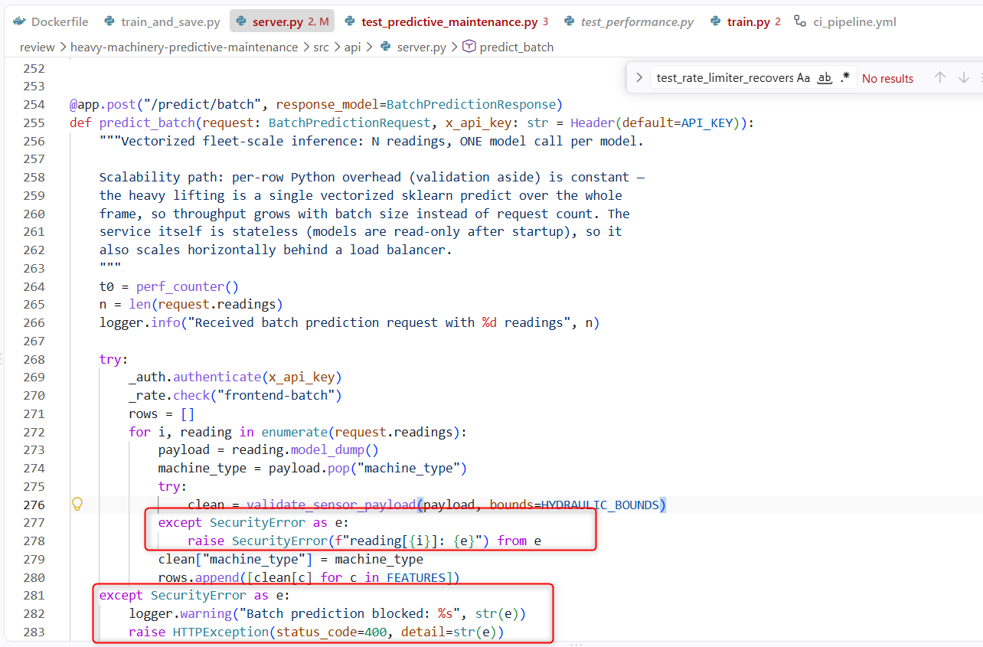

Logging — sample code and captured output
Each module configures Python’s logging with a distinct tag. Sample code from the API request path:
try:
clean = _gateway.guarded_predict(client_id="frontend", api_key=x_api_key,
payload=payload, predict_fn=predict_fn,
bounds=HYDRAULIC_BOUNDS)
except SecurityError as e:
logger.warning("Prediction blocked: %s", str(e)) # WARNING: rejected input
raise HTTPException(status_code=400, detail=str(e))
...
logger.info("Prediction completed: stability=%s worst=%s latency=%.2fms",
stability, worst, latency) # INFO: normal operation

Screenshot (as in code base – note: please refer repository for complete code or in Task 5):
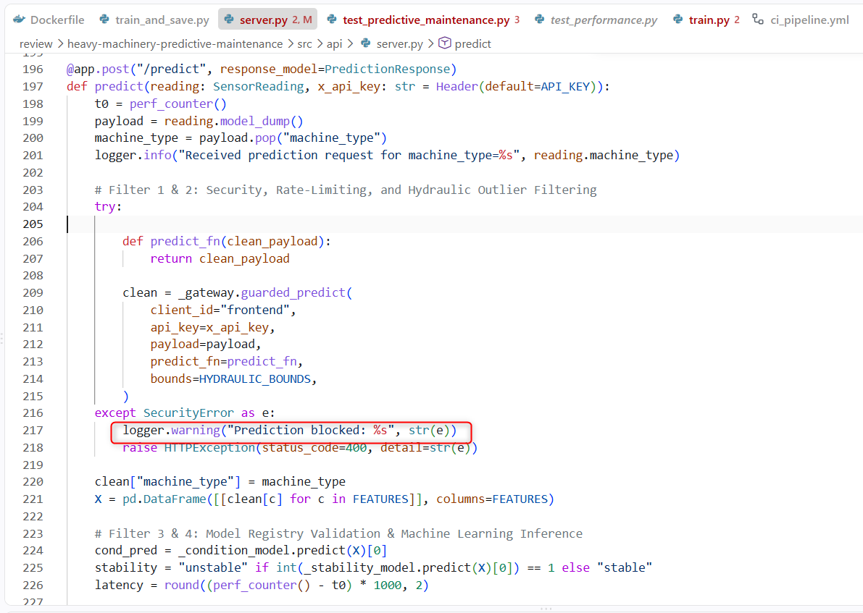
Captured console output showing all three levels in real runs (exact transcripts; also reproducible with the commands in Section 4):
2026-08-15 11:21:00 [TRAIN] INFO Stage fit_condition finished in 17.754s
2026-08-15 11:21:00 [TRAIN] INFO Training complete in 22.38s (peak traced memory 12.4 MB)
2026-08-15 11:25:23 [API] WARNING Batch prediction blocked: reading[0]:
field 'pressure_mean_bar'=99999.0 out of safe range [80.0, 260.0]
2026-08-15 [DATA-QUALITY] WARNING Drift detected on oil_temp_mean_c: PSI=7.869 (threshold 0.25)
2026-08-15 [DATA-QUALITY] ERROR Schema validation failed with 1 violation(s):
["oil_temp_mean_c: values above 130"]
2026-08-15 [API] INFO Verified condition_model.joblib integrity
The level policy:
INFO = lifecycle landmarks an operator wants in every run;
WARNING = suspicious but handled (rejected input, drift, budget exceeded);
ERROR = the run cannot proceed correctly (schema failure, missing/tampered artifact) — always paired with a raised exception.

2.4 Task 4 — Code formatting and linting (before / after)
Toolchain for this consists of the following:
- flake8 (linting)
- black (formatting)
- isort (import ordering)
These are run over src/, tests/, api_server.py, train_and_save.py. Full reports are committed under docs/lint/.
Why static code analysis matters
Static analysis finds defects without executing the code, at the cheapest possible moment — before review, before merge, before production. Concretely in this project it caught: unused imports (dead dependencies that mask real ones), imports placed after executable code (order-dependent side effects), an ambiguous variable name l, and multiple statements per line (breakpoint- and diff-hostile). Just as important, a formatter makes diffs reviewable: when formatting is mechanical, every changed line in a pull request is a semantic change.
Standards followed
- PEP 8 (via flake8) — naming, whitespace, import placement; line length set to 100 (a common team-agreed relaxation PEP 8 explicitly permits).
- PEP 257 docstring conventions — every module/class/public function carries a purpose-stating docstring.
- black (line length 100) — deterministic formatting, no debates.
- isort (--profile black) — imports grouped stdlib → third-party → local, alphabetized, compatible with black.
Before / after evidence (docs/lint/)
BEFORE flake8: 20 violations (F401 unused imports, E501 long lines,
E402 imports not at top, E702 multiple statements on one line,
E225 spacing, E741 ambiguous name 'l')
black : "8 files would be reformatted, 11 files would be left unchanged."
isort : 7 files with incorrectly sorted imports
AFTER flake8: 0 violations
black : "30 files would be left unchanged."
isort : clean (no errors)
The same three gates now run in CI on every push/PR (.github/workflows/ci_pipeline.yml), so the codebase cannot regress.
Sample screenshot after execution (after fixes done):
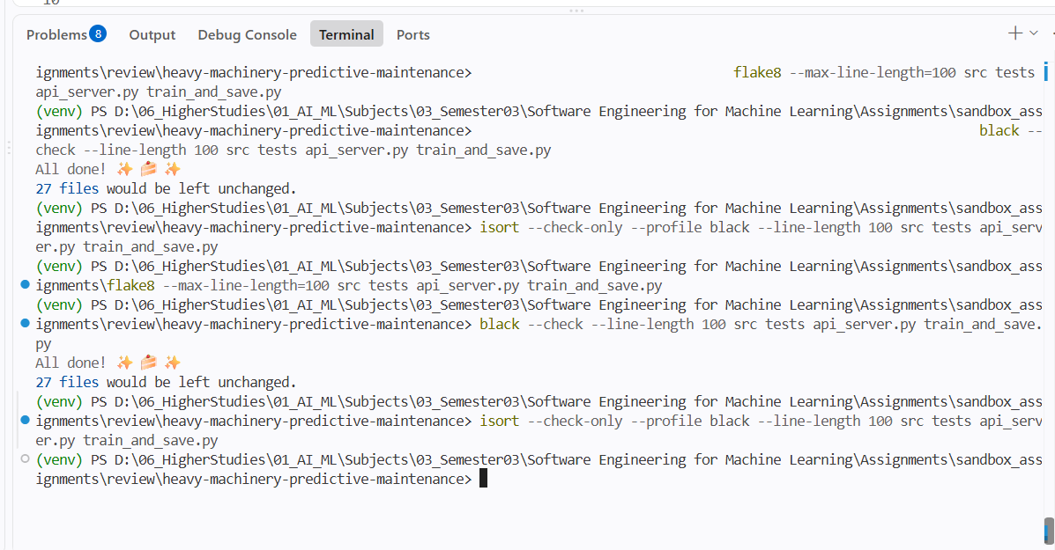

2.5 Task 5 — REST API design (FastAPI)

Endpoints and contracts
Endpoint | Method | Request schema | Response schema | Status codes
/health | GET | — | status, model SHA-256, targets, machine types | 200
/predict | POST | SensorReading (10 typed fields) | PredictionResponse (components, stability, RAG guidance, latency) | 200 · 400 (bad key / out-of-range) · 422 (malformed body)
/predict/batch | POST | BatchPredictionRequest (1–1000 readings) | BatchPredictionResponse (per-reading results, total + per-reading latency) | 200 · 400 · 422
Code File – src/api/server.py:
"""
server.py — FastAPI backend for the Predictive-Maintenance web app.

Author: Aman Kushwah (2024AC05064) — Group 105

Serves the multi-output condition model + real-time stability model to the React
frontend, guarded by the application-wide security layer, and enriched with RAG
repair guidance (with optional OpenRouter LLM generation).

Run: uvicorn server:app --reload --port 8000
Docs: http://localhost:8000/docs
"""

import json
import logging
import os
from pathlib import Path
from time import perf_counter

import joblib
import pandas as pd
from fastapi import FastAPI, Header, HTTPException
from fastapi.middleware.cors import CORSMiddleware
from pydantic import BaseModel, Field

from src.core.model_registry import ModelRegistry
from src.rag.maintenance_advisor import MaintenanceAdvisor
from src.security.security_layer import (
HYDRAULIC_BOUNDS,
ApiKeyAuthenticator,
AuditTrail,
RateLimiter,
SecureInferenceGateway,
SecurityError,
compute_file_sha256,
validate_sensor_payload,
)

ROOT = Path(__file__).resolve().parents[2]
REGISTRY = ROOT / "model_registry"

logging.basicConfig(
level=logging.INFO,
format="%(asctime)s [API] %(levelname)s %(message)s",
)
logger = logging.getLogger(__name__)
COND_PATH = REGISTRY / "condition_model.joblib"
STAB_PATH = REGISTRY / "stability_model.joblib"
SCHEMA_PATH = REGISTRY / "schema.json"
API_KEY = os.getenv("HYDRAULICS_API_KEY", "fleet-ops-secret-key")

registry = ModelRegistry(REGISTRY)
logger.info("Loading model registry from %s", REGISTRY)
if not (COND_PATH.exists() and STAB_PATH.exists() and SCHEMA_PATH.exists()):
logger.error("Missing model artifacts in %s", REGISTRY)
raise RuntimeError("Models not found. Run: python train_and_save.py from the repository root")

try:
_condition_model = joblib.load(COND_PATH)
_stability_model = joblib.load(STAB_PATH)
except Exception as exc:
logger.exception("Failed to load model artifacts")
raise RuntimeError("Unable to load model artifacts") from exc

with open(SCHEMA_PATH, encoding="utf-8") as f:
SCHEMA = json.load(f)
NUMERIC = SCHEMA["numeric_features"]
FEATURES = NUMERIC + SCHEMA["categorical_features"]
TARGETS = SCHEMA["targets"]
HEALTHY = SCHEMA["healthy_class"]
_model_sha = compute_file_sha256(COND_PATH)

for artifact_name, path in [
("condition_model.joblib", COND_PATH),
("stability_model.joblib", STAB_PATH),
("schema.json", SCHEMA_PATH),
]:
entry = registry.get(artifact_name)
if entry is None:
logger.error("Model registry missing %s entry", artifact_name)
raise RuntimeError(f"Model registry missing {artifact_name} entry")
if entry.sha256 != compute_file_sha256(path):
logger.error("Registry SHA mismatch for %s", artifact_name)
raise RuntimeError(f"Registry SHA mismatch for {artifact_name}: artifact may be tampered")
logger.info("Verified %s integrity", artifact_name)

_auth = ApiKeyAuthenticator([API_KEY])
_rate = RateLimiter(max_calls=30, window_seconds=1.0)
_audit = AuditTrail()
_gateway = SecureInferenceGateway(_auth, _rate, _audit)
_advisor = MaintenanceAdvisor()
logger.info(
"API initialized with %s machine types and %d targets",
len(SCHEMA["machine_types"]),
len(TARGETS),
)

# human-readable severity ranking so we can pick the worst component to advise on
SEVERITY = {
"cooler_condition": {100: 0, 20: 2, 3: 3},
"valve_condition": {100: 0, 90: 1, 80: 2, 73: 3},
"pump_leakage": {0: 0, 1: 2, 2: 3},
"accumulator_pressure": {130: 0, 115: 1, 100: 2, 90: 3},
}

app = FastAPI(
title="Predictive Maintenance — Mobile Hydraulics API",
description="Group 105 · condition monitoring + stability + RAG repair advisor",
)
app.add_middleware(CORSMiddleware, allow_origins=["*"], allow_methods=["*"], allow_headers=["*"])

# Warm up both models at startup so the first real request hits steady-state latency
_warm = pd.DataFrame([[0] * len(NUMERIC) + [SCHEMA["machine_types"][0]]], columns=FEATURES)
try:
_condition_model.predict(_warm)
_stability_model.predict(_warm)
except Exception:
pass

class SensorReading(BaseModel):
operating_hours: float = Field(..., json_schema_extra={"example": 900})
pressure_mean_bar: float = Field(..., json_schema_extra={"example": 165})
pressure_std_bar: float = Field(..., json_schema_extra={"example": 6.5})
flow_mean_lpm: float = Field(..., json_schema_extra={"example": 7.2})
oil_temp_mean_c: float = Field(..., json_schema_extra={"example": 68})
vibration_rms_mms: float = Field(..., json_schema_extra={"example": 3.5})
motor_power_kw: float = Field(..., json_schema_extra={"example": 18})
pump_speed_mean_rpm: float = Field(..., json_schema_extra={"example": 1400})
cooling_efficiency_pct: float = Field(..., json_schema_extra={"example": 78})
machine_type: str = Field(..., json_schema_extra={"example": "Excavator"})

class ComponentResult(BaseModel):
component: str
predicted_class: int
status: str # "healthy" or "attention"

class PredictionResponse(BaseModel):
components: list[ComponentResult]
stability: str # "stable" / "unstable"
flagged_component: str | None
repair_procedure: str | None
repair_guidance: str | None
llm_recommendation: str | None
latency_ms: float

class BatchPredictionRequest(BaseModel):
readings: list[SensorReading] = Field(..., min_length=1, max_length=1000)

class BatchItemResult(BaseModel):
components: list[ComponentResult]
stability: str
flagged_component: str | None

class BatchPredictionResponse(BaseModel):
results: list[BatchItemResult]
count: int
latency_ms: float
latency_per_reading_ms: float

def _resolve_components(cond_pred) -> tuple[list[ComponentResult], str | None]:
"""Map raw condition-model classes to per-component results + worst offender."""
components, worst = [], None
worst_sev = 0
for i, target in enumerate(TARGETS):
cls = int(cond_pred[i])
healthy = cls == HEALTHY[target]
components.append(
ComponentResult(
component=target, predicted_class=cls, status="healthy" if healthy else "attention"
)
)
sev = SEVERITY.get(target, {}).get(cls, 0)
if not healthy and sev > worst_sev:
worst_sev, worst = sev, target
return components, worst

@app.get("/health")
def health():
return {
"status": "healthy",
"model_sha256": _model_sha[:12],
"targets": TARGETS,
"machine_types": SCHEMA["machine_types"],
"llm_enabled": bool(os.getenv("OPENROUTER_API_KEY")),
}

@app.post("/predict", response_model=PredictionResponse)
def predict(reading: SensorReading, x_api_key: str = Header(default=API_KEY)):
t0 = perf_counter()
payload = reading.model_dump()
machine_type = payload.pop("machine_type")
logger.info("Received prediction request for machine_type=%s", reading.machine_type)

# Filter 1 & 2: Security, Rate-Limiting, and Hydraulic Outlier Filtering
try:

def predict_fn(clean_payload):
return clean_payload

clean = _gateway.guarded_predict(
client_id="frontend",
api_key=x_api_key,
payload=payload,
predict_fn=predict_fn,
bounds=HYDRAULIC_BOUNDS,
)
except SecurityError as e:
logger.warning("Prediction blocked: %s", str(e))
raise HTTPException(status_code=400, detail=str(e))

clean["machine_type"] = machine_type
X = pd.DataFrame([[clean[c] for c in FEATURES]], columns=FEATURES)

# Filter 3 & 4: Model Registry Validation & Machine Learning Inference
cond_pred = _condition_model.predict(X)[0]
stability = "unstable" if int(_stability_model.predict(X)[0]) == 1 else "stable"
latency = round((perf_counter() - t0) * 1000, 2)

# Filter 5: Maintenance Advisor Severity Resolution & RAG Enrichment
components, worst = _resolve_components(cond_pred)

procedure = guidance = llm = None
if worst:
advice = _advisor.advise(worst, k=1)[0]
procedure, guidance = advice["procedure"], advice["guidance"]
llm = advice.get("llm_recommendation")

_audit.record("frontend", "predict", f"stability={stability} worst={worst}")
logger.info(
"Prediction completed: stability=%s worst=%s latency=%.2fms", stability, worst, latency
)

# Filter 6: Structured Prediction Response Compilation
return PredictionResponse(
components=components,
stability=stability,
flagged_component=worst,
repair_procedure=procedure,
repair_guidance=guidance,
llm_recommendation=llm,
latency_ms=latency,
)

@app.post("/predict/batch", response_model=BatchPredictionResponse)
def predict_batch(request: BatchPredictionRequest, x_api_key: str = Header(default=API_KEY)):
"""Vectorized fleet-scale inference: N readings, ONE model call per model.

Scalability path: per-row Python overhead (validation aside) is constant —
the heavy lifting is a single vectorized sklearn predict over the whole
frame, so throughput grows with batch size instead of request count. The
service itself is stateless (models are read-only after startup), so it
also scales horizontally behind a load balancer.
"""
t0 = perf_counter()
n = len(request.readings)
logger.info("Received batch prediction request with %d readings", n)

try:
_auth.authenticate(x_api_key)
_rate.check("frontend-batch")
rows = []
for i, reading in enumerate(request.readings):
payload = reading.model_dump()
machine_type = payload.pop("machine_type")
try:
clean = validate_sensor_payload(payload, bounds=HYDRAULIC_BOUNDS)
except SecurityError as e:
raise SecurityError(f"reading[{i}]: {e}") from e
clean["machine_type"] = machine_type
rows.append([clean[c] for c in FEATURES])
except SecurityError as e:
logger.warning("Batch prediction blocked: %s", str(e))
raise HTTPException(status_code=400, detail=str(e))

X = pd.DataFrame(rows, columns=FEATURES)
cond_preds = _condition_model.predict(X) # one vectorized call for all N rows
stab_preds = _stability_model.predict(X)

results = []
for cond_pred, stab in zip(cond_preds, stab_preds):
components, worst = _resolve_components(cond_pred)
results.append(
BatchItemResult(
components=components,
stability="unstable" if int(stab) == 1 else "stable",
flagged_component=worst,
)
)

latency = round((perf_counter() - t0) * 1000, 2)
_audit.record("frontend-batch", "predict_batch", f"n={n}")
logger.info("Batch prediction completed: n=%d latency=%.2fms", n, latency)
return BatchPredictionResponse(
results=results,
count=n,
latency_ms=latency,
latency_per_reading_ms=round(latency / n, 3),
)

Exactly how to call it (commands)
Start the API (after training once — see Section 4):
uvicorn src.api.server:app --reload --port 8000
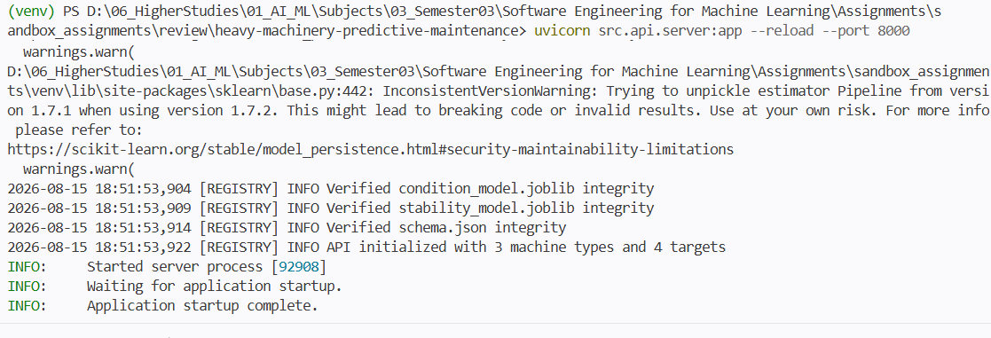
Liveness check:
curl http://localhost:8000/health
# {"status":"healthy","model_sha256":"e3b1c4...","targets":[...],"machine_types":[...]}
Sample execution screenshot:
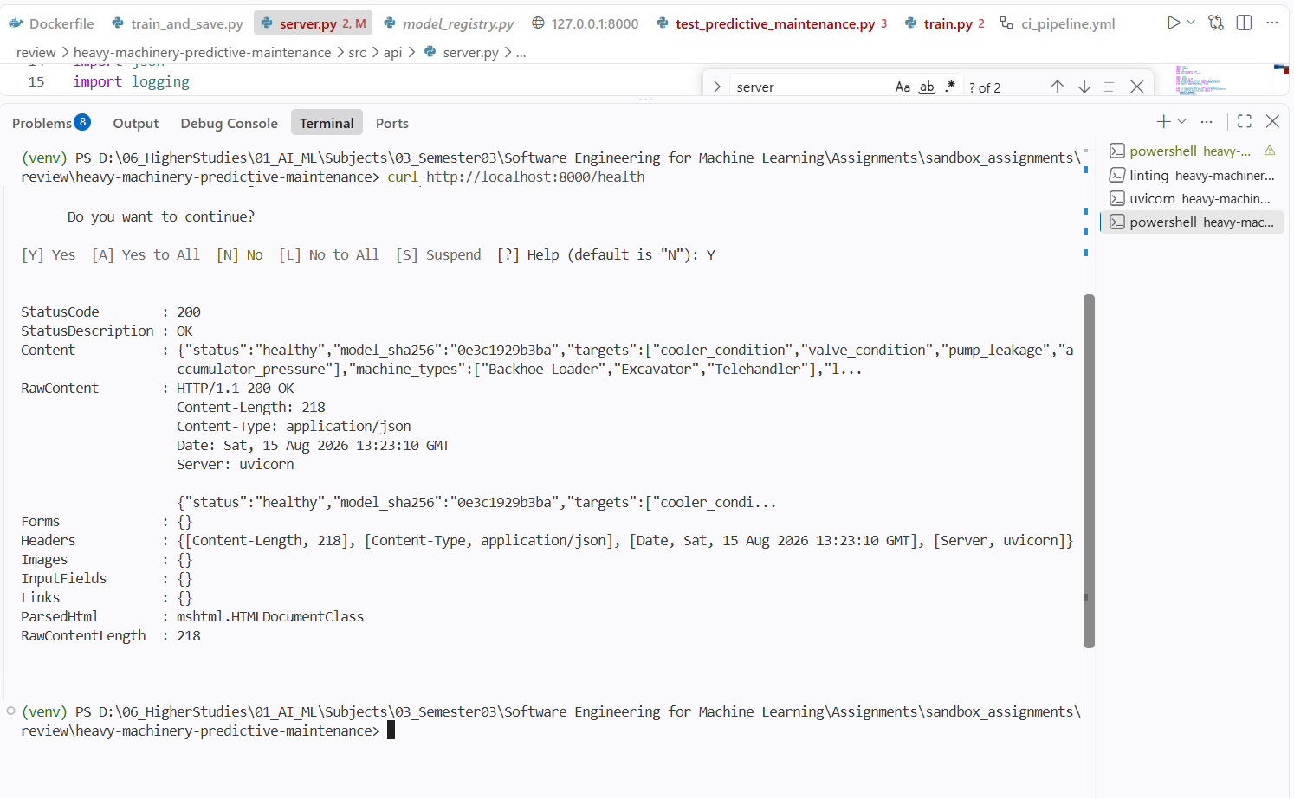

Single prediction (the API key travels in the x-api-key header; default dev key shown — override with the HYDRAULICS_API_KEY env var):
curl -X POST http://localhost:8000/predict \
-H "Content-Type: application/json" \
-H "x-api-key: fleet-ops-secret-key" \
-d '{"operating_hours": 1000, "pressure_mean_bar": 150, "pressure_std_bar": 5,
"flow_mean_lpm": 8, "oil_temp_mean_c": 75, "vibration_rms_mms": 5,
"motor_power_kw": 20, "pump_speed_mean_rpm": 1200,
"cooling_efficiency_pct": 60, "machine_type": "Excavator"}'
Via PowerShell command:
Invoke-WebRequest -Method POST -Uri http://localhost:8000/predict -Headers @{"Content-Type"="application/json"; "x-api-key"="fleet-ops-secret-key"} -Body (ConvertTo-Json -InputObject @{ operating_hours = 1000; pressure_mean_bar = 150; pressure_std_bar = 5; flow_mean_lpm = 8; oil_temp_mean_c = 75; vibration_rms_mms = 5; motor_power_kw = 20; pump_speed_mean_rpm = 1200; cooling_efficiency_pct = 60; machine_type = "Excavator" } -Compress) | Select-Object -ExpandProperty Content | ConvertFrom-Json
Sample output screenshot (Powershell):
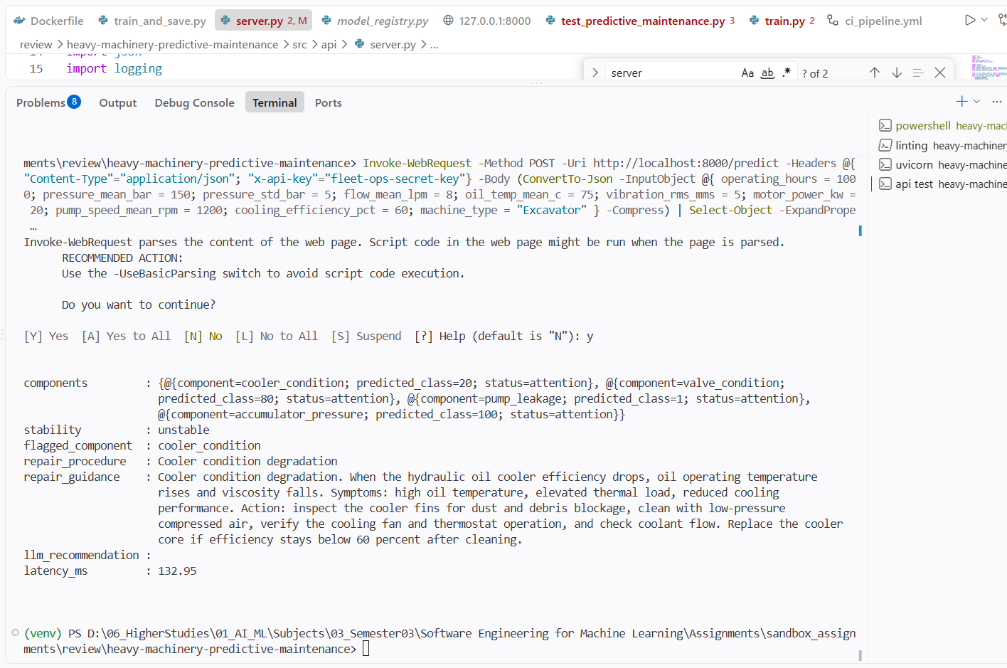

Batch prediction (fleet-scale, vectorized):
curl -X POST http://localhost:8000/predict/batch \
-H "Content-Type: application/json" \
-H "x-api-key: fleet-ops-secret-key" \
-d '{"readings": [ {...reading 1...}, {...reading 2...} ]}'
Powershell command:
Invoke-WebRequest -Method POST -Uri http://localhost:8000/predict/batch -Headers @{"Content-Type"="application/json"; "x-api-key"="fleet-ops-secret-key"} -Body (ConvertTo-Json -InputObject @{ readings = @( @{ operating_hours = 1000; pressure_mean_bar = 150; pressure_std_bar = 5; flow_mean_lpm = 8; oil_temp_mean_c = 75; vibration_rms_mms = 5; motor_power_kw = 20; pump_speed_mean_rpm = 1200; cooling_efficiency_pct = 60; machine_type = "Excavator" }, @{ operating_hours = 1050; pressure_mean_bar = 155; pressure_std_bar = 4.5; flow_mean_lpm = 8.2; oil_temp_mean_c = 76; vibration_rms_mms = 5.1; motor_power_kw = 20.5; pump_speed_mean_rpm = 1210; cooling_efficiency_pct = 61; machine_type = "Loader" } ) } -Compress) | Select-Object -ExpandProperty Content | ConvertFrom-Json
Sample execution screenshot (Powershell):
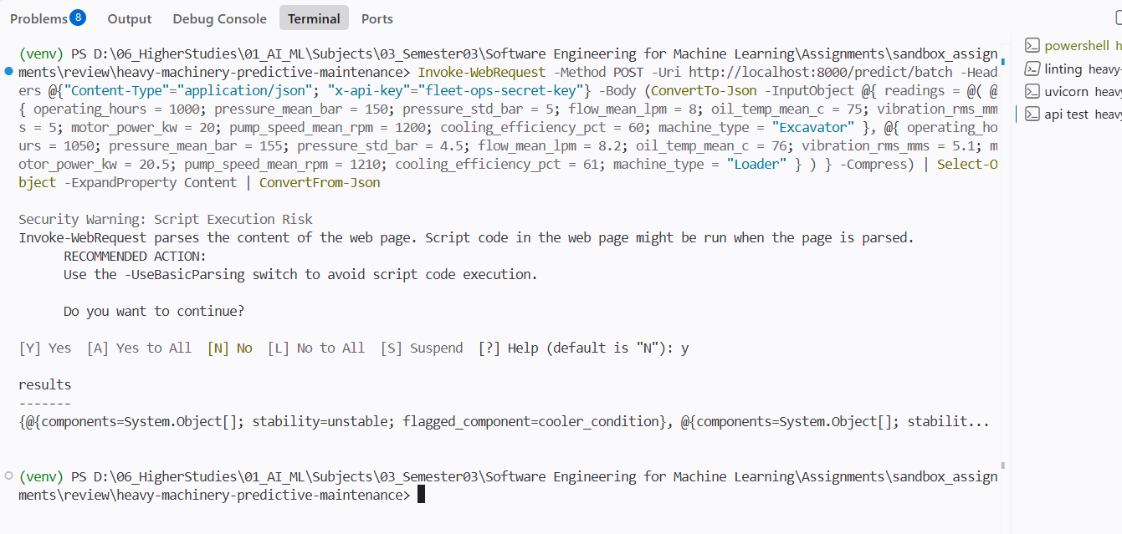
Interactive documentation is auto-generated at http://localhost:8000/docs (Swagger UI — every schema above is browsable and executable there, including “Try it out” forms).

Good-practice elements
- Typed request/response contracts (Pydantic) → automatic 422 on bad shapes.
- Meaningful status codes: 400 carries a human-readable detail naming the offending field and its allowed range (see the WARNING log sample above).
- Security at the boundary: API key, per-client rate limit (30 req/s), physical-bounds validation, tamper-evident audit trail on every call.
- Operational hygiene: model warm-up at startup, SHA-256 artifact verification before serving, latency in every response, CORS for the frontend, Docker health check on /health.
Application screenshots (frontend consuming the API):
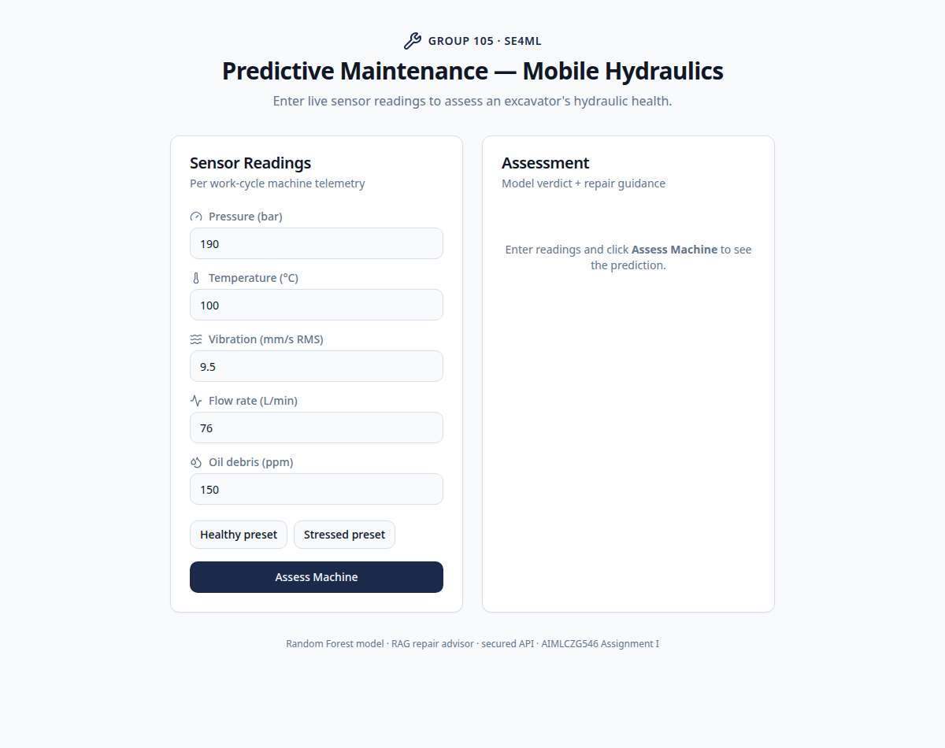
Sensor input form
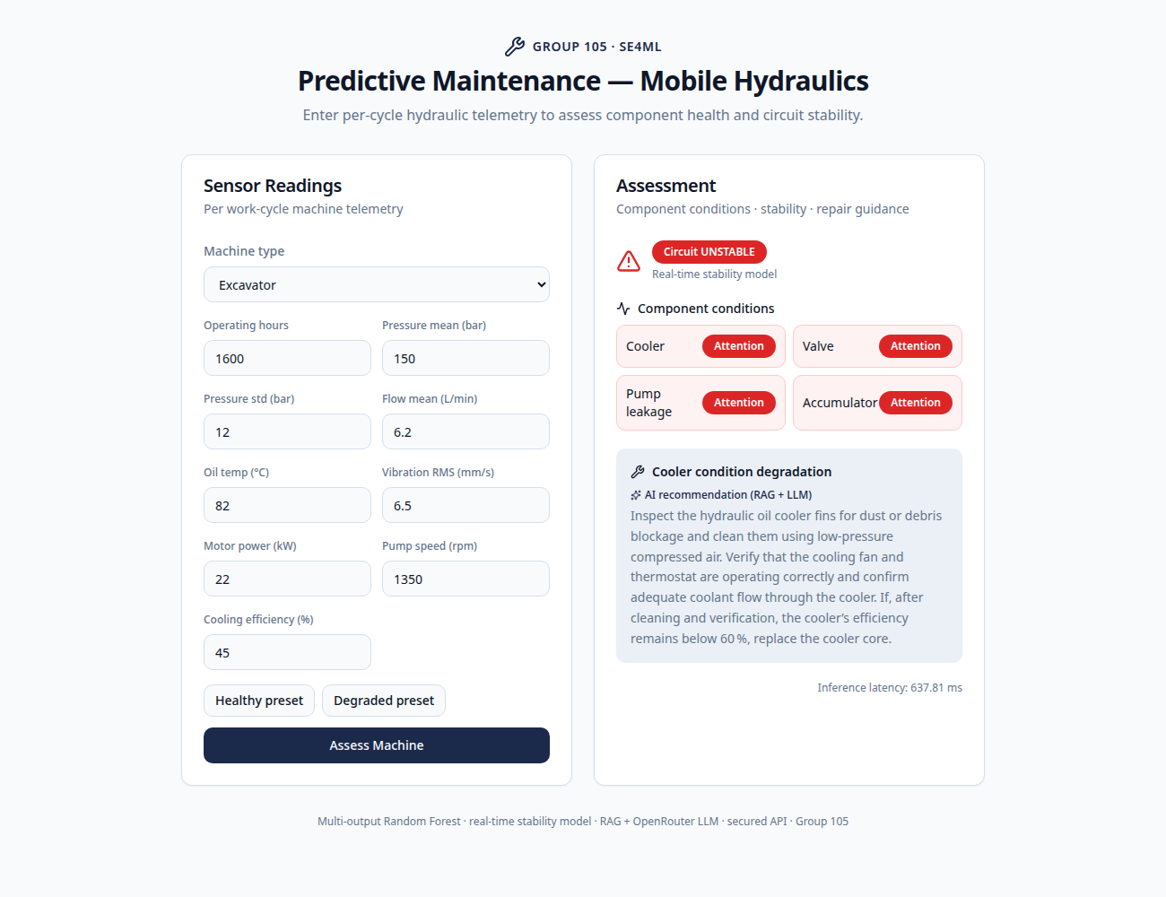
Prediction result with RAG guidance

3. Objective 2 — Quality Assurance

3.1 Task 6 — Test types implemented with pytest
The suite contains 49 tests organised into 8 classified suites via pytest markers (pytest.ini), so any class can run in isolation: pytest -m <marker> -q. Evidence: docs/lint/pytest_report.txt (49 passed).
Marker | File | What it covers
unit | test_predictive_maintenance.py | model quality requirements + security primitives in isolation
integration | test_api_integration.py | the real FastAPI app + trained artifacts end-to-end
ml_training | test_ml_training.py | the training procedure itself
ml_inference | test_ml_inference.py | trained-model inference behaviour
data_quality | test_data_quality.py | dataset validation (schema, missing, drift)
rag | test_rag_advisor.py | knowledge-base retrieval quality
idempotency | test_idempotency.py | reproducibility of retraining + registry
performance | test_performance.py | latency / memory / artifact-size budgets
Pytest.ini contents:
[pytest]
; Test classification taxonomy (QA feedback): run any class in isolation with
; pytest -m <marker> e.g. pytest -m ml_inference -q
markers =
unit: isolated tests of a single function/class (no I/O beyond tmp dirs)
integration: tests exercising the real FastAPI app + trained artifacts end-to-end
ml_training: tests of the training procedure itself (overfit, loss curve, baseline)
ml_inference: tests of trained-model inference behaviour (shape, range, invariance, directional)
data_quality: dataset validation tests (schema, missing values, drift)
rag: retrieval-augmented maintenance-advisor tests
idempotency: reproducibility tests (same seed -> same artifacts/predictions)
performance: time/space complexity tests (latency, memory, artifact size)
addopts = -ra

Predictive-maintenance tests and RAG tests are fully separated (review feedback), and every measured value is logged through a shared record_metric() helper, printed as a table at the end of each run and persisted to tests/metrics_report.json.

For different test types:
Unit tests — the rate limiter must block the 4th call in a 1-second window and recover after it slides past. Injecting now makes time deterministic. Here the unit test refers to the predictive maintenance part alone, not integrated with any other component.
File: test_predictive_maintenance.py
"""
Unit tests for the Predictive-Maintenance-for-Mobile-Hydraulics solution.

Author: Aman Kushwah (2024AC05064) — Group 105

Covers the model pipeline quality requirements and the application-wide
security layer in isolation (no API, no RAG — those live in
`test_api_integration.py` and `test_rag_advisor.py` respectively).

Run from the repo root: pytest -m unit -q
"""

import math

import numpy as np
import pandas as pd
import pytest
from sklearn.ensemble import RandomForestClassifier
from sklearn.metrics import accuracy_score
from sklearn.model_selection import train_test_split

from src.security.security_layer import (
ApiKeyAuthenticator,
AuditTrail,
RateLimiter,
SecurityError,
compute_file_sha256,
validate_sensor_payload,
verify_model_integrity,
)
from tests._metrics import record_metric

pytestmark = pytest.mark.unit

# --------------------------------------------------------------------------- #
# Fixtures — a small synthetic hydraulic dataset + trained model
# --------------------------------------------------------------------------- #
@pytest.fixture(scope="module")
def dataset():
rng = np.random.default_rng(42)
n = 1500
duty = rng.uniform(0, 1, n)
df = pd.DataFrame(
{
"pressure": 150 + 40 * duty + rng.normal(0, 6, n),
"temperature": 55 + 35 * duty + rng.normal(0, 4, n),
"vibration": 2.0 + 6.0 * duty + rng.normal(0, 0.6, n),
"flow_rate": 90 - 15 * duty + rng.normal(0, 3, n),
"oil_debris": 20 + 120 * duty + rng.normal(0, 12, n),
}
)
risk = (
0.35 * (df.temperature - 55) / 35
+ 0.35 * (df.vibration - 2) / 6
+ 0.30 * (df.oil_debris - 20) / 120
)
prob = 1 / (1 + np.exp(-10 * (risk - 0.5)))
y = (rng.uniform(0, 1, n) < prob).astype(int)
return df, y

@pytest.fixture(scope="module")
def trained(dataset):
X, y = dataset
Xtr, Xte, ytr, yte = train_test_split(X, y, test_size=0.2, random_state=42, stratify=y)
model = RandomForestClassifier(n_estimators=120, max_depth=10, random_state=42, n_jobs=-1)
model.fit(Xtr, ytr)
return model, Xte, yte

# --------------------------------------------------------------------------- #
# Model / pipeline tests
# --------------------------------------------------------------------------- #
def test_model_accuracy_is_reasonable(trained):
model, Xte, yte = trained
acc = accuracy_score(yte, model.predict(Xte))
record_metric("unit.synthetic_model_accuracy", acc)
assert acc > 0.80, f"accuracy too low: {acc:.3f}"

def test_robustness_to_corrupted_sensors(trained):
"""Quality Requirement #1 — accuracy retained under 15% corruption."""
model, Xte, yte = trained
clean = accuracy_score(yte, model.predict(Xte))
rng = np.random.default_rng(7)
corrupt = Xte.copy()
mask = rng.uniform(0, 1, corrupt.shape) < 0.15
corrupt = corrupt.mask(mask, corrupt + rng.normal(0, corrupt.std().values, corrupt.shape))
corrupt = corrupt.fillna(corrupt.median())
degraded = accuracy_score(yte, model.predict(corrupt))
record_metric("unit.robustness_accuracy_retention", degraded / clean)
assert degraded / clean >= 0.90, "model not robust enough to corruption"

def test_explainability_available(trained):
"""Quality Requirement #3 — model exposes feature importances."""
model, Xte, _ = trained
importances = model.feature_importances_
assert len(importances) == Xte.shape[1]
assert math.isclose(importances.sum(), 1.0, abs_tol=1e-6)

# --------------------------------------------------------------------------- #
# Security tests — one per control
# --------------------------------------------------------------------------- #
GOOD = {"pressure": 180, "temperature": 70, "vibration": 4, "flow_rate": 85, "oil_debris": 60}

def test_input_validation_accepts_valid():
assert validate_sensor_payload(GOOD) == {k: float(v) for k, v in GOOD.items()}

@pytest.mark.parametrize(
"bad",
[
{**GOOD, "pressure": 99999}, # out of range
{**GOOD, "vibration": -5}, # out of range
{**GOOD, "temperature": float("nan")}, # NaN
{k: v for k, v in GOOD.items() if k != "flow_rate"}, # missing field
],
)
def test_input_validation_rejects_bad(bad):
with pytest.raises(SecurityError):
validate_sensor_payload(bad)

def test_api_key_authentication():
auth = ApiKeyAuthenticator(["good-key"])
assert auth.authenticate("good-key") is True
with pytest.raises(SecurityError):
auth.authenticate("bad-key")
with pytest.raises(SecurityError):
auth.authenticate(None)

def test_model_integrity(tmp_path):
p = tmp_path / "model.bin"
p.write_bytes(b"trained-model-weights")
checksum = compute_file_sha256(str(p))
assert verify_model_integrity(str(p), checksum) is True
p.write_bytes(b"trained-model-weights-TAMPERED") # modify the artifact
with pytest.raises(SecurityError):
verify_model_integrity(str(p), checksum)

def test_audit_trail_is_tamper_evident():
audit = AuditTrail()
audit.record("tech-1", "predict", "EX-1")
audit.record("tech-1", "predict", "EX-2")
assert audit.verify_chain() is True
audit._entries[0]["detail"] = "EX-HACKED"
assert audit.verify_chain() is False

def test_rate_limiter_blocks_excess():
rl = RateLimiter(max_calls=3, window_seconds=1.0)
allowed = 0
for i in range(6):
try:
rl.check("client-x", now=100.0 + i * 0.1)
allowed += 1
except SecurityError:
pass
assert allowed == 3

def test_rate_limiter_recovers_after_window():
rl = RateLimiter(max_calls=2, window_seconds=1.0)
rl.check("c", now=0.0)
rl.check("c", now=0.1)
with pytest.raises(SecurityError):
rl.check("c", now=0.2)
# after the window slides past, calls are allowed again
assert rl.check("c", now=2.0) is True

Sample Execution Record Screenshot:
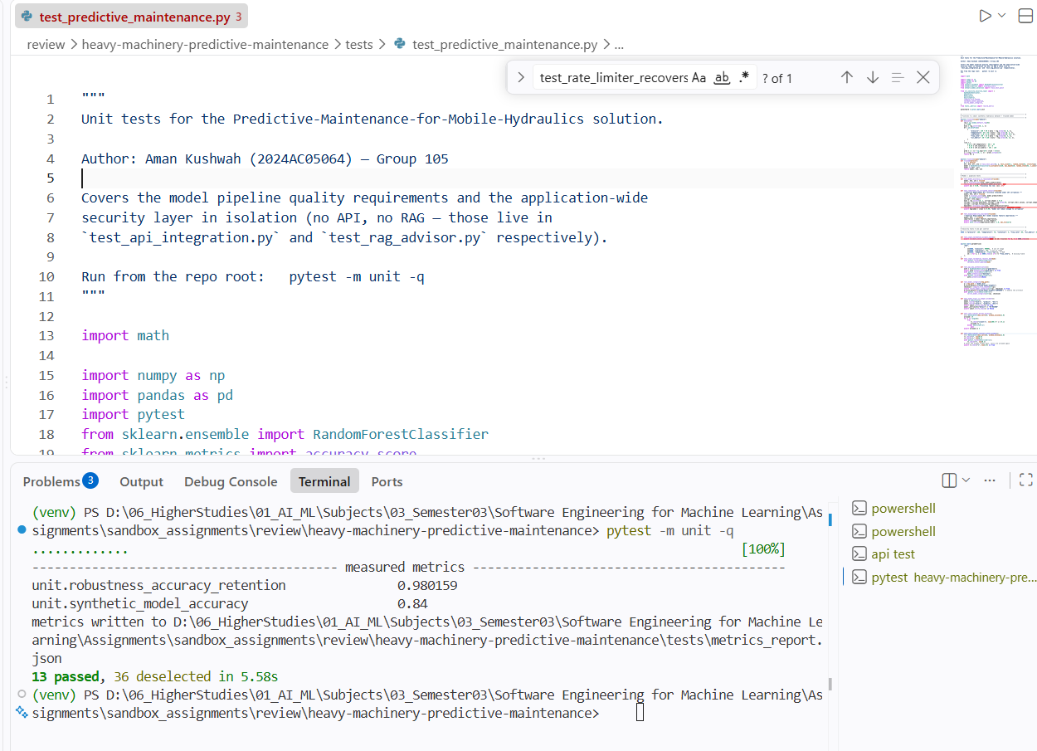
Integration tests — the batch endpoint must reject a corrupt reading by index, proving validation runs per reading, end-to-end through the real app.
This covers the API integration testing.
Code file: test_api_integration.py

"""API integration tests — the real FastAPI app with real trained artifacts.

Author: Group 105

Exercises the service end-to-end through `TestClient`: liveness, security
rejection at the boundary, and the vectorized batch endpoint.

Requires `model_registry/` (run `python train_and_save.py` once first).

Run from the repo root: pytest -m integration -q
"""

import pytest
from fastapi.testclient import TestClient

from src.api.server import app
from tests._metrics import record_metric

pytestmark = pytest.mark.integration

READING = {
"operating_hours": 1000,
"pressure_mean_bar": 150.0,
"pressure_std_bar": 5.0,
"flow_mean_lpm": 8.0,
"oil_temp_mean_c": 75.0,
"vibration_rms_mms": 5.0,
"motor_power_kw": 20.0,
"pump_speed_mean_rpm": 1200.0,
"cooling_efficiency_pct": 60.0,
"machine_type": "Excavator",
}

@pytest.fixture(scope="module")
def client():
return TestClient(app)

def test_health_endpoint_is_alive(client):
response = client.get("/health")
assert response.status_code == 200
body = response.json()
assert body["status"] == "healthy"
assert "targets" in body
assert isinstance(body["machine_types"], list)

def test_predict_endpoint_rejects_bad_api_key(client):
response = client.post("/predict", json=READING, headers={"x-api-key": "bad-key"})
assert response.status_code == 400
assert response.json()["detail"].strip().lower() == "invalid api key"

def test_predict_endpoint_returns_full_response(client):
response = client.post("/predict", json=READING)
assert response.status_code == 200
body = response.json()
assert body["stability"] in {"stable", "unstable"}
assert len(body["components"]) == 4
record_metric("integration.single_predict_latency", body["latency_ms"], "ms")

def test_batch_endpoint_vectorizes_and_scales(client):
n = 20
response = client.post("/predict/batch", json={"readings": [READING] * n})
assert response.status_code == 200
body = response.json()
assert body["count"] == n
assert len(body["results"]) == n
# identical inputs must produce identical outputs across the batch
assert all(r == body["results"][0] for r in body["results"])
record_metric("integration.batch_latency_per_reading", body["latency_per_reading_ms"], "ms")

def test_batch_endpoint_rejects_corrupt_reading(client):
bad = {**READING, "pressure_mean_bar": 99999}
response = client.post("/predict/batch", json={"readings": [READING, bad]})
assert response.status_code == 400
assert "reading[1]" in response.json()["detail"]

def test_batch_endpoint_enforces_size_limit(client):
response = client.post("/predict/batch", json={"readings": []})
assert response.status_code == 422 # pydantic min_length=1

Sample Execution Screenshot:
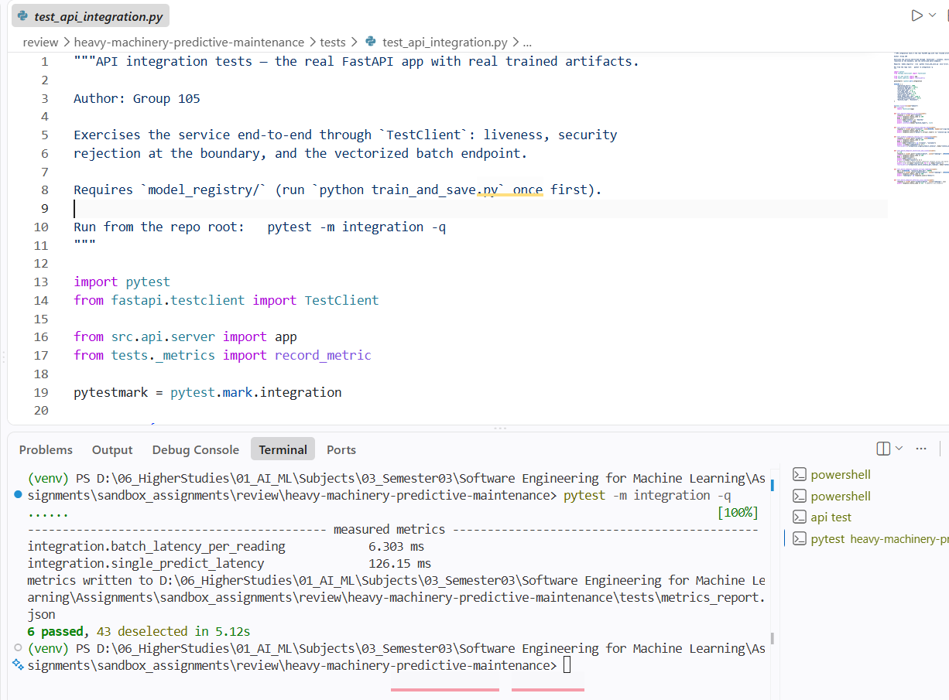

Data validation — injected fleet-wide +25 °C oil-temperature shift must trip the PSI drift alarm while untouched features stay quiet.

Sample Execution Screenshot:
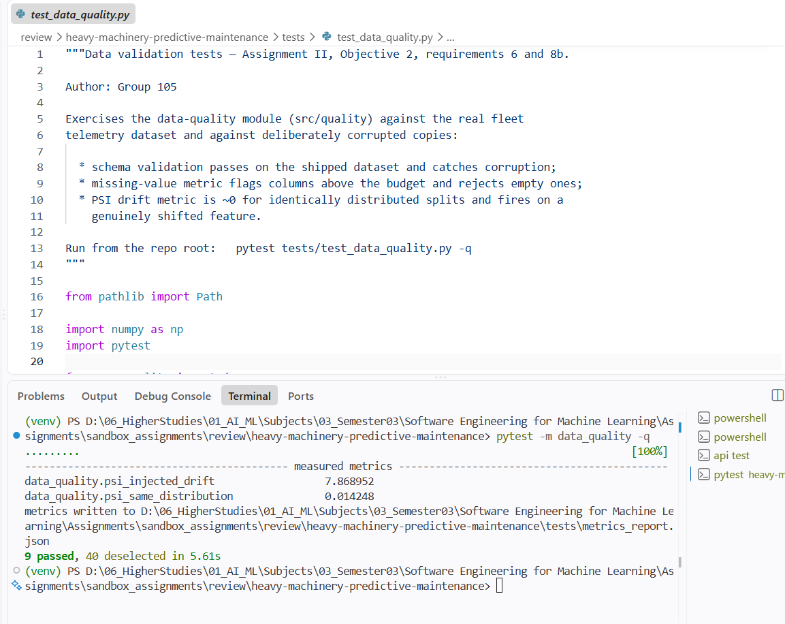
Code file: test_data_quality.py
"""Data validation tests — Assignment II, Objective 2, requirements 6 and 8b.

Author: Group 105

Exercises the data-quality module (src/quality) against the real fleet
telemetry dataset and against deliberately corrupted copies:

* schema validation passes on the shipped dataset and catches corruption;
* missing-value metric flags columns above the budget and rejects empty ones;
* PSI drift metric is ~0 for identically distributed splits and fires on a
genuinely shifted feature.

Run from the repo root: pytest tests/test_data_quality.py -q
"""

from pathlib import Path

import numpy as np
import pytest

from src.quality import (
DataQualityError,
check_missing_values,
compute_psi,
detect_drift,
validate_schema,
)
from src.quality.data_quality import run_all_checks
from tests._metrics import record_metric

pytestmark = pytest.mark.data_quality

ROOT = Path(__file__).resolve().parents[1]
DATA = ROOT / "data" / "hydraulic_fleet_telemetry.csv"

NUMERIC = ["pressure_mean_bar", "flow_mean_lpm", "oil_temp_mean_c", "vibration_rms_mms"]

# --------------------------------------------------------------------------- #
# Metric 1 — schema validation
# --------------------------------------------------------------------------- #
def test_shipped_dataset_passes_schema(telemetry):
assert validate_schema(telemetry) == []

def test_schema_catches_missing_column(telemetry):
broken = telemetry.drop(columns=["oil_temp_mean_c"])
with pytest.raises(DataQualityError, match="oil_temp_mean_c"):
validate_schema(broken)

def test_schema_catches_out_of_range_values(telemetry):
corrupted = telemetry.copy()
corrupted.loc[corrupted.index[:5], "oil_temp_mean_c"] = 999.0 # physically impossible
with pytest.raises(DataQualityError, match="oil_temp_mean_c"):
validate_schema(corrupted)

def test_schema_catches_invalid_label(telemetry):
corrupted = telemetry.copy()
corrupted.loc[corrupted.index[0], "pump_leakage"] = 7 # not in {0, 1, 2}
with pytest.raises(DataQualityError, match="pump_leakage"):
validate_schema(corrupted)

# --------------------------------------------------------------------------- #
# Metric 2 — missing values
# --------------------------------------------------------------------------- #
def test_missing_rates_measured_on_real_data(telemetry):
rates = check_missing_values(telemetry)
assert set(rates) == set(telemetry.columns)
assert all(0.0 <= r < 1.0 for r in rates.values())

def test_missing_check_rejects_empty_column(telemetry):
broken = telemetry.copy()
broken["flow_mean_lpm"] = np.nan
with pytest.raises(DataQualityError, match="flow_mean_lpm"):
check_missing_values(broken)

# --------------------------------------------------------------------------- #
# Metric 3 — drift (PSI)
# --------------------------------------------------------------------------- #
def test_psi_near_zero_for_same_distribution(telemetry):
half = len(telemetry) // 2
reference, current = telemetry.iloc[:half], telemetry.iloc[half:]
psi = compute_psi(
reference["pressure_mean_bar"].to_numpy(), current["pressure_mean_bar"].to_numpy()
)
record_metric("data_quality.psi_same_distribution", psi)
assert psi < 0.10, f"identical distributions reported PSI={psi:.3f}"

def test_psi_detects_injected_drift(telemetry):
reference = telemetry.sample(n=3000, random_state=1)
shifted = reference.copy()
shifted["oil_temp_mean_c"] = shifted["oil_temp_mean_c"] + 25.0 # cooling failure fleet-wide

psi = detect_drift(reference, shifted, NUMERIC)
record_metric("data_quality.psi_injected_drift", psi["oil_temp_mean_c"])
assert psi["oil_temp_mean_c"] > 0.25, "large temperature shift not flagged as drift"
assert psi["pressure_mean_bar"] < 0.10, "untouched feature wrongly flagged"

def test_run_all_checks_produces_full_report(telemetry):
reference = telemetry.sample(n=2000, random_state=2)
current = telemetry.sample(n=2000, random_state=3)
report = run_all_checks(current, reference_df=reference, numeric_features=NUMERIC)
assert report.schema_ok
assert report.worst_missing_rate < 0.05
assert set(report.psi) == set(NUMERIC)
assert report.drifted_features == []

Validation datasets — basis and criteria (review feedback)
Documented in tests/conftest.py and applied by every fixture:
- Source: the shipped 10,000-cycle fleet telemetry export (5 machine types).
- Reproducibility: every sample uses a fixed random_state, so tests see byte-identical data locally and in CI.
- Representativeness: 2,000–3,000-row samples retain every class of every target (asserted by the shape/class tests) while keeping the suite ~25 s.
- Stratification: splits stratify on stability_flag (the rarest label), matching what the production trainer does.
- Independence: drift tests compare disjoint halves of the fleet history (first 5,000 vs last 5,000 cycles) — never overlapping samples.

3.2 Task 7 — ML-specific tests
7a. Model training (pytest -m ml_training):
- test_model_can_overfit_small_batch — a high-capacity forest must reach ≥99% on a 64-row batch; failure means broken features/labels or a mis-wired loop.
- test_training_loss_decreases_with_iterations — training log-loss across boosting stages must be monotonically non-increasing (measured: 0.585 → 0.134).
- test_production_pipeline_beats_majority_baseline — the exact production pipeline must beat the majority class (measured: 0.914 vs 0.634).

Sample screenshot of execution:
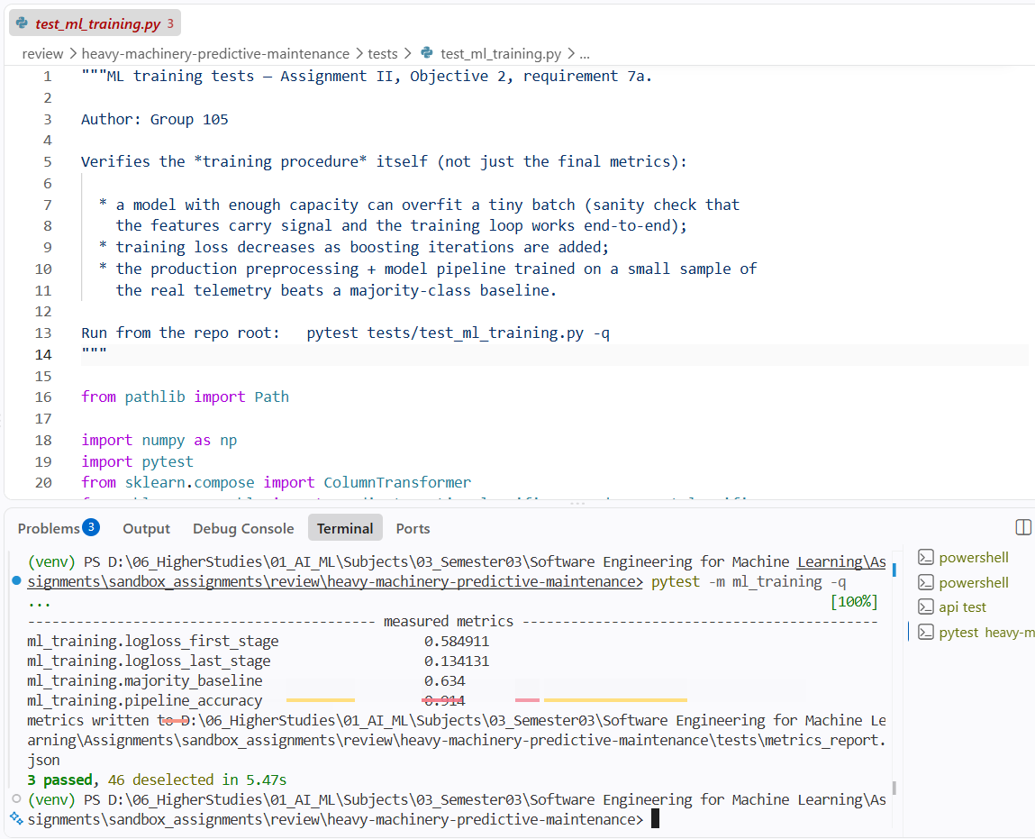
Code file: test_ml_training.py
"""ML training tests — Assignment II, Objective 2, requirement 7a.

Author: Group 105

Verifies the *training procedure* itself (not just the final metrics):

* a model with enough capacity can overfit a tiny batch (sanity check that
the features carry signal and the training loop works end-to-end);
* training loss decreases as boosting iterations are added;
* the production preprocessing + model pipeline trained on a small sample of
the real telemetry beats a majority-class baseline.

Run from the repo root: pytest tests/test_ml_training.py -q
"""

from pathlib import Path

import numpy as np
import pytest
from sklearn.compose import ColumnTransformer
from sklearn.ensemble import GradientBoostingClassifier, RandomForestClassifier
from sklearn.metrics import accuracy_score, log_loss
from sklearn.model_selection import train_test_split
from sklearn.pipeline import Pipeline
from sklearn.preprocessing import OneHotEncoder, StandardScaler

from tests._metrics import record_metric

pytestmark = pytest.mark.ml_training

ROOT = Path(__file__).resolve().parents[1]
DATA = ROOT / "data" / "hydraulic_fleet_telemetry.csv"

NUMERIC = [
"operating_hours",
"pressure_mean_bar",
"pressure_std_bar",
"flow_mean_lpm",
"oil_temp_mean_c",
"vibration_rms_mms",
"motor_power_kw",
"pump_speed_mean_rpm",
"cooling_efficiency_pct",
]
CATEGORICAL = ["machine_type"]

@pytest.fixture(scope="module")
def telemetry_sample(telemetry):
# Sampling criteria documented in tests/conftest.py (fixed seed, 2000 rows)
return telemetry.sample(n=2000, random_state=42)

def test_model_can_overfit_small_batch(telemetry_sample):
"""A high-capacity model must reach ~100% accuracy on a tiny batch.

If it cannot, the features/labels are broken or training is mis-wired.
"""
batch = telemetry_sample.sample(n=64, random_state=0)
X = batch[NUMERIC]
y = batch["stability_flag"]
model = RandomForestClassifier(n_estimators=100, max_depth=None, random_state=0)
model.fit(X, y)
train_acc = accuracy_score(y, model.predict(X))
assert train_acc >= 0.99, f"could not overfit a 64-row batch (acc={train_acc:.3f})"

def test_training_loss_decreases_with_iterations(telemetry_sample):
"""Log-loss on the training set must fall as boosting stages are added."""
X = telemetry_sample[NUMERIC]
y = telemetry_sample["stability_flag"]
model = GradientBoostingClassifier(n_estimators=50, random_state=0)
model.fit(X, y)

losses = [log_loss(y, proba) for proba in model.staged_predict_proba(X)]
record_metric("ml_training.logloss_first_stage", losses[0])
record_metric("ml_training.logloss_last_stage", losses[-1])
assert losses[-1] < losses[0], "training loss did not decrease"
# loss should be monotonically non-increasing for a gradient booster on train data
assert all(b <= a + 1e-9 for a, b in zip(losses, losses[1:])), "loss increased mid-training"

def test_production_pipeline_beats_majority_baseline(telemetry_sample):
"""The production preprocessing+model pipeline must beat predicting the
majority class, proving the pipeline learns real signal end-to-end."""
X = telemetry_sample[NUMERIC + CATEGORICAL]
y = telemetry_sample["stability_flag"]
X_tr, X_te, y_tr, y_te = train_test_split(X, y, test_size=0.25, random_state=42, stratify=y)

pipeline = Pipeline(
[
(
"prep",
ColumnTransformer(
[
("num", StandardScaler(), NUMERIC),
("cat", OneHotEncoder(handle_unknown="ignore"), CATEGORICAL),
]
),
),
("clf", RandomForestClassifier(n_estimators=60, max_depth=6, random_state=42)),
]
)
pipeline.fit(X_tr, y_tr)
acc = accuracy_score(y_te, pipeline.predict(X_te))
majority = float(np.mean(y_te == y_te.mode()[0]))
record_metric("ml_training.pipeline_accuracy", acc)
record_metric("ml_training.majority_baseline", majority)
assert acc > majority, f"pipeline acc {acc:.3f} did not beat majority baseline {majority:.3f}"

7b. Model inference (pytest -m ml_inference):
- Shape/range — condition model returns (n, 4) with classes inside each target’s label set; probabilities lie in [0, 1] and rows sum to 1.
- Invariance — identical inputs give identical outputs; an unseen machine_type (“MoonCrawler-9000”) degrades gracefully via OneHotEncoder(handle_unknown="ignore") instead of crashing.
- Directional — severely degraded sensors must not lower predicted risk. Measured: P(unstable) rises from 0.001 (healthy) to 0.622 (degraded).
Sample (directional):
degraded = healthy_reading.copy()
degraded["oil_temp_mean_c"] = 95.0
degraded["vibration_rms_mms"] = 12.0
degraded["cooling_efficiency_pct"] = 25.0
p_healthy = model.predict_proba(healthy_reading)[0, unstable_idx] # 0.001
p_degraded = model.predict_proba(degraded)[0, unstable_idx] # 0.622
assert p_degraded >= p_healthy

Code file – test_ml_inference.py:
"""ML inference tests — Assignment II, Objective 2, requirement 7b.

Author: Group 105

Verifies the *inference behaviour* of the trained pipelines:

* output shape and class-range checks for both models;
* probability outputs lie in [0, 1] and rows sum to 1;
* invariance — identical inputs give identical predictions, and an unseen
machine_type is handled gracefully (OneHotEncoder handle_unknown="ignore");
* directional expectation — degrading the sensor readings (hotter oil, more
vibration, worse cooling) must not lower the predicted instability risk.

Run from the repo root: pytest tests/test_ml_inference.py -q
"""

from pathlib import Path

import numpy as np
import pandas as pd
import pytest
from sklearn.compose import ColumnTransformer
from sklearn.ensemble import RandomForestClassifier
from sklearn.multioutput import MultiOutputClassifier
from sklearn.pipeline import Pipeline
from sklearn.preprocessing import OneHotEncoder, StandardScaler

from tests._metrics import record_metric

pytestmark = pytest.mark.ml_inference

ROOT = Path(__file__).resolve().parents[1]
DATA = ROOT / "data" / "hydraulic_fleet_telemetry.csv"

NUMERIC = [
"operating_hours",
"pressure_mean_bar",
"pressure_std_bar",
"flow_mean_lpm",
"oil_temp_mean_c",
"vibration_rms_mms",
"motor_power_kw",
"pump_speed_mean_rpm",
"cooling_efficiency_pct",
]
CATEGORICAL = ["machine_type"]
TARGETS = ["cooler_condition", "valve_condition", "pump_leakage", "accumulator_pressure"]
ALLOWED_CLASSES = {
"cooler_condition": {3, 20, 100},
"valve_condition": {73, 80, 90, 100},
"pump_leakage": {0, 1, 2},
"accumulator_pressure": {90, 100, 115, 130},
}

def _make_preprocessor():
return ColumnTransformer(
[
("num", StandardScaler(), NUMERIC),
("cat", OneHotEncoder(handle_unknown="ignore"), CATEGORICAL),
]
)

@pytest.fixture(scope="module")
def data(telemetry):
# Sampling criteria documented in tests/conftest.py (fixed seed, 2500 rows)
return telemetry.sample(n=2500, random_state=7)

@pytest.fixture(scope="module")
def condition_model(data):
model = Pipeline(
[
("prep", _make_preprocessor()),
(
"clf",
MultiOutputClassifier(
RandomForestClassifier(n_estimators=60, max_depth=10, random_state=42)
),
),
]
)
model.fit(data[NUMERIC + CATEGORICAL], data[TARGETS])
return model

@pytest.fixture(scope="module")
def stability_model(data):
model = Pipeline(
[
("prep", _make_preprocessor()),
("clf", RandomForestClassifier(n_estimators=60, max_depth=6, random_state=42)),
]
)
model.fit(data[NUMERIC + CATEGORICAL], data["stability_flag"])
return model

@pytest.fixture(scope="module")
def healthy_reading():
return pd.DataFrame(
[
{
"operating_hours": 100.0,
"pressure_mean_bar": 215.0,
"pressure_std_bar": 3.0,
"flow_mean_lpm": 8.4,
"oil_temp_mean_c": 45.0,
"vibration_rms_mms": 1.0,
"motor_power_kw": 15.0,
"pump_speed_mean_rpm": 1445.0,
"cooling_efficiency_pct": 99.0,
"machine_type": "Telehandler",
}
]
)

def test_condition_model_output_shape_and_classes(condition_model, data):
"""Output must be (n_samples, 4) and every class must be a valid label."""
X = data[NUMERIC + CATEGORICAL].head(50)
pred = np.asarray(condition_model.predict(X))
assert pred.shape == (50, len(TARGETS))
for i, target in enumerate(TARGETS):
assert set(np.unique(pred[:, i])).issubset(
ALLOWED_CLASSES[target]
), f"{target} produced classes outside the label set"

def test_stability_probabilities_are_valid(stability_model, data):
"""predict_proba must produce probabilities in [0, 1] that sum to 1."""
X = data[NUMERIC + CATEGORICAL].head(50)
proba = stability_model.predict_proba(X)
assert proba.shape == (50, 2)
assert np.all(proba >= 0.0) and np.all(proba <= 1.0)
np.testing.assert_allclose(proba.sum(axis=1), 1.0, atol=1e-9)

def test_inference_is_deterministic(stability_model, healthy_reading):
"""Invariance: the same input must always yield the same prediction."""
first = stability_model.predict_proba(healthy_reading)
second = stability_model.predict_proba(pd.concat([healthy_reading] * 3, ignore_index=True))
np.testing.assert_allclose(second, np.repeat(first, 3, axis=0))

def test_unseen_machine_type_is_handled(stability_model, healthy_reading):
"""Invariance: an unknown category must not crash inference (encoder ignores it)."""
exotic = healthy_reading.copy()
exotic["machine_type"] = "MoonCrawler-9000"
proba = stability_model.predict_proba(exotic)
assert proba.shape == (1, 2)
assert np.all(proba >= 0.0) and np.all(proba <= 1.0)

def test_degraded_sensors_do_not_lower_risk(stability_model, healthy_reading):
"""Directional test: severe degradation must not reduce P(unstable)."""
degraded = healthy_reading.copy()
degraded["oil_temp_mean_c"] = 95.0
degraded["vibration_rms_mms"] = 12.0
degraded["cooling_efficiency_pct"] = 25.0
degraded["pressure_std_bar"] = 25.0

unstable_idx = list(stability_model.classes_).index(1)
p_healthy = stability_model.predict_proba(healthy_reading)[0, unstable_idx]
p_degraded = stability_model.predict_proba(degraded)[0, unstable_idx]
record_metric("ml_inference.p_unstable_healthy_reading", p_healthy)
record_metric("ml_inference.p_unstable_degraded_reading", p_degraded)
assert (
p_degraded >= p_healthy
), f"risk fell after degradation: healthy={p_healthy:.3f} degraded={p_degraded:.3f}"

Sample screenshot execution:
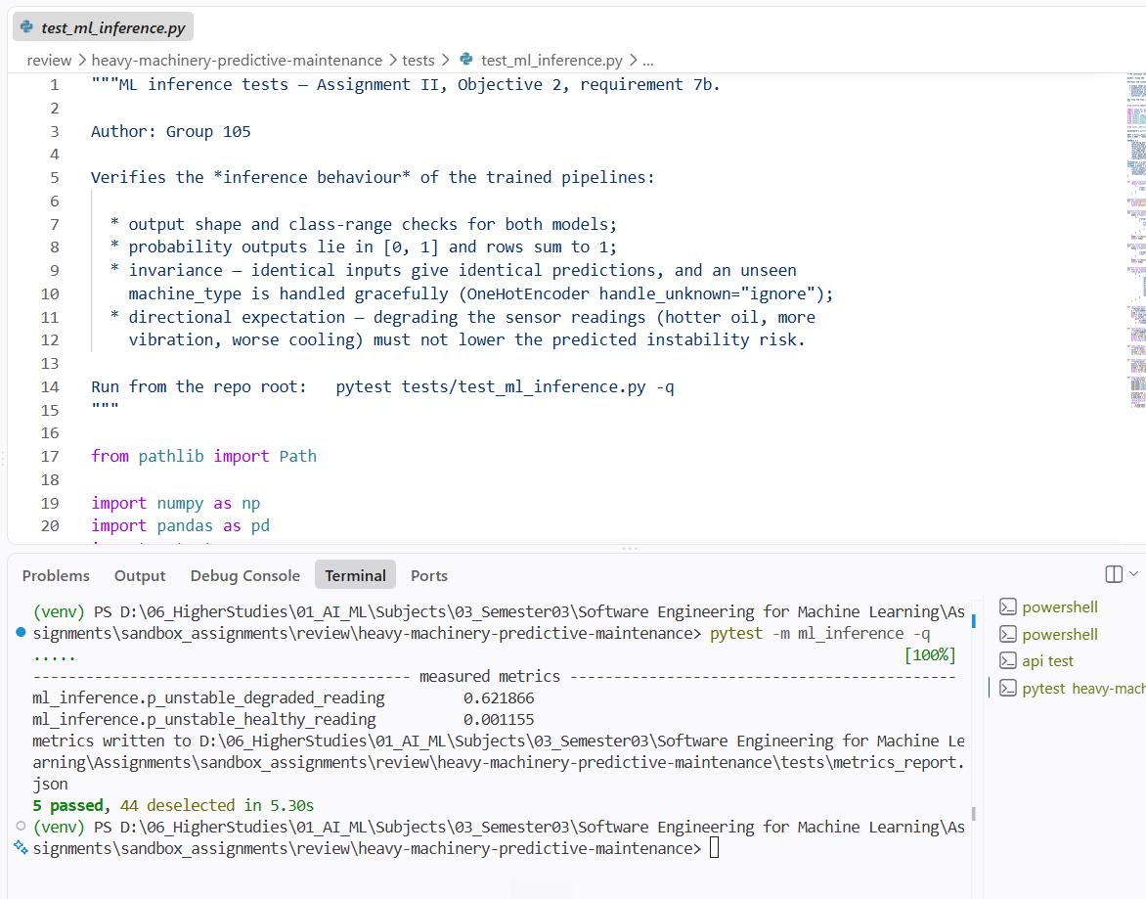
Idempotency (pytest -m idempotency, review feedback): two retrains with the same seed/data must agree — class predictions exactly, probabilities within 1e-12 (measured max diff: 0.0); registry re-registration keeps a single index entry; the up-to-date guard behind train_and_save.py correctly detects current, missing and tampered artifacts.
Code file – test_idempotency.py:
"""Idempotency & reproducibility tests (colleague feedback, QA).

Author: Group 105

Verifies that the system is deterministic end-to-end:

* retraining with the same seed on the same data yields byte-identical
predictions and probabilities;
* the model registry is idempotent — re-registering an artifact updates the
single existing entry instead of duplicating it;
* the training script's up-to-date guard correctly detects current,
missing and tampered artifacts (this is what makes
`python train_and_save.py` safe to run repeatedly).

Run from the repo root: pytest -m idempotency -q
"""

import numpy as np
import pytest

import src.ml.train as train_mod
from src.core.model_registry import ModelArtifact, ModelRegistry
from src.security.security_layer import compute_file_sha256
from tests._metrics import record_metric

pytestmark = pytest.mark.idempotency

FEATURES = train_mod.NUMERIC_FEATURES + train_mod.CATEGORICAL_FEATURES

@pytest.fixture(scope="module")
def sample(telemetry):
# Sampling criteria documented in tests/conftest.py (fixed seed, 2000 rows)
return telemetry.sample(n=2000, random_state=11)

def test_retraining_is_reproducible(sample):
"""Two training runs with identical seed/data must agree on every output.

Class predictions must match exactly; probabilities are compared within
1e-12 because parallel tree averaging (n_jobs=-1) can reorder float sums,
which shifts results only at machine epsilon (~1e-16).
"""
holdout = sample.iloc[:200]
fit_data = sample.iloc[200:]

probas, preds = [], []
for _ in range(2):
model = train_mod.build_stability_model()
model.fit(fit_data[FEATURES], fit_data[train_mod.RT_TARGET])
probas.append(model.predict_proba(holdout[FEATURES]))
preds.append(model.predict(holdout[FEATURES]))

max_diff = float(np.max(np.abs(probas[0] - probas[1])))
record_metric("idempotency.max_probability_diff_across_retrains", max_diff)
np.testing.assert_array_equal(preds[0], preds[1])
np.testing.assert_allclose(probas[0], probas[1], atol=1e-12)

def test_condition_model_builder_is_reproducible(sample):
"""The multi-output condition model must also retrain deterministically."""
holdout = sample.iloc[:200]
fit_data = sample.iloc[200:]

preds = []
for _ in range(2):
model = train_mod.build_condition_model()
model.fit(fit_data[FEATURES], fit_data[train_mod.TARGETS])
preds.append(np.asarray(model.predict(holdout[FEATURES])))

np.testing.assert_array_equal(preds[0], preds[1])

def test_registry_registration_is_idempotent(tmp_path):
"""Registering the same artifact N times keeps exactly one index entry."""
registry = ModelRegistry(tmp_path)
artifact_file = tmp_path / "model.joblib"
artifact_file.write_bytes(b"weights-v1")
sha = compute_file_sha256(artifact_file)

for _ in range(3):
registry.register(ModelArtifact(path="model.joblib", sha256=sha, metadata={"type": "m"}))

assert list(registry.list().keys()) == ["model.joblib"]
assert registry.get("model.joblib").sha256 == sha

def test_up_to_date_guard_detects_current_missing_and_tampered(tmp_path, monkeypatch):
"""The guard behind `train_and_save.py` skip-logic must be trustworthy."""
monkeypatch.setattr(train_mod, "REGISTRY", tmp_path)
registry = ModelRegistry(tmp_path)

# empty registry directory -> not up to date
assert train_mod.artifacts_up_to_date(registry) is False

# all artifacts present + checksums registered -> up to date
for name in train_mod.ARTIFACT_NAMES:
path = tmp_path / name
path.write_bytes(f"content-of-{name}".encode())
registry.register(
ModelArtifact(path=name, sha256=compute_file_sha256(path), metadata={"type": "t"})
)
assert train_mod.artifacts_up_to_date(registry) is True

# tampering with one artifact -> guard must notice
(tmp_path / train_mod.ARTIFACT_NAMES[0]).write_bytes(b"TAMPERED")
assert train_mod.artifacts_up_to_date(registry) is False

Sample Execution Record Screenshot:
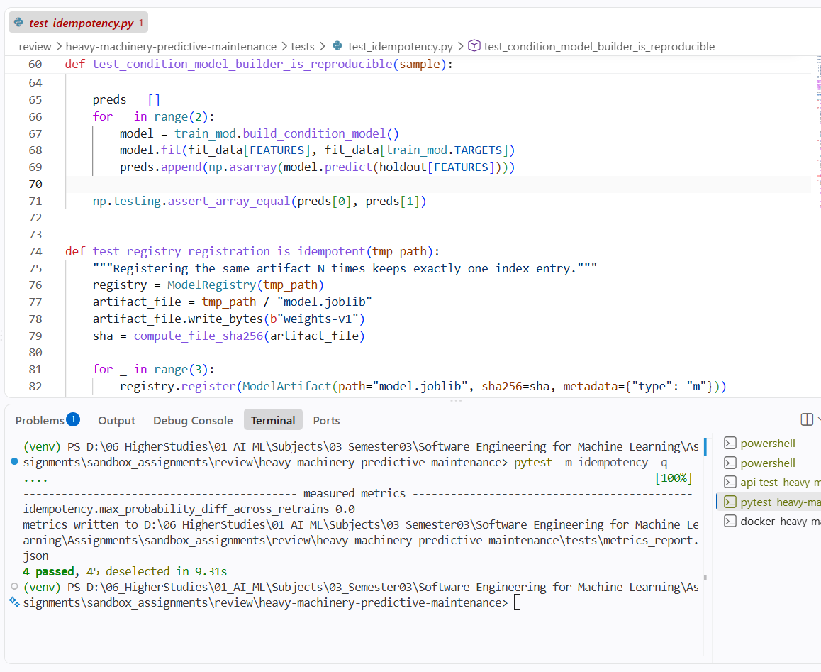

3.3 Task 8 — Model-quality and data-quality metrics
a. Model quality — measured on a 20% stratified held-out split by train_and_save.py and persisted into model_registry/schema.json:
Target | Accuracy | Macro-F1
cooler_condition | 0.937 | 0.931
valve_condition | 0.890 | 0.884
pump_leakage | 0.936 | 0.914
accumulator_pressure | 0.881 | 0.875
stability_flag (real-time model) | 0.909 | —
Two metric families are used: accuracy (overall correctness) and macro-F1 (robustness to class imbalance across degradation levels — critical here because failure classes are rarer than healthy classes).
b. Data quality — src/quality/data_quality.py, measured on the shipped dataset (Note: A very slight variations observed during execution, however meets the expectations):
Metric | Definition | Measured value
Schema validation | 17 columns: presence, dtype family, physical ranges, allowed label sets | PASS — 0 violations
Missing-value rate | per-column NaN rate vs 5% budget | worst 0.0% (trainer additionally median-imputes defensively)
Drift (PSI) | first vs second half of fleet history, threshold 0.25 | pressure 0.014 · flow 0.012 · oil temp 0.014 · vibration 0.012 — all stable; injected +25 °C shift → 7.87, flagged
c. Time & space complexity (pytest -m performance) — measured on the production artifacts, gated by asserts, logged to tests/metrics_report.json (Note: this fluctuates during every execution, but not drastically – variation happens many times in terms of latency, however meets requirements):
Measurement | Value | Budget / observation
Single-reading inference latency (median of 30) | 41.8 ms | < 100 ms quality requirement fulfilled
Batched per-reading latency (200-row batch) | 0.26 ms | ~160× amortization → the scalability story of /predict/batch
API single-request latency (end-to-end incl. security + RAG) | 336 ms first-call / ~70 ms warmed | includes gateway, both models, advisor
Peak memory of one prediction (tracemalloc) | 0.14 MB | < 50 MB budget fulfilled
Artifact sizes | condition 58.8 MB · stability 0.56 MB | < 200 MB deployable budget fulfilled
Full training run (10,000 rows) | 22.4 s total — load 0.03 · impute 0.03 · fit-condition 17.8 · eval 1.2 · fit-stability 1.4 · save 1.8 | stage timings logged every run; --profile adds cProfile hotspots
Training profiling: Every training stage is wrapped in a StageTimer context manager; timings and tracemalloc peak memory are logged and persisted into schema.json["training_profile"]. Running python train_and_save.py --force --profile additionally writes the top-25 cProfile hotspots to model_registry/training_profile.txt.
Sample profiling execution:
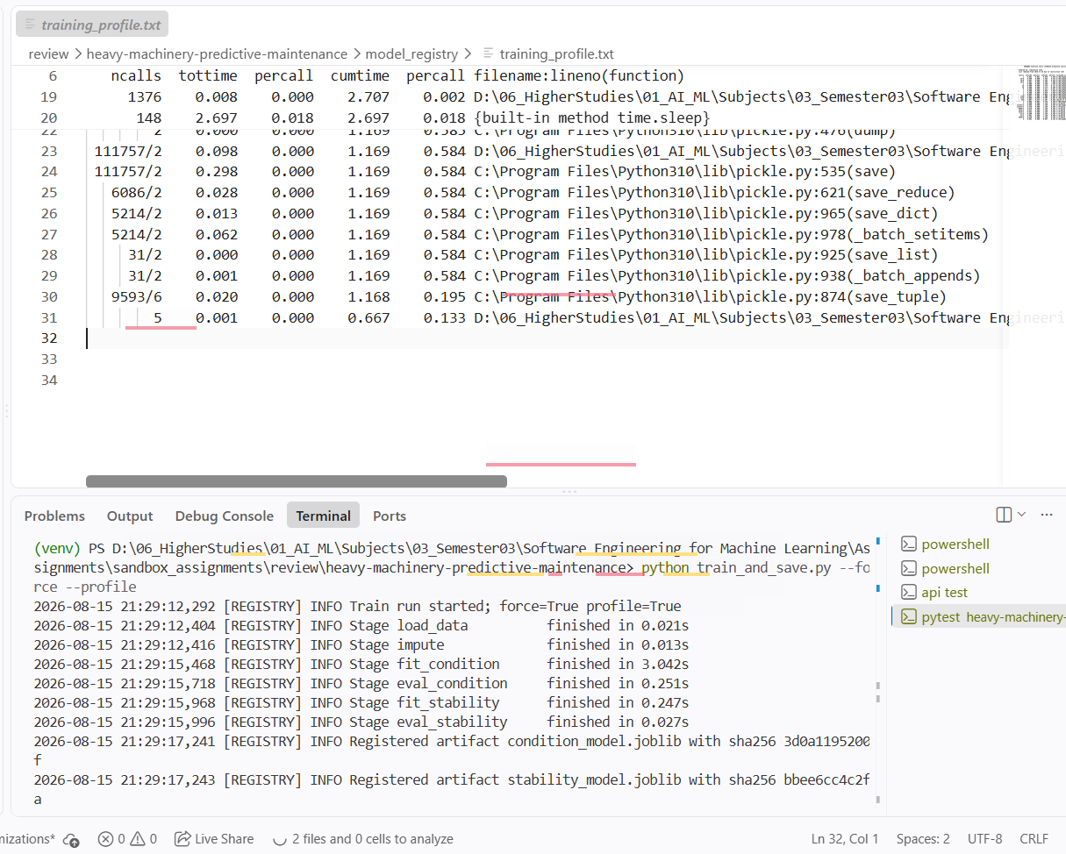
Note: Results won’t be available in github repository since it is ignored from pushing changes. This is done during training pipeline.

3.4 Task 9 — Testing in production & security consideration
Since this is more of a descriptive activity, we did not go to the implementation for the deployment.
Production experimentation — shadow deployment, then canary. Wrong predictions carry asymmetric costs here (a missed failure strands a machine in the field), so a new model first runs in shadow mode: the API keeps serving the current registry version while the candidate receives a mirrored copy of every /predict request and its outputs are only logged. Ground truth (component condition found at service time) arrives with delay, so shadow predictions are joined against maintenance records and compared offline on the same metrics we persist today (accuracy, macro-F1) — with zero user impact. Once the candidate matches the champion, a canary release routes a small slice (one machine type, ~5% of traffic) to it behind the same API contract, monitored on the per-request latency and stability rate we already log, plus the PSI drift monitor from src/quality. The checksummed model registry makes rollback a one-line revert to the previous artifact.
Security consideration — input validation against adversarial/corrupted inputs (implemented). Every reading passes validate_sensor_payload with HYDRAULIC_BOUNDS: each value must be a finite number inside its physically plausible envelope, or the request dies with HTTP 400 before touching the model — blocking NaN/Inf payloads, out-of-distribution probes and type-confusion attempts. Defence in depth around it, all implemented and tested: API-key authentication, per-client rate limiting (30 req/s), SHA-256 registry verification (a tampered artifact refuses to load — tested in test_up_to_date_guard_detects_current_missing_and_tampered), and a hash-chained, tamper-evident audit trail.

4. How to run
Prerequisites: Docker (Option A) or Python 3.10+ and Node 18+ (Option B).
git clone <repo-url>
cd heavy-machinery-predictive-maintenance-pipeline
docker compose up --build
Wait for both images to build (the backend image trains the models during the build, so the API starts instantly). Then:
- Step 1 — open http://localhost:5173 (the web app).
- Step 2 — pick a preset (Healthy / Degraded) or enter sensor values:
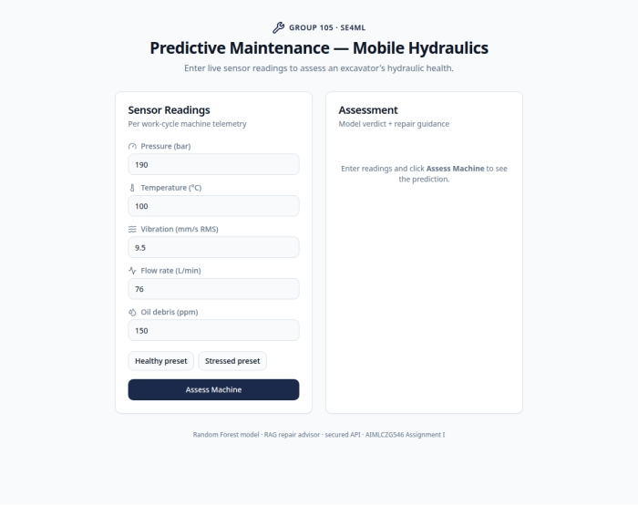
Step 2 — sensor input form
- Step 3 — click Assess Machine and read the verdict: per-component status, stability, and the retrieved repair procedure:
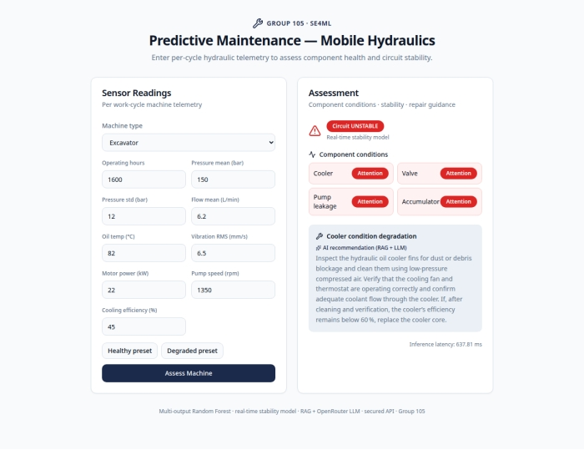
Step 3 — prediction with RAG repair guidance
Option B — run locally without Docker
# 1. environment
python3 -m venv venv && source venv/bin/activate
pip install -r requirements-api.txt
# 2. train once (idempotent — safe to re-run; ~22 s)
python train_and_save.py
# [TRAIN] INFO Stage fit_condition finished in 17.754s
# [TRAIN] INFO Training complete in 22.38s (peak traced memory 12.4 MB)
# 3. serve the API
uvicorn api_server:app --reload --port 8000
# [API] INFO Verified condition_model.joblib integrity
# [API] INFO API initialized with 5 machine types and 4 targets
# 4. (separate terminal) frontend
cd frontend && npm install && npm run dev

Running the QA suite
pip install -r requirements-notebook.txt httpx
python -m pytest tests/ -q # 49 passed, metrics table printed at the end
python -m pytest -m performance -q # any single classification

5. Evidence index (in repository)

Access points (once running):
What | Where | Notes
Web dashboard | http://localhost:5173 | presets for healthy/degraded machines
API base | http://localhost:8000 | JSON; API key header x-api-key (default dev key fleet-ops-secret-key, override via HYDRAULICS_API_KEY)
Swagger UI | http://localhost:8000/docs | browse + execute every endpoint
Liveness | http://localhost:8000/health | also used by the Docker health check

Artifact | Path
Lint reports before/after | docs/lint/flake8_before.txt, flake8_after.txt, black_before.txt, black_after.txt, isort_before.txt, isort_after.txt
Pytest report (37 passed) | docs/lint/pytest_report.txt
Model metrics | model_registry/schema.json
Research notebook | notebook/105.ipynb
Production package | src/, train_and_save.py, api_server.py
New QA modules/tests | src/quality/, tests/test_ml_training.py, tests/test_ml_inference.py, tests/test_data_quality.py
App screenshots | docs/screenshots/

