AIMLCZG546 — Software Engineering for Machine Learning
Assignment II — Predictive Maintenance in Mobile Hydraulic Systems

BITS Pilani — Work Integrated Learning Programmes

M.Tech. Artificial Intelligence & Machine Learning
Course: AIMLCZG546 — Software Engineering for Machine Learning

Assignment II
Work Title: Predictive Maintenance in Mobile Hydraulic Systems
GitHub repository: heavy-machinery-predictive-maintenance-pipeline

Group No. 105

Group Member Names with Contribution
Sl. No | BITS ID | Name | Contribution of team member (Qualitative) | Percentage Contribution (Out of 100)
1 | 2024AC05744 | Srinivasan R | Code refactoring into OOP modules (src/core, src/api), Model Registry design, architectural patterns, code review and system integration. | 100%
2 | 2024AC05100 | Vineet Kumar | Docker-based deployment of API + frontend, CI support, linting/formatting toolchain (black, isort, flake8) and lint reports. | 100%
3 | 2024AD05482 | Vibhav Sharma | Data-quality metrics module (schema validation, missing-value checks, PSI drift detection), production testing strategy write-up, report preparation. | 100%
4 | 2024AC05064 | Aman Kushwah | Model training/evaluation, FastAPI REST API, security layer, pytest test suite (unit, integration, ML training/inference and data-validation tests), documentation. | 100%

1. Introduction
This assignment builds on our Assignment I system: an IoT-based predictive-maintenance application for mobile hydraulic systems (excavators, telehandlers, backhoe loaders). The system ingests fleet telemetry (pressure, flow, oil temperature, vibration, motor power, pump speed, cooling efficiency), predicts the health of four hydraulic components (cooler, valve, pump, accumulator) plus an overall stability flag, and serves the results through a FastAPI backend with a React frontend and a RAG-based maintenance advisor.
Assignment II focuses on implementation quality and testing/QA. This report walks through each requirement of the two objectives with evidence from the repository.
Repository layout (production package):
├── api_server.py # thin uvicorn entry point -> src/api/server.py
├── train_and_save.py # production training script -> model_registry/
├── src/
│ ├── api/server.py # FastAPI REST API (endpoints, schemas, status codes)
│ ├── core/model_registry.py # on-disk model registry w/ SHA-256 integrity
│ ├── core/pipeline.py # pipe-and-filter composition helpers
│ ├── ml/train.py # modular training pipeline
│ ├── quality/data_quality.py # schema / missing-value / drift metrics (NEW)
│ ├── rag/maintenance_advisor.py # TF-IDF retriever + advisor
│ └── security/security_layer.py # auth, validation, rate limit, audit
├── tests/
│ ├── test_predictive_maintenance.py # unit + integration tests
│ ├── test_ml_training.py # ML training tests (NEW)
│ ├── test_ml_inference.py # ML inference tests (NEW)
│ └── test_data_quality.py # data-validation tests (NEW)
├── notebook/105.ipynb # research notebook (Assignment I prototype)
├── data/hydraulic_fleet_telemetry.csv
├── docs/lint/ # before/after lint + pytest reports
└── docker-compose.yml, Dockerfile, frontend/

2. Objective 1 — Implementation and Code Sharing

2.1 Task 1 — Refactoring with OOP / functional principles
The application is decomposed into single-responsibility modules under src/, combining OOP (classes for stateful components) with functional style (pure functions for stateless computations):
Module | Responsibility | Principle / Pattern
src/ml/train.py | Data ingestion, preprocessing, model training | Pipeline pattern (sklearn.Pipeline + ColumnTransformer), pure main()
src/core/model_registry.py | Artifact registration + SHA-256 integrity index | Model Registry pattern, @dataclass ModelArtifact, single responsibility
src/api/server.py | REST inference service | Layered architecture; Pydantic schemas as DTOs
src/security/security_layer.py | Auth, input validation, rate limiting, audit | Facade (SecureInferenceGateway) composing ApiKeyAuthenticator, RateLimiter, AuditTrail
src/rag/maintenance_advisor.py | Knowledge-base retrieval for repair guidance | Strategy-style retriever (TfidfRetriever), immutable Document dataclass
src/quality/data_quality.py | Schema, missing-value and drift metrics | Pure functions + DataQualityReport dataclass
Top-level shims (src/model_registry.py, src/security_layer.py, src/maintenance_advisor.py) are thin facades that re-export the concrete implementations, so callers depend on stable import paths while implementations can evolve independently.
Example — the registry artifact as an immutable value object plus a single-responsibility registry class (src/core/model_registry.py):
@dataclass
class ModelArtifact:
path: str
sha256: str
metadata: dict[str, Any]
class ModelRegistry:
"""Minimal on-disk model registry for the hydraulic predictive-maintenance system."""
def register(self, artifact: ModelArtifact) -> None: ...
def get(self, path: str) -> ModelArtifact | None: ...
def list(self) -> dict[str, Any]: ...

2.2 Task 2 — Research code vs production code
We demonstrate the contrast on the model-training component, which exists in both forms in the repository:
Aspect | Research code — notebook/105.ipynb | Production code — train_and_save.py + src/
Purpose | Exploration: EDA, feature experiments, model comparison | Repeatable artifact production for the API
Structure | Linear cells, global state, inline plots | Functions/classes, main() entry point, importable modules
Reproducibility | Depends on cell execution order | Deterministic script: python train_and_save.py; DVC stage (dvc.yaml) pins data + code deps
Error handling | None — exceptions surface in the cell | Explicit checks (dataset presence, artifact load failures) with logging and meaningful exceptions
Outputs | Transient (in-memory, plots) | Versioned artifacts in model_registry/ with SHA-256 checksums + schema.json contract
Testing | Manual visual inspection | pytest suite (37 tests), lint-clean under flake8/black/isort
Interface | A human reading the notebook | The FastAPI service and CI consume the artifacts
The notebook remains the system of record for experiments; the src/ package is the system of record for behaviour. The training logic promoted to production was rewritten with schema contracts (model_registry/schema.json) so the API never hard-codes feature lists.

2.3 Task 3 — Error handling and logging
Python’s logging module is configured in four critical modules, each with a distinct tag and meaningful levels:
Module | Logger | INFO | WARNING | ERROR
src/api/server.py | [API] | request received / completed, artifact verification | prediction blocked by security layer | missing artifacts, SHA mismatch, load failure (logger.exception)
src/security/security_layer.py | hydraulics.security | guarded predict lifecycle | — (violations raise SecurityError) | auth/validation failures
src/core/model_registry.py | [REGISTRY] | artifact registered | — | —
src/quality/data_quality.py | [DATA-QUALITY] | checks passed with measured rates | missing-rate budget exceeded, drift detected | schema violations, fully-missing column
Errors are typed: the security layer raises SecurityError, the data-quality module raises DataQualityError, and the API converts security failures into HTTP 400 responses rather than crashing:
try:
clean = _gateway.guarded_predict(client_id="frontend", api_key=x_api_key,
payload=payload, predict_fn=predict_fn,
bounds=HYDRAULIC_BOUNDS)
except SecurityError as e:
logger.warning("Prediction blocked: %s", str(e))
raise HTTPException(status_code=400, detail=str(e))
Example log line from the data-quality module (WARNING level firing on injected drift during tests):
2026-08-12 17:51:41 [DATA-QUALITY] WARNING Drift detected on oil_temp_mean_c: PSI=1.877 (threshold 0.25)

2.4 Task 4 — Code formatting and linting (before / after)
Toolchain: flake8 (linting), black (formatting), isort (import ordering), run over src/, tests/, api_server.py, train_and_save.py. Full reports are committed under docs/lint/.
Before (docs/lint/*_before.txt):
flake8 : 20 violations (F401 unused imports, E501 long lines, E402 imports
not at top, E702 multiple statements, E225 spacing, E741 ambiguous name)
black : "8 files would be reformatted, 11 files would be left unchanged."
isort : 7 files with incorrectly sorted imports
Representative flake8-before excerpt:
src/api/server.py:26:1: F401 'src.security_layer.validate_sensor_payload' imported but unused
src/api/server.py:102:36: E702 multiple statements on one line (semicolon)
src/rag/maintenance_advisor.py:121:39: E741 ambiguous variable name 'l'
train_and_save.py:57:1: E402 module level import not at top of file
Actions: isort --profile black and black --line-length 100 applied to the whole codebase; remaining semantic issues (unused imports, ambiguous variable name, import placement) fixed by hand.
After (docs/lint/*_after.txt):
flake8 : 0 violations
black : "24 files would be left unchanged."
isort : clean (no errors)

2.5 Task 5 — REST API design (FastAPI)
src/api/server.py exposes the inference functionality with explicit request/response schemas and status codes. Interactive documentation is auto-generated at http://localhost:8000/docs.
Endpoint | Method | Request schema | Response schema | Status codes
/health | GET | — | service status, model SHA-256, targets, machine types | 200
/predict | POST | SensorReading (10 typed fields with examples) | PredictionResponse (per-component results, stability, RAG guidance, latency) | 200; 400 invalid API key / out-of-range input; 422 malformed body (FastAPI validation)
Good-practice elements:
- Typed contracts: Pydantic models (SensorReading, ComponentResult, PredictionResponse) validate every request and serialize every response.
- Meaningful status codes: security violations → 400 with a clear detail; schema violations → 422 automatically; healthy service → 200.
- Security at the boundary: API-key header, per-client rate limiting, physical-bounds input validation and an audit trail wrap every prediction.
- Operational hygiene: model warm-up at startup, artifact SHA verification before serving, latency reported in every response, CORS configured for the frontend, Docker health check on /health.
Application screenshots (frontend consuming the API):
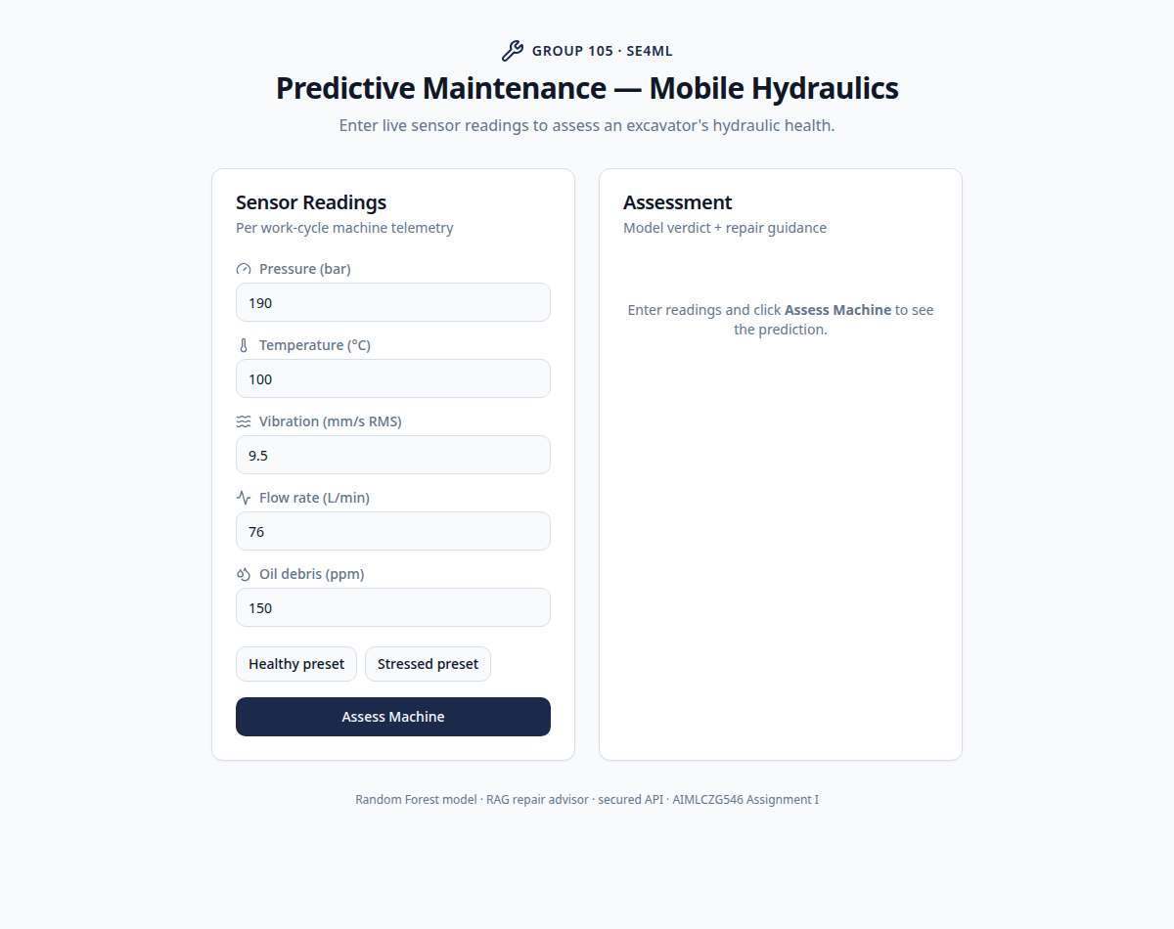
Sensor input form
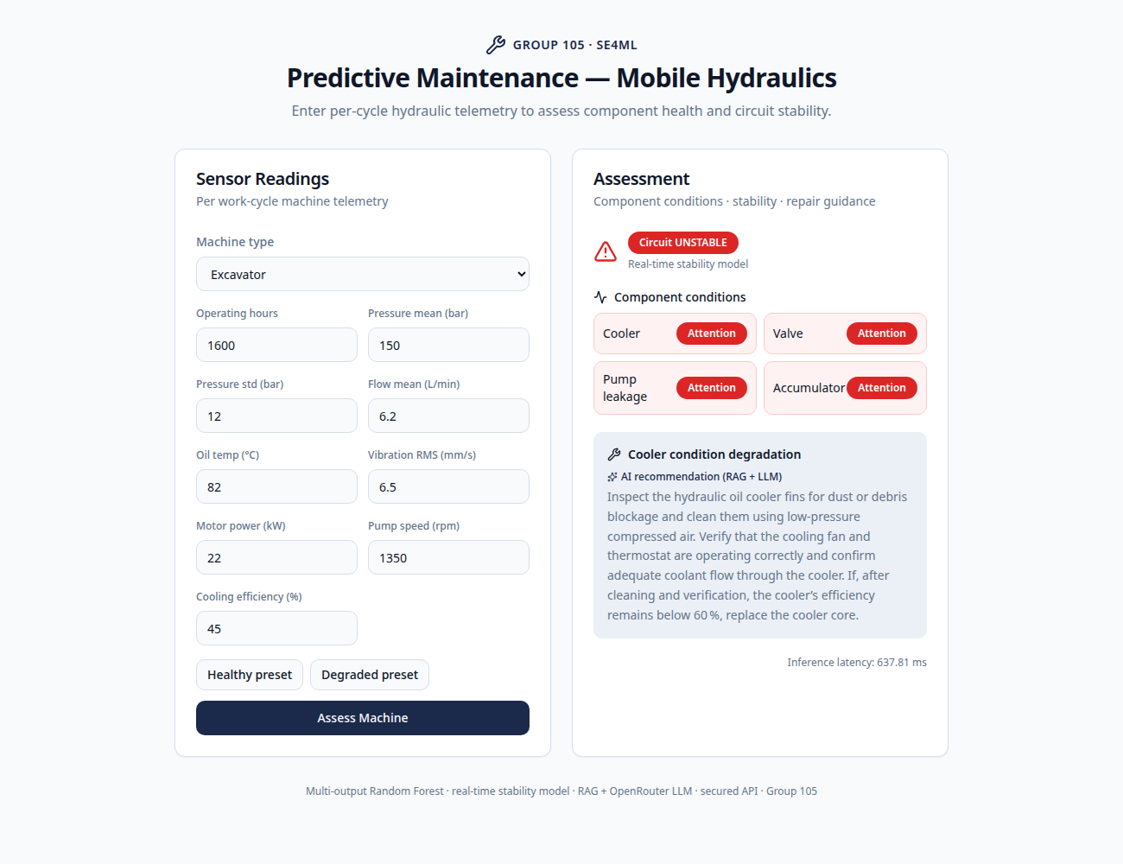
Prediction result with RAG guidance

3. Objective 2 — Quality Assurance

3.1 Task 6 — Test types implemented with pytest
The suite contains 37 tests across three distinct types (evidence: docs/lint/pytest_report.txt, 37 passed):
- Unit tests (tests/test_predictive_maintenance.py) — security primitives in isolation: input validation, API-key auth, rate limiter, SHA-256 model integrity, tamper-evident audit trail, TF-IDF retriever ranking.
- Integration tests (same file, TestClient(app)) — the real FastAPI app with real trained artifacts: /health liveness and /predict rejecting a bad API key end-to-end through the security gateway.
- Data-validation tests (tests/test_data_quality.py) — the shipped dataset against the schema, injected corruption, missing-value budgets and drift detection (details in 3.3).

3.2 Task 7 — ML-specific tests
7a. Model training (tests/test_ml_training.py):
- test_model_can_overfit_small_batch — a high-capacity RandomForest must reach ≥99% accuracy on a 64-row batch; failure indicates broken features/labels or a mis-wired training loop.
- test_training_loss_decreases_with_iterations — training log-loss over GradientBoostingClassifier.staged_predict_proba must be monotonically non-increasing and end below its starting value.
- test_production_pipeline_beats_majority_baseline — the exact production preprocessing+model pipeline must beat the majority-class baseline on held-out data, proving end-to-end learning.
7b. Model inference (tests/test_ml_inference.py):
- Shape/range checks — the multi-output condition model returns shape (n, 4) with classes inside each target’s label set; stability predict_proba lies in [0, 1] and rows sum to 1.
- Invariance tests — identical inputs give identical outputs (determinism), and an unseen machine_type (“MoonCrawler-9000”) is handled gracefully by OneHotEncoder(handle_unknown="ignore") instead of crashing.
- Directional test — severely degraded sensors (oil 95 °C, vibration 12 mm/s, cooling 25%) must not decrease the predicted instability probability relative to a healthy reading.

3.3 Task 8 — Model-quality and data-quality metrics
a. Model quality — measured on a 20% stratified held-out split by train_and_save.py and persisted into model_registry/schema.json:
Target | Accuracy | Macro-F1
cooler_condition | 0.937 | 0.931
valve_condition | 0.890 | 0.884
pump_leakage | 0.936 | 0.914
accumulator_pressure | 0.881 | 0.875
stability_flag (real-time model) | 0.909 | —
Two metric families are used: accuracy (overall correctness) and macro-F1 (robustness to class imbalance across degradation levels — critical here because failure classes are rarer than healthy classes).
b. Data quality — implemented in src/quality/data_quality.py and measured on the shipped dataset (10,000 cycles):
Metric | Definition | Measured value
Schema validation | 17 columns: presence, dtype family, physical ranges (e.g. oil temp within −20…130 °C) and allowed label sets | PASS — 0 violations
Missing-value rate | per-column NaN rate vs 5% budget | worst rate 0.0% (training additionally median-imputes noisy sensor columns defensively)
Drift (PSI) | Population Stability Index, first half of fleet history vs second half; threshold 0.25 | pressure 0.014, flow 0.012, oil temp 0.014, vibration 0.012 — all stable
The same PSI metric fires correctly when drift is injected in tests (+25 °C fleet-wide oil-temperature shift → PSI = 1.88 > 0.25, flagged with a WARNING log).

3.4 Task 9 — Testing in production & security consideration
Production experimentation approach — shadow deployment, then canary. For a maintenance system, wrong predictions have asymmetric costs (a missed failure strands a machine in the field), so we would first deploy a new model in shadow mode: the API keeps serving the current model_registry version while the candidate model receives a mirrored copy of every /predict request and its outputs are only logged. Because ground truth (actual component condition found at service time) arrives with delay, shadow predictions are joined against maintenance records to compare accuracy/macro-F1 offline — with zero user impact. Once the candidate matches or beats the champion, a canary release routes a small slice of fleet traffic (e.g. one machine type, 5% of requests) to it behind the same API contract, monitored on the metrics we already log per request (latency, stability rate, audit trail) and on the PSI drift monitor from src/quality. Docker + the model registry make rollback a one-line revert to the previous checksummed artifact.
Security consideration — input validation against adversarial/corrupted inputs (implemented). Every /predict request passes through validate_sensor_payload with HYDRAULIC_BOUNDS: each sensor value must be a finite number inside its physically plausible range, otherwise the request is rejected with HTTP 400 before it ever reaches the model. This blocks NaN/Inf payloads, out-of-range values that would push the model far outside its training distribution, and type-confusion attacks. Defence in depth around it: API-key authentication, per-client rate limiting (30 req/s) against scraping/DoS, SHA-256 registry verification so tampered model artifacts refuse to load, and a hash-chained audit trail making prediction history tamper-evident.

4. How to run
# full stack (frontend + API):
docker compose up --build # frontend :5173, API docs :8000/docs
# training (produces model_registry/):
python train_and_save.py
# tests:
pytest -q # 37 passed
# lint gates:
flake8 --max-line-length=100 src tests api_server.py train_and_save.py
black --check --line-length 100 src tests api_server.py train_and_save.py
isort --check-only --profile black --line-length 100 src tests

5. Evidence index (in repository)
Artifact | Path
Lint reports before/after | docs/lint/flake8_before.txt, flake8_after.txt, black_before.txt, black_after.txt, isort_before.txt, isort_after.txt
Pytest report (37 passed) | docs/lint/pytest_report.txt
Model metrics | model_registry/schema.json
Research notebook | notebook/105.ipynb
Production package | src/, train_and_save.py, api_server.py
New QA modules/tests | src/quality/, tests/test_ml_training.py, tests/test_ml_inference.py, tests/test_data_quality.py
App screenshots | docs/screenshots/

