Azure MCP Server Agent

# Overview

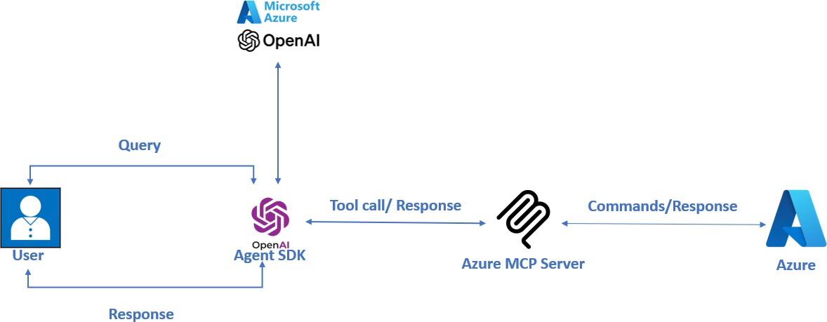

The application provides an interactive interface where users can:

1. Connect to Azure services using natural language commands
2. List Azure resources (Storage, Cosmos DB, etc.)
3. Execute Azure CLI commands
4. Query and explore Azure resources without remembering syntax

# Prerequisites

Before you begin, ensure you have the following installed:

* + Python 3.10 or higher
  + Node.js and npx (for the MCP Azure server)
  + Azure subscription with appropriate permissions
  + Azure CLI
  + OpenAI API key
  + uv package manager (faster alternative to pip)

# Project Setup

## Installing uv Package Manager

If you don't have uv installed yet:

pip install uv

## Creating a Project Environment

Create a new project environment using uv:

uv init azure-mcp-assistant cd azure-mcp-assistant

## Installing Required Packages

Install all required packages using uv:

uv add python-dotenv openai-agents==0.0.12 "mcp[cli]>=1.6.0"

## Environment Configuration

Create a .env file in your project directory with the following configuration:

OPENAI_API_KEY=your_openai_api_key

## Running the Application

1. Place the app.py file in your project directory.
2. Ensure you're logged in to Azure CLI:

az login

1. Run the application:

python app.py

1. Enter your queries when prompted

## Example Queries

* + "List my Azure storage accounts"
  + "Show me all my Cosmos DB databases"
  + "List my resource groups"
  + "Show me the tables in my Storage account"
  + "Query my Log Analytics workspace"
  + "List my App Configuration stores"

# Understanding the Code

Let's break down the main components of the app.py script:

## Imports and Configuration

import os import asyncio

from agents import Agent, Runner

from agents.mcp import MCPServerStdio

This section imports necessary libraries and loads environment variables from your .env file.

## MCP Azure Server

async with MCPServerStdio( name="Azure MCP Server",

params={"command": "npx", "args": ["-y", "@azure/mcp@latest", "server", "start"]},

) as server:

This configures the Model Context Protocol (MCP) server for Azure access. The server allows the application to interact with your Azure resources.

## Agent Setup

agent = Agent( name="Assistant",

instructions="You are a helpful assistant. Use the available tools to answer the user's questions about Azure resources and services.",

mcp_servers=[mcp_server]

)

This creates an agent with access to Azure MCP tools and the specified Azure OpenAI model.

## Main Application Loop

The run() function establishes connections and handles user interaction:

async def run(mcp_server: MCPServerStdio): # Implementation details

This function:

* + Sets up an agent with Azure MCP tools
  + Manages the chat loop, handling user input and displaying responses
  + Maintains conversation history

# Technical Details

## Authentication Methods

The Azure MCP Server uses Azure Identity's DefaultAzureCredential, which tries these credentials in order:

1. Environment Variables
2. Shared Token Cache
3. Visual Studio Credentials
4. Azure CLI (Recommended)
5. Azure PowerShell
6. Azure Developer CLI
7. Interactive Browser

## MCP Azure Tools

The application provides access to these Azure services:

### Azure Resource Management

* + List and manage resource groups
  + Manage individual resources

### Azure Storage

* + List storage accounts
  + Manage blob containers and blobs
  + Work with storage tables

### Azure Cosmos DB

* + List accounts and databases
  + Execute SQL queries against containers

### Azure Monitor

* + Query logs using KQL
  + List available tables and workspaces

### Azure App Configuration

* + Manage key-value pairs
  + Handle labeled configurations

### Azure CLI Integration

* + Execute any Azure CLI command directly