Predicting Book Popularity And Suggestion With Visual Features

Srinidhi.D Department Of Computing *(of Affiliation)*  
Coimbatore Institute Of Technology *(of Affiliation)*Coimbatore,INDIA  
srinidhidevaraj12@gmail.com

s

*Abstract*— **The Rapid advancement of smart devices has enabled people to be able to read books through their devices anytime and anywhere.The world of information has opened up many boundaries to delve into customer interests over the internet. The people are anticipating businesses to access and gratify them with their anticipations and wants. The suggestion process is essential to overcome the choice overloading complication by suggesting a book of interest to users. Here, when a user uses the system for the first time and not yet provided any information about him/her, the system may not be able to bring forth customized suggestions for that user. In such a *Cold* *Start* situation, many real-world suggestion systems suggest popular books to the new user. Those books are very acceptable to be interesting to new users. This cold-start complication customarily arises when the system does not have any information about the users and on books. The idea behind this paper is to employ machine learning algorithms for predicting the popularity of online books. However, there exists thousands of online books said to be Long Tail that remain stagnant ion the webserver for years that are concealed by users because of its least rating. The recommender system builds using machine learning algorithms in this paper uses a rating-based unhoarding technique that favors not only top-rated books to get recommended, but also recommend Long-Tail books. The dataset for analyzing and predicting is taken from Kaggle datasets. The idea behind examining this dataset is to get a fair idea about the relationships between the multiple attributes a book might have, such as the aggregate rating of each book, the trend of the authors over the years and books with numerous languages. With over a hundred thousand ratings, some books just tend to become popular as each day seems to pass. And also consider the magical persona books seem to hold, and to step out on a journey to see what kind of books drives people to read in this era of modern smart devices. This paper focuses on employing Exploratory Data Analysis techniques to find the popularity of the books based on user ratings and anticipated to provide a suggestion system with the best accuracy. As known random forests, is acclimated to develop prediction models here in this case random forest, is used to build a forest of random uncorrelated decision trees with the available attributes in the dataset to arrive at the result that defines well the attributes available. The clustering algorithms are to be used to find out the books that are highly liked and would be recommendable for the new users. Hence by using above and more algorithm some interesting aspects of this book datasets have been identified. And so, as observed on ratings are rather small, suggesting that book rating is mainly driven by other aspects, hopefully including the quality of the book itself. Here the next task is to frame a suggestion list of available books to easily help the new users. For this purpose of personalized suggestion Collaborative Filtering techniques can be used which is a standard method for product suggestions. By using CF algorithms, a perfect suggestion system with the best accuracy will be developed as a solution for cold start problems of the user.**

*Keywords— Exploratory Data Analysis, Clustering Algorithm, Random Forest and Collaborative Filtering Algorithms.*

Introduction

A Recommendation Engine, in real definition can be alluded to as a framework that can keep running on grouped/non bunched condition taking client online impression as one of its info set and creating a plausible impression for the client accordingly giving its clients a forecast nearer to the real world. Proposal frameworks were advanced as shrewd calculations, which can produce brings about the type of suggestions to clients. They decrease the overhead connected with settling on best decisions among the bounty. Presently, Recommender frameworks can be actualized in any space from E-business to arrange security as customized administrations. They give advantage to both the purchaser and the maker, by proposing things to customers, which can't be requested until the suggestions. Suggestion framework attempts to foresee the enthusiasm of a client and prescribe items that match their enthusiasm as precisely as could be expected under the circumstances. Additionally, web-based business will be benefitted by the expansion of offers which will clearly happen when the client is given more things that he/she would likely find to coordinate the intrigue. There are fundamentally two methodologies for Recommendation System:

Collaborative filtering: This methodology fabricates a model from a client's past conduct just as comparative choices made by different clients to anticipate things that the client may have an enthusiasm for.

Content-based filtering: In content-based filterings approach the attributes of a thing are investigated to prescribe things to the client. A recommender stage with the blend of every one of these strategies is additionally conceivable. It is known as a Hybrid Recommender System. Various strategies have been developed after some time to give precise suggestions. Aside from the customary separating strategies, different methodologies are being received. Philosophy based suggestions , Demographic-based proposals have picked up significance lately. It streamlines the clients work along these lines making it valuable for both the client just as the vendor. They likewise help the clients to deal with their perusing list by knowing their inclination. Suggestion framework attempts to anticipate the enthusiasm of a client and prescribe items that match their enthusiasm as precisely as could be expected under the circumstances. Likewise, online business will be benefitted by the expansion of offers which will clearly happen when the client is given more things that he/she would likely find to coordinate the intrigue. In the proposed book suggestion motor, books will be shown by the readers‟ inclinations in a various leveled approach to arrange readers‟ enthusiasm for various kinds, the users‟ example of looking through changed books and to shape a powerful arrangement of decides dependent on that. New books will be properly displayed by users‟ needs. Over the most recent couple of years the utilization of suggestion framework has been expanded in light of the fact that by utilizing a few methods it furnishes client with the chose and intrigued things of utilization and show them on the highest point of rundown as indicated by client decision of intrigue. This procedure of related things and significant highlights or prerequisites are useful in recommending client as indicated by likenesses which he looked through ordinarily. Proposal strategy is helpful in giving recommendations which are reasonable to clients. 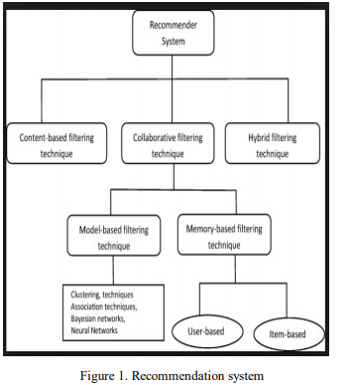 Each recommender framework contains two substances, one is client and other is thing. A client can be any client or purchaser of any item or things, who get the proposals. Contribution to proposal calculation can be a database of client and things and yield mindlessly will be the suggestions. As for our situation, inputs comprise of database of clients and database of books and yield indicates the book suggestions. An assortment of procedures has been proposed till today for performing suggestions. The systems, for example, content-based, community, learning based and statistic are utilized for suggestions. Now and then, the highlights of these strategies are consolidated in half and half recommenders to improve the exhibition of proposal motor. This paper displays another methodology for prescribing books to the purchasers. This framework joins the highlights of substance separating, shared sifting to create proficient and viable suggestions.

# issues or challenges faced by recommendation system

*A. Cold-start problem:*

It's hard to offer suggestions to new clients as his profile is practically unfilled and he hasn't evaluated any things yet so his taste is obscure to the framework. This is known as the virus start issue. In some recommender frameworks this issue is fathomed with overview when making a profile. Things can likewise have a virus start when they are new in the framework and haven't been appraised previously. Both of these issues can be additionally illuminated with half and half approaches.

*B. Trust*:

The voices of individuals with a short history may not be that pertinent as the voices of the individuals who have rich history in their profiles. The issue of trust emerges towards assessments of a specific client. The issue could be explained by dispersion of needs to the clients.

*C. Scalability*:

With the development of quantities of clients and things, the framework needs more assets for preparing data and shaping suggestions. Dominant part of assets is overwhelmed by the reason for deciding clients with comparative tastes, and products with comparative depictions. This issue is additionally explained by the mix of different sorts of channels and physical improvement of frameworks. Portions of various calculations may likewise be executed disconnected so as to quicken issuance of proposals on the web.

*D. Sparsity:*

In online shops that have an immense number of clients and things there are quite often clients that have evaluated only a couple of things. Utilizing synergistic and different methodologies recommender frameworks by and large make neighborhoods of clients utilizing their profiles. In the event that a client has assessed only scarcely any things, at that point it's really hard to decide his taste and he/she could be identified with an inappropriate neighborhood. Sparsity is the issue of absence of data.

*E. Privacy:*

Protection has been the most significant issue. So as to get the most precise and right suggestion, the framework must procure the most measure of data conceivable about the client, including statistic information, and information about the area of a specific client. Normally, the subject of unwavering quality, security and classification of the given data emerges. Numerous online shops offer compelling insurance of security of the clients by using particular calculations and projects.

# Existing system

Following are a portion of the current book suggestion motors utilized by the first-class book acquiring sites. The current motors utilize ordinary calculations for suggestions.

In Content based Recommendation Engine, framework creates proposals from source dependent on the highlights related with items and the client's data. Content-based recommenders treat proposal as a client explicit arrangement issue and become familiar with a classifier for the client's preferences dependent on item includes.

In Collaborative Recommendation Engine, recommendations are created based on appraisals given by gathering of individuals. It finds peer clients with a rating history like the present client and produces proposals for the client. In Context based Recommendation Engine, framework requires the extra information about the setting of thing utilization like time, temperament and conduct viewpoints. This information might be utilized to improve the proposal contrasted with what could be performed without this extra wellspring of data.

# proposed system

The possibility of the framework is to build up a proposal motor that can prescribe books to the clients with expanded precision by breaking down the enthusiasm of the client and highlights of the books. The informational collection considered is an enormous arrangement of books which is a major information. The proposed model attempts to dispense with the issues like virus start issue by utilizing statistic-based suggestion, overspecialization issue by utilizing model which attempts to foresee books so that the proposal rundown contains book which has not been investigated by the client yet.

## Architecture

The general design of the created framework is given beneath:

Another client needs to enlist himself in the framework by tapping the register connection present in the landing page. He needs to fill in the subtleties like email id, secret key, area, Age, calling in the register page and submit it. On accommodation the framework sidetracks to the landing page. At that point, the client needs to login with his enlisted email id and secret phrase to get to his record. After login, three choices are seen they are to include another book, to scan for a book and to get the suggestions. To include another book the client needs to tap on the "new book" interface where he can add book to the database by filling the subtleties like book-title, writer, ISBN, distributer and year of production. To look for a book the client needs to give the watchword present in the book title and snap on search. A rundown of books will be shown which will contain that catchphrase which the client has looked for. On clicking it he/she will be diverted to google page which comprise of different site selling that book and the audits for that book. To get the suggestion the client needs to tap the "Proposal "interface. On the off chance that the client is another client, he can rank a few books by tapping the given connection, he will be diverted to the underlying positioning page with the names of five books where he needs to give evaluations to each bookfive books where he needs to furnish appraisals to each book with the estimation of 0 to 10 and submit it. Subsequent to rating the book, he can enter his client id and submit it so as to get the suggestions. He will get the suggestion of two books each for dependent on past-likes, in view of Age, in light of area and dependent on client's preferred Author. The rundown of books that are shown under the proposal, are connections to the google page which contains the data of the site where the client can get the data about the cost of the book in various destinations. On the off chance that free digital book duplicate of the book is accessible he can download it.

## Techniques used

Suggestion procedures have various potential characterizations. The characterization depends on the wellsprings of information on which suggestion is based and the utilization to which that information is put. All in all, recommender frameworks have (I) foundation information, the data that the framework has before the proposal procedure starts, (ii) input information, the data that client must convey to the framework so as to produce a proposal, and (iii) a calculation that consolidates foundation and info information to land at its recommendations. The suggestion procedures are characterized into five kinds: 1] Collaborative. 2] Content based. 3] Demographic. 4] Utility based. 5] Knowledge based. In this paper, for the proposed book suggestion motor collective, content-based and statistic procedures are utilized. Following Table 1 gives outline of the proposal strategies. Expect that I is the arrangement of things over which suggestions may be made, U is the arrangement of clients whose inclinations are known, u is the client for whom proposals should be produced, and I is something for which we might want to anticipate u’s inclination.

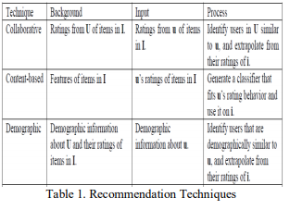

# recommendation techniques

There are many techniques used to build the recommendation system that is represented by the diagram below: 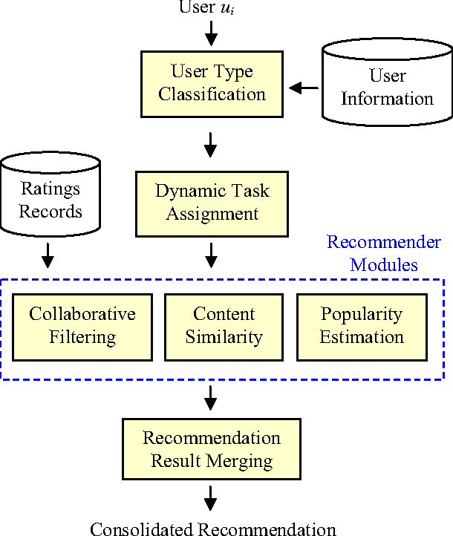

## Content-based Filtering Technique:

* Content-based filtering technique is utilized to investigations set of things that appraised before by the client or different clients that enthusiasm for to create a forecast.

This system utilized with a page, news to make some suggestion for the client. these proposals done dependent on the client assessment with some thing before. 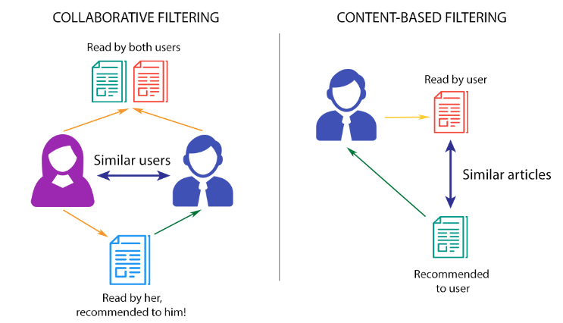

* To produce a significance full suggestion will utilize various kinds of models to discover the similitude between reports, for example, Vector Space Model, Probabilistic models and Neural Networks. In this proposal, we needn't bother with a client profile since it was finished by utilizing AI or factual investigation.
* The upside of this procedure is 1.Ensures protection that implies non-requirement for sharing the client profile. 2. The suggestion has finished with a brief period. 3. Suggest new things regardless of whether there is no rate in it.
* On the other hand, the weakness: 1. Content-put together separating depends with respect to the thing metadata. 2. restricted substance examination means need a point by point portrayal of the things. 3.Content overspecialization.

## Collaborative Filtering Technique

* This technique cannot easily describe by using meta data because it is a domain-independent prediction technique. This technique uses to build a database between the user-item as an array of performance for items by users then will calculate the similarity by matching the users with relevant items after that will make a recommendation based on the similarity result between users.
* Recommended item for the user depends on how similar users rate this item or other users rate another item. Moreover, this technique has two types: Model-based filtering technique that depends on the clustering techniques, association techniques, Bayesian network and neural network and Memory-based filtering technique: such as user-based, item-based. Also, it has some advantages, such as 1. Need the users rating to find the similarity between them to set the recommendation. 2.Display recommendation items that unknown user like or rate. 3. A new item can be suggested even if they are no rating.
* On the other hand, it has a disadvantage: 1. For the new user, the recommendation will not be provided correctly. 2. Items will not be recommended if there is no enough information to discriminate.

## Hybrid Filtering Technique

* This procedure is finished by joining numerous strategies to stay away from confinement in the frameworks. Along these lines, the outcome will be more exact instead of a solitary calculation.
* The subscript for the penetrability of vacuum 0, and other regular logical constants, is zero with subscript designing, not a lowercase letter "o".

Each method has shortcomings could be overwhelmed by whining it with another system. There are various approaches to do the mix: 1. Execute the calculations independently then will consolidate the outcome. 2. Utilize content-based sifting in the community oriented separating approach. 3. Utilize community sifting in content-based separating approach.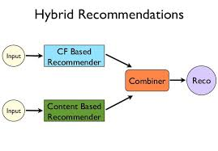

* Weighted: A weighted hybridization procedure joins the proposals of at least two suggestion frameworks by processing weighted totals of their scores.

• Switching: In this strategy, as indicated by the current, conditions framework chose one of the prescribed techniques. Exchanging half breeds require a prophet that chooses which recommender ought to be utilized in a particular circumstance, depending on the user profile and/or the quality of recommendation results.

• Mixed: A mixed hybridization methodology joins the aftereffects of various recommender frameworks at the degree of the UI, in which results from various strategies are exhibited together.

• Feature Combination: An element mix mixture is a solid proposal part that uses an assorted scope of info information.

• Feature Augmentation: Feature expansion is another solid hybridization structure that might be utilized to incorporate a few suggestion calculations. This half and half doesn't just join and pre-process a few kinds of info, but instead applies increasingly complex change steps. Truth be told, the yield of a contributing recommender framework enlarges the component space of the genuine recommender by pre-preparing its information sources.

•Cascade: Cascade half breeds depend on a sequenced request of procedures, where each succeeding recommender just refines the proposals of its ancestor. The proposal rundown of the successor procedure is in this way limited to things that were additionally suggested by the former system.

• Meta-level: In a meta-level hybridization plan, one recommender fabricates a model that is abused by the head recommender to make suggestions. Recommendation algorithm

To depict the model officially, let U be the arrangement of clients, I be the arrangement of things, FU be the arrangement of client highlights, and FI the arrangement of thing highlights. Every client communicates with various things, either in an ideal way (a positive cooperation), or in a troublesome way (a negative connection). The arrangement of all client thing cooperation sets (u; I) ɛU * I is the association of both positive S+ and negative collaborations S-. Users and things are completely portrayed by their highlights. Every client u is portrayed by a lot of highlights fu ɛ FU. Similar holds for everything I whose highlights are given by fi ɛ FI. The highlights are known ahead of time and speak to client and thing metadata. The model is parameterized as far as d-dimensional client and thing highlight implanting's eUf and eIf for each component f. Each component is additionally depicted by a scalar inclination term (bUf for client and bIf for thing highlights). The inactive portrayal of client u is given by the total of its highlights' idle vectors:



The same holds for item i:



The bias term for user u is given by the sum of the features' biases:



The same holds for item i:



The improvement objective for the model comprises in expanding the probability of the information restrictive on the parameters. The probability is given by: 

# exploratory data analysis

Exploratory Data Analysis was created by John Tukey at Bell Labs as a method for efficiently utilizing the instruments of measurements on an issue before a theory about the information were created. It is another option or inverse way to deal with "corroborative information investigation". The original portrayal of the procedure was in Tukey's 1977 book Exploratory Data Analysis. The goal is to comprehend the issue so as to produce testable speculations. All things considered, the results like the charts and synopsis measurements are just for you to improve your comprehension, not to exhibit a relationship in the information to a general group of spectators. This gives the deft flavour to the procedure.

Questions to be answered?

•Which are the books with most events in the rundown?

•What is the appropriation of books crosswise over dialects?

•Which are the main 10 most evaluated books?

•Which are the writers with generally books?

•Performance of a creator after some time:

O Stephen King

o Agatha Christie

o Dan Brown

o J.K. Rowling

•Which are the best 10 exceptionally evaluated creators?

•What is the rating dissemination for the books?

•Is there connection among appraisals and audit checks?

•Is there a connection between number of pages and appraisals?

•Is there a connection among appraisals and evaluations check?

•Which are the books with the most noteworthy audits?

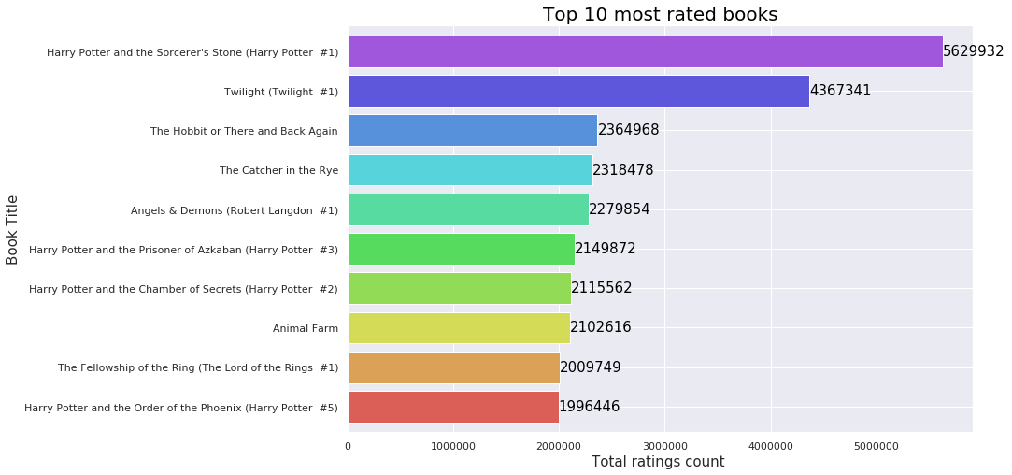

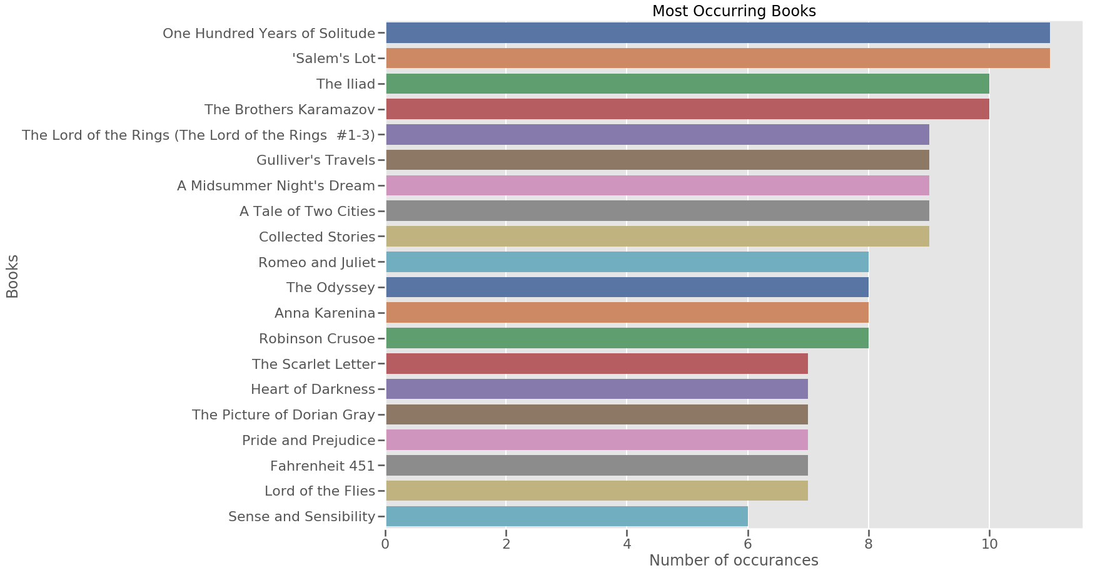

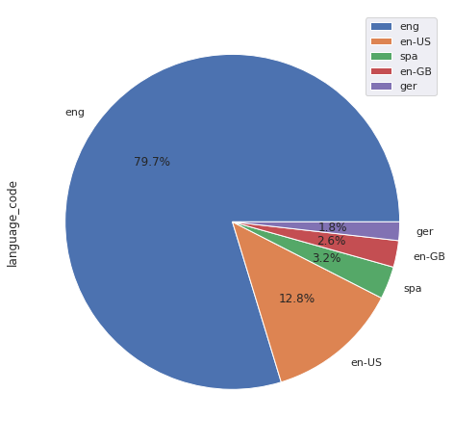

# discussion and conclusions

Recommender frameworks are an incredibly strong apparatus used to help the choice procedure simpler for clients. The executed book proposal motor is an able framework to prescribe Books for e-clients. This recommender framework will be an incredible web application actualized in Java language. Such kind of web application will be demonstrated gainful for the present high requesting internet obtaining sites. This cross-breed recommender framework is increasingly precise and proficient as it consolidates the highlights of different suggestion strategies. The book proposal motor will lessen the overhead connected with settling on the best selections of books among the bounty. This framework means to give customized proposal of books to the client. This framework thinks about huge information of books. The framework utilizes both substance based and cooperative separating calculation all together diminish the virus start issue and furnishes the client with proposal list. The framework attempts to anticipate the positioning by considering the thing's similitude just as client's comparability so a client can get proposals of new books. The objective of the most suggestion framework is to anticipate the purchaser's advantage and prescribes the books as needs be. This book suggestion has considered numerous parameters like substance of the book and nature of the book by doing synergistic separating of evaluations by different purchasers. This recommender framework additionally utilizes acquainted model to give more grounded suggestions. This framework doesn't have execution issue since it constructed the suggestions disconnected.

##### Acknowledgment

*Working on this project “*Predicting Book Popularity And Suggestion With Visual Features*” was a source of immense knowledge to us. We are very thankful to the Department of Computing for the golden opportunity to work on this project.*

##### References

[1] Z.‎ Zhang‎ and‎ S.‎ Qian,‎ “The‎ Research‎ of‎ E-commerce Recommendation System Based on Collaborative Filtering Technology,”‎ Advances‎ in‎ CSIE,‎ Vol.‎ 1,‎ AISC‎ 168,‎ SpringerVerlag Berlin Heidelberg, pp. 507–512, 2012.

[2] M. J.‎ pazzani‎ and‎ ‎ D.‎ billsus,‎ “content-based recommendation system,”‎ The‎ Adaptive‎ Web,‎ LNCS‎ 4321,‎ Springer-Verlag Berlin Heidelberg, pp. 325–341, 2007.

[3] A. Felfering, G. Friedrich and L. Schmidt-Thieme,‎ “Guest Editors' Introduction: Recommender Systems,”‎ IEEE‎ Intelligent systems, Volume 22 Issue 3, pp. 18–21, doi: 10.1109/MIS.2007.52 , May 2007.

[4] D. Jannach, M. Zanker, A. Felfernig and G. Friedrich, “Recommender‎ systems‎ :‎ an‎ introduction,”‎ Printed‎ in‎ the‎ United States of America, Cambridge University Press, 2011.

[5] W. Hill, L. Stead, M. Rosenstein, and G. Furnas, “Recommending and evaluating choices in a virtual community‎ of‎ use,”‎ In‎ Proceedings‎ of‎ ACM‎ CHI'95‎ Conference on Human Factors in Computing Systems, doi: 10.1145/223904.223929, Pages 194-201, New York, USA, 1995.

[6] S.K. Ko, S.M. Choi, H.S. Eom, J.W. Cha, H. Cho, L. Kim, and Y.S.‎ Han,‎ “A Smart Movie Recommendation System, “‎ Human‎ Interface, Part I, HCII 2011, LNCS 6771, Springer-Verlag Berlin Heidelberg, pp. 558–566, 2011.

[7] T. D. Pessemier, S. Coppens, K. Geebelen, C. Vleugels, S. Bannier, E. Mannens, K. Vanhecke, and L. Martens, “Collaborative‎ recommendations‎ with‎ content-based filters for cultural‎ activities‎ via‎ ‎ a‎ scalable‎ event‎ distribution‎ platform,”‎ Multimedia Tools and Applications, Volume 58, Issue 1, DOI 10.1007/s11042-010-0715-8, 58:167–213. ,2012.

[8] J.S. Breese, D. Heckerman,‎ and‎ C.‎ Kadie,‎ “Empirical‎ Analysis‎ of Predictive Algorithms for Collaborative‎ Filtering,”‎ 14th‎ Conf. Uncertainty in Artificial Intelligence, University of Wisconsin, madison, July 1998.

[9] C.‎ Desrosier,‎ and‎ G.‎ Karypis,‎ “A‎ comprehensive‎ survey‎ of‎ neighborhood-based‎ recommendation‎ methods,” in Recommender Systems Handbook, Part 1, DOI: 10.1007/978- 0-387-85820-3_4, pp. 107-144, 2011.

[10] R. Ghiyasi, H. Hani Zavarehe,‎ “Evaluation and classification methods‎ for‎ creating‎ personalized‎ recommender‎ systems,”‎ The‎ Fourth Iran Conference on Electrical Engineering, Iran, Islamic Azad University Gonabad, 2012.