Market Segmentation and Product Positioning by using Clustering Technique

1:Srinidhi.D
Department Of Computing
(of Affiliation)
Coimbatore Institute Of Technology
(of Affiliation)
Coimbatore, INDIA
srinidhidevaraj12@gmail.com
Chandia.S
Department Of Computing
(of Affiliation)
Coimbatore Institute Of Technology
(of Affiliation)
Coimbatore,INDIA
chandiacit@gmail.com
:Rithika Raj
Department Of Computing
(of Affiliation)
Coimbatore Institute Of Technology
(of Affiliation)
Coimbatore, INDIA
rithuraj08@gmail.com
Sathya.C
Department Of Computing
(of Affiliation)
Coimbatore Institute Of Technology
(of Affiliation)
Coimbatore,INDIA
sathya.chinnathambi@gmail.com

Abinaya.K
Department Of Computing
(of Affiliation)
Coimbatore Institute Of Technology
(of Affiliation)
Coimbatore,INDIA
abinayak8420000@gmail.com

Abstract— Clustering is the process of dividing the population or data points into a number of groups such that the data points are indistinguishable from other data points in the same group than those in other groups. The aim is to request the groups with similar traits and assign them into clusters. The cluster analysis is an exploratory analysis that helps to identify the structures in the data. The exploratory data analysis (EDA) is used for analyzing the dataset and summarize the main characteristics. Clustering also help marketers to discover distinct groups in their customer base. So that they can characterize their customer groups based on the purchasing patterns. Even large business firms faces failure and lost the market due to many factors. One of those factors are your customer and positioning of your product. So we believe in identifying your customer and perfect positioning of your product. For this purpose we use cluster analysis for market segmentation and a perfect area to position the product. Thus by using cluster analysis we can identify the customers similar needs and attitudes. Here we have decided to apply cluster analysis on marketing field for market segmentation and product positioning. The models to be used in the analysis are Distribution model-means clustering, Gaussian mixture model and other clustering models to segment or cluster the data. The language used for analysis is R language. On conclusion of this project we state that on analysis of the company marketing data the areas the company should develop effective strategy to gain customers good will and attention. This would help in extending the business tree across country. This analysis predicts area that are in need of actions and according to the needs strategies should be developed. This project on analysis of the company we are here to suggest the actions to be taken by the business firms for their improvement in business and marketing sections.

Keywords—Distribution model, k-means, logistic regression, time series analysis, predictive analysis, trend Box-Jenkins(ARIMA Method).

Introduction
The purpose of data mining technique is to excavate information from a bulky data set and make over it into a reasonable form for ancillary purpose. Data mining helps us to analyze and summarize different elements of information. The Mining process is where all the data and information are extracted for the purpose of future benefit. Data mining is also known as the analysis step of the knowledge discovery in databases (KDD).Data mining practice has the four main everyday jobs. These are Anomaly detection, Association, Classification, Clustering. In this paper, clustering analysis is done. Clustering is a remarkable task in data analysis and data mining applications. Cluster Analysis, an automatic process to find similar objects from a database. It is setting apart of combination a set of objects so that objects in the alike group are more related to each other than to those in other groups (clusters). Cluster is an ordered list of data which have the well known characteristics. It is a basic operation in data mining. A good clustering method will produce high superiority clusters with high intra-class similarity and low inter-class similarity. With the help of data mining , when you work in a marketing industry one can understand the matters of customer behavior and habits. Cluster analysis is used in a variety of applications. It is used to identify the consumer segments, for geo-demographic segmentation, etc. The data should be separated into segments and consecutive analysis is performed within each segment to develop segment-specific insights. Even if there are no natural segments in our data this is the case. Customers are the most important property of an organization. There cannot be any business opportunities without satisfied customers who remain loyal and develop their relationship with the organization. This makes any organization to employ certain strategy for treating customers. The main objective of every company is to understand each customer individually and use that to make it easier for the customer to do business with them rather than with competitors. Here comes the need for customer relationship management (CRM).There should be strategy for building, managing, and strengthening loyal and long-lasting customer relationships. Customer segmentation is the process of separating customers into various, meaningful, and alike subgroups based on various attributes and characteristics. It is used as a differentiation marketing tool. Differentiated strategies are built in order to understand their customers. Although it expands rapidly, data mining is still foreign issue for many marketers who trust only their experiences. Data mining techniques cannot substitute the remarkable role of domain experts and their business knowledge. We can gain useful results by combining data mining techniques and business expertise. For situation, we may combine person experience in the field or information of business with a data mining model to build more successful outcomes. Moreover, these results should always be judged by business experts. Thus, business knowledge can help and embellish the data mining results. In the other hand, data mining techniques can identify patterns that even the most experienced business people may have missed. As a result, the alliance of business domain expertise with the power of data mining techniques can help organizations to gain a competitive advantage in their efforts to optimize customer management. Customer segmentation is done using data mining techniques.

DATA MINING TECHNIQUES

Knowledge Discovery and Data Mining
The most important step in the knowledge discovery process is Data mining. Data mining is the process of extracting interesting patterns from large amounts of data. The major steps involved in a data mining process are:
- Extract, transform and load data into a data warehouse
- Store and manage data in a multidimensional databases
- Provide data access to business analysts using application software
- Present analyzed data in easily understandable forms, such as graphs.
it is about problems are solved by analyzing the data. Automated learning from the past data and models for predicting future trends and behaviors are developed with the help of the tools provided. The essence of data mining is the nontrivial process of identifying valid, novel, potentially useful, and eventually understandable patterns in data. It specifies the kind of patterns to be found in data mining tasks. Data mining tasks are classified into two categories: descriptive and predictive. Predictive mining perform inference on the current data in order to make predictions, in other words, try to forecast unknown values or future trends or behaviors depending on other variables or past values presented in the mined database. Data mining is broadly used by various companies and organizations especially in the field of medical, retail, marketing, finance, communication, and science. It enables these companies to gain information about sales behavior, customer satisfaction, purchasing patterns and corporate profits. With the use of data mining, organizations can increase the profitability of their interactions with patients, customers, and improve risk management in marketing. The drawn out patterns using data mining help organizations to have better decisions.
B. Data Mining Tasks

Using data mining task depends on the application domain and the structure of the patterns that are expected to be drawn out.There is no single method which is suitable for all possible problems. The universal method is an idealistic imagination. There are some basic data mining process such as association rules, sequential pattern, clustering and classification. Clustering separates a data set into various groups. The process of grouping objects into clusters such that the objects from the same cluster are similar and objects from different clusters are dissimilar.The efforts to produce a rather simple group structure from a complex data essentially require a measure of closeness or similarity. In clustering data objects have no class label and when we start clustering we do not know what the resulted clusters will be. For this reason, clustering is also called unsupervised learning. Clustering is used in various fields, including artificial intelligence, biology, CRM, image processing, machine learning, marketing, medicine, and statistics. Clustering has various process and techniques such as Partitioning Methods,Hierarchical Methods, Density based Methods, Grid based Methods, and Model based Methods. Each of them includes some parameters in which users can set them and gain various outcomes.

DATA MINING PROCEDURES
With the use of data mining techniques we can analyze customer information but clustering and association rules mining are most popular in this field. It works because customer behaviors captured in corporate data are not random, but reflect the differing needs, preferences, propensities, and treatments of customers. The goal of data mining is to extract patterns in past data. The assignment is not an easy job, because the design are not always strong, and the signals sent by customers are noisy and confusing. Data mining can aid to show distinct customer segments, facilitating the improvement of customized new products and product offerings which better address the specific priorities of the customers. It can help achieve personalized interactions with customers and hence increased satisfaction and money-making customer relationships through data analysis.. Simply they are responsible for getting, developing, and keeping the customers. Marketers use direct marketing campaigns for communicating with their customers through mail, the Internet, e-mail, phone, and other direct channels.
- Collect and clean the necessary data from different sources.
- Customer analysis and segmentation (clustering) into different groups.
- Targeted marketing campaigns should be developed in order to select the right customers.
- The appropriate channel, the appropriate time, and the appropriate offer for each campaign is choosed in campaign execution.
- Campaign evaluation through the use of test and control groups. Partition of the population into test and control groups and comparison of the positive responses is done.
- Analysis of campaign results to improve the campaign for the next round in terms of targeting, time, offer, product, communication, and so on.
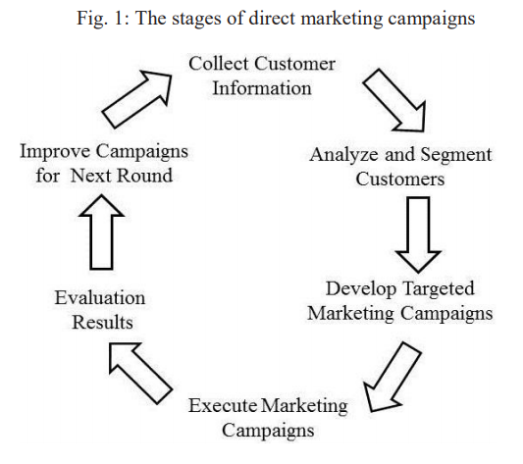

1.Data understanding: This phase involves considering the data requirements for properly addressing the defined goal and an investigation of the availability of the required data. Initially the data is collected, exploration with summary statistics and to understand the data visualization tools and identify problems in the quality and availability.
- Data preparation: For the Data mining model, the data to be used is identified, selected, and prepared to be included. The data must be collected, integrated and formatted according to the needs of the project. It is then cleaned and transformed according to the requirements of the algorithm. New fields(aggregation) such as sums, ratios, averages, flags, etc should be derived to enrich the customer information, summarize the characteristics of the customer in a better way, and therefore it enhances the performance of the models.
- Modeling: The prepared dataset is then used for model training. Appropriate modeling technique is to be selected for the particular business objective. Before training of the models in predictive modeling, the modeling dataset should be partitioned so that the model performance is evaluated on a separate dataset. This phase involves the examination of alternative modeling algorithms and parameter settings and a comparison of their fit and performance in order to find the one that yields the best results. The model settings are revised and tuned finely by evaluating the results of the model.
- Deployment: The projects findings and conclusions are summarized in a report, but this is hardly the end of the project. If the results are not integrated into the organizations everyday marketing operations there is a chance of failure even for the best models. To enable the scoring of customers and updating the results a procedure is designed and developed. Therefore, the distribution of the model results in the enterprise and their incorporation in the organizations database and operational CRM system is enabled by the deployment procedure.

CUSTOMER SEGMENTATION AND DATA MINING
Customer segmentation is the process of dividing the customers into distinct, homogeneous subgroups which are meaningful based on the various characteristics and attributes. It is used as a differentiation marketing tool. It also helps the organizations to understand their customers and build differentiated strategies for efficient growth. Industries tend to use market segmentation schemes that are based on demographics and value information. For the past few decades many organizations have been deciding their marketing activities and developing their new products and services based on these simple, business rule segments. The traditional survey based market research is a challenge which provides a lot of information about a few customers and one should have a greater understanding of all the characteristics of the customers to use the results of market research effectively. Market research will find interesting segments of customers. These then need to be projected onto the existing customer base using available data. In today’s competitive markets, this approach is not sufficient and efficient. Also, to gain a competitive advantage organizations should have a complete view of their customers. The customers needs, behavior, preferences, attitude and perceptions, are to be focused to analyze the data for identifying the underlying segments. To manage and target the groups more effectively with customized product offerings, promotions and other things, the groups should be identified with unique characteristics. Customer segmentation is a popular application of data mining with established customers. A segmentation project starts with the definition of the business objectives and ends with the delivery of differentiated marketing strategies for the segments. For segmentation, many different types are available based on the specific criteria or attributes. Specifically, customers can be segmented according to their value. The type of segmentation used depends on the specific business objective. Data mining can also be used for the development of segmentation schemes based on the current or expected value of the customers. According to the importance of each customer marketing interventions and customer handling are prioritized for which these segments are needed. This methods lead to clusters of similar customers but it may be hard to understand how these clusters relate to the business.

Segmentation in marketing can be used for the following:
• To have a Greater understanding of the customer
•Rather than mass market, each segments characteristics are focused for design and development of new products/services .
•Helps in the identification of new marketing opportunities.
• Based on each segments, wants and needs product offering strategies are customized to the existing customers.
• Tailored rewards and incentives could be offered.
•Appropriate advertising and communication message could be done.
•Appropriate sales and service channel could be selected.
•Based on the specific characteristics of each segment the brand image could be determined.
•More effective resource allocation according to the potential return from each segment.
• According to each segments importance and value priorities could be given in marketing initatives which aim in customer retention and development.
•Customer service according to each segments importance could be differentiated.

The following segmentation types are most widely used:
1.Social and life-stage: This type reveals different customer groupings based on social and/or life-stage information such as gender, race, age, social status, education, occupation, income, and marital status. Specific life-stage-based products is promoted as well as life stage marketing is supported by this type of segmentation appropriately.
2.Needs/attitudinal: The type based on market research data. The customers needs, wants, preferences, perceptions and attitude pertaining to the company’s services/ products segments are identified. New product development and to determine the brand image and key product features to be communicated are supported. Data is collected Through market surveys and the segments are identified with the help of a cluster model on collected questionnaire responses.

IV.MARKET SEGMENTATION SURVEY
Market segmentation is one of the most fundamental strategic planning and marketing concepts where a group of people is separated under different categories such as the purchasing capability and the interest to buy. Customers are divided into homogeneous groups which have similar characteristics such as buying habits, life style, food preferences etc. According to the similarity in customers in various dimensions related to a product under consideration, the operations are performed in the segment. The company is more successful in the marketplace if the segments are more accurate and appropriate. The main objective is to predict the needs and wants of the customers for improving the profitability by manufacturing products in right quality and quantity at right time for the right customer at optimum cost. k-means clustering technique can be applied for the appropriate segmentation of the market and for quality planning decisions .

A.K-MEANS CLUSTERING TECHNIQUE
The letter k represents the number of clusters chosen hence the algorithm is named as k-means. The principal function of algorithm involves finding the k-means. The First step involves defining an initial set of means and then subsequent classification is done based on their distances to the centroids. Next, the clusters mean is computed again and then reclassification is done based on the new set of means. This process is repeated until cluster means don’t change much between successive iterations . Finally, the clusters means are calculated once again and then all the cases are assigned to the permanent clusters.
The simple basic algorithm is
- The initial centroids are selected as K points.
2. Repeat it.
3. K clusters are formed by assigning each point to its closest centroid.
4.The centroid point of each cluster is recomputed until the centroid does not change.
The k-means algorithm has the following important properties:
- It is efficient in processing large data sets.
- It often terminates at a local optimum.
- It works only on numeric values.
4. The clusters have convex shapes.
Finally, this algorithm aims at minimizing an objective function know as squared error function given by:
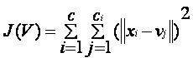
where,
‘||x_{i} - v_{j}||’ is the Euclidean distance between x_{i} and v_{j.}
‘c_{i}’ is the number of data points in i^{th} cluster.
‘c’ is the number of cluster centers.
Algorithmic steps for k-means clustering
Let X = {x₁,x₂,x₃,……..,x_{n}} be the set of data points and V = {v₁,v₂,…….,v_{c}} be the set of centers.
1) Randomly select ‘c’ cluster centers.
2) Calculate the distance between each data point and cluster centers.
3) Assign the data point 3 to the cluster center whose distance from the cluster center is minimum of all the cluster centers.
4) Recalculate the new cluster center using:
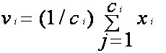
where, ‘c_{i}’ represents the number of data points in i^{th} cluster.
5) Recalculate the distance between each data point and new obtained cluster centers.
6) If no data point was reassigned then stop, otherwise repeat from step 3).

B. DENSITY BASED CLUSTERING:

The Density based clustering detects areas where points are concentrated and where they are separated by areas that are empty or sparse. It locates regions (neighborhood) of high density that are separated from one another by regions of low density. Points that are not part of a cluster are labelled as noise. Density based algorithms are considered unsupervised because they do not require any training on what it means to be a cluster. The two important parameters are 1.maximum radius of the neighborhood → Eps 2.minimum number of points in an Eps neighborhood of a point → MinPts. If a point has more than a specified number of points (MinPts) within Eps(points at the interior of a cluster) is called a core point. If a point has fewer than MinPts within Eps, but the point is in the neighborhood of a core point then it is said to be the border point. A point that is not a core point nor a border point is the noise point. Density reachability and density connectivity are the two concepts used.
Density Connectivity - The point "x" and "y" are density connected if point "r" exists which has a sufficient number of points in its neighbors and both the points "x" and "y" are within the ε distance. This process is called as the chaining process. Therefore, if the point "y" is a neighbor of the point "a", the point "a" is a neighbor of the point "b", the point "b" is a neighbor of the point "c" and the point "c" is neighbor of the point "x" implies that "y" is neighbor of "x".
Density Reachability - A point "x" is density reachable from point "y" if the point "x" is within ε distance from the point "y" and "y" has sufficient number of points in its neighbors which are within distance ε.
Density Based Spatial Clustering of Applications Noise

DBSCAN (Density Based Spatial Clustering of Applications Noise) algorithm is a density based clustering algorithm. It Uses a specified distance to separate dense clusters from sparser noise. This algorithm is the fastest of the clustering methods, but it is only appropriate if there is a clear Search Distance to use, and that should work well for all the clusters. The requirement is that all the meaningful clusters must have similar densities. It requires only those two parameters and has no prior knowledge of the number of clusters. Noise is When the Search Distance is smaller than the core-distance .It is a part of the cluster When the Search Distance is greater than the core-distance. The Eps and MinPts can be selected by •The k -th nearest neighbors , roughly at the same distance are the points in cluster. • The k -th nearest neighbor at farther distance are noise points.
Algorithm for DBSCAN clustering:
1. Randomly select a point p

2.Extract all the density-reachable points from p – the Eps and MinPts

3. Form a cluster if p is a core point.

4. If no points are density-reachable from p, that is, if p is a border point→ go to the next data point

5. repeat the process until all the points have been visited

C. LOGISTIC REGRESSION:
Logistic regression is a widely used statistical model which is used to describe data and to explain the relationship between one dependent binary variable and one or more nominal, ordinal, interval or ratio-level independent variables. There are only two possible outcomes (in which The outcome is measured with a dichotomous variable). Like all regression analyses, the logistic regression is a predictive analysis used to see the effectives and accuracy of the segmented market and predict whether the product will be purchased by customer in segment. In logistic regression, the dependent variable is binary(dichotomous), i.e. it only contains data as 1 or 0 (will purchase or will not purchase) ,it predicts the probability of occurrence of an event by fitting data to a logit function. The logistic regression is to find the best fitting model to describe the relationship between the dichotomous characteristic of interest where the dependent variable is response (outcome variable) and a set of independent variables. Logistic regression generates the coefficients (and its standard errors and significance levels) of a formula to predict a logit transformation of the probability of presence of the characteristic that is predicting whether the product will be purchased by the customer or not.
where p is the probability of purchasing the product (probability of presence of characteristic)
The logit transformation is defined as the logged odds:
and
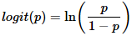
The parameters that maximize the likelihood of observing the sample values are chosen to estimate logistic regression. Further to evaluate the performance of the logistic regression model, Confusion matrix is the most commonly used metric. It is a tabular representation of Actual vs Predicted values. This helps us to find the accuracy of the model and also avoids overfitting.
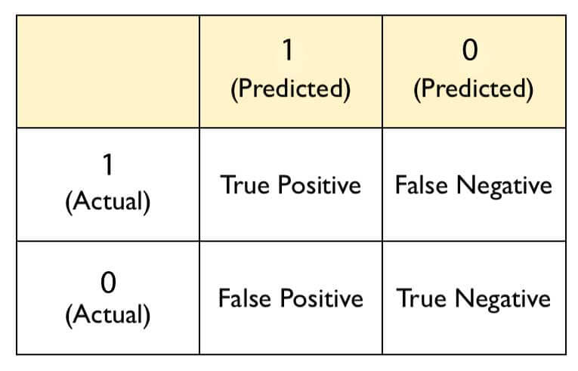
 | FALSE | TRUE
0 | 22 | 2
1 | 10 | 16
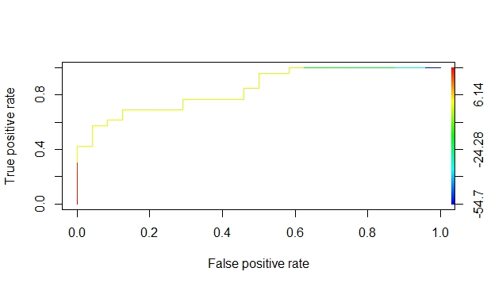
Fig1.ROCR Plot
The confusion matrix measures the actual and predicted values s in a tabular format and helps to avoids confusion Following are the metrics that could be derived from a confusion matrix:
True Positive (TP): These are the events that were correctly predicted by the model as the customer purchased the product.
True Negative (TN): These are the events that were correctly predicted by the model as the customer will not purchase the product.
False Positive (FP): These are the events that were predicted that the product would not be purchased by the customer but in reality, it was purchased.
False Negative (FN): This is the opposite of FP, predicted as will not be purchased, but in reality it was purchased by the customer.
Accuracy – determining the overall predicted accuracy of the model. It is given by Accuracy = (TP + TN)/(TP + TN + FP + FN)
True Positive Rate (TPR) – In overall, it indicates how many positive values, have been correctly predicted. It is calculated by (TP/TP + FN).It is Also known as sensitivity or recall.
False Positive Rate (FPR) – In overall, It indicates how many negative values, have been incorrectly predicted. It is calculated by (FP/FP + TN).
True Negative Rate (TNR) – In overall ,It indicates how many negative values, have been correctly predicted. It is calculated by (TN/TN + FP). It is also known as specificity.
False Negative Rate (FNR) – In overall, It indicates how many positive values, have been incorrectly predicted. The formula to calculate false negative rate is (FN/FN + TP).
Precision: It is calculated using the formula:(TP / TP + FP).It helps in indicating how many values, out of all the predicted positive values, are actually positive. F Score: The harmonic mean of precision and recall is the F-Score which lies between 0 and 1. Higher the value of F-Score, better the model. It is calculated as 2((precision*recall) / (precision+ recall )). Thus the model is evaluated and the purchase of the product based on the segmented market is analyzed.
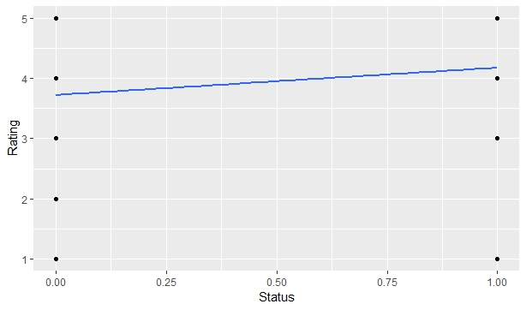
Fig:2.Logistic Model

D.ARIMA METHOD
ARIMA stands for Autoregressive Integrated Moving Average models. ARIMA is a univariate (single value) forecasting technique that is used to project the future values of a series based on its own inertia entirely. Box and Jenkins in 1970 introduced the ARIMA model. It is also called as Box-Jenkins methodology composed of set of activities for identifying, estimating and diagnosing ARIMA models with time series data. In financial forecasting the model has a very important role. ARIMA models have shown efficient capability to generate short-term forecasts. It constantly outperformed complex structural models in short-term prediction. In ARIMA model, a linear combination of past values and past errors is the future value of a variable, which is expressed as :
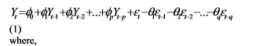
y_{t} is the actual value and ε_{t} is the random error at t, φ_{i} and θ_{j} are the coefficients, p and q are integers that are often referred to as autoregressive and moving average, respectively. The steps involved in building ARIMA predictive model are identification of the model, estimation of parameter and diagnostic checking. Among the several experiments performed ,the best ARIMA model is determined by the following criteria which study for each stock index.
• Very small Bayesian or Schwarz Information Criterion
• Small standard error of regression
• High adjusted R²
• Q-statistics showing that there is no significant pattern left in the autocorrelation functions and partial autocorrelation functions of the residuals, which means that the residual of the selected mode are white noise. 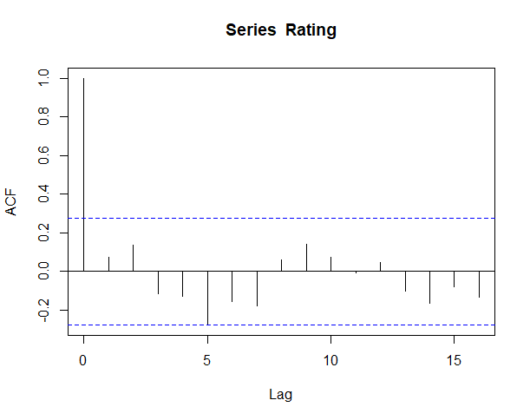
Fig 3: ACF
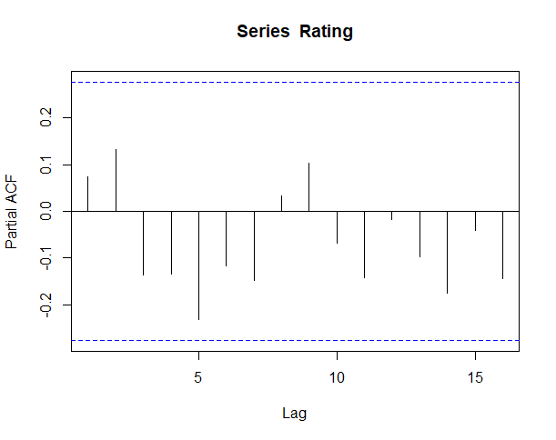
Fig 3: PARTIAL ACF

V. CONCLUSION
Market segmentation is the backbone of business tactics. It allows for customers retention and addresses the needs of the customer in an efficient approach. This study has highlighted the various aspects of which the urban consumer considers while making decisions. An analysis of the consumption pattern, decision making, awareness and attitude reveals a very optimistic state of affair as far as urban consumers are concerned. Marketers are advised to include customer centric orientation in their work culture and operations, promote their services vigorously, in order to keep their market share intact in the long run. They should also go for differentiating customer relationship marketing strategies in order to retain the customers. Further, research on the traditions, customs, belief, habits, tastes, preferences and psychological mindsets of consumers is also required. The marketers should concentrate on the urban segmentation and target the identified customer groups are used with proper marketing to position the product or brand as perceived by the target segment. Further, the target may be the younger generations, as they are literate and have a greater impact to changing values and lifestyles.

Suggestions,
- It was found that the brand retention is also considerably high among the urban consumers, so marketers should concentrate on brand value i.e. the quality, utility and reliability of their products.
- It is also a very critical aspect in urban markets that the leading brands compete with substitute also. While competing with substitute, the marketers should educate consumer using demonstration and trial and also design a product with comparative superiority which could be easily perceived by the consumers.
- As the consumption pattern of the people has changed vigorously, hence to serve them properly it is needed to improve the efficiency and scope of distribution network so that they can get the products at the right time in right place with in affordable prices.
- Thus the important and key concern for the managing personnel is the customers whose reviews on the services provided should be paid a special attention to retain the customers, and also there should be a eye on the competitors.

Acknowledgment

Working on this project “Market Segmentation and Product Positioning by using Clustering Technique” was a source of immense knowledge to us. We would like to express our sincere gratitude to Mrs.Chandia.S and Mrs.Sathya.C for their guidance and valuable support throughout the project. We are very thankful to the Department of Computing for the golden opportunity to work on this project.

References

- K. Tsiptsis and A. Chorianopoulos, “Data Mining Techniques in CRM: Inside Customer Segmentation”, John Wiley and Sons, Ltd., Publication, 2009.
- J. Clerk Maxwell, A Treatise on Electricity and Magnetism, 3rd ed., vol. 2. Oxford: Clarendon, 1892, pp.68–73.
- Ph. Kotler and K. Lane Keller. Marketing Management (12th Edition) (Marketing Management). Upper Saddle River: Prentice Hall, 2005.
- A. Kristin. Customer Relationship Management. New York: McGraw-Hill, 2002
- J.A. Berry and S. Gordon Linoff, Mastering Data Mining: The Art and Science of Customer Relationship Management. New York: Wiley, 1999
- J.A. Berry and S. Gordon Linoff, Data Mining Techniques for Marketing, Sales, and Customer Relationship Management. Second Edition, Wiley Computer, 2004.
- J. Han and M. Kamber. Data Mining Concepts and Techniques. Morgan Kaufmann, Edition 2, 2006
- P.N. Tan, M. Steinbach, V. Kumar, Introduction to Data Mining. (2005) Addison-Wesley, Boston.
- S. Dasgupta and Y. Freund, “Random Trees for Vector Quantization,” IEEE Trans. on Information Theory, vol. 55, pp. 3229-3242, 2009.
- M. Mahajan, P. Nimbhorkar, and K. Varadarajan, “The Planar K-Means Problem is NP-Hard,” LNCS, Springer, vol. 5431, pp. 274-285, 2009.
- ] D. D. S. Garla and G. Chakraborty, “Comparison of Probabilistic-D and k-Means Clustering in Segment Profiles for B2B Markets,” SAS Global Forum 2011, Management, SAS Institute Inc., USA.
- H.-B. Wang, D. Huo, J. Huang, Y.-Q. Xu, L.-X. Yan, W. Sun, X.-L. Li, and Jr. A. R. Sanchez, “An approach for improving K-means algorithm on market segmentation,” in Proc. International Conference on Systme Science and Engineering (ICSSE), IEEE Xplore, 2010.
.

