Membrane Robot Hackathon — Problem Statement
Nov 2, 2026 ·

The challenge
Build a robot that fetches what you ask for, using nothing but its own eyes.
Your team builds a simulated robot in any game engine, and a Claude agent that drives it. A user types a command: "Bring the red cube to the green square." Claude looks through the robot's camera, works out which shape is the red cube, and steers the robot to fetch it and drop it in the zone. No coordinates. No object list. No shortcuts. Just pixels, a depth reading, and a collision flag.
That is Phase 1, and it is most of your score. In Phase 2 you record what the robot saw and send the clip through a human feedback API. Real users watch it and tell you whether the robot did the job.

Why this problem
Real robots fail in ways their own logs never show. The log says "object delivered". The video shows the robot scraped a wall, shoved another object aside, and dropped the cube half outside the zone. Robotics teams pay human raters to watch exactly this footage, because the only honest judge of how a robot behaves is a person who watches it.
This hackathon gives you a small version of that loop. Phase 1 is the robotics problem: see, decide, move, with no cheats. Phase 2 is the feedback problem: a human feedback API puts your robot's footage in front of real users within minutes and returns their verdict. You close a loop that a real robotics lab needs weeks to set up.

Phase 1: Build a robot Claude can drive
Goal: a typed command goes in, a completed Fetch comes out, with no human help in between. Target: working by hour 14. Nothing in Phase 2 can start without it.
Phase 1 is image-driven. The only thing Claude knows about the world is what the robot's camera shows, plus two optional sensors: a depth reading and a collision flag. No object data of any kind enters the system from the engine.

Architecture
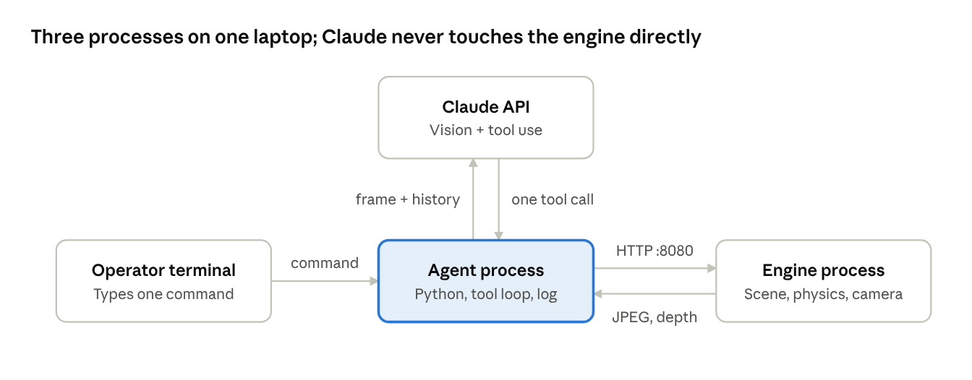
Phase 1 architecture · 3 processes, 1 cloud API
The engine knows everything about the scene. The agent knows only what the engine returns over HTTP. Claude knows only what the agent sends it. Object data stops at the engine boundary.
- Engine process: runs the scene at 30 fps or more, renders the robot camera to a texture, and hosts a small HTTP server on localhost:8080. It owns physics, collisions, and the state machine.
- Agent process: a Python script. It holds the command, runs the Claude tool-use loop, calls the engine endpoints, and writes the log. Nothing else.
- Claude API: receives the command, the latest frame, the depth value, and the recent history. Returns exactly one tool call per step.
The control loop
- ☐ One Claude call per step.
- ☐ Expect 15 to 40 steps per run. Each Claude call takes 2 to 5 seconds with an image.
- ☐ Freeze the engine clock while Claude thinks. The scene advances only during /move and /turn. Real robot motion then totals 10 to 20 seconds per run, which is your clip length.
- ☐ Send the /look image to Claude as an image content block inside the tool result. Do not describe the image in text.
Data contract
Item | Specification
Units | Metres for distance, degrees for angles. Heading 0 = +x axis, positive = clockwise from above.
/look image | JPEG, 640 x 480, 90° horizontal field of view. Camera at the robot's front, 0.5 m above the floor, tilted 10° down. Fixed for the whole hackathon.
/depth value | Single ray from the camera centre. Float metres, max 10. null if nothing within range.
/state body | {"name": "Carry", "x": 2.1, "y": 0.4, "heading": 90, "holding": true, "retries": 0}
/move | Body {"distance": 1.0}. Negative = reverse. Speed 1 m/s. Returns {"moved": 0.6, "collided": true}.
/turn | Body {"degrees": 30}. Positive = right. Speed 90°/s. Returns {"heading": 120}.
/pickup | Reach 0.5 m, within ±30° of heading. Returns {"ok": true}. Never says which object.
/drop | Returns {"ok": true, "in_zone": false}.
Collision | Robot has a physics collider. On contact the move stops, the robot backs off 0.1 m, collided is true, and the state machine enters Blocked.
Log | One JSONL line per step: step, timestamp, tool, args, result, frame_path. Frames saved as PNG next to the log.
You may tune the numbers above for your engine. Write your values in your README. Judges will check that the camera, not the engine, is the only source of object information.

The task: Fetch
The robot must bring one named object to one marked drop zone on a single plain-language command.
Scene
- One flat room with four walls. No furniture.
- 4 to 6 primitive shapes on the floor: cubes, spheres, cylinders, cones, in different colours. At least two share a colour and at least two share a shape, for example a red cube, a red sphere, and a blue cube.
- One marked drop zone: a coloured square painted on the floor, or a flat platform.
- One wheeled robot with a forward-facing camera. A capsule with a camera is enough.
Command
- A person types one sentence to Claude. Examples: "Bring the red cube to the green square." "Fetch the blue sphere."
- Judges will also give commands that need some reasoning, such as "Bring the round red thing." or "Bring the tallest object."
Robot behaviour
- The robot finds the object with its camera only. It does not get object positions, names, colours, or shapes from the engine.
- The robot drives to the object, picks it up, drives to the drop zone, and releases it.
- Pick-up is a snap. When the robot touches the object, the object attaches to it. No grasping physics needed.
- The engine must stop the robot when it hits a wall or another object, and tell it that it hit something. Collisions must be visible in the clip.
- Optional sensors: a depth reading (distance to the nearest thing straight ahead, in metres) and a collision flag (true or false). Nothing else.
Rules
- Any game engine is allowed: Unity, Godot, Unreal, Three.js, PyBullet, or your own.
- Primitive shapes and free assets are allowed. You do not need a 3D artist.
- No object data may enter Claude's context from the engine. This means no names, ids, colours, shapes, positions, distances to objects, or object counts, anywhere: not in /state, not in the system prompt, not in tool descriptions, not in file names. Everything Claude knows about the objects comes from pixels in /look, plus the optional depth reading and collision flag.
- The depth reading tells the robot how far the nearest thing ahead is. It does not say what the thing is.
- One command per run. One run per clip.
- A run ends when the robot reaches the drop zone with an object, or when it gives up after 3 retries.

Robot states
The robot is in exactly one state at a time. Your clip starts when it leaves Idle and stops when it reaches Done.
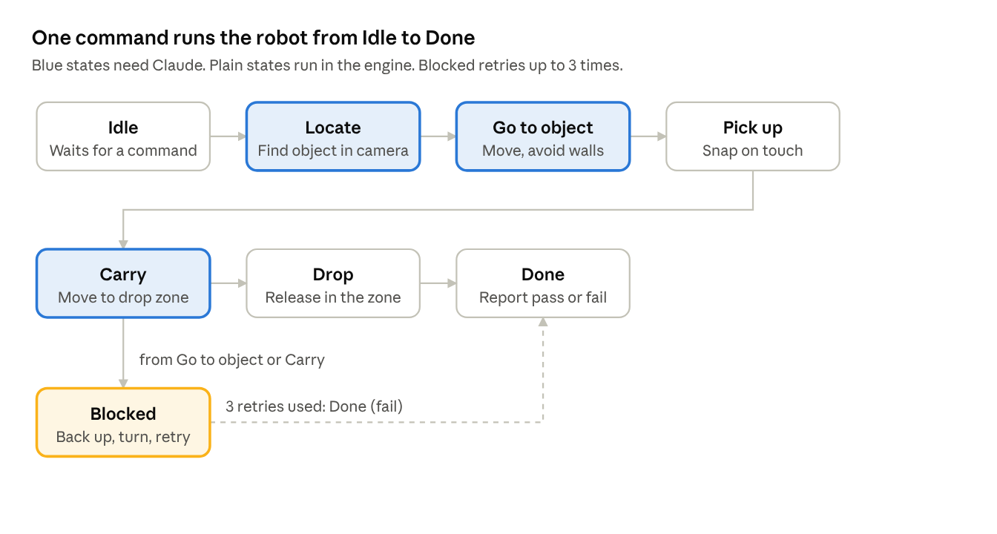
robot states · 7 states, 1 retry branch
Blocked fires when the robot has not moved for 2 seconds or has hit something. After 3 retries the run ends in Done with a fail result.
State | Enters when | Leaves when | Who decides
Idle | Scene is loaded | Claude sends a command | Claude
Locate | Command is parsed | Target object is identified in the camera view | Claude
Go to object | Target is known | Robot is within reach | Claude or robot code
Pick up | Within reach | Object is attached | Robot code
Carry | Object is attached | Robot is inside the drop zone | Claude or robot code
Drop | Inside the drop zone | Object is released | Robot code
Done | Drop finished, or retries used up | Result is reported | Robot code
Blocked | No movement for 2 s, or collision | Path is clear, or 3 retries used | Robot code
Done always writes one result: pass, fail_wrong_object, fail_not_reached, or fail_collision. These match the pulse labels, so you can compare your own log with the crowd's verdict.

Robot API and Claude agent
Two parts: the robot in the engine and the Claude agent that drives it. You build both.
1. Robot API (engine side)
Your engine must expose a small local HTTP server. Claude talks to the robot only through it.
Endpoint | Returns or does
GET /state | Current state name, robot x, y, heading, whether it holds something, retry count. Nothing about the objects.
GET /look | One JPEG frame from the robot's camera, as the robot sees it now. This is Claude's only view of the objects.
GET /depth | Optional. Distance in metres to the nearest thing straight ahead. Does not say what it is.
POST /move {distance} | Drive forward or back by a distance in metres. Stops early on collision and returns collided: true.
POST /turn {degrees} | Turn left or right in place.
POST /pickup | Attach the nearest object if within reach. Returns success or failure only, not what was picked up.
POST /drop | Release the held object. Returns whether it landed in the drop zone.
You may add POST /go_to {x, y} so the engine handles path-finding. Claude still has to find the object first with /look.
Requesting extra sensors or endpoints
You may ask for more. A mentor approves or rejects within 15 minutes. The test is one question: would a real robot have this sensor, and does it stay silent about what an object is?
- Likely approved: a multi-ray 360 deg depth scan (lidar-style), bump sensors per side, a second or wider camera, a downward camera for the drop zone, wheel odometry, an IMU.
- Always rejected: anything that returns object ids, names, colours, shapes, positions, counts, distance to a named target, segmentation masks, or drop-zone coordinates.
- Every approved sensor is published to all teams within the hour. No private sensors.
2. Claude agent
- Use the Claude API with tool use. Each tool calls one endpoint above.
- Claude receives the command, calls /look, reads the image, decides what to do, and loops until Done.
- Claude must identify the object and the drop zone from the image. It must work out where they are by looking, turning, and looking again.
- The system prompt may describe the robot and its tools. It may not describe the room or the objects in it.
- Keep a log of every tool call and every image Claude saw. Judges will read it.
Your Claude budget – NOT A STRICT BUDGET
Each team gets one API key with a $40 target. There is no hard block. Mentors get an alert at $30 and will talk to you. The limits below are how you stay inside $40 without thinking about money.
Limit | Number | Why
Images per step | 1 | One /look before each decision. Never two in a row without a move or turn between them.
Claude calls per step | 1 | One call in, one tool call out.
Steps per run, soft target | 25 | A clean run: 4 to 6 looks to find the object, 6 to 10 to reach it, 6 to 10 to carry it, 2 for pickup and drop.
Steps per run, hard stop | 60 | The agent reports fail at step 60. No exceptions.
Cost per step | ~$0.009 | One 640 x 480 image plus prompt and recent history on Sonnet 5.5.
Cost per run | ~$0.25 at 25 steps, ~$0.55 at 60 | Long runs cost double. Fix the agent, do not let it wander.
Runs in $40 | ~150 | 100 development, 40 rehearsal, 3 hidden commands, rest is buffer.
Rules that keep you inside the budget:
- When to look: after every /move or /turn, once. Not after /pickup or /drop, their result already tells you what happened.
- How to find the object: turn 45°, look, repeat. Eight looks cover the room. If the object is not in any of them, drive 2 m toward open space and sweep again.
- Send only the latest frame to Claude. Earlier steps go in as one line of text each. Five images in history makes every call five times more expensive and no smarter.
- Put the system prompt and tool definitions first and enable prompt caching. Cached input costs 10 % of normal.
- Test your HTTP plumbing with Claude Haiku 5.5 or with a dummy agent that returns fixed moves. Do not spend Sonnet calls on finding out whether your server starts.
- Count your runs. At 120 runs, stop developing and keep the rest for rehearsal and the hidden commands.
Phase 1 is complete when
- You type a command and the robot ends in Done with pass on at least 3 different commands.
- Claude found each object from /look images. Your tool-call log shows it.
- Nobody touched the keyboard or mouse during the run.
- You demo this live to a mentor. When the mentor signs off, you receive your human feedback API key and the API guide. Phase 2 starts there.

Phase 2: Connect the robot to Membrane
Goal: real users watch your robot and tell you how it did. You record the camera view and send the clip through the human feedback API. You get the API key only after a mentor has signed off your Phase 1 demo.

Record the POV clip
- Record the robot camera view. Screen capture of the camera window is fine. OBS is fine.
- Format: mp4, 720p or higher, 10 to 20 seconds. No audio needed.
- Start recording when the state leaves Idle. Stop when it reaches Done.
- Show the typed command as text on screen for the first 2 seconds, so the viewer knows what the robot was asked to do.
- No team names, logos, or code visible in the clip.

How the crowd judges you
Users watch your clip and answer two short questions. Each question is a "pulse". They see only the video. They know nothing about your team or your code.
Pulse 1: binary
"Did the robot bring the correct object to the drop zone?" Yes or no.
Pulse 2: labels
"What went wrong?" Pick one: hit something, wrong object, did not reach the drop zone, too slow, nothing wrong.
Hidden test commands
- You develop with your own commands for the first 20 hours.
- At hour 18, judges publish three commands nobody has seen. Example: "Bring me something to drink."
- You run each command once, record it, and upload the three clips by hour 20.
- Only these three clips go to the pulses. Hard-coding a single path will not help you.
Results
- Each clip gets at least 30 user responses.
- You receive a result sheet per clip: yes-rate for pulse 1 and the label split for pulse 2.
- Results come back within 45 minutes of upload. Use them for the stretch goal or for your demo.

Milestones over 24 hours
Phase 1 fills the first 14 hours. Phase 2 has two hard gates: hidden commands at hour 18, clip upload at hour 20. Everything else is a suggested order.

24-hour plan · 6 milestones, 2 gates
Teams that reach hour 14 with Claude driving the robot have time for the stretch goal. Teams that spend more than 8 hours on the engine should simplify the scene, not the agent.
Stretch goals (any one counts)
- Read the pulse result sheet and change the robot's behaviour before the demo. Show the before and after clips.
- Add furniture or walls inside the room that block the straight path to the object.
- Claude plans the full path itself with move and turn only, no go_to.
- Commands that need reasoning across several views: "Bring the cube that is farthest from the green square."

Scoring
Phase 1 decides 65 % of your score. Phase 2 adds 20 %. Stretch goals add 15 %.
Part | Weight | How it is measured
Phase 1: Fetch works | 40 % | Live demo on two judge commands. Pass or fail per command, plus how directly the robot went.
Phase 1: image-driven agent | 25 % | Judges read your tool-call log and image log. Did Claude find the object from pixels, recover from a collision, and reason about the command?
Phase 2: user verdict | 20 % | Yes-rate on pulse 1 and "nothing wrong" share on pulse 2, averaged across your 3 clips
Stretch goal | 15 % | Any one stretch goal shown working in the demo
- A team with no clips uploaded by hour 20 scores 0 on Phase 2.
- Any object data found leaking into Claude's context scores 0 on both Phase 1 parts.
- Clips that break the rules (team name on screen, over 20 seconds) are not sent out and score 0 on Phase 2.
- Ties are broken by the Phase 1 demo score.

