AI Project Intelligence & Risk Advisor
Milestone 1 — Architecture & Design Document

1. Purpose & Scope
This document describes the system architecture delivered for Milestone 1: a document ingestion module and a Retrieval-Augmented Generation (RAG) pipeline that together allow project documents to be uploaded, processed, and made searchable by semantic similarity. Later milestones will add analysis agents (risk, scope, health scoring) and a chat assistant on top of this foundation; this document scopes only what M1 implements.

2. High-Level Architecture
The system follows a linear pipeline: a client uploads a document, the ingestion layer extracts raw text, the RAG layer splits it into chunks, generates vector embeddings for each chunk, and stores them in a persistent vector index. A separate query path embeds a natural-language question the same way and retrieves the most semantically similar chunks. Both paths converge on the same embedding step, so a query is compared against the exact vector space the documents were indexed into.
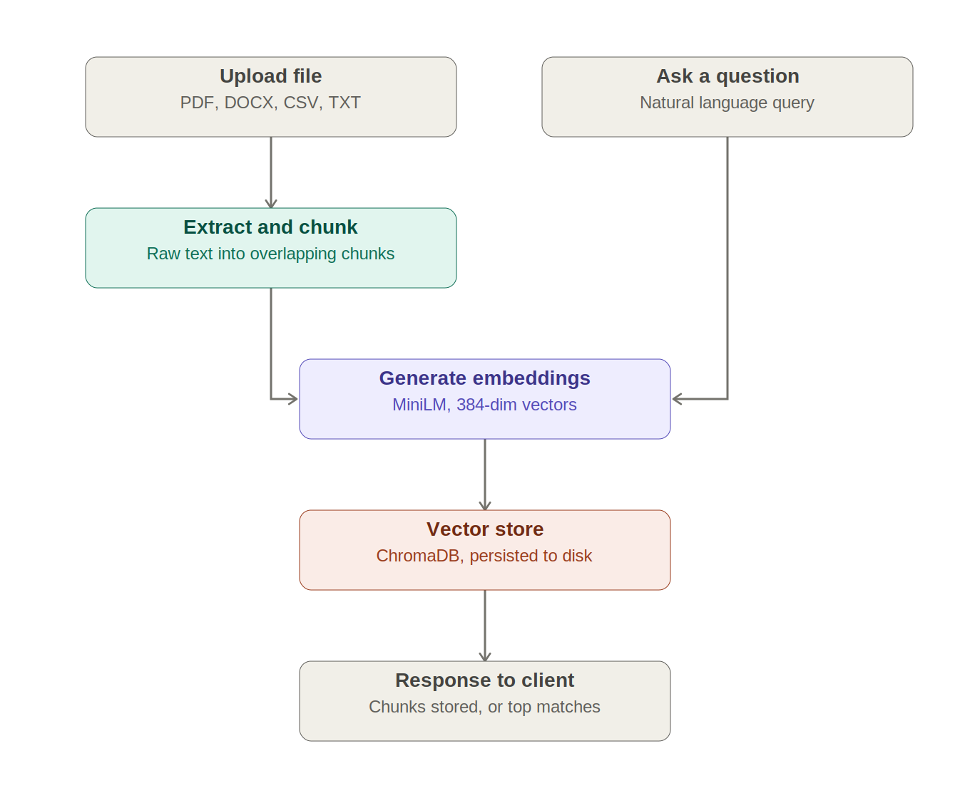

3. Module Breakdown
Module | Responsibility
app/ingestion/extractors.py | Detects file type (PDF/DOCX/CSV/TXT) and converts it to plain text
app/ingestion/router.py | /upload endpoint: orchestrates extract -> chunk -> embed -> store
app/rag/chunker.py | Splits text into overlapping, fixed-size word chunks
app/rag/embedder.py | Converts text chunks/queries into vector embeddings (sentence-transformers)
app/rag/vector_store.py | Wraps ChromaDB: add chunks, similarity search, persistence
app/rag/router.py | /query endpoint: embeds a question and returns similar chunks
app/models/schemas.py | Pydantic request/response contracts for the API
app/config.py | Central settings: paths, chunk size/overlap, embedding model name

4. Data Flow

4.1 Ingestion Flow (/upload)
- File is received and saved to data/uploads/
- extract_text() routes to the correct extractor based on file extension
- chunk_documents() splits extracted text into ~200-word chunks with 40-word overlap
- embed_texts() converts each chunk into a 384-dimension vector using all-MiniLM-L6-v2
- add_chunks() stores vectors + chunk text + source metadata in ChromaDB, persisted to disk

4.2 Query Flow (/query)
- User's natural-language question is embedded using the same model as ingestion
- query_similar() performs cosine-distance similarity search against stored vectors
- Top-k matching chunks are returned with their source file, chunk id, and distance score

5. Data Models
Entity | Fields | Notes
Chunk (stored) | id (source::chunk_id), text, embedding, source, chunk_id | One row per chunk in ChromaDB collection 'project_documents'
UploadResponse | filename, chunks_added, total_chunks_in_store | Returned by /upload
QueryRequest | query (str), top_k (int, default 5) | Input to /query
QueryResponse | query, results: [RetrievedChunk] | Returned by /query
RetrievedChunk | text, source, chunk_id, distance | One retrieved match

6. Technology Stack
Layer | Choice | Reason
API framework | FastAPI | Async, automatic Swagger UI for manual testing, low boilerplate
PDF extraction | pypdf | Lightweight, no external binary dependency
DOCX extraction | python-docx | Standard library-grade docx reader
CSV extraction | pandas | Robust CSV parsing, reused elsewhere in the project
Embedding model | sentence-transformers (all-MiniLM-L6-v2) | Runs locally, no API key or cost, fast, 384-dim
Vector store | ChromaDB (persistent client) | Required by project spec; simple local persistence, no external server

7. Design Decisions & Trade-offs
- Word-count-based chunking (not sentence/paragraph-aware) was chosen for M1 for simplicity and speed; can be upgraded to semantic chunking later if retrieval quality needs improvement.
- Embeddings run locally rather than via an external API to avoid key management and cost, and to keep the pipeline fully offline-capable.
- ChromaDB runs in persistent local mode (no server) to minimize setup complexity for this milestone; the same code can point to a hosted Chroma instance later without interface changes.
- Retrieval only returns raw chunks in M1 by design — answer generation (the 'AG' in RAG) is deliberately deferred to the milestone that introduces the chat assistant/agents, per project scope.

8. Out of Scope for Milestone 1
- Risk/scope/health-scoring agents
- Chat assistant / LLM-generated answers
- Authentication, multi-user support
- Dashboard/UI beyond the Swagger test interface

