

**Government of INDIA**

**Department of Space**

**Indian Space Research Organization**

**INTERNSHIP REPORT**

***At***

**Laboratory for Electro-Optics Systems**

**(LEOS-ISRO)**

**Bangalore – Department of Space, Govt. of India**

1st cross, Peenya Industrial Estate, Bengaluru Pincode-580058

***Submitted by***

**Sumit Kumar**

**(2100640400011)**

***Student of***

**Hindustan College of Science and Technology**

***Pursuing the Degree of***

**BACHELOR IN TECHNOLOGY IN**

**MECHANICAL ENGINEERING**

***Under the supervision and guidance of***

**SHRI ARVIND KUMAR SHARMA SHRI MADAN MOHAN MEHRA**

**Head, MSOD** Scientist/Engineer (SE)

Bengaluru-560058 Industry Project Guide

**DECLARATION**

I declare that this project entitled “**Design, Modelling, and Analysis of a Magneto Hydrodynamic Angular Rate Sensor”** submitted in partial fulfilment of the degree in **B. Tech in Mechanical Engineering**, is a record of original work carried out by me under the supervision of **LEOS-ISRO, Bengaluru**, and **Shri. Arvind Kumar Sharma** (Division Head), LEOS-ISRO, Bengaluru. This work has not been submitted for the award of any other degree or diploma at any other institution or university. In accordance with the ethical practices of reporting scientific information, due acknowledgements have been made wherever the findings of others have been cited. This report has not been submitted, in part or full, to any other university, institution, or professional body for the award of any degree, diploma, or fellowship.

Signature:

Name:

Place:

Roll No:

Date:

**CERTIFICATE**

This is to certify that the internship project work entitled ‘**DESIGN, MODELING AND ANALYSIS OF MAGNETO-HYDRODYNAMIC ANGULAR RATE SENSOR**’ was successfully completed by **MR. SUMIT KUMAR** (HCST21ME001), student of Bachelor in Technology in Mechanical Engineering. Hindustan College of Science and Technology at **LABORATORY FOR ELECTRO-OPTICS SYSTEMS (LEOS), INDIAN SPACE RESEARCH ORGANISATION (ISRO),** Peenya Industrial Estate, Bengaluru 560058, under the guidance of Shri. Arvind Kumar Sharma, Division Head-MSOD, from 1 July 2024 to 30 September 2024.

**SHRI ARVIND KUMAR SHARMA SHRI MADAN MOHAN MEHRA**

**Head, MSOD** Scientist/Engineer (SF)

Bengaluru-560058 Industry Project Guide

H.O.D Seal with Signature

**ACKNOWLEDGEMENT**

I would like to express my deepest gratitude to everyone who supported me throughout my internship.

Firstly, I am deeply grateful to the Laboratory for Electro-Optics Systems (LEOS) at ISRO for providing me with the opportunity to intern over the past three months.

Next, I thank Shri. Arvind Kumar Sharma, Division Head of MSOD, for his exceptional guidance and supervision. His support was instrumental in making this internship a valuable learning experience.

I am also grateful to the Scientists and Engineers at MSOD and LEOS for sharing their knowledge and providing valuable insights. Special thanks to Shri. Madan Mohan Mehra for his direct involvement and support in my project work.

I would also like to thank Shri. Rajnish Singh for his valuable support, which greatly contributed to the success of my tasks.

My appreciation extends to the staff of the LEOS Library for their assistance and support during my internship.

Finally, I wish to thank my college, my parents, and my family for their continuous encouragement and support. This internship has significantly contributed to my personal and professional growth, and I am thankful for the help I received from everyone involved.

**Table of Content**

1. Introduction 9

1.1 Internship Objective 10

1.2 The significance of internship for students is manifold 11

2. Company Background and Organizational Structure 13

2.1 Indian Space Research Organization (ISRO) 13

2.2 Laboratory for Electro-Optics Systems (LEOS) 13

2.3 Application 14

2.4 Launch Vehicles 15

2.5 Organization Background 16

2.6 Company logo 17

2.7 Company Structure 17

3. Weekly Job Summary 19

4. Learnings 22

Autocollimator Operation 22

NX Software Proficiency 22

Assembly in NX 22

Advanced Simulations 22

5. Introduction To Project Topic 23

5.1 Introduction 23

5.2 Aim and Purpose 24

5.3 Emerging Technological Trends 25

5.4 Problem Statement 25

5.5 Outline of the Proposed Work 26

5.6 Overview of Modeling Software 26

5.6.1 Fractures of NX 27

5.6.2 Functions of NX 28

5.7 Autocollimator 28

5.7.1 Applications of Autocollimator (ACM) 29

5.7.2 Alignment Procedure using Autocollimator 30

6. Literature Review/ Field Survey 33

7. Magneto-Hydrodynamic Angular Rate Sensor 36

7.1 MHD-ARS 36

7.2 Principles of Operation 36

7.3 Components of MHD-ARS 36

7.4 Working of Magneto-Hydrodynamic Angular Rate Sensor 41

8. Design Consideration 43

8.1 Material Selection for Sensor Components 43

8.1.1 Comparative Study of Magnet Materials 44

8.1.2 Comparative Study of Conductive Fluid Shell Material 45

8.1.3 Comparative Study of Insulating Layer Material 46

8.1.4 Comparative Study of Electrode Materials 47

8.2 Fluid Dynamics 48

8.2.1 Calculation of Boundary Layer Thickness 49

8.2.2 Motion of Mercury in MHD-ARS Sensor 50

8.2.3 Key Considerations 51

8.2.4 Impact on Performance 51

8.3 Compactness & Weight 52

9. Modeling and Methodology 53

9.1 Modeling in NX 53

9.1.1 Conceptual Design 53

9.1.2 Material Assignment 54

9.2 Assembly Creation and Tolerance Control 55

9.2.1 Assembly Process in NX 56

9.2.2 Tolerance Control 57

9.3 Assembly Challenges 58

10. Finite Element Analysis of MHD-ARS Sensor 59

10.1 FE Model Summary 59

10.1.1 Mesh Details 59

10.1.2 Meshed Components 60

10.2 Material properties 61

10.2 Free-Free Modal Analysis 62

10.2.1 Key Aspects 62

10.2.2 Procedure 63

10.2.3 Methods 63

10.2.4 Significance 63

10.2.5 Results 64

10.2.6 Visualization 65

10.3 Clamped Modal Analysis 67

10.3.1 Procedure 67

10.3.2 Significance 67

10.3.3 Results 68

10.3.4 Visualization 69

10.4 Static Analysis 71

10.4.1 Key Aspects 71

10.4.2 Load Cases of Static Analysis 71

10.4.3 Results 73

10.5 Random Analysis 76

10.5.1 Results 80

11. Results and Discussion 83

11.1 Sensitivity Calculation 83

11.1.1 Discussion 84

11.2 Minimum Detectable Angular Rate Calculation 84

11.2.1 Discussion 84

11.2.2 Modal and Vibrational Analysis Results 84

12. Conclusion 87

13. Reference 88

**List of Figures**

Figure 2. 1: Laboratory for Electro Optics Systems located in Peenya, Bangaluru 13

Figure 2. 2: List of ISRO Launch Vehicles 15

Figure 2. 3: Company Logo 17

Figure 2. 4: Company Structure 17

Figure 5. 1: Magneto Hydrodynamic Angular Rate Sensor 23

Figure 5. 2: Autocollimator 29

Figure 5. 3: Alignment Setup 30

Figure 5. 4: Reflective Cube 30

Figure 5. 5: 6 D.O.F Cube Reading Setup 31

Figure 5. 6: Alignment of Laser Beam 32

Figure 7. 1: Mercury Metal 37

Figure 7. 2: Housing 37

Figure 7. 3: Magnet 38

Figure 7. 4: Magnet Cover 38

Figure 7. 5: Conductive Fluid Shell 39

Figure 7. 6: Insulating Layer 39

Figure 7. 7: Top Layer 39

Figure 7. 8: Lock Nut 40

Figure 7. 9: Cover 40

Figure 7. 10: Electrode Cover 40

Figure 7. 11: Electrode 41

Figure 7. 12: Working of MHD-ARS 42

Figure 9. 1: Section View of MHD-ARS Assembly 55

Figure 10. 1: Meshed Assembly of MHD-ARS 62

Figure 10. 2: Mode 1 – Rigid Body Motion (Translational) 65

Figure 10. 3: Mode 7 – First Natural Frequency (Structural Vibration) 66

Figure 10. 4: Mode 1 – Structural Deformation. 69

Figure 10. 5: Mode 3 - Higher Structural Frequency 70

Figure 10. 6: Von-Mises contour in X- Direction (Static Analysis) 73

Figure 10. 7: Von-Mises contour in Y- Direction (Static Analysis) 74

Figure 10. 8: Von-Mises contour in Z- Direction (Static Analysis) 75

Figure 10. 9: Response dynamic table 77

Figure 10. 10: Random Response in X-direction 77

Figure 10. 11: Random Response in Y-direction 78

Figure 10. 12: Random Response in Z-direction 79

Figure 10. 13: Von-Mises contour in X- Direction (Random Analysis) 80

Figure 10. 14: Von-Mises contour in Y- Direction (Random Analysis) 81

Figure 10. 15: Von-Mises contour in Z- Direction (Random Analysis) 82

**List of Tables**

Table 8. 1: Comparison of different Materials for Magnet 44

Table 8. 2: Comparison of Materials for Conductive Fluid Shell 46

Table 8. 3: Comparison of Materials for Insulating Layer 47

Table 8. 4: Comparative Study of Electrode Material 48

Table 8. 5: Weight of Components 52

# Table 9. 1: Tolerance Table ………………………………………………………………… 58

Table 10. 1: Material Properties ……...……………………………………………………...61

Table 10. 2: Frequencies for different modes of free-free modal analysis 64

Table 10. 3: Frequencies for different modes of clamped modal analysis 68

Table 10. 4: Static Analysis Load Cases 71

Table 10. 5: Stress Metrix 72

# **1****. Introduction**

## 1.1 Internship Objective

ISRO's industrial training program for mechanical interns is designed to achieve several key objectives:

1. **Exposure to Aerospace Technologies**: Provide hands-on experience with cutting-edge aerospace technologies, emphasizing the design, development, and operation of satellites and launch vehicles.
2. **Project-Based Learning**: Engage interns in real-world engineering challenges associated with ISRO’s projects, allowing them to apply their theoretical knowledge to practical engineering problems.
3. **Collaboration and Teamwork**: Develop teamwork skills through active participation in interdisciplinary team meetings and collaboration with ISRO scientists and engineers.
4. **Standards and Quality Assurance Compliance**: Educate interns on the importance of adhering to safety protocols, industry standards, and quality assurance measures essential in mechanical engineering.
5. **Professional Development**: Offer training in project management, effective communication, career growth, and ethical engineering practices. Encourage interns to develop problem-solving skills, creativity, and critical thinking.
6. **Networking Opportunities**: Facilitate opportunities for interns to network with industry professionals through ISRO events, conferences, and other networking platforms.
7. **Feedback and Assessment**: Provide regular feedback and evaluations to monitor intern’s progress, identify areas for improvement, and guide their professional development.
8. **Motivation and Inspiration**: Inspire interns by highlighting the significance of their contributions to ISRO's space missions and fostering a strong passion for advancing India’s space exploration efforts.
9. **Practical Experience**: Equip interns with practical knowledge in key areas such as temperature control systems, propulsion systems, structural analysis, material selection, and manufacturing techniques relevant to mechanical engineering.

## 1.2 The significance of internship for students is manifold

1. **Application in Practice:** Industrial training enables students to apply theoretical knowledge in real-world scenarios, refining their understanding and practical skills.
2. **Professional Skill Enhancement:** Students develop crucial abilities essential for their future careers, including time management, problem-solving, teamwork, and effective communication.
3. **Industry Exposure:** Exposure to industry practices during training gives students a competitive edge by enhancing their comprehension of market dynamics, trends, and challenges.
4. **Networking Opportunities:** Interaction with professionals during training allows students to establish valuable connections for employment prospects, mentorship, and professional growth.
5. **Career Exploration:** Industrial training provides students a platform to explore various career paths within their field, aiding them in making informed career decisions.
6. **Resume Enhancement:** Completing industrial training adds credibility to resumes by displaying real-world experience and industry exposure to potential employers.
7. **Personal Development:** Overcoming challenges during training cultivates resilience, confidence, and self-awareness among students
8. **Transition to Employment:** By equipping students with relevant skills and industry knowledge, industrial training facilitates a smoother transition from academia to the workforce.
9. **Promotion of Lifelong Learning:** Exposure to new technologies and methodologies during training inspires students to embrace lifelong learning and stay updated in their respective fields.
10. **Improved Employability:** Overall, industrial training enhances students' employability by equipping them with professional skills, practical experience, and industry insights necessary for successful employment.

# **2****. Company Background and Organizational Structure**

## 2.1 Indian Space Research Organization (ISRO)

The National Space Agency of India uses the acronym the Indian Space Research Organization. It operates as the main branch of the Department of Space (DOS), which is directly under the direct supervision of the Indian Prime Minister and is controlled by the Chairman of ISRO.ISRO is responsible for advancing space technology and conducting various space missions, focusing on satellite communication, Earth observation, and deep space exploration. Among the six major government space agencies globally, ISRO is distinguished for its expertise in cryogenic technology, its capability to execute interplanetary missions, and its management of a large fleet of satellites. It also excels in performing soft landings on other celestial bodies without crewed missions.

## 2.2 Laboratory for Electro-Optics Systems (LEOS)



Figure 2. 1: Laboratory for Electro Optics Systems located in Peenya, Bengaluru

The Indian Space Research Organization owns the Laboratory for Electro-Optics Systems (LEOS), a laboratory dedicated to research. It includes designing and developing sensor modules and optics that can be mounted with the launch vehicle or on board the satellite. The Laboratory for Electro-Optics Systems was founded in 1993 in Bangalore, the same city that saw the fabrication of the nation's first satellite, Aryabhata, in 1975. The lab created sensors for satellites that were launched when space exploration was just getting started in India so they could follow the Earth and stars. The sensors created by this laboratory have been installed on satellites such as Aryabhata, Bhaskara, Apple, IRS, SROSS, and INSAT-2. [1] The facility also took part in Chandrayaan-1, India's first lunar expedition. They are using an instrument called Aditya-L1 on ISRO's mission to the Sun to detect the magnetic fields surrounding Lagrangian points.

## 2.3 Application

* **Earth Observation**

The Indian space program began modestly in the early 1960s and has grown into an emblem of the nation's advanced technological capabilities and rising influence both domestically and internationally. The Indian Space program has achieved amazing progress in the last forty years. The main goal of the Indian Space Programme is to develop space technology and application programs to fulfil the nation's developmental requirements. Two major operating systems have been established to meet this goal: The Indian Remote Sensing Satellite (IRS) for disaster management support and natural resource monitoring, and the Indian National Satellite (INSAT) for telecommunication, television broadcasting, and meteorological service.

* **Satellite Navigation**

A new satellite-based technology with both commercial and strategic uses is satellite aviation service. To satisfy changing needs for location, navigation, and timing based on an independent satellite navigation system, as well as requirements from the civil aviation industry, ISRO is dedicated to offering satellite-based navigation services.

* **Satellite Communication**

With the launch of the APPLE satellite, the communication satellite series expanded to include the INSAT and GSAT series, which comprise a massive constellation of satellites. These satellites revolutionized the technological and economic development of the nation. One of the biggest domestic satellite communication systems, the INSAT system delivers regular services for broadcasting, commercial and personal communication, telecommunications, and meteorological and weather forecasting.

## 2.4 Launch Vehicles

Currently, India operates three distinct launch vehicles:

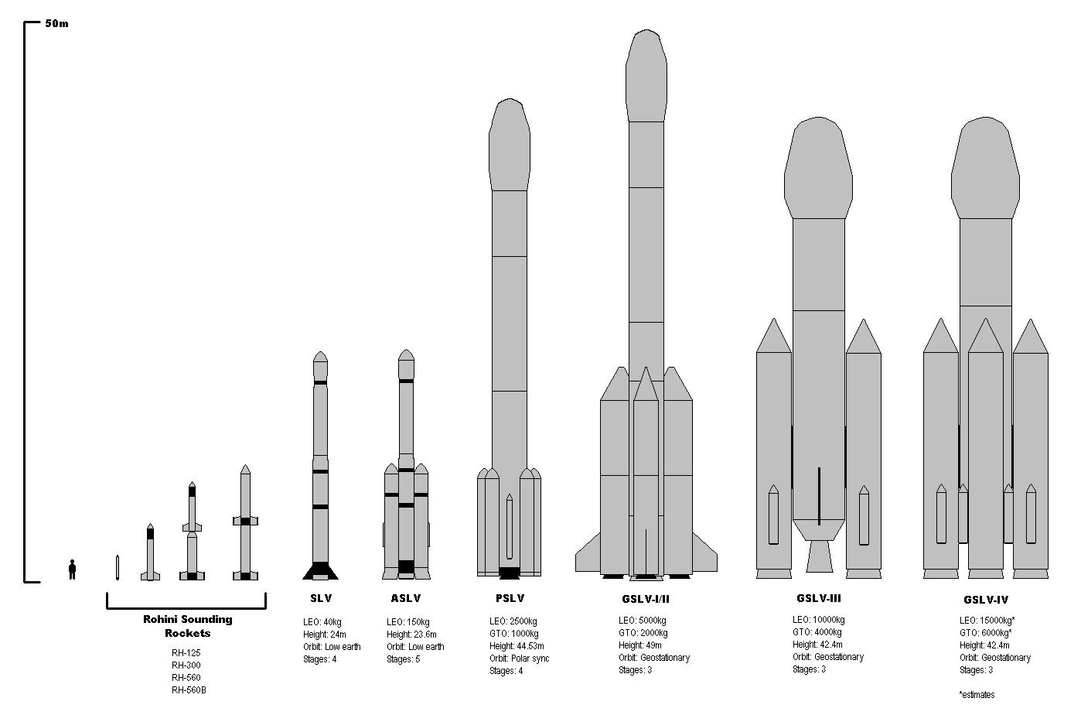

Figure 2. 2: List of ISRO Launch Vehicles

**Polar Satellite Launch Vehicle (PSLV):** Renowned as the Indian Space Research Organization's (ISRO) mainstay, the PSLV is a versatile launch vehicle available in various configurations, including core-alone and versions with different numbers of solid rocket strap-on engines. The selection of variants depends on factors such as the intended orbit and payload mass. With a remarkable track record of success, the PSLV has been instrumental in deploying a diverse array of payloads, including navigation, geostationary, and Earth observation satellites.

* 1. **Geosynchronous Satellite Launch Vehicle (GSLV):** Designed to deploy communication satellites weighing up to two tonnes, the GSLV is equipped with an indigenous cryogenic upper stage.
  2. **Geosynchronous Satellite Launch Vehicle Mk-III (LVM3):** Representing India's leap in launch vehicle technology, the LVM3 is entirely developed using domestic expertise. Capable of launching payloads weighing up to 10 tonnes into Low Earth Orbits (LEOs) and communication satellites weighing up to 4 tonnes, the LVM3 is a significant advancement. Notably, its C25 cryogenic stage is entirely indigenous. Since its inaugural development flight, the LVM3 has achieved multiple successful launches. Dubbed the Human-rated LVM3 (HRLV), it is also designated as the launch vehicle for India's maiden manned spaceflight program, the Gaganyaan mission.

## 2.5 Organization Background

Before its establishment by the Indian government in 1962, SRO was known as the Indian National Committee for Space Research (INCOSPAR), an idea conceived by Dr. Vikram Sarabhai. On August 15, 1969, ISRO was established, replacing INCOSPAR with a more expansive mission to utilize space technology. In 1972, DOS was established, and ISRO came under its purview.

The development and use of space technology for diverse national needs is ISRO/DOS's main goal. To achieve this goal, ISRO has built significant space systems for resource management and monitoring, communication, television transmission, and meteorological services. It has also constructed space-based navigation services. ISRO has created the PSLV and GSLV satellite launch vehicles to get the satellites into the necessary orbits.

In addition to advancing technology, ISRO supports national science initiatives and science education. Under the Department of Space's sponsorship, numerous specialized research centres and independent organizations for atmospheric sciences, astronomy and astrophysics, remote sensing, and space sciences in general operate. In addition to offering useful information to the scientific community, which advances research, ISRO's own lunar and interplanetary missions and other scientific endeavours support and foster science education.

## 

## 2.6 Company logo



Figure 2. 3: Company Logo

## 2.7 Company Structure

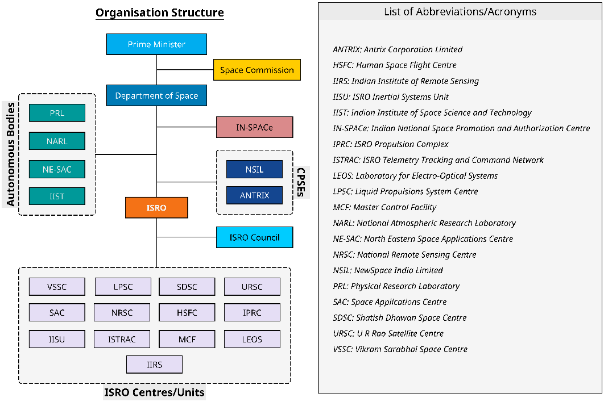

Figure 2. 4: Company Structure

List of Abbreviations:

* ANTRIX: Antrix Corporation Limited
* HSFC: Human Space Flight Centre
* IIRS: Indian Institute of Remote Sensing
* IISU: ISRO Inertial Systems Unit
* IIST: Indian Institute of Space Science and Technology
* IN-SPACE: Indian National Space Promotion and Authorization Centre
* IPRC: ISRO Propulsion Complex
* ISTRAC: ISRO Telemetry Tracking and Command Network
* LEOS: Laboratory for Electro-Optical Systems
* LPSC: Liquid Propulsions System Centre
* MCF: Master Control Facility
* NARL: National Atmospheric Research Laboratory
* NE-SAC: North Eastern Space Applications Centre
* NRSC: National Remote Sensing Centre
* NSIL: New Space India Limited
* PRL: Physical Research Laboratory
* SAC: Space Applications Centre
* SDSC: Satish Dhawan Space Centre
* URSC: U R Rao Satellite Centre
* VSSC: Vikram Sarabhai Space Centre

# **Weekly Job Summary**

|  |  |
| --- | --- |
| **DATE** | **Assigned Work** |
| **01/07/24 – 05/07/24**  **(Week 1)** | * Read the review document of different types of Sensors (Attitude Sensors). * Learn how the Autocollimator work. |
| **08/07/24 – 12/07/24**  **(Week 2)** | * Learn CAD software, NX. * Made some CAD Design’s to get familiar with software. * Studied the space environment and Earth’s atmospheric structure. |
| **15/07/24 – 19/07/24**  **(Week 3)** | * Prepare and Deliver a presentation on the topic of Chandrayaan-4. * Commenced the MHD-ARS (Magneto Hydrodynamic Angular Rate Sensor) project. * Reviewed some research papers on Magneto Hydrodynamic Angular Rate Sensors. * Created the design for various components of Magneto Hydrodynamic Angular Rate Sensors based on literature review. |
| **22/07/24 – 26/07/24**  **(Week 4)** | * Evaluated and compared various materials for each component of the MHD-ARS, and selected the most suitable materials based on the study. * Calculated the tolerance values for each component. * Implemented the suggested design corrections to enhance the performance of the Magneto Hydrodynamic Angular Rate Sensor. |
| **29/07/24 – 02/08/24**  **(Week 5)** | * Learn Drafting and assembly in NX software. * Created the assembly of MHD-ARS sensor with all components. * Studied and compared various sealing methods, identifying the best option based on the analysis. |
| **05/08/24 – 09/08/24**  **(Week 6)** | * Prepared fabrication drawings for each component. * Created a design for new component and updated the model accordingly. * Updated the fabrication drawings to reflect the modifications. * Started exploring simulation features in NX. |
| **12/08/24 – 16/08/24**  **(Week 7)** | * Started learning the fundamentals of meshing, including its importance in simulation and analysis. * Explored different types of meshes such as structured, unstructured, and hybrid meshing. * Reviewed the significance of mesh quality and its impact on simulation accuracy and convergence. * Meshed all components with optimized element types and densities, focusing on accuracy and efficiency, especially for key parts like the housing, magnet, and conductive fluid shell. |
| **19/08/24 – 23/08/24**  **(Week 8)** | * Identified and resolved common issues and errors encountered during the meshing process. * Practiced techniques for refining mesh in critical areas to improve simulation results. * Prepared the assembly for initial test runs to validate the simulation setup and resolve any potential errors. |
| **26/08/24 – 30/08/24**  **(Week 9)** | * Study the physical and mechanical properties of materials like SmCo, Teflon, and Copper used in the MHD-ARS sensor. * Used the studied properties to create and define each material in the NX local library for simulation purposes. |
| **02/09/24 – 06/09/24**  **(Week 10)**  **09/09/24 – 13/09/24**  **(Week 11)** | * Acquired knowledge on implementing bolt connections and 1D connections in NX Simulation to model and connect screw holes effectively. * Conducted modal analysis in NX and explored its significance in identifying resonance frequencies to ensure structural integrity and avoid potential failure modes. * Completed free-free modal analysis to determine natural frequencies and mode shapes in an unconstrained state. * Successfully conducted clamped modal analysis, simulating the sensor's behavior when mounted. * Learned about static analysis and the process for evaluating stress distribution and Factor of Safety. |
| **16/09/24 – 20/09/24**  **(Week 12)** | * Conducted static analysis to evaluate the stress distribution across the MHD-ARS sensor under operational loads. * Identified the maximum Von-Mises stress and calculated the minimum Factor of Safety (FOS) to ensure structural integrity. |
| **23/09/24 – 30/09/24**  **(Week 13)** | * Explored the fundamentals of random analysis in NX software. * Performed a random analysis in NX, setting parameters and reviewing results to evaluate the model’s response to vibrations. * Analyzed and plotted amplitude versus frequency graphs to evaluate the sensor’s vibrational response. |

# **4. Learnings**

## Autocollimator Operation

* Learned to operate an autocollimator, a precision instrument for measuring small angular differences with high accuracy.
* Applied this knowledge in alignment tasks, particularly in high-precision systems like optical instruments.
* Gained hands-on experience in using precision measurement tools, improving my skills in fine-tuned calibration.

## NX Software Proficiency

* Developed a strong command of 3D modelling in NX, specifically for the Magneto Hydrodynamic Angular Rate Sensor (MHD-ARS) components.
* Created detailed technical drawings for fabrication, ensuring each design met manufacturing standards.
* Gained a deep understanding of translating design concepts into precise, production-ready models.

## Assembly in NX

* Learned to assemble multiple complex components within NX, applying constraints for proper alignment and fitment.
* Strengthened my understanding of how parts interact mechanically and their importance in ensuring seamless integration.
* Gained valuable experience with tolerances and precision in assembling the sensor’s components.

## Advanced Simulations

* Conducted Modal Free, Modal Clamp, Random Analysis, Static Analysis and Random Analysis in NX to evaluate the sensor’s performance under different conditions.
* Analyzed the dynamic behavior of components under mechanical loads, vibrations, and stress, providing insights into durability and reliability.
* Static analysis helped in understanding how the system responds to steady-state forces, contributing to the optimization of component design for strength and stability.

# 

# **5**. **Introduction to Project Topic**

## 5.1 Introduction

Magneto Hydrodynamic (MHD) angular rate sensors are advanced devices used to measure the angular rate of an object. Magneto-Hydrodynamic Angular Rate Sensor (MHD-ARS) operates on the principles of **Magneto-Hydrodynamics (MHD)**, Specifically, **Faraday's Law of Electromagnetic Induction** and the **Lorentz Force** are key to its function.

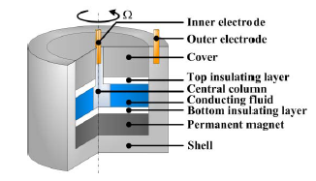

Figure 5. 1: Magneto Hydrodynamic Angular Rate Sensor

In the evolving field of space exploration and advanced aerospace applications, precise measurement of angular rate is crucial for navigation, control, and stabilization of spacecraft and other high-velocity systems. Traditional angular rate sensors, such as gyroscopes, have been widely used, but their limitations in extreme environments and high-precision applications call for innovative solutions.

Magneto-hydrodynamics (MHD) is the study of the dynamics of conducting fluids in the presence of magnetic fields. By leveraging MHD principles, new technologies offer novel approaches to angular rate measurement, harnessing the interactions between a conducting fluid and magnetic fields to produce highly accurate and reliable measurements. This technology is particularly advantageous in the space environment, where traditional sensors may struggle due to microgravity and extreme temperatures.

The MHD-ARS operates on the principle that the motion of a conducting fluid in a magnetic field generates electric currents, which can be measured to determine rotational rates. This method promises enhanced sensitivity, reduced noise, and greater resilience to environmental factors compared to conventional sensors. This report will detail the design, development, and testing of the MHD-ARS, highlighting its potential advantages and applications in space technology.

Through rigorous analysis and experimental validation, this project aims to demonstrate the feasibility and benefits of the MHD-ARS, paving the way for its integration into future space missions and advanced aerospace systems. The following sections will explore the theoretical foundations of MHD, the engineering design of the sensor, and the results of performance evaluations, providing a comprehensive overview of this innovative technology.

## 5.2 Aim and Purpose

**Aim:**

The aim of this project is to develop a highly sensitive and reliable Magneto hydrodynamic Angular Rate Sensor (MHD-ARS) capable of detecting minimal angular displacements, particularly for use in high-precision applications such as space missions and advanced navigation systems.

**Purpose:**

1. **Precision Measurement:** To design an MHD-ARS that can measure extremely small angular displacements, with a focus on achieving sub-microradian resolution to meet the demands of precision-guided systems.
2. **Magneto hydrodynamic Principles:** To explore and apply the principles of magneto hydrodynamics in the sensor's design, optimizing the interaction between the conductive fluid and magnetic fields to enhance sensor performance.
3. **Material and Structural Optimization:** To investigate and select the most suitable materials for the sensor's components, including the conductive fluid and electrodes, ensuring minimal contact resistance and high sensitivity.
4. **Space-Readiness:** To adapt the MHD-ARS for space applications, addressing challenges such as temperature extremes, radiation exposure, and vacuum conditions, to ensure reliable operation in space environments.
5. **Theoretical and Experimental Validation:** To develop both theoretical models and experimental setups that validate the sensor’s performance, ensuring that the design meets the accuracy, stability, and durability requirements for its intended applications.
6. **Contribution to Sensor Technology:** To advance the field of angular rate sensing by introducing new methodologies and technologies that improve the accuracy and reliability of MHD sensors, contributing to both academic research and practical applications.
7. **Scalability and Integration:** To explore the potential for scaling the sensor for different applications and integrating it into larger systems, such as spacecraft navigation or autonomous vehicles, ensuring compatibility and ease of use.

## 5.3 Emerging Technological Trends

Before the introduction of the Magneto Hydrodynamic Angular Rate Sensor (MHD-ARS), mechanical gyroscopes were widely used to measure angular velocity. Developed in the early 19th century, mechanical gyroscopes utilized a spinning rotor to detect changes in orientation. However, they were bulky, required regular maintenance, and had limited lifespan due to moving parts.

The development of MHD-ARS began in the 1960s as a more durable and efficient alternative. Instead of moving parts, it used the interaction between a magnetic field and a conductive fluid (like mercury) to detect angular motion. This innovation eliminated the need for mechanical components, reducing wear and improving reliability.

Throughout the 1980s and 1990s, MHD-ARS technology saw significant advancements. Improvements in magnetic materials (such as Samarium Cobalt) and fluid dynamics increased sensitivity and precision. The integration of digital signal processing further enhanced performance, making MHD-ARS a preferred choice in aerospace applications, especially in space exploration due to its compact size, long life, and high accuracy.

## 5.4 Problem Statement

In space missions, precise angular rate measurement is crucial for navigation, stabilization, and control of spacecraft. Traditional angular rate sensors, such as mechanical gyroscopes and MEMS devices, face significant challenges in extreme space environments. Mechanical gyroscopes are prone to wear due to moving parts, while MEMS sensors often struggle with accuracy and durability in space conditions.

The Magneto Hydrodynamic Angular Rate Sensor (MHD-ARS) offers a more durable solution by utilizing the interaction between a magnetic field and a conductive fluid, eliminating mechanical components to reduce wear. However, testing the space worthiness of the MHD-ARS sensor is essential to confirm its ability to perform reliably in high-vibration conditions experienced during launch and under the extreme environments of space.

This project involves the design, simulation, and testing through vibration analysis of the MHD-ARS sensor to evaluate its suitability for space applications, ensuring that it meets the stringent demands of aerospace missions while maintaining performance and reliability.

## 5.5 Outline of the Proposed Work

The project focuses on designing and simulating the Magneto Hydrodynamic Angular Rate Sensor (MHD-ARS) for space applications. Key areas include:

* **Design**: Develop the MHD-ARS sensor, emphasizing key components and material selection to ensure optimal performance.
* **Simulation**: Use NX software for modal, structural, and random analysis to predict the sensor’s performance under simulated conditions.
* **Analysis**: Evaluate simulation results to assess the sensor’s effectiveness and reliability for space missions.

The goal is to validate the sensor’s design and performance through comprehensive simulation and analysis, ensuring its suitability for aerospace applications.

## 5.6 Overview of Modeling Software

Siemens NX software integrates Computer-Aided Design (CAD), Computer-Aided Manufacturing (CAM), and Computer-Aided Engineering (CAE) capabilities into a single platform. Its advanced modeling features include surface, solid, sheet, aerodynamic, and parametric modeling. NX enables designers and manufacturers to accelerate product development by reducing the need for prototypes and minimizing rework. Additionally, it enhances design quality, helps manage deadlines efficiently, and enables faster delivery of products.

Siemens NX is used for various tasks, including:

* Design: Parametric and direct solid/surface modeling.
* Engineering Analysis: Static, dynamic, electro-magnetic, thermal, and other analyses.
* Manufacturing: Utilizing machining modules to manufacture finished designs.

In the aerospace industry, Siemens NX is employed for the design, simulation, testing, and optimization of aircraft, rockets, satellites, and drones. Its Product Lifecycle Management (PLM) capabilities enable companies to design, test, and validate their products efficiently. For instance, SpaceX uses NX for rocket design, and designers use it to simulate motion and identify interferences in virtual mock-ups.

Originally known as “Unigraphics,” Siemens NX has been under Siemens Digital Industries Software’s ownership since 2007. It is a direct competitor to other leading software such as CATIA, Creo, and Autodesk Inventor.

## 5.6.1 Fractures of NX

1. **Parametric Modeling:** Siemens NX allows for the creation and modification of designs using parameters and constraints. It also provides intuitive direct modeling capabilities, enabling manipulation of solid and surface models without predefined constraints.
2. **Sheet Metal Design:** The software includes specialized tools for designing and manufacturing sheet metal parts.
3. **Static and Dynamic Analysis:** NX evaluates the behavior of structures under static loads and assesses responses to dynamic loads such as vibrations.
4. **Thermal and Electro-Magnetic Analysis:** It examines how temperature variations affect materials and structures and analyzes electromagnetic fields and their effects on components.
5. **Machining Modules:** Includes tools for creating machining processes like milling, turning, and drilling. NX also supports additive manufacturing processes such as 3D printing.
6. **Motion and Structural Simulation:** The software models the movement of parts and assemblies to detect interferences and optimize motion, and predicts how parts will behave under various loading conditions.
7. **Product Lifecycle Management (PLM):** Facilitates the management of product data and processes throughout the lifecycle and enables team collaboration through integrated project management and data sharing tools.
8. **Virtual Prototyping and Interference Detection:** Allows for the creation and testing of digital prototypes before physical production, and identifies and resolves conflicts in assemblies and designs.

## 5.6.2 Functions of NX

* Computer-aided design (CAD) (Design).
* Parametric solid modelling (feature-based and direct modelling).
* Freeform surface modelling, class A surfaces.
* Reverse engineering.
* Styling and computer-aided industrial design.
* Product and manufacturing information (PMI).
* Reporting and analytics verification and validation.
* Knowledge reuse, including knowledge-based engineering.
* Sheet metal design.
* Assembly modelling and digital mock-up.
* Routing for electrical wiring and mechanical piping.
* Computer-aided engineering (CAE) (Simulation).
* Stress analysis / finite element analysis (FEA).

## 5.7 Autocollimator

An autocollimator is an optical instrument used for non-contact measurement of angles. It is commonly employed in mechanical and optical systems to measure deflections and align components. The device projects an image onto a target mirror and measures the deflection of the image as it is returned against a scale, either visually or with the help of an electrical detector.

Electrical autocollimators offer significantly higher resolution compared to visual autocollimators, with the ability to measure angles as small as 1 arc second (4.85 micro radians). They are used to ensure precise alignment and verify angular positions over time. Visual autocollimators are often utilized to check the parallelism of optical windows and wedges, and to align laser rods.

Electronic and digital autocollimators serve as standards for measuring angles and tracking angular movement over extended periods, ensuring repeatability in mechanical systems. Specialized high-speed servo-feedback loops for stable-platform applications use servo autocollimators, which are compact versions of electronic autocollimators. Typically, electronic autocollimators are calibrated to accurately measure the mirror angle, enhancing their precision and reliability in various applications.

Figure 5. 2: Autocollimator

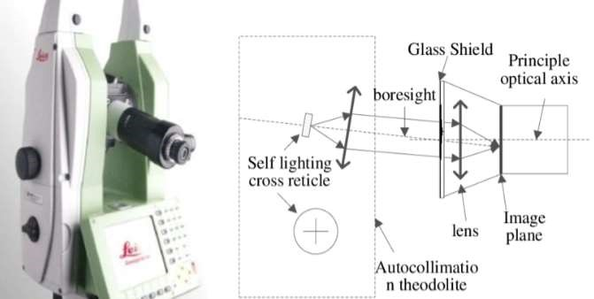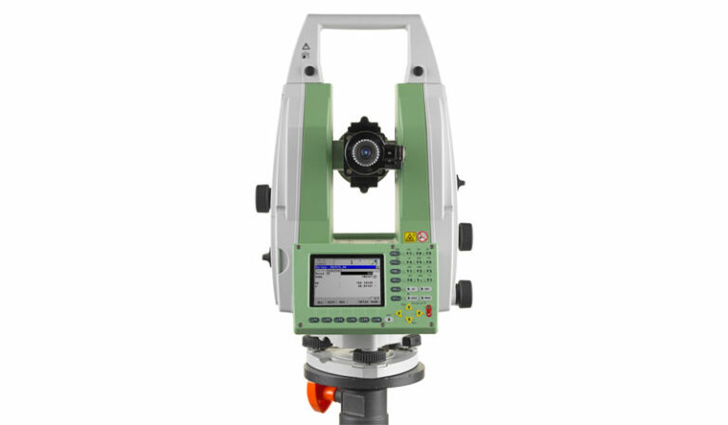

## **5.7.1 Applications of Autocollimator (ACM**)

An electronic autocollimator can be used in the measurement of straightness of machine components (such as guide ways) or the straightness of lines of motion of machine components. Flatness measurement, of granite surface plates, other applications include:

* Aircraft assembly jigs
* Satellite testing
* Nuclear reactors
* Retro reflector measurement
* Roof prism measurement
* Optical assembly procedures
* Alignment of beam delivery systems
* Alignment of laser cavity
* Testing perpendicularity of laser rods in respect to its axis
* Real time measurement of angular stability of mirror elements.

## 5.7.2 Alignment Procedure using Autocollimator

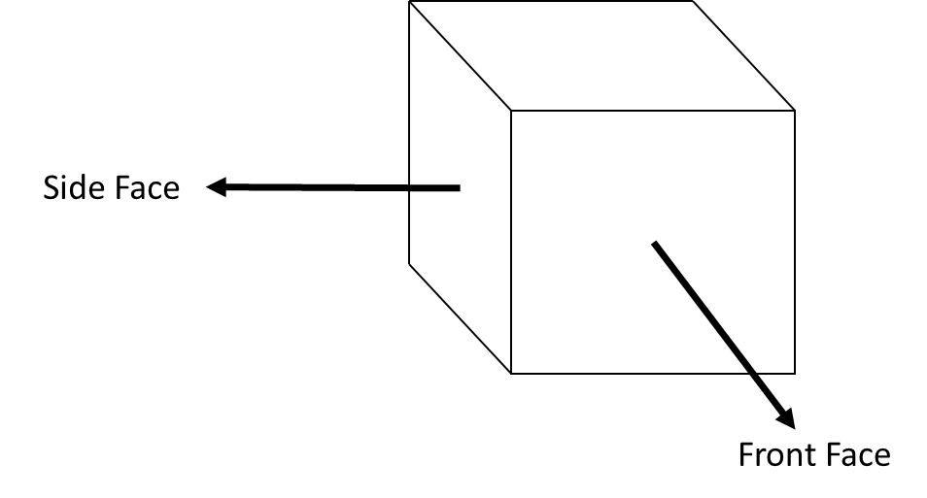 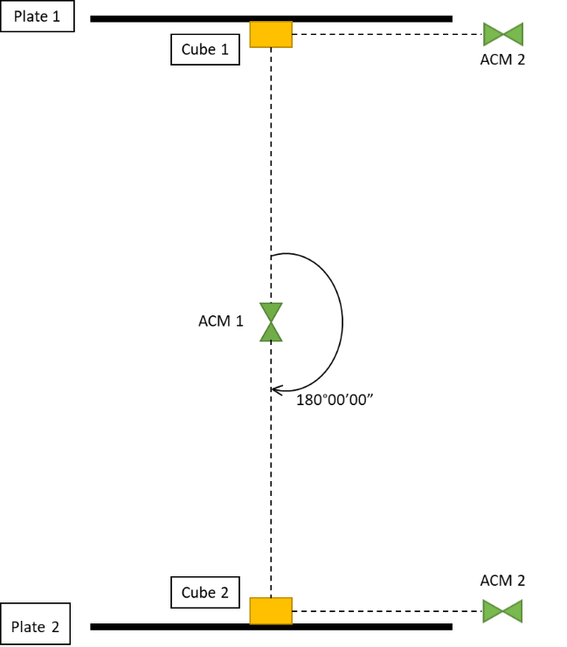

Figure 5.3: Alignment Setup

Figure 5.4: Reflective Cube

**Steps for aligning two planes:**

1. ACM is placed in between both the plates at an appropriate distance.
2. The levelling is check and bought to <0.00005. The laser is turned on and the reflection in theodolite mode is checked.
3. The reference hole next to the cube is matched such that it is at the centre of the ACM’s crosshair by moving the ACM in X and/or Y direction.
4. Once the hole centre is matched and the reflection is visible on the cube in theodolite mode, levelling of the ACM is checked and the scope is rotated towards infinity and made sure the elevation is at 90° 00 ‘00”.
5. If not then the elevation of the plate is set to 90° 00’ 00” using the Huber.
6. The scope is rotated counter-clockwise and focused on the reference hole, to make sure that the reference hole stays at the centre of the crosshair, if not then steps 6-8 are repeated until the elevation is 90° 00’ 00” and the reference hole is perfectly matched.
7. Another ACM is placed at the side of the plates to determine the side face values. The levelling is checked and the ACM is pointed towards the side face of the cube, the value of elevation is checked by aligning the laser beam once the reflection is found in theodolite mode.
8. 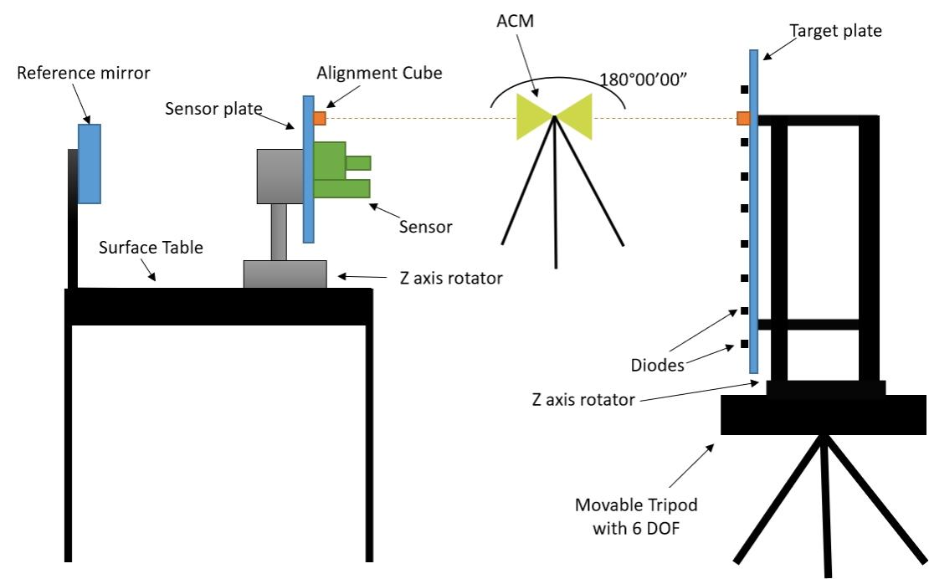Correction in the elevation is made if required and set it to 90° 00’ 00” by rotating the plate in Z-axis via Huber.

Figure 5.5: 6 D.O.F Cube Reading Setup

Figure 5.5: 6 D.O.F Cube Reading Setup

1. Once again front face of the cube is checked using ACM and checks for any changes in the elevation and/or azimuth is done, then corrected if needed.
2. ACM is rotated by 180° 00’ 00” in Azimuth and the levelling of ACM is checked. The reflection from the cube in theodolite mode is checked on plate 2, then alignment of the reference hole of the plate 2 is done by moving the Plate in X and/or Y direction.
3. Once the reference hole next to the cube of second plate is aligned, the scope is rotated towards infinity and checks are done to see if the beam reflection is at the centre of the ACM’s crosshair.
4. Another ACM is placed at the side of the plates to determine the side face values. Levelling is checked and the ACM is pointed at the side face of the cube at plate 2, then elevation of the side face is checked by aligning the laser beam once the reflection is found in theodolite mode.
5. Correction in the elevation is made if required and then set to 90° 00’ 00” by rotating the plate in Z-axis using the Huber.
6. Once again front face of the cube is checked using ACM and checks for any changes in the elevation and/or azimuth is done, then corrected if needed.

Reflection of the laser beam

Reflection of the laser beam

Reflection of the laser beam

Reflection of the laser beam

Reflection of the laser beam

Reflection of the laser beam

Reflection of the laser beam

Reflection of the laser beam

Reflection of the laser beam

Reflection of the laser beam

Reflection of the laser beam

Reflection of the laser beam

Reflection of the laser beam

Reflection of the laser beam

Reflection of the laser beam

Reflection of the laser beam

Reflection of the laser beam

Reflection of the laser beam

Reflection of the laser beam

Reflection of the laser beam

Reflection of the laser beam

Reflection of the laser beam

Reflection of the laser beam

Reflection of the laser beam

Reflection of the laser beam

Reflection of the laser beam

Reflection of the laser beam

Reflection of the laser beam

Reflection of the laser beam

Reflection of the laser beam

Reflection of the laser beam

Reflection of the laser beam

Reflection of the laser beam

Reflection of the laser beam

Reflection of the laser beam

Reflection of the laser beam

Reflection of the laser beam

Reflection of the laser beam

Reflection of the laser beam

Reflection of the laser beam

Reflection of the laser beam

Reflection of the laser beam

Reflection of the laser beam

Reflection of the laser beam

Reflection of the laser beam

Reflection of the laser beam

Reflection of the laser beam

Reflection of the laser beam

Reflection of the laser beam

Reflection of the laser beam

Reflection of the laser beam

Reflection of the laser beam

Reflection of the laser beam

Reflection of the laser beam

Reflection of the laser beam

Reflection of the laser beam

Reflection of the laser beam

Reflection of the laser beam

Reflection of the laser beam

Reflection of the laser beam

Reflection of the laser beam

Reflection of the laser beam

Reflection of the laser beam

Reflection of the laser beam

Reflection of the laser beam

Reflection of the laser beam

Reflection of the laser beam

Reflection of the laser beam

Reflection of the laser beam

Reflection of the laser beam

Reflection of the laser beam

Reflection of the laser beam

Reflection of the laser beam

Reflection of the laser beam

Reflection of the laser beam

Reflection of the laser beam

Reflection of the laser beam

Reflection of the laser beam

Reflection of the laser beam

Reflection of the laser beam

Reflection of the laser beam

Reflection of the laser beam

Reflection of the laser beam

Reflection of the laser beam

Reflection of the laser beam

Reflection of the laser beam

Reflection of the laser beam

Reflection of the laser beam

Reflection of the laser beam

Reflection of the laser beam

Reflection of the laser beam

Reflection of the laser beam

Reflection of the laser beam

Reflection of the laser beam

Reflection of the laser beam

Reflection of the laser beam

Reflection of the laser beam

Reflection of the laser beam

Reflection of the laser beam

Reflection of the laser beam

Reflection of the laser beam

Reflection of the laser beam

Reflection of the laser beam

Reflection of the laser beam

Reflection of the laser beam

Reflection of the laser beam

Reflection of the laser beam

Reflection of the laser beam

Reflection of the laser beam

Reflection of the laser beam

Reflection of the laser beam

Reflection of the laser beam

Reflection of the laser beam

Reflection of the laser beam

Reflection of the laser beam

Reflection of the laser beam

Reflection of the laser beam

Reflection of the laser beam

Reflection of the laser beam

Reflection of the laser beam

Reflection of the laser beam

Reflection of the laser beam

Reflection of the laser beam

Reflection of the laser beam

Reflection of the laser beam

Reflection of the laser beam

Reflection of the laser beam

Reflection of the laser beam

Crosshair of the ACM

Figure 5. 6: Alignment of Laser BeamCrosshair of the ACM

Figure 5. 6: Alignment of Laser BeamCrosshair of the ACM

Figure 5. 6: Alignment of Laser BeamCrosshair of the ACM

Figure 5. 6: Alignment of Laser BeamCrosshair of the ACM

Figure 5. 6: Alignment of Laser BeamCrosshair of the ACM

Figure 5. 6: Alignment of Laser BeamCrosshair of the ACM

Figure 5. 6: Alignment of Laser BeamCrosshair of the ACM

Figure 5. 6: Alignment of Laser BeamCrosshair of the ACM

Figure 5. 6: Alignment of Laser BeamCrosshair of the ACM

Figure 5. 6: Alignment of Laser BeamCrosshair of the ACM

Figure 5. 6: Alignment of Laser BeamCrosshair of the ACM

Figure 5. 6: Alignment of Laser BeamCrosshair of the ACM

Figure 5. 6: Alignment of Laser BeamCrosshair of the ACM

Figure 5. 6: Alignment of Laser BeamCrosshair of the ACM

Figure 5. 6: Alignment of Laser BeamCrosshair of the ACM

Figure 5. 6: Alignment of Laser BeamCrosshair of the ACM

Figure 5. 6: Alignment of Laser BeamCrosshair of the ACM

Figure 5. 6: Alignment of Laser BeamCrosshair of the ACM

Figure 5. 6: Alignment of Laser BeamCrosshair of the ACM

Figure 5. 6: Alignment of Laser BeamCrosshair of the ACM

Figure 5. 6: Alignment of Laser BeamCrosshair of the ACM

Figure 5. 6: Alignment of Laser BeamCrosshair of the ACM

Figure 5. 6: Alignment of Laser BeamCrosshair of the ACM

Figure 5. 6: Alignment of Laser BeamCrosshair of the ACM

Figure 5. 6: Alignment of Laser BeamCrosshair of the ACM

Figure 5. 6: Alignment of Laser BeamCrosshair of the ACM

Figure 5. 6: Alignment of Laser BeamCrosshair of the ACM

Figure 5. 6: Alignment of Laser BeamCrosshair of the ACM

Figure 5. 6: Alignment of Laser BeamCrosshair of the ACM

Figure 5. 6: Alignment of Laser BeamCrosshair of the ACM

Figure 5. 6: Alignment of Laser BeamCrosshair of the ACM

Figure 5. 6: Alignment of Laser BeamCrosshair of the ACM

Figure 5. 6: Alignment of Laser BeamCrosshair of the ACM

Figure 5. 6: Alignment of Laser BeamCrosshair of the ACM

Figure 5. 6: Alignment of Laser BeamCrosshair of the ACM

Figure 5. 6: Alignment of Laser BeamCrosshair of the ACM

Figure 5. 6: Alignment of Laser BeamCrosshair of the ACM

Figure 5. 6: Alignment of Laser BeamCrosshair of the ACM

Figure 5. 6: Alignment of Laser BeamCrosshair of the ACM

Figure 5. 6: Alignment of Laser BeamCrosshair of the ACM

Figure 5. 6: Alignment of Laser BeamCrosshair of the ACM

Figure 5. 6: Alignment of Laser BeamCrosshair of the ACM

Figure 5. 6: Alignment of Laser BeamCrosshair of the ACM

Figure 5. 6: Alignment of Laser BeamCrosshair of the ACM

Figure 5. 6: Alignment of Laser BeamCrosshair of the ACM

Figure 5. 6: Alignment of Laser BeamCrosshair of the ACM

Figure 5. 6: Alignment of Laser BeamCrosshair of the ACM

Figure 5. 6: Alignment of Laser BeamCrosshair of the ACM

Figure 5. 6: Alignment of Laser BeamCrosshair of the ACM

Figure 5. 6: Alignment of Laser BeamCrosshair of the ACM

Figure 5. 6: Alignment of Laser BeamCrosshair of the ACM

Figure 5. 6: Alignment of Laser BeamCrosshair of the ACM

Figure 5. 6: Alignment of Laser BeamCrosshair of the ACM

Figure 5. 6: Alignment of Laser BeamCrosshair of the ACM

Figure 5. 6: Alignment of Laser BeamCrosshair of the ACM

Figure 5. 6: Alignment of Laser BeamCrosshair of the ACM

Figure 5. 6: Alignment of Laser BeamCrosshair of the ACM

Figure 5. 6: Alignment of Laser BeamCrosshair of the ACM

Figure 5. 6: Alignment of Laser BeamCrosshair of the ACM

Figure 5. 6: Alignment of Laser BeamCrosshair of the ACM

Figure 5. 6: Alignment of Laser BeamCrosshair of the ACM

Figure 5. 6: Alignment of Laser BeamCrosshair of the ACM

Figure 5. 6: Alignment of Laser BeamCrosshair of the ACM

Figure 5. 6: Alignment of Laser BeamCrosshair of the ACM

Figure 5. 6: Alignment of Laser BeamCrosshair of the ACM

Figure 5. 6: Alignment of Laser BeamCrosshair of the ACM

Figure 5. 6: Alignment of Laser BeamCrosshair of the ACM

Figure 5. 6: Alignment of Laser BeamCrosshair of the ACM

Figure 5. 6: Alignment of Laser BeamCrosshair of the ACM

Figure 5. 6: Alignment of Laser BeamCrosshair of the ACM

Figure 5. 6: Alignment of Laser BeamCrosshair of the ACM

Figure 5. 6: Alignment of Laser BeamCrosshair of the ACM

Figure 5. 6: Alignment of Laser BeamCrosshair of the ACM

Figure 5. 6: Alignment of Laser BeamCrosshair of the ACM

Figure 5. 6: Alignment of Laser BeamCrosshair of the ACM

Figure 5. 6: Alignment of Laser BeamCrosshair of the ACM

Figure 5. 6: Alignment of Laser BeamCrosshair of the ACM

Figure 5. 6: Alignment of Laser BeamCrosshair of the ACM

Figure 5. 6: Alignment of Laser BeamCrosshair of the ACM

Figure 5. 6: Alignment of Laser BeamCrosshair of the ACM

Figure 5. 6: Alignment of Laser BeamCrosshair of the ACM

Figure 5. 6: Alignment of Laser BeamCrosshair of the ACM

Figure 5. 6: Alignment of Laser BeamCrosshair of the ACM

Figure 5. 6: Alignment of Laser BeamCrosshair of the ACM

Figure 5. 6: Alignment of Laser BeamCrosshair of the ACM

Figure 5. 6: Alignment of Laser BeamCrosshair of the ACM

Figure 5. 6: Alignment of Laser BeamCrosshair of the ACM

Figure 5. 6: Alignment of Laser BeamCrosshair of the ACM

Figure 5. 6: Alignment of Laser BeamCrosshair of the ACM

Figure 5. 6: Alignment of Laser BeamCrosshair of the ACM

Figure 5. 6: Alignment of Laser BeamCrosshair of the ACM

Figure 5. 6: Alignment of Laser BeamCrosshair of the ACM

Figure 5. 6: Alignment of Laser BeamCrosshair of the ACM

Figure 5. 6: Alignment of Laser BeamCrosshair of the ACM

Figure 5. 6: Alignment of Laser BeamCrosshair of the ACM

Figure 5. 6: Alignment of Laser BeamCrosshair of the ACM

Figure 5. 6: Alignment of Laser BeamCrosshair of the ACM

Figure 5. 6: Alignment of Laser BeamCrosshair of the ACM

Figure 5. 6: Alignment of Laser BeamCrosshair of the ACM

Figure 5. 6: Alignment of Laser BeamCrosshair of the ACM

Figure 5. 6: Alignment of Laser BeamCrosshair of the ACM

Figure 5. 6: Alignment of Laser BeamCrosshair of the ACM

Figure 5. 6: Alignment of Laser BeamCrosshair of the ACM

Figure 5. 6: Alignment of Laser BeamCrosshair of the ACM

Figure 5. 6: Alignment of Laser BeamCrosshair of the ACM

Figure 5. 6: Alignment of Laser BeamCrosshair of the ACM

Figure 5. 6: Alignment of Laser BeamCrosshair of the ACM

Figure 5. 6: Alignment of Laser BeamCrosshair of the ACM

Figure 5. 6: Alignment of Laser BeamCrosshair of the ACM

Figure 5. 6: Alignment of Laser BeamCrosshair of the ACM

Figure 5. 6: Alignment of Laser BeamCrosshair of the ACM

Figure 5. 6: Alignment of Laser BeamCrosshair of the ACM

Figure 5. 6: Alignment of Laser BeamCrosshair of the ACM

Figure 5. 6: Alignment of Laser BeamCrosshair of the ACM

Figure 5. 6: Alignment of Laser BeamCrosshair of the ACM

Figure 5. 6: Alignment of Laser BeamCrosshair of the ACM

Figure 5. 6: Alignment of Laser BeamCrosshair of the ACM

Figure 5. 6: Alignment of Laser BeamCrosshair of the ACM

Figure 5. 6: Alignment of Laser BeamCrosshair of the ACM

Figure 5. 6: Alignment of Laser BeamCrosshair of the ACM

Figure 5. 6: Alignment of Laser BeamCrosshair of the ACM

Figure 5. 6: Alignment of Laser BeamCrosshair of the ACM

Figure 5. 6: Alignment of Laser BeamCrosshair of the ACM

Figure 5. 6: Alignment of Laser BeamCrosshair of the ACM

Figure 5. 6: Alignment of Laser BeamCrosshair of the ACM

Figure 5. 6: Alignment of Laser BeamCrosshair of the ACM

Figure 5. 6: Alignment of Laser BeamCrosshair of the ACM

Figure 5. 6: Alignment of Laser Beam

*Figure represent the alignment of the reflection of laser beam and crosshair of ACM when the scope is rotate to infinity.*

# **Literature Review/ Field Survey**

This chapter provides a detailed literature review based on the problem statement to understand existing technologies and concepts related to angular rate sensors. The review primarily focuses on research articles that offer insights into the limitations of current sensor technologies and the advancements in innovative solutions. The chapter aims to familiarize readers with the core concepts and guide the development of more effective solutions.

#### **1. "Theoretical and Experimental Study of Radial Velocity Generation for Extending Band Width of MHD-ARS Sensor at Low frequency”**

**Authors:** Yue Ji, Xingfei Li, Tengfei Wu and Cheng Chen

**Journal:** MDPI

**Year:** 2015

**Summary:** This paper introduces a modified Magneto-Hydrodynamic Angular Rate Sensor (MHD-ARS) that combines the Coriolis effect with MHD effects to broaden the measurement scope. It presents a method for generating radial flow velocity using an MHD pump, crucial for integrating these two effects. Numerical simulations and experiments were conducted to study the impact of structural and physical parameters. The consistency between the simulated and experimental velocity measurements validates the method's effectiveness, demonstrating its ability to extend the measurement range of the MHD-ARS throughout the entire bandwidth.

#### **2. "Preliminary Study on the Magneto hydrodynamic (MHD) Angular Rate Sensor Combining Coriolis Effect at Low- frequency"**

**Authors:** Yue Ji, Xingfei Li, Tengfei Wu and Jun Wu

**Journal:** IEEE Xplore

**Year: 2017**

**Summary: This paper presents a preliminary study on the Magneto hydrodynamic (MHD) angular rate sensor and Coriolis effect in order to achieve low frequency bandwidth expansion and comparison study of mercury (Hg) and Galinstan liquid metals. In this paper numerical simulation and experiments are explained based on the designed device. The Simulation results describe that the Coriolis effect is induced at low frequency. This study provides a preliminary understanding of Magneto hydrodynamic angular rate sensor combining with Coriolis effect (C- MHD ARS).**

#### **3. "Study on the Performance of Liquid- Solid Contact Resistance Based on Magneto hydrodynamic Micro-Angular Vibration Sensor"**

**Authors:** Ganmin Xia, Weixiao Tuo, Xingfei Li and Xinyu Liu

**Journal:** MDPI

**Year: 2022**

**Summary:** This paper investigates how the contact resistance between conductive fluid and metal electrodes affects the performance of magnetic fluid micro angular vibration sensors. A theoretical model is developed, considering factors like resistivity, temperature, pressure, and angular vibration. Experiments with electrodes made of silver (Ag), copper (Cu), and titanium (Ti) show that static contact resistance increases with material resistivity and temperature but decreases with surface roughness and contact pressure. Additionally, dynamic resistance fluctuates with the amplitude and frequency of input voltage. The findings suggest that reducing contact resistance can significantly improve sensor performance.

#### **4. "**Design and Experiment Study for MHD Microradian Angular Vibratory Sensor**"**

**Authors:** Tong Li, K. Wang

**Journal:** IEEE Xplore

**Year: 2016**

**Summary:** This paper focuses on a Magneto hydrodynamic (MHD) microradian angular vibratory sensor, which offers high precision, long life, and small size without the mechanical wear of traditional gyroscopes or the limitations of optical sensors. The study reviews research from various institutions and explains the sensor's working principle. After selecting a design based on international MHD products, the paper details the sensor's transfer function, structure, and magnetic field design. It also presents a prototype and evaluates its performance through experiments. The results provide valuable insights for enhancing the design and functionality of MHD sensors.

#### **5. "MHD Sensor for Measuring Microradian Angular Rates and Displacements"**

**Authors:** Darren R. Laughlin, Albuquerque

**Journal:** United States Patent

**Year: 2001**

**Summary:** This paper explains the design and functionality of a sensor that measures extremely small angular movements, down to sub-microradian displacements. The sensor operates using a cylindrical column of conductive fluid, aligned along the axis of rotation. A permanent magnet, along with a shunt structure, generates a radial magnetic field through the fluid. Two electrodes, located at the top and bottom of the fluid column, detect an electrostatic potential created by the sensor's rotation. This potential generates a current that flows through a central electrode connecting the two ends. A transformer coil surrounding the central electrode amplifies the signal from this current, producing an output that corresponds to the rate of rotation. The paper details how this design enables precise measurement of small angular displacements.

##### **6. “Research on Magneto hydrodynamic Angular Rate Sensor Denoising for a Space Laser Stabilization Control System”**

**Authors:** Yunhao Su, Caiwen Ma, Junfeng Han, Xuan Wang, Yuanyuan Wang, and Zhou Ji

**Journal:** MDPI

**Year: 2023**

**Summary: The paper presents a novel method for enhancing the signal quality of Magneto hydrodynamic Angular Rate Sensors (MHD ARS), which measure spacecraft vibrations with very low amplitude and potential. The proposed technique combines Complete Ensemble Empirical Mode Decomposition with Adaptive Noise (CEEMDAN) and Wavelet Threshold Denoising (WTD) to effectively reduce noise. By using CEEMDAN to decompose noisy signals and autocorrelation to identify relevant modes, followed by improved thresholding for denoising, the method achieves superior results compared to conventional approaches. Experiments show that this approach significantly improves signal clarity in both static and dynamic conditions.**

7. Magneto-Hydrodynamic Angular Rate Sensor

## 7.1 MHD-ARS

Magneto hydrodynamic (MHD) angular rate sensors are advanced devices used to measure the angular velocity of an object. They operate on the principles of Magneto hydrodynamics, which is the study of the dynamics of electrically conducting fluids in the presence of magnetic fields. These sensors are particularly valued in aerospace and space applications due to their high precision, robustness, and ability to function in extreme environments.

## 7.2 Principles of Operation

The fundamental principle behind MHD angular rate sensors is the interaction between a conductive fluid and a magnetic field. When a conductive fluid, such as a liquid metal, moves through a magnetic field, it generates an electric potential due to electromagnetic induction. This electric potential is proportional to the velocity of the fluid, which can be correlated to the angular velocity of the sensor.

The MHD effect is governed by the equations of magneto hydrodynamics, which combine the Navier-Stokes equations of fluid dynamics with Maxwell's equations of electromagnetism. The key equation in this context is the induction equation, which describes how the magnetic field is affected by the motion of the conducting fluid. The induced electric potential, or electromotive force (EMF), is given by:

[ E = B v ]

where ( E ) is the induced electric potential, ( B ) is the magnetic field, and ( v ) is the velocity of the conductive fluid.

## 7.3 Components of MHD-ARS

1. **Conductive Fluid:** The core component of an MHD angular rate sensor is the conductive fluid, often a liquid metal like mercury or an alloy such as Galinstan. This fluid must have

high electrical conductivity and low viscosity to respond quickly to changes in angular velocity and generate a measurable electric potential.

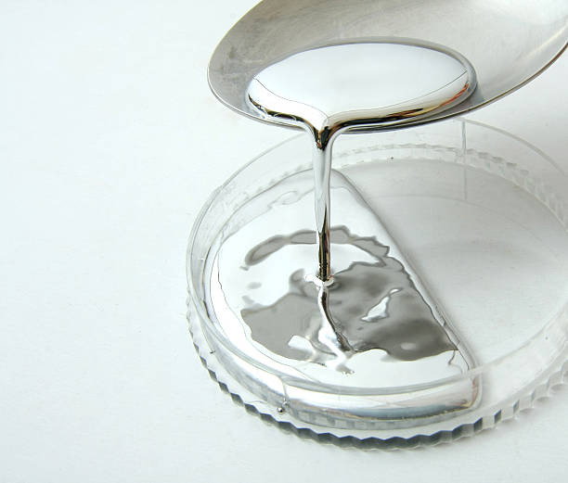

Figure 7. 1: Mercury Metal

1. 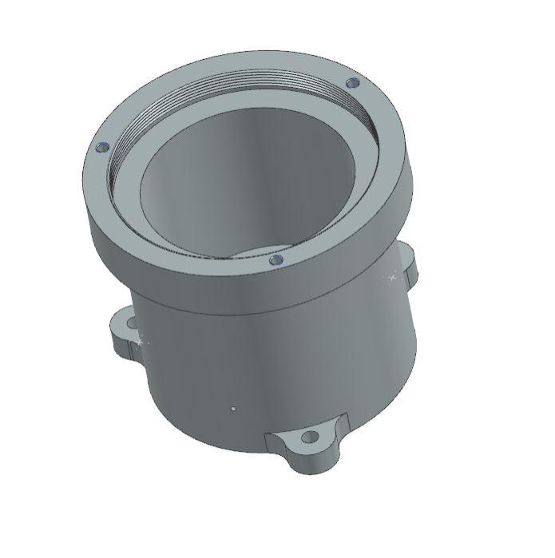**Housing:** The cylindrical housing is the main structural component that holds all the internal parts of the sensor. It provides mechanical stability and protection against external forces. This housing must be strong enough to ensure that all components remain securely in place during the sensor’s operation, especially in the demanding conditions of space.

Figure 7. 2: Housing

1. **Permanent Magnet:** The permanent magnet generates the magnetic field necessary for the sensor’s operation. This magnetic field interacts with the conductive fluid, creating electrical signals that correspond to the angular movement of the sensor. The magnet’s strength and stability are crucial for accurate measurements of angular velocity.



Figure 7. 3: Magnet

1. 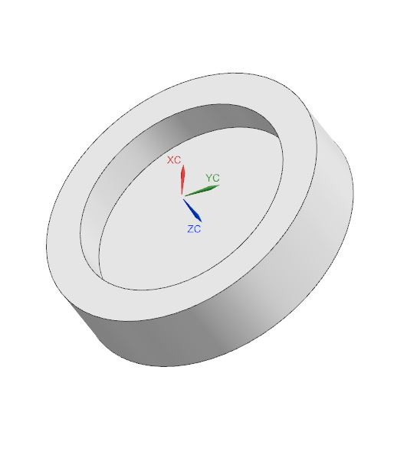**Magnet Cover:** The magnet cover surrounds the permanent magnet, providing protection and influencing the distribution of the magnetic field. It ensures that the magnet remains properly positioned and is shielded from any external disturbances that could affect the sensor’s performance.

Figure 7. 4: Magnet Cover

**Conductive Fluid Shell:** The conductive fluid shell encloses the conductive fluid, which plays a critical role in generating the electrical signals needed to measure angular velocity. This shell must be highly durable and capable of maintaining the integrity of the fluid inside, ensuring accurate and consistent signal generation.

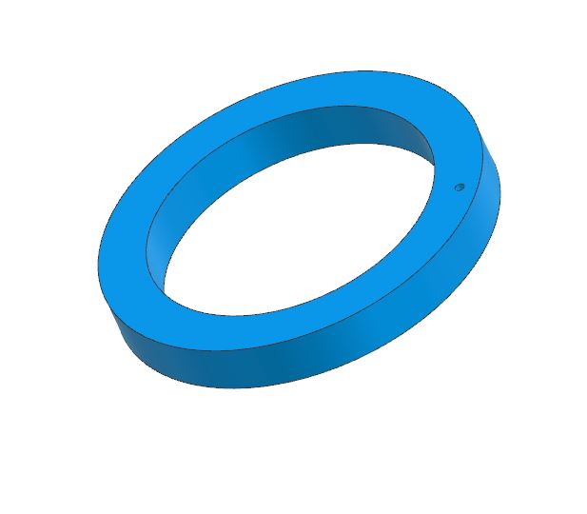

Figure 7. 5: Conductive Fluid Shell

1. 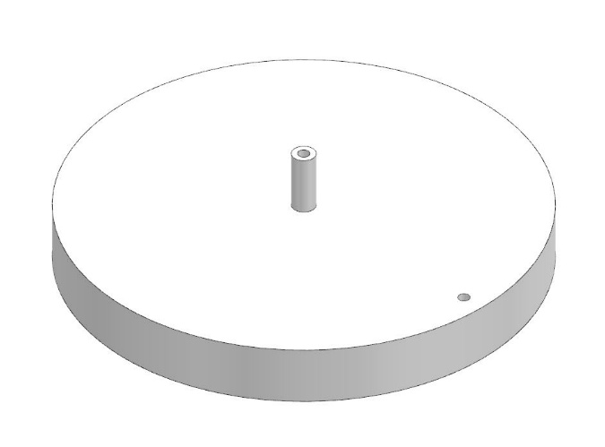**Insulating Layer:** The insulating layer is positioned between various components to prevent unintended electrical conduction. This layer is vital in ensuring that the electrical signals generated within the sensor are not compromised by leakage currents or short circuits, maintaining the sensor’s accuracy.

Figure 7. 6: Insulating Layer

1. 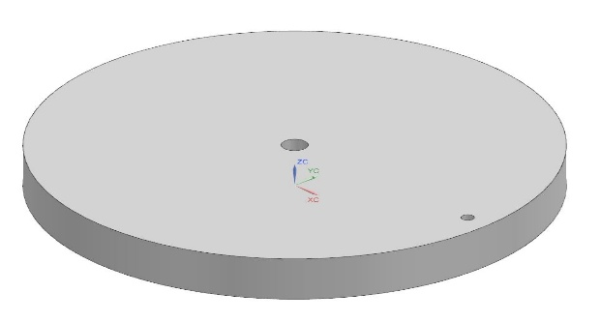**Top Layer:** The top layer provides structural support and serves as a barrier to protect the internal components from external impacts. It helps maintain the overall integrity of the sensor assembly and ensures that all parts remain securely enclosed.

Figure 7. 7: Top Layer

1. **Lock Nut:** The lock nut secures all internal parts of the sensor, preventing them from shifting during operation. It plays an essential role in ensuring that the assembly remains stable, even under the intense vibrations and other challenges faced during space missions.

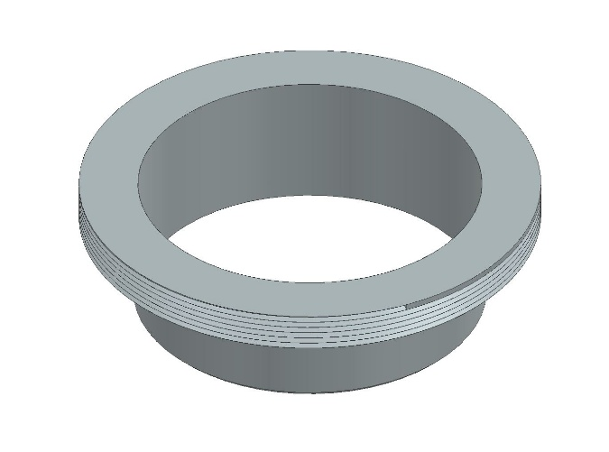

Figure 7. 8: Lock Nut

1. **Cover:** The cover seals the top of the cylindrical housing, protecting the internal components from the external environment. It provides a secure enclosure that safeguards the sensor’s performance over long periods, even in extreme conditions.

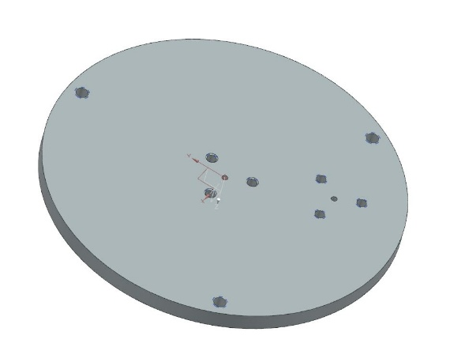

Figure 7. 9: Cover

1. **Electrode Cover:** The electrode cover protects the electrodes from external impacts and environmental factors.

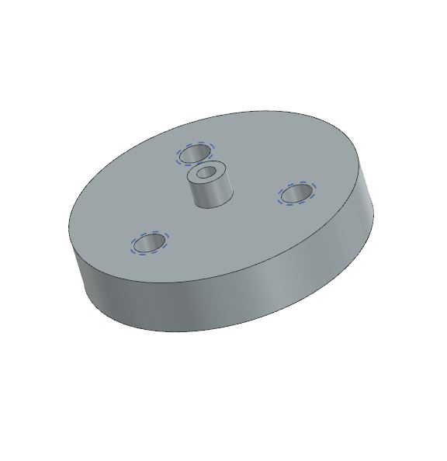

Figure 7. 10: Electrode Cover

It ensures that the electrodes remain securely positioned and free from interference, which is crucial for maintaining accurate measurement results.

1. 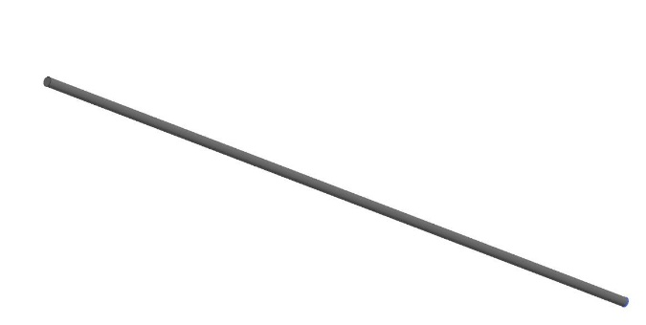**Electrode:** The electrode measures the voltage generated by the movement of the conductive fluid within the sensor. It is precisely positioned to capture these electrical signals, which are then processed to determine the angular velocity of the sensor.

Figure 7. 11: Electrode

1. **Signal Processing Unit:** The signal processing unit amplifies, filters, and processes the signals detected by the electrodes. This unit converts the raw electrical signals into precise measurements of angular velocity, ensuring that the sensor delivers accurate data during operation.

## 7.4 Working of Magneto-Hydrodynamic Angular Rate Sensor

The Magneto Hydrodynamic Angular Rate Sensor (MHD-ARS) operates based on the principles of Faraday's Law of Electromagnetic Induction. This law states that a change in magnetic flux through a conductor induces an electromotive force (EMF), or voltage, within the conductor.

The core of the MHD-ARS sensor consists of a conductive fluid shell containing a liquid metal, such as mercury (Hg), and a magnetic field generated by a permanent magnet. The magnetic field passes vertically through the conductive fluid. The sensor is designed to detect angular vibrations or rotations around a sensitive axis.

When the sensor experiences angular vibrations or rotational motion, the inertia of the conductive fluid causes it to resist movement relative to the boundaries of the fluid shell. As a result, there is relative motion between the conductive fluid and the magnetic field generated by the permanent magnet. This relative motion causes the magnetic field lines to be cut by the moving conductive fluid.

According to Faraday's Law, this cutting of magnetic field lines induces a potential difference (voltage), VzV_zVz​, across the fluid. The magnitude of this potential difference is directly proportional to the angular velocity or vibration of the sensor. In other words, the faster the rotation or vibration, the greater the induced voltage.

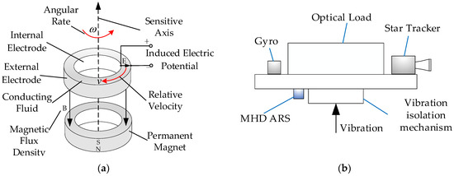By measuring this induced voltage, the sensor can detect the angular velocity or vibration. The collected voltage signal is then processed and analyzed to extract relevant information about the rotational motion. This makes the MHD-ARS sensor a valuable tool for measuring precise angular rates in various applications, such as in spacecraft, where accurate measurement of rotation is critical for navigation and control.

Figure 7. 12: Working of MHD-ARS

# **8. Design Consideration**

This section focuses on the key design and performance factors for the Magneto Hydrodynamic Angular Rate Sensor (MHD-ARS). This includes material selection and structural design additionally, considerations for space environments, such as radiation resistance and thermal management, are addressed to ensure long-term reliability. The focus is on how each design decision impacts the sensor’s overall performance.

## 8.1 Material Selection for Sensor Components

This section of the report explains the rationale behind choosing specific materials for each component of the Magneto Hydrodynamic Angular Rate Sensor (MHD-ARS). For the permanent magnet, Samarium Cobalt (SmCo) was selected due to its ability to generate a strong magnetic field. Mercury was chosen as the conductive fluid because of its high conductivity, and copper was selected for both the conductive fluid shell and the electrodes to ensure effective containment, interaction, and accurate measurement of the voltage generated by the conductive fluid. Teflon was chosen for the top insulating layer due to its excellent insulation properties and its ability to withstand extreme temperatures. Each material is selected to optimize the sensor's performance, durability, and reliability in space environment. The factors considered in selecting these materials include:

* **Mechanical Properties:** To ensure the material can withstand physical stresses and strains.
* **Electrical Properties:** To determine the material’s conductivity or insulation capability.
* **Thermal Properties:** To handle temperature variations and heat dissipation.
* **Chemical Resistance:** To prevent degradation or adverse reactions with other substances.
* **Compatibility:** To ensure materials interact well without causing issues like corrosion.
* **Weight:** To minimize weight, which is crucial for space applications.
* **Cost and Availability:** To balance performance with economic feasibility and sourcing ease.
* **Manufacturability:** To ensure efficient processing and integration into the sensor’s design.

## 8.1.1 Comparative Study of Magnet Materials

|  |  |  |  |
| --- | --- | --- | --- |
| Property | Alnico | Samarium Cobalt (SmCo) | Neodymium Iron Boron (NdFeB) |
| Magnet Material | Alnico | Samarium Cobalt | Neodymium Iron Boron |
| Composition | Aluminum, Nickel, Cobalt, Iron | Samarium, Cobalt | Neodymium, Iron, Boron |
| Max Energy Product (BHmax) (MGOe) | 5-9 | 16-32 | 28-52 |
| Remanence (Br) (T) | 0.6-1.35 | 0.9-1.2 | 1.0-1.4 |
| Coercivity (Hci) (kA/m) | 50-160 | 600-2000 | 750-2000 |
| Curie Temperature (°C) | 860-890 | 720 | 310 |
| Density (g/cm³) | 7.3 | 8.2-8.4 | 7.4 |
| Corrosion Resistance | Poor | Excellent | Poor |
| Mechanical Strength | Good | Moderate | Moderate |
| Temperature Stability | Very good up to 550°C | Good up to 300°C | Poor above 80°C |
| Cost | Moderate | High | Low |

Table 8. 1: Comparison of different Materials for Magnet

The comparison of Alnico, Samarium Cobalt (SmCo), and Neodymium Iron Boron (NdFeB) highlights their respective strengths. **Alnico** offers good temperature stability but has a lower energy product, while **NdFeB** provides the highest energy but lacks temperature stability and corrosion resistance. **Samarium Cobalt (SmCo)** is selected for the MHD-ARS due to its **high performance** and **environmental resilience**. SmCo combines a strong magnetic field, excellent corrosion resistance, and good coercivity, making it well-suited for the demanding conditions of space applications.

8.1.2 Comparative Study of Conductive Fluid Shell Material

|  |  |  |  |
| --- | --- | --- | --- |
| ****Material**** | ****Copper**** | ****Aluminum**** | ****Stainless Steel**** |
| ****Conductivity**** | **Outstanding electrical conductivity,** crucial for the sensor’s functionality, ensuring optimal interaction with the mercury. | **Moderate electrical conductivity,** which is lower than copper but still suitable for some applications. | **Low electrical conductivity**, making it the least suitable for conductive fluid interaction in this context. |
| ****Thermal Performance**** | **High thermal conductivity**, ideal for managing heat dissipation within the sensor. | **Moderate thermal conductivity**, good but less efficient than copper for heat dissipation. | **Low thermal conductivity**, making it less effective in handling heat. |
| ****Corrosion Resistance**** | **Moderate corrosion resistance**, can corrode over time when exposed to mercury or other chemicals, requiring protective coatings. | **Good corrosion resistance**, but prone to oxidation. Additional coatings might be necessary in certain environments. | **Excellent corrosion resistance**, highly resistant to chemical interactions, including mercury, making it ideal for long-term use. |
| ****Weight**** | **Relatively heavy** (8.96  g/cm³), which could increase the overall mass of the sensor, a concern in space applications. | **Very lightweight** (2.7 g/cm³), significantly reducing the total weight of the sensor, which is advantageous in space environments. | **Heavy** (7.8 g/cm³), which may not be suitable for weight-sensitive applications like space missions. |
| ****Cost**** | **Moderate cost**, widely available, and commonly used in electrical and mechanical applications. | **Low cost**, making it a more economical option for large-scale use, with easy availability. | **Higher cost**, due to its specialized properties and less widespread availability compared to copper and aluminum. |
| ****Machinability**** | **Excellent machinability**, making it easier to process into complex forms required for the sensor. | **Highly machinable**, allowing for efficient manufacturing and shaping. | **Difficult to machine**, requires more advanced equipment due to its hardness and strength. |

Table 8. 2: Comparison of Materials for Conductive Fluid Shell

Based on the above comparative study, Copper is the ideal material for the conductive fluid shell in the MHD-ARS due to its superior electrical and thermal conductivity, essential for optimal interaction with mercury and effective heat dissipation. While heavier than alternatives like aluminum, copper’s performance advantages outweigh the weight concern, and its moderate corrosion resistance can be managed with protective coatings. Compared to Aluminum and Stainless Steel, copper offers the best balance of conductivity, durability, and machinability, making it the most suitable choice for this application.

8.1.3 Comparative Study of Insulating Layer Material

|  |  |  |  |
| --- | --- | --- | --- |
| Materials | Teflon | Ceramic | Polyimide |
| Thermal Stability | High thermal stability up to 260°C, ideal for extreme temperature conditions. | Exceptional thermal stability up to 1600°C, suitable for the most demanding environments. | Good thermal stability up to 300°C, effective but less extreme than ceramic. |
| Electrical Insulation | Excellent electrical insulator, providing reliable performance in preventing unintended conduction. | Superior electrical insulation, effective in high-voltage applications. | Effective electrical insulator, though not as high-performing as Teflon or ceramic |
| Chemical Resistance | Highly resistant to a broad range of chemicals, including strong acids and bases. | Highly resistant to chemical degradation, suitable for harsh chemical environments. | Resistant to many chemicals, but can degrade with certain substances. |
| Weight | Lightweight, contributing minimally to the overall mass of the sensor. | Heavier, which might affect the overall mass of the sensor. | Lightweight, which helps in reducing the sensor’s total weight. |
| Cost | Moderate cost, affordable and commonly used in various applications. | Higher cost, due to the advanced materials and processing involved. | Moderate to high cost, depending on specific formulations and manufacturing methods. |
| Manufacturability | Easy to fabricate and shape, allowing for complex designs. | Challenging to machine, requiring specialized techniques. | Moderate ease of fabrication, workable for complex shapes but less straightforward than Teflon. |

Table 8. 3: Comparison of Materials for Insulating Layer

Teflon (PTFE) is the best choice for the insulating layer in the MHD-ARS sensor due to its high thermal stability, excellent electrical insulation, and chemical resistance. Although Ceramic offers superior thermal and chemical properties, its higher cost and weight make it less practical. Polyimide is effective but does not match Teflon’s performance in chemical resistance and can be expensive. Therefore, Teflon (PTFE) provides the optimal balance of performance and cost for the insulating layer.

8.1.4 Comparative Study of Electrode Materials

|  |  |  |  |
| --- | --- | --- | --- |
| ****Material**** | ****Copper**** | ****Platinum**** | ****Graphite**** |
| **Electrical Conductivity** | Excellent, ideal for efficient signal transmission. | High, but less than copper. | Good, lower than copper and platinum. |
| **Corrosion Resistance** | Moderate, may need protection in harsh environments. | Excellent, suitable for extreme conditions. | Good, stable but can degrade over time. |
| **Thermal Conductivity** | High, aids in efficient heat dissipation. | High, maintains stable temperatures. | Moderate, less efficient than metals. |
| **Mechanical Strength** | Good, suitable for durable designs. | High, maintains integrity under stress. | Moderate, can be brittle. |
| **Cost** | Low, economical and widely available. | High, due to rarity and processing. | Moderate, more affordable than platinum. |
| **Manufacturability** | Easy to machine, precise design possible. | Challenging to machine, needs specialized equipment. | Moderately easy, workable but less straightforward. |

Table 8. 4: Comparative Study of Electrode Material

Copper is selected for its excellent electrical and thermal conductivity, ensuring efficient signal transmission and heat dissipation. It is cost-effective and easy to machine, making it practical for manufacturing. While Platinum provides superior corrosion resistance and Graphite offers useful properties, Copper delivers the best overall balance of performance, affordability, and ease of fabrication.

## 

## 8.2 Fluid Dynamics

Fluid dynamics plays a critical role in the functioning of the Magneto Hydrodynamic Angular Rate Sensor (MHD-ARS). The sensor operates by measuring the movement of a conductive fluid, such as mercury, within a cylindrical cavity when the sensor is subjected to angular motion. This fluid motion, influenced by the rotation of the sensor and the presence of a magnetic field, generates an electromotive force (EMF), which is then used to determine the angular velocity of the system.

In the MHD-ARS, a conductive fluid shell is placed over the magnet cover, and an insulating layer is positioned above the fluid shell. The hollow inner diameter of 30 mm of conductive fluid shell forms a cavity where the conductive fluid is contained. When the sensor rotates, the fluid moves within this cavity, interacting with the magnetic field generated by the permanent magnet. This interaction induces a voltage, which is proportional to the rate of rotation.

The design and behavior of the fluid are carefully considered to ensure accurate and reliable measurements, making fluid dynamics an essential component of the MHD-ARS sensor's performance.

## 8.2.1 Calculation of Boundary Layer Thickness

We have,

R= 0.015

ω = 0.01 rad/s (assumed)

L= h= 0.005m

v=

μ =

Where,

R = Radius of Cavity filled with Mercury (Hg)

ω = Angular Rate

L = Characteristic Length

v = Kinematic Viscosity

μ = Viscosity of the fluid (

* **Reynold’s Number:**

The Reynolds number is a dimensionless quantity that helps predict fluid flow patterns in different situations by measuring the ratio between inertial and viscous forces. At low Reynolds numbers, flows tend to be dominated by laminar flow, while at high Reynolds numbers, flows tend to be turbulent.

Re = =

Re =

Re = 6.52

Since Re < 2000, so flow is Laminar and boundary layer thickness formula is given as

* **Boundary Layer Thickness:**

The boundary layer thickness in the MHD-ARS sensor directly affects the interaction between the conductive fluid and the magnetic field, influencing the sensor's sensitivity. A thinner boundary layer enhances fluid movement and allows for more precise detection of angular rate changes. Optimizing this layer is crucial for achieving high sensitivity and accurate measurements in space applications.

The boundary layer thickness of meters allows efficient fluid interaction with the magnetic field, enhancing the MHD-ARS sensor’s sensitivity for detecting small angular rate changes.

## 8.2.2 Motion of Mercury in MHD-ARS Sensor

When the MHD-ARS sensor undergoes angular rotation, the entire sensor system, including the cavity and its walls, rotates. However, the mercury inside the sensor resists changes to its state of motion due to its inertia. Here’s a step-by-step breakdown of the process:

1. **Inertia and Initial State**: Initially, when the sensor starts rotating, the mercury inside the cylindrical cavity tends to remain in its initial state due to its inertia. This means that while the sensor and its housing rotate, the mercury tries to stay static relative to its initial position.
2. **Relative Motion**: As the sensor and the walls of the cavity rotate, there is a relative motion generated between the mercury and the rotating walls. The walls of the cavity, in contact with the mercury, create a shear force.
3. **Shear Force Generation**: This shear force arises from the difference in rotational speeds between the mercury (which resists rotational change) and the rotating walls of the cavity. The force acts on the mercury, causing it to start rotating.
4. **Mercury Rotation**: Due to this shear force, the mercury begins to rotate and flow in a circular pattern within the cavity. This motion aligns with the rotation of the sensor, although the mercury initially resists this change due to inertia.
5. **Interaction with Magnetic Field**: As the mercury rotates, it moves through the magnetic field generated by the permanent magnet located at the bottom of the sensor housing. The interaction between the rotating mercury and the magnetic field generates an electromotive force (EMF). This EMF is proportional to the rate of rotation and is used to measure the sensor’s angular velocity.

## 8.2.3 Key Considerations

**1. Conductivity of the Fluid:** Mercury’s high conductivity is essential for generating electrical signals. As the mercury flows through the magnetic field, its conductivity facilitates the creation of an electromotive force (EMF) proportional to the angular velocity of the sensor, enabling accurate measurement.

**2. Viscosity and Flow Patterns:** The viscosity of mercury affects its flow within the cylindrical cavity. Higher viscosity results in more resistance to flow, influencing the fluid’s movement and the establishment of boundary layers and flow patterns in the sensor.

**3. Boundary Layer Effects:** The boundary layer near the cavity walls affects fluid velocity and flow dynamics. Variations in velocity within this layer impact the sensor's sensitivity. Accurate sensitivity calculations must consider these boundary layer effects to ensure precise measurements.

## 

## 8.2.4 Impact on Performance

The fluid dynamics within the MHD-ARS sensor directly influence its performance. The accuracy of angular rate measurements depends on the precise interaction between the moving mercury and the magnetic field.

* + - 1. **Fluid Flow and Measurement Precision:** The flow patterns of mercury, influenced by its viscosity and the cavity’s shape, impact the consistency of the electromotive force (EMF) generated. Variations in fluid velocity and boundary layer effects can cause fluctuations in the measured signals, affecting the sensor’s precision.
      2. **Optimization for Space Conditions:** In space, where gravity is absent, the sensor’s ability to accurately measure angular velocity relies on optimizing fluid dynamics. Ensuring smooth and predictable fluid flow minimizes errors in EMF generation, leading to more reliable measurements. Proper design and simulation of the fluid dynamics are essential to maintain sensor performance in the harsh space environment, where precise angular rate detection is critical.

## 8.3 Compactness & Weight

The design of the MHD-ARS sensor prioritizes compactness and lightweight construction, essential for optimizing performance in space applications. The total weight of the sensor assembly is approximately 433 grams, which includes a carefully balanced distribution of component weights.

The following table details the weight of each component:

|  |  |  |  |
| --- | --- | --- | --- |
| Component | Weight (grams) | Quantity | Total Weight (grams) |
| Housing | 237 | 1 | 237 |
| Electrode Cover | 2.27 | 2 | 4.54 |
| Magnet Cover | 39.6 | 1 | 39.6 |
| Lock Nut | 19.9 | 1 | 19.9 |
| Liquid Metal Shell | 22.8 | 1 | 22.8 |
| Magnet | 29.1 | 1 | 29.1 |
| Insulating Layer | 13.8 | 1 | 13.8 |
| Top Insulating Layer | 27.73 | 1 | 27.73 |
| Cover | 37.2 | 1 | 37.2 |

Table 8. 5: Weight of Components

The sensor’s lightweight and compact nature contribute to its efficient integration within spacecraft, reducing the impact on launch weight and overall spacecraft performance. This optimization is crucial for space missions where every gram is significant, ensuring the sensor’s functionality does not compromise the spacecraft’s efficiency and cost-effectiveness.

# 

# **9. Modeling and Methodology**

## 9.1 Modeling in NX

Modeling in NX involves creating comprehensive 3D models of all components of the Magneto Hydrodynamic Angular Rate Sensor (MHD-ARS). This includes designing the geometry, assigning materials, and assembling the components to ensure the sensor meets the specified requirements.

## 9.1.1 Conceptual Design

In the conceptual design phase of the MHD-ARS sensor, the focus is on establishing the fundamental layout and configuration of the sensor based on its functional requirements. This involves defining the overall structure, component arrangement, and key dimensions. The process starts with gathering requirements related to sensor performance, such as angular rate measurement accuracy and integration with spacecraft systems. Various design alternatives are explored and assessed to identify the most suitable approach. For the MHD-ARS sensor, this phase includes determining the dimensions of the housing, placement of the permanent magnet, and arrangement of other components like the conductive fluid shell and insulating layers. The conceptual design serves as the foundation for detailed geometric modeling, ensuring that the final design will meet the necessary performance and operational criteria.

1. **Detailed Geometry Creation:** The geometry creation process begins with the design of the housing, which is a fundamental component of the MHD-ARS sensor. After conducting a thorough study and reviewing various designs, the housing was conceptualized and modelled. It features an outer diameter of 50 mm and an inner diameter of 40 mm, with a height of 50 mm. The first 40 mm maintains a consistent diameter, while the top 10 mm includes a step where the diameter expands to 60 mm. This step contributes to the sensor’s structural integrity.
2. **Internal Components:**

* **Magnet:** Positioned at the bottom of the housing, this cylindrical magnet generates the magnetic field essential for the sensor’s operation. Its dimensions are carefully defined to ensure effective interaction with the conductive fluid.
* **Magnet Cover:** This non-conductive cover surrounds the magnet, protecting it and shaping the magnetic field distribution within the sensor to ensure it effectively influences the conductive fluid.
* **Liquid Metal Shell:** Designed with a hollow inner diameter of 30 mm, this cylindrical shell contains the mercury. The shell’s dimensions are crucial for proper fluid containment and optimal interaction with the magnetic field.
* **Top Insulating Layer:** A cylindrical insulating layer made of Teflon (PTFE) is placed above the liquid metal shell. It maintains electrical isolation between the conductive fluid and other components, ensuring accurate measurements.
* **Top Layer:** Positioned above the insulating layer, this additional structural layer provides support and stability, enhancing the overall robustness of the sensor.
* **Lock Nut:** This component secures and maintains the alignment of the internal parts within the housing, ensuring that all components remain in place during operation.
* **Cover:** The top cover seals the housing, enclosing all internal components to prevent contamination or leakage, thus maintaining the integrity of the sensor assembly.
* **Electrode Cover:** Designed to protect the electrodes, this cover allows accurate measurement of the electrical signals generated by the mercury while keeping the electrodes securely positioned.

## 9.1.2 Material Assignment

For the material assignment in Magneto Hydrodynamic Angular Rate Sensor (MHD-ARS) project, I used NX's material library to accurately model the performance of each component. The material selection process was driven by the functional requirements of each part, considering factors such as conductivity, magnetic properties, and structural integrity.

**1. Permanent Magnet:** The permanent magnet is a critical component for generating the magnetic field. After comparing different magnet materials like Alnico, Samarium Cobalt (SmCo), and Neodymium Iron Boron (NdFeB), I selected **Samarium Cobalt (SmCo)** for its high performance, durability, and ability to maintain its magnetic properties in harsh conditions. In NX, I created a custom SmCo material using specific magnetic and physical properties from my research and assigned it to the magnet component.

**2. Conductive Fluid Shell and Electrode:** The conductive fluid shell, which contains the mercury, and the electrode, which measures the voltage generated by the movement of the conductive fluid, both require high electrical conductivity. For these components, I selected **Copper** due to its excellent electrical and thermal conductivity. Copper’s properties were readily available in the NX material library, and I assigned them to both the conductive fluid shell and the electrode.

**3. Insulating Layer:** To prevent unintended electrical conduction, an insulating material was necessary. **Teflon (PTFE)** was chosen for the insulating layer because of its excellent electrical insulation and high resistance to temperature and chemicals. I created a Teflon material in the NX material library by entering its relevant properties and assigned it to the insulating layer.

**4. Housing, Lock Nut, Cover, and Other Structural Components:** The housing, lock nut, magnet cover, and other structural components needed to be strong, lightweight, and resistant to corrosion. **Ti-6Al-4V (Titanium Alloy)** was selected for these parts due to its high strength-to-weight ratio, excellent corrosion resistance, and suitability for space applications. I used the predefined Ti-6Al-4V material in the NX library and assigned it to all relevant components.

By assigning materials in NX, I ensured that the physical and functional characteristics of each component were accurately represented for simulation and analysis. This step was crucial in performing modal, structural, and random analyses effectively.

## 

## 9.2 Assembly Creation and Tolerance Control

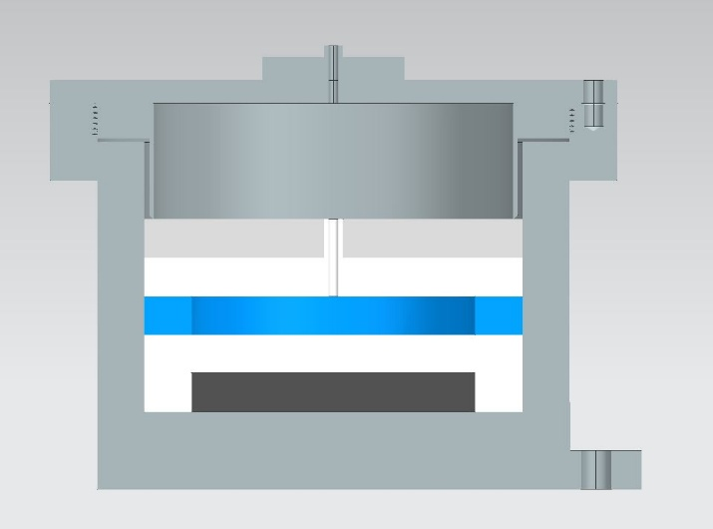The assembly of the Magneto Hydrodynamic Angular Rate Sensor (MHD-ARS) was performed in NX to integrate all individual components into a cohesive and fully functional model.

Figure 9. 1: Section View of MHD-ARS Assembly

This process ensured precise alignment, structural connectivity, and seamless interaction between the parts, which was essential for accurate simulations, including modal, structural, and random analyses. Each component was strategically positioned based on its specific functional requirements and physical constraints, ensuring the overall sensor assembly operated as designed for optimal performance.

## 9.2.1 Assembly Process in NX

The assembly of the Magneto Hydrodynamic Angular Rate Sensor (MHD-ARS) in NX followed a systematic approach to ensure proper integration and alignment of all components. The process began with the **housing**, which served as the foundation for the assembly. To achieve a fully functional model of the MHD-ARS sensor, the assembly process was carried out systematically in NX. Below are the detailed steps involved in assembling the various components of the sensor:

* The assembly began with the **Housing**, which served as the foundation for all components.
* The **permanent magnet** was positioned at the bottom of the housing to generate the required magnetic field.
* The **magnet cover** was placed over the permanent magnet to shield it and guide the magnetic field.
* The **conductive fluid shell**, containing the mercury, was aligned above the magnet cover, ensuring proper placement to avoid gaps or misalignments that might disrupt sensor function.
* The **insulating layer** was placed on top of the conductive fluid shell to prevent unintended electrical conduction between the mercury and surrounding components.
* The **top layer** was added to secure the insulating layer and further stabilize the assembly.
* A **lock nut** was used to tighten and secure all internal components within the cylindrical housing.
* The **cover** was attached to the top of the housing to fully enclose the assembly and protect the internal parts.
* The **electrodes** were then positioned to measure the voltage generated by the conductive mercury as it moved within the sensor.
* Finally, the **electrode cover** was placed over the electrodes to protect them from external interference and ensure accurate measurements.

## 9.2.2 Tolerance Control

In high-precision devices like the Magneto Hydrodynamic Angular Rate Sensor (MHD-ARS), maintaining tight tolerances is crucial for ensuring proper assembly and optimal performance. Tolerances define the allowable variation in the dimensions of each component, ensuring that they fit together correctly without gaps, misalignments, or interference. By carefully controlling these variations, the integrity of the sensor is maintained, which is critical for its operation in environments such as space, where even small deviations can affect the sensor’s performance.

The following table lists the tolerances assigned to key components in the MHD-ARS sensor. Each tolerance has been chosen based on the functional requirements of the component to ensure a seamless assembly and reliable performance.

|  |  |  |  |
| --- | --- | --- | --- |
| Components | Dimension | Tolerance | Significance |
| Housing | Internal Diameter (40 mm) | 0 to +0.02 mm | Ensures a precise fit for internal components and prevents misalignment. |
| Conductive Fluid Shell | Outer Diameter(40mm) | -0.02 to 0mm | Maintains proper alignment and fit to avoid gaps affecting performance. |
| Top Insulating Layer | Outer Diameter(40mm) | -0.02 to 0mm | Ensures snug fit over the fluid shell, preventing electrical conduction. |
| Top Layer | Outer Diameter(40mm) | -0.02 to 0mm | Secures the insulating layer and maintains assembly integrity. |
| Magnet Cover | Outer Diameter(40mm)  Inner Diameter(30mm) | -0.02 to 0mm  0 to +0.05mm | Ensures the cover fits correctly and provides proper protection. |
| Permanent Magnet | Outer Diameter(30mm) | +0.03 mm to +0.018 mm | Allows for slight variations while ensuring correct fit and alignment |

Table 9. 1: Tolerance Table

## Assembly Challenges

1. **Electrode Alignment:** Ensuring accurate alignment of the electrodes through multiple layers, such as the top insulating layer, conductive fluid shell, top layer, cover, and electrode cover, was particularly difficult due to the tight tolerances and small clearances involved.
2. **Component Interference:** Any slight misalignment of the electrode could cause interference with the surrounding components, affecting the sensor's overall function and requiring multiple realignments during assembly.
3. **Frequent Adjustments:** Achieving proper alignment required constant adjustments and checks, as even small deviations in positioning could lead to issues in the final assembly.
4. **Narrow Hole Tolerances:** The holes in the components had very narrow tolerances, which made it challenging to insert the electrodes without causing misalignment or interference between parts.

# **10. Finite Element Analysis of MHD-ARS Sensor**

The **Finite Element Method (FEM)** is a widely used numerical technique for solving complex differential equations, particularly in engineering and mathematical modeling. It is commonly applied in fields such as **structural analysis, heat transfer, fluid flow, mass transport**, and **electromagnetic potential**. By breaking down large, complex systems into smaller, more manageable components, FEM provides highly accurate results for a variety of physical and engineering problems. FEM works by solving **partial differential equations (PDEs)** over two or three space variables, typically for problems involving boundary value conditions. To approach a solution, FEM divides the problem into smaller, simpler regions known as **finite elements**. These elements are connected together by constructing a **mesh** of the object, effectively discretizing the problem domain into a finite number of points. This discretization allows FEM to transform the complex equations into a set of simpler algebraic equations, which can be solved efficiently. By leveraging FEM, engineers and researchers can gain precise insights into how physical systems behave under different conditions, making it a crucial tool for solving real-world problems across various industries.

## 10.1 FE Model Summary

Finite Element modeling of the Magneto Hydrodynamic Angular Rate Sensor (MHD-ARS) assembly was conducted using NX CAE software. Tetrahedral elements were utilized for meshing all components to ensure accurate representation of the complex geometries. Components were rigidly connected using surface contacts and spider connections where appropriate. Material properties, such as Ti-6Al-4V for the housing and SmCo for the permanent magnet, were assigned based on their respective mechanical characteristics. Duplicate nodes at the interface of mating parts were merged to ensure rigid connectivity between components, maintaining structural integrity throughout the assembly.

## 10.1.1 Mesh Details

* Total number of elements in the part: 289720
* Total number of nodes in the part: 202059
* FE model mass: 433grams

## Meshed Components

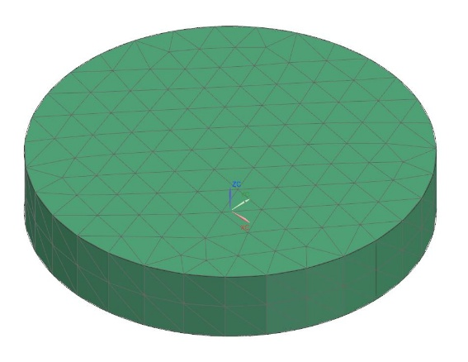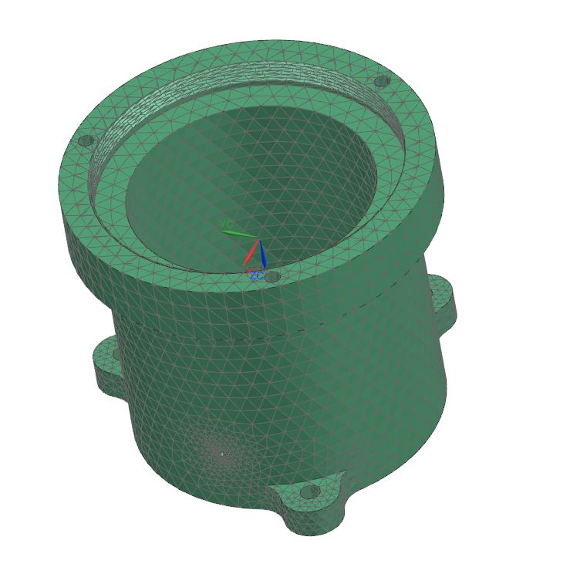

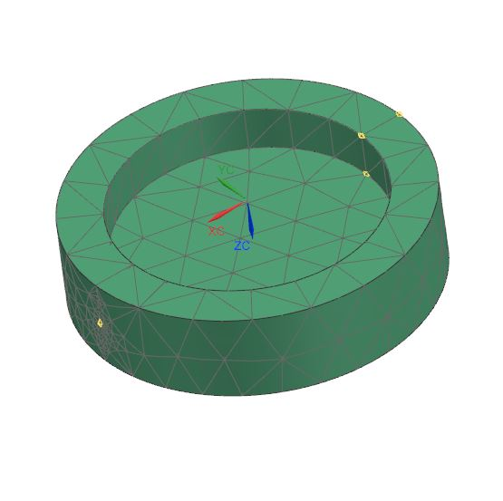 *1.* Housing 2. Magnet

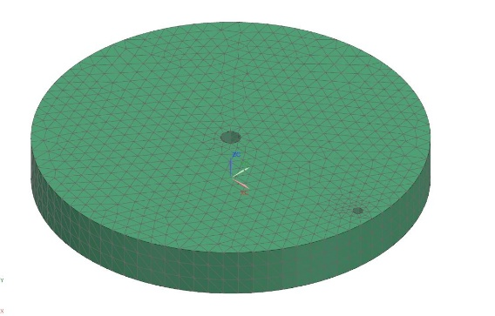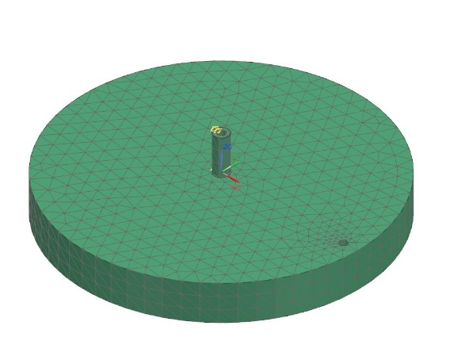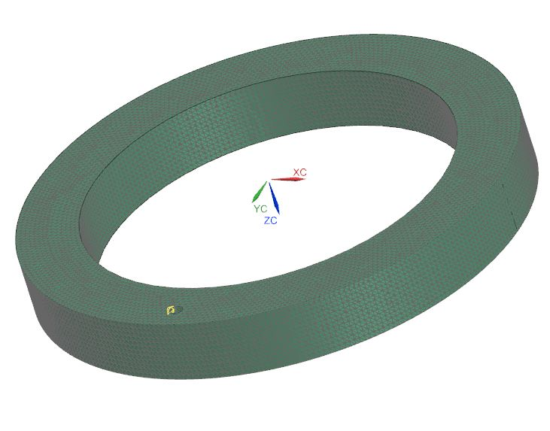 3. Magnet Cover 4. Conductive Fluid Shell

5. Insulating Layer 6. Top Layer

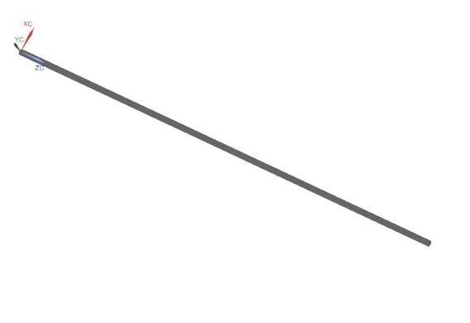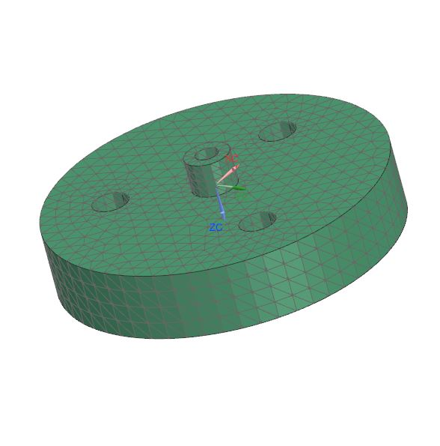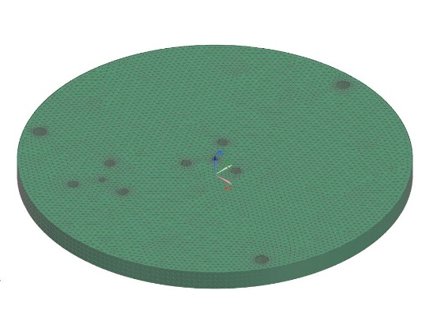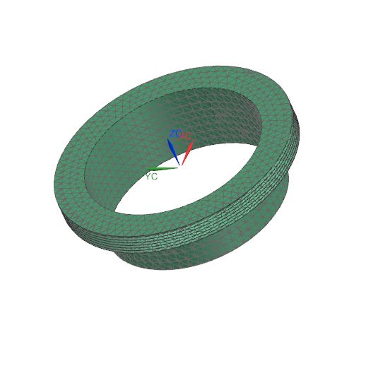 7. Lock Nut 8. Cover

9. Electrode Cover 10. Electrode

## 10.2 Material properties

The following are the material properties utilized in the Finite Element model of the MHD-ARS sensor:

|  |  |  |  |  |  |  |
| --- | --- | --- | --- | --- | --- | --- |
| S. No. | Material | Component | Density  (kg/) | Young’s  modulus  (MPa) | Poisson’s  ratio | CTE  (/°C) |
| 01 | Ti-6Al-4V | Housing, Magnet Cover, Top Layer, Lock Nut, Cover, Electrode Cover | 4.43e-6 | 114000 | 0.342 | 8.80e-6 |
| 02 | PTFE(Teflon) | Top Insulating Layer | 2.2e-6 | 496.4 | 0.46 | 120e-6 |
| 03 | Cu | Electrodes, Liquid Metal Shell | 8.96e-6 | 123280 | 0.34 | 16.5e-6 |
| 04 | SmCo | Magnet | 8.3e-6 | 165100 | 0.27 | 10e-6 |

Table 10. 1: Material Properties

## 10.2 Free-Free Modal Analysis

Modal analysis is a vital method in mechanical engineering for determining the inherent vibration properties of a structure or component. This analysis focuses on identifying key factors like natural frequencies, mode shapes, and damping ratios. The primary objective is to predict how the structure will behave under dynamic or vibrational loads, which is critical for designing components that can withstand operational stresses without failure. By understanding these vibration characteristics, engineers can ensure that the structure avoids resonance, maintains durability, and performs efficiently under real-world conditions.

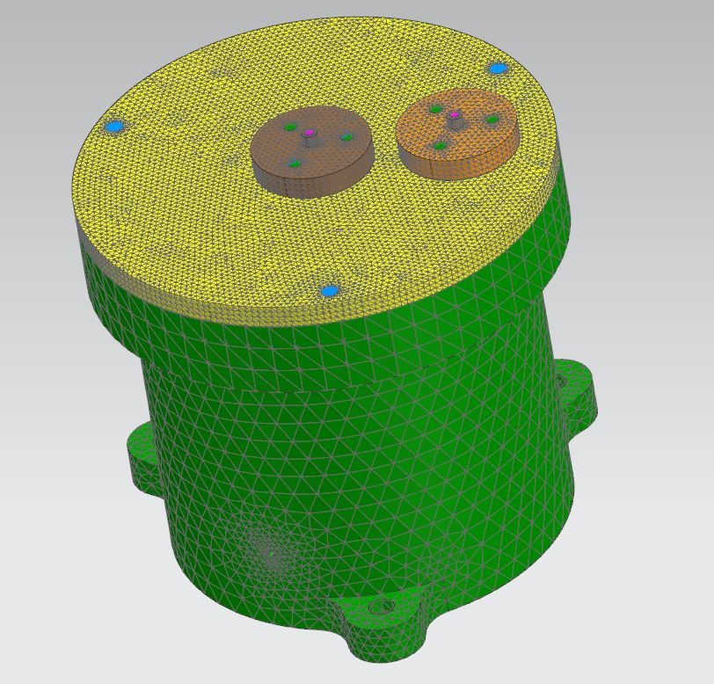

Figure 10. 1: Meshed Assembly of MHD-ARS

## 10.2.1 Key Aspects

* **Natural Frequencies:** These are the specific frequencies at which a structure naturally vibrates when disturbed. Each structure has a set of these frequencies, and they can vary depending on its material properties, shape, and design.
* **Mode Shapes:** Mode shapes describe the deformation pattern a structure undergoes at each natural frequency. This helps identify the areas most affected by vibrations and those that experience minimal movement.
* **Damping Ratios**: Damping describes how quickly a structure dissipates vibrational energy. The damping ratio helps quantify how much the vibration will decrease over time, which is important for maintaining the component’s stability and preventing excessive oscillation.

## 10.2.2 Procedure

* **Meshing:** The entire structure was meshed in NX using tetrahedral elements for accuracy. A finer mesh was applied to critical regions, ensuring precise modal extraction.
* **Boundary Conditions:** No constraints were applied (free-free condition), allowing the structure to vibrate freely in all directions.
* **Analysis:** The analysis was conducted to identify the first 10 modes of vibration. It is common to observe near-zero frequencies for the first 6 modes, which correspond to rigid body motion in a free-free state.

## 10.2.3 Methods

* **Experimental Modal Analysis:** Involves physical testing where the structure is excited using a known force, and its response is measured.
* **Finite Element Analysis (FEA):** Uses numerical methods to model the structure and predict its modal properties.

## 10.2.4 Significance

* **Preventing Resonance:** Modal analysis is essential for identifying and avoiding resonance, which occurs when the system’s natural frequency aligns with external forces, potentially leading to catastrophic failure.
* **Enhancing Performance:** By understanding the vibration behavior of a system, engineers can adjust designs to ensure stability, longevity, and performance, particularly in dynamic environments.
* **Facilitating Advanced Research:** Modal analysis supports advanced research and development by providing insights into the fundamental vibrations of complex systems. This information can lead to innovative solutions and improvements in emerging technologies and applications.

## 10.2.5 Results

The table presents the frequencies for the first 10 modes of the **Free-Free Modal Analysis**. In this analysis, the first six modes are rigid body modes, with frequencies very close to zero, as expected in a **free-free** condition where the structure is not constrained.

|  |  |  |
| --- | --- | --- |
| Mode No. | Frequency(Hz) | Mode Type |
| 01 | 0.0087 | Rigid Body Mode |
| 02 | 0.0055 | Rigid Body Mode |
| 03 | 0.0044 | Rigid Body Mode |
| 04 | 0.0019 | Rigid Body Mode |
| 05 | 0.0061 | Rigid Body Mode |
| 06 | 0.0087 | Rigid Body Mode |
| 07 | 3.747E+03 | Natural Frequency Mode |
| 08 | 4.999E+03 | Natural Frequency Mode |
| 09 | 7.025E+03 | Natural Frequency Mode |
| 10 | 7.756E+03 | Natural Frequency Mode |

Table 10. 2: Frequencies for different modes of free-free modal analysis

* **Rigid Body Modes:** The first 6 modes represent the **rigid body motion** of the structure, where no significant structural deformation occurs. This is expected in a free-free state, where the sensor can move or rotate freely in space.
* **Natural Frequency Modes:** From the seventh mode onwards, the structure exhibits meaningful vibration behavior, indicating the natural frequencies of the sensor. These values help in identifying how the MHD-ARS will respond to vibrational inputs in space.

10.2.6 Visualization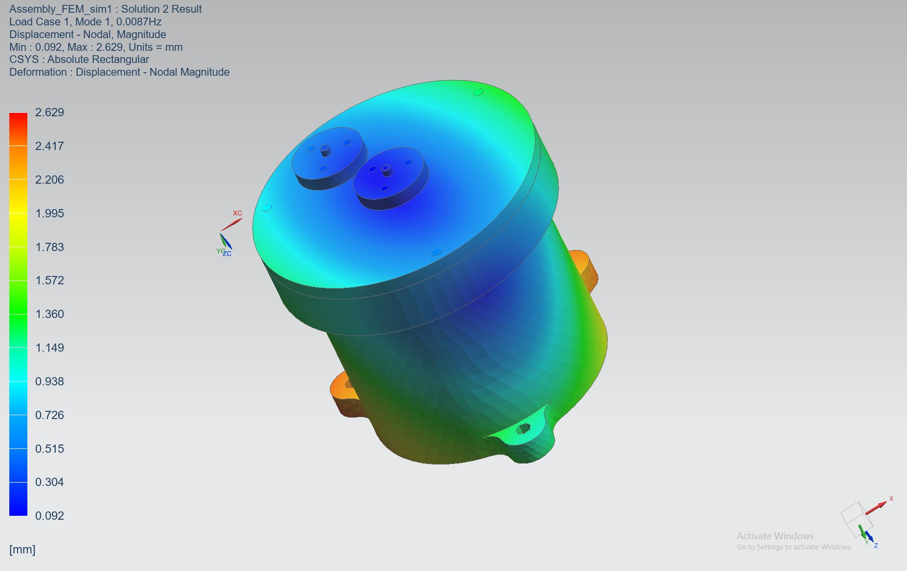

Figure 10. 2: Mode 1 – Rigid Body Motion (Translational)

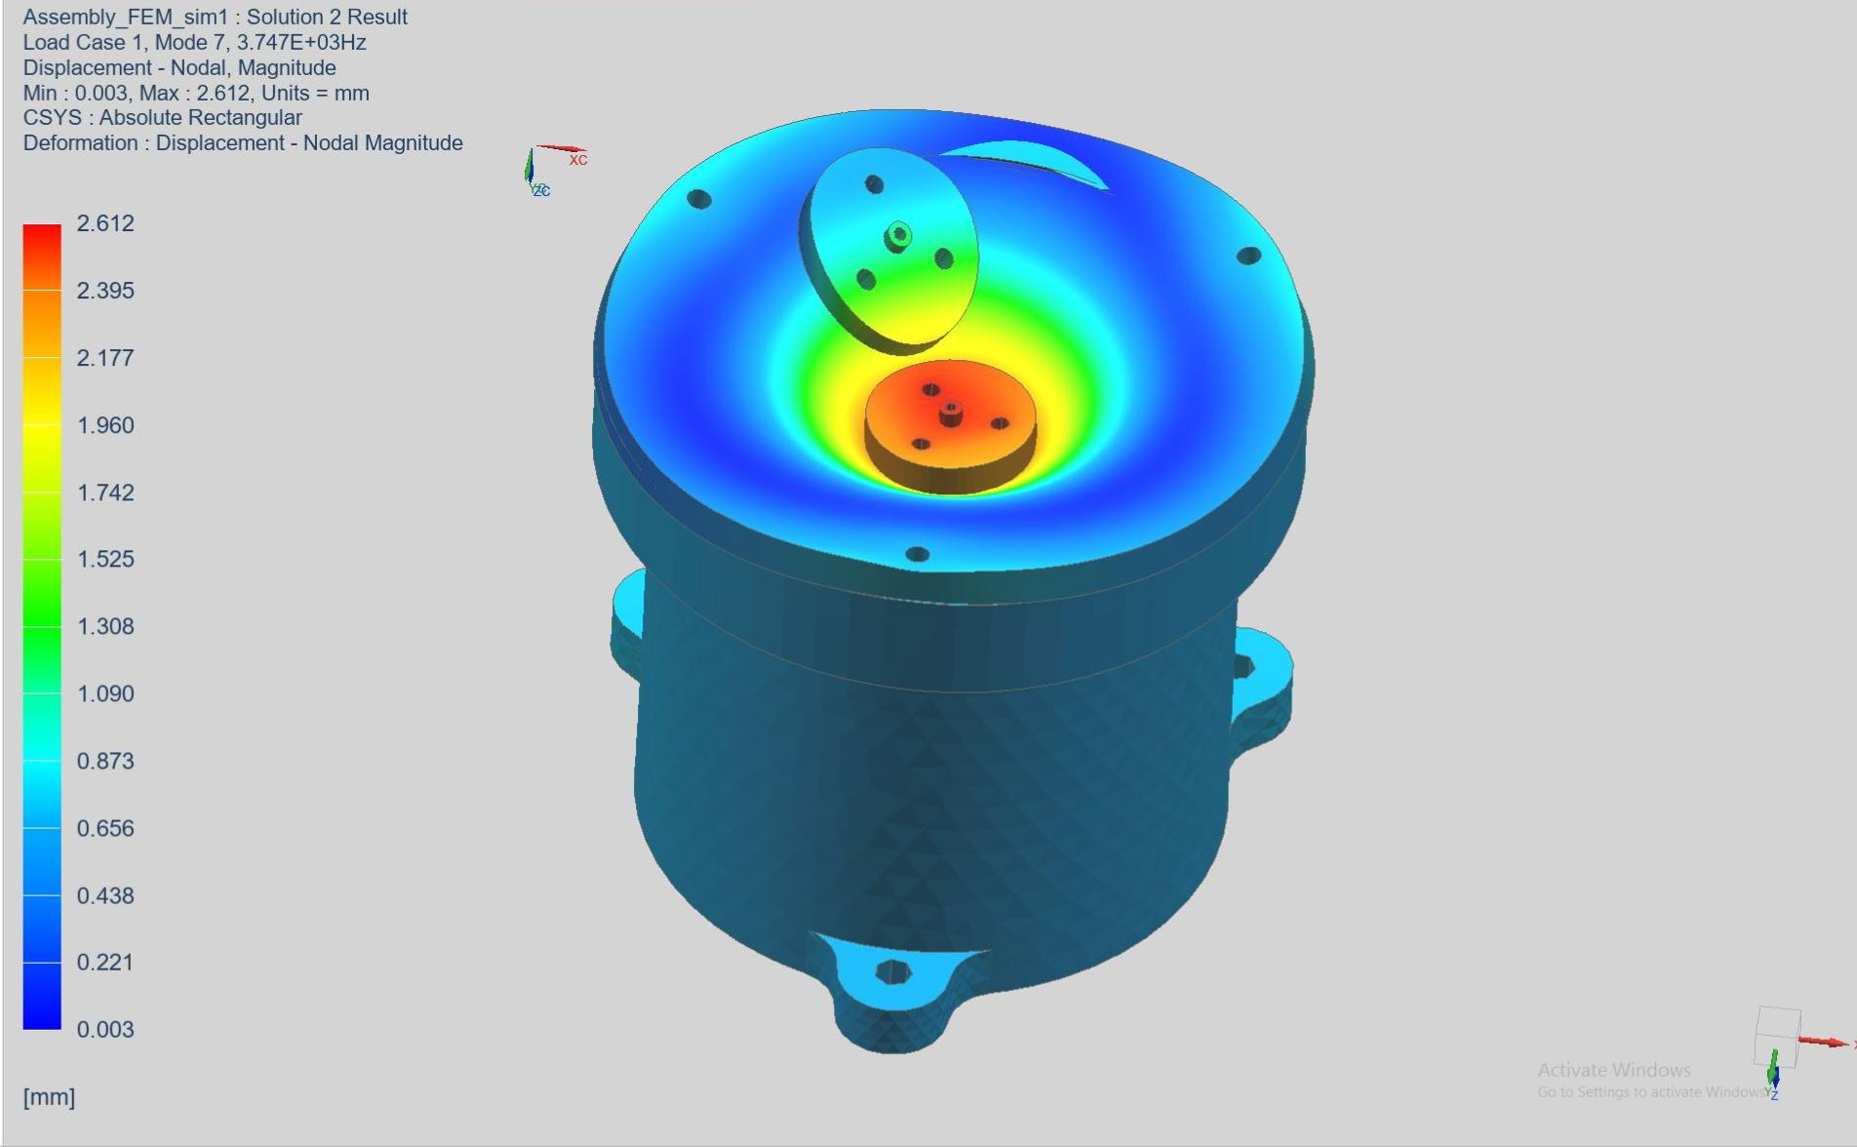

Figure 10. 3: Mode 7 – First Natural Frequency (Structural Vibration)

## 

## 10.3 Clamped Modal Analysis

The Clamped Modal Analysis evaluates the behavior of the Magneto Hydrodynamic Angular Rate Sensor (MHD-ARS) when it is fixed at critical points, as it would be during actual operation. In this the sensor is constrained at three mounting holes located at the base of the sensor, simulating its attachment to a spacecraft or another support structure.

This analysis is essential for determining how the sensor behaves under real-life vibrational forces, especially when it is securely mounted. It shows how the natural frequencies and mode shapes of the sensor are altered due to these constraints, offering valuable insight into whether the structure is rigid enough to perform well in harsh conditions or if it will undergo unwanted vibrations.

By comparing the results of the clamped modal analysis with those of the free-free modal analysis, we can observe how the fixed conditions influence the sensor’s dynamic behavior. The clamped analysis highlights the areas that may experience higher stress or deformation, enabling engineers to predict performance under operational constraints and improve the overall design to prevent failure.

## 10.3.1 Procedure

* **Meshing:** The same meshing approach was applied as in the free-free analysis to ensure consistent results.
* **Boundary Conditions:** In this constraint are applied at three mounting holes at the base of the MHD-ARS sensor, simulating its attachment to a support structure, ensuring accurate analysis of its behavior under real conditions.
* **Analysis:** The clamped analysis was conducted in the same manner, but the applied constraints significantly influenced the frequencies and mode shapes.

## 10.3.2 Significance

* **Real-World Simulation:** Offers a realistic view of the sensor’s behavior when mounted or constrained, ensuring that performance predictions align with actual operating conditions.
* **Structural Stiffness Evaluation:** Assesses the rigidity or flexibility of the sensor, providing crucial insights into how it will react to operational forces and vibrations.
* **Design Validation:** Verifies that the sensor can reliably perform in its intended environment, ensuring it withstands stresses and vibrations without failure.
* **Improved Accuracy:** Enhances the precision of dynamic analyses, such as vibration testing, by aligning predictions with real-world scenarios, leading to more reliable system behavior forecasts.

## 10.3.3 Results

In this analysis, constraints were applied at three mounting holes located at the base of the Magneto Hydrodynamic Angular Rate Sensor (MHD-ARS), simulating its attachment to a spacecraft or support structure.

The following table summarizes the mode frequencies identified during the analysis:

|  |  |  |
| --- | --- | --- |
| Mode No. | Frequency (Hz) | Mode Type |
| 01 | 1.850E+03 | Structural Vibration Mode 1 |
| 02 | 1.864E+03 | Structural Vibration Mode 1 |
| 03 | 2.934E+03 | Structural Vibration Mode 1 |
| 04 | 4.502E+03 | Structural Vibration Mode 1 |
| 05 | 4.641E+03 | Structural Vibration Mode 1 |

Table 10. 3: Frequencies for different modes of clamped modal analysis

The following points summarize the critical findings from the analysis:

* The table shows the vibrational frequencies for each mode of the MHD-ARS sensor under clamped conditions. These frequencies highlight how the sensor’s natural vibrations are affected by the constraints applied at the mounting points.
* The analysis reveals both fundamental vibrational modes (lower frequencies) and higher-order modes (higher frequencies). Understanding these frequencies is critical for evaluating how the sensor will respond to vibrations and dynamic forces when installed on a spacecraft.
* By examining these frequencies, we can assess the sensor’s structural stiffness and flexibility. This assessment helps determine the sensor’s ability to endure and perform under dynamic loads and vibrations.
* The frequencies obtained from this analysis validate the robustness of the MHD-ARS sensor’s design. They confirm that the sensor is capable of maintaining its performance and reliability under the expected operational conditions.

## 

## ****10.3.4 Visualization****

Figure 10. 4: Mode 1 – Structural Deformation.

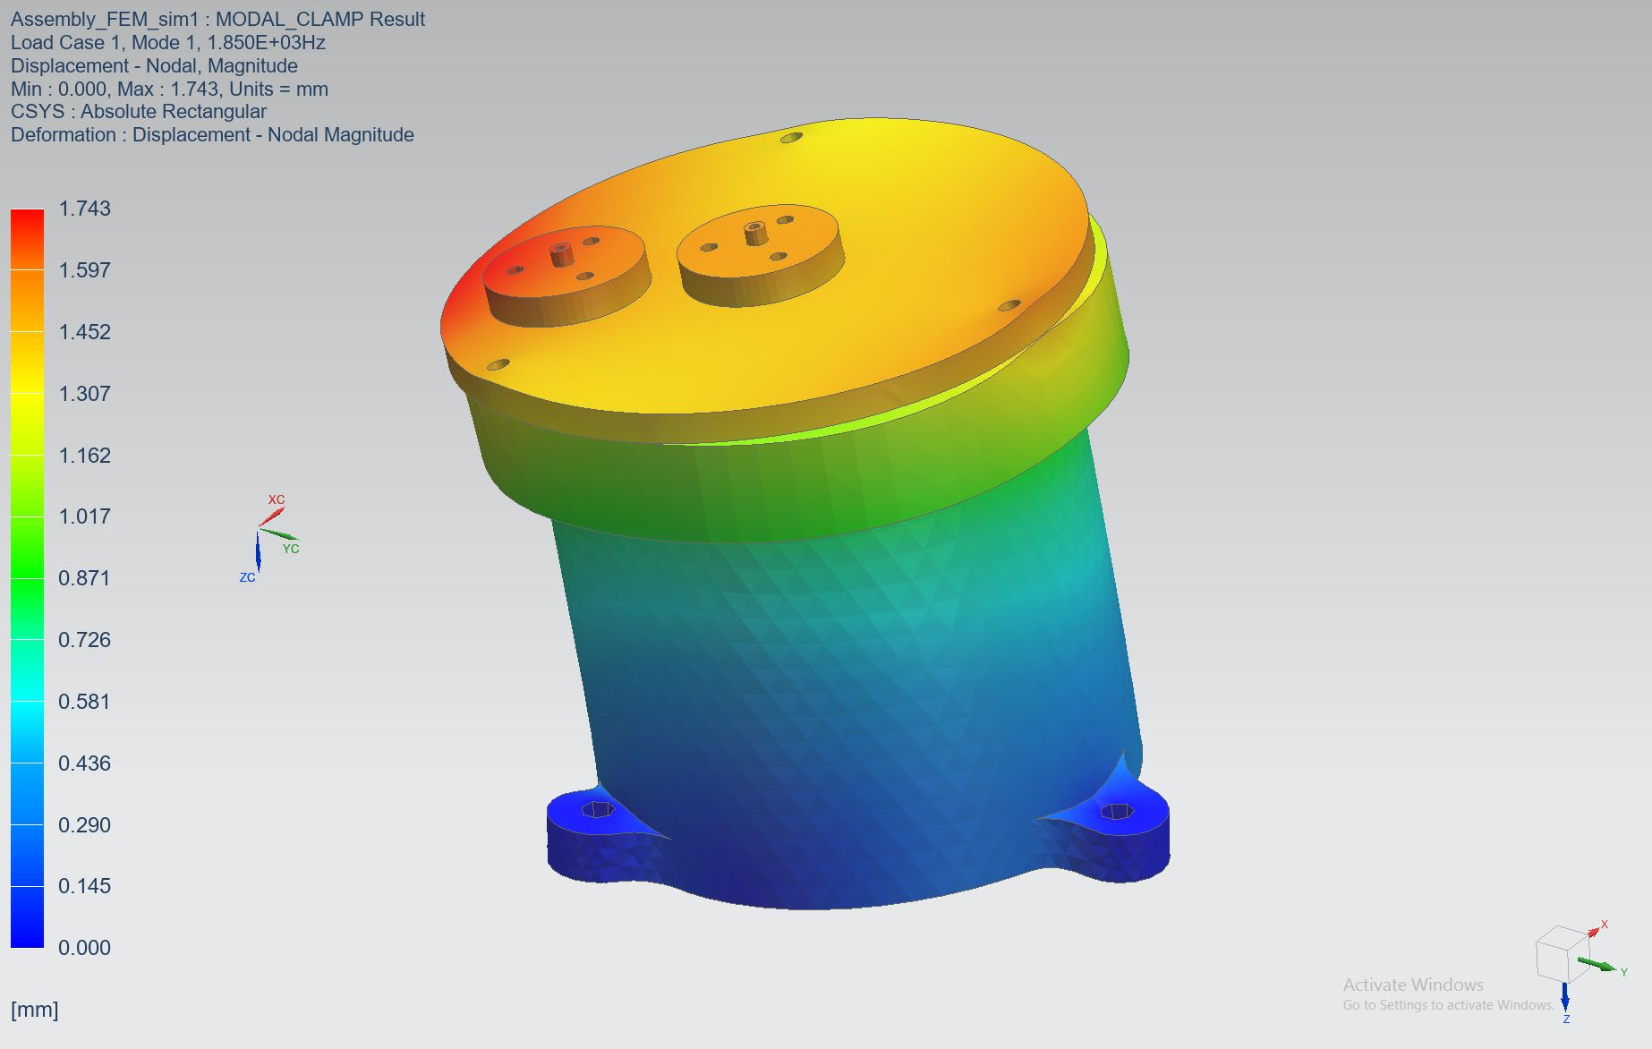

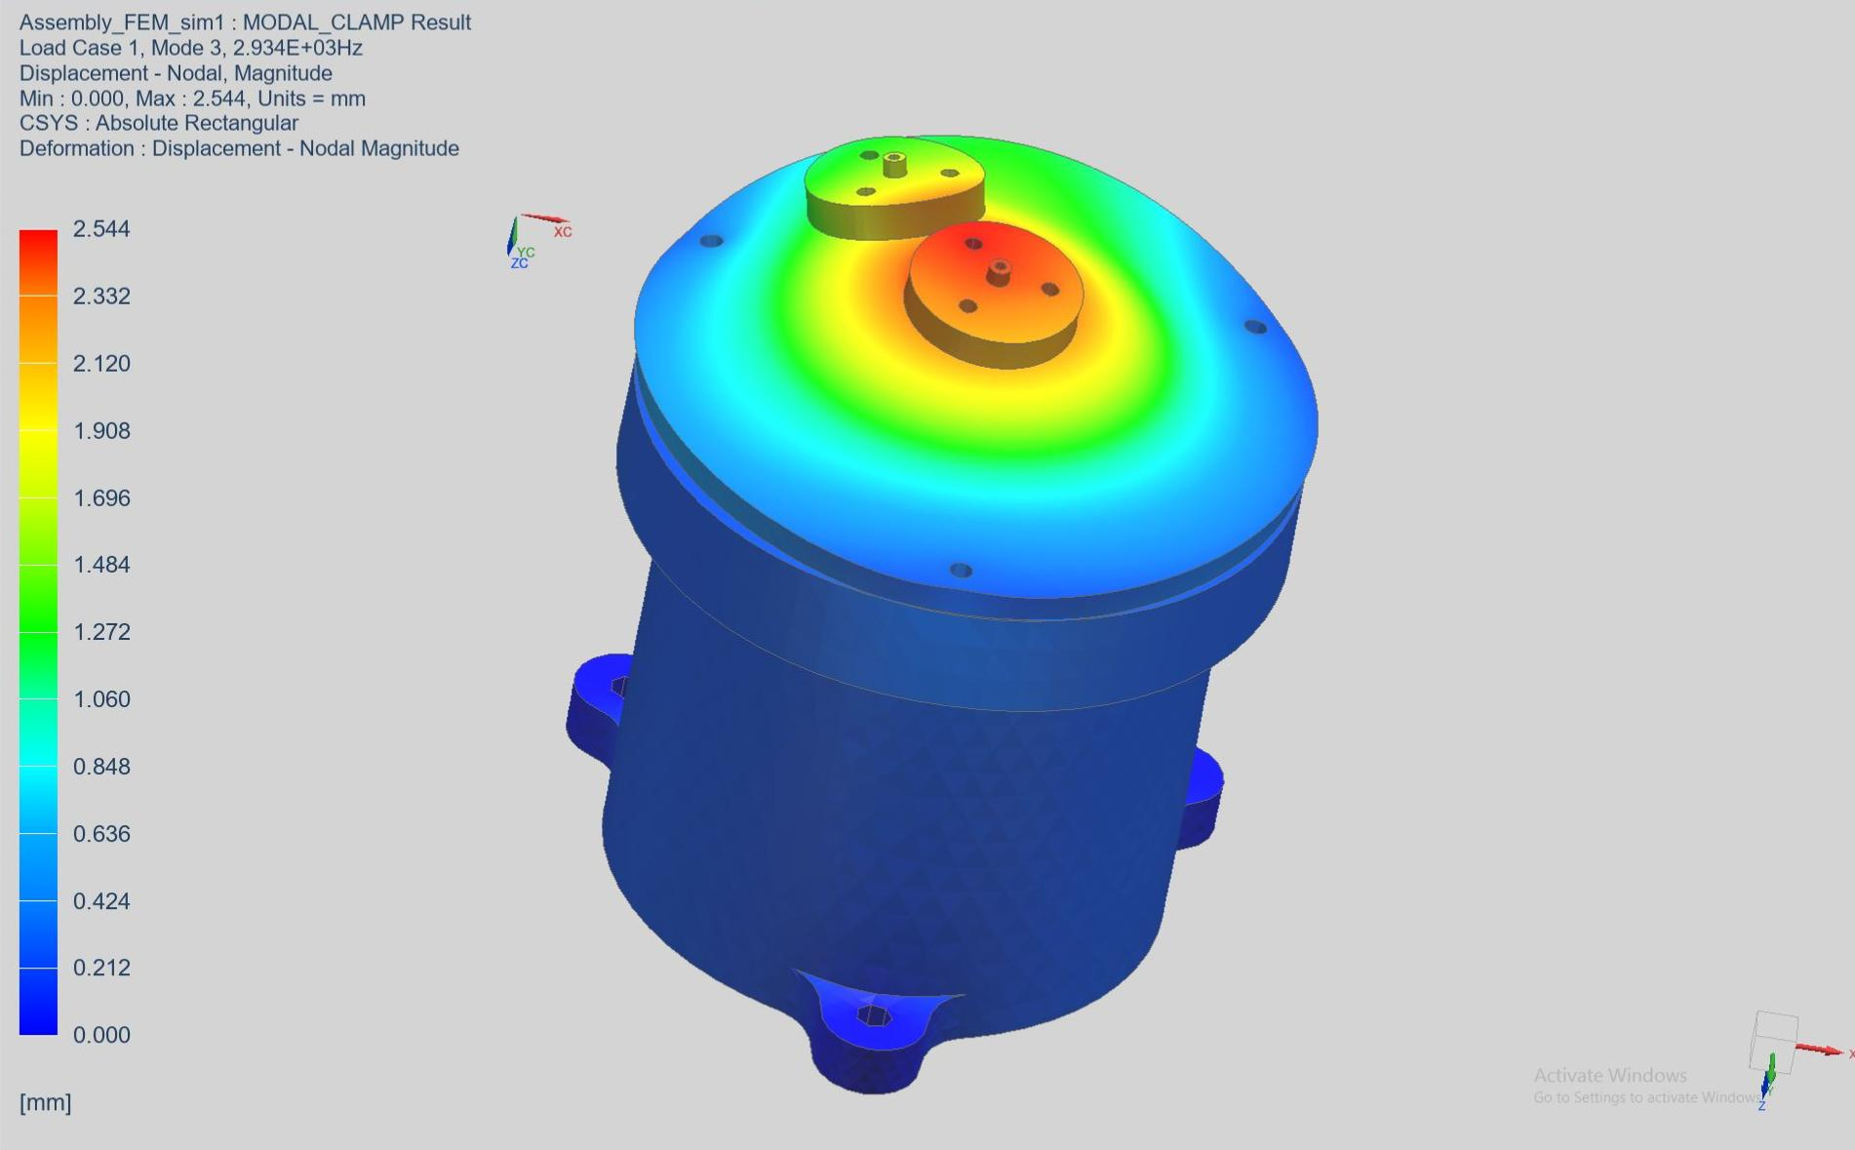

Figure 10. 5: Mode 3 - Higher Structural Frequency

## 

## 10.4 Static Analysis

Static analysis is a fundamental computational technique used to evaluate the behavior of structures or components under static (non-dynamic) loads. For the Magneto Hydrodynamic Angular Rate Sensor (MHD-ARS), static analysis is employed to assess the structural integrity and performance of the sensor under steady-state loading conditions. This analysis ensures that the sensor can withstand operational loads without experiencing excessive deformation or failure.

## 10.4.1 Key Aspects

**1. Load Types:** Includes dead loads (permanent loads like the weight of the structure), live loads (temporary loads like people or furniture), and environmental loads (like wind or snow).

**2. Stress and Strain:** Stress is the internal force per unit area within a material, while strain is the deformation or displacement per unit length caused by the applied stress.

**3. Displacement:** The movement of a structure or its components under the applied load.

## 10.4.2 Load Cases of Static Analysis

For the static analysis, three load cases were evaluated, as outlined in Table 10.4. The boundary conditions involved fully constraining the sensor at the mounting locations in the housing. This setup restricts all translational and rotational movements in the X, Y, and Z directions, closely simulating the actual attachment conditions for accurate stress and deformation analysis in each load case.

|  |  |  |
| --- | --- | --- |
| **S.No.** | **Load Case** | **Summary** |
| 1 | 30gX | Inertial load of 1g is applied in XX' axis. |
| 2 | 30gY | Inertial load of 1g is applied in YY’ axis. |
| 3 | 30gZ | Inertial load of 1g is applied in ZZ' axis. |

Table 10. 4: Static Analysis Load Cases

In static analysis, the Factor of Safety (FOS) is calculated by comparing observed stresses to the material’s design strength, using von-Mises stresses, principal stresses, and shear stresses. This ensures that the sensor’s design can handle operational forces and thermal effects safely and effectively.

|  |  |  |  |  |  |  |
| --- | --- | --- | --- | --- | --- | --- |
| Material | Stress | Tensile strength (MPa) | 30Gx | 30Gy | 30Gz | Factor of Safety (FOS) |
| Ti-6Al-4V | Von-Mises Stress | 950 | 17.16 | 16.62 | 11.1 | 85.58 |
| Worst  Principle stress | 26.61 | 24.21 | 14.34 | 66.24 |
| Max. Shear Stress | 9.72 | 9.06 | 6 | 158.33 |
| Cu | Von-Mises Stress | 210 | 1.224 | 1.344 | 2.115 | 171.568 |
| Worst  Principle stress | 1.719 | 2.31 | 1.941 | 122.164 |
| Max. Shear Stress | 0.705 | 0.705 | 1.221 | 297.872 |
| SmCo | Von-Mises Stress | 600 | 1.314 | 1.404 | 0.738 | 813.008 |
| Worst  Principle stress | 1.566 | 0.954 | 0.09 | 6666.667 |
| Max. Shear Stress | 0.681 | 0.729 | 0.381 | 1574.803 |
| Teflon | Von-Mises Stress | 21 | 0.0621 | 0.05964 | 0.08388 | 352.112 |
| Worst Principle Stress | 0.17094 | 0.15225 | 0.09798 | 214.329 |
| Max. Shear Stress | 0.03528 | 0.03405 | 0.04752 | 616.740 |

Table 10. 5: Stress Metrix

## 10.4.3 Results

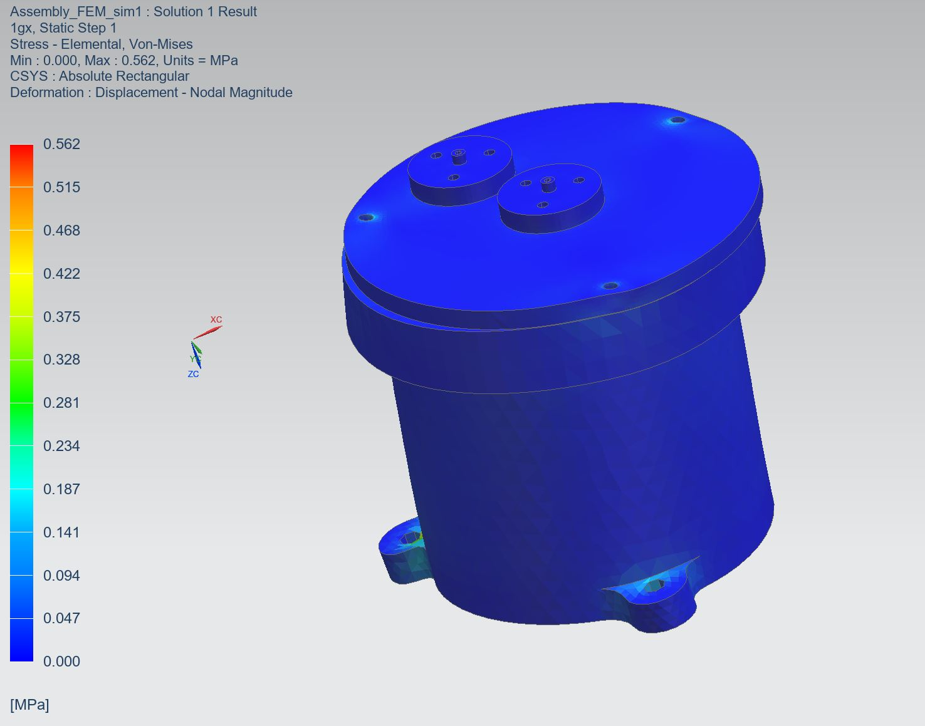The static analysis of the Magneto Hydrodynamic Angular Rate Sensor (MHD-ARS) assessed its performance under various load conditions. The analysis indicated maximum von Mises stress values concentrated around the mounting points, confirming the sensor’s ability to withstand operational loads. Deformation results showed minimal displacement, indicating robust structural integrity. Images illustrating stress distribution, deformation patterns, and other relevant results are presented below providing a visual representation of the analysis findings.

Figure 10. 6: Von-Mises contour in X- Direction (Static Analysis)

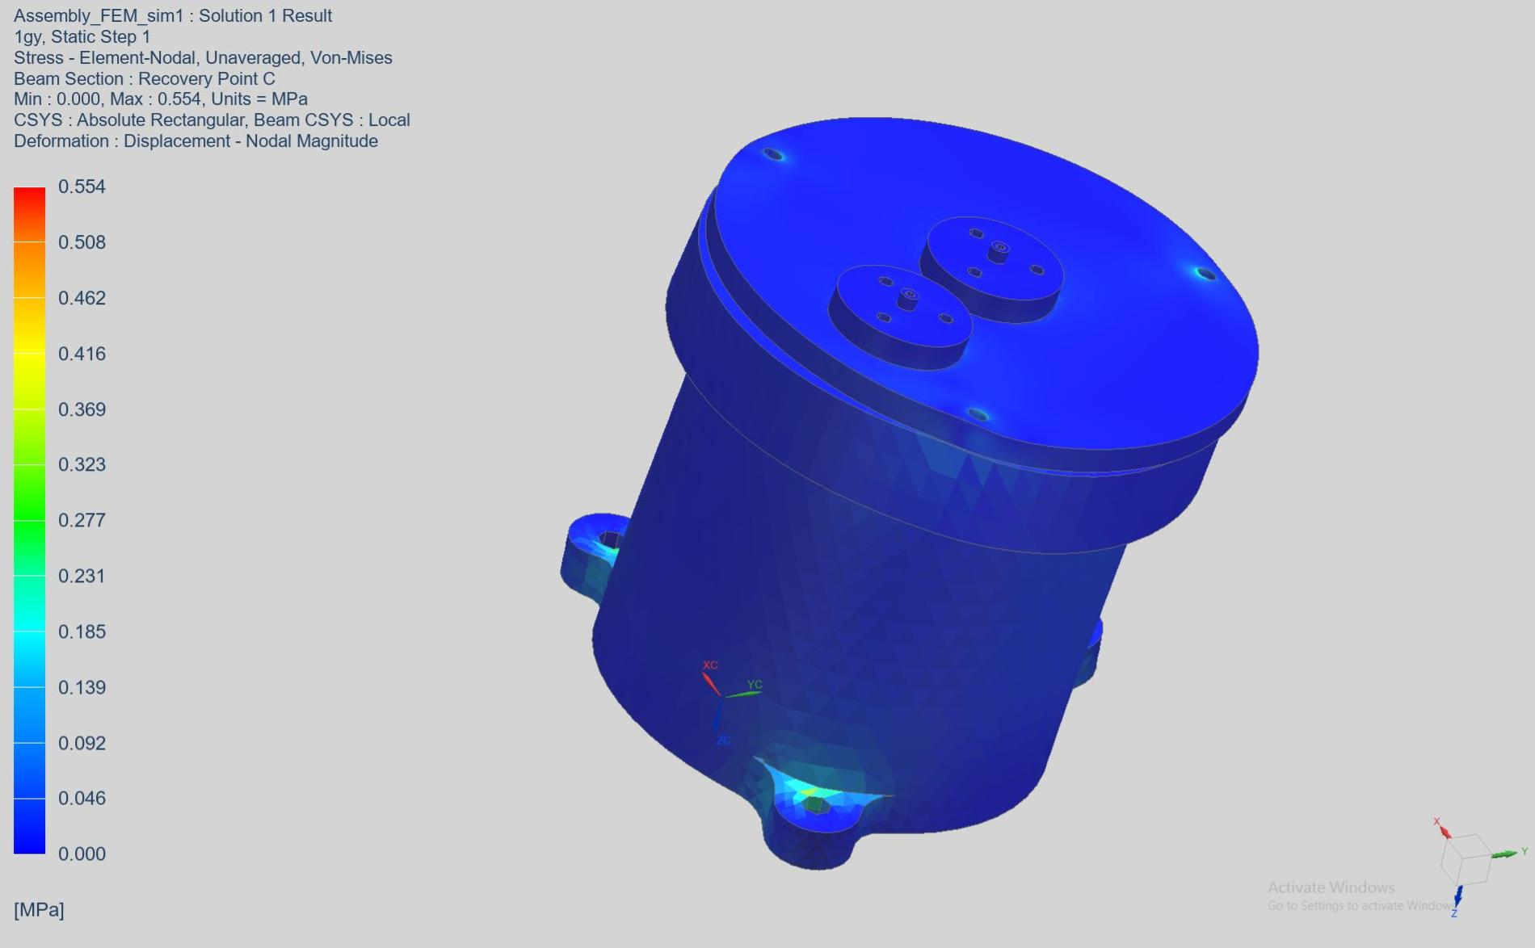

Figure 10. 7: Von-Mises contour in Y- Direction (Static Analysis)

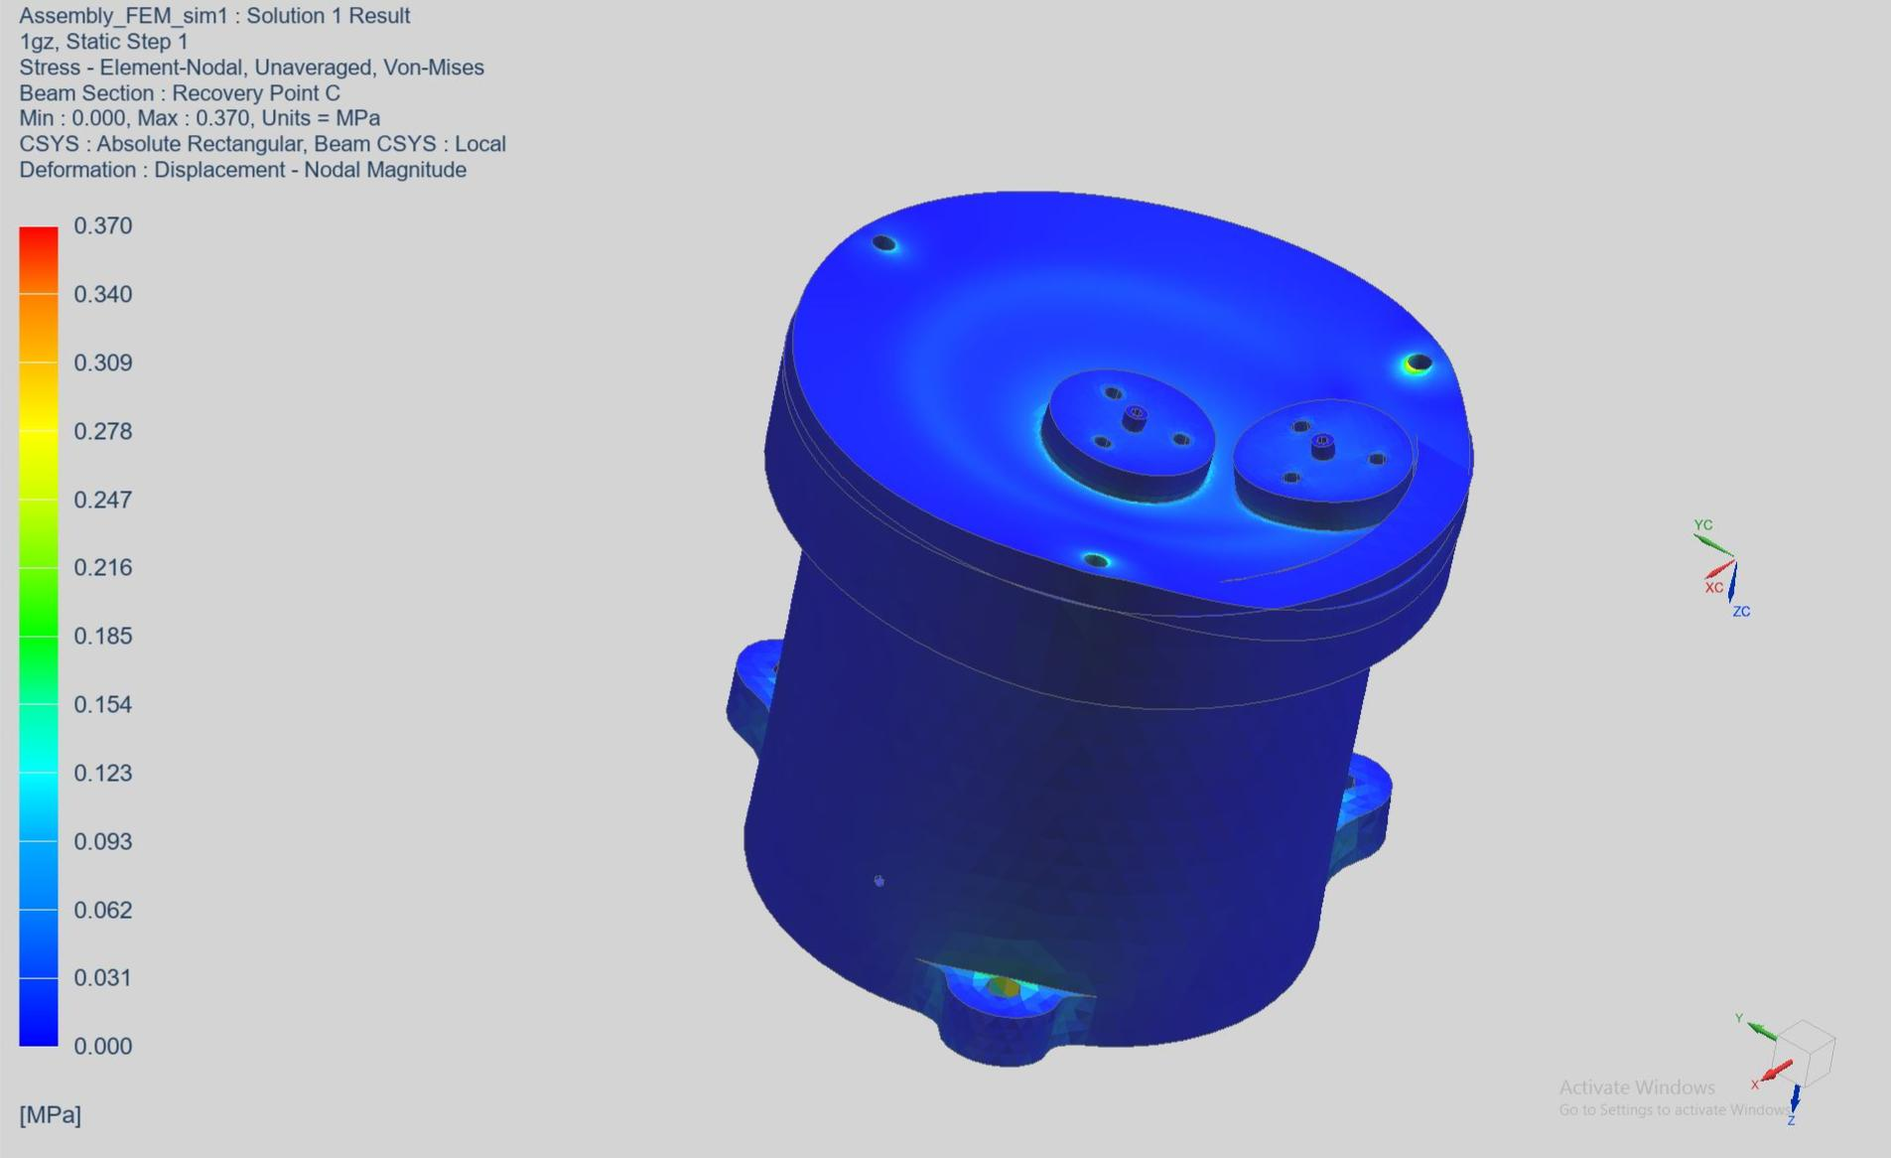

Figure 10. 8: Von-Mises contour in Z- Direction (Static Analysis)

## 

## 10.5 Random Analysis

In random vibration analysis, excitations are applied in the X, Y, and Z directions. In practical scenarios, random vibration analysis is typically performed in two directions, based on the input excitations: normal to the plane and parallel to the plane. Similarly, in Finite Element Analysis (FEA), vibration analysis is conducted based on the input excitations provided. A structural damping coefficient of 4% was assigned to the structure to account for energy dissipation.

John W. Miles developed an equation to calculate peak acceleration g(peak) while researching fatigue failure in aircraft structural components, which were subjected to jet engine vibrations and gust loads. His research simplified the system by modeling it as a single degree of freedom (SDOF).

In a multiple degree of freedom (MDOF) system, accelerations at resonant frequencies due to random loads can be approximated using Miles’ equation. This provides an estimate of the overall acceleration occurring at a resonant peak compared to the complete frequency spectrum.

Miles’ equation for peak acceleration is given by:

Gpeak

Where:

𝑓= Frequency

Q = Transmissibility

w = Input Power Spectral Density (PSD)

g = Equivalent static acceleration

The equivalent static acceleration (g) is represented by Gpeak. The transmissibility factor (Q) is calculated as:

## 10.5.1 Key Aspects

1. **Power Spectral Density (PSD):**
   * The excitation in random vibration analysis is described by a **Power Spectral Density (PSD)** function, which quantifies how the power (energy per unit time) of the input vibrations is distributed across different frequencies.
   * PSD is usually expressed in units of g2/Hzg^2/Hzg2/Hz (acceleration squared per Hertz) or m2/s3m^2/s^3m2/s3 (displacement squared per frequency), where higher PSD values indicate more energy at a particular frequency range.
   * The PSD curve allows engineers to model real-world random forces by defining vibration intensity across a spectrum of frequencies rather than a single frequency.
2. **System Response:**
   * The system’s dynamic response to the random vibrations is evaluated over a range of frequencies using the PSD of the input.
   * The response is calculated in terms of the **output PSD**, which provides insights into how the structure distributes vibrational energy at different points.
   * Engineers can predict responses such as displacements, velocities, accelerations, and stresses at various locations in the system.
3. **Root Mean Square (RMS) Values:**
   * The **RMS response** values of displacement, stress, or acceleration are derived from the PSD and indicate the average magnitude of the system’s response over time. RMS values are essential for assessing fatigue and structural integrity over extended periods of vibration exposure.
4. **Resonance and Fatigue:**
   * A random vibration analysis with a PSD input helps identify frequencies where the structure may resonate or experience high stress. Resonance occurs when the natural frequency of the system coincides with high-energy frequencies in the PSD, potentially leading to fatigue or failure.

### 10.5.2 Test Specifications

|  |  |
| --- | --- |
| **Frequency(Hz)** | **PSD(/Hz)** |
| **Qualification level** |
| 20-100 | +3db/Octave |
| 100-700 | 0.1 |
| 700-2000 | -3db/Octave |
| Overall RMS | g |

Table 10. 6: PSD input data for X and Y axes

|  |  |
| --- | --- |
| **Frequency(Hz)** | **PSD(/Hz)** |
| **Qualification level** |
| 20-100 | +3db/Octave |
| 100-700 | 0.2 |
| 700-2000 | -6db/Octave |
| Overall RMS | g |

Table 10. 7: PSD Input data for Z axes

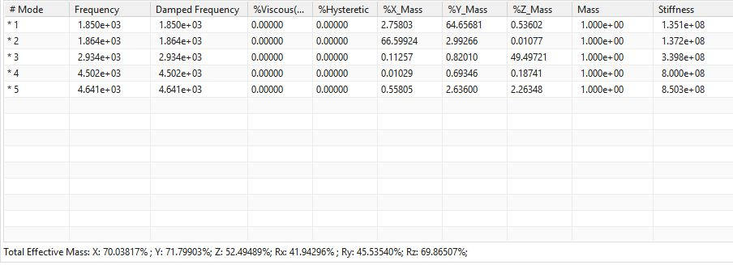

Table 10. 8: Dynamic Response Data

### 10.5.3 PSD Analysis in X-Direction

The PSD plot demonstrates that the MHD-ARS sensor is well-suited for space applications due to its high resonance frequency at **1852.3251 Hz**, which helps it avoid interference from low-frequency launch vibrations. The flat response at lower frequencies indicates robustness against such disturbances, ensuring the sensor provides reliable and precise measurements in challenging space environments.

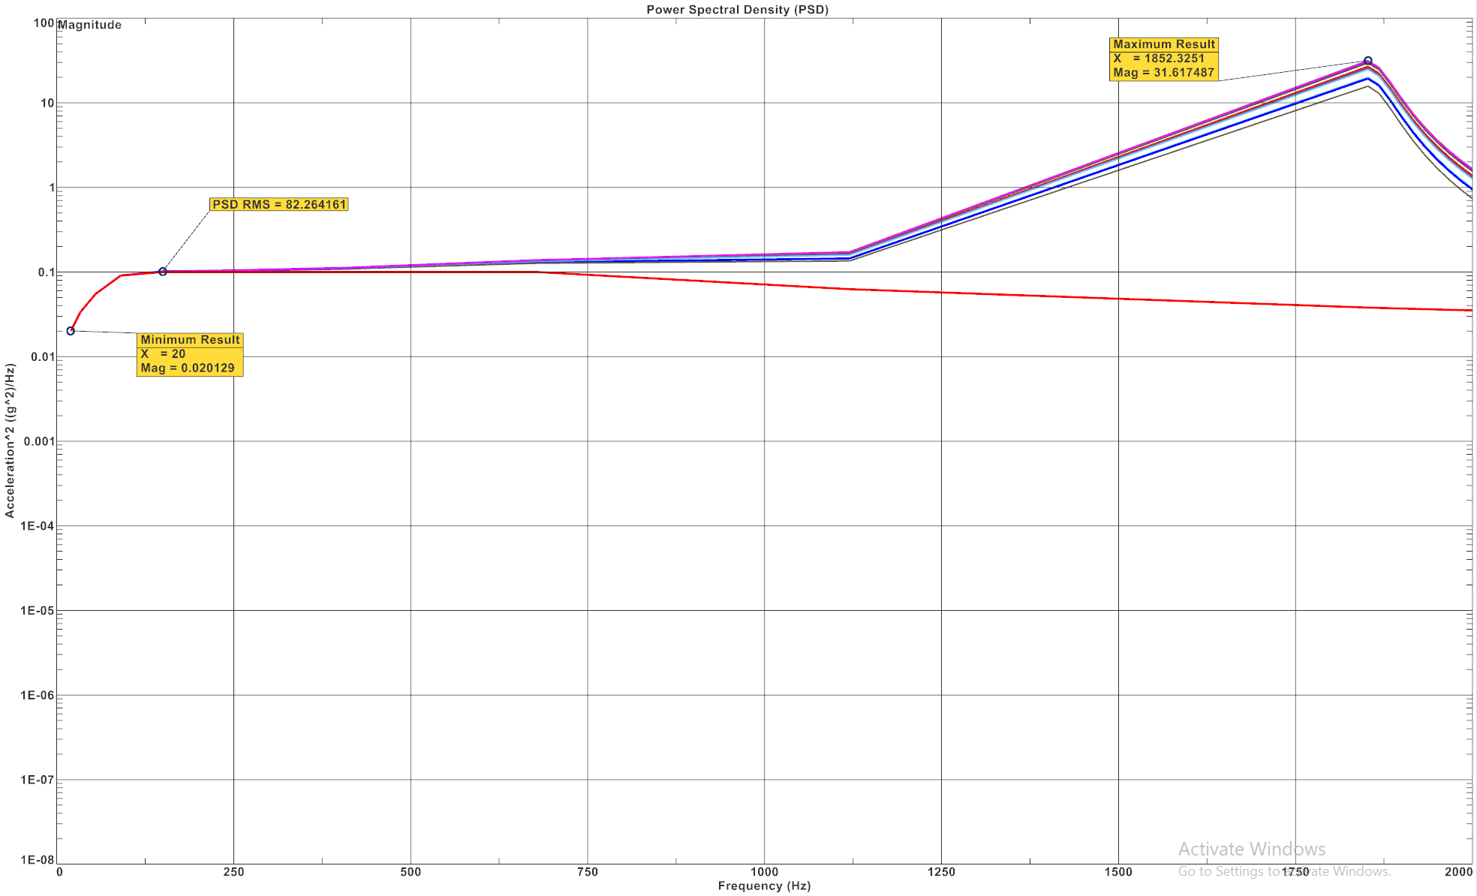

Figure 10. 9: Acceleration and Power Spectral Density (PSD) Plot in X Axes

### 10.5.4 PSD Analysis in Y-Direction

The **random analysis** of the MHD-ARS sensor along the **Y-axis**, with a significant resonance at **1814.5474 Hz**, shows that the sensor is well-optimized for handling random vibration environments typical in space missions. By avoiding lower-frequency disturbances and responding primarily at higher frequencies, the sensor ensures reliable, stable, and accurate performance even in unpredictable, multi-frequency vibration conditions experienced during launch and spacecraft operations.

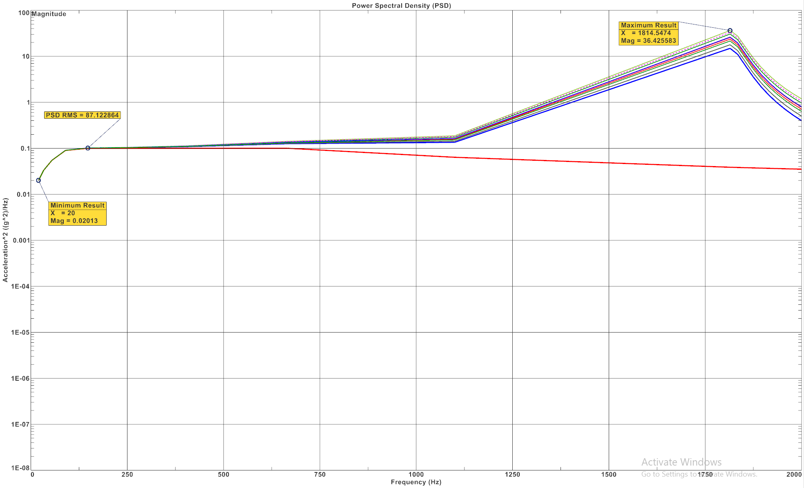

Figure 10. 10: Acceleration and Power Spectral Density (PSD) Plot in Y Axes

### 10.5.5 PSD Analysis in Z-Direction

The PSD analysis of the Magneto Hydrodynamic Angular Rate Sensor (MHD-ARS) along the z-axis, in the context of random analysis, reveals a significant resonance at approximately 1399.6304 Hz. This high-frequency resonance effectively minimizes the impact of lower frequency launch vibrations, indicating that the sensor design is well-suited for space applications

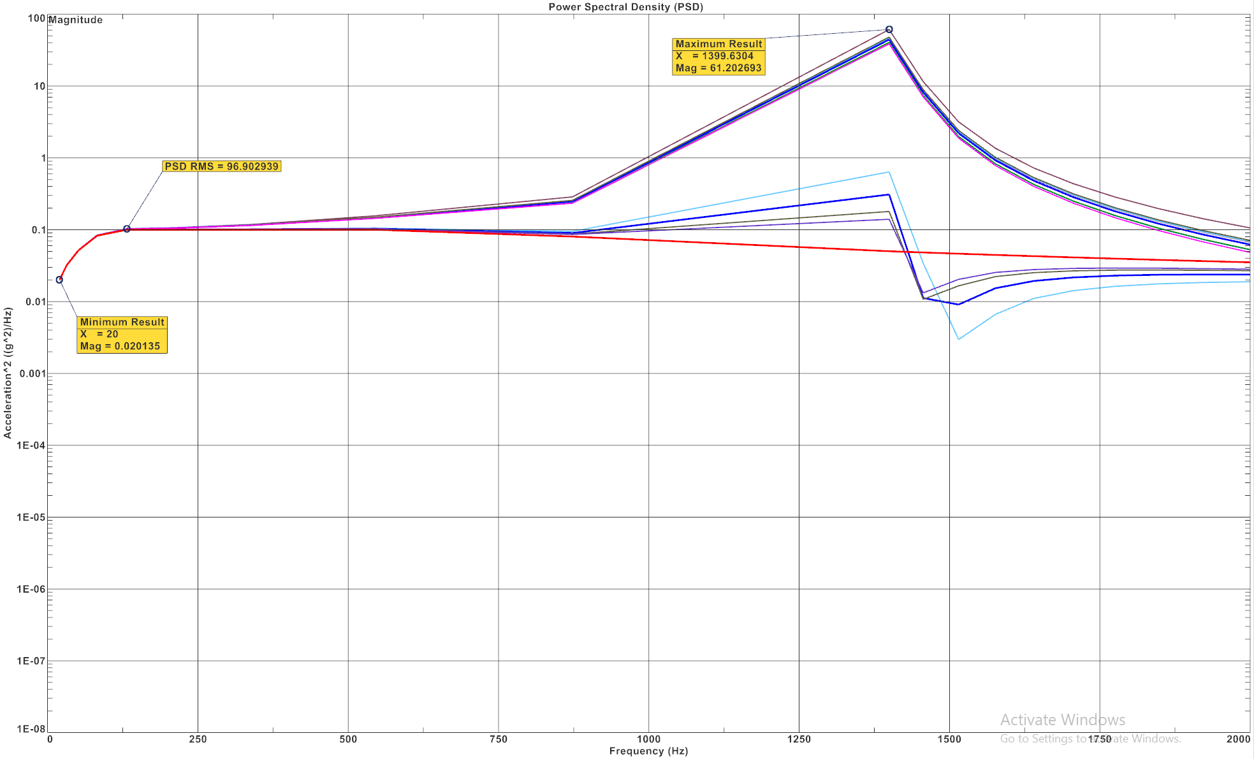

Figure 10. 11: Acceleration and Power Spectral Density (PSD) Plot in Z Axis

## 10.5.6 Results

The random vibration analysis of the Magneto Hydrodynamic Angular Rate Sensor (MHD-ARS) was conducted to evaluate the structural response under random excitations in the X, Y, and Z axes. The results are visualized through von-Mises stress contour plots, which highlight stress distribution across the sensor assembly for each directional excitation. The corresponding plots are as follow.

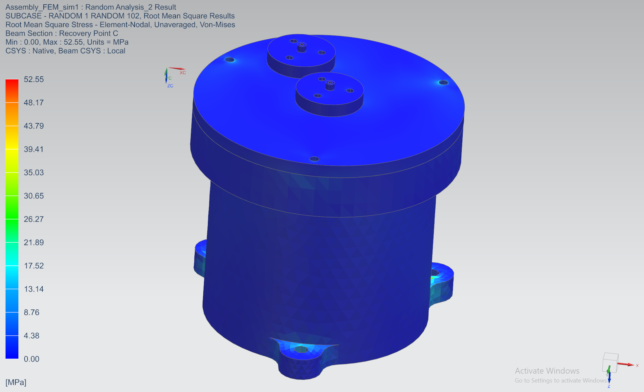

Figure 10.12: Von-Mises contour in X- Direction (Random Analysis)

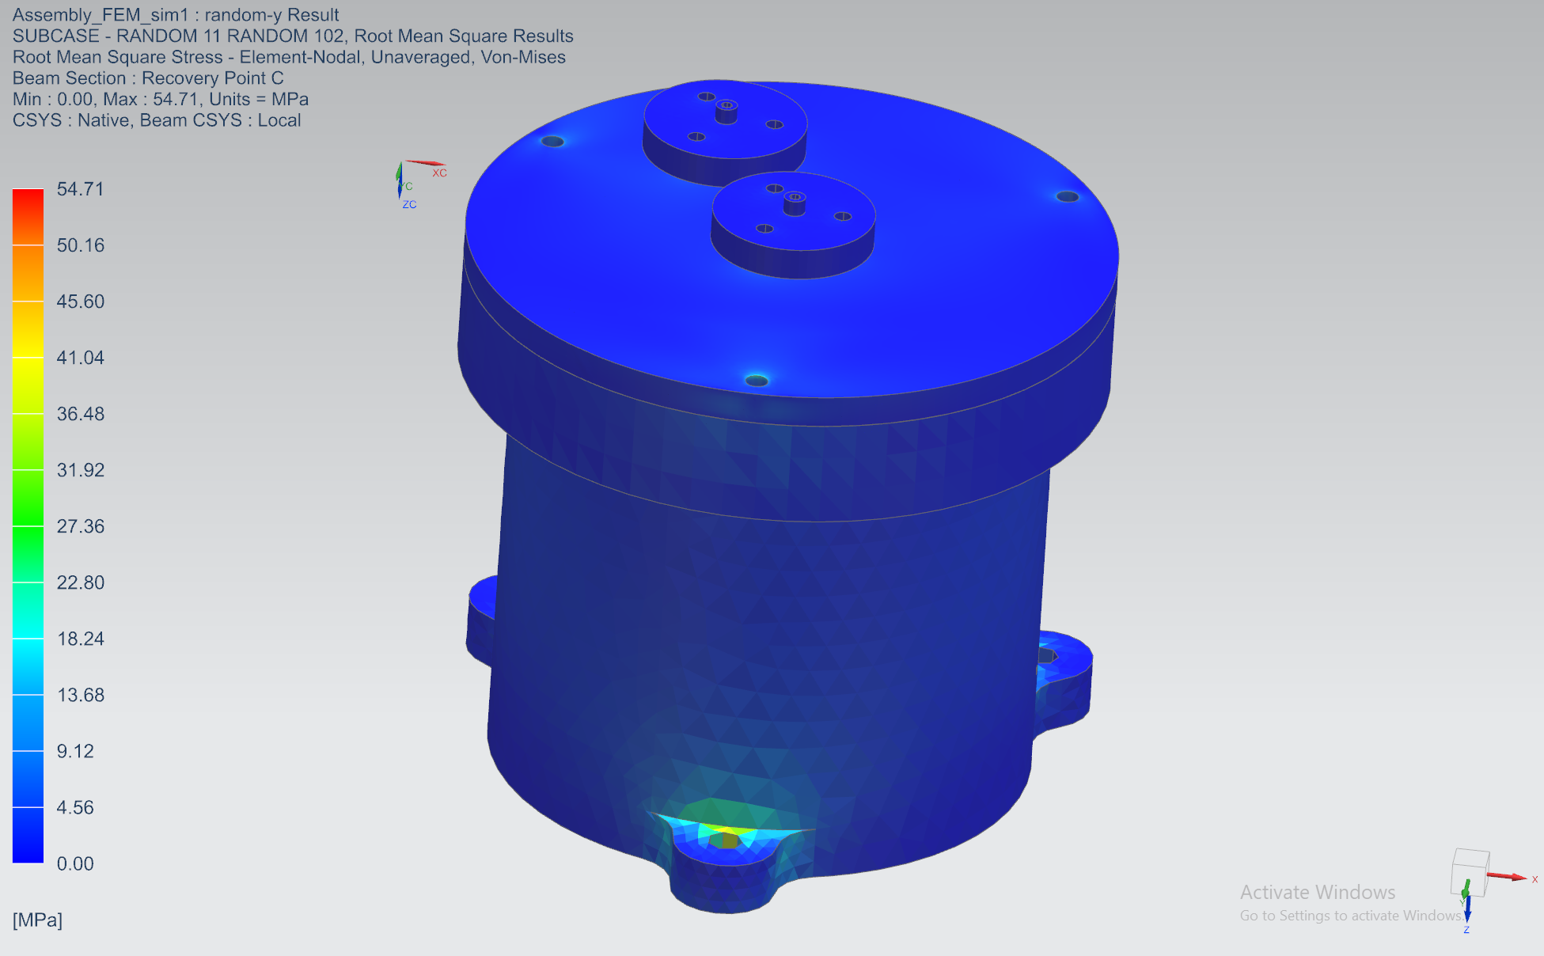

Figure 10.13: Von-Mises contour in Y- Direction (Random Analysis)

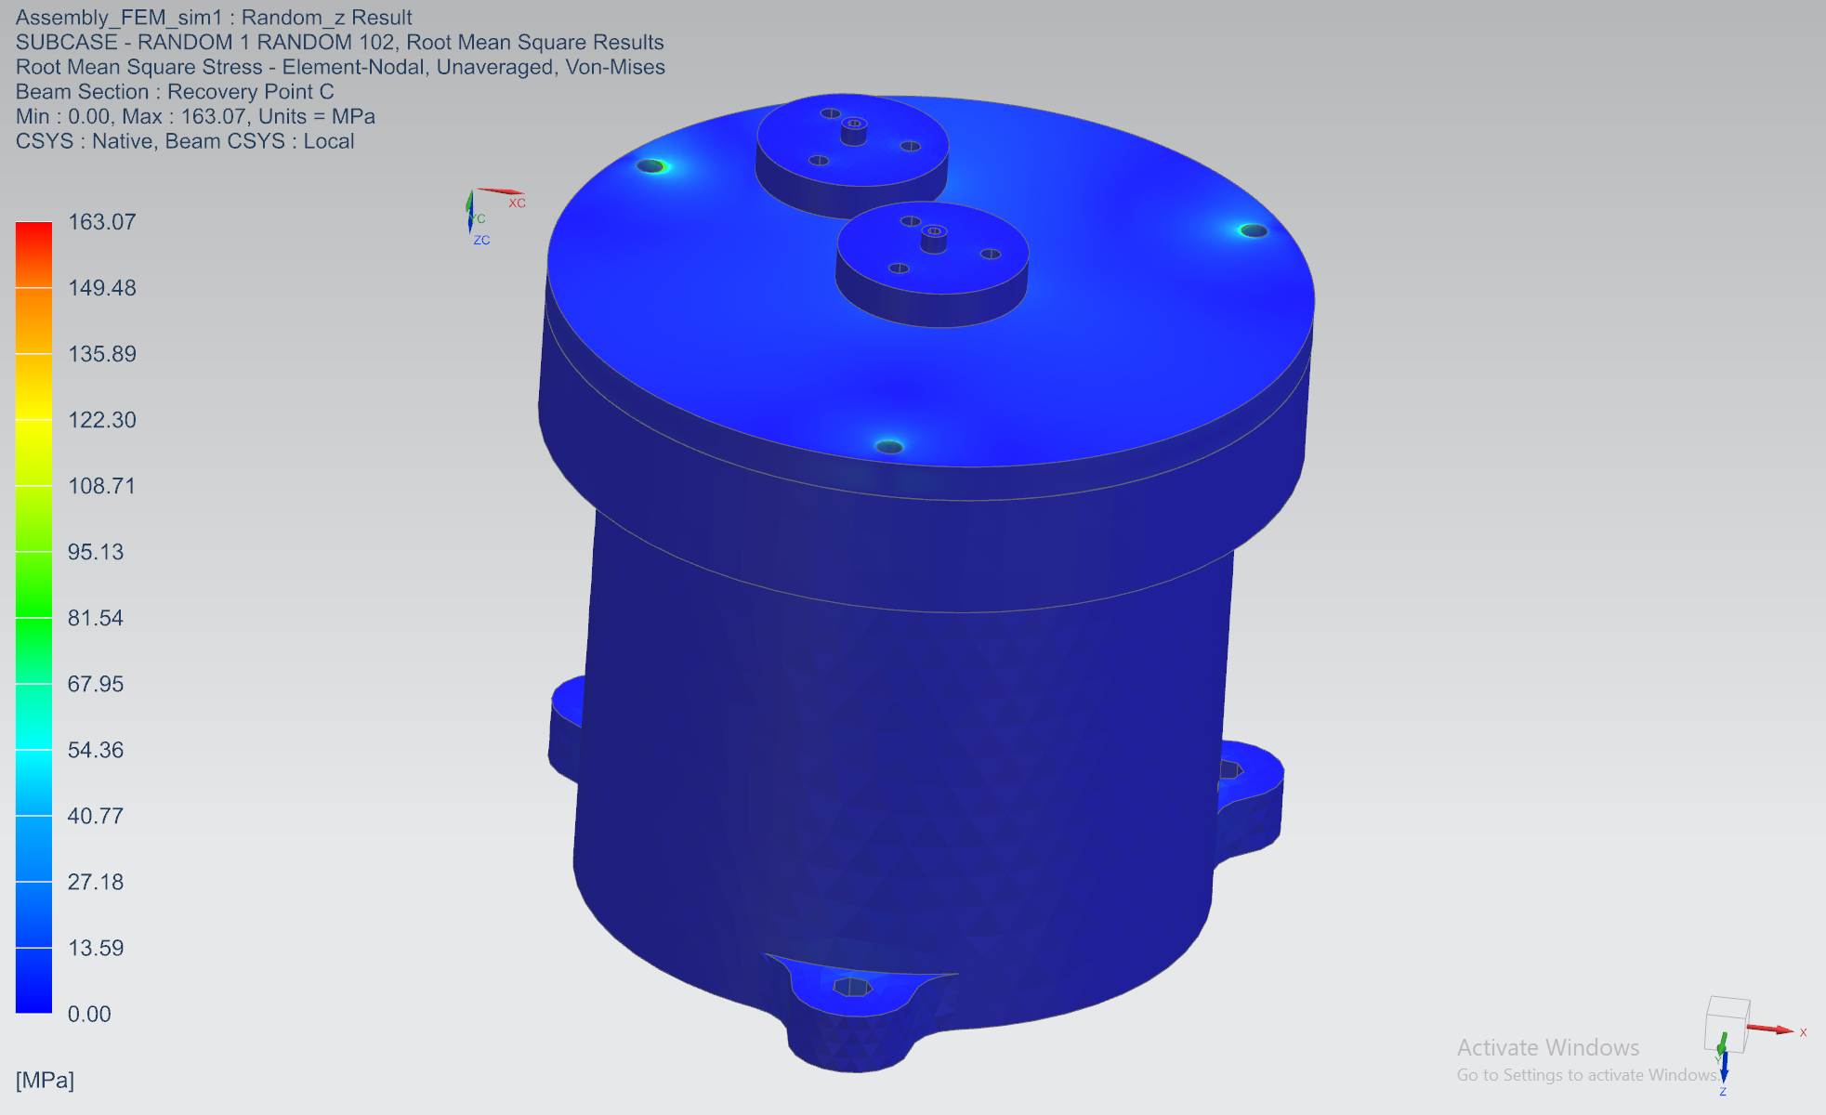

Figure 10.14: Von-Mises contour in Z- Direction (Random Analysis)

# **11. Results and Discussion**

This section provides a detailed analysis of the results obtained from the various simulations and assessments conducted on the Magneto Hydrodynamic Angular Rate Sensor (MHD-ARS). The analyses performed include modal analysis, static analysis, random vibration analysis, and sensitivity calculations. Below, we summarize the key findings from each analysis and discuss their implications for the sensor’s overall performance.

## 11.1 Sensitivity Calculation

The sensitivity of the MHD-ARS was calculated as follows:

1. **Effective Radius:**
2. **Induced Voltage:**
3. **Sensitivity:**

Sensitivity(S) =

The calculated sensitivity is 88.42 V/(rad/s), which reflects the sensor’s responsiveness to changes in angular rate.

## 11.1.1 Discussion

A sensitivity of 88.42 V/(rad/s) indicates the sensor’s high capability to detect even minute variations in angular rate. This high sensitivity is crucial for applications requiring precise measurements, such as spacecraft navigation, where accurate detection of small angular changes is essential. The result meets the design specifications, affirming the sensor’s effectiveness for its intended high-precision applications. The careful selection of materials and optimization of component design have played a significant role in achieving this high sensitivity.

## 11.2 Minimum Detectable Angular Rate Calculation

ω

ω

ω

The minimum detectable angular rate was calculated to be rad/s. This value represents the smallest angular rate change that the sensor can reliably detect.

## 11.2.1 Discussion

The minimum detectable angular rate of highlights the sensor’s precision and sensitivity. This low detection threshold is essential for applications that require extremely fine measurements, such as in spacecraft navigation systems. The sensor’s design, including material properties and geometric configuration, has been tailored to achieve this high level of detection capability.

## Modal and Vibrational Analysis Results

1. **Free-Free Modal Analysis:**

The free-free modal analysis was conducted to determine the natural frequencies and mode shapes of the Magneto Hydrodynamic Angular Rate Sensor (MHD-ARS) assembly in an unconstrained state, simulating the conditions in space where the sensor is not rigidly fixed.

* **Findings:**  
  The first six modal frequencies were near zero, as expected, indicating the six degrees of freedom corresponding to rigid body motions. The seventh mode was found to occur at (3.747E+03 Hz). This frequency corresponds to the first non-rigid mode shape, where the structure begins to exhibit elastic deformation rather than rigid body motion.
* **Implications:**  
  The presence of the seventh mode at (3.747E+03) Hz confirms that the sensor's design is free from low-frequency resonance issues that could interfere with its operation in space. The relatively high value of this frequency also suggests that the sensor is structurally stiff and well-suited to endure the dynamic environment of space without significant deformation. This result ensures that the MHD-ARS sensor will remain stable and function accurately in its intended operational context, even when subjected to external perturbations.

1. **Clamped Modal Analysis:**

To evaluate the vibrational characteristics of the MHD-ARS sensor under fixed conditions, a clamped modal analysis was performed. This simulates the scenario where the sensor is securely mounted within a spacecraft.

* **Findings:**

The analysis revealed that the first mode of vibration occurs at 1,850 Hz, indicating the lowest frequency at which the sensor structure begins to deform elastically. The fifth and final mode analyzed showed a frequency of 4,641 Hz. These results highlight the range of natural frequencies that the sensor will experience when mounted.

* **Implications:**

The first mode at 1,850 Hz is sufficiently high, ensuring that the sensor will not resonate with lower-frequency disturbances, which are common in spacecraft environments. The fifth mode at 4,641 Hz suggests that even higher-frequency vibrations will be efficiently managed by the sensor’s design. This confirms that the MHD-ARS sensor is structurally robust and can maintain its performance integrity under a wide range of operational conditions when mounted.

1. **Static Analysis:**

The static analysis revealed the following key results, which are summarized below.

* **Maximum Von-Mises Stress:**

The analysis identified the highest stress concentration occurring in the MHD-ARS sensor, with a maximum Von-Mises stress of [17.16 MPa]. This value is within the yield strength of the material used, ensuring that the component will not fail under the applied loads.

* **Minimum Factor of Safety (FOS):**

The minimum FOS was calculated as indicating the margin of safety before the material reaches its yield point. The FOS is above the acceptable threshold, demonstrating that the sensor has a sufficient safety margin to operate reliably under the specified conditions.

* **Implications:**  
  The results indicate that the MHD-ARS sensor is structurally sound and capable of withstanding the static loads encountered during operation. The maximum Von-Mises stress being within safe limits and the FOS being above the minimum required value ensure that the sensor will not experience plastic deformation or failure under typical operational conditions. This analysis confirms the durability and reliability of the sensor design, contributing to its long-term operational success in space applications.

1. **Random Analysis:**

In the random analysis conducted on the Magneto Hydrodynamic Angular Rate Sensor (MHD-ARS), several key findings emerged from the acceleration versus Power Spectral Density (PSD) plots and Von-Mises stress contour.

* **Findings:**

1. **Acceleration vs PSD Plots:**   
   The PSD plots indicated significant resonance frequencies, crucial for understanding the sensor's behavior under random vibrations. The analysis revealed resonance peaks that demonstrate the sensor's ability to withstand low-frequency launch vibrations, confirming its suitability for space applications. The resonance frequencies are **1852.3251 Hz,** **1814.5474** **Hz** and **1399.6304 Hz** along the X, Y, and Z axes, indicating a robust design capable of maintaining performance in diverse conditions.
2. **Von Mises Stress Analysis:**  
   The von Mises stress contour images provided valuable insights into stress distribution across the sensor components. The maximum von Mises stress values observed were 52.55 MPa along the X-axis, 54.71 MPa along the Y-axis, and 163.07 MPa along the Z-axis. The relatively higher stress in the Z-axis suggests this direction experiences more significant loading, likely due to the weight of the components and operational conditions in a space environment.

**Implications:**

The results indicate that the MHD-ARS sensor design is structurally sound and can handle the dynamic conditions of space. The findings underscore the importance of ensuring that the materials used can withstand the identified stress levels without failure. The higher stress observed along the Z-axis may necessitate a review of the component design or material selection to enhance durability and performance in that direction.

Additionally, the ability of the sensor to mitigate low-frequency vibrations enhances its reliability during launch and in-orbit operations, making it a viable candidate for applications in aerospace engineering. Overall, the analysis provides confidence that the MHD-ARS sensor will deliver reliable performance in the challenging conditions of space.

# 

\

# **12. Conclusion**

In conclusion, my experience with the MHD-ARS project at LEOS has been incredibly valuable and enlightening. This project provided me with the opportunity to delve deeply into various aspects of engineering design and analysis, particularly focusing on the Magneto Hydrodynamic Angular Rate Sensor (MHD-ARS). Throughout the project, I enhanced my proficiency with NX software, which played a crucial role in my development.

I engaged extensively in modeling, assembly, drafting, and simulation using NX. This involved creating detailed models of the sensor components, assembling them accurately, and conducting various simulations to ensure the sensor's performance and reliability. Learning to effectively utilize NX for these tasks was a significant part of the project, and it allowed me to develop a comprehensive understanding of both the software and the engineering principles underlying the sensor design.

Working on the MHD-ARS project required a meticulous approach to handling design challenges and performing analyses. I was involved in tasks such as adjusting component tolerances, managing assembly alignments, and interpreting simulation results. These experiences sharpened my problem-solving skills and deepened my knowledge in areas such as modal and static analysis, crucial for evaluating the sensor's performance.

The project also provided me with practical insights into the importance of precision and accuracy in engineering design. Each step, from initial modeling to final simulation, contributed to my overall growth and understanding of complex engineering systems. This hands-on experience has not only broadened my technical skill set but also reinforced my capability to apply theoretical knowledge to real-world challenges.

In summary, my journey with the MHD-ARS project has been a significant learning experience, equipping me with essential skills and knowledge in engineering design and simulation. This experience has been instrumental in my development as an engineer and has prepared me for future challenges in the field.

# **13. Reference**

1. Yunhao Su, Caiwen Ma, JunFeng Han, Xuan Wang, Yuanyuan Wang, and Zhou Ji, (2023). “Research on Magneto hydrodynamic Angular Rate Sensor Denoising for a Space Laser Stabilization Control System” Appl.1. Sci.2023,13,5895.
2. Ganmin Xia, Weixiao Tuo, Xingfei Li and Xinyu Liu. (2022) “Study on the Performance of Liquid-Solid Contact Resistance Based on Magneto hydrodynamic Micro-Angular Vibration Sensor” 2022, 22, 9204.
3. Yue Ji, Xingfei Li, Tengfei Wu and Cheng Chen, (2015), “Theoretical and Experimental Study of Radial Velocity Generation for Extending Band Width of MHD-ARS Sensor at Low frequency ".
4. Y. Ji, X. Li, T. Wu, C. Chen and S. Zhang, “Quantitative Analysis Method of Error Sources in Magneto hydrodynamic Angular Rate Sensor for Structure Optimization,” in IEEE Sensors Journal, vol. 16, no. 11, pp. 4345-4353, June1, 2016, doi: 10.1109/JSEN.2016.2544942.
5. Yue Ji, Xingfei Li, Tengfei Wu and Jun Wu, (2017), "Preliminary Study on the Magneto hydrodynamic (MHD) Angular Rate Sensor Combining Coriolis Effect at Low- frequency".
6. Tong Li, K. Wang, (2016), “Design and Experiment Study for MHD Microradian Angular Vibratory Sensor".
7. Darren R. Laughlin, Albuquerque, (2001) "MHD Sensor for Measuring Microradian Angular Rates and Displacements".
8. Y. Su et al., “Adaptive Kalman Filter Based on Online ARW Estimation for Compensating Low-Frequency Error of MHD ARS,” in IEEE Transactions on Instrumentation and Measurement, vol. 73, pp. 1-10, 2024, Art no. 9509510, doi: 10.1109/TIM.2024.3375962.
9. D.R. Laughlin, “Low frequency angular velocity sensor.”

<https://patents.google.com/patent/WO1992009897A1/en> (accessed Jul. 25, 2024).

1. “WIPO – Search International and National Patent Collections,” patentscope.wipo.int. <https://patentscope.wipo.int/search/en/detail.jsf?docId=WO1992009897> (accessed Jul. 14, 2024).
2. Simcenter 3D Assembly FEM and Response Dynamics Demonstration under team center. YouTube. Available at: <https://youtu.be/fU-E1grMTJI?si=fPs3LaZQhs663itQ>
3. Frequency Response and Random Response (Dynamic Response in Nastran). YouTube. Available at: <https://youtu.be/VKF5bMM-KpQ?si=DGd9Vx51IRD56sxe>
4. Random and Modal Vibration Analysis of Girder Assembly using ANSYS. YouTube. Available at: <https://youtu.be/6LQjCFaU0pk?si=Xe7cQ-4YqgC725uW>
5. “WIPO – Search International and National Patent Collections,” patentscope.wipo.int. <https://patentscope.wipo.int/search/en/detail.jsf?docId=WO1992009897> (accessed Jul. 25, 2024).
6. “Angular rate sensor” Wikipedia,3rd May 2001, <https://en.m.wikipedia.org/wiki/Angular_rate_sensor>(accessed July 3rd 2024).