

**Government of INDIA**

**Department of Space**

**Indian Space Research Organization**

**INTERNSHIP REPORT**

***At***

**Laboratory for Electro-Optics Systems**

**(LEOS-ISRO)**

**Bangalore – Department of Space, Govt. of India**

1st cross, Peenya Industrial Estate, Bengaluru Pincode-580058

***Submitted by***

**SRINIDHI S (20211CSD0114)**

***Student of***

**Presidency University**

***Pursuing the Degree of***

**BACHELOR OF TECHNOLOGY IN**

**COMPUTER SCIENCE & ENGINEERING**

***Under the supervision and guidance of***

**THAMARAI V KRISHNA KUMMARI**

**Division Head, LQAD** Scientist/Engineer-SD

Scientist/Engineer-SG LEOS-ISRO

SRQG,LEOS-ISRO

**DECLARATION**

I declare that this project entitled “**{{title}}”** submitted in partial fulfilment of the degree in **B. Tech in Computer Science & Engineering**, is a record of original work carried out by me under the supervision of **LEOS-ISRO, Bengaluru**, and **Shri. Krishna Kummari** LEOS-ISRO, Bengaluru. This work has not been submitted for the award of any other degree or diploma at any other institution or university. In accordance with the ethical practices of reporting scientific information, due acknowledgements have been made wherever the findings of others have been cited. This report has not been submitted, in part or full, to any other university, institution, or professional body for the award of any degree, diploma, or fellowship.

Signature:

Name:

Place:

Roll No:

Date:

**CERTIFICATE**

This is to certify that Mr. **SRINIDHI S (USN:20211CSD0114)** is a student of Presidency University, Bengaluru has carried outthe Internship work entitled ‘{{title}}’ at **LABORATORY FOR ELECTRO-OPTICS SYSTEMS (LEOS), INDIAN SPACE RESEARCH ORGANISATION (ISRO),** Peenya Industrial Estate, Bengaluru 560058, under the guidance of Shri. Krishna Kummari, from 28th Jan 2025 to 28th April 2025.

*Signature of the Head Signature of Guide*

**Smt. Thamarai V SHRI Krishna Kummari**

**Division Head, LQAD** Scientist/Engineer-SD

Bengaluru-560058

# ACKNOWLEDGEMENT

We take this opportunity to acknowledge all those who have willingly helped us in the this internship.

Firstly, We sincerely thank the Laboratory for Electro-Optics Systems (LEOS), ISRO for allowing us to intern for three months at their premises. We extend our gratitude and appreciation to Dr A R Srinivas was instrumental in giving us this opportunity and we thank him for all his support.

Next, we thank Sri Krishna K , for his support, guidance and supervision in our internship.

We also thank all the Scientists/Engineers, LQAD, and LEOS, for their guidance and sharing of their experience and knowledge, and the rest of the QAD staff for their support and advice.

We thank Smt. Thamarai .V (Division Head – QAD) who supervised and involved us in work. We thank the entire LEOS staff for being very supportive and helpful. The internship helped our personal and professional development.

We would also like to thank the LEOS Library and its staff who continuously supported us during the time & was present there for the completion of our work.

Lastly, we thank our college, parents and the rest of family for their constant support and motivation.

# 1. Introduction

## 1.1 Industrial Training Objective

ISRO’s industrial training program for mechanical interns is designed to provide an immersive and practical learning experience, helping students transition from academic studies to real-world aerospace applications. The program focuses on the following key areas:

1. **Exploring Aerospace Technologies** – Interns get hands-on experience with advanced aerospace systems, gaining insights into satellite development, propulsion mechanisms, and structural analysis.
2. **Applying Knowledge to Real-World Challenges** – Instead of just theoretical learning, interns contribute to ongoing ISRO projects, solving practical engineering problems and understanding the complexities of space technology.
3. **Developing Teamwork and Collaboration** – Working alongside ISRO scientists and engineers, interns engage in interdisciplinary teamwork, learning how different engineering domains come together in space missions.
4. **Understanding Safety and Quality Standards** – The program emphasizes adherence to industry safety protocols, material selection criteria, and precision in aerospace manufacturing to ensure mission success.
5. **Enhancing Professional and Technical Skills** – Interns receive exposure to project management, problem-solving techniques, and ethical engineering practices, equipping them with skills crucial for their careers.
6. **Expanding Professional Networks** – Through interactions with experts, technical discussions, and networking events, interns gain insights into career opportunities and future developments in the aerospace industry.
7. **Receiving Continuous Guidance and Feedback** – Regular assessments and mentorship help interns refine their approach, improve technical proficiency, and maximize their learning experience.
8. **Inspiring Future Innovators** – By being part of ISRO’s mission-driven projects, interns witness first hand the impact of their work, fuelling their passion for aerospace and space exploration.

1. **Gaining Practical Exposure to Key Engineering Concepts** – The training covers essential topics such as thermal management in spacecraft, advanced propulsion systems, material sciences, and cutting-edge manufacturing techniques

## 1.2 The significance of industrial training for students is manifold

1. **Application in Practice:** Industrial training enables students to apply theoretical knowledge in real-world scenarios, refining their understanding and practical skills.
2. **Professional Skill Enhancement:** Students develop crucial abilities essential for their future careers, including time management, problem-solving, teamwork, and effective communication.
3. **Industry Exposure:** Exposure to industry practices during training gives students a competitive edge by enhancing their comprehension of market dynamics, trends, and challenges.
4. **Networking Opportunities:** Interaction with professionals during training allows students to establish valuable connections for employment prospects, mentorship, and professional growth.
5. **Career Exploration:** Industrial training provides students a platform to explore various career paths within their field, aiding them in making informed career decisions.
6. **Resume Enhancement:** Completing industrial training adds credibility to resumes by displaying real-world experience and industry exposure to potential employers.
7. **Personal Development:** Overcoming challenges during training cultivates resilience, confidence, and self-awareness among students
8. **Transition to Employment:** By equipping students with relevant skills and industry knowledge, industrial training facilitates a smoother transition from academia to the workforce.
9. **Promotion of Lifelong Learning:** Exposure to new technologies and methodologies during training inspires students to embrace lifelong learning and stay updated in their respective fields.
10. **Improved Employability:** Overall, industrial training enhances students' employability by equipping them with professional skills, practical experience, and industry insights necessary for successful employment.

# 2. Company Background and Organizational Structure

## 2.1 Indian Space Research Organization (ISRO)

The Indian Space Research Organization (ISRO) is India’s national space agency, playing a pivotal role in the country's space exploration and satellite technology development. It operates under the Department of Space (DoS), which functions directly under the guidance of the Prime Minister of India and is led by the Chairman of ISRO.

ISRO is responsible for a wide range of space-related activities, including satellite development, space exploration, international collaborations, and advancements in space technologies. It has made remarkable contributions to global space research and has positioned India as a key player in the space industry.

One of ISRO’s greatest achievements is its capability to develop and deploy cryogenic engines, a critical technology for heavy-lift rockets. The agency has also successfully conducted interplanetary missions, such as the Mars Orbiter Mission (Mangalyaan) and Chandrayaan lunar explorations. Additionally, ISRO is one of the few space agencies in the world capable of performing soft landings on other celestial bodies without human presence, as demonstrated in the Chandrayaan-3 mission.

With a strong track record in cost-effective satellite launches, earth observation programs, and deep-space missions, ISRO continues to push the boundaries of space exploration while contributing to technological advancements for both national and global benefits.

## 2.2 Laboratory for Electro-Optics Systems (LEOS)



Figure 1: LEOS Laboratory located in Peenya, Bengaluru

The laboratory for Electro optic systems (LEOS), Functioning under the prestigious Indian Space Research Organisation (ISRO) has positioned itself as a lighthouse of innovation in the domain of optical and sensor module development, particularly designed for satellite and launch vehicle integrations.

Established in 1993, LEOS occupies historical significance site in Bangalore, where the legacy of Indian’s space ventures began with the construction of its first satellite, Aryabhatta in 1975, Over the years, LEOS has etched its mark as forerunner in devising sensor technologies, essential for Earth and celestial tracking during Indias formative years in space exploration. The lab has played an instrumental role in enriching various landmarks space projects, embedding its sophisticated sensors in satellites such as Aryabhatta , Bhaskara, Apple, IRS, SROSS and INSAT-2. Notably, LEOS prowess was always pivotal in India’s inaugural lunar mission, Chandrayaan 1.

Charged with the design, creation, and execution of avant-grade electro-optic sensor and optical solutions tailored for space missions, LEOS boasts an extensive range of expertise. This includes the development of earth sensors, solar and celestial trackers, magnetometers, fibre optic gyros, and thermal sensors, enriched with advanced electronic processing capabilities. In addition, the institution’s proficiency encompasses the creation of specialised optics for varied purposes such as aerial surveillance cameras, radiometers, and start tracker optics, They’re also adept at fashioning detailed optical elements like optical filters, stencils, laminates, IR detectors, and MEMS-centric inclinometers.

While primarily and ISRO establishment, LEOS has collaborated with carious national and international agencies and institution.

Additionally, understanding the importance of nurturing the next generation, LEOS often engages with educational institutions through workshops, internships and training sessions. The laboratory not only shares its knowledge, but also inspires young minds, kindling their passions for space science.

**ABSTRACT**

This report presents the development and implementation of a web-based internal data management system carried out during an internship at the Laboratory for Electro-Optics Systems (LEOS), Indian Space Research Organisation (ISRO), Bengaluru. The project aimed to streamline the handling of job orders and related sensor configuration data by leveraging the Django web framework to build a secure, scalable, and user-friendly platform.

The system provides a centralized interface for managing crucial project information such as job order numbers, technical specifications, and departmental workflows. Designed with a focus on data integrity, the platform ensures that core information remains unaltered once submitted, thus minimizing risks associated with data inconsistency and accidental overwrites.

Key features include robust user authentication using employee credentials, fine-grained access controls to protect sensitive information, and a comprehensive audit trail that records all modifications with timestamps and user identities. These capabilities not only reinforce data security but also enhance traceability and accountability across operational processes.

By integrating practical software engineering skills with the organizational needs of a high-precision scientific environment, this project demonstrates the potential of web technologies to improve internal operations in research institutions. The system lays the groundwork for future enhancements, including analytics, version tracking, and integration with existing ISRO infrastructure.

**CONTENTS**

**Introduction**

**1.1Brief Insight**

This project is a robust, web-based application developed using the Django framework, aimed at improving internal data management and streamlining workflows across departments. It provides a centralized platform for handling job orders, ensuring consistent, accurate, and secure management of vital project information such as job order numbers, project details, and sensor configurations.

A key focus of the system is on preserving data integrity. Core job information remains immutable once entered, thereby preventing accidental modifications or overwrites. This design ensures that essential details remain reliable and verifiable throughout the entire lifecycle of a job order.

To maintain security and proper access control, the application integrates an authentication mechanism using employee ID and password. Sensitive information and actions are restricted to authorized personnel, while certain data can remain publicly accessible through a hybrid access model. This balance helps maintain confidentiality where needed while promoting transparency where appropriate.

The platform places strong emphasis on traceability and auditability. Each update or submission is timestamped and associated with the corresponding user, enabling accurate monitoring and facilitating internal reviews. This structured logging mechanism also strengthens accountability and supports future referencing.

In developing this report, special attention was given to retaining the original formatting style as observed in similar documentation. Maintaining this structure allows for easier comparison, improved readability, and consistency across related reports and technical documentation.

The user interface was developed with simplicity and usability in mind, offering an intuitive experience that minimizes the learning curve and supports smooth adoption by users. The system reduces manual intervention, limits errors, and supports confident, data-driven decision-making across operational workflows.

**1.2 Objective**

The primary objective of this project was to digitize the existing hardcopy-based job order management process at LEOS-ISRO by developing a centralized, web-based application. This system aims to replace manual paperwork with a secure digital platform, enabling efficient data entry, storage, retrieval, and tracking of job orders and sensor configurations. By transitioning to a digital workflow, the project enhances operational efficiency, reduces the risk of data loss, and ensures improved accessibility and traceability across departments.

**1.3 What is a Job Order?**

A Job Order is a formal instruction issued by an individual/ department/ organization to initiate and manage specific tasks or activities. It serves as an essential tool for tracking work assignments, allocating resources, and ensuring accountability throughout the execution process. Job orders are commonly used across various industries—such as manufacturing, engineering, IT, and research—to streamline workflows and maintain clear communication between departments.

Generally, a job order includes key details such as a description of the task, responsible personnel, deadlines, materials or resources required, and any special instructions. It helps standardize operations, reduce miscommunication, and provide a structured approach to task management.

By maintaining accurate records of job orders, organizations can monitor progress, ensure quality control, and facilitate better decision-making. In modern systems, digitizing job orders enhances efficiency, provides real-time access to data, and supports integration with broader project management tools.

**1.4 Software Development Life Cycle(SDLC)**

The Software Development Life Cycle (SDLC) provides a systematic framework to streamline the creation of software, aiming for efficiency in production time and cost, while ensuring high quality. It serves as a roadmap for developers to craft software that not only aligns with, but ideally surpasses, user expectations and requirements.

SDLC breaks down the entire development process into specific stages or phrases each with its distinct activities and outcomes. By faithfully following SDLC developers can accelerate the development process and reduce potential risks.

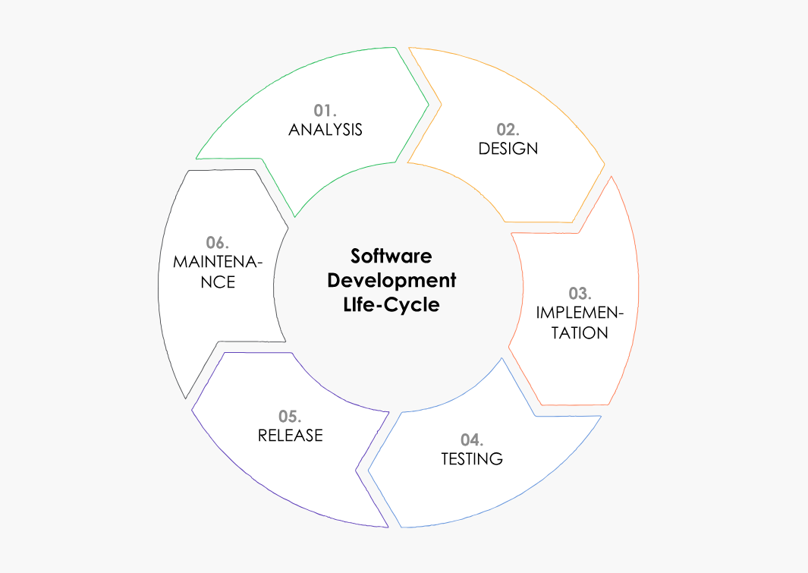

Figure 2: Representation of SDLC phases.

PROJECT PHASES AS PER SDLC

**2.1 Requirement Gathering**

For this project at **LEOS-ISRO**, requirements were gathered through discussions with engineers, other staff. The focus was on understanding the existing hardcopy job order process, identifying essential data fields, defining user access levels, and outlining the workflow for job order creation, approval, and tracking. This helped in designing a system that improves efficiency while maintaining data security and traceability.

**2.2 Planning**

**Define project goals**: To digitize and replicate the existing hardcopy(SWCT) job order process into a secure, user-friendly, and traceable web-based system without altering its original structure.

**Allocate Resources:** Human Resources, tools for conversion, Validation.

Python has been chosen as the ideal programming language due to its ease of use, Object-Oriented nature, and robust support for scalability and future expansions, making it a perfect fit for our project. Complementing this, Django has been selected as the web framework for its elegance, rapid development capabilities, and a rich set of built-in features that not only streamline the development process but also provide a strong foundation for future enhancements and integrations.

**About Python:**

Python stands out as a high-level programming language known for its clarity and adaptability. Its straightforward syntax, coupled with a vast collection of libraries and a supportive community, makes it our preferred choice. As a multifaceted programming language, Python boasts attributes like ease of use, a clear coding structure, and a rich set of libraries. These characteristics render it suitable for diverse domains such as web design, data analytics, artificial intelligence, and task automation. With a robust community backing and its expanding role in next-generation tech solutions, Python's relevance and demand continue to surge across sectors.

**About Django**: Django is a powerful and high-level web framework designed for rapid development and clean, pragmatic design. Its built-in features, such as an integrated admin panel, security mechanisms, and ORM, streamline the development process, making it our preferred choice for web applications. As a versatile and scalable framework, Django simplifies complex web development tasks while maintaining a strong focus on maintainability and reusability. These qualities make it ideal for building robust web applications across various domains, including e-commerce, content management, and social networking. With a strong community, extensive documentation, and continuous improvements, Django’s demand and influence in web development continue to grow across industries.

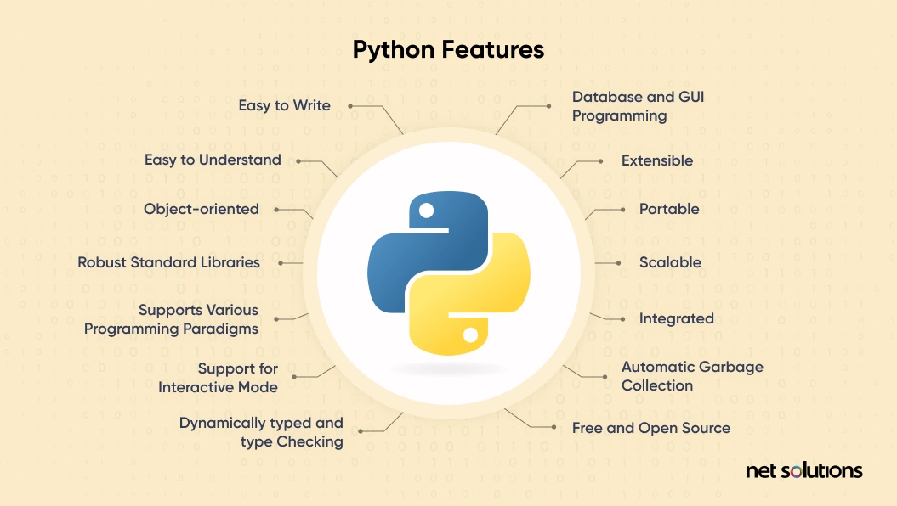

Figure 3: Pythons’ Robust Features

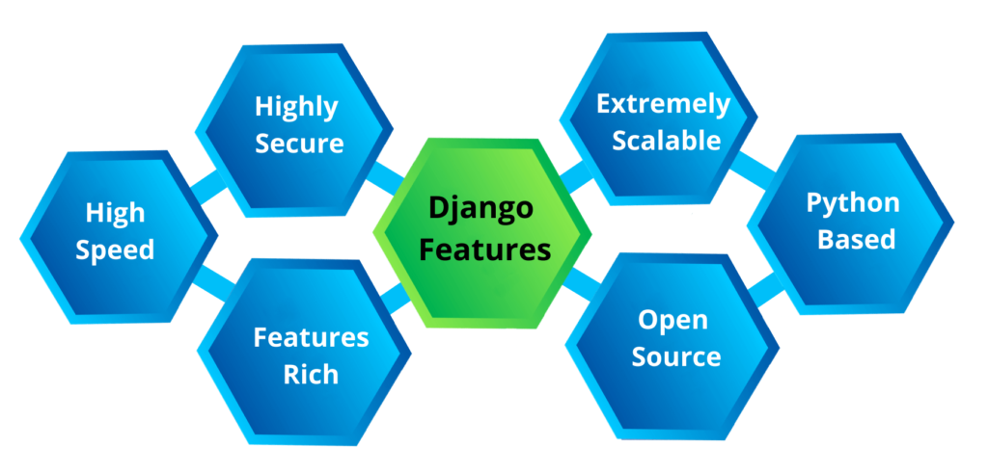 Figure 4: Features of Django

**2.3 Design & Implementation**

In this phase we design and implement the detailed system, architectural blueprint, and user interface. It lays the foundation for subsequent development cycle while ensuring alignment the client requirement and project goals.

In this design and implementation phase, due to scope and time constraints, it has been decided to limit the digitization process to a single activity. Accordingly, this project will focus exclusively on the digitization of the SWCT activity, ensuring a detailed and functional implementation within the available resources.

**2.4 Design & Implementation**

**Phase 1**: Digitization of Hard Copies

In this distinct phase, the conversion of hard copies into web pages was carried out with careful consideration of existing constraints, varying input types, and necessary data validations. Each aspect was thoroughly reviewed upon completion of the conversion to ensure accuracy and consistency. This step served as the foundation for digitizing the previously manual process.

**Phase 2**: Development of Web-Application

During this phase, the web application was developed using Python and the Django framework. The core components, including database models, forms, views were carefully designed and implemented to digitize the SWCT activity. Emphasis was placed on ensuring seamless data handling, accurate input validations, and alignment with the original manual process. Once the application was developed, internal testing was conducted to validate its functionality, performance, and data integrity.

**Phase 3**: Testing Application

In this phase, testing was carried out manually by entering data through the web application and then cross-checking it with the database to ensure accuracy and consistency. The focus was on verifying that the **CRUD (Create, Read, Update, Delete) operations** worked as expected, with data correctly created, retrieved, and updated in the database. This process helped ensure that the application maintained data integrity and accurately replicated the manual process without errors or inconsistencies.

**Phase 1**: Digitization of Hard Copies

Screenshots are attached for reference, illustrating the conversion of hard copies to web pages and templates, providing a clear overview of the digitization process.

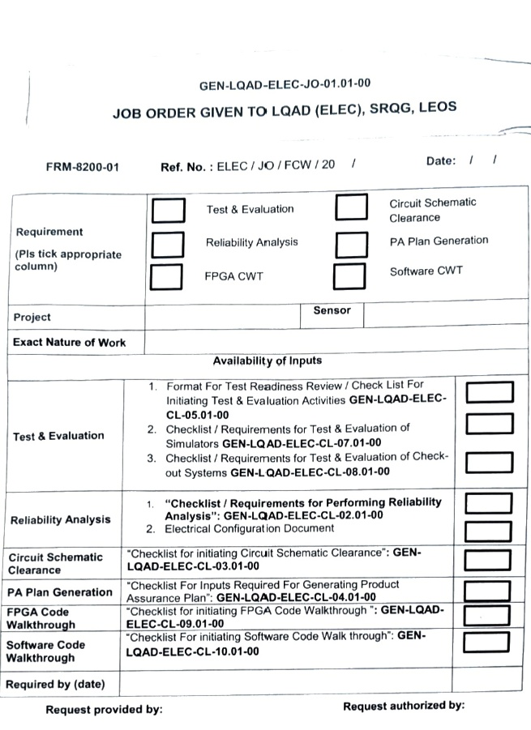 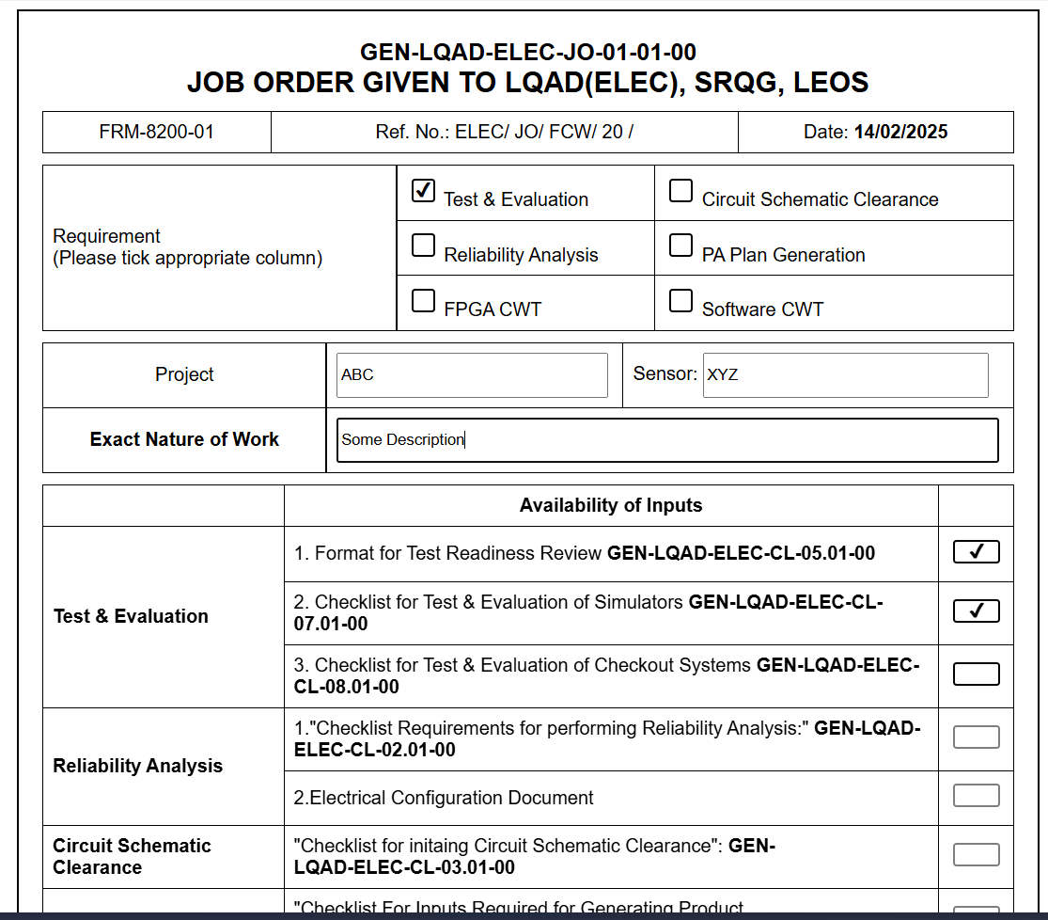

*Figure 5.2: Web Page version of JOB ORER*

*Figure 5.1: Hard Copy of JOB ORDER*

Once all the templates were developed in a similar format, ensuring the retention of the original layout and structure, they were ready for further integration into the web application.

**Phase 2**: Development of Web-Application

The homepage was developed with an interactive user interface (UI), incorporating elements such as Bootstrap navbars, sidebars, and quick links to enhance navigation and user experience. These features allow users to easily access key sections of the application, improving overall accessibility and usability.

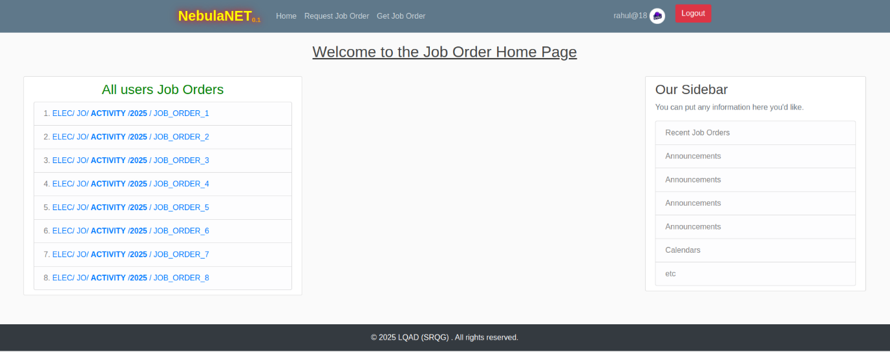

*Figure 6: Home Page of Web Application*

Key Features:

* Quick links to access recent Job orders.
* Navigation bar to access "Request Job Order" and "Get Job Order."
* Sidebar to display Recent Announcements, Events, etc.

The user can request a new Job Order through the navigation bar, which renders a template within the existing layout, retaining the format and structure of the original first-page design.

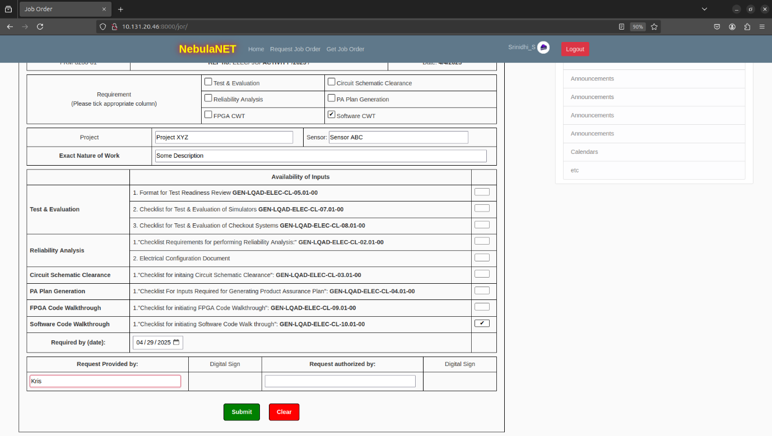

*Figure 7.1: First Page of Job Order*

Sample data was entered into this template to verify the input validations and ensure the form could be successfully submitted without any issues.

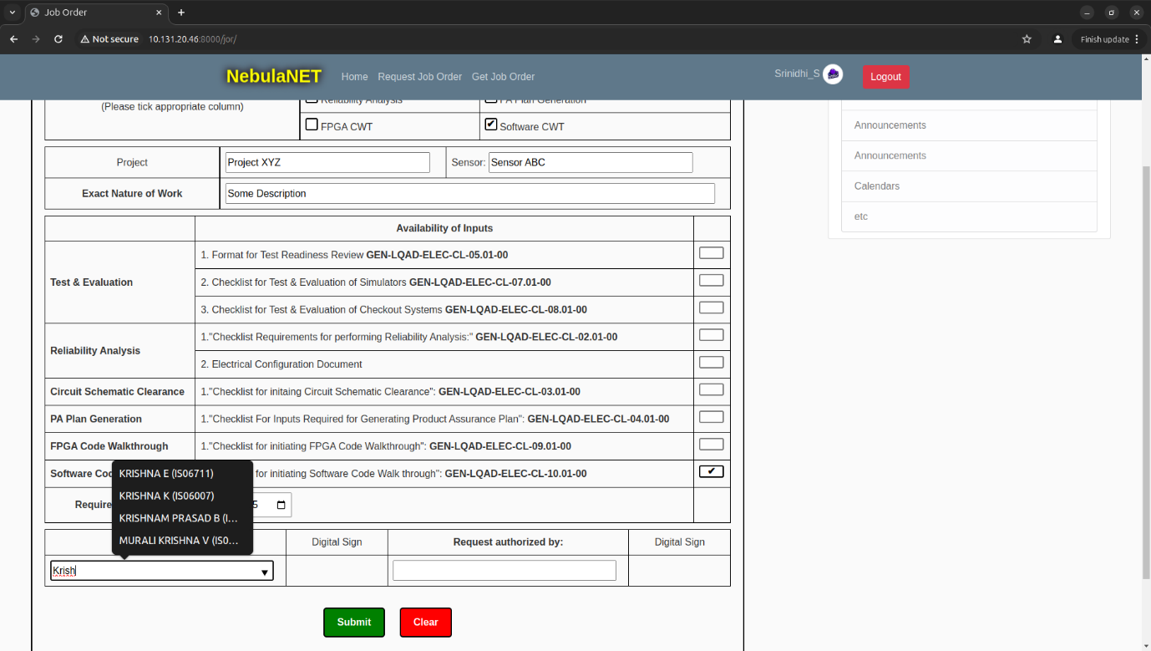

*Figure 7.2: Highlighted Features of the Template*

This image highlights additional features such as dropdown menus for usernames or employee IDs, auto-detected dates, and disabled checkboxes for other activities when one is selected — all designed to enhance the form's functionality and ease of use.

**Validations:**

In case of missing or invalid inputs, alerts are displayed to notify the user and guide them in correcting the entries.

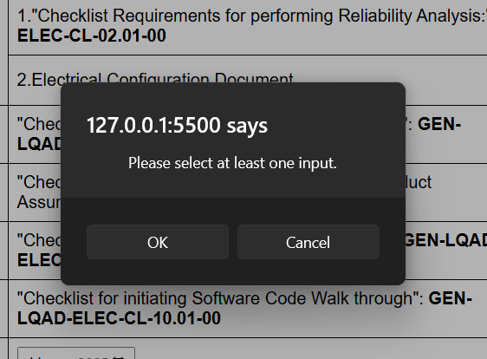 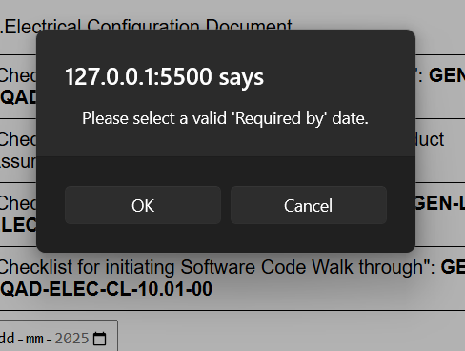 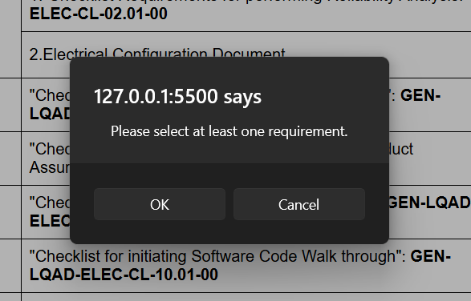

*Figure 8.1: Alert message on not selecting a requirement.*

*Figure 8.1: Alert message on selecting an invalid date.*

*Figure 8.1: Alert message on not selecting an input*

Upon successful submission of the First Page, with all validations satisfied, the user is directed to the second page of the Software Code Walkthrough, which corresponds to be Requirement Page.

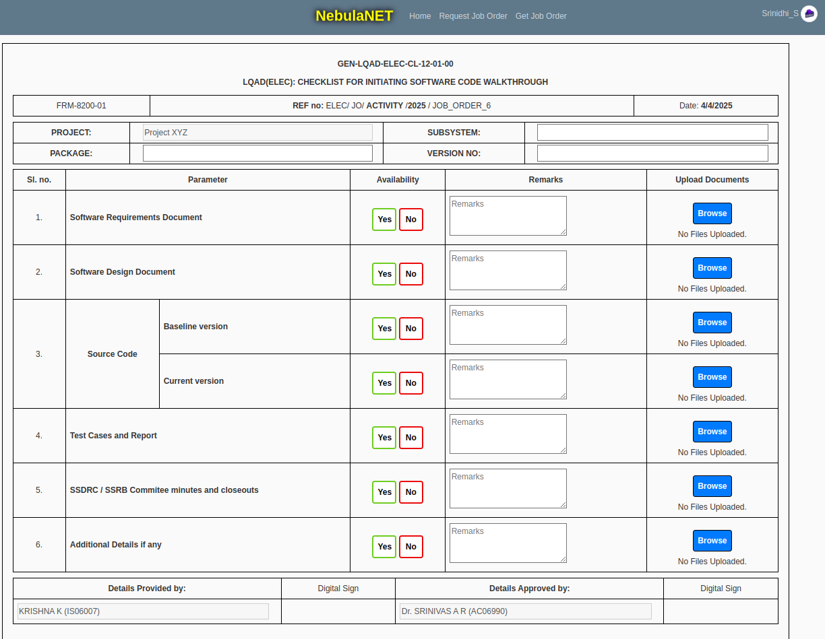

*Figure 9: Second Page of SWCT*

**Key Features:**

* **Job Order Number**: A unique 'JOB ORDER' number is generated and displayed on the second page of SWCT after submitting the First Page.
* **File Upload**: Users can upload multiple files as required.
* **Auto-Populated Data**: Relevant data from the First Page is carried over to the second page, reducing redundancy and improving user efficiency

Similar validations are implemented on this page as well. If the user fails to meet the required inputs, they are not allowed to proceed to the next step until all validations are satisfied.

Due to time constraints, the 'Roles and Responsibilities' section could not be implemented. However, assuming roles are predefined, the responsibility of the person raising the Job Order concludes at this point. The next step, the 'Job Allotment Form,' will be filled out by the respective role person.

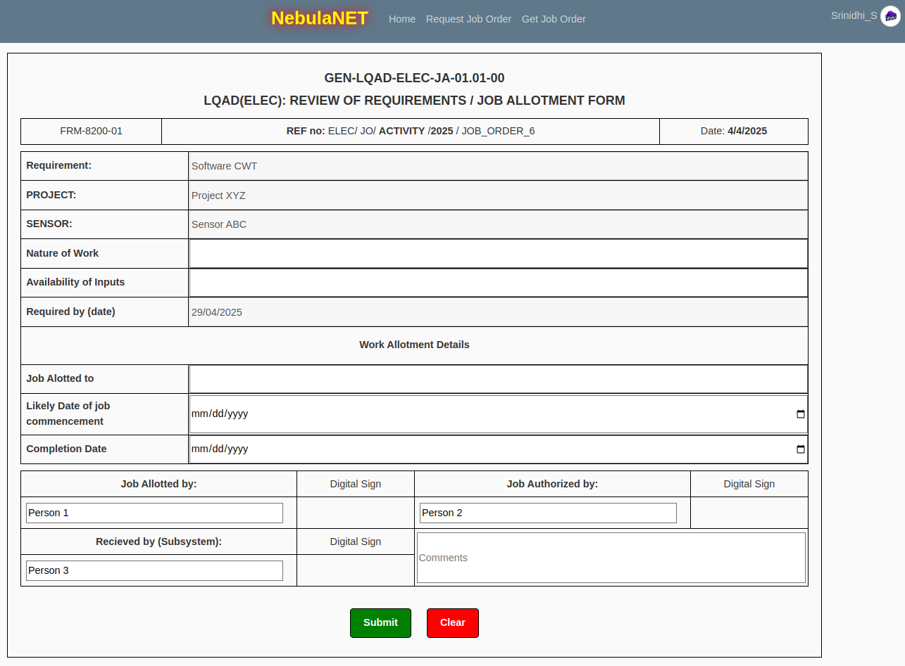

*Figure 10: Review of Requirements /Job Allotment form*

On this page, data from the previous two pages is pulled and displayed, with fields muted to prevent any edits and avoid data manipulation. However, certain fields must be filled out by the user in order to proceed with the application.

Similar validations are implemented on this page as well. If the user fails to meet the required inputs, they are not allowed to proceed to the next step until all validations are satisfied.

Upon successful submission of this page, the Job Review page is generated and displayed to the respective role for further review and action.

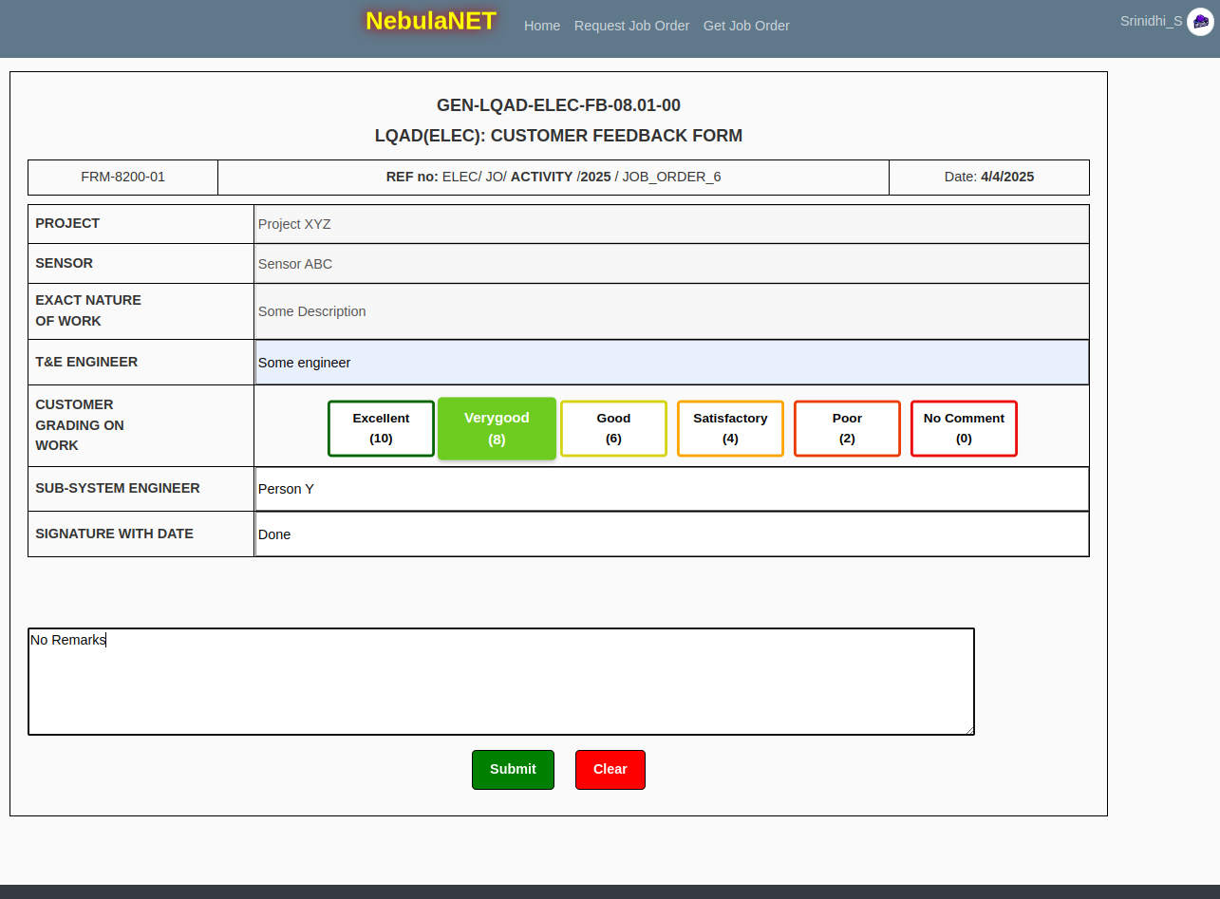

*Figure 11: Customer Feedback Form*

On this page, data from the previous two pages is pulled and displayed, with fields muted to prevent any edits and avoid data manipulation. However, certain fields must be filled out by the user in order complete this action.

To ensure seamless functionality and maintain data integrity, Django was chosen for its robust framework, while SQLite3 was used as the database to provide lightweight and efficient data storage. Django’s model and ORM (Object-Relational Mapping) played a key role in simplifying backend development and managing the database structure, making data handling and relationships more efficient and easier to maintain.

**{{DATABASE CODE}}**

Since this project focused on the SWCT activity, the 'Checklist' pages for other activities could not be implemented due to time constraints. If a user selects any other activity, they are notified about the unavailability of the software for that option. However, the other three pages remain the same and intact across all activities.

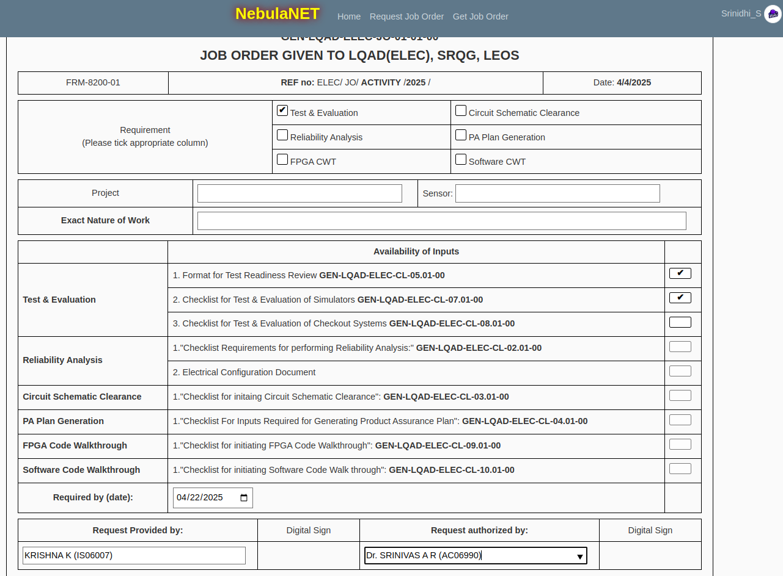

*Figure 12.1: Job Order first Page for other Activities*

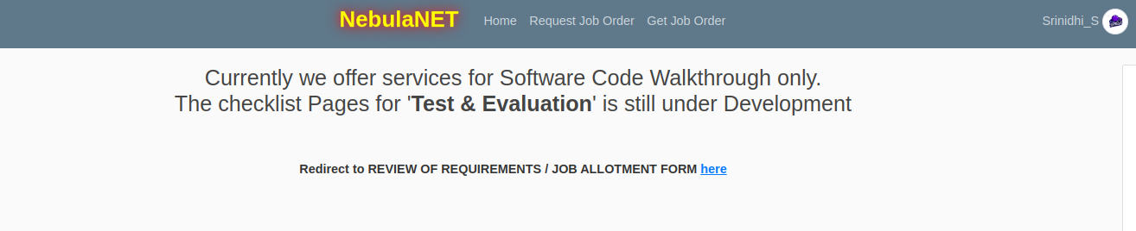

*Figure 12.2: Notification displaying unavailability of Checklist Pages*

Once a Job Order is successfully raised, it can be viewed at any time in the future either through the 'Recent Job Orders' quick link (if listed) or by using the 'Get Job Order' option available in the navigation bar.

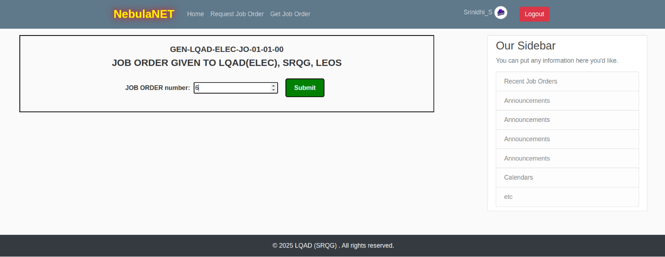

*Figure 13: Get JOB ORDER Page*

In this page the user can Enter the Job order number that was notified while raising a request for a new job order and view the details.

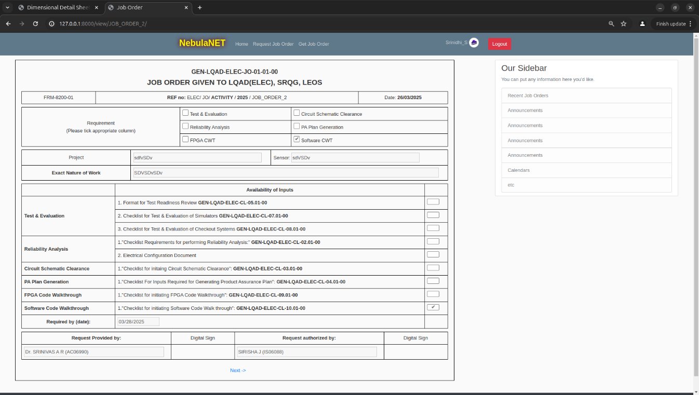

*Figure 14.1: First Page of JOB ORDER 2 in muted format for SWCT activity*

User can Paginate from one page to other using the Next and Previous Page buttons listed right below the page

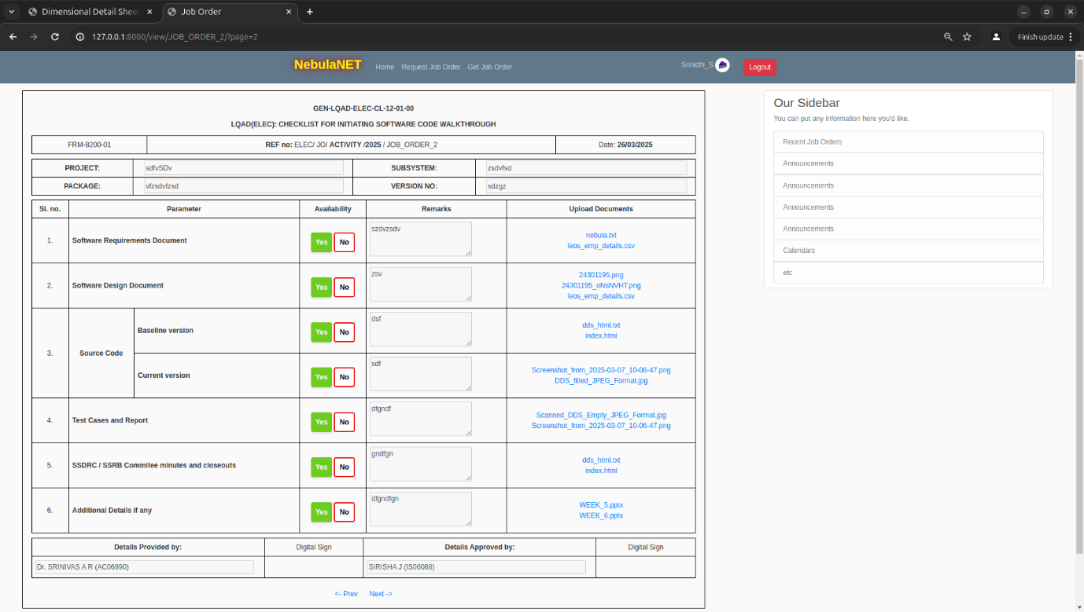

*Figure 14.2: Second Page of JOB ORDER 2 in muted format*

Key Features:

* Muted Data
* Downloadable files
* Job Order Number Display

The user can view Job Orders raised for other activities at any time in the future. While accessing these, the user is again notified about the unavailability of the 'Checklist' pages, whereas the remaining pages are displayed as usual.

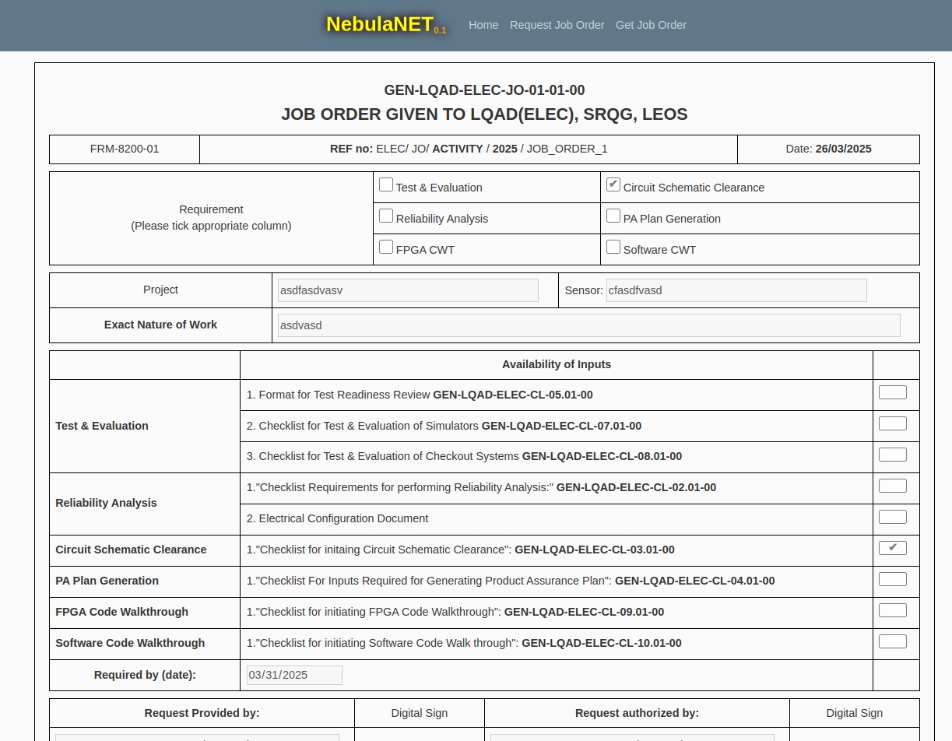*Figure 14.3: First Page of JOB ORDER 1 in muted format for CCS activity*

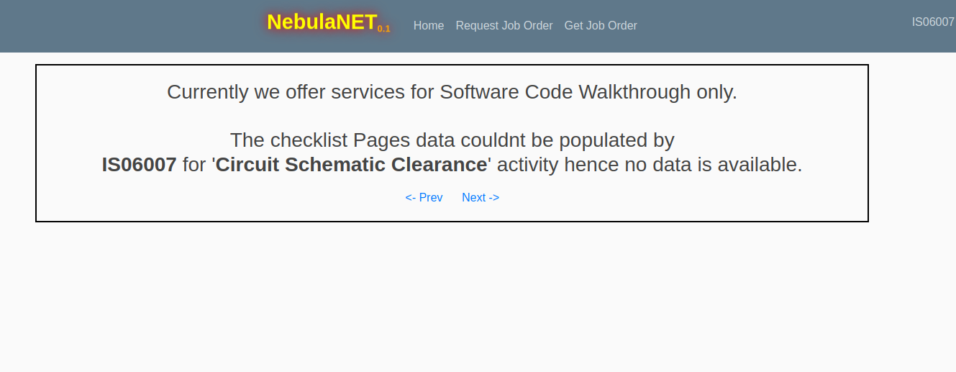

*Figure 14.3: Notification of unavailability of Checklist pages.*

**Login & Signup Functionality**

This functionality enhances the security of the application by ensuring that only users with valid usernames and passwords can access the system.

This functionality was implemented after completing the primary developments, as incorporating it at an earlier stage would have made iterative testing of the application more difficult.

Below are some screenshots that give a good view on Login and Signup Page. 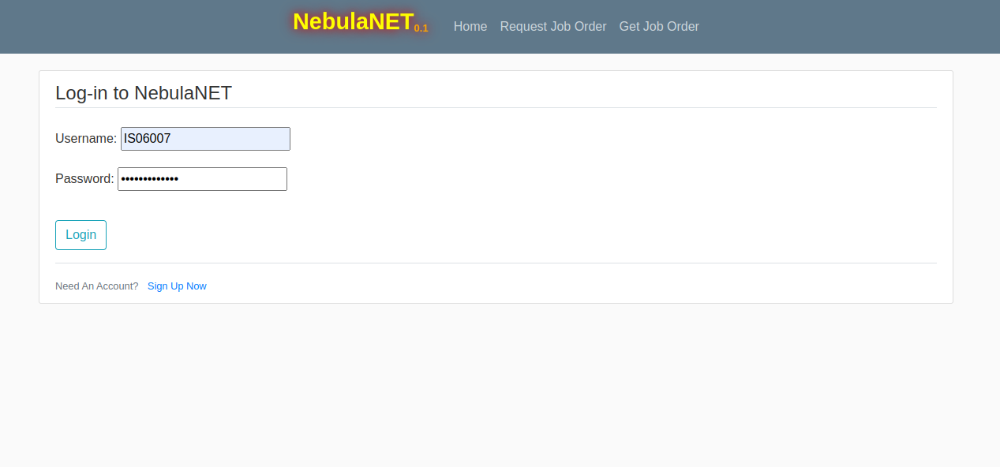

*Figure 15.1: Login Page*

This functionality ensure the user can access the application only after entering their username and password correctly.

Any First time user can simply redirect to Sign-Up page by using the link in the Login Page.

Once redirected the user has to fill all the details to create a account.

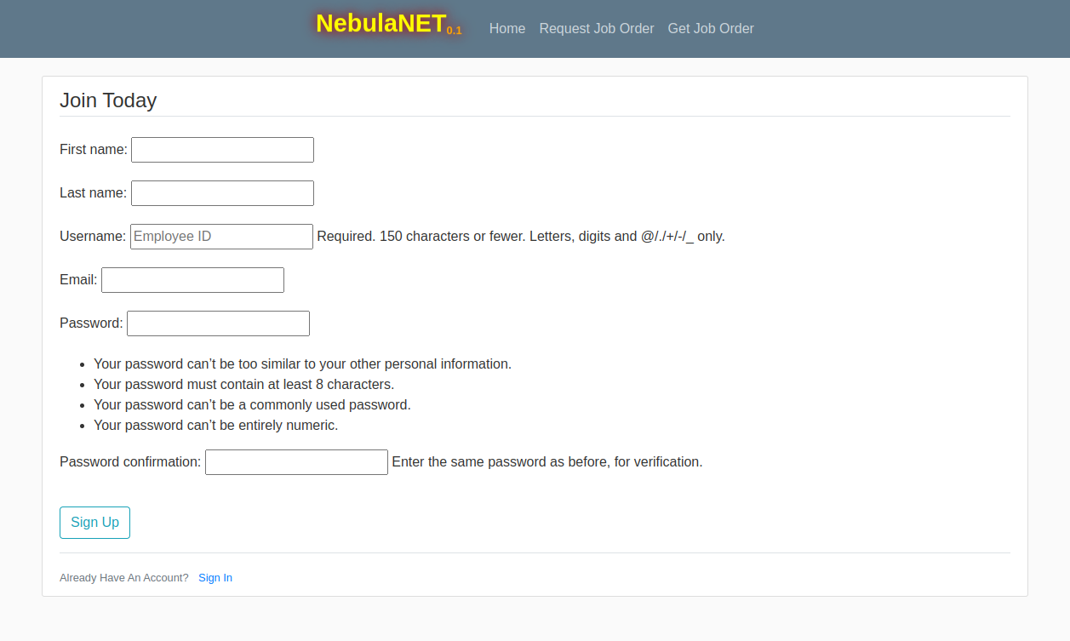

*Figure 15.2: Sign-up Page*

After the successful login the user is redirected to home page where they get access to full application



*Figure 15.3: Home Page*

User can also view their profile and make edits whenever they want

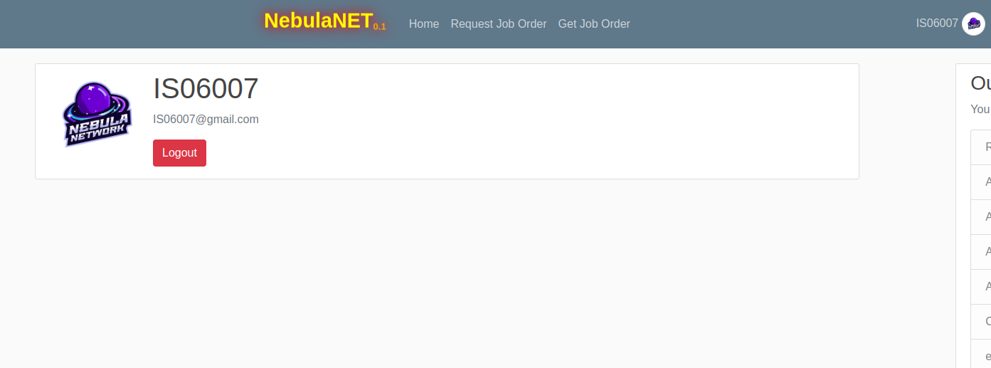

*Figure 15.2: Profile Page*

After completing all necessary actions, the user can log out of the application using the 'Logout' button available in the navigation bar or within the profile section.

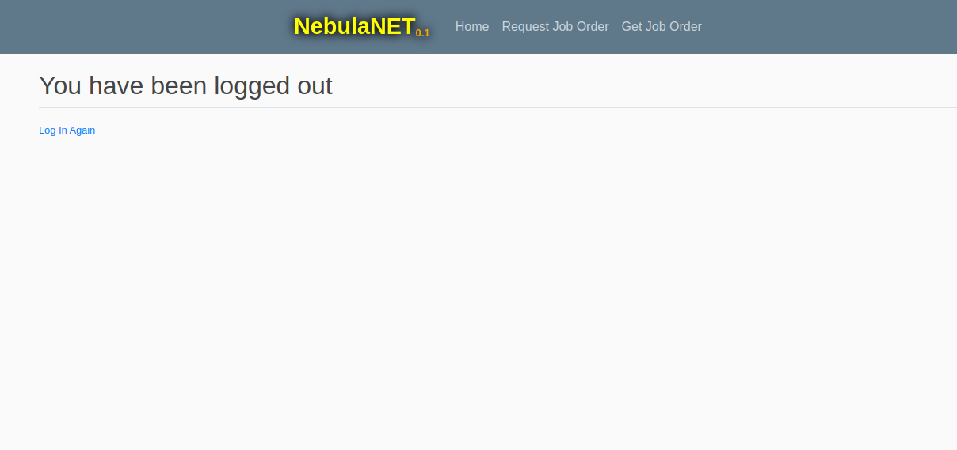

*Figure 15.2: Logged out Page*

The user can use the link to login again or simply by visiting the website URL.

**Admin Functionality:**

The Admin functionality is a key feature in Django, accessible only to users with the admin role in this application. It provides administrative privileges such as adding new users, managing existing user information, and performing other administrative operations.

**{{ADMIN PAGE}}**

Future Scope:

**{{Future Scope}}**