Retail Ordering Website: Designing
1. Project Overview
This project is a web-based application designed to allow users to browse retail products and place orders through a simple interface. Products are organized by brand and category to improve accessibility and browsing experience.
Customers can view available products and place orders, while managers can manage the product inventory by adding, updating, or removing products. All product and order information is stored in a database.
The application demonstrates a full-stack architecture, integrating a frontend interface, backend services, and a relational database to support product management and order processing.

2. Technology Stack
2.1 Backend
Technologies
- Spring Boot
- Java
- Spring Web
- Spring Data JPA
- Lombok
Purpose
- Develop REST APIs
- Implement business logic
- Handle communication with the database

2.2 Database
Technology

- MySQL
Purpose
- Store product information
- Store order details
2.3 Frontend
Technology
- React
Purpose
- Provide a user interface for customers and managers
- Display product information
- Enable order placement and product management
2.4 API Testing
Tool
- Postman
Purpose
- Test and validate backend APIs
2.5 Version Control
Platform
- GitHub
Purpose
- Maintain source code repository
- Enable collaboration during development
3. System Workflow
3.1 Product Management (Manager)
- The manager adds product details such as name, brand, category, and price.
- Product information is stored in the database.
- The products become available for customers to view and order.
3.2 Customer Ordering
- The customer accesses the application.
- The system retrieves product data from the backend.
- Products are displayed on the interface.
- The customer selects a product and places an order.
3.3 Order Processing
- The order request is sent to the backend API.
- The backend processes the request and stores order details in the database.
- The system confirms the order to the user.
- Managers can view all placed orders from the management interface.
4. System Architecture Diagram
The system follows a layered architecture, where each layer handles a specific responsibility in the application.
Architecture Layers
Frontend Layer (React)
- Provides user interfaces for customers and managers.
- Handles user interactions and sends requests to backend APIs.
API Layer (Spring Boot Controllers)
- Processes HTTP requests from the frontend.
- Exposes REST endpoints for product and order operations.
Service Layer
- Implements the business logic of the application.
- Manages product operations and order processing.
Persistence Layer
- Uses Spring Data JPA repositories to access the database.
Database Layer (MySQL)
- Stores product and order information.
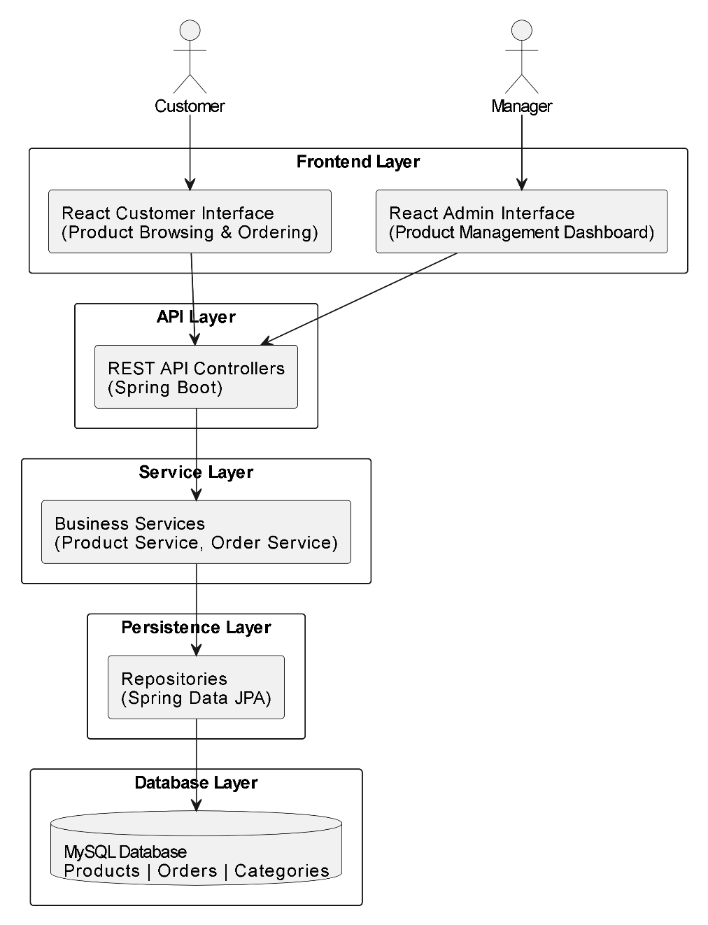

5. Database Design
The application uses a relational database to store information related to users, products, categories, and orders. The structure maintains clear relationships between entities and avoids data duplication.
The system contains the following tables:
- Users
- Categories
- Products
- Orders

5.1 Users Table
The Users table stores details of both customers and managers.
Field Name | Description
user_id (PK) | Unique user identifier
name | Name of the user
email | User email address
address | User delivery address
role | Role of the user (Customer / Manager)
Purpose
- Store user details
- Distinguish between customers and managers

5.2 Categories Table
The Categories table stores product categories.
Field Name | Description
category_id (PK) | Unique category identifier
category_name | Name of the category
Purpose
- Organize products into groups
- Improve product browsing

5.3 Products Table
The Products table stores all product information.
Field Name | Description
product_id (PK) | Unique product identifier
name | Product name
brand | Product brand
price | Product price
category_id (FK) | Reference to category
Purpose
- Store product details
- Link products to categories

5.4 Orders Table
The Orders table stores all customer orders.
Field Name | Description
order_id (PK) | Unique order identifier
user_id (FK) | Customer placing the order
product_id (FK) | Ordered product
quantity | Quantity ordered
total_price | Total order cost
order_date | Order timestamp
Purpose
- Track customer purchases
- Store order information

5.5 Table Relationships
Users → Orders
- One user can place multiple orders.
Users (1) → (Many) Orders

Categories → Products
- One category can contain multiple products.
Categories (1) → (Many) Products

Products → Orders
- A product can appear in multiple orders.
Products (1) → (Many) Orders

This design ensures:
- Clear relationships between entities
- Reduced data redundancy
- Efficient data storage and retrieval

