- select * from Customer;

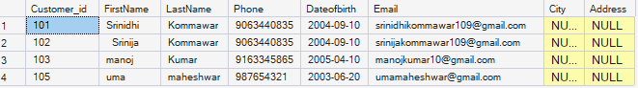
- select Customer_id,policy_id,startdate,enddate from PolicyAssignment;

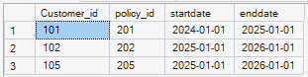

- select policy_id,PolicyName,PolicyType from Policies where PolicyName = 'Health';
- select policy_id,PolicyName,PolicyType from Policies where PolicyName = 'Health';
- select distinct(city) from Agents;
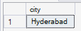
- select PolicyName from Policies where PolicyType = 'Life Insurance' or PolicyName = 'Health' or PolicyName = 'Motor'

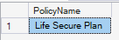
- select PolicyName from Policies where PolicyType in('Life Insurance' , 'Health', 'Motor')



- select FirstName , LastName from Customer where Dateofbirth > '2001-01-01' and Dateofbirth < '2020-12-31';

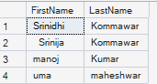
- select FirstName , LastName from Customer where Dateofbirth between '2001-01-01'and '2020-12-31'
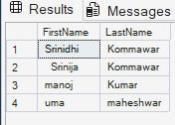
- select * from Claims where claimstatus = 'Pending' or claimstatus = 'Rejected';
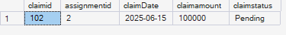
- select agentname from Agents where city like '_y%';
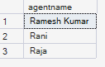
- select max(claimamount) as max_claim_amount , min(claimamount) as min_claim_amount from Claims;
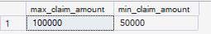
- select * from Claims order by claimDate desc;
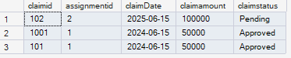
- select PreAmount + (PreAmount /100)*10 as premium_amount from Policies where PolicyType like '%Life%';
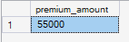
- delete from PolicyAssignment where EndDate < CAST(GETDATE() AS DATE);
- select count(*) from Claims where claimstatus in ('rejected','pending');
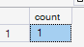
- select Policy_id,PolicyName, PreAmount,PreAmount * 0.06 AS LocalTaxes,PreAmount + (PreAmount * 0.06) AS PremiumAmountWithTax,(PreAmount +(PreAmount * 0.06)) / 12 AS MonthlyPremiumAmount FROM Policies;

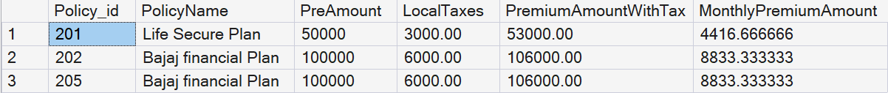
- Alter table Customer add City varchar(50) , Address varchar(50);
- Alter table Agents add DevOfId varchar(50)

21. select c.FirstName , c.LastName , p.PolicyName from Customer c join PolicyAssignment pa on pa.Customer_id = c.Customer_id join Policies p
on pa.policy_id = p.policy_id where c.Customer_id = 105;



22. select c.FirstName , c.LastName , p.PolicyName from Customer c
join PolicyAssignment pa on pa.Customer_id = c.Customer_id
join Policies p on pa.policy_id = p.policy_id ;

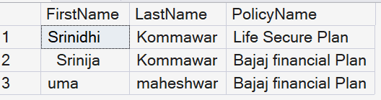

23. select cu.FirstName,cu.LastName , C.claimid,C.claimDate,C.claimamount,C.claimstatus from Customer cu
left join PolicyAssignment pa on pa.Customer_id = cu.Customer_id
left join Claims C on pa.AssId = C.assignmentid;

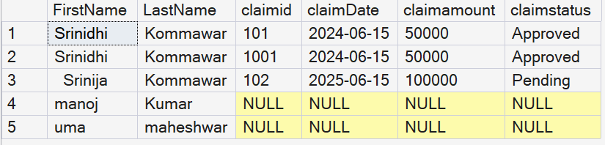

24. select c.FirstName,c.LastName,p.PolicyName,a.agentname,pa.startdate,pa.enddate
from Customer c join PolicyAssignment pa on pa.Customer_id = c.Customer_id
join Policies p on pa.policy_id = p.policy_id
join Agents a on pa.agentid = a.agentid;

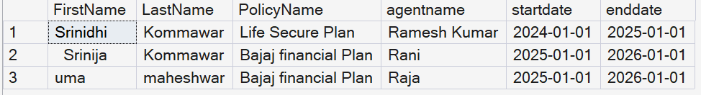

25. select c.FirstName , p.PolicyName , cl.claimAmount , cl.claimstatus , cl.claimDate
from Customer c join policyAssignment pa on pa.Customer_id = c.Customer_id
join Policies p on pa.policy_id = p.policy_id
join Claims cl on pa.AssId = cl.assignmentid;

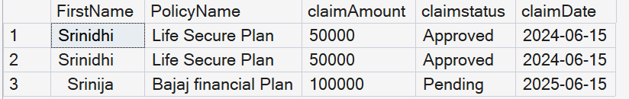

26. select cu.FirstName,cu.LastName,P.PolicyName, P.PolicyType from Customer cu
left join PolicyAssignment pa on pa.Customer_id = cu.Customer_id
left join Policies P on P.policy_id= pa.policy_id;

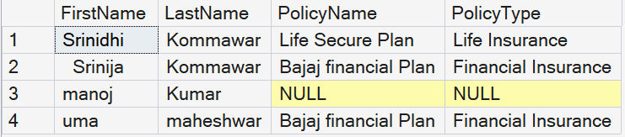

27. select distinct c.Customer_id,c.FirstName,c.LastName from Customer c
left join PolicyAssignment pa on pa.Customer_id = c.Customer_id
left join Claims cl on pa.AssId = cl.assignmentid
where cl.claimId is null;

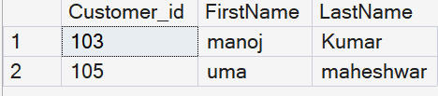

28. select c.Customer_id,c.FirstName,c.LastName,Sum(cl.ClaimAmount) as TotalClaimAmount from Customer c
left join PolicyAssignment pa on pa.Customer_id = c.Customer_id
left join Claims cl on pa.AssId = cl.assignmentid
group by c.Customer_id,c.FirstName,c.LastName;

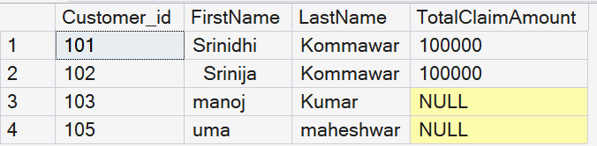

29. select c.Customer_id,c.FirstName,c.LastName,Sum(cl.ClaimAmount) as TotalClaimAmount from Customer c
left join PolicyAssignment pa on pa.Customer_id = c.Customer_id
left join Claims cl on pa.AssId = cl.assignmentid
group by c.Customer_id,c.FirstName,c.LastName having sum(cl.ClaimAmount) > 50000;

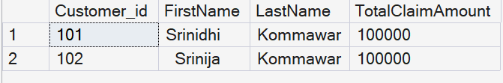

30. select a.agentid,a.agentname,count(pa.policy_id) as Policy_Cont
from Agents a left join PolicyAssignment pa on pa.agentid = a.agentid
group by a.agentid , a.agentname;

