DevOps Project

Name: Srinidhi P Rao

Email-Id: [srinidhi.prao2022@vitstudent.ac.in](mailto:srinidhi.prao2022@vitstudent.ac.in)

Question: Create a complete DevOps CI/CD Pipeline with Jenkins for a Use Case (different from the Calculator application) by using GIT, Maven, Puppet/Ansible/Terraform, Docker, JUnit, Graphite, and Grafana. You can add more tools if you want.

DevOps Tools Used:

* Git
* Jenkins
* Pip (package manager)
* Venv (Virtual Environment)
* Docker (Containerisation)
* Graphite
* Prometheus (Metrics)
* Loki (Logs)
* Pytest (Testing Framework)
* Ansible
* Terraform

Tech Stack:

* FastAPI (Backend)

Initialising a git repository

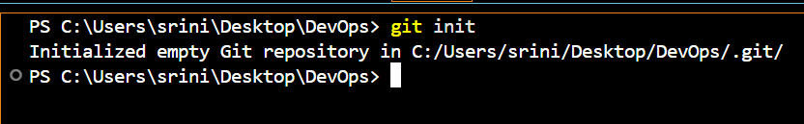

Creating a Virtual Environment

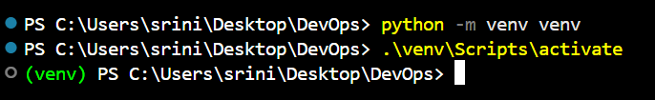

Setting up Loki, Prometheus, Grafana for the FastAPI App using Docker and Docker Compose

Dockerfile

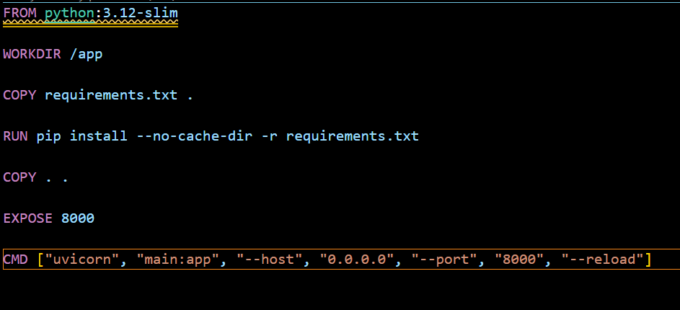

docker-compose.monitoring.yml