Objective
The objective of this task is to containerize a full-stack Home Services application using Docker. The backend service is built using Node.js and the frontend service is served using Nginx. Docker Compose is used to manage both services, and the resulting images are published to Docker Hub.

Project Architecture
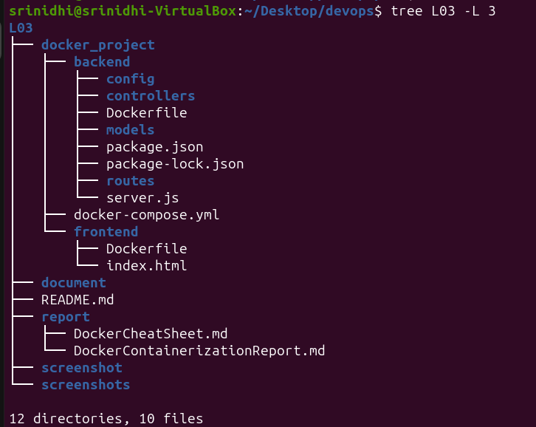
The application consists of two services:
1. Backend Service developed using Node.js.
2. Frontend Service served using Nginx.

Docker Compose is used to manage both services together.

Backend Containerization

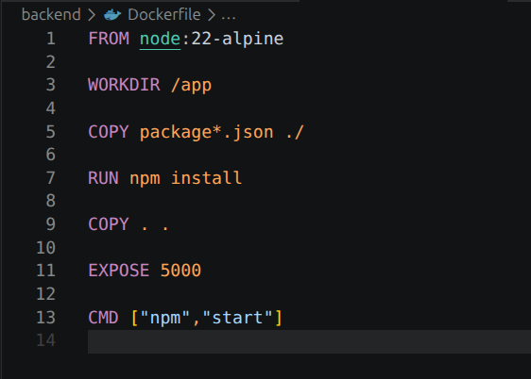

The backend Dockerfile uses Node 22 Alpine as the base image.
Dependencies are installed using npm install.
Application files are copied into the container.
Port 5000 is exposed and the application starts using npm start

Frontend Containerization
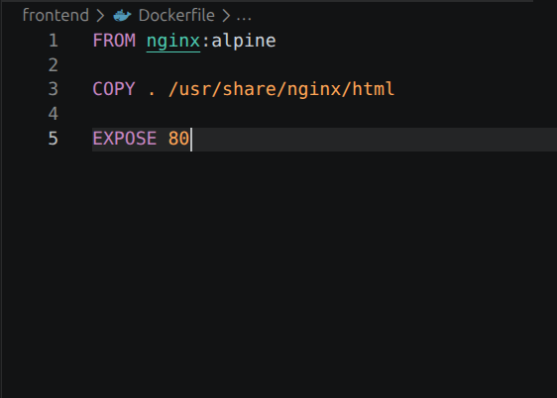
The frontend Dockerfile uses Nginx Alpine as the base image.
Static files are copied into the Nginx web directory.
Port 80 is exposed to serve the frontend application.

Docker Compose Configuration
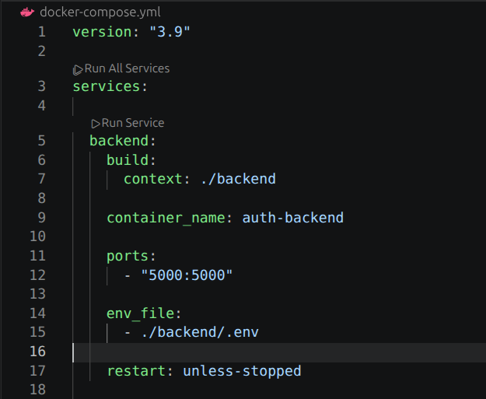
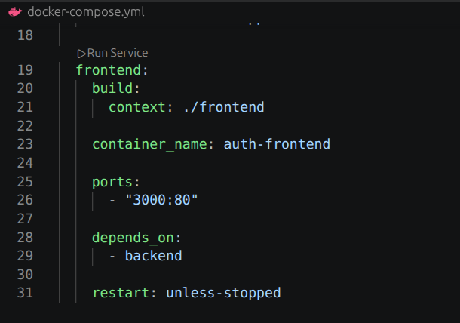
Docker Compose was used to define and run multi-container applications.

Backend Service:
- Builds image from backend directory.
- Maps port 5000.
- Loads environment variables.
- Automatically restarts if stopped.

Frontend Service:
- Builds image from frontend directory.
- Maps port 3000 to container port 80.
- Depends on backend service.

Building Docker Images
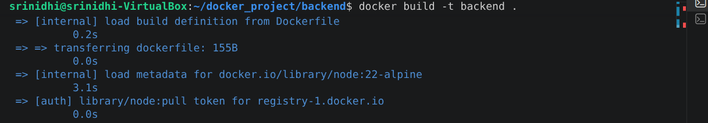

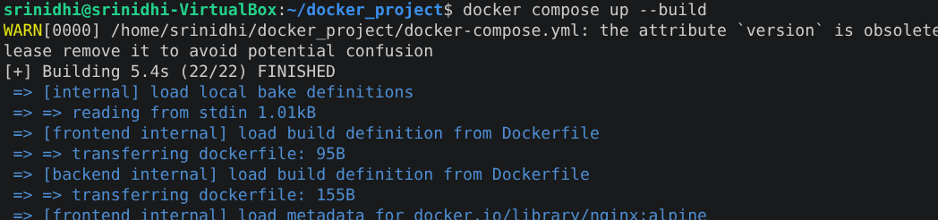

Docker images were successfully built using Dockerfiles.
The build process installed dependencies and created runnable container images.

Running Containers
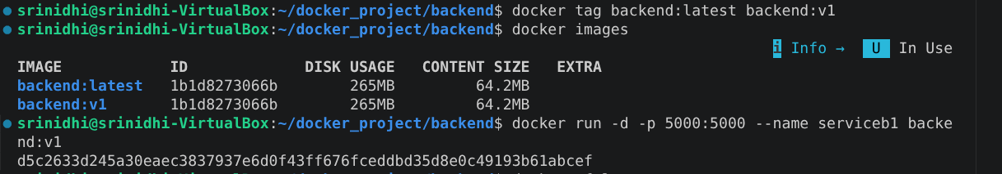
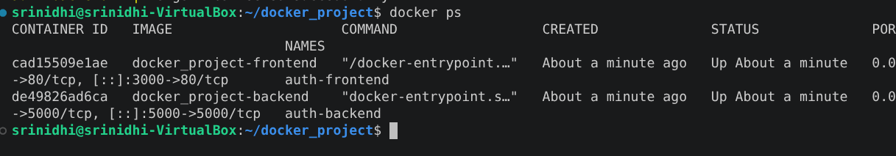
Containers were started successfully using Docker Compose.
Both frontend and backend services were running simultaneously.

Application Verification

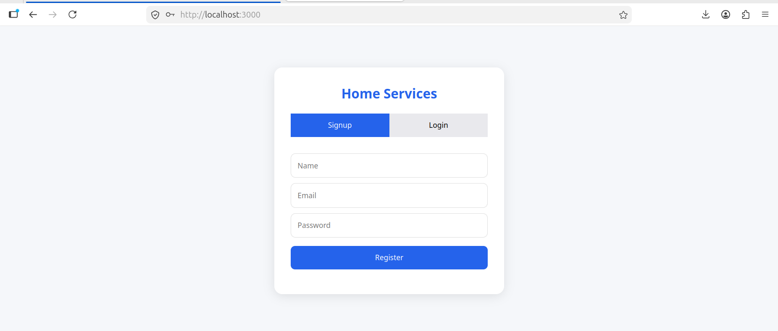

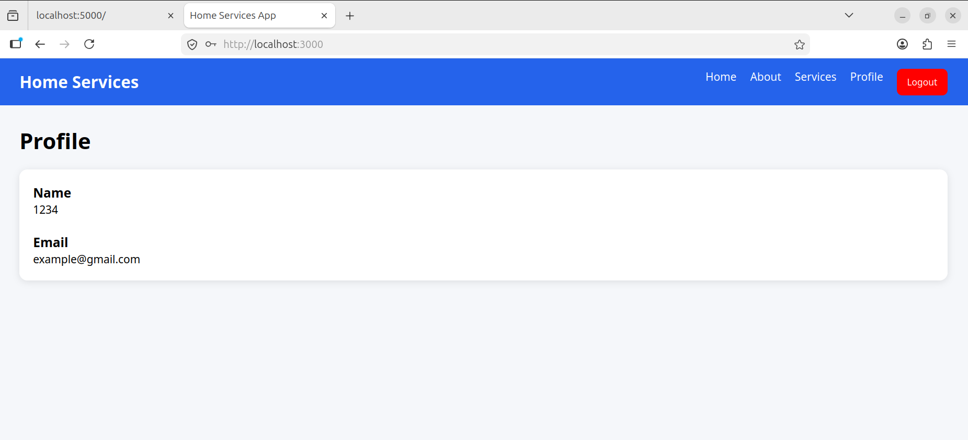

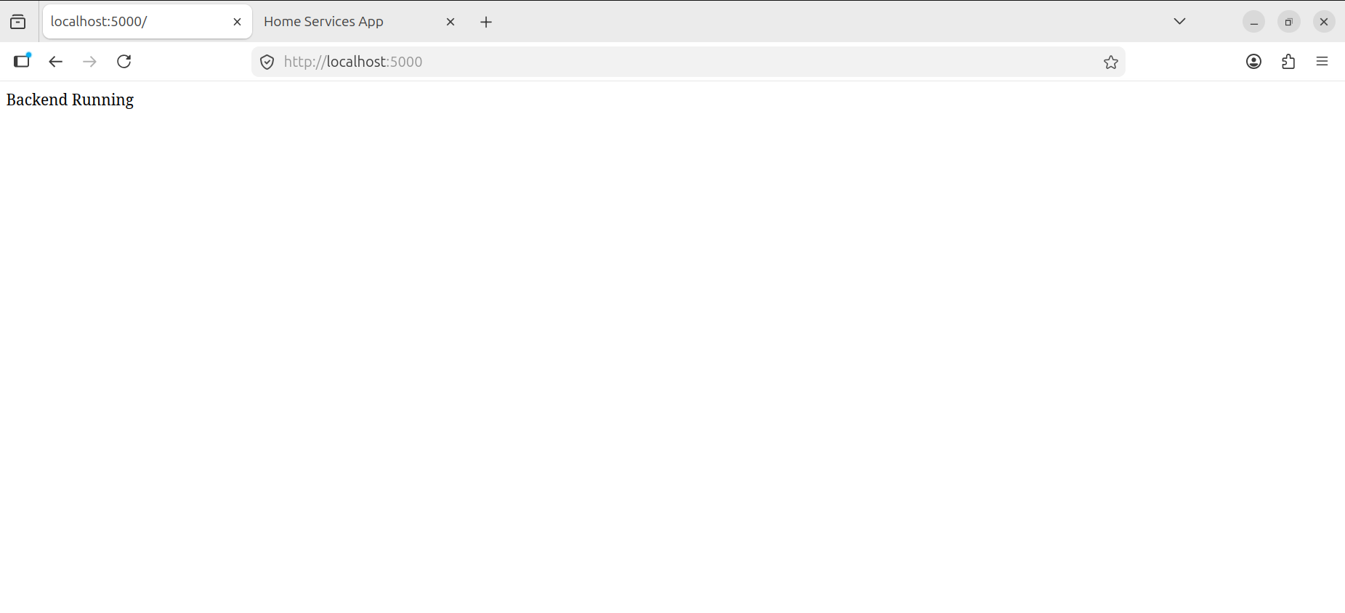
The frontend application was accessible on localhost:3000.
The backend application was accessible on localhost:5000.
This verified successful container deployment.

Docker Logs Monitoring
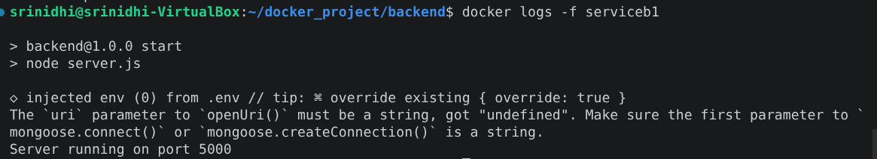
Docker logs were used to monitor container execution and validate successful application startup.

Docker Hub Integration
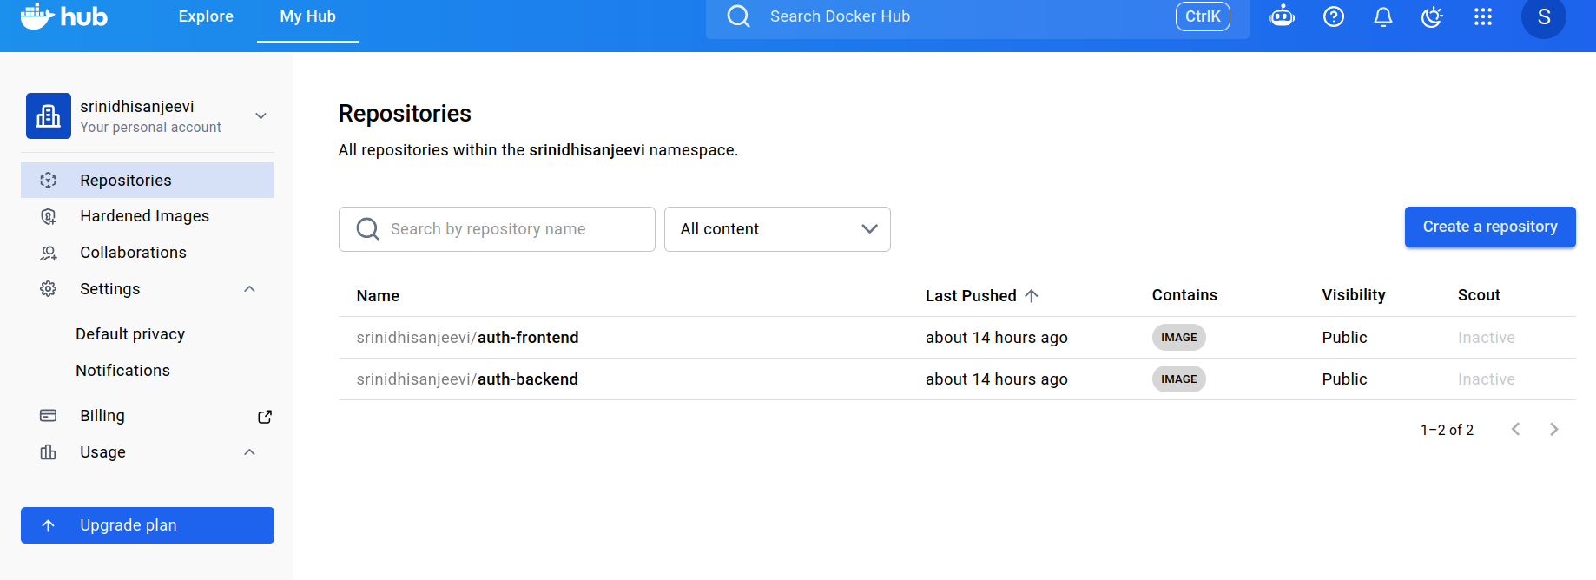
Images were tagged and pushed to Docker Hub.

Repositories:
- auth-backend
- auth-frontend

This allows images to be shared and deployed across environments.

Commands Practiced

docker build
docker images
docker run
docker ps
docker logs
docker stop
docker rm
docker compose build
docker compose up
docker compose up -d
docker compose down
docker login
docker tag
docker push
docker pull
docker system df
docker system prune -a

