CICD Using Jenkins

Commands to install Jenkins

Update Packages

sudo apt update

Install Java

sudo apt install openjdk-21-jdk

Add Jenkins Repository Key

curl -fsSL https://pkg.jenkins.io/debian-stable/jenkins.io-2023.key | sudo tee \

/usr/share/keyrings/jenkins-keyring.asc > /dev/null

Add Jenkins Repository

echo deb [signed-by=/usr/share/keyrings/jenkins-keyring.asc] \

https://pkg.jenkins.io/debian-stable binary/ | sudo tee \

/etc/apt/sources.list.d/jenkins.list > /dev/null

Install Jenkins

sudo apt update

sudo apt install jenkins -y

Start Jenkins

sudo systemctl start jenkins

Enable Jenkins on Boot

sudo systemctl enable jenkins

Check Jenkins Status

sudo systemctl status jenkins

Active: active (running)

9. Access Jenkins

http://localhost:8080

Or

http://<ip>:8080

Get Initial Admin Password

sudo cat /var/lib/jenkins/secrets/initialAdminPassword

Jenkins Commands

Check status:

sudo systemctl status jenkins

Start:

sudo systemctl start jenkins

Stop:

sudo systemctl stop jenkins

Restart:

sudo systemctl restart jenkins

View logs:

sudo journalctl -u jenkins -f

Check version:

jenkins --version

Environment Validation

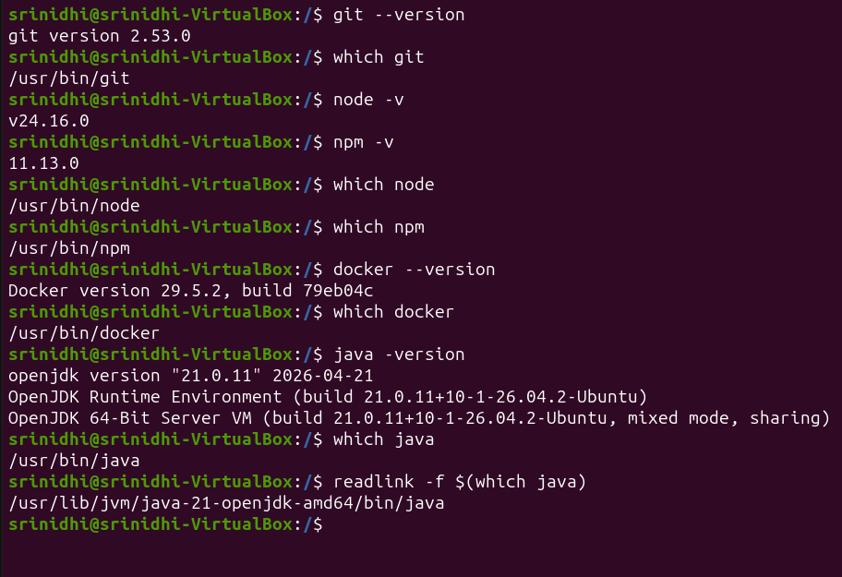
Tool Validation and Environment Verification

Verified installation paths and versions of Git, Node.js, NPM, Docker, and Java required for successful CI/CD pipeline execution.

Verified the installation and paths of all required tools before pipeline execution.

Tools Validated:

• Git 2.53.0

• Node.js 24.16.0

• NPM 11.3.0

• Docker 29.5.2

• Java OpenJDK 21

This validation ensures the Jenkins agent environment is properly configured for CI/CD execution.

Git Repository Configuration

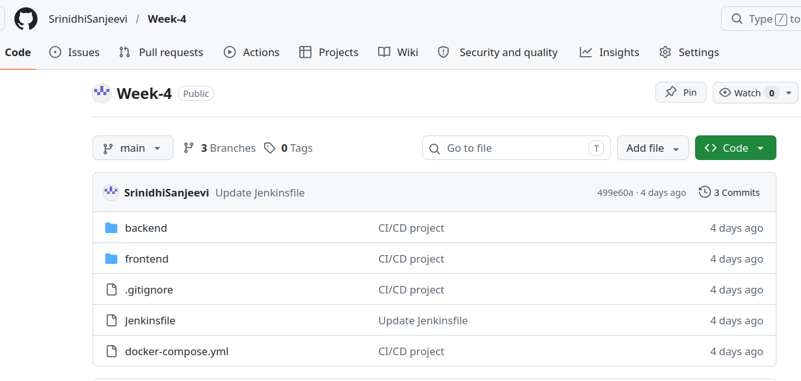

Git Repository Configuration in Jenkins :

Configured Jenkins Pipeline to fetch source code from the GitHub repository.
The pipeline uses Pipeline Script from SCM and automatically retrieves the Jenkinsfile from the repository
Jenkins Pipeline Configuration
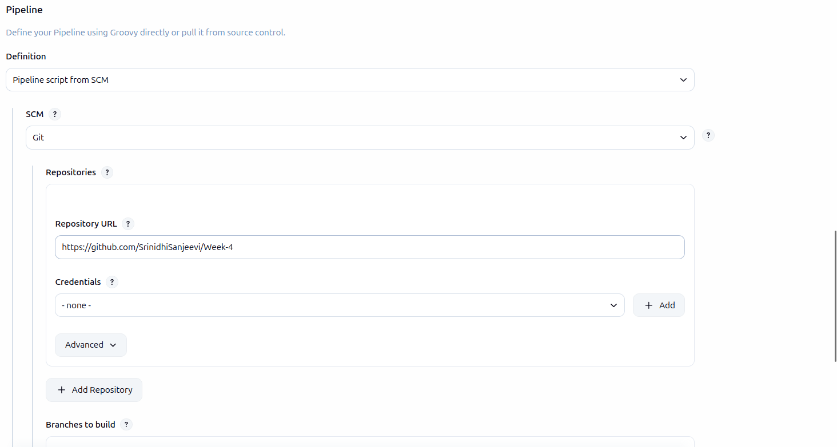
Pipeline SCM Configuration :

Configured Jenkins Pipeline to pull source code from GitHub using Git SCM integration.
The repository URL and branch configuration were defined within the pipeline job.

Jenkinsfile

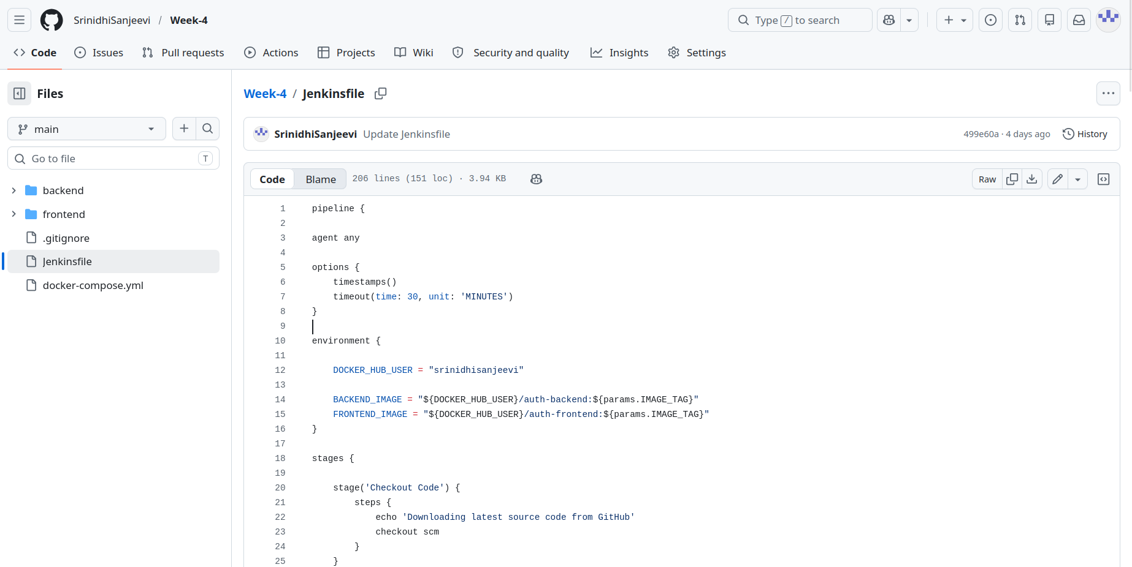

Implemented Declarative Jenkins Pipeline with environment variables, parameterized builds, parallel execution, Docker authentication, image push, and post-build actions.
Pipeline Script Path
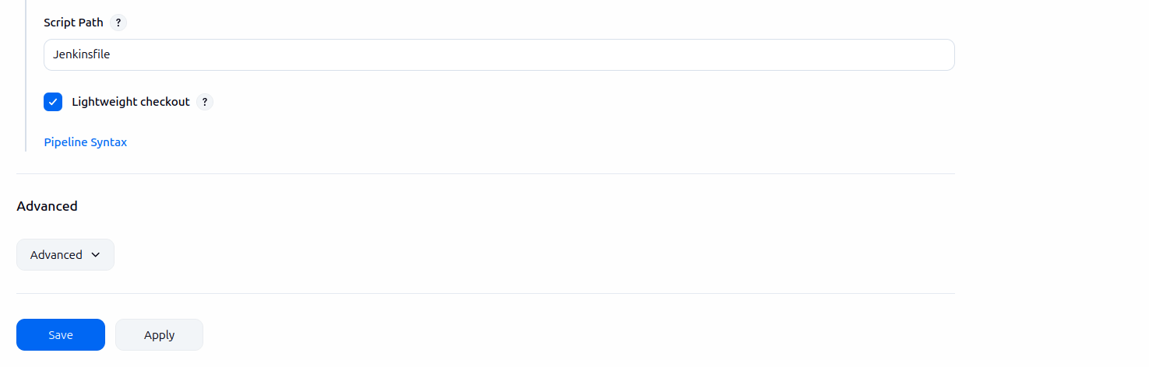

Pipeline Script Path Configuration :

Configured Jenkins to execute the Jenkinsfile stored in the root directory of the repository.
Lightweight checkout is enabled for faster retrieval of the Jenkinsfile.

Docker Hub Credentials

Go 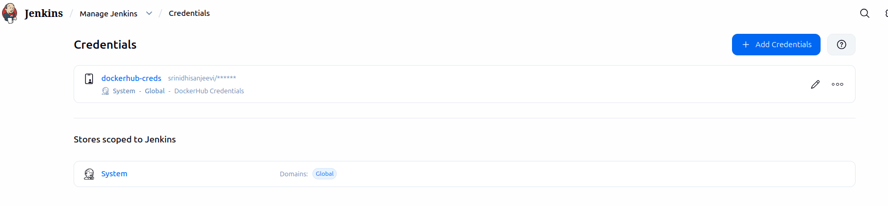Manage Jenkins
→ Credentials

Stored Docker Hub credentials securely using Jenkins Credentials Manager and accessed them through withCredentials().

Parameterized Build
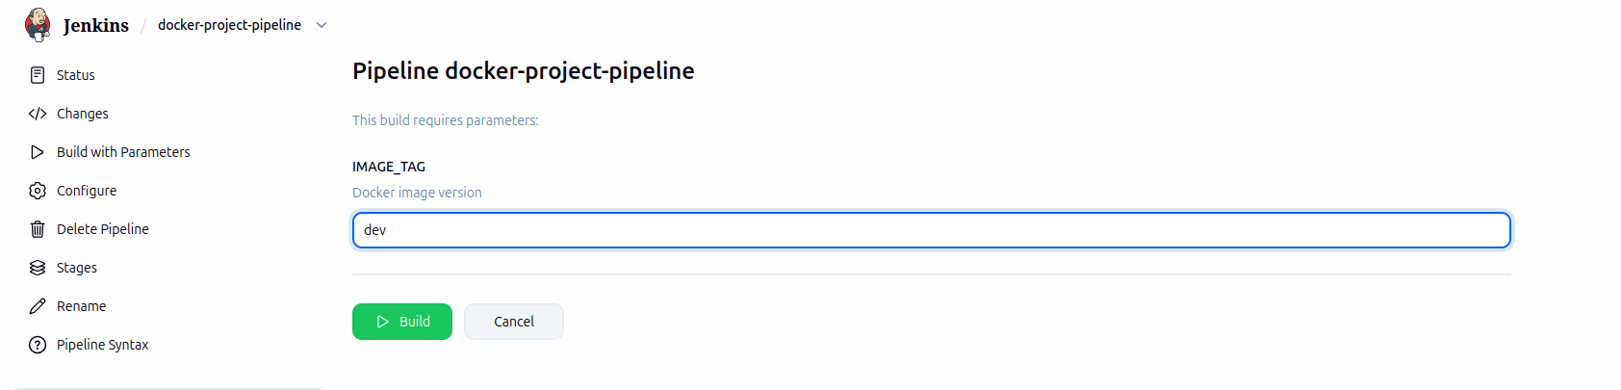

Parameterized Build Execution :

Implemented parameterized builds using IMAGE_TAG parameter.
Users can provide different Docker image tags such as dev, v1, v2, or prod during runtime without modifying the Jenkinsfile.

Pipeline Success
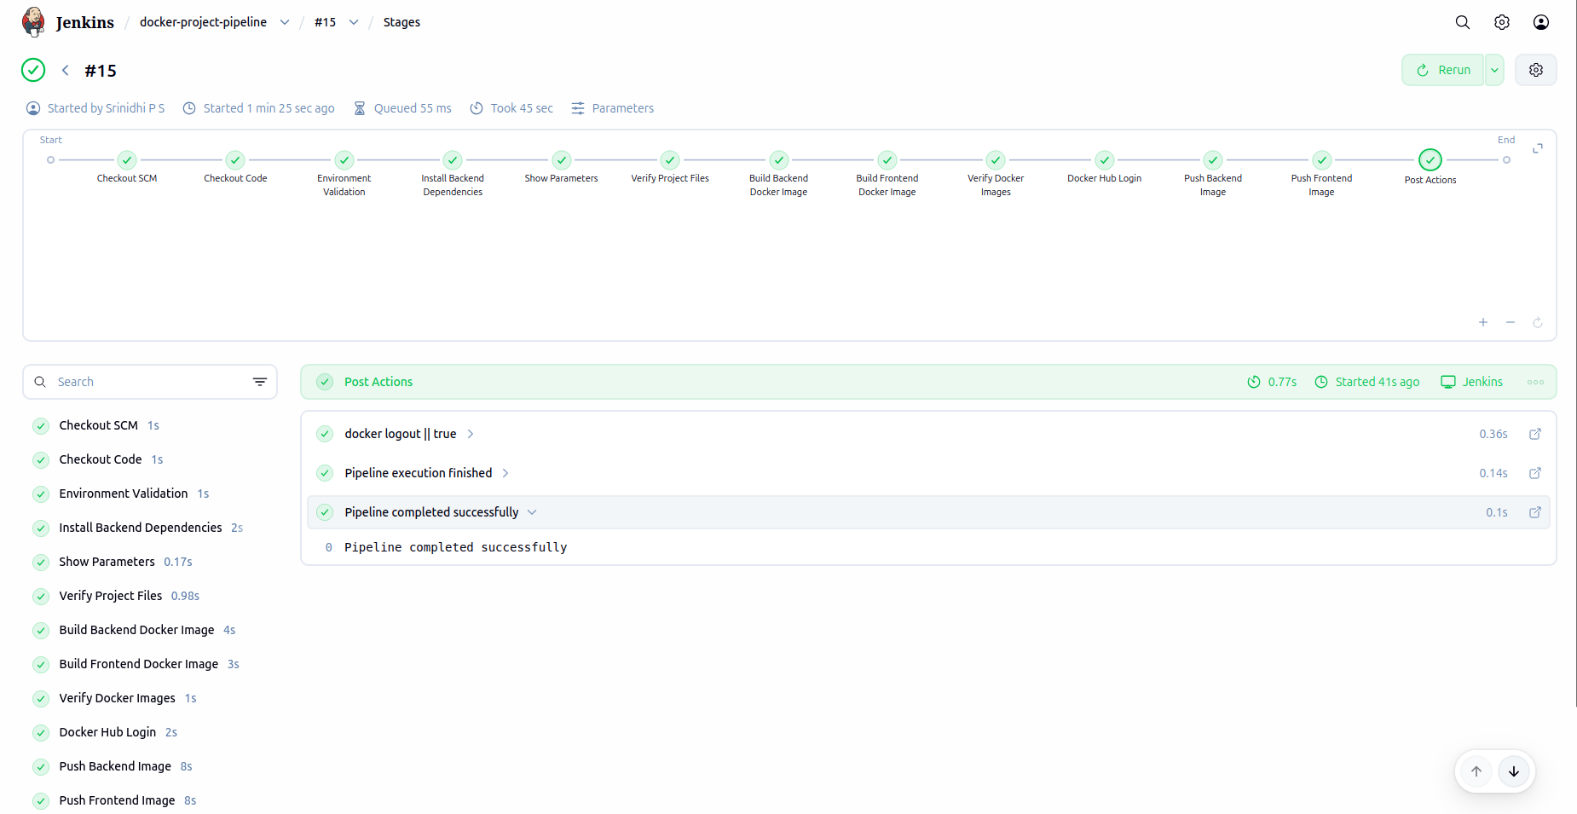

Successful CI/CD Pipeline Execution :

Pipeline completed successfully after code checkout, validation, Docker image build, Docker Hub authentication, and image push operations.

Console Output
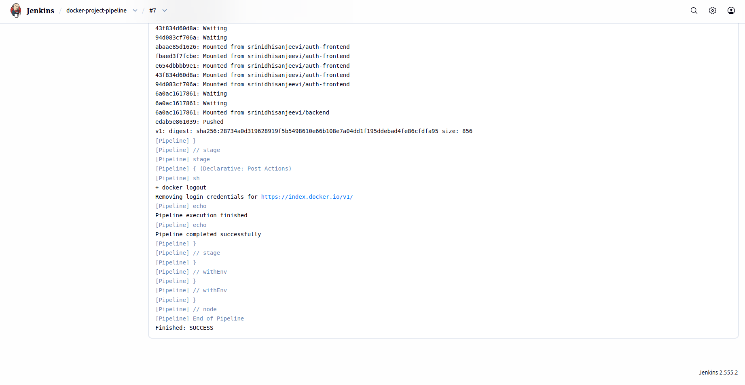
Pipeline Console Output :

Console logs showing Docker image push operations, authentication, image upload to Docker Hub, and successful pipeline completion.

Pipeline Stage View
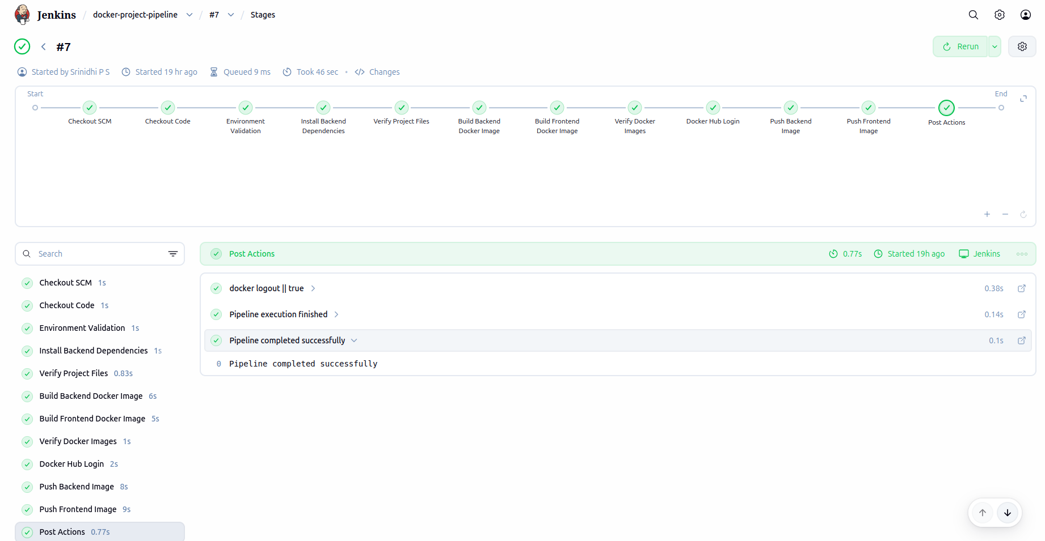

Jenkins Pipeline Stage View :

Visual representation of all pipeline stages executed sequentially, including source code checkout, dependency installation, Docker image creation, authentication, image push, and post-build actions.

Pipeline Steps
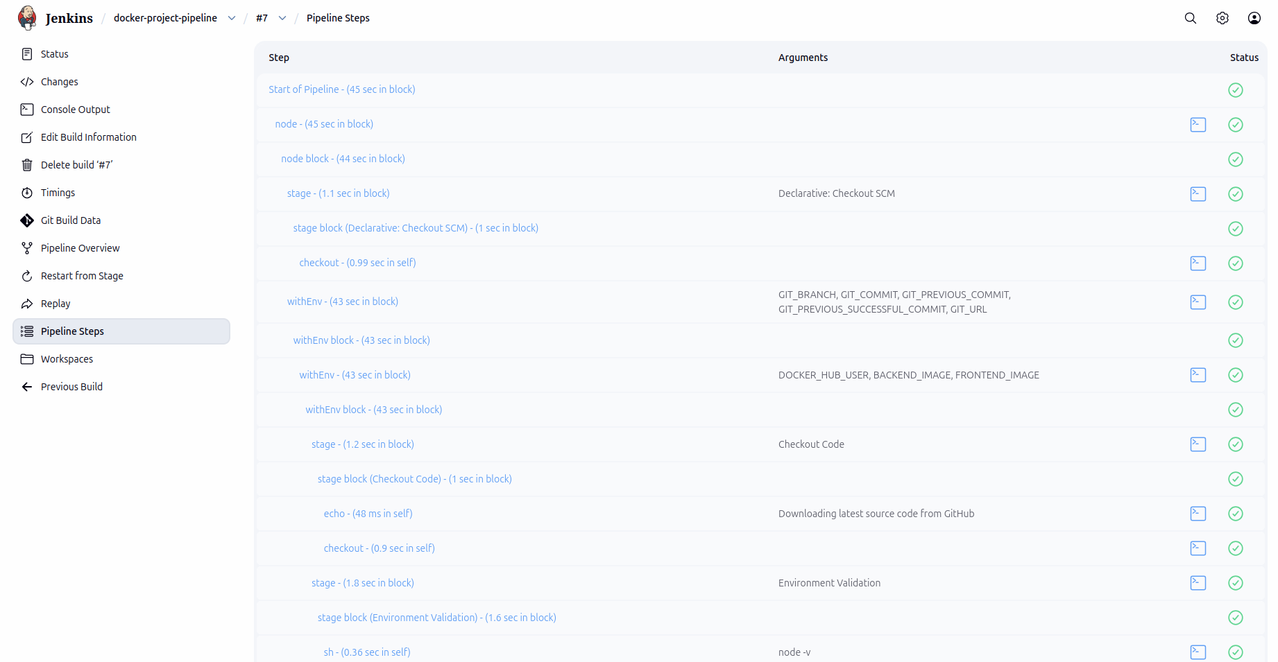
Detailed Pipeline Execution Steps :

Detailed breakdown of Jenkins pipeline execution showing environment variables, checkout operations, shell commands, and stage execution flow.

Parallel Pipeline Code
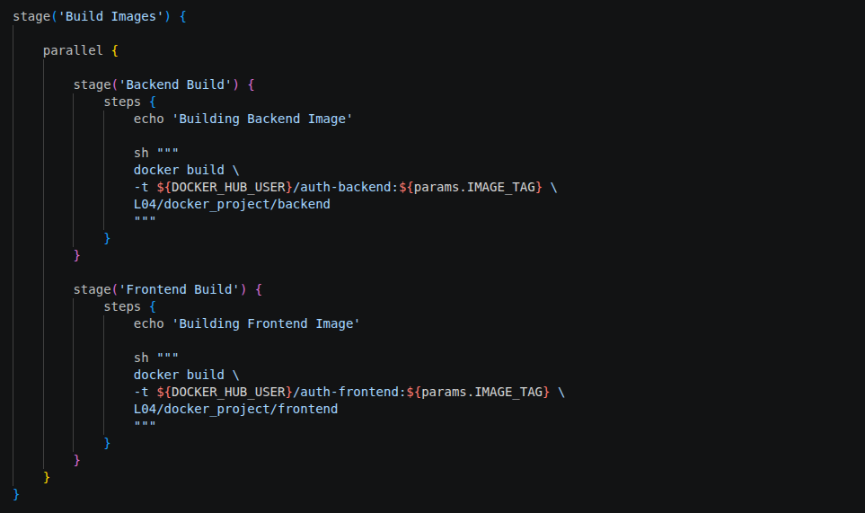

Parallel Stage Implementation in Jenkinsfile :

Implemented parallel execution for backend and frontend Docker image builds.
This reduces overall pipeline execution time by running independent stages simultaneously.

Parallel Execution Result
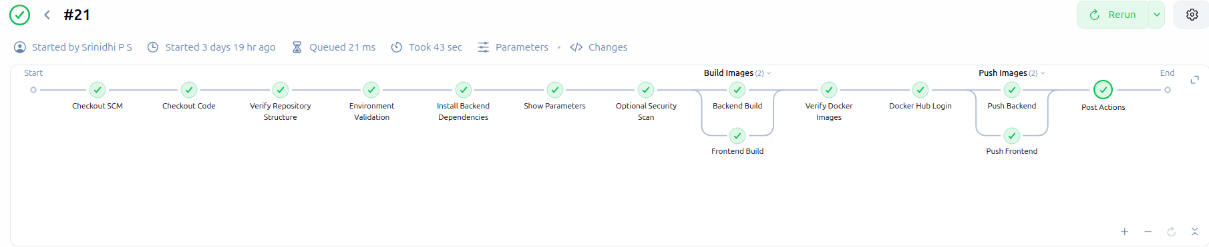

Parallel Docker Build Execution :

Backend and frontend Docker image builds were executed concurrently using Jenkins parallel stages, improving CI/CD efficiency.
Jenkins stage visualization displaying parallel backend and frontend build stages running simultaneously within the CI/CD workflow.

Docker Hub Repository
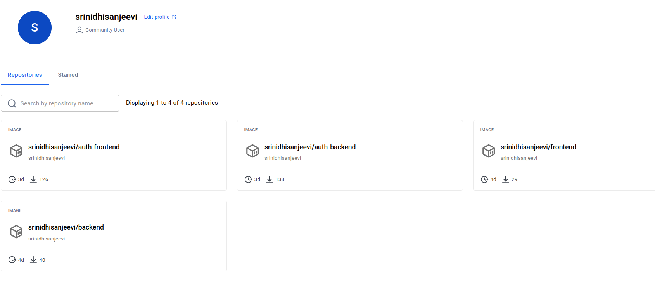
auth-backend:v1
auth-frontend:v1

Successfully published backend and frontend Docker images to Docker Hub repository.

Multi-Branch Pipeline
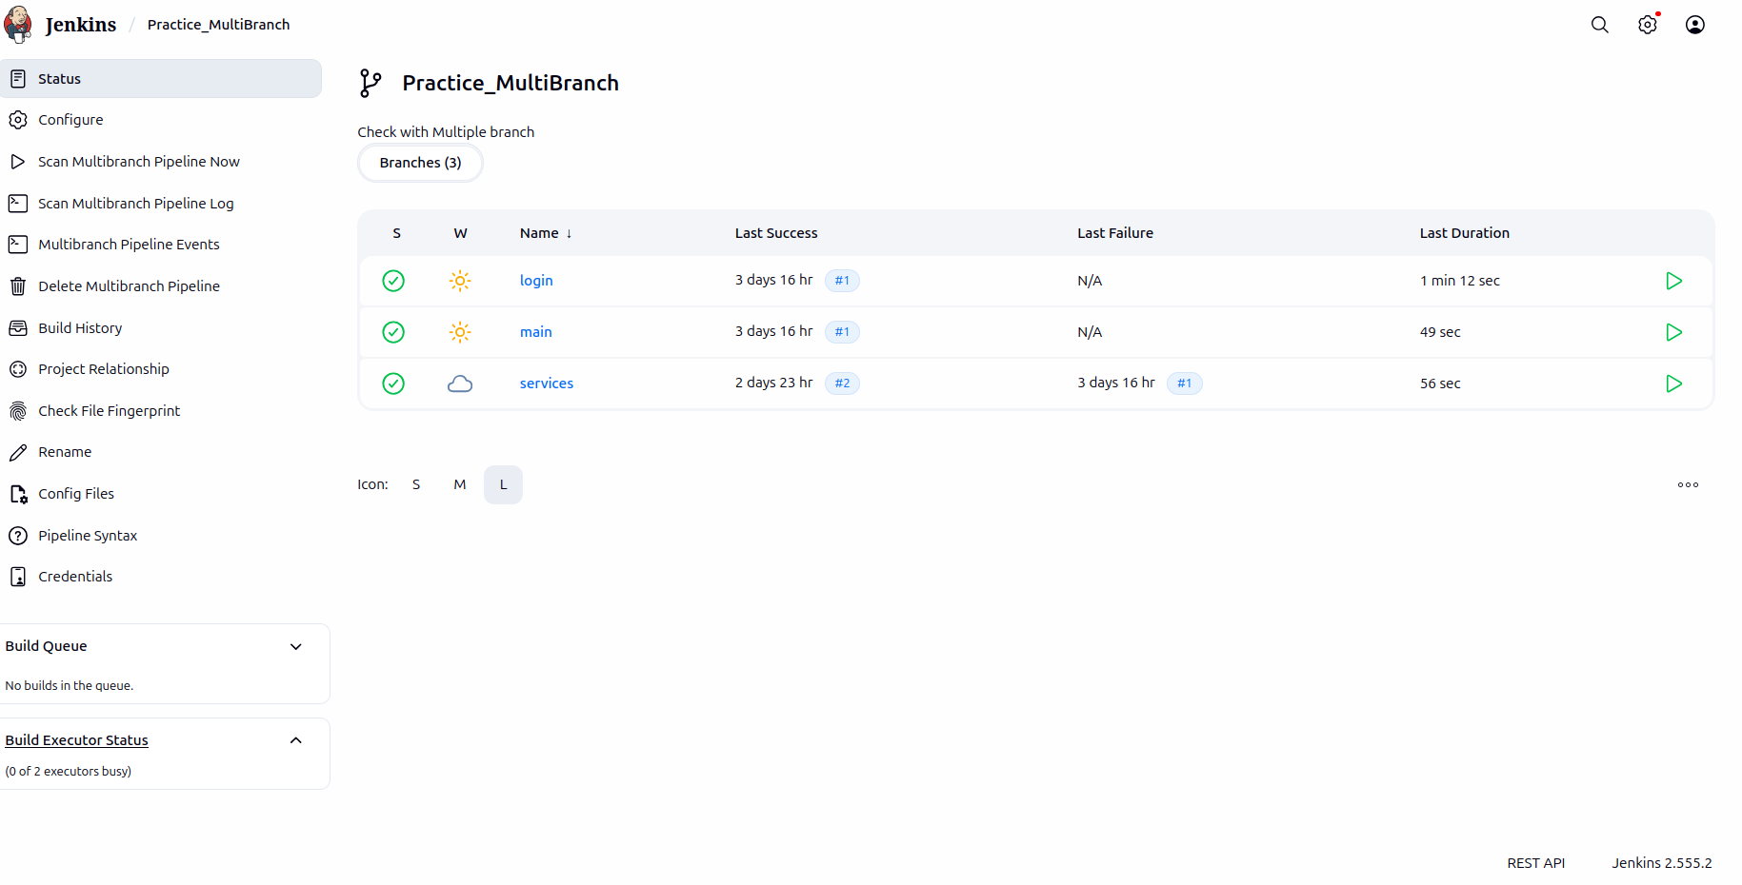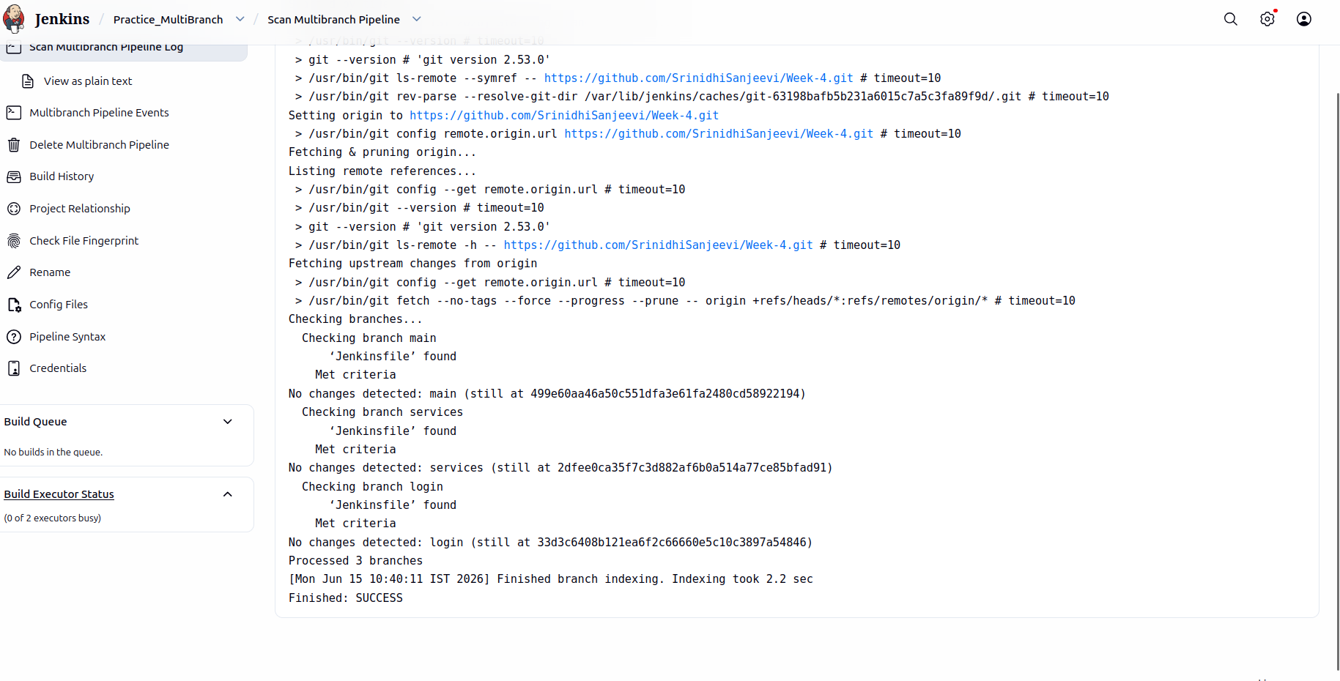
Implemented Jenkins MultiBranch Pipeline to automatically discover and build multiple Git branches.

Detected Branches:
• main
• login
• services

Each branch maintains an independent pipeline execution workflow.

Error Handling

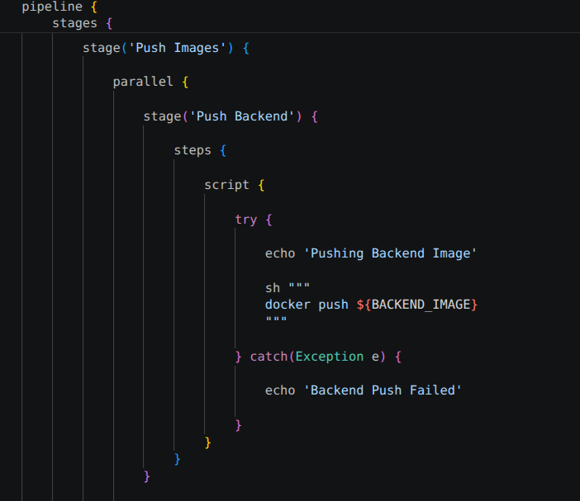

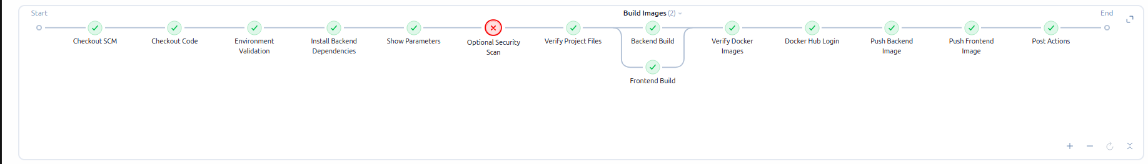

Using Catch Error Technique

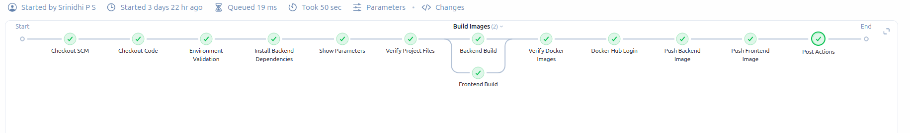

Using Try Catch Technique
Implemented exception handling using try-catch blocks and catchError() in Jenkins Pipeline.

Features:
• Pipeline continues even if optional stages fail.
• Security scan failures do not terminate the build.
• Backend and Frontend image push failures are handled gracefully.
• Improves pipeline reliability and fault tolerance.

